Figure S4
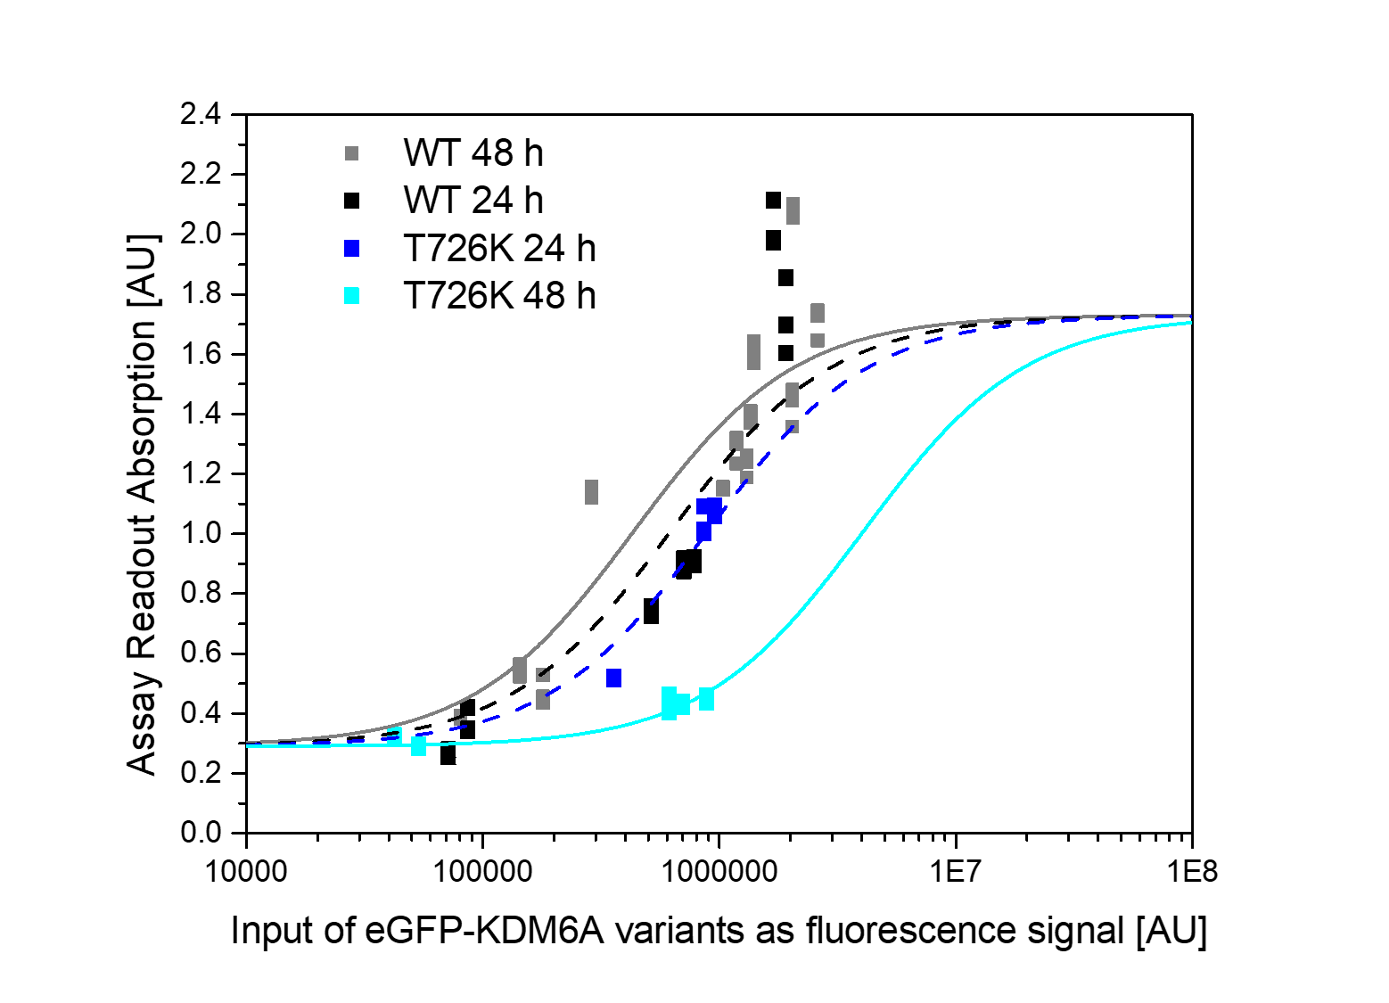
Post-transfection time-dependency of KDM6A T726K. Activity of T726K is dependent on expression time. WT activity does not change significantly between 24 h (black) to 48 h (grey), whereas in T726K activity is slightly changed after 24 h (blue) and more strongly reduced after 48 h (cyan) as depicted by C50 values.

