Supplementary Materials

High-Temperature-and-Humidity Reduces Plasma Insulin and Gut Hormones through FXR Activation Accompanied by a Metabolic Compensatory Gut Microbiota

The PDF file includes:
Table S1 to S2
Figs. S1 to S11

Suppmentary Figure 1. Dynamics of blood biochemistry parameters after high-temparature and humidity (HTH) exposure.
(A) Fasting glucose levels. (B) Total cholesterol levels. (C) Triglyceride levels. (D) High-density lipoprotein (HDL) levels. (E)Low-density lipoprotein (LDL) levels.

Suppmentary Figure 2. Dynamics of plasma level of glucose-dependent insulinotropic polypeptide (GIP) after high-temparature and humidity (HTH) exposure.

Suppmentary Figure 3. Community distribution of the fecal microbiota based on 16s rRNA gene surveys
Alpha diversity was applied to analyse the complexity of species of the NC group and HTH group. (A) Indices of Simpson and (B) Shannon , as well as Operational Taxonomic Units (OUT) numbers, are displayed. (D) Principal component analysis (PCA) at the OTU level. The PCA of all the samples was based on the relative abundance of the OTUs. Percentiles represent the contributions of principal components to differences among samples.

Supplementary Figure 4. The comparison of relative proportion of top 30 enriched genus between the HTH group and NC group at week 1.
*P<0.05, **:P<0.01 respectively analyzed with Mann-Whitney non-parametric test.

Supplementary Figure 5. The comparison of relative proportion of top 30 enriched genus between the HTH group and NC group at week 2.
*P<0.05, **:P<0.01 respectively analyzed with Mann-Whitney non-parametric test.

Supplementary Figure 6. The comparison of relative proportion of top 30 enriched genus between the HTH group and NC group at week 4.
*P<0.05, **:P<0.01 respectively analyzed with Mann-Whitney non-parametric test.

Supplementary Figure 7. The comparison of relative proportion of top 30 enriched genus between the HTH group and NC group at week 6.
*P<0.05, **:P<0.01 respectively analyzed with Mann-Whitney non-parametric test.

Supplementary Figure 8. The comparison of relative proportion of top 30 enriched genera between the HTH group and NC group at week 8.
*P<0.05, **:P<0.01 respectively analyzed with Mann-Whitney non-parametric test.

Suppmentary Figure 9. The predicted functional KEGG pathways differentially enriched between HTH group and NC group. (Ranked by P-values with direction from bottom to top).

Suppmentary Figure 10. Dynamics of blood biochemistry parameters and gut hormones in germ-free (GF) mice received fecal microbiota transfer (FMT) from high-temparature and humidity (HTH) exposed mice at week 4 and week 8.

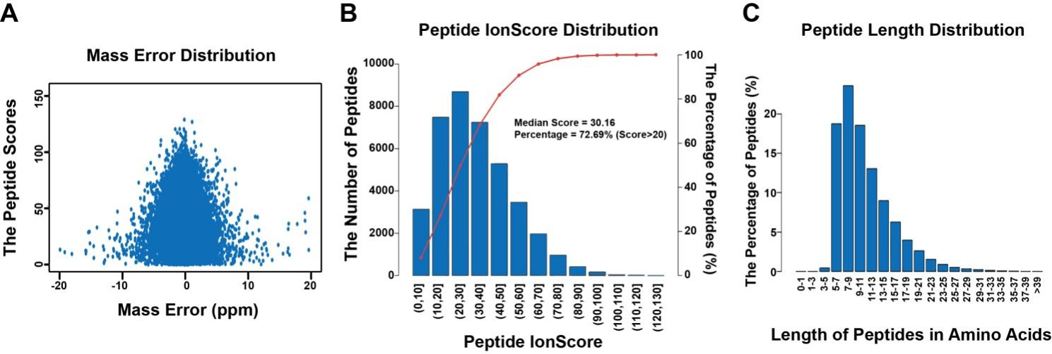
Suppmentary Figure 11. The MS data validation of TMT and LC-MS/MS proteomic analysis
(A) Mass error distribution. (B) Peptide IonScore. (C) The distribution of peptide length.

Supplementary Table 1. Mediation analysis of the gut bacteria on bio-clinical parameters induced by environmental high-temperature-and-humidity (HTH).
Mediator genus | Outcome | ACME.p | ADE.p | prop.mediated
Mucispirillum | GLP1 | 0.016 | <2e-16 | -0.204
Helicobacter | GLP1 | 0.044 | <2e-16 | -0.180
Acinetobacter | GLP1 | 0.01 | <2e-16 | -0.251
Acinetobacter | GHRL | 0.012 | <2e-16 | -0.248
Eubacterium_nodatum_group | GHRL | 0.014 | 0.002 | 0.227
Lachnoclostridium | INS | 0.032 | <2e-16 | -0.140
Ruminococcaceae_UCG-013 | INS | 0.044 | <2e-16 | -0.124
GCA-900066575 | CHOL | 0.016 | 0.08 | -0.568
Hydrogenophaga | CHOL | 0.03 | 0.9 | 0.485
Family_XIII_AD3011_group | GC | 0.04 | 0.12 | -0.346
Ruminococcaceae_UCG-013 | GLU | 0.038 | 0.032 | -0.448
GCA-900066575 | HDL | 0.014 | 0.42 | 0.528
Hydrogenophaga | HDL | 0.024 | 0.262 | -0.298
Hydrogenophaga | LDL | 0.04 | 0.92 | 0.423
Note: ACME.p: P value of average causal mediation effect. ADE.p: P value of average direct effect (the unmediated effect). Prop.mediated: The proportion of the effect of the predictor on the dependent variable which is mediated， which is computed with ACME divided by Total Effect. Numbers in red or blue indicate the proportions of positive contribution or negative contribution respectively.

Supplementary Table 2. The ileal protein abundance of PKA and CREB target genes.
Protein Name | Gene Name | HTH/NC ratio | P-value
cAMP-dependent protein kinase type II-alpha regulatory subunit | PRKAR2A | 1.009 | 0.019
cAMP-dependent protein kinase type I-alpha regulatory subunit | PRKAR1A | 1.040 | 0.024
Secretogranin-2 | SCG2 | 1.179 | 0.038
cAMP-dependent protein kinase catalytic subunit alpha | PRKACA | 1.066 | 0.062
Bicaudal D homolog 1 | BICD1 | 1.106 | 0.084
cAMP-dependent protein kinase type II-beta regulatory subunit | PRKAR2B | 1.090 | 0.148
Carboxypeptidase E | CPE | 0.948 | 0.186
cAMP-dependent protein kinase catalytic subunit beta | PRKACB | 1.030 | 0.212
Secretogranin-1 | CHGB | 1.049 | 0.769
Adenylate cyclase type 2 | ADCY2 | Not identified
gamma-aminobutyric acid type A receptor subunit beta3 | GABRB3 | Not identified
Brain Expressed X-Linked 1 | BEX1 | Not identified
Secretogranin-3 | SCG3 | Not identified
Note: HTH: high-temperature-and-humidity (HTH). NC: normal control.

