Table S1 20 μL reaction system

Fig. S1 Iris tectorum pot experiment design. The sole cultivation of Iris tectorum is ITI group, while of that is CrITI group with adding Cr(VI) 200mg kg⁻¹; The two mixed cultivation of Iris tectorum and Cyperus alternifolius are ITII group, while of those are CrITII group with adding Cr(VI) 200mg kg⁻¹; The three mixed cultivation of Iris tectorum, Cyperus alternifolius and Iris pseudacorus are ITIII group, while of those are CrITIII group with adding Cr(VI) 200mg kg⁻¹; Only the bulk of soil is CK group. There is the above sample group within three repeated samples.

Fig. S2 Bacterial community dilution curve of soil sample. The Alpha diversity index was used as the ordinate to draw the curve, and whether the amount of sequencing data was sufficient was judged according to whether the curve was flat. A, C,and E were the control group without Cr in Iris tectorum single, double and three plants, respectively. B, D,and F were polluted groups with Iris tectorum single, double and triple Cr treatments, respectively. G is for unplanted and bulk soil (CK).

Fig. S3 Venn diagram (a、b). OTUs Venn diagram of soil rhizosphere microbial community under Cr stress. Different colors represent different treatments, the number of overlapping parts is the number of common species in different treatments, and the number of endemic species in non-overlapping parts is the number of corresponding treatments. A, C,and E were the control group without Cr in Iris tectorum single, double and three plants, respectively. B, D,and F were polluted groups with Iris tectorum single, double and triple Cr treatments, respectively. G is for unplanted and bulk soil (CK).

Fig. S4 ANOSIM analysis (R=0.1623, P<0. 05). Control contains treatments of ITI, ITII and ITIII, Contamination contains treatments of CrITI, CrITII and CrITIII, Total contains treatments of Control and Contamination Group. Three duplicate samples. The box of ANOSIM represent between-group variance of Total, Control and Contamination Group. R value represents the difference between groups and P value represents confidence coefficient.

Fig. S5 Wilcoxon rank-sum test bar plot on Class level. Each column corresponding to the species represents the relative abundance of the species in each sample, and different colors represent different samples. The middle region is within the confidence interval set, and the values corresponding to the dots represent the difference in relative abundance of species between the two samples. A and B are Iris tectorum monoculture control and Contamination respectively, C and D are Iris tectorum bioculture control and Contamination respectively, E and F are the control and Contamination of Iris tectorum respectively.

Fig. S6 Collinear network graph. It mainly reflects the co-existence of species in environmental samples. A, C,and E were the control group without Cr in Iris tectorum single, double and three plants, respectively. B, D,and F were polluted groups with Iris tectorum single, double and triple Cr treatments, respectively. G is for unplanted and bulk soil (CK).

Table S1

Name | Size | Name | Size
5×FastPfu Buffer | 4 μL | FastPfu Polymerase | 0.4 μL
2.5 mM dNTPs | 2 μL | BSA | 0.2 μL
Forward Primer(5 μM) | 0.8 μL | Template DNA | 10 ng
Reverse Primer(5 μM) | 0.8 μL | Replenish dd H₂O | 20 μL

Figure S1
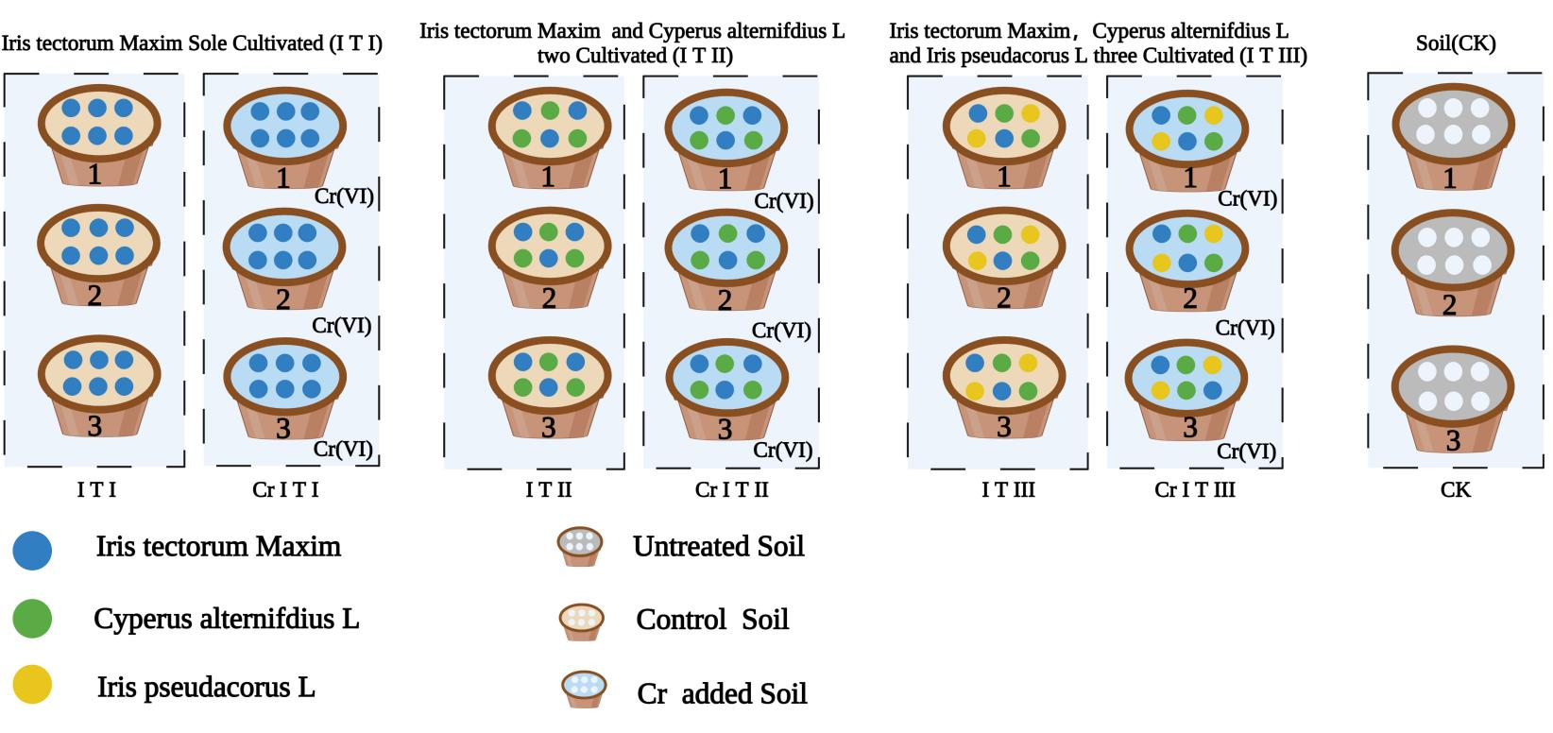

Figure S2

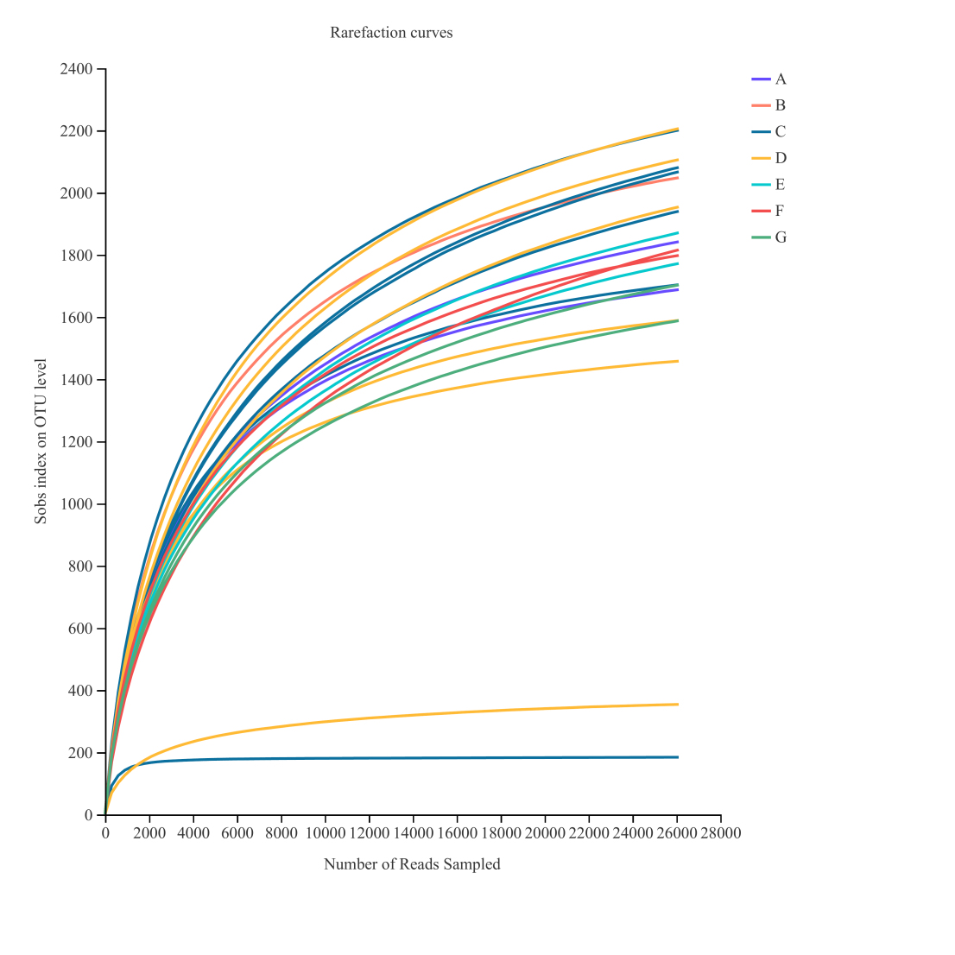

Figure S3

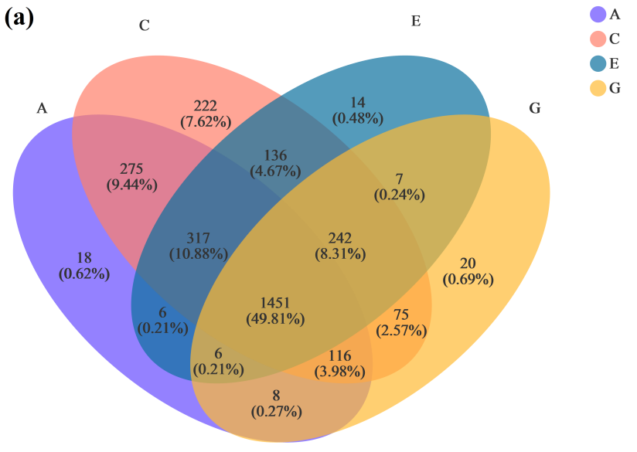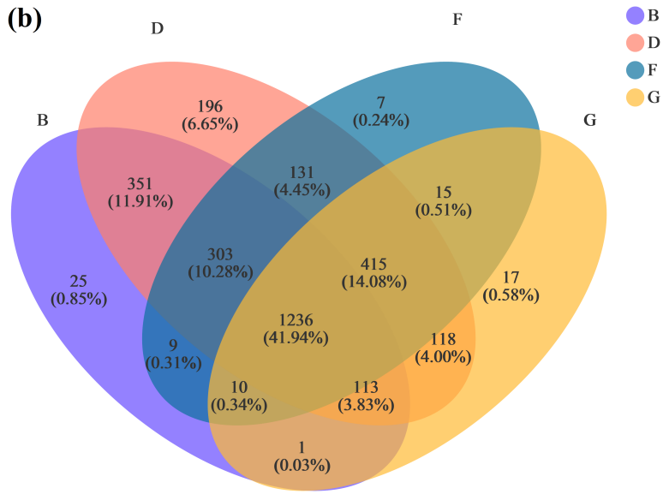

Figure S4

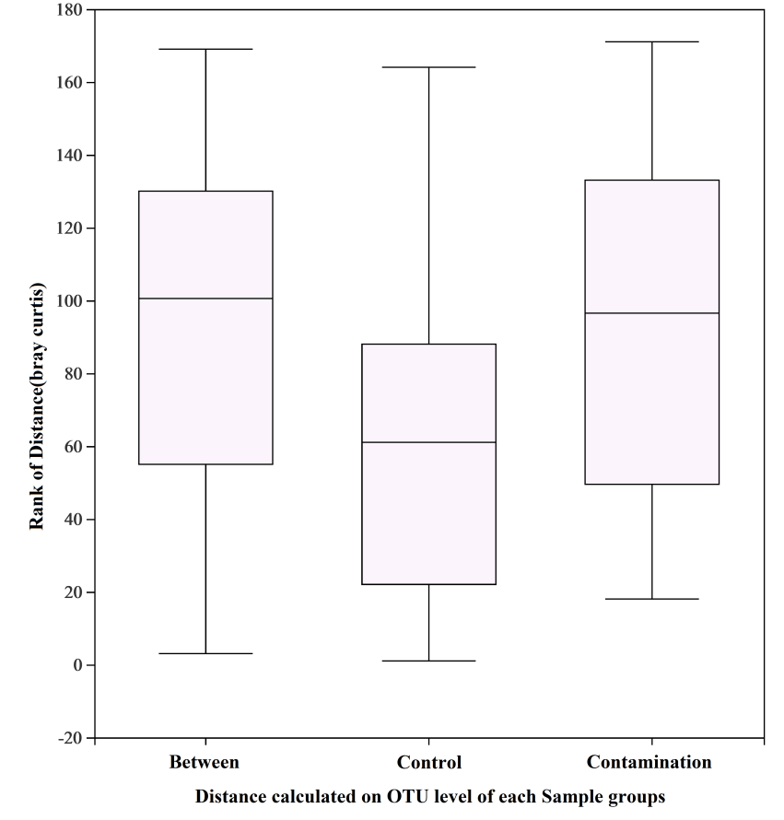

Figure S5

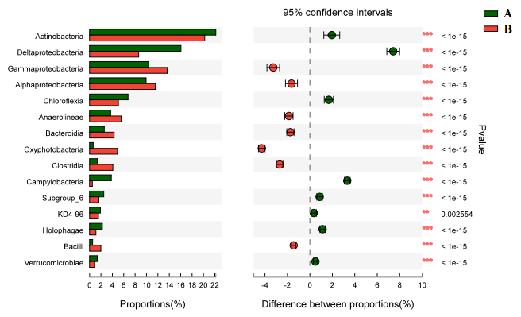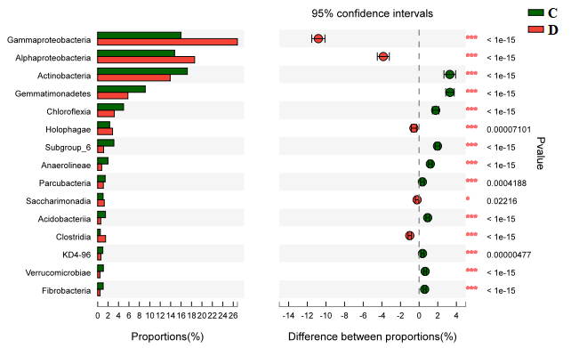
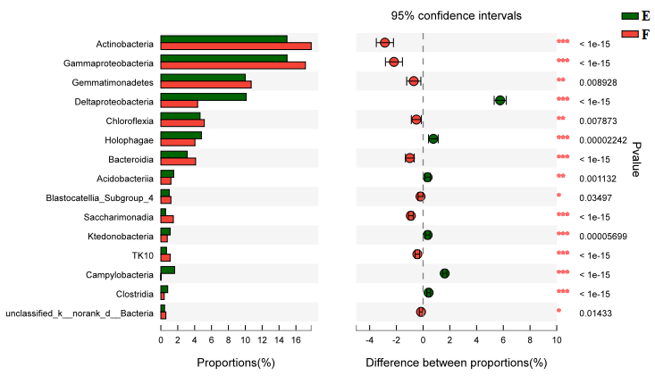

Figure S6

