Multicomponent Synthesis And In-Vitro Studies Of Isoxazole Derivatives As Potent Antioxidant And Antibacterial Agents And Their DFT Analysis
Ajay Thakura, Monika Vermaa, Parul Setiaa, Ruchi Bhartia,*, Renu Sharmaa, Ajay Sharmaa, Neelam Negib, Vivek Ananda and Ravi Bansalc
a Department of Chemistry, University Institute of Sciences, Chandigarh University, Mohali, Punjab, India.
b Department of Biotechnology, University Institute of Sciences, Chandigarh University, Mohali, Punjab, India.
c School of Studies in Chemistry, Jiwaji University, Gwalior, Madhya Pradesh, India.
Title Page | S1
General Experimental information | S2
Analytical Data of IR,¹H &¹³C NMR spectra for 4a-4n and 5 | S3-S5
IR,¹H &¹³C NMR spectra for 4a-4n and 5 | S6-S46
Cyrstallography Data of 4j | S47-S56

Experimental:
The solvents and starting materials used in this protocol are of commercially available synthesis grade and have been used without any further purification. The purity of the synthesized compounds is ensured with the help of Thin-layer chromatography. The melting point of the compounds is observed with the help of digital melting point apparatus. IR spectra have been recorded with the help of Shimadzu FTIR spectrophotometer. 1H NMR and 13C NMR spectra have been recorded on 500 MHz Bruker Avance NEO apparatus taking Me4Si as internal standard. Elemental analyses have been recored using Perkin Elmer 2400 automatic carbon, hydrogen, nitrogen analyzer.
General procedure:
Synthesis of isoxazole derivatives was (4a-4n) attained by using various aldehydes (1) (1 mmol), hydroxylamine hydrochloride (2) (1 mmol), and ethylacetoacetate (3) (1 mmol) by using 10 mol% DABCO as the catalyst in the presence of 5 ml water under reflux conditions. The progress of reaction was monitored by TLC using ethyl acetate and hexane (30:70) solvent system. The solid crude product obtained was simply purified via recrystallization using ethanol.

Spectral Data Analysis
(E)-4-benzylidene-3-methylisoxazol-5(4H)-one (4a)
Yellow needles, mp 140-142℃; IR (KBr): 3057, 2948, 1736, 1616, 1447, 1384, 1219, 1114, 1021, 987, 879, 759 cm-1; ¹H NMR (500 MHz, CDCl₃) δ: 8.34 (d, J=10Hz, 2H), 7.59-7.55 (m, 1H), 7.51-7.48 (m, 2H), 7.44 (s, 1H), 2.29 (s, 3H) ppm. ¹³C NMR (125 MHz, CDCl₃) δ: 167.91, 161.23, 150.08, 134.02, 133.83, 132.30, 130.50, 129.03, 128.93, 119.61, 11.62 ppm. Elemental Analysis Calc. (MW: 187.20): C, 70.58; H, 4.85; N, 7.48 Elemental Analysis (found): C, 70.73; H, 4.82; N, 6.67
(E)-4-(4-methoxybenzylidene)-3-methylisoxazol-5(4H)-one (4b)
Color: Yellow needles, mp 177-179℃; IR (KBr): 3083, 3030, 1785, 1552, 1429, 1313, 1260, 1167, 1013, 927, 841, 774 cm-¹; ¹H NMR (500 MHz, CDCl₃) δ: 8.43 (d, J=10Hz, 2H), 7.34 (s, 1H), 7.01 (d, J=10Hz, 2H), 3.92 (s, 3H), 2.28 (s, 3H) ppm; ¹³C NMR 125 MHz, CDCl₃) δ: 168.77, 164.62, 161.27, 149.32, 136.96, 125.84, 116.37, 114.67, 55.71, 11.64 ppm; Elemental Analysis Calc. (MW: 217.22): C, 66.35; H, 5.10; N, 6.45; Elemental Analysis (found): C, 66.30; H, 5.07; N, 6.34
(E)-4-(4-hydroxybenzylidene)-3-methylisoxazol-5(4H)-one (4c)
Yellow needles, mp 214-216℃; Ir (KBr): 3247, 3034, 2959, 1724, 1623, 1545, 1373, 1223, 1122, 890, 774 cm-¹; ¹H NMR (500 MHz, DMSO-d6) δ: 11.02 (s, 1H), 8.45 (d, J= 10Hz, 2H), 7.78 (s, 1H), 6.96 (d, J= 10Hz, 2H), 2.26 (s, 3H) ppm; ¹³C NMR (125 MHz, DMSO-d6) δ: 168.70, 163.73, 162.11, 151.35, 137.40, 124.45, 116.03, 113.76, 11.14 ppm; Elemental Analysis Calc. (MW: 203.20): C, 65.02; H, 4.46; N, 6.89; Elemental Analysis (found): C, 65.97; H, 5.04; N, 6.78
(E)-4-(4-bromo-2-fluorobenzylidene)-3-methylisoxazol-5(4H)-one (4d)
Color: Yellow needles, mp 155-157℃; IR (KBr): 3105, 3042, 1754, 1620, 1556, 1406, 1346, 1227, 1103, 1073, 875, 774 cm-¹; ¹H NMR (500 MHz, CDCl₃) δ: 8.92 (t, J=10Hz, 1H), 7.66 (s, 1H), 7.46 (d, J=10Hz, 1H), 7.38 (d, J=10Hz, 1H), 2.32 (s, 3H) ppm; ¹³C NMR (125 MHz, CDCl₃) δ: 167.58, 162.87, 161.01, 160.79, 138.68, 133.89, 129.88, 128.44, 121.38, 119.37, 11.54 ppm; Elemental Analysis Calc. (MW: 284.08): C, 46.51; H, 2.48; N, 4.93; Elemental Analysis (found): C, 46.46; H, 2.45; N, 4.82
(E)-4-(3-hydroxybenzylidene)-3-methylisoxazol-5(4H)-one (4e)
Color: Yellow, mp 199-202℃; IR (KBr): 3210, 3083, 2963, 1736, 1605, 1477, 1346, 1245, 1111, 1032, 901, 777 cm-¹; ¹H NMR (500 MHz, DMSO-d6) δ: 9.90 (s, 1H), 7.93 (s, 1H), 7.83 (s, 1H), 7.68 (d, J=10Hz, 1H), 7.37 (t, J=10Hz, 1H), 7.07 (d, J=10Hz, 1H), 2.27 (s, 3H) ppm; ¹³C NMR (125 MHz, DMSO-d6) δ: 167.66, 162.10, 157.31, 151.84, 133.51, 129.75, 125.20, 121.28, 119.33, 118.42, 11.17 ppm; Elemental Analysis Calc. (MW: 203.20): C, 65.02; H, 4.46; N, 6.89; Elemental Analysis (found): C, 64.97; H, 4.43; N, 6.78
(E)-3-methyl-4-(4-methylbenzylidene)isoxazol-5(4H)-one (4f)
Yellow needles, mp 129-131℃; IR (KBr): 3098, 2997, 1728, 1623, 1511, 1410, 1350, 1219, 1107, 1025, 935, 879, 774 cm-¹; ¹H NMR (500 MHz, CDCl₃) δ: 8.27 (d, J=10Hz, 2H), 7.38 (s, 1H), 7.30 (d, J=10Hz, 2H), 2.44 (s, 3H), 2.28 (s, 3H) ppm; ¹³C NMR (125 MHz, CDCl₃) δ: 168.22, 161.26, 150.00, 145.72, 134.16, 131.05, 129.96, 129.88, 129.74, 118.38, 22.06, 11.62 ppm. Elemental Analysis Cacl. (MW: 201.23): C, 71.63; H, 5.51; N, 6.96; Elemental Analysis (found): C, 71.58; H, 5.48; N, 6.85
(E)-4-(4-(dimethylamino)benzylidene)-3-methylisoxazol-5(4H)-one (4g)
Color : Red, mp 230-232℃, IR (KBr): 3090, 2918, 1713, 1552, 1436, 1380, 1204, 1099, 953, 834, 774 cm-¹; ¹H NMR (500 MHz, CDCl₃) δ: 8.39 (d, J=10Hz, 2H), 7.19 (s, 1H), 6.70 (d, J=10Hz, 2H), 3.15 (s, 6H), 2.22 (s, 3H) ppm; ¹³C NMR (125 MHz, CDCl₃) δ:: 170.11, 161.57, 154.25, 149.25, 137.62, 121.54, 111.52, 111.12, 40.09, 11.54 ppm; Elemental Analysis Calc. (MW: 230.27): C, 67.81; H, 6.13; N, 12.17; Elemental Analysis (found): C, 67.76; H, 6.10; N, 12.06
(E)-4-(2-hydroxybenzylidene)-3-methylisoxazol-5(4H)-one (4h)
Color: Yellow, mp 150-152℃; IR (KBr): 3154, 2984, 1739, 1601, 1459, 1350, 1156, 1092, 901, 766 cm-¹; ¹H NMR (500 MHz, DMSO-d6) δ: 10.98 (s, 1H), 8.75-.8.73 (m, 1H), 8.09 (s, 1H), 7.50-7.47 (m, 1H), 7.01 (d, J=10Hz, 1H), 6.95-6.92 (m, 1H), 2.26 (s, 3H) ppm; ¹³C NMR (125 MHz, DMSO-d6) δ: 168.13, 161.99, 159.51, 144.85, 136.58, 132.18, 119.37, 118.96, 116.31, 116.02, 11.06 ppm; Elemental Analysis Calc. (MW: 203.20): C, 65.02; H, 4.46; N, 6.89; Elemental Analysis (found): C, 64.97; H, 4.43; N, 6.78
(E)-4-(4-bromobenzylidene)isoxazol-5(4H)-one (4j)
Color: Yellow, mp 154-156℃; IR (KBr): 3079, 2952, 1664, 1552, 1432, 1391, 1238, 1118, 1069, 849, 744 cm-¹; ¹H NMR (500 MHz, DMSO-d6) δ: 7.50 (d, J=10Hz, 2H), 7.17 (d, J=10Hz, 2H), 4.78 (s, 1H), 1.90 (s, 3H) ppm; ¹³C NMR (125 MHz, DMSO-d6) δ: 171.10, 161.31, 150.00, 139.11, 135.06, 131.01, 129.96, 119.42, 10.81 ppm; Elemental Analysis Calc. (MW: 252.07): C, 49.65; H, 3.03; N, 5.26; Elemental Analysis (found): C, 49.60; H, 3.00; N, 7.03
(E)-3-methyl-4-(naphthalen-1-ylmethylene)isoxazol-5(4H)-one (4k)
Color: Yellow, mp 148-149℃; IR (KBr): 3143, 1702, 1612, 1537, 1447, 1380, 1294, 1152, 931, 826, 774 cm-¹; ¹H NMR (500 MHz, DMSO-d6) δ: 8.66 (d, J=10Hz, 1H), 8.46 (d, J=10Hz, 1H), 8.20-8.15 (m, 1H), 8.06 (d, J=10Hz, 1H), 7.72-7.69 (m, 1H), 7.67-7.63 (m,2H), 2.43 (s, 3H) ppm; ¹³C NMR (125 MHz, DMSO-d6) δ: 167.41, 161.83, 148.49, 133.43, 132.86, 131.26, 130.68, 128.79, 127.63, 126.56, 124.90, 124.55, 123.97, 120.22, 11.20 ppm; Elemental Analysis Calc. (MW: 237.26): C, 75.94; H, 4.67; N, 5.9; Elemental Analysis (found): C, 75.89; H, 4.63; N, 5.79

(E)-4-(3,4-dihydroxybenzylidene)-3-methylisoxazol-5(4H)-one (4l)
Color: Yellow, mp 211-212℃; IR (KBr): 3143, 1702, 1612, 1537, 1447, 1380, 1294, 1152, 931, 826, 774 cm-¹; ¹H NMR (500 MHz, DMSO-d6) δ: 10.52 (s, 1H), 9.55 (s, 1H), 8.15 (s,1H), 7.73-7.70 (m, 1H), 7.58 (s, 1H), 6.84 (d, J=10Hz, 1H), 2.15 (s, 3H) ppm; ¹³C NMR (125 MHz, DMSO-d6) δ: 168.76, 162.17, 153.18, 151.84, 145.30, 130.30, 125.05, 120.32, 115.76, 113.37, 11.17 ppm; Elemental Analysis Calc (MW: 219.20): C, 60.28; H, 4.14; N, 6.39; Elemental Analysis (found): C, 60.23; H, 4.11; N, 6.28
(E)-3-methyl-4-(thiophen-2-ylmethylene)isoxazol-5(4H)-one (4m)
Color: Yellow, mp 144-146℃; IR (KBr):: 3075, 2984, 1730, 1596, 1403, 1298, 1122, 1029, 992, 859, 774 cm-¹; ¹H NMR (500 MHz, DMSO-d6) δ:8.32-8.31 (m, 1H), 8.24 (s, 1H), 8.22 (d, J=10Hz, 1H), 7.39-7.37 (m, 1H), 2.27 (s, 3H) ppm; ¹³C NMR (125 MHz, DMSO-d6) δ: 168.37, 161.47, 142.88, 141.41, 140.98, 136.06, 128.83, 112.92, 10.95 ppm; Elemental Analysis Calc. (MW: 193.22): C, 55.95; H, 3.65; N, 7.25; Elemental Analysis (found): C, 55.90; H, 3.62; N, 7.14
(E)-4-(furan-2-ylmethylene)-3-methylisoxazol-5(4H)-one (4n)
Color: Black, mp 237-238℃; IR (KBr): 3124, 2986, 1711, 1601, 1537, 1441, 1349, 1225, 1175, 1008, 881, 753 cm⁻¹; ¹H NMR (500 MHz, DMSO-d6) δ: 7.21 (d, J=10Hz, 1H), 7.10 (d, J=10Hz, 1H), 7.00(t, J=10Hz, 1H), 6.49 (s, 1H), 2.18 (s, 3H) ppm; Elemental Analysis (Calc.): C, 61.02; H, 3.98; N, 7.91; Elemental Analysis (found): C, 60.97; H, 3.95; N, 7.80
(Z)-2,6-dichlorobenzaldehyde oxime (5)
Color: White crystalline needle shaped, mp 147-151℃; IR (KBr): 3274, 3120, 3068, 1581, 1436, 1297, 1185, 1093, 915, 877, 774 cm-¹; ¹H NMR (500 MHz, DMSO-d6) δ: 8.92 (t, J=10Hz, 1H), 7.66 (s, 1H), 7.46 (d, J=10Hz, 1H), 7.38 (d, J=10Hz, 1H), 2.32 (s, 3H) ppm; ¹³C NMR (125 MHz, DMSO-d6) δ: 143.66, 133.80, 130.84, 129.27, 128.79 ppm; Elemental Analysis Calc. (MW: 190.02): C, 44.25; H, 2.65; N, 7.37; Elemental Analysis (found): C, 44.20; H, 2.62; N, 7.26

IR, ¹H & ¹³C NMR Spectral Data of 4a
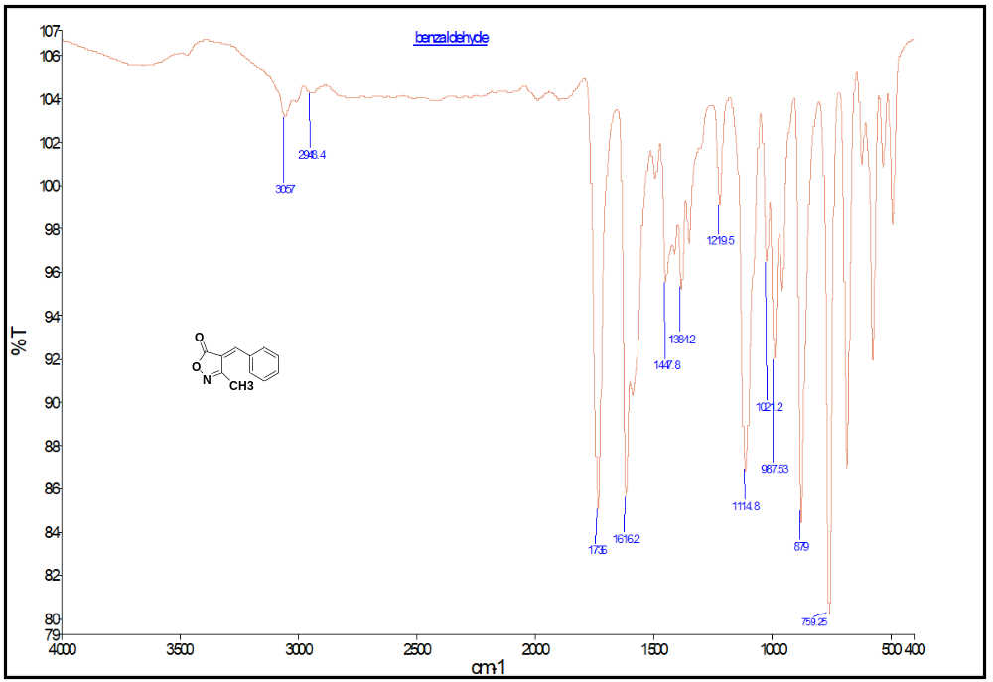
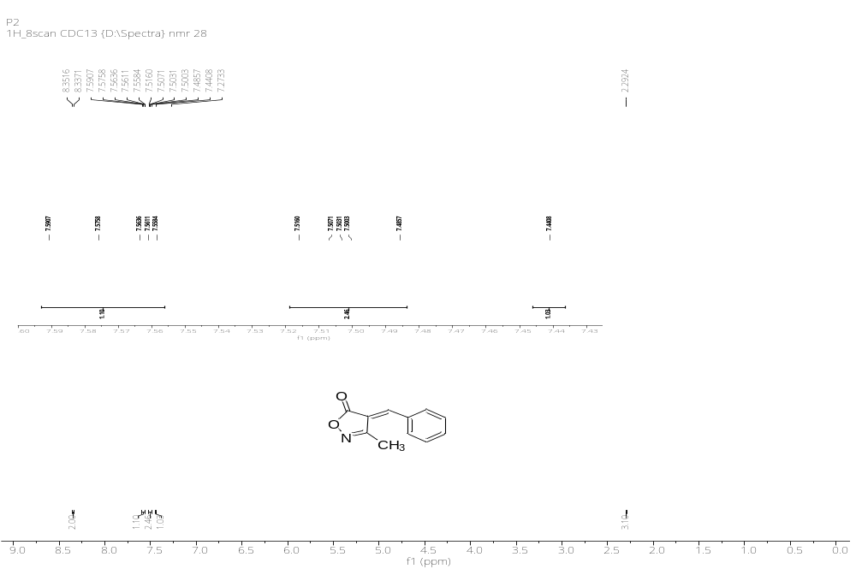
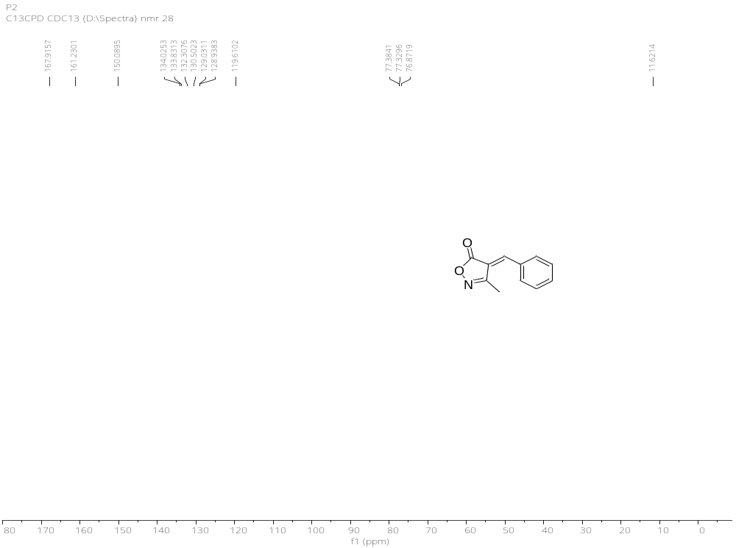

IR, ¹H & ¹³C NMR Spectral Data of 4b
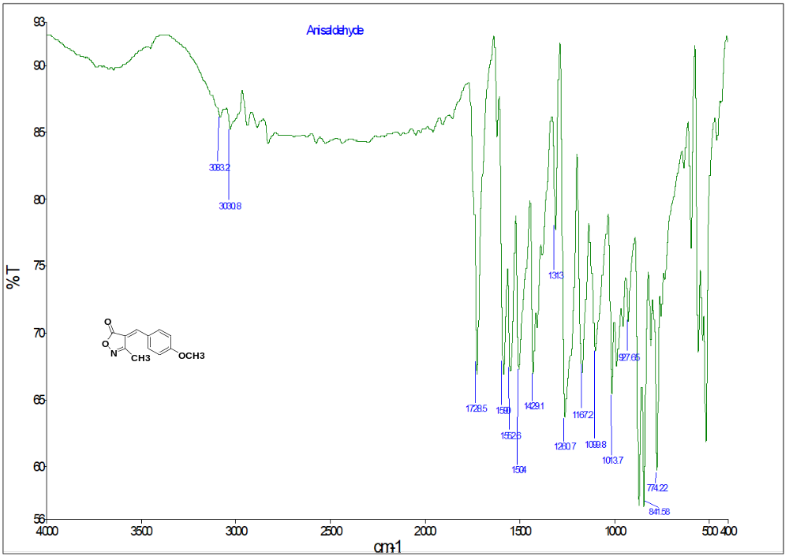
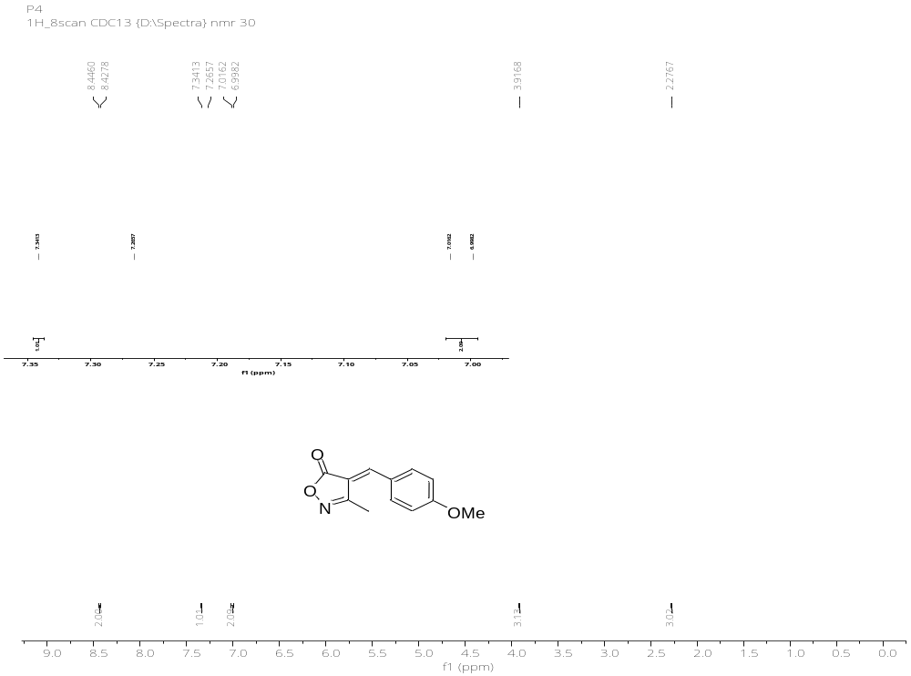
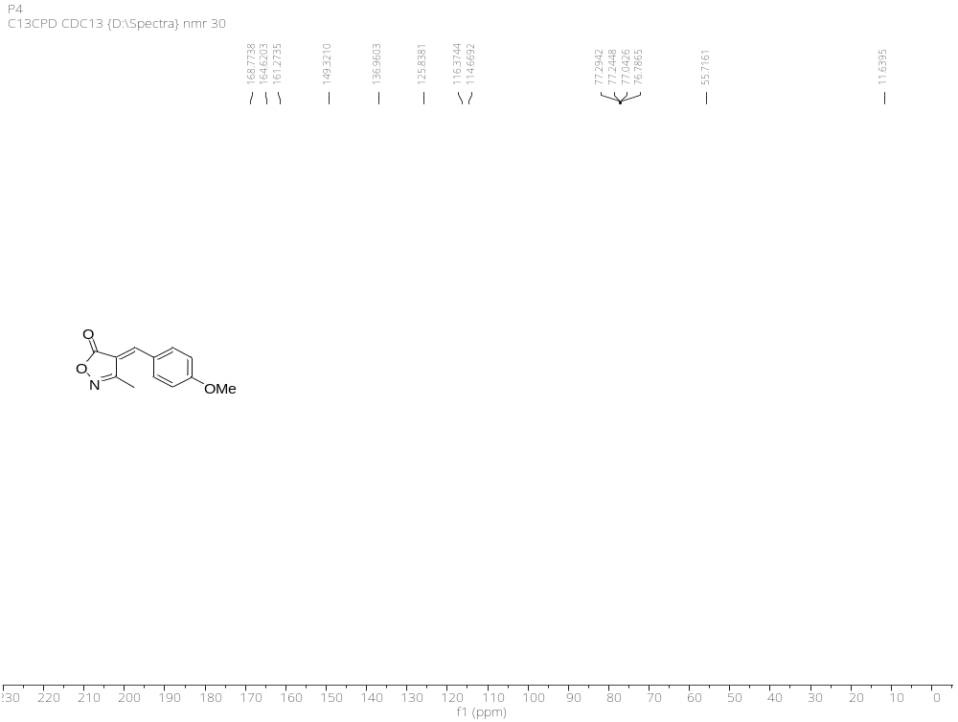

IR, ¹H & ¹³C NMR Spectral Data of 4c
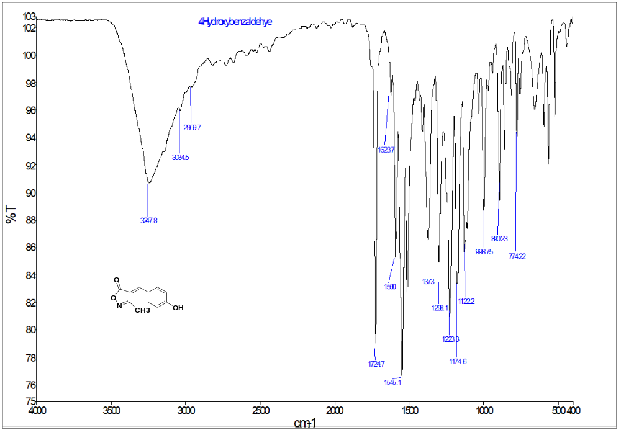
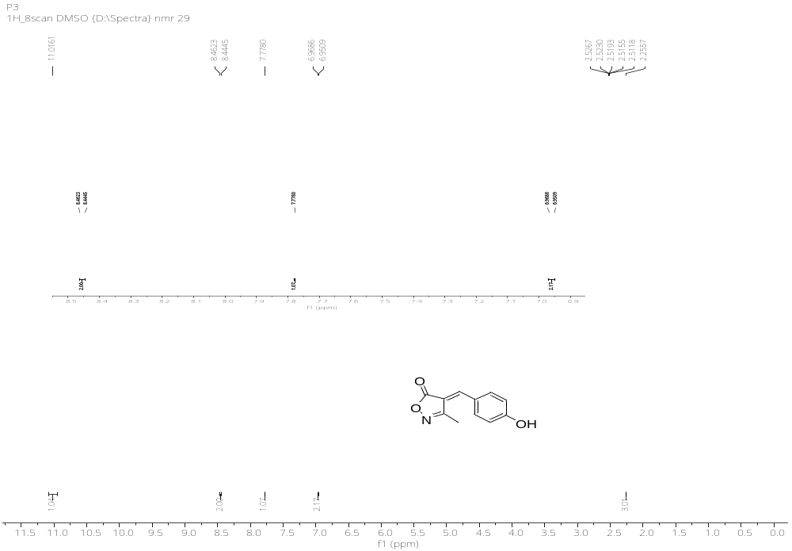
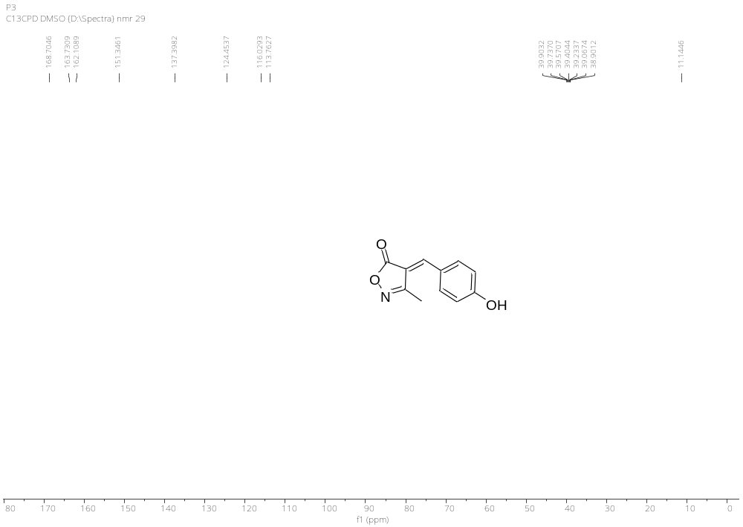

IR, ¹H & ¹³C NMR Spectral Data of 4d
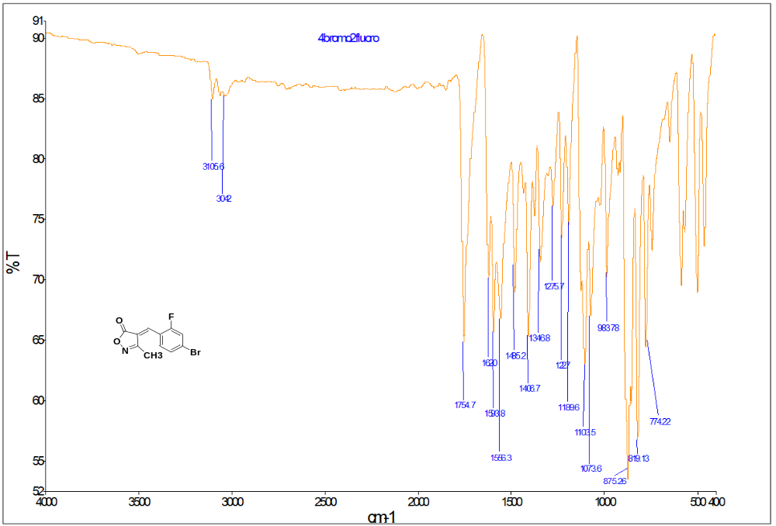
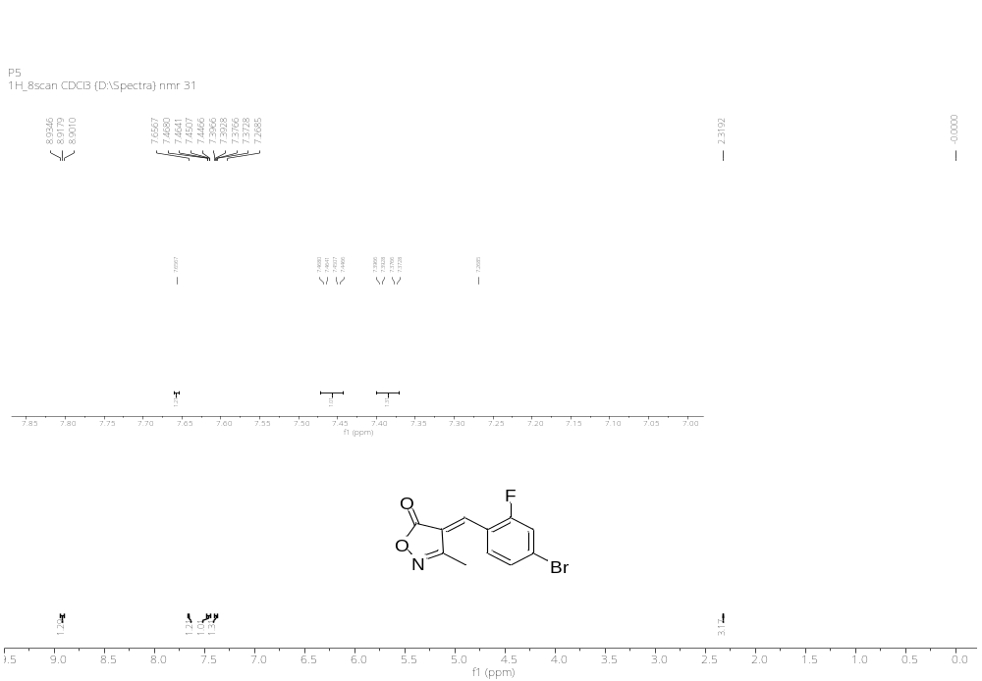
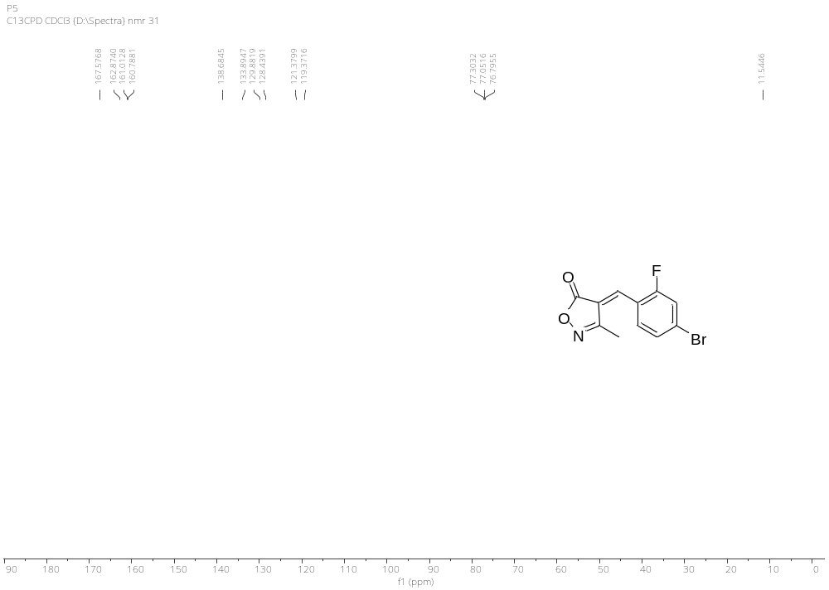

IR, ¹H & ¹³C NMR Spectral Data of 4e
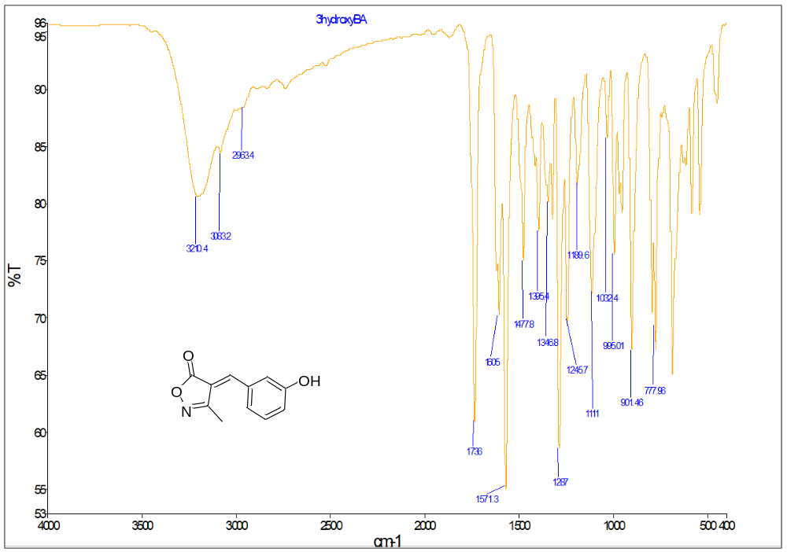
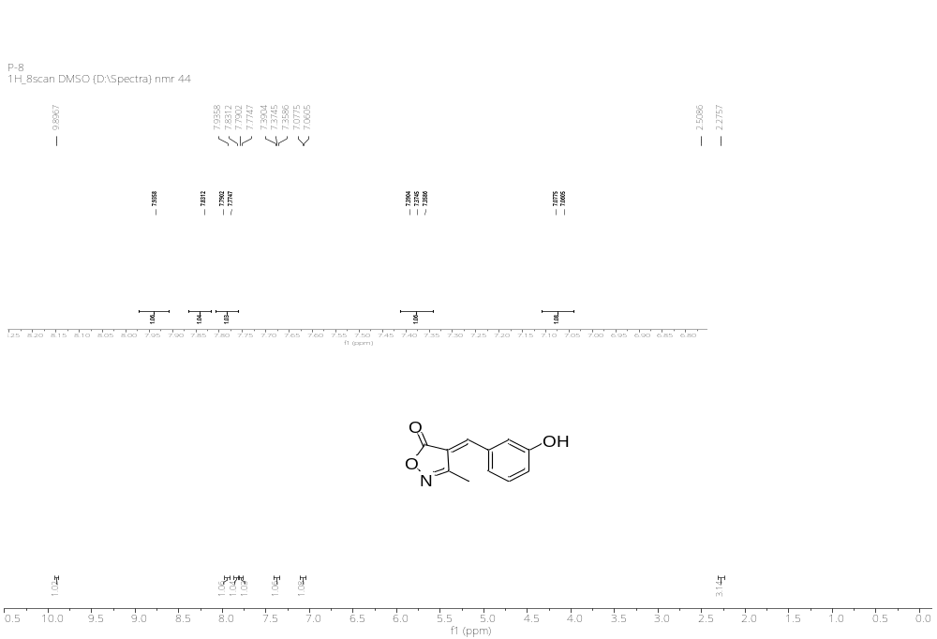
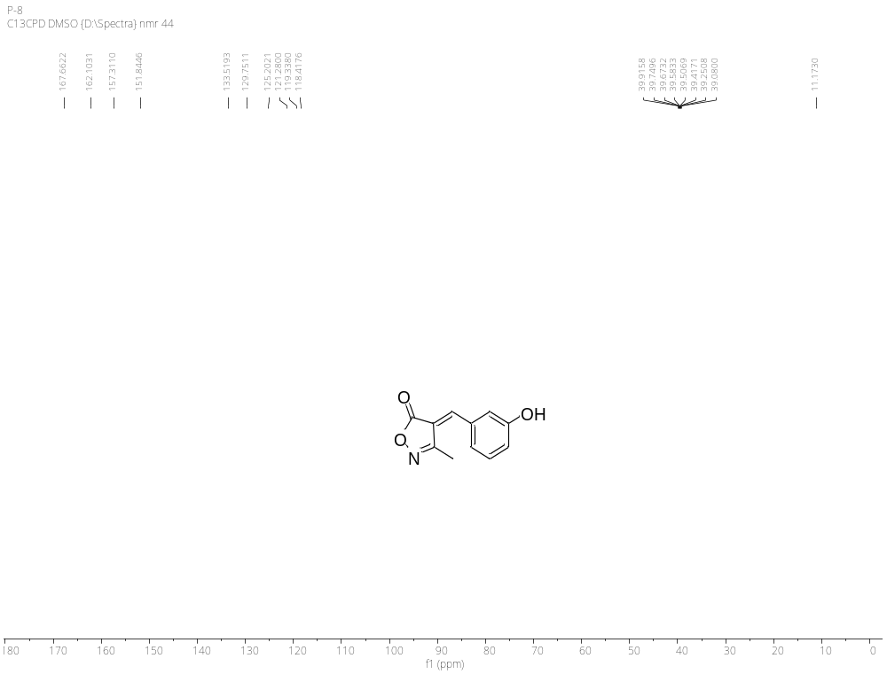

IR, ¹H & ¹³C NMR Spectral Data of 4f
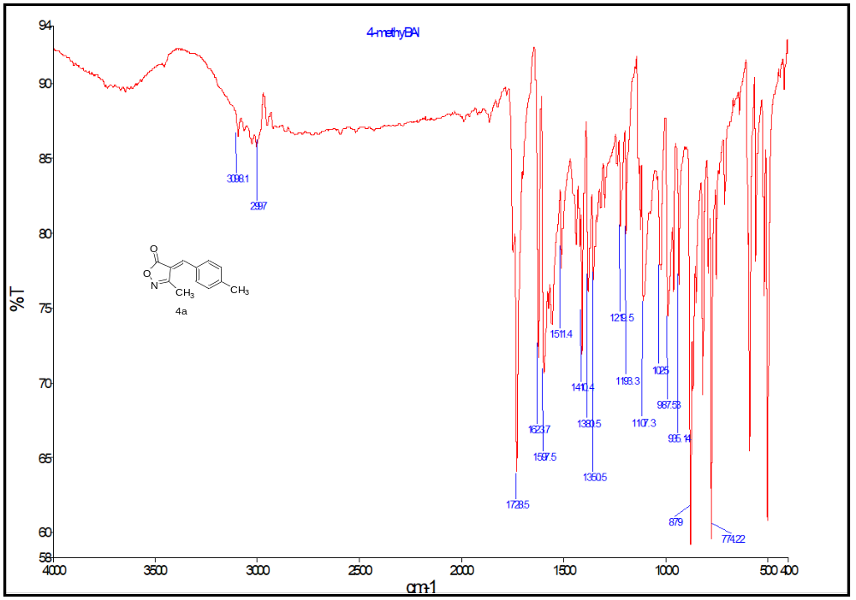
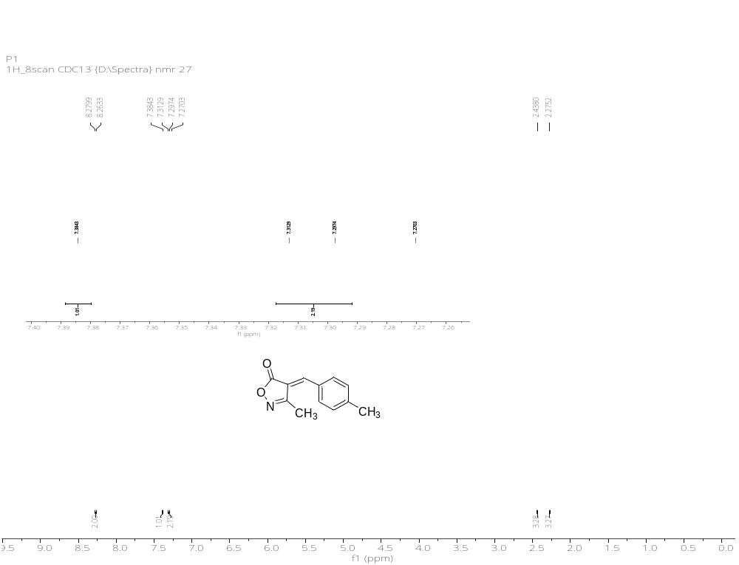
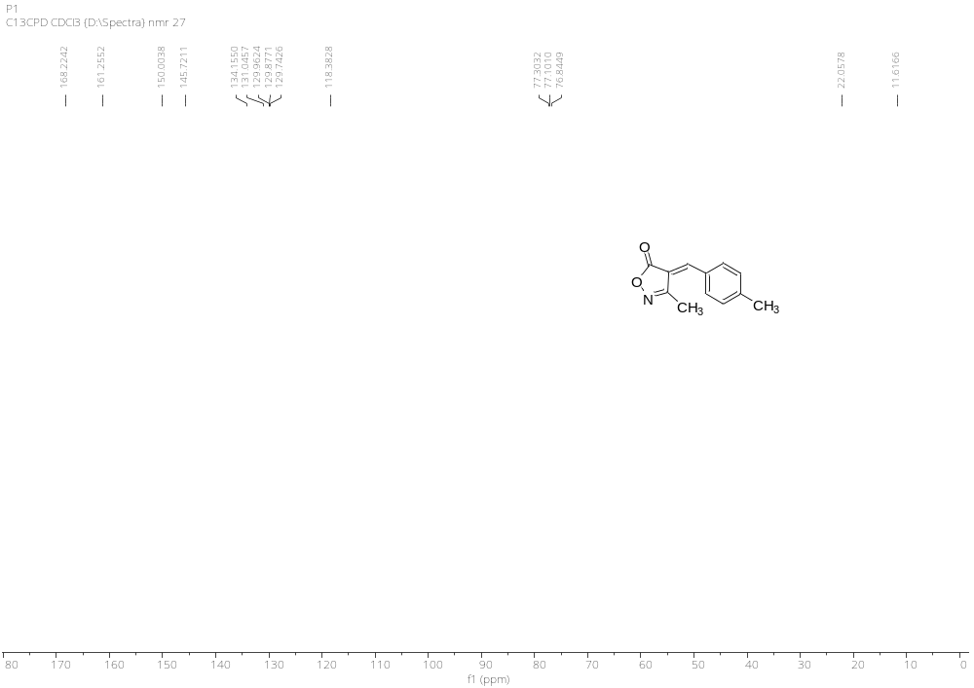

IR, ¹H & ¹³C NMR Spectral Data of 4g
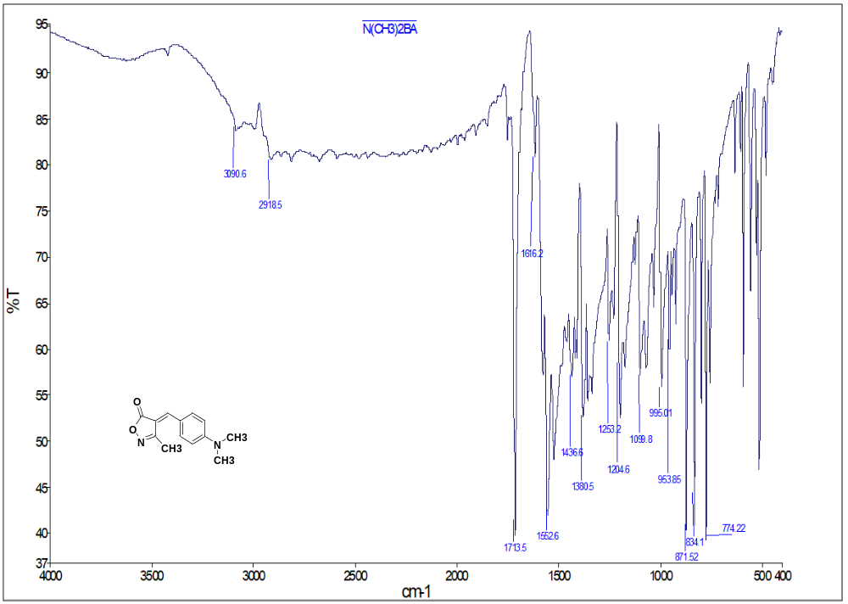
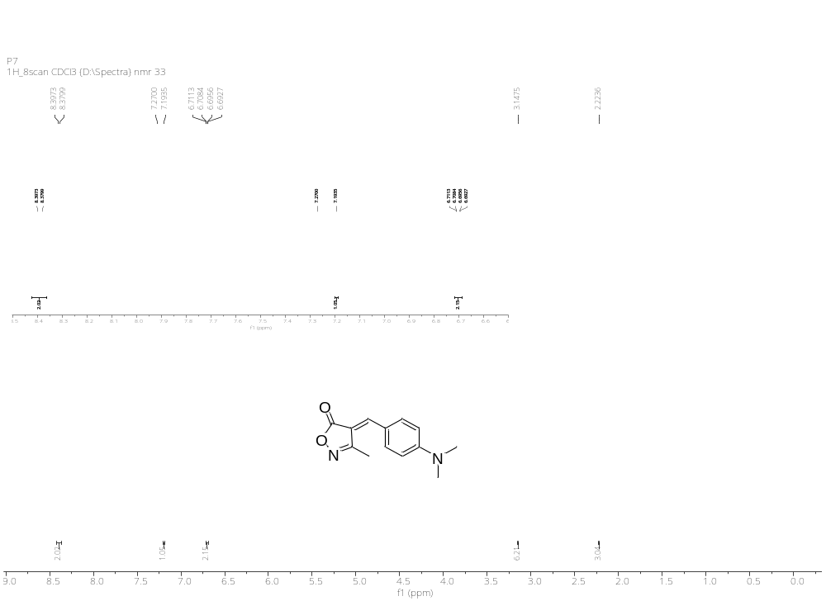

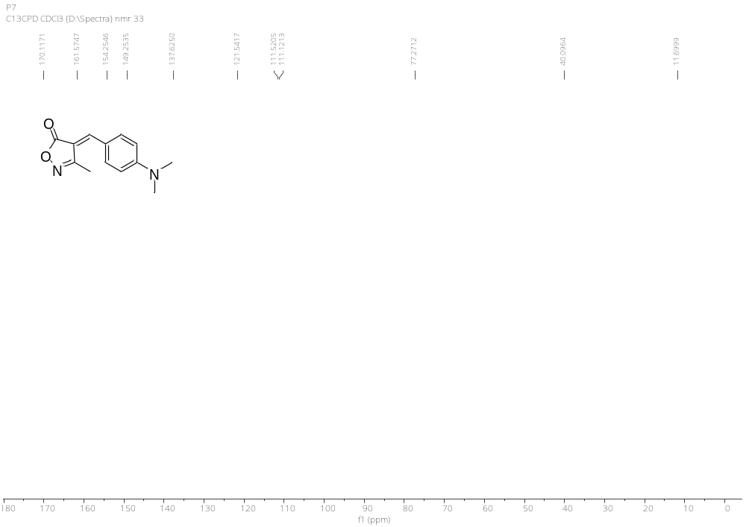

IR, ¹H & ¹³C NMR Spectral Data of 4h
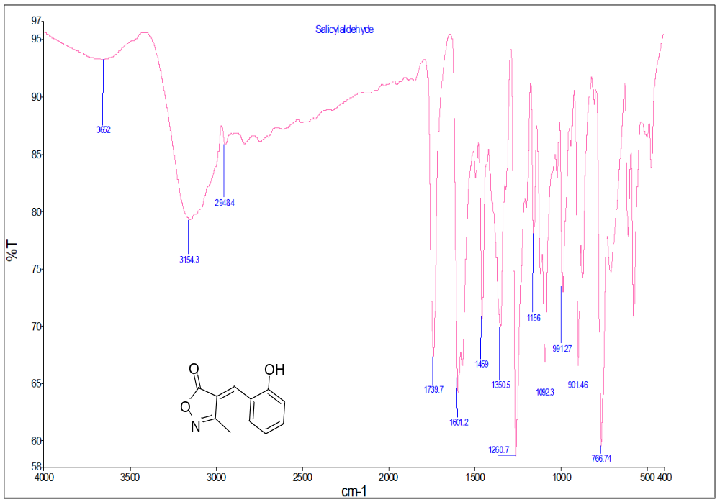
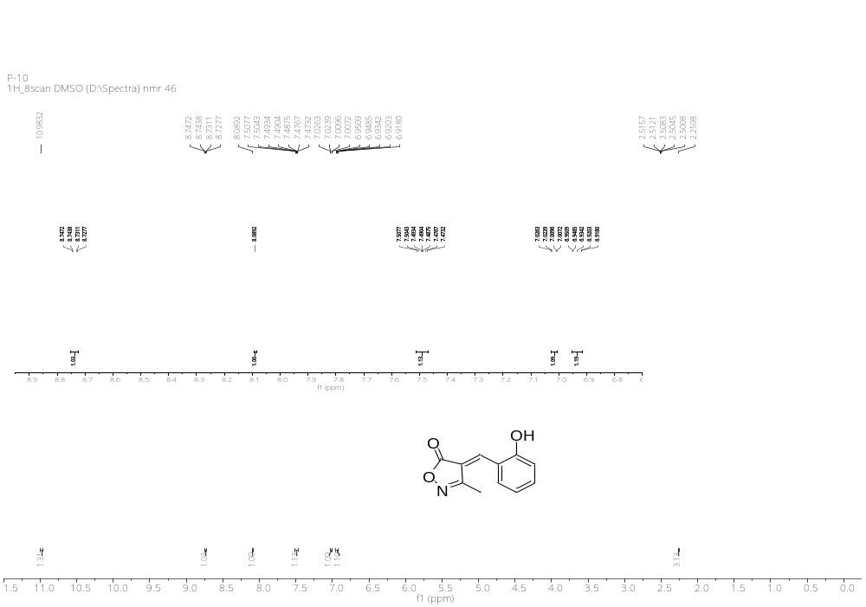
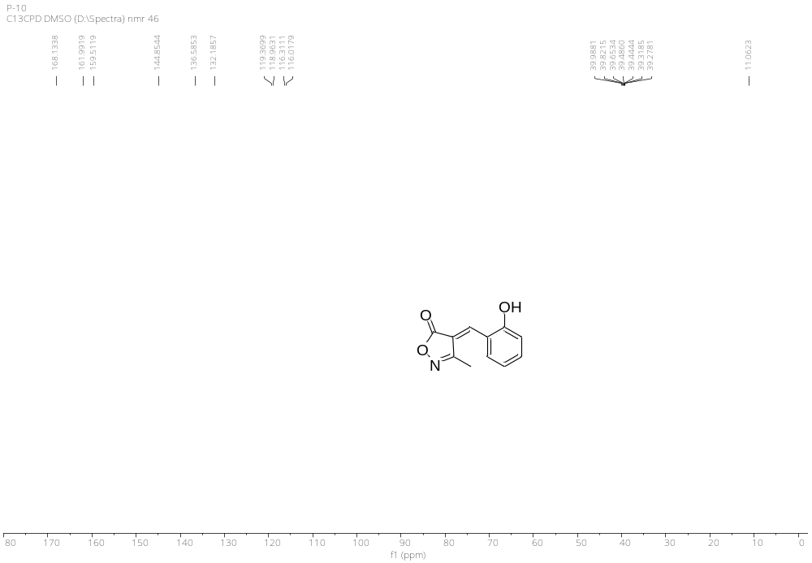

IR, ¹H & ¹³C NMR Spectral Data of 4j
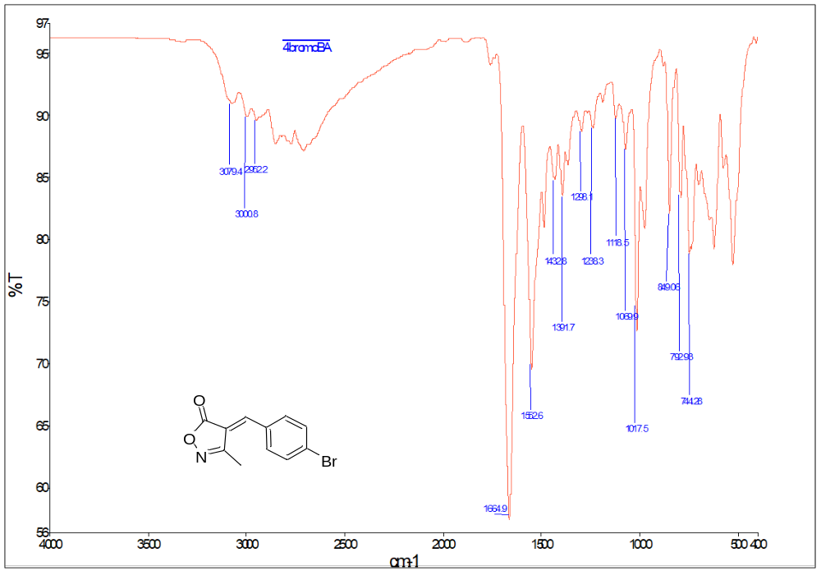
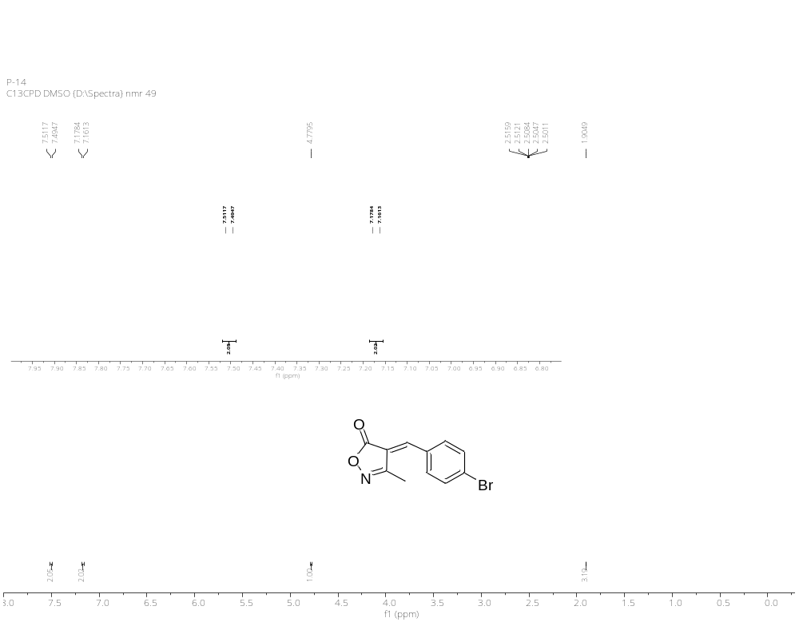
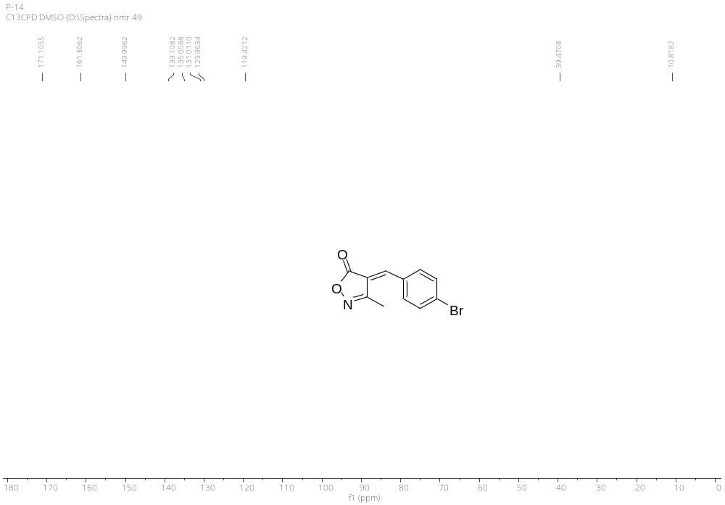

IR, ¹H & ¹³C NMR Spectral Data of 4k
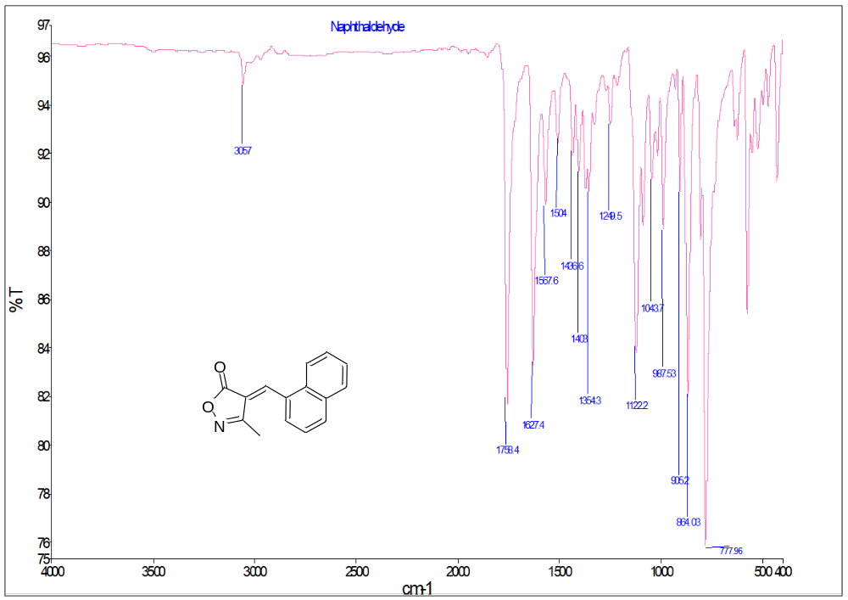
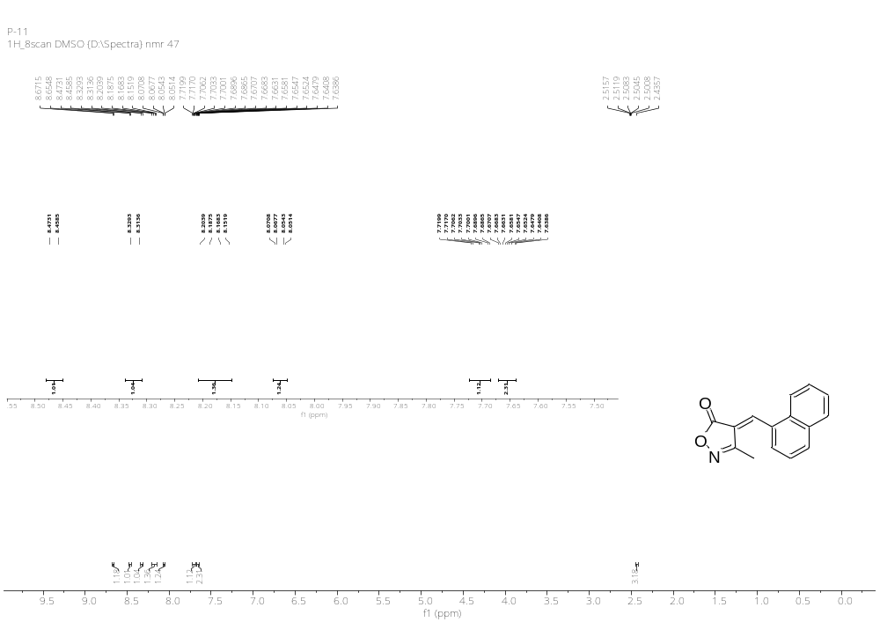
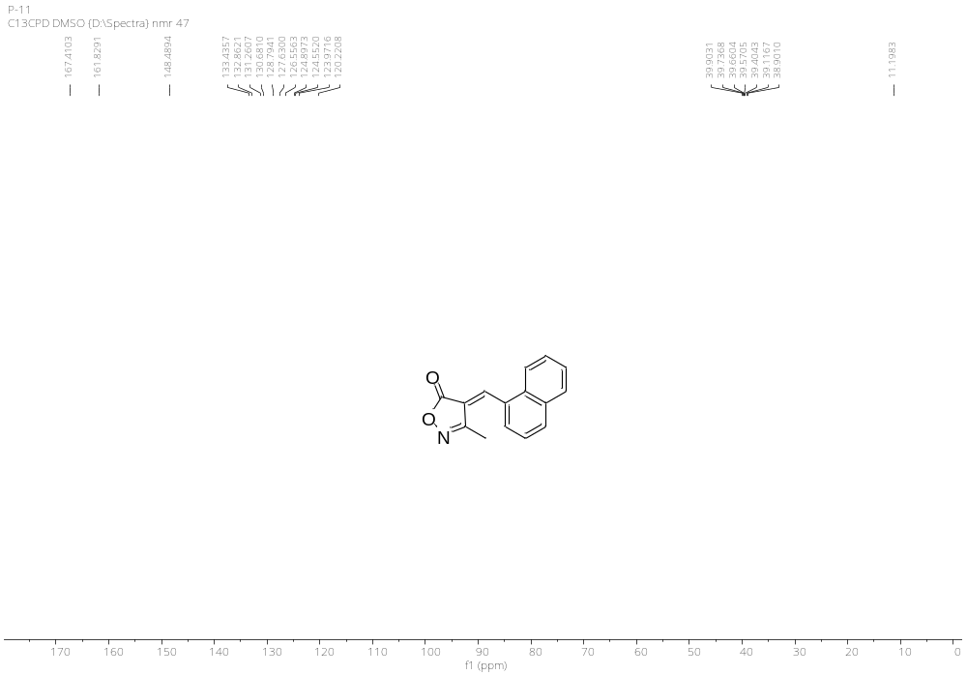

IR, ¹H & ¹³C NMR Spectral Data of 4l
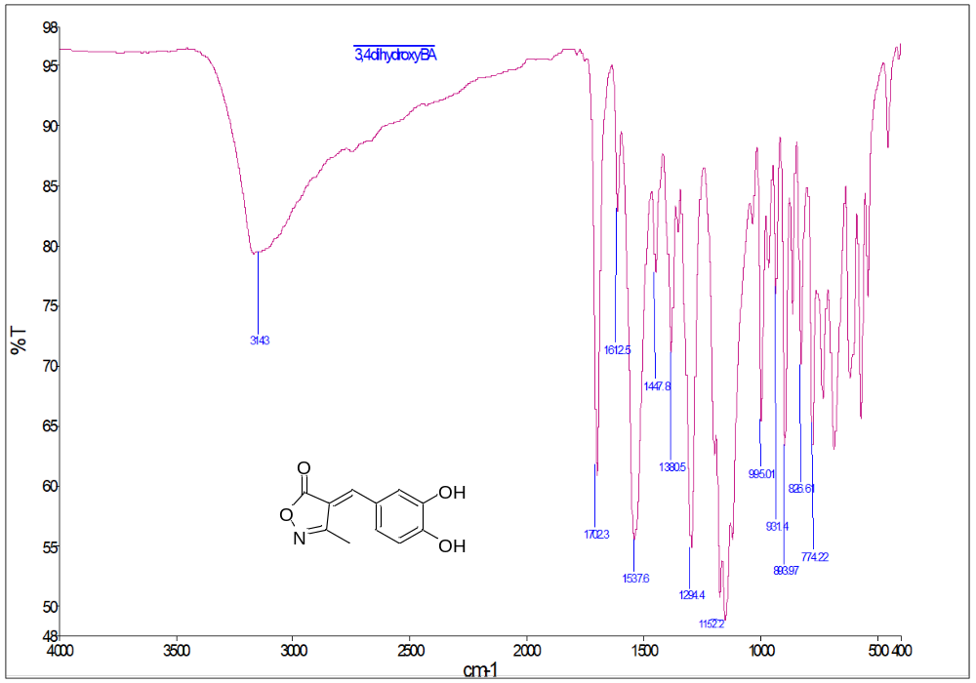
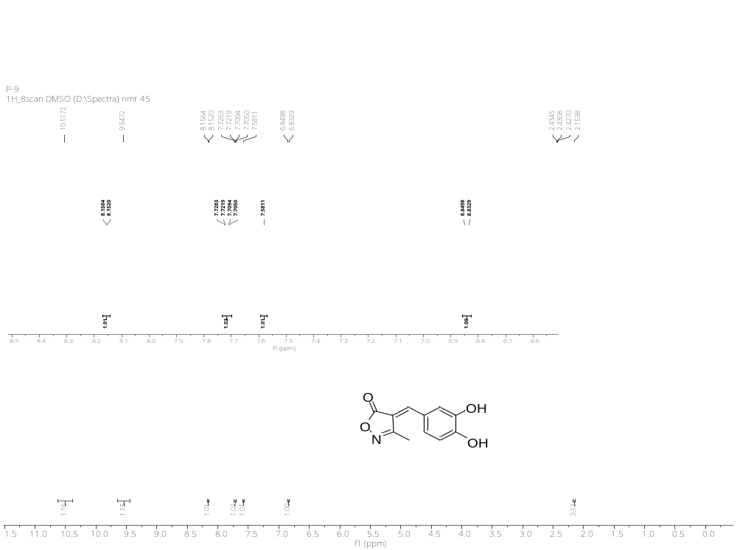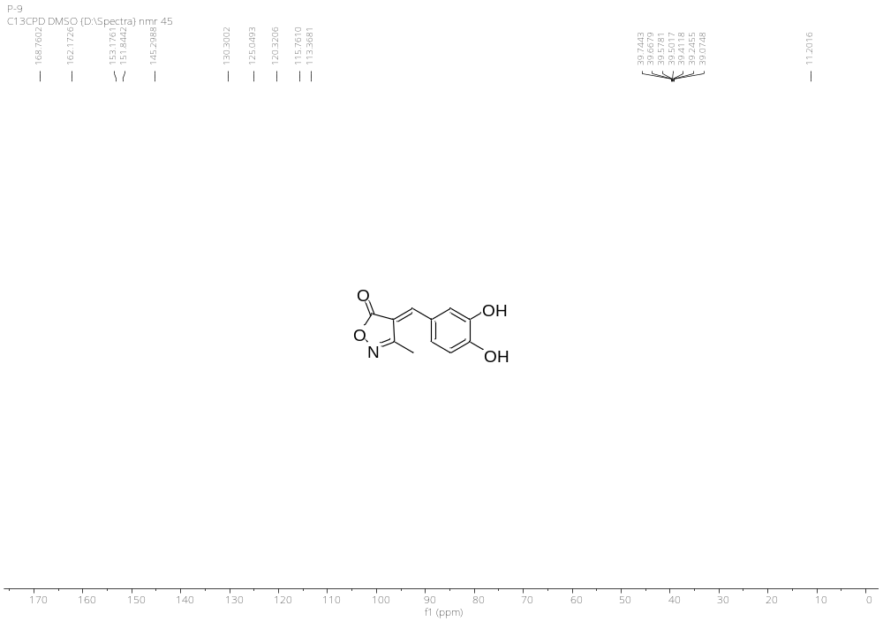

IR, ¹H & ¹³C NMR Spectral Data of 4m
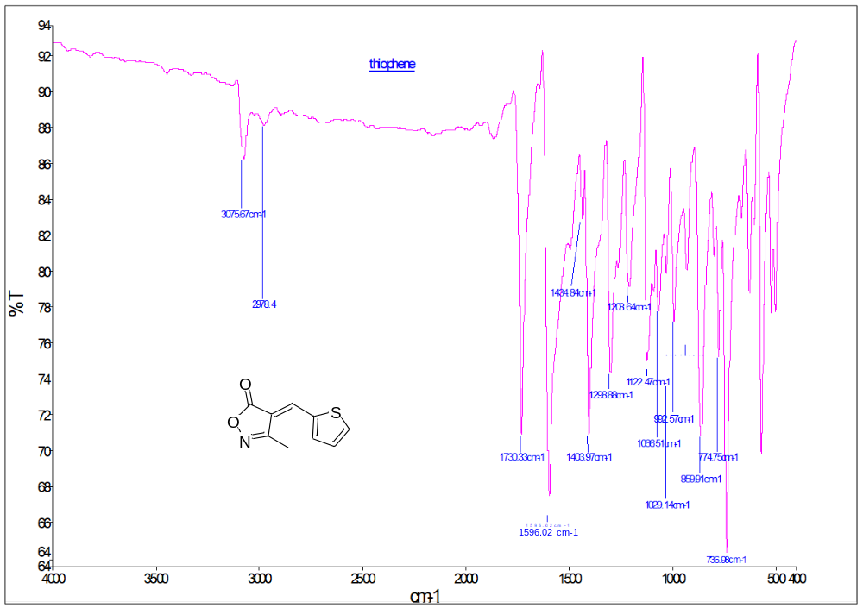
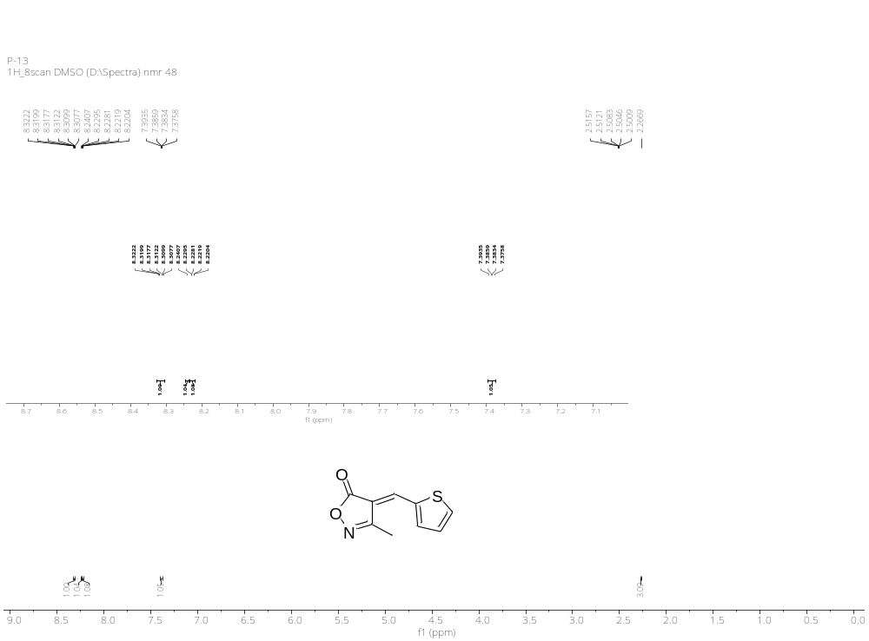
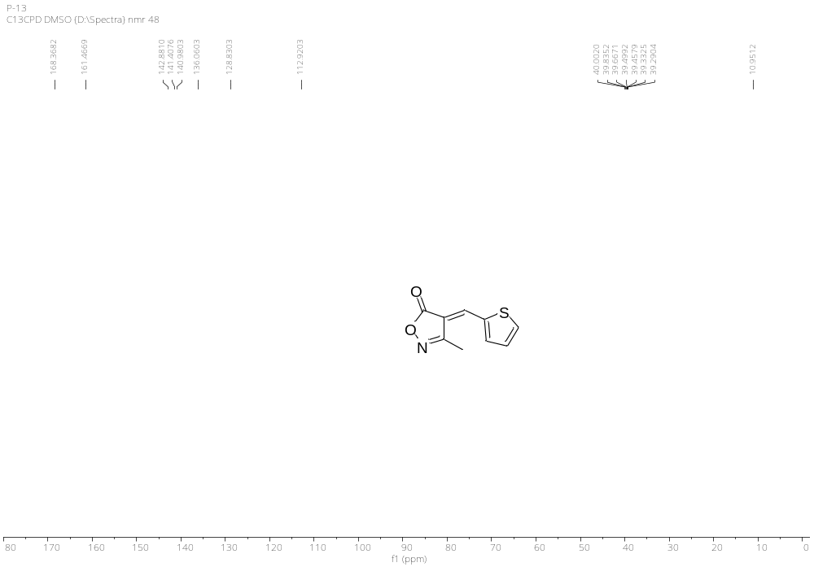

IR, ¹H & ¹³C NMR Spectral Data of 4n
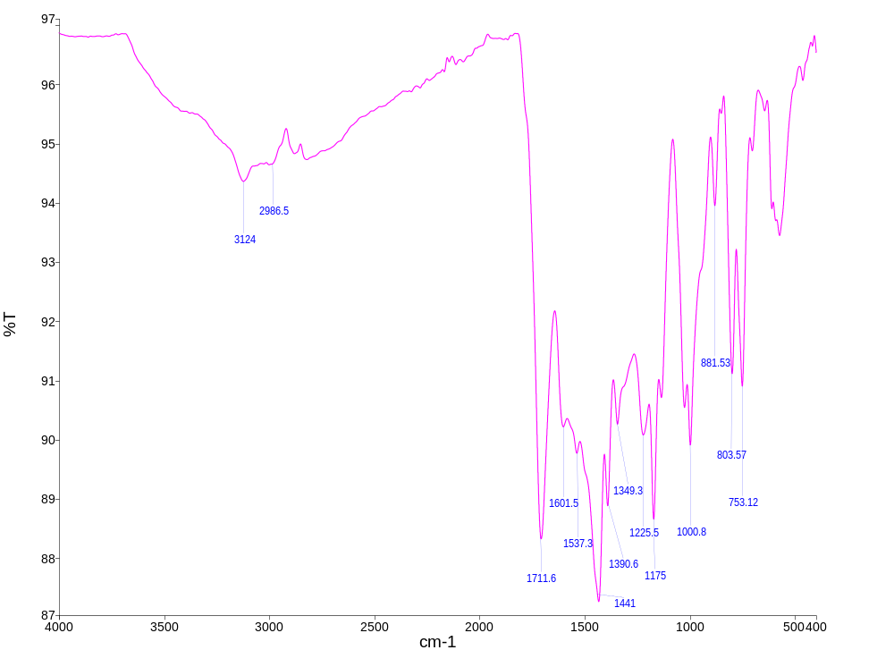
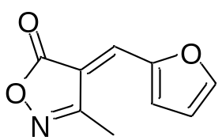
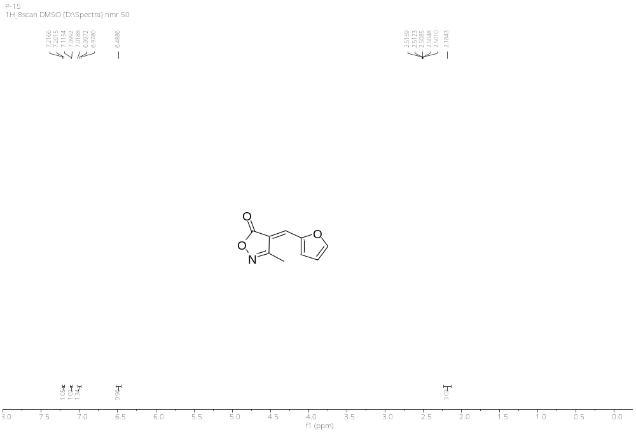

IR, ¹H & ¹³C NMR Spectral Data of 5
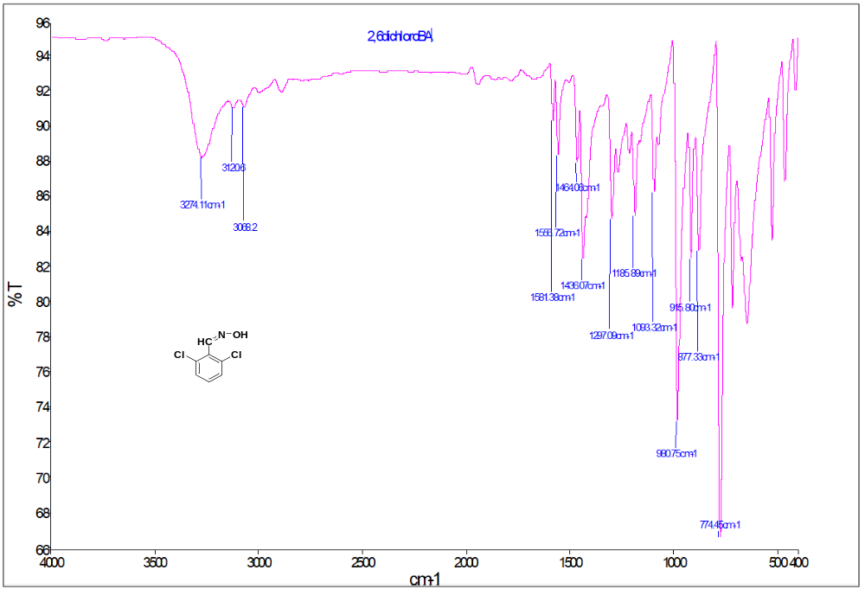
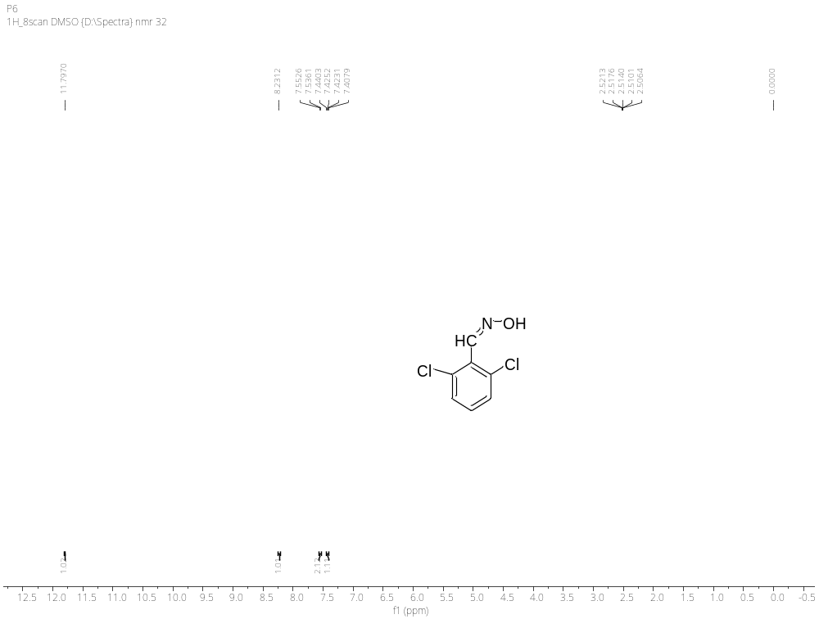
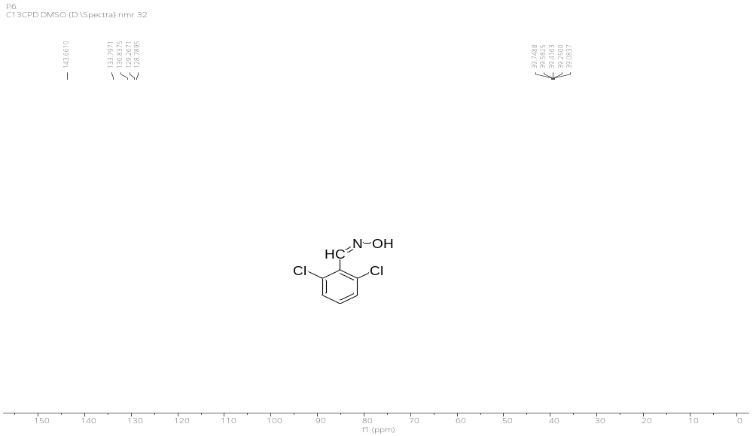

Cyrstallography Data of 4j
- Atomic coordinates ( x 104) and equivalent isotropic displacement parameters (Å2x 103). U(eq) is defined as one third of the trace of the orthogonalized Uij tensor.
________________________________________________________________________________
x y z U(eq)
________________________________________________________________________________
C(1) 4521(3) 6876(3) 6400(20) 74(2)
C(2) 4505(3) 7161(3) 8324(19) 77(2)
C(3) 4019(3) 7308(2) 9090(20) 67(2)
C(4) 3554(3) 7165(3) 7990(20) 74(2)
C(5) 3571(3) 6882(3) 6095(19) 69(2)
C(6) 4060(3) 6730(2) 5219(18) 64(2)
C(7) 4122(3) 6435(2) 3260(16) 64(2)
C(8) 3792(3) 6246(2) 1660(20) 62(2)
C(9) 3207(4) 6289(3) 1160(17) 70(2)
C(10) 3943(3) 5958(3) -257(18) 67(2)
C(11) 4490(4) 5791(3) -680(20) 88(3)
O(1) 3078(2) 6038(2) -790(18) 86(2)
O(2) 2861(2) 6484(2) 2118(15) 90(2)
Br(1) 3988(1) 7703(1) 11653(1) 74(1)
N(1) 3552(3) 5833(3) -1669(16) 78(2)
________________________________________________________________________________

- Bond lengths [Å] and angles [°].
_____________________________________________________
C(1)-C(2) 1.384(13)
C(1)-C(6) 1.401(12)
C(1)-H(1) 0.9300
C(2)-C(3) 1.375(12)
C(2)-H(2) 0.9300
C(3)-C(4) 1.385(13)
C(3)-Br(1) 1.884(10)
C(4)-C(5) 1.369(14)
C(4)-H(4) 0.9300
C(5)-C(6) 1.406(12)
C(5)-H(5) 0.9300
C(6)-C(7) 1.430(12)
C(7)-C(8) 1.333(12)
C(7)-H(7) 0.9300
C(8)-C(10) 1.443(13)
C(8)-C(9) 1.498(13)
C(9)-O(2) 1.196(10)
C(9)-O(1) 1.356(11)
C(10)-N(1) 1.294(11)
C(10)-C(11) 1.500(12)
C(11)-H(11A) 0.9600
C(11)-H(11B) 0.9600
C(11)-H(11C) 0.9600
O(1)-N(1) 1.450(10)

C(2)-C(1)-C(6) 122.3(8)
C(2)-C(1)-H(1) 118.8
C(6)-C(1)-H(1) 118.8
C(3)-C(2)-C(1) 119.0(8)
C(3)-C(2)-H(2) 120.5
C(1)-C(2)-H(2) 120.5
C(2)-C(3)-C(4) 120.2(9)
C(2)-C(3)-Br(1) 119.7(6)
C(4)-C(3)-Br(1) 120.1(6)
C(5)-C(4)-C(3) 120.7(8)
C(5)-C(4)-H(4) 119.6
C(3)-C(4)-H(4) 119.6
C(4)-C(5)-C(6) 120.9(8)
C(4)-C(5)-H(5) 119.5
C(6)-C(5)-H(5) 119.5
C(1)-C(6)-C(5) 116.8(8)
C(1)-C(6)-C(7) 117.7(8)
C(5)-C(6)-C(7) 125.4(8)
C(8)-C(7)-C(6) 134.8(8)
C(8)-C(7)-H(7) 112.6
C(6)-C(7)-H(7) 112.6
C(7)-C(8)-C(10) 125.9(8)
C(7)-C(8)-C(9) 132.2(8)
C(10)-C(8)-C(9) 101.7(7)
O(2)-C(9)-O(1) 118.6(8)
O(2)-C(9)-C(8) 133.8(8)
O(1)-C(9)-C(8) 107.6(7)
N(1)-C(10)-C(8) 114.2(8)
N(1)-C(10)-C(11) 119.3(9)
C(8)-C(10)-C(11) 126.5(8)
C(10)-C(11)-H(11A ) 109.5
C(10)-C(11)-H(11B) 109.5
H(11A)-C(11)-H(11B) 109.5
C(10)-C(11)-H(11C) 109.5
H(11A)-C(11)-H(11C) 109.5
H(11B)-C(11)-H(11C) 109.5
C(9)-O(1)-N(1) 109.7(7)
C(10)-N(1)-O(1) 106.8(7)
_____________________________________________________________
Symmetry transformations used to generate equivalent atoms
- Anisotropic displacement parameters (Å2x 103). The anisotropic displacement factor exponent takes the form: -2p2[ h2a*2U11 + ... + 2 h k a* b* U12 ]
______________________________________________________________________________
U11 U22 U33 U23 U13 U12
______________________________________________________________________________
C(1) 63(4) 87(5) 73(5) -23(5) -2(5) -3(4)
C(2) 62(5) 96(6) 74(6) -18(4) -8(4) -9(4)
C(3) 75(5) 74(5) 51(4) 8(3) 3(4) -8(3)
C(4) 68(5) 82(5) 72(5) -7(5) 12(4) 6(4)
C(5) 69(5) 80(5) 59(6) -11(4) 0(4) -2(4)
C(6) 69(5) 66(4) 56(4) -10(4) 6(3) -2(3)
C(7) 56(4) 74(5) 64(5) -4(4) 0(3) -4(3)
C(8) 64(4) 66(4) 55(4) -8(4) 2(4) -6(3)
C(9) 71(5) 87(5) 54(5) -9(4) -1(4) -6(4)
C(10) 75(5) 70(5) 55(5) -7(4) 6(3) -6(4)
C(11) 94(6) 89(5) 80(6) -25(6) 15(6) 0(5)
O(1) 75(3) 105(4) 77(4) -25(4) -5(4) -12(3)
O(2) 64(3) 122(5) 84(5) -27(4) -2(3) 0(3)
Br(1) 91(1) 72(1) 60(1) -11(1) 1(1) 0(1)
N(1) 94(6) 79(4) 61(5) -20(3) 2(4) -8(4)

- Hydrogen coordinates ( x 104) and isotropic displacement parameters (Å2x 103).
________________________________________________________________________________
x y z U(eq)
________________________________________________________________________________
H(1) 4850 6778 5884 89
H(2) 4817 7251 9085 92
H(4) 3227 7262 8545 89
H(5) 3255 6790 5378 83
H(7) 4475 6356 3052 77
H(11A) 4735 5912 503 132
H(11B) 4484 5510 -404 132
H(11C) 4601 5845 -2421 132
________________________________________________________________________________
F) Torsion angles [°].
________________________________________________________________
C(6)-C(1)-C(2)-C(3) -0.4(16)
C(1)-C(2)-C(3)-C(4) 1.5(16)
C(1)-C(2)-C(3)-Br(1) -178.9(8)
C(2)-C(3)-C(4)-C(5) -1.4(16)
Br(1)-C(3)-C(4)-C(5) 179.0(8)
C(3)-C(4)-C(5)-C(6) 0.1(16)
C(2)-C(1)-C(6)-C(5) -0.9(15)
C(2)-C(1)-C(6)-C(7) -179.9(9)
C(4)-C(5)-C(6)-C(1) 1.0(15)
C(4)-C(5)-C(6)-C(7) 179.9(9)
C(1)-C(6)-C(7)-C(8) -176.0(10)
C(5)-C(6)-C(7)-C(8) 5.1(17)
C(6)-C(7)-C(8)-C(10) 178.5(9)
C(6)-C(7)-C(8)-C(9) 4.5(18)
C(7)-C(8)-C(9)-O(2) -5.0(19)
C(10)-C(8)-C(9)-O(2 ) 179.9(11)
C(7)-C(8)-C(9)-O(1) 176.2(10)
C(10)-C(8)-C(9)-O(1) 1.2(9)
C(7)-C(8)-C(10)-N(1) -176.3(9)
C(9)-C(8)-C(10)-N(1) -0.8(10)
C(7)-C(8)-C(10)-C(11) 5.1(16)
C(9)-C(8)-C(10)-C(11) -179.4(9)
O(2)-C(9)-O(1)-N(1) 179.9(9)
C(8)-C(9)-O(1)-N(1) -1.1(10)
C(8)-C(10)-N(1)-O(1) 0.2(11)
C(11)-C(10)-N(1)-O(1) 178.9(9)
C(9)-O(1)-N(1)-C(10) 0.6(11)
________________________________________________________________
Symmetry transformations used to generate equivalent atoms:

G) Hydrogen bonds [Å and °].
____________________________________________________________________________
D-H...A d(D-H) d(H...A) d(D...A) <(DHA)
____________________________________________________________________________
C(11)-H(11C)...O(2)#1 0.96 2.52 3.360(14) 146.7
____________________________________________________________________________
Symmetry transformations used to generate equivalent atoms:
#1 x+1/4,-y+5/4,z-3/4

