Table 2. Substrate scope of the optimized reaction.

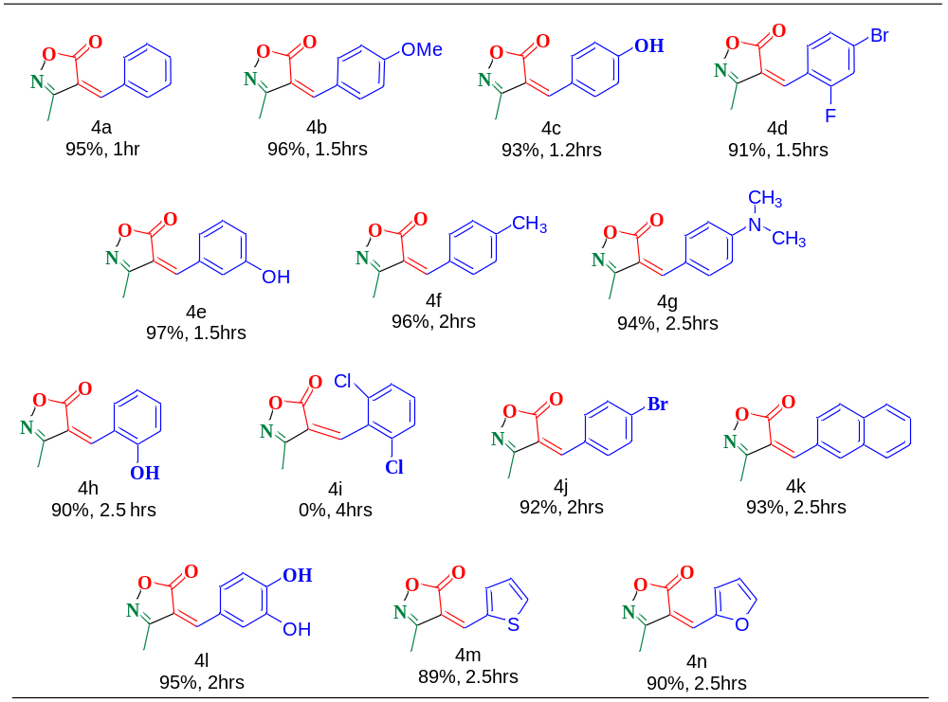

Table 6: Antioxidant activity of the synthesized deriavatives

Sr. No. | Isoxazole derivatives | DPPH | ABTS | TAC
4a | 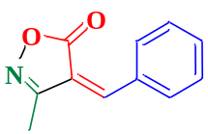 | 45.16±0.31 | 94.87±0.16 | 13.49±0.09
4b | 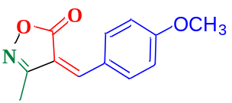 | 66.87±0.18 | 61.53±0.55 | 13.14±0.2
4c | 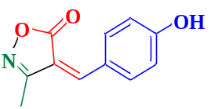 | 32.12±0.55 | 64.60±0.18 | 8.07±0.16
4d | 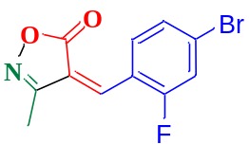 | 85.88±.03 | 62.14±0.26 | 13.69±0.13
4e | 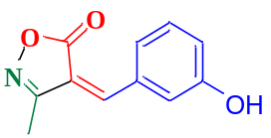 | 54.10±0.87 | 73.89±0.12 | 42.99±0.13
4f | 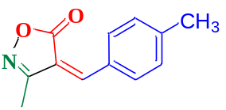 | 8.19±.04 | 67.96±1.50 | 10.0±0.03
4g | 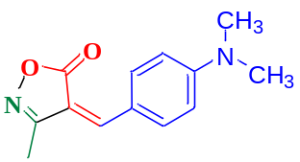 | NA | 63.05±0.15 | 18.26±0.04
4h | 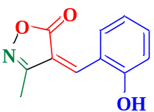 | 67.81±0.09 | 70.28±0.15 | 12.79±0.03
4j | 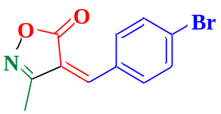 | 31.23±0.10 | 100 | 11.14±0.03
4k | 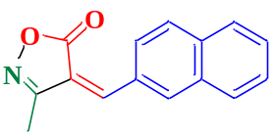 | 85.40±0.16 | 84.89±0.80 | 13.46±0.24
4l | 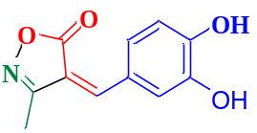 | 64.14±0.15 | 79.10±0.26 | 11.59±0.07
4m | 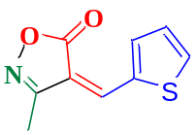 | 84.98±0.40 | 100 | 16.91
4n | 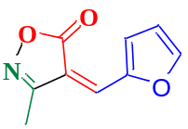 | 28.69±0.24 | NA | 43.56±0.03
5 | 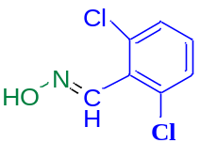 | 66.89±0.15 | 77.88±0.15 | 12.58±0.06
STD1 | Ascorbic Acid | 88.46±0.60 | 95.98±0.09 | -
STD2 | Gallic Acid | 90.74±0.47 | 95.87±0.08 | 83.23±0.01
DPPH: 2,2-diphenyl-1-picrylhydrazyl radical scavenging assay; ABTS; 2,2’-azino-bis (3-ethylbenzothiazoline-6-sulphonic acid); TAC: Total antioxidant capacity; NA representsno activity; Activity was performed in triplet so mean values are presented in the table±Standard error mean (n=3).

