Appendix
Type  of  Education | Management | Numbers of Institution | Numbers of Teacher |  |  |  |  | Numbers of Student
Type  of  Education | Management | Numbers of Institution | Total | Female | Male | %  Female | %  Male | Total | Girl | Boy | %  Girl | %  Boy
Secondary Education | Private | 18,176 | 213,028 | 59,097 | 153,931 | 27.74 | 72.26 | 8,473,466 | 4,704,885 | 3,768,581 | 55.52 | 44.48
Secondary Education | Public | 615 | 12,556 | 3,916 | 8,640 | 31.19 | 68.81 | 543,307 | 260,573 | 282,734 | 47.96 | 52.04
Secondary Education | Total | 18,791 | 225,584 | 63,013 | 162,571 | 27.93 | 72.07 | 9,016,773 | 4,965,458 | 4,051,315 | 55.07 | 44.93
English Medium School | Private | 142 | 7,734 | 5,229 | 2,505 | 67.61 | 32.39 | 27,370 | 11,552 | 15,818 | 42.21 | 57.79
English Medium School | Public | 0 | 0 | 0 | 0 | 0.00 | 0.00 | 0 | 0 | 0 | 0.00 | 0.00
English Medium School | Total | 142 | 7,734 | 5,229 | 2,505 | 67.61 | 32.39 | 27,370 | 11,552 | 15,818 | 42.21 | 57.79
School and  College | Private | 1,324 | 43,529 | 14,533 | 28,996 | 33.39 | 66.61 | 1,453,851 | 779,547 | 674,304 | 53.62 | 46.38
School and  College | Public | 64 | 2,266 | 738 | 1,528 | 32.57 | 67.43 | 95,451 | 42,497 | 52,954 | 44.52 | 55.48
School and  College | Total | 1,388 | 45,795 | 15,271 | 30,524 | 33.35 | 66.65 | 1,549,302 | 822,044 | 727,258 | 53.06 | 46.94
College Education | Private | 2,704 | 83,366 | 22,063 | 61,303 | 26.47 | 73.53 | 1,857,475 | 966,044 | 891,431 | 52.01 | 47.99
College Education | Public | 607 | 26,401 | 7,005 | 19,396 | 26.53 | 73.47 | 2,361,262 | 1,154,591 | 1,206,671 | 48.90 | 51.10
College Education | Total | 3,311 | 109,767 | 29,068 | 80,699 | 26.48 | 73.52 | 4,218,737 | 2,120,635 | 2,098,102 | 50.27 | 49.73
Madrasah Education | Private | 9,302 | 112,611 | 19,084 | 93,527 | 16.95 | 83.05 | 2,548,861 | 1,410,173 | 1,138,688 | 55.33 | 44.67
Madrasah Education | Public | 3 | 80 | 6 | 74 | 7.50 | 92.50 | 4,578 | 524 | 4,054 | 11.45 | 88.55
Madrasah Education | Total | 9,305 | 112,691 | 19,090 | 93,601 | 16.94 | 83.06 | 2,553,439 | 1,410,697 | 1,142,742 | 55.25 | 44.75
Technical- Vocational (Independent) | Private | 1,903 | 27,838 | 5,643 | 22,195 | 20.27 | 79.73 | 432,032 | 120,562 | 311,470 | 27.91 | 72.09
Technical- Vocational (Independent) | Public | 571 | 9,644 | 1,514 | 8,130 | 15.70 | 84.30 | 286,887 | 56,736 | 230,151 | 19.78 | 80.22
Technical- Vocational (Independent) | Total | 2,474 | 37,482 | 7,157 | 30,325 | 19.09 | 80.91 | 718,919 | 177,298 | 541,621 | 24.66 | 75.34
Professional Education | Private | 616 | 7,542 | 3,253 | 4,289 | 43.13 | 56.87 | 138,854 | 72,557 | 66,297 | 52.25 | 47.75
Professional Education | Public | 125 | 8,261 | 3,905 | 4,356 | 47.27 | 52.73 | 40,074 | 29,245 | 10,829 | 72.98 | 27.02
Professional Education | Total | 741 | 15,803 | 7,158 | 8,645 | 45.30 | 54.70 | 178,928 | 101,802 | 77,126 | 56.90 | 43.10
University Education | Private | 105 | 16,070 | 4,870 | 11,200 | 30.30 | 69.70 | 349,160 | 101,213 | 247,947 | 28.99 | 71.01
University Education | Public | 46 | 15,524 | 4,057 | 11,467 | 26.13 | 73.87 | 820,430 | 310,622 | 509,808 | 37.86 | 62.14
University Education | International | 2 | 158 |  | 158 | 0.00 | 100 | 3,311 | 954 | 2,357 | 28.81 | 71.19
University Education | Total | 153 | 31,752 | 8,927 | 22,825 | 28.11 | 71.89 | 1,172,901 | 412,789 | 760,112 | 35.19 | 64.81
Total (Post-primary) | Private | 34,403 | 513,554 | 134,345 | 379,209 | 26.16 | 73.84 | 15,296,323 | 8,172,305 | 7,124,018 | 53.43 | 46.57
Total (Post-primary) | Public | 2,125 | 76,186 | 21,513 | 54,673 | 28.24 | 71.76 | 4,172,239 | 1,864,760 | 2,307,479 | 44.69 | 55.31
Total (Post-primary) | Total | 36,528 | 589,740 | 155,858 | 433,882 | 26.43 | 73.57 | 19,468,562 | 10,037,065 | 9,431,497 | 51.56 | 48.44

Appendix 1.a: Numbers and ratios of the students and teachers including genders and academic institutions’ types (Source: BANBEIS, 2021)
Type of Education | Teacher Student Ratio [1:n] | Students Per Institution | Teachers Per Institution
Secondary Education | 40 | 480 | 12
English Medium School | 4 | 193 | 54
Bangla Medium School | 34 | 1,116 | 33
College Education | 38 | 1,274 | 33
Madrasah Education | 23 | 274 | 12

Appendix 1.b: Teacher and student ratio per academic institution (Source: BANBEIS, 2021)

Category of Education | Type | Class 6 | Class 7 | Class 8 | Class 9 | Class 10 | Class 11 | Class12
School | Private | 2,103,517 | 2,114,103 | 2,059,228 | 1,750,890 | 1,614,989 | 0 | 0
School | Public | 115,580 | 120,459 | 129,096 | 124,566 | 119,698 | 0 | 0
School | Total | 2,219,097 | 2,234,562 | 2,188,324 | 1,875,456 | 1,734,687 | 0 | 0
College | Private | 0 | 0 | 0 | 0 | 0 | 773,840 | 872,304
College | Public | 0 | 0 | 0 | 0 | 0 | 412,945 | 422,378
College | Total | 0 | 0 | 0 | 0 | 0 | 1,186,785 | 1,294,682
Madrasah | Private | 509,721 | 465,565 | 472,341 | 365,778 | 327,906 | 122,334 | 111,259
Madrasah | Public | 51 | 63 | 94 | 121 | 131 | 500 | 368
Madrasah | Total | 509,772 | 465,628 | 472,435 | 365,899 | 328,037 | 122,834 | 111,627
Sub Total |  | 2,728,869 | 2,700,190 | 2,660,759 | 2,241,355 | 2,062,724 | 1,309,619 | 1,406,309
Other Segments'  Student Number |  | 349,233 |  |  |  |  | 503,853
Total |  | 15,962,911

Appendix 1.c: Class-wise students’ number (Source: BANBEIS, 2021)
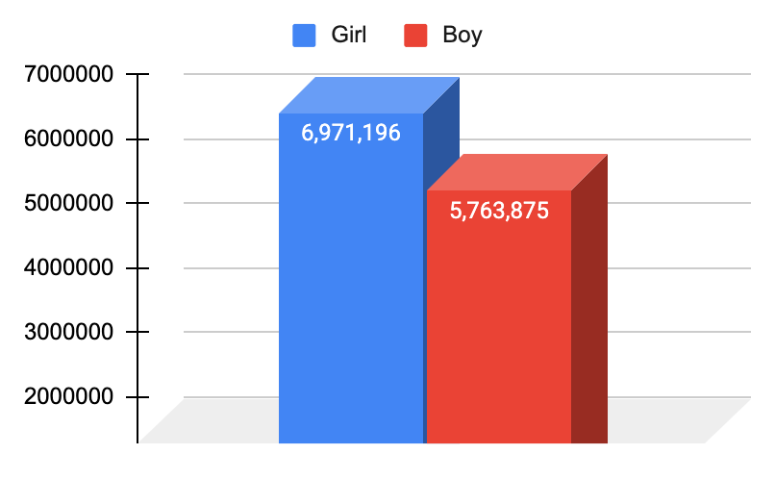
Appendix 1.d: Comparison between the numbers of female and male students of secondary education (Class 6-10) (Source: BANBEIS, 2021)

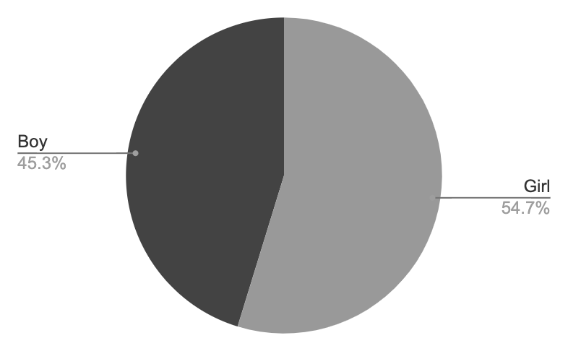

Appendix 2.e: Secondary (Class 6-10) students' ratio according to gender (Source: BANBEIS, 2021)
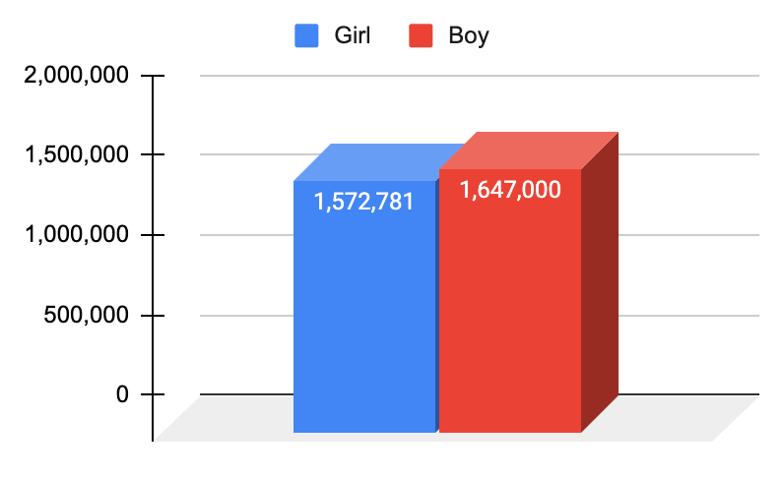

Appendix 1.f: Comparison between the numbers of female and male students of higher secondary education (Class 11-12) (Source: BANBEIS, 2021)

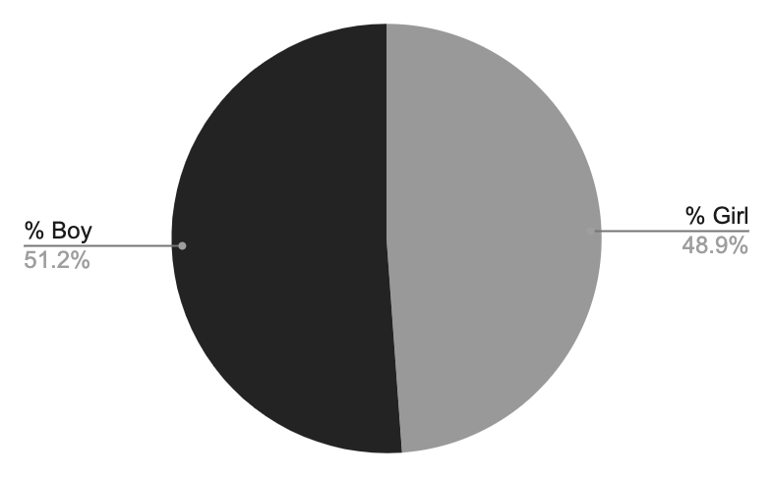

Appendix 1.g: Higher Secondary (Class 11-12) students' ratio according to gender (Source: BANBEIS, 2021)

Type of Disabilities | School |  |  | College |  |  | Madrasah |  |  | Total
Type of Disabilities | Total | Female | Male | Total | Female | Male | Total | Female | Male | Total | Female | Male
Visual impairment | 6,416 | 2,761 | 3,655 | 875 | 451 | 424 | 1,050 | 523 | 527 | 8,341 | 3,735 | 4,606
Hearing impairment | 2,654 | 973 | 1,681 | 426 | 196 | 230 | 350 | 193 | 157 | 3,430 | 1,362 | 2,068
Physical impairment | 12,588 | 4,603 | 7,985 | 4,715 | 1,352 | 3,363 | 1,592 | 739 | 853 | 18,895 | 6,694 | 12,201
Intellectual impairment | 3,599 | 1,063 | 2,536 | 142 | 60 | 82 | 442 | 230 | 212 | 4,183 | 1,353 | 2,830
Speech impairment | 2,066 | 823 | 1,243 | 207 | 98 | 109 | 401 | 246 | 155 | 2,674 | 1,167 | 1,507
Autistic | 610 | 215 | 395 | 64 | 35 | 29 | 109 | 33 | 76 | 783 | 283 | 500
Chronic psychiatric impairment | 347 | 160 | 187 | 112 | 68 | 44 | 41 | 23 | 18 | 500 | 251 | 249
Hearing and eyesight impairment | 370 | 184 | 186 | 57 | 41 | 16 | 76 | 36 | 40 | 503 | 261 | 242
Cerebral palsy | 34 | 8 | 26 | 6 | 3 | 3 | 1 | 1 | 0 | 41 | 12 | 29
Multi  dimensional impairment | 68 | 41 | 27 | 4 | 4 | 0 | 9 | 5 | 4 | 81 | 50 | 31
Down Syndrome | 58 | 39 | 19 | 14 | 9 | 5 | 39 | 11 | 28 | 111 | 59 | 52
Others | 756 | 350 | 406 | 122 | 94 | 28 | 5,138 | 495 | 4,643 | 6,016 | 939 | 5,077
Total | 29,566 | 11,220 | 18,346 | 6,744 | 2,411 | 4,333 | 9,248 | 2,535 | 6,713 | 45,558 | 16,166 | 29,392

Appendix 1.h: Number of the student with special needs according to the needs’ type (Source: BANBEIS, 2021)

