Supporting Information

Materials and methods
Cell culture
Human colorectal adenocarcinoma cells HCT116, purchased from American Type Culture Collection, were cultured in 1640 medium containing 10% fetal bovine serum, 100 units/mL penicillin, and 100 mg/mL streptomycin, and the medium was changed every 2 days. Oxaliplatin-resistant human colorectal cancer cells HCT116/DR, purchased from Shanghai Meixuan Biotechnology Co., Ltd., was generated in a stepwise manner by exposing drug-sensitive HCT116 cells to increasing doses of OX. The surviving cells were subsequently maintained in the conditioned medium with 1 μg/mL OX to retain its drug-resistant phenotype.

Cell Viability Assay
HCT116 cells or OX resistant HCT116/DR (HCT116/DR) cells were seeded at a density of 8 × 10³ cells/well in 96-well plates and cultured for 24 h. OX, Se-MnP, and OX@Se-MnP NPs were added to each well and incubated for 24 and 48 h. Oxaliplatin was used as a positive control, and a pure medium without adding any compounds was designed as a blank control. Cell viability was performed by CCK-8 reagent kit, and the optical density value was measured by a microplate reader (Eon, BioTek, U.S.A.) at a wavelength of 450 nm.

ROS Generation
ROS generation was measured by intracellular conversion of dichloroﬂuorescein diacetate (DCFH/DA) into a ﬂuorescent product DCF. HCT116/DR cells were plated in 6-well plates at a 1 × 10⁶ cells/well density. After culturing for 24 h, the cells were separately incubated of OX (20 μg/mL), Se-MnP (100 μg/mL), OX@Se-MnP (120 μg/mL) for 12 h. After that, DCFH/DA (1 μM) (Beyotime, China) was added to each well and incubated at 37 °C for 30 min before the cells were detached. The cells were subsequently collected by centrifugation, washed twice with PBS, and resuspended in PBS. Then, the generation of ROS in cells of different groups was observed under a Laser Scanning Confocal Microscopy (LSCM, FluoViewFV1000, Olympus, Japan).

Cellular Uptake
For laser confocal scanning microscopy (LCSM) analysis, HCT116/DR cells were seeded on sterile glass coverslips in 6-well plates at a density of 1 × 10⁶ cells/well and allowed to attach for 24 h. To each well, free OX, Se-MnP, and OX@Se-MnP were respectively added and incubated for 2, 4, 8 and 10 h. At each time point, the cells were washed with PBS, ﬁxed with 4% paraformaldehyde for 20 min, and stained with 10 μg/mL DAPI solution. The intracellular location was visualized under a CSLM (FluoViewFV1000, Olympus, Japan).

Western Blotting
HCT116/DR cells were separately treated with OX of 20 μg/mL, Se-MnP of 100 μg/mL, and OX@Se-MnP of 120 μg/mL to analyze apoptotic proteins at 24 h. The Cells were lysed for 30 min on ice, centrifuged at 12000 rpm at 4 °C. The supernatant was mixed with loading buffer and the protein concentration was determined by BCA method. For each group, 30 μg of protein was loaded to SDS-polyacrylamide gel, separated by electrophoresis at 100 V for 2 h, then transferred to polyvinylidene ﬂuoride (PVDF) membranes. After blocking with TBST (0.1% Tween-20, 10% tri-sec-buﬀer saline, 89.9% deionized water) containing 5% nonfat milk, these membranes were incubated with primary antibodies (Cell Signaling) overnight at 4 °C, then incubated with HRP-conjugated secondary antibodies. The immunoreactive blots were observed using the ECL kit (Thermo Scientiﬁc Pierce, U.S.A.) with a chemiluminescence system (Bio-Rad).

Construction of Animal Model
The colorectal cancer model was constructed using BALB/c nude mice (4−6 weeks) to investigate antitumor activities of Se-MnP and OX@Se-MnP in vivo. The animal proposal was approved by the Institutional Animal Care and Use Committee of Shanghai Tenth People’s Hospital. The colorectal cance model was inoculated at the left shoulder by injecting 5 × 10⁶ cells/site of HCT116/DR cells. Fourteen days after cell implantation, the tumor volume was approximately 100 mm³. The mice were randomly divided into 4 groups (5 mice per group), including OX (4 mg/kg), Se-MnPs (16 mg/kg), OX@Se-MnPs (20 mg/kg), and the blank control of physiological saline. The mice were intratumor injected with 100 μL of nanoparticles and PBS for each mouse.

Evaluation of Anti-Colorectal cancer Activity in Vivo
The mice were repeatedly treated and weighed every 2 days, and the tumor volume was measured with a vernier caliper according to the equation: volume (mm³) = (length × width²)/2. On day 14, all mice were euthanized, and an autopsy was conducted. The tumors were detached, weighed, and ﬁxed with 10% neutral formalin. Tumor tissues were embedded with paraﬃn, sectioned at a thickness of 5 μm, and mounted onto slides for histological examination. Tumor growth status and organ tissue lesions were observed using HE staining. Apoptotic colorectal cance cells in tumor tissues were detected with the Ki-67 assay. The caspase-3 was investigated by immunohistochemical analysis according to a previously reported method. The expression of MDR protein ABCB1, ABCC1, and ABCG2 were investigated by immunohistochemical analysis according to a previously reported method.

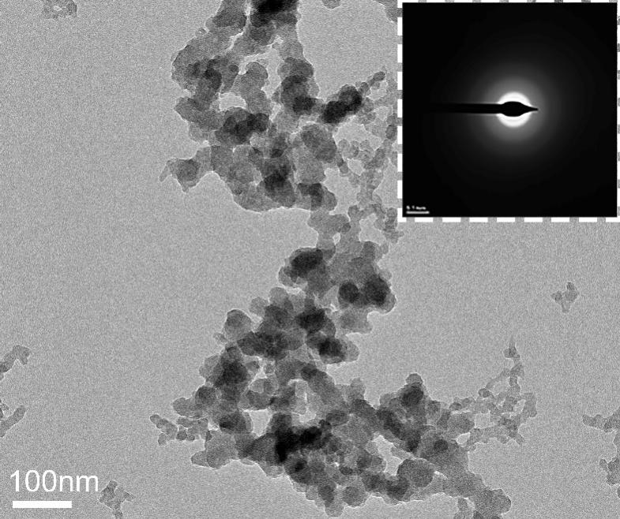
Fig.S1. (A) Transmission electron microscopy (TEM) of MnP.
Fig. S2. Thermogravimetric analysis of Se-MnP and OX@Se-MnP.

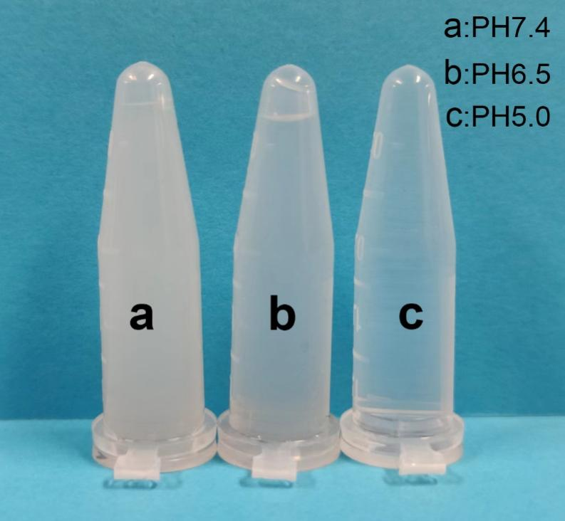
Fig. S3. Stability of Se-MnP at PBS solution with different pH values of 7.4, 6.5 and 5.0 for 24 h.

Fig.S4. (A, B) Viability of HCT116/DR and HCT116 cells of treatment with OX with different concentration

Fig.S5. (A, B) Viability of HCT116/DR and HCT116 cells of treatment with Se-MnP with different concentration

Fig.S6. The images of Calcein AM and PI stained HCT116/DR cells treated with OX, Se-MnP, OX+Se-MnP, and OX@Se-MnP.
$$DL\%=\frac{Weight of loaded drug}{Weight of nanoparticle and drug}*100\%$$
$$EE\%=\frac{Weight of loaded drug}{Weight of feeding drug}*100\%$$

Supplement Table
Table S1. Cytotoxic effects of Se-MnP and Oxaliplatin.
Material | IC50 (μg/mL)
Material | HCT116 | HCT116/DR | RI
Se-MnP (48 h) | 37.35 | 24.09 | 0.64
OX (48 h) | 8.63 | 42.34 | 4.90
RI (resistance index): the ratio of IC50 (HCT116/DR) against IC50 (HCT116).

