Morphology dynamics of Nile tilapia (Oreochromis niloticus Linn. 1758) in Victoria Nile as depicted from geometric morphometrics.
Papius Dias Tibihika^{1,2*}, Manuel Curto^{2,4}, Harald Meimberg², Cassius Aruho¹, George Muganga³, Jerome Sebadduka Lugumira³, Victoria Tibenda Namulawa¹, Margaret Aanyu¹, Richard Ddungu¹, Constantine Chobet Ondhoro⁵, Tom Okurut³
¹National Agricultural Research Organization (NARO), National Fisheries Resources Research Institute (NaFIRRI), Aquaculture Research and Development Centre Kajjansi (ARDC) P.O. Box 530 Kampala, Uganda. papiust@yahoo.com, aruhoc@gmail.com, tibendaviki@gmail.com, ddungurichard@yahoo.com
²University of Natural Resources and Life Sciences Vienna (BOKU), Department of Integrative Biology Research, Institute for Integrative Nature Conservation Research, Gregor Mendel Straße 33, 1180 Wien, Austria manuel.curto@boku.ac.at, meimberg@boku.ac.at
³National Environment Management Authority (NEMA), P.O. Box 22255 Jinja Road, Kampala-Uganda.
george.muganga@nema.go.ug, jerome.lugumira@nema.go.ug, tookurut@gmail.com
⁴MARE, Marine and Environmental Sciences Center, Faculty of Sciences, University of Lisbon, Lisbon, Portugal, macurto@fc.ul.pt
⁵Buginyanya Zonal Agricultural Research and Development Institute, NARO, P.O. Box 1356, Mbale, Uganda.
occonstantine88@gmail.com

Supplementary materials
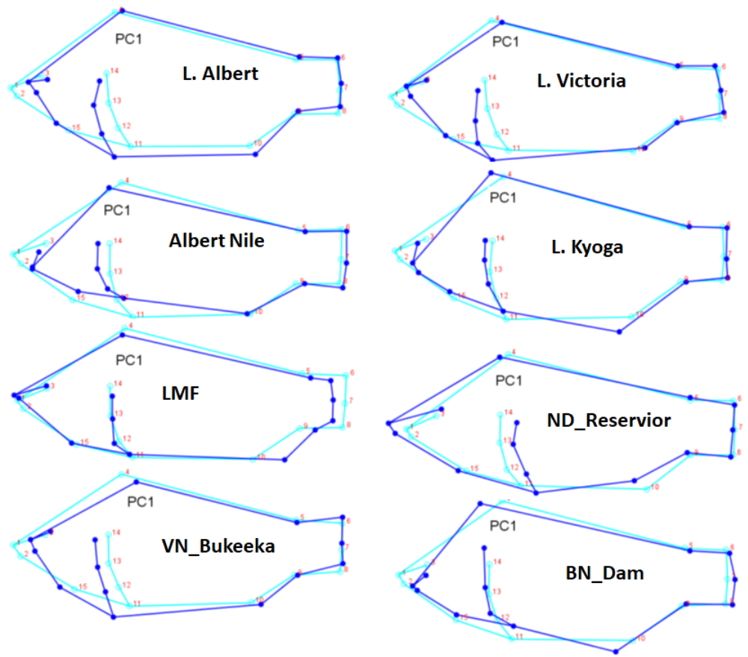
Figure S. 1. Morphological feature changes for specific populations depicted from PC1
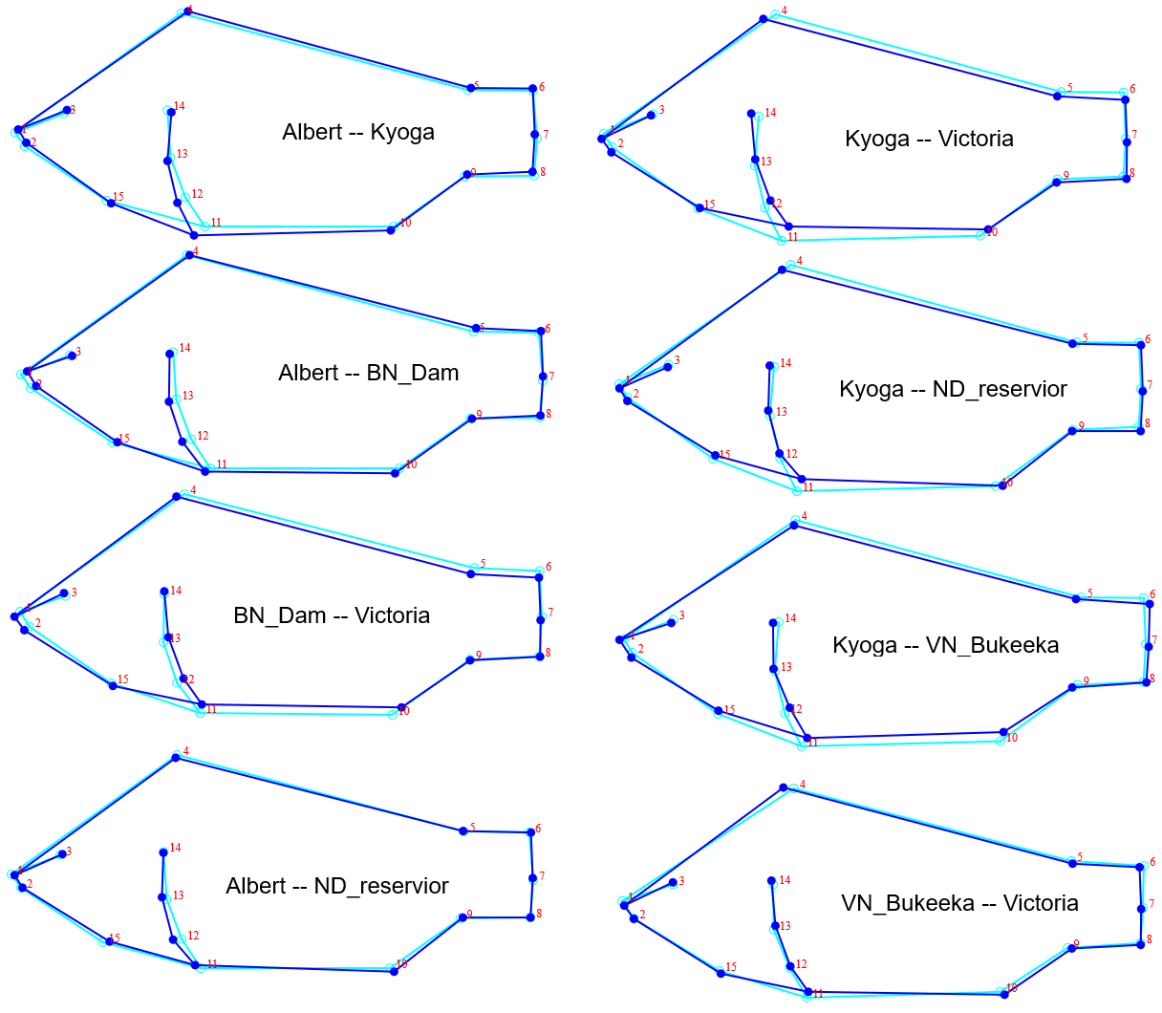
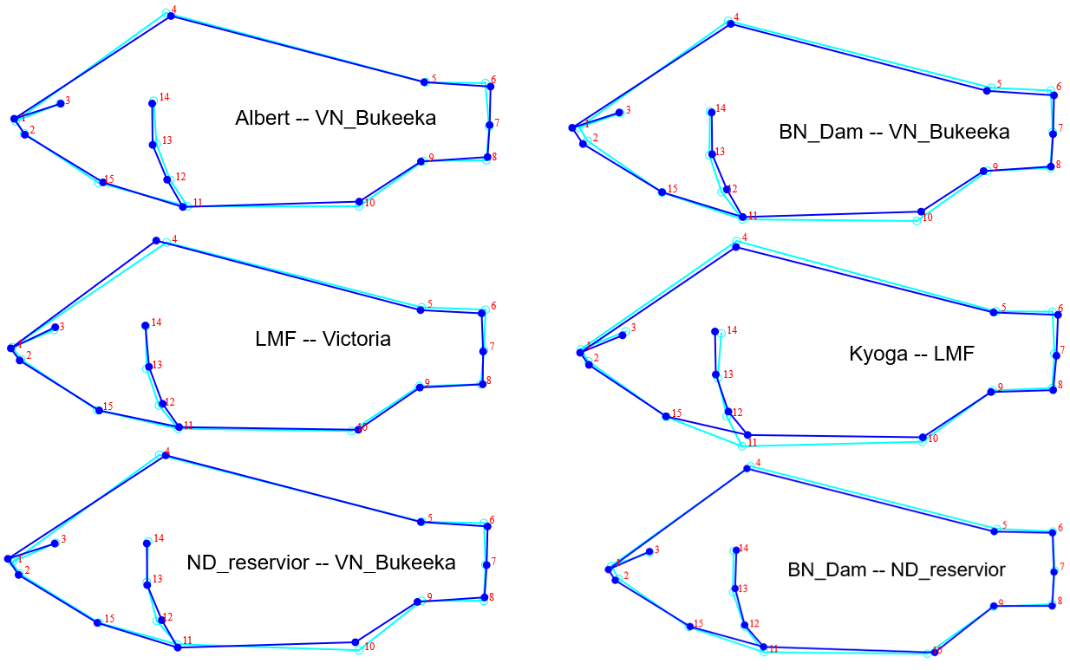
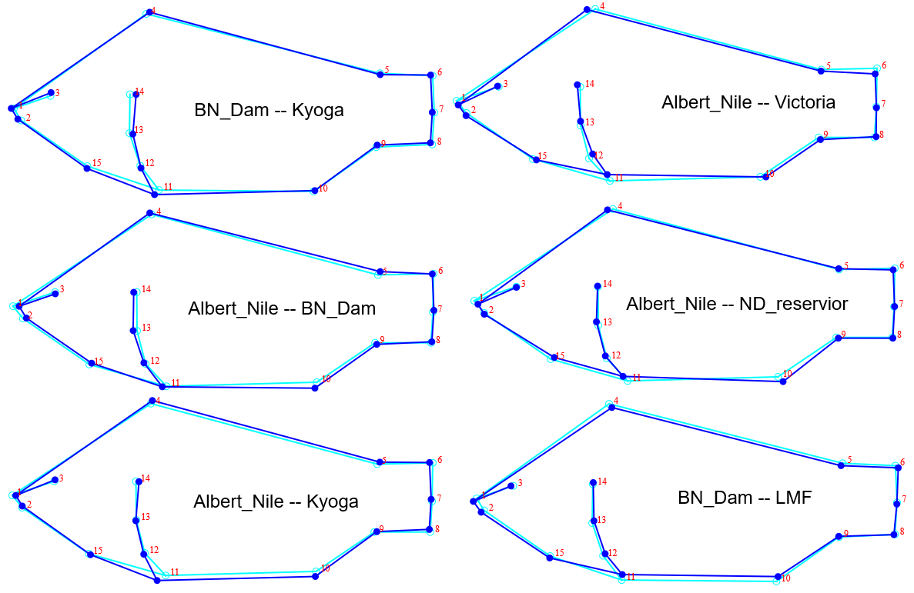
Figure S. 2. Population pairwise comparison of Nile tilapia morphotypes based on discriminant function analysis (DFA).

