Supplementary information Table 1. Abstract Screening Tool

Questions
Does the title/abstract describe a primary research study as opposed to a review?
Does the title/abstract describe the use of a parenting programme as the primary intervention?
Does the intervention target behavioural problems/disorders as an outcome?
Does the intervention include children aged between 2-12 years old?
Notes. *If one question is a maybe/unsure still an overall yes; *More than one maybe/unsure mark as overall maybe

Supplementary information Figure 1. Overall % of Studies’ Risk of Bias Assessment

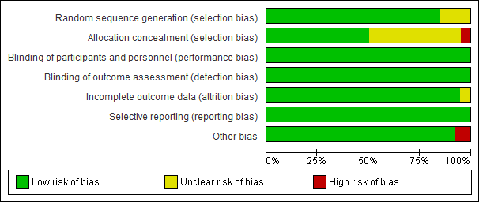

Supplementary information Figure 2. Risk of bias assessment

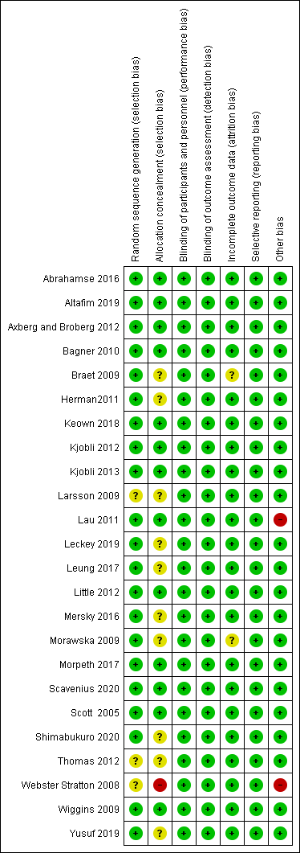

Supplementary information Figure 3. Funnel plot of included studies
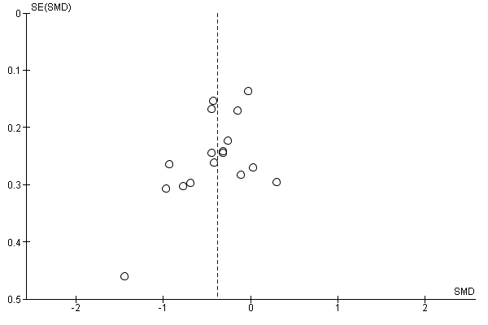

Supplementary information Figure 4. Sensitivity analysis: Overall treatment effect

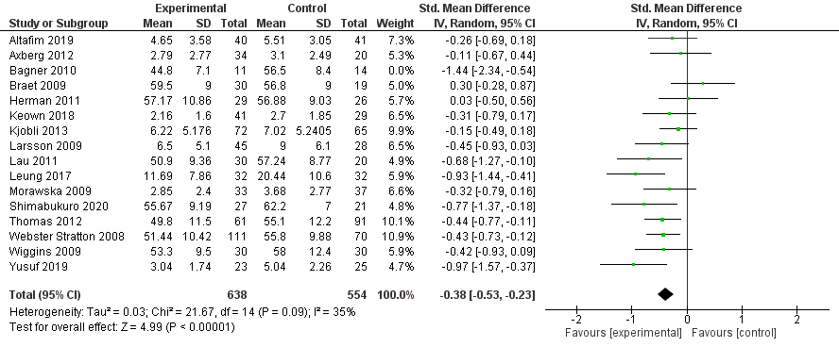
Notes. Standard mean difference for Bagner 2010 removed for sensitivity analysis.

Supplementary information Figure 5. Sensitivity analysis: Age comparisons

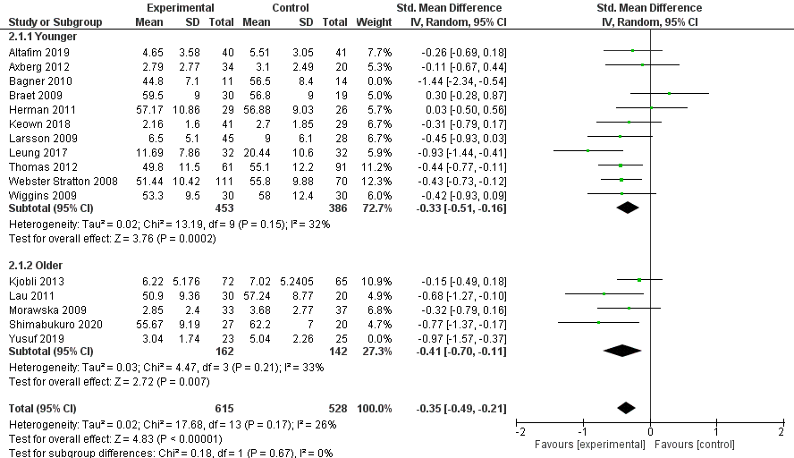
Notes. Standard mean difference for Bagner 2010 and Yusuf 2019 removed for sensitivity analysis.

Supplementary information Figure 6. Sensitivity analysis: Baseline internalising symptoms

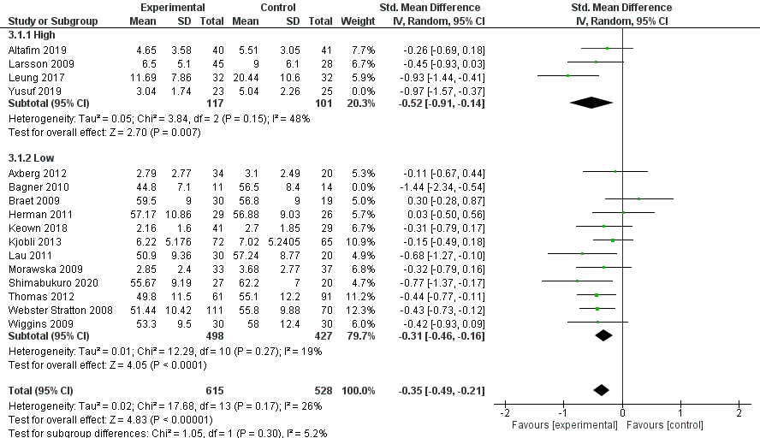
Notes. Standard mean difference for Bagner 2010 and Yusuf 2019 removed for sensitivity analysis.

Supplementary information Figure 6. Sensitivity analysis: Measures
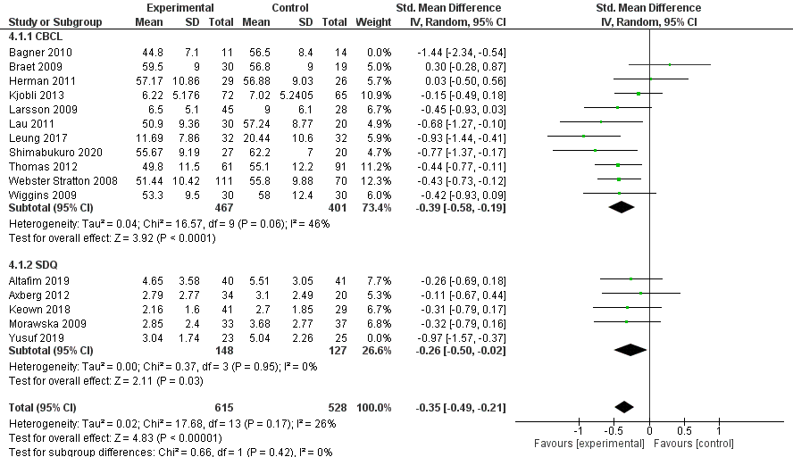

Notes. Standard mean difference for Bagner 2010 and Yusuf 2019 removed for sensitivity analysis.

Supplementary information Figure 7. Sensitivity analysis: Measures
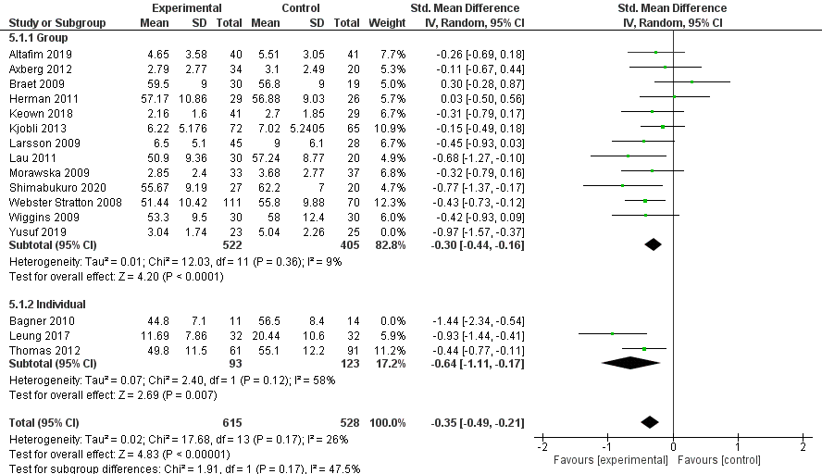
Notes. Standard mean difference for Bagner 2010 and Yusuf 2019 removed for sensitivity analysis.

Supplementary information Figure 8. Sensitivity analysis: Programme type
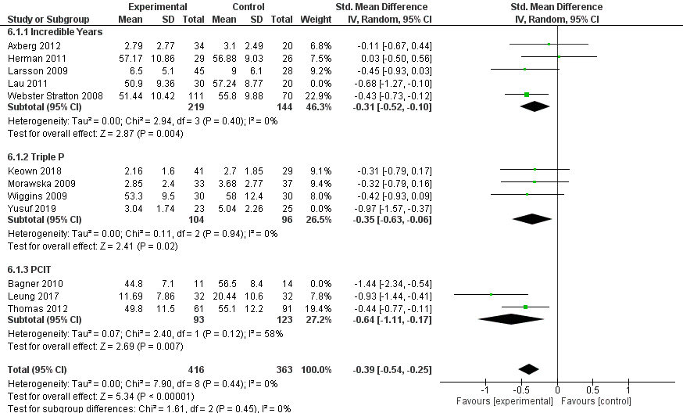
Notes. Standard mean difference for Lau 2011, Bagner 2010 and Yusuf 2019 removed for sensitivity analysis.

