Simultaneous Adsorption of Chromium and Acidic Dye from Leather Tannery Model Wastewater Using a Novel Modified Nanoclay

Journal of Environmental Earth Sciences

M. Golghasemi Sorkhabiª, H. Aghdasinia^{a*}, F. Notghi Oskuiª, A, Karimi^{b}, M. Golizadeh^{b}
ª Faculty of chemical and petroleum engineering, University of Tabriz, Tabriz, Iran
^{b} Faculty of advanced technologies in medicine, Iran university of medical sciences, 1449614535 Tehran, Iran

* Corresponding author: Hassan Aghdasinia
E-mail address: aghdasinia@tabrizu.ac.ir/ Hassan.Aghdasinia@gmail.com
Tel: +98-41-3339-2931 Fax: +98-41-3333-8497
E-mail addresses of authors:
Mahsa Golghasemi Sorkhabi Mahsa.Golghasemi@gmail.com
Fatemeh Notghi Oskui Notghi1992@gmail.com
Afzal Karimi Karimi.af@iums.ac.ir
Mortaza Golizadeh Mor.golizadeh@gmail.com

List of Figures:
1) Parity plot for (a) dye and (b) Cr (III).
2) The normal probability of the residuals for (a) dye and (b) Cr (III).

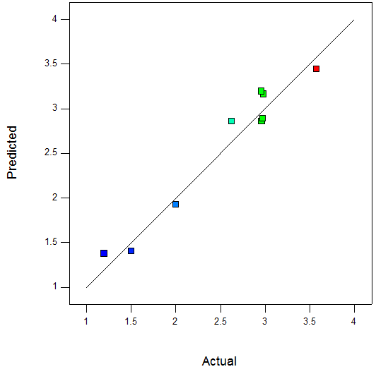 | 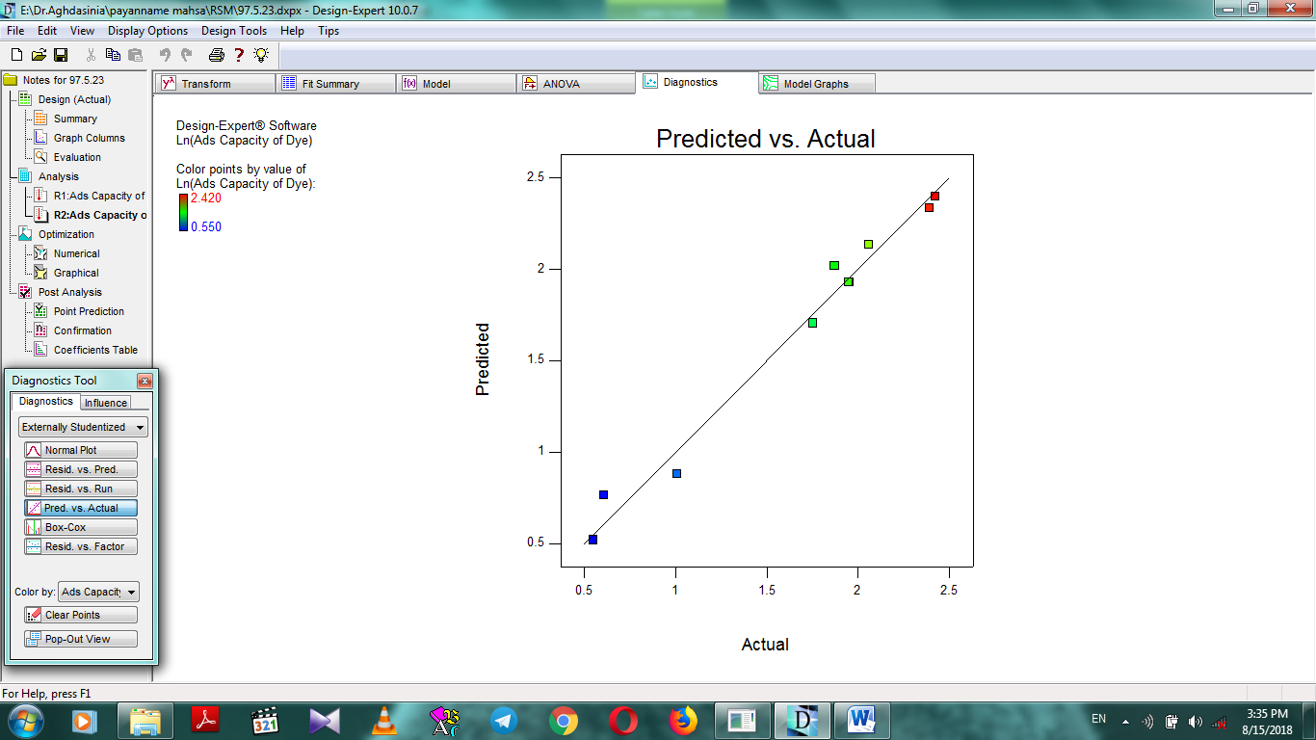
(b) | (a)
Fig. 1

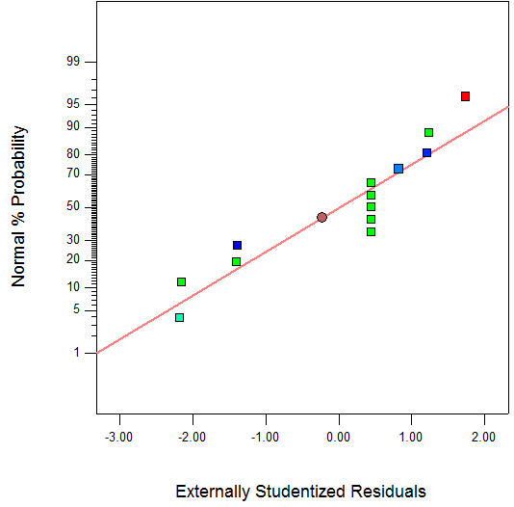 | 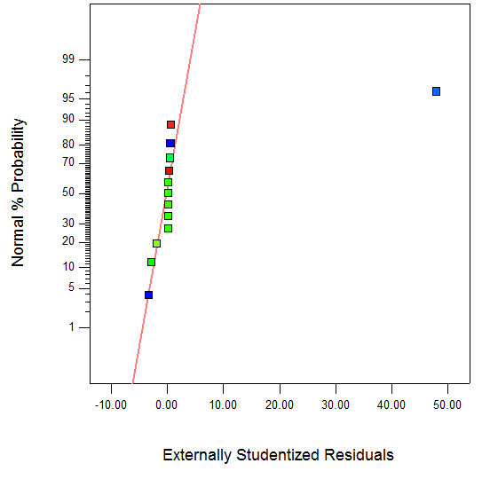
(b) | (a)
Fig. 2

List of Tables:
1) Non-linear isotherm parameters for simultaneous adsorption of Cr (III).
2) Non-linear isotherm parameters for simultaneous adsorption of dye.
3) Non-linear isotherm parameters for single adsorption of Cr (III).
4) Non-linear isotherm parameters for single adsorption of dye.
5) Adsorption capacities for Langmuir isotherm.
6) $R_{L}$ values of Langmuir isotherm.

Table 1
Langmuir isotherm
Error function
Chi square | HYBRID | SSE
193.1401 | 193.1390 | 32.9671 | $$q_{mL}$$
0.3267 | 0.3269 | 3.0591 | $$b$$
74.2864 | 74.2864 | 62.1031 | SSE
127.5918 | 127.5918 | 185.5791 | HYBRID
6.3796 | 6.3796 | 9.2789 | Chi square
2.3751 | 2.3751 | 2.8360 | SNE
Freundlich isotherm
64.4087 | 64.4080 | 67.5192 | $$K_{F}$$
0.9699 | 0.9699 | 1 | $$n_{F}$$
75.9017 | 75.9016 | 70.1730 | SSE
127.6910 | 127.6910 | 140.4557 | HYBRID
6.3845 | 6.3846 | 7.0228 | Chi square
2.4141 | 2.4141 | 2.9245 | SNE
D-R isotherm
25.8391 | 25.8391 | 23.8900 | $$q_{SD}$$
0.0382 | 0.0382 | 0.0317 | $$K_{ad}$$
63.3071 | 63.3071 | 56.9794 | SSE
104.1891 | 104.1891 | 137.6983 | HYBRID
5.2094 | 5.2094 | 6.8849 | Chi square
2.5133 | 2.5133 | 2.9000 | SNE
R-P isotherm
1679269 | 1465680 | 100.8481 | $$K_{R}$$
27824.32 | 24285.17 | 3.0590 | $$a_{R}$$
0 | 0 | 1 | $$g$$
75.4271 | 75.4271 | 62.1031 | SSE
128.0513 | 128.0513 | 185.5782 | HYBRID
6.4026 | 6.4026 | 9.2789 | Chi square
2.5560 | 2.5560 | 2.8233 | SNE

Table 2
Langmuir isotherm
Error function
Chi square | HYBRID | SSE
144.1782 | 144.1782 | 46.1439 | $$q_{mL}$$
0.0016 | 0.0016 | 0.0064 | $$b$$
5.5116 | 5.5116 | 4.7731 | SSE
15.9550 | 15.9550 | 22.3910 | HYBRID
0.7977 | 0.7977 | 1.1195 | Chi square
2.4252 | 2.4252 | 2.8660 | SNE
Freundlich isotherm
0.2179 | 0.2179 | 0.2181 | $$K_{F}$$
1 | 1 | 1 | $$n_{F}$$
6.0807 | 6.0807 | 6.0804 | SSE
16.6676 | 16.6676 | 16.6682 | HYBRID
0.8334 | 0.8334 | 0.8334 | Chi square
2.9999 | 2.9999 | 2.9999 | SNE
D-R isotherm
11.2121 | 11.2121 | 13.4360 | $$q_{SD}$$
17.8221 | 17.8221 | 50.2566 | $$K_{ad}$$
16.9670 | 16.9670 | 8.1904 | SSE
47.6635 | 47.6635 | 75.6374 | HYBRID
2.3832 | 2.3832 | 3.7819 | Chi square
2.2603 | 2.2603 | 2.4827 | SNE
R-P isotherm
21.5570 | 26.6966 | 0.3065 | $$K_{R}$$
91.4568 | 113.5035 | 0.0074 | $$a_{R}$$
0.0178 | 0.0178 | 1 | $$g$$
7.4913 | 7.4914 | 6.2114 | SSE
42.0166 | 42.0162 | 47.3484 | HYBRID
2.1008 | 41.6836 | 6.6859 | Chi square
1.9378 | 1.9043 | 1.9895 | SNE

Table 3
Langmuir isotherm
Error function
Chi square | HYBRID | SSE
900 | 900 | 738.6743 | $$q_{mL}$$
0.0275 | 0.0275 | 0.0423 | $$b$$
227.8484 | 227.8484 | 126.1830 | SSE
496.6093 | 496.6093 | 601.6349 | HYBRID
24.8305 | 24.8305 | 30.0817 | Chi square
2.6509 | 2.6509 | 2.5538 | SNE
Freundlich isotherm
28.1209 | 28.1209 | 29.9484 | $$K_{F}$$
0.7057 | 0.7057 | 1 | $$n_{F}$$
200.4758 | 200.4758 | 126.7146 | SSE
403.5003 | 403.5003 | 574.8163 | HYBRID
20.1750 | 20.1750 | 28.7308 | Chi square
2.3318 | 2.3318 | 2.6321 | SNE
D-R isotherm
173.7462 | 173.7462 | 13.4360 | $$q_{SD}$$
1.0253 | 1.0253 | 50.2566 | $$K_{ad}$$
182.0090 | 182.0090 | 2796.167 | SSE
444.6280 | 444.6280 | 2666.644 | HYBRID
17.7851 | 17.7851 | 106.6657 | Chi square
0.3986 | 0.3986 | 3 | SNE
R-P isotherm
937000.4 | 817818.7 | 202.0916 | $$K_{R}$$
38385.39 | 33502.84 | 5.7561 | $$a_{R}$$
0 | 0 | 0.0396 | $$g$$
218.1445 | 218.1445 | 126.2006 | SSE
1951.174 | 488.1460 | 605.5346 | HYBRID
24.4073 | 97.5587 | 31.2714 | Chi square
2.2502 | 1.0602 | 1.2094 | SNE

Table 4
Langmuir isotherm
Error function
Chi square | HYBRID | SSE
16.6606 | 16.6606 | 15.4512 | $$q_{mL}$$
0.0292 | 0.0292 | 0.0385 | $$b$$
9.9898 | 9.9898 | 8.7093 | SSE
38.8881 | 38.8881 | 46.1521 | HYBRID
1.9444 | 1.9444 | 2.3076 | Chi square
2.6852 | 2.6852 | 2.8718 | SNE
Freundlich isotherm
0.1544 | 0.1544 | 0.1410 | $$K_{F}$$
1 | 1 | 1 | $$n_{F}$$
63.8291 | 63.8291 | 60.6562 | SSE
188.3103 | 188.3103 | 193.8583 | HYBRID
9.4155 | 9.4155 | 9.6927 | Chi square
2.9428 | 2.9428 | 2.9503 | SNE
D-R isotherm
10.4108 | 10.4108 | 11.0042 | $$q_{SD}$$
13.2432 | 13.2432 | 15.1191 | $$K_{ad}$$
13.1342 | 13.1342 | 12.2304 | SSE
32.4068 | 32.4068 | 35.2514 | HYBRID
1.2963 | 1.2963 | 1.4100 | Chi square
2.8386 | 2.8386 | 2.9312 | SNE
R-P isotherm
62924.81 | 55005.74 | 1.1201 | $$K_{R}$$
40308.01 | 35235.2 | 0.2379 | $$a_{R}$$
0.5450 | 0.5450 | 0.7640 | $$g$$
8.3535 | 8.3535 | 7.3263 | SSE
17773811 | 46.1452 | 43.0236 | HYBRID
2.3073 | 888690.5 | 989255.2 | Chi square
2.0000 | 1.0500 | 1.8770 | SNE

Table 5
Initial Concentration $({mg}/L)$ | 25 | 50 | 75 | 100 | 150 | 200 | 300
Adsorption capacity $({mg}/g)$ | 1.2867 | 2.5672 | 3.9226 | 5.7742 | 8.8009 | 11.7562 | 16.2294

Table 6
Initial Concentration $({mg}/L)$ | 25 | 50 | 75 | 100 | 150 | 200 | 300
R_{L} | 0.1366 | 0.0733 | 0.0494 | 0.0341 | 0.0226 | 0.017 | 0.0124

