Supplementary Information
Operando reconstruction towards CuI nanodots with favorable facets and stable Cu⁺ state for selective CO₂-to-C₂H₄ conversion

Wenjie Xue¹, Hongxia Liu², Ruoou Yang³, Youwen Liu³, Bao Yu Xia¹ and Bo You¹*

¹Key Laboratory of Material Chemistry for Energy Conversion and Storage, Ministry of education, Hubei Key Laboratory of Material Chemistry and Service Failure, School of Chemistry and Chemical Engineering, Huazhong University of Science and Technology, Wuhan, Hubei, 430074, China
²School of Chemistry and Chemical Engineering, Wuhan Textile University, Wuhan, 430200, China
³State Key Laboratory of Materials Processing and Die & Mould Technology, and School of Materials Science and Engineering Huazhong University of Science and Technology Wuhan, Hubei, 430074, China

*Corresponding author. Email: youbo@hust.edu.cn

- Supplementary data
Supplementary Fig. 1 XRD pattern of the Cu(OH)₂ precursors.

Supplementary Fig. 2 High-resolution Cu 2p XPS spectra of CuI-CO₂, CuI-N₂ and Cu-CO₂ catalysts.

Supplementary Fig. 3 SEM image of the CuI-CO₂ catalysts.

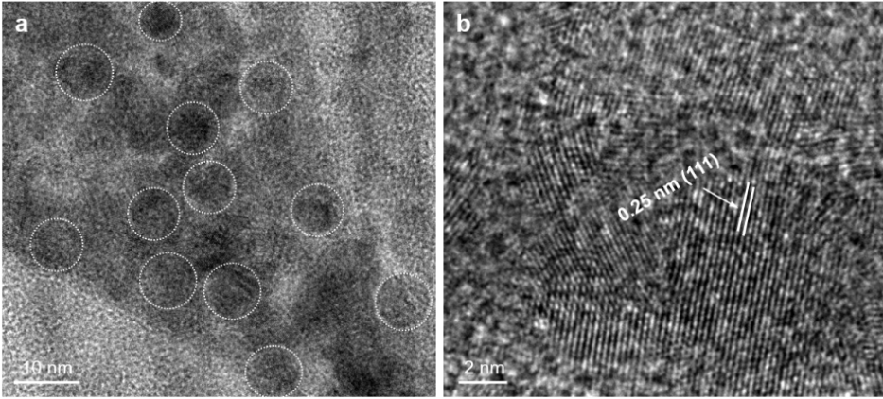
Supplementary Fig. 4 a TEM and b HR-TEM image of Cu(OH)₂ precursors.

Supplementary Fig. 5 The main product distributions in CO₂-saturated 0.1 M KHCO₃/KI solution during the synthesis of CuI-CO₂ catalysts.

Supplementary Fig. 6 Standard curves for the main liquid products of a formate and b ethanol using ¹H NMR analysis.

Supplementary Fig. 7 a Current density vs potential curves of CuI-CO₂, CuI-N₂ and Cu-CO₂ catalysts for CO₂ electroreduction. b Nyquist plots of CuI-CO₂, CuI-N₂ and Cu-CO₂ catalysts. Electrochemical impedance spectrums uncover a similar contact resistance between CuI-CO₂ (26.09 ohm) and CuI-N₂ (26.25 ohm), and a slight lower contact resistance for Cu-CO₂ (21.65 ohm) as indicated by the approximate equivalent series resistance (ESR) obtained from the x-intercept of the Nyquist plots.

Supplementary Fig. 8 Cyclic voltammograms of a CuI-CO₂. b CuI-N₂ and c Cu-CO₂ catalysts at scan rates from 5 to 50 mV s⁻¹. d Scan rate dependence of the current densities of CuI-CO₂, CuI-N₂ and Cu-CO₂ catalysts for ECSA measurements.

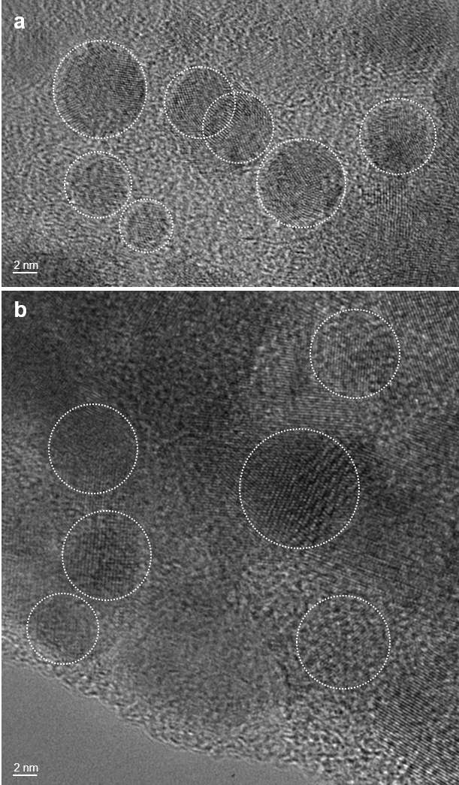
Supplementary Fig. 9 TEM images of a CuI-N₂ and b Cu-CO₂ catalysts.

Supplementary Fig. 10 High-resolution XPS spectra for a Cu 2p and b I 3d of CuI-CO₂ catalysts after 20 h stability test in a H-cell.

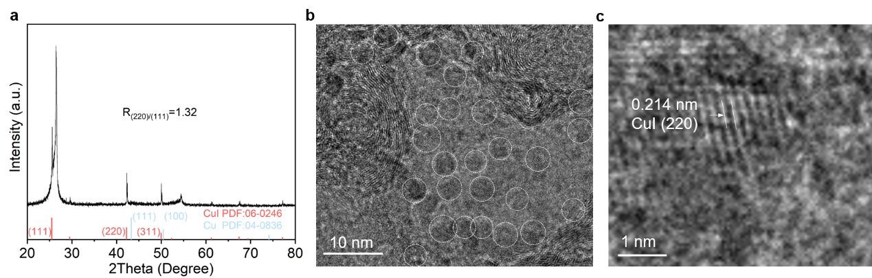
Supplementary Fig. 11 a XRD pattern, b TEM image and c HR-TEM image of CuI-CO₂ electrocatalysts after 12 h stability test at 400 mA cm⁻² in a flow cell.

Supplementary Fig. 12 Crystal face models of a Cu(111) for Cu-CO₂ catalysts. b CuI(111). c CuI(220). d CuI(311) for CuI-CO₂ catalysts.

Supplementary Table 1 FEs of CuI-CO₂ for CO₂R at different potentials in a H-cell.
Potential  (V) | FE (%)
Potential  (V) | C₂H₄ | C₂H₅OH | C₂H₆ | CH₄ | CO | HCOOH | H₂
-0.9 | 22.6 | 0.0 | 0.0 | 0.0 | 26.4 | 19.1 | 28.0
-1 | 31.7 | 6.5 | 0.2 | 0.6 | 14.6 | 14.5 | 31.2
-1.1 | 40.1 | 12.7 | 0.3 | 1.1 | 7.4 | 9.0 | 28.3
-1.2 | 45.3 | 13.3 | 0.0 | 1.3 | 11.7 | 5.4 | 21.5
-1.3 | 42.2 | 9.7 | 0.0 | 4.3 | 8.3 | 3.1 | 33.0
-1.4 | 32.3 | 3.3 | 0.2 | 7.8 | 3.0 | 2.8 | 51.4

Potential  (V) | FE (%)
Potential  (V) | C₂H₄ | C₂H₅OH | C₂H₆ | CH₄ | CO | HCOOH | H₂
-0.9 | 14.5 | 0 | 0.0 | 0.0 | 21.9 | 11.2 | 52.6
-1 | 21.4 | 0.0 | 0.0 | 0.2 | 15.2 | 10.7 | 51.5
-1.1 | 30.6 | 3.1 | 0.0 | 1.0 | 9.3 | 9.2 | 45.2
-1.2 | 35.7 | 8.3 | 0.0 | 3.0 | 7.7 | 8.5 | 36.6
-1.3 | 34.0 | 8.1 | 0.0 | 5.0 | 3.6 | 4.3 | 44.1
-1.4 | 23.7 | 2.5 | 0.0 | 5.0 | 1.3 | 2.7 | 62.1
Supplementary Table 2 FEs of CuI-N₂ for CO₂R at different potentials in a H-cell.

Supplementary Table S3 FEs of Cu-CO₂ for CO₂R at different potentials in a H-cell.
Potential  (V) | FE (%)
Potential  (V) | C₂H₄ | C₂H₅OH | C₂H₆ | CH₄ | CO | HCOOH | H₂
-0.9 | 7.0 | 0.0 | 0.0 | 0.7 | 19.2 | 16.3 | 56.9
-1 | 11.7 | 3.2 | 0.0 | 4.5 | 13.9 | 13.4 | 54.3
-1.1 | 15.6 | 5.2 | 0.0 | 0.9 | 10.4 | 11.8 | 51.7
-1.2 | 24.9 | 5.3 | 0.0 | 3.6 | 5.2 | 7.3 | 50.9
-1.3 | 26.5 | 4.7 | 0.0 | 6.4 | 4.9 | 4.2 | 49.0
-1.4 | 20.4 | 2.4 | 0.0 | 7.2 | 3.9 | 3.7 | 62.6

Current density  (mA cm⁻²) | FE (%)
Current density  (mA cm⁻²) | C₂H₄ | CH₄ | CO | H₂
400 | 47.6 | 0.65 | 28.24 | 16.7
500 | 56.98 | 4.51 | 14.92 | 13.27
600 | 59.85 | 0.9 | 16.19 | 17.97
700 | 71.85 | 3.64 | 18.35 | 12.23
800 | 72.43 | 6.42 | 11.39 | 13.27
900 | 65.5 | 7.22 | 8.23 | 24.97
1000 | 55.12 | 8.46 | 5.37 | 41.98
Supplementary Table 4 FEs of CuI-CO₂ for CO₂R at different potentials in a flow cell.

Supplementary Table 5 Comparison of CO₂R performance of CuI-CO₂ with recently reported Cu-based catalysts in a flow cell.
Materials | J (mA cm⁻²) | FE of C₂H₄ | Electrolyte | Reference
CuI-CO₂ | 800 | 72.4% | 0.5 M KHCO₃/KI | This work
S-HKUST-1 | 400 | 57% | 1.0 M KOH | Angew. Chem. Int. Ed. 61, e202111700 (2022). | 1
Cu dimer distorted  HKUST-1 | 260 | 45% | 1.0 M KOH | J. Am. Chem. Soc. 140, 11378-11386 (2018). | 2
graphite/carbon  NPs/Cu/PTFE | 275 | 66% | 10.0 M KOH | Science 360, 783-787 (2018). | 3
CuAl-GDE | 400 | 80% | 1.0 M KOH | Nature 581, 178-183 (2020). | 4
molecular tuned Cu catalyst | ~320 | 72% | 1.0 M KHCO₃ | Nature 577, 509-51 (2020). | 5
Cu-F | 800 | 65% | 2.5 M KOH | Nat. Catal. 3, 478-487 (2020). | 6
Cu-polyamine hybrid | ~433 | 72% | 1 M KOH | Nat. Catal. 4, 20-27 (2021). | 7
Cu(OH)₂-D/CP | ~250 | 58% | 1 M KOH | Angew. Chem. Int. Ed. 60, 4879-4885 (2021). | 8
multihollow Cu₂O | ~250 | 38% | 2 M KOH | J. Am. Chem. Soc. 142, 6400-6408 (2020). | 9
Cu-CuI | ~710 | 35% | 1 M KOH | Angew. Chem. Int. Ed. 60, 14329-14333 (2021). | 10
3D porous CuO | ~653 | 39% | 1 M KOH | Adv. Mater. 30, 1803111 (2018). | 11
CuAg Alloy | ~300 | 60% | 1 M KOH | J. Am. Chem. Soc. 140, 5791-5797 (2018). | 12
AEI-OD-Cu nanosheets | 800 | 62% | 1 M KOH | J. Am. Chem. Soc. 144, 10446-10454 (2022). | 13
Cu-PTFE  NNs | 300 | 45% | 1 M KOH | J. Am. Chem. Soc. 144, 3039-3049 (2022) | 14

Supplementary References

- Wen, C. F. et al. Highly ethylene‐selective electrocatalytic CO₂ reduction enabled by isolated Cu-S motifs in Metal–Organic Framework Based Precatalysts. Angew. Chem. Int. Ed. 61, e202111700 (2022).
- Nam, D. H. et al. Metal-organic frameworks mediate Cu coordination for selective CO₂ electroreduction. J. Am. Chem. Soc. 140, 11378-11386 (2018).
- Dinh, C. T. et al. CO₂ electroreduction to ethylene via hydroxide-mediated copper catalysis at an abrupt interface. Science 360, 783-787 (2018).
4. Zhong, M. et al. Accelerated discovery of CO₂ electrocatalysts using active machine learning. Nature 581, 178-183 (2020).
5. Li, F. et al. Molecular tuning of CO₂-to-ethylene conversion. Nature 577, 509-513 (2020).
6. Ma, W. et al. Electrocatalytic reduction of CO₂ to ethylene and ethanol through hydrogen-assisted C-C coupling over fluorine-modified copper. Nat. Catal. 3, 478-487 (2020).
7. Chen, X. et al. Electrochemical CO₂-to-ethylene conversion on polyamine-incorporated Cu electrodes. Nat. Catal. 4, 20-27 (2021).
8. Zhong, D. et al. Coupling of Cu (100) and (110) facets promotes carbon dioxide conversion to hydrocarbons and alcohols. Angew. Chem. Int. Ed. 60, 4879-4885 (2021).
9. Yang, P. P. et al. Protecting copper oxidation state via intermediate confinement for selective CO₂ electroreduction to C₂₊ Fuels. J. Am. Chem. Soc. 142, 6400-6408 (2020).
10. Li, H. et al. High‐rate CO₂ electroreduction to C₂₊ products over a copper‐copper iodide catalyst. Angew. Chem. Int. Ed. 60, 14329-14333 (2021).
11. Lv J. J. et al. A highly porous copper electrocatalyst for carbon dioxide reduction, Adv. Mater. 30, 1803111 (2018).
12. Hoang, T. T. H. et al. Nanoporous copper-silver alloys by additive-controlled electrodeposition for the selective electroreduction of CO₂ to ethylene and ethanol, J. Am. Chem. Soc. 140, 5791-5797 (2018).
13. Zhao, Y. et al. Industrial-current-density CO₂-to-C₂₊ electroreduction by anti-swelling anion-exchange ionomer-modified oxide-derived Cu nanosheets. J. Am. Chem. Soc. 144, 10446-10454 (2022).
14. Yang, B. et al. Accelerating CO₂ electroreduction to multicarbon products via synergistic electric-thermal field on copper nanoneedles. J. Am. Chem. Soc. 144, 3039-3049 (2022).

