GNP/FE ELECTRODE FOR REAL TIME EMG SIGNAL ACQUISITION
a)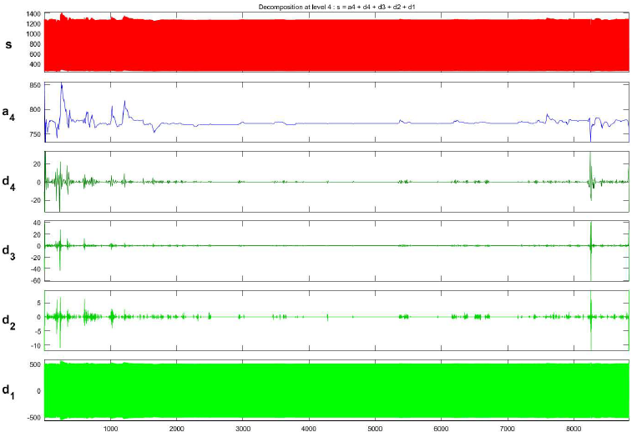b)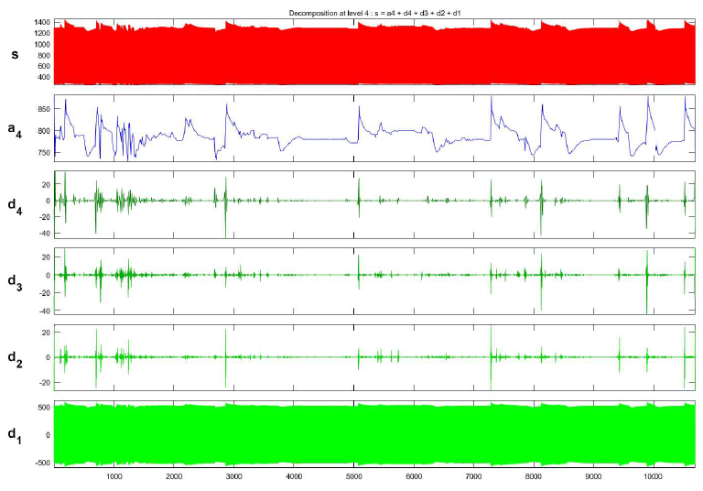
c)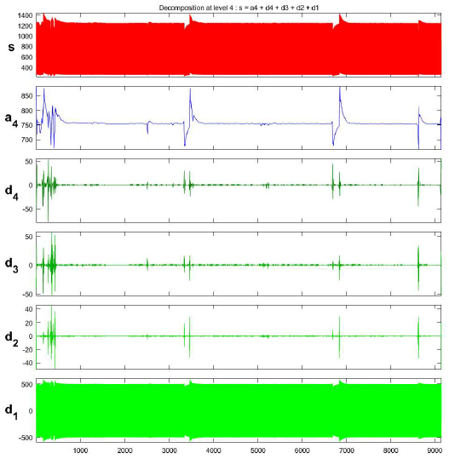d) 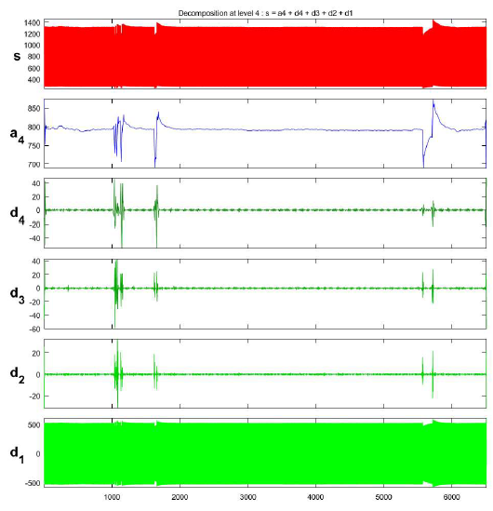
Figure 5 :EMG signal acquired using 3:0 GNP/FE2O3@PVDF electrodes for age group (a)below 10 (b)20s (c)40s (d)60s after applying WT.

