Supporting information
Preparation of humidity-responsive cinnamon essential oil nanomicelles and its effect on post-harvest quality of strawberries
Yali Luo¹, Jingyi Su¹, Shuangfeng Guo¹, Zhaoxin Cao¹, Zhiming Liu¹, Shang Wu², Yueyang Mao², Yan Zheng², Wen Shen^{2*}, Tingting Li^{1*}, Xuemei Ge^{1*}
¹ College of Light Industry and Food Engineering, Nanjing Forestry University, Nanjing, Jiangsu 210037, China
² School of Food and Biological Engineering, Shaanxi University of Science & Technology, Xi’an 710021, PR China.
*Corresponding author: Xuemei Ge, Wen Shen, Tingting Li
E-mail address: gexuemei@njfu.edu.cn
Address: No.159 Long Pan Road, Nanjing, Jiangsu Province, 210037, China
shenwensm@sust.edu.cn
Address: Shaanxi Univ Sci & Technol, Sch Food & Biol Engn, Xian 710021, Peoples R China
lttnjfu@njfu.edu.cn
Address: No.159 Long Pan Road, Nanjing, Jiangsu Province, 210037, China

Figure S1
Figure. S1. Size distribution cruves of PEG_{2k}-PCL_{5k} blank micelles (A), PEG_{2K}-PCL_{8K} blank micelles (B) and PEG_{2k}-PCL_{8k}-CEO micelles (C).

Figure S2
Figure. S2. The calibration curve for the calculation of cinnamaldehyde concentration within the range of 1-500 mg/L, and the equation was y =126302x+95339 (y: the area of peak; x: the concentration of cinnamaldehyde) with a related coefficient of R²= 1.

Figure S3
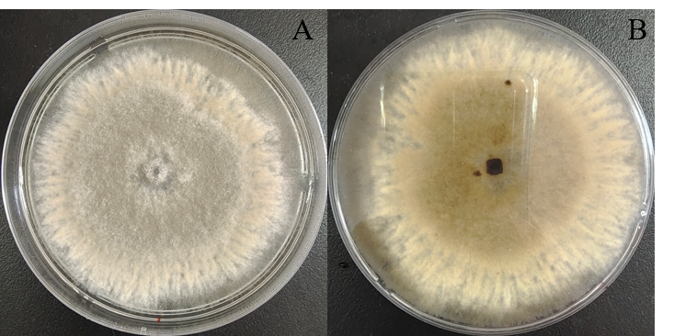
Figure. S3. Obverse and reverse side of colony morphology of Botrytis cinerea strain CM–H1 of on PDA at 26 °C after incubation for 7 d.

