The Beneficial Effect of Low-Dose Aspirin on the Survival of Pathological Advanced-Stage Oral Squamous Cell Carcinoma Patients
Sheng-Dean Luo, MD^{1,2}, Shao-Chun Wu, MD^{2,3}, Wei-Chih Chen, MD¹, Ching-Nung Wu, MD¹, Tai-Jan Chiu, MD^{2,4}, Yao-Hsu Yang, MD ^{5,6,7}, Shau-Hsuan Li, MD⁴, Fu-Min Fang, MD⁸, Tai-Lin Huang, MD⁴, Chang-Chun Hsiao, Ph.D.^{2,9*}, Chang-Han Chen, Ph.D.^{10,11*}

¹ Department of Otolaryngology, Kaohsiung Chang Gung Memorial Hospital and Chang Gung University College of Medicine, Kaohsiung 833, Taiwan.
² Graduate Institute of Clinical Medical Sciences, College of Medicine, Chang Gung University, Taoyuan 333, Taiwan.
³ Department of Anesthesiology, Kaohsiung Chang Gung Memorial Hospital and Chang Gung University College of Medicine, Kaohsiung 833, Taiwan.
⁴ Department of Hematology-Oncology, Kaohsiung Chang Gung Memorial Hospital and Chang Gung University College of Medicine, Kaohsiung 833, Taiwan.
⁵ Department of Traditional Chinese Medicine, Chang Gung Memorial Hospital, Chiayi, Taiwan.
⁶ Health Information and Epidemiology Laboratory of Chang Gung Memorial Hospital, Chiayi, Taiwan.
⁷ School of Traditional Chinese Medicine, College of Medicine, Chang Gung University, Taoyuan, Taiwan.
⁸ Department of radiation Oncology, Kaohsiung Chang Gung Memorial hospital and Chang Gung University College of Medicine, Kaohsiung, Taiwan.
⁹ Division of Pulmonary and Critical Care Medicine, Kaohsiung Chang Gung Memorial Hospital and Chang Gung University College of Medicine, Kaohsiung 83301, Taiwan
¹⁰ Guangdong Research Institute of Gastroenterology, and Guangdong Provincial Key Laboratory of Colorectal and Pelvic Floor Disease, The Sixth Affiliated Hospital of Sun Yat-sen University, Guangzhou, 510665, China.
¹¹ Department of Applied Chemistry, and Graduate Institute of Biomedicine and Biomedical Technology, National Chi Nan University, Nantou 54561, Taiwan.

Supplemental Results
Table S1. Baseline Characteristics of OSCC Patients Before and After Propensity-Score Matching (PSM).
Characteristics | Before Propensity Score Matching |  |  |  |  |  |  | After Propensity Score Matching
Characteristics | Non-users  (Control)  n=6018 |  | Aspirin Users  ≥180 days  (Intervention)  n=306 |  | SMD |  | Non-users  (Control)  n=1220 |  |  | Aspirin Users  ≥180 days  (Intervention)  n=305 | SMD
Propensity Score (IQR) | 0.036(0.022-0.059) |  | 0.064(0.041-0.102) |  | 0.6874 |  |  |  | 0.063(0.041-0.103) | 0.063(0.041-0.102) | 0.0098
Gender
Female (%) | 521(8.66%) |  | 20(6.54%) |  | 0.0801 |  |  | 58(4.75%) |  | 20(6.56%) | 0.0780
Male (%) | 5497(91.34%) |  | 286(93.46%) |  | 0.0801 |  | 1162(95.25%) |  |  | 285(93.44%) | 0.0780
Age (IQR)
Years | 52(45-59) |  | 58(53-65) |  | 0.6154 |  | 58(52-65) |  |  | 58(53-65) | 0.0072
Pathological Stages
of Cancer (AJCC)ª
I & II(%) |  | 2882(47.89%) |  | 182(59.48%) | 0.2338 |  |  | 711(58.28%) |  | 181(59.34%) | 0.0216
III & IV^{b} (%) |  | 3136(52.11%) |  | 124(40.52%) | 0.2338 |  |  | 509(41.72%) |  | 124(40.66%) | 0.0216
Treatments
Surgery |  | 3224(53.57%) |  | 177(57.84%) | 0.0860 |  |  | 681(55.82%) |  | 176(57.7%) | 0.0380
Surgery & RT or CCRT |  | 2794(46.43%) |  | 129(42.16%) | 0.0860 |  |  | 539(44.18%) |  | 129(42.3%) | 0.0380
Abbreviations: SMD Standardized Mean Difference; RT radiotherapy; CCRT concurrent chemoradiotherapy.

ª Pathological AJCC Cancer Staging 7th Edition;
^{b} Stages IVa and IVb only.

Table S2. Univariate and multivariate Cox proportional hazards of prognostic
factors for OSCC survival, Model C: adjusted additional to all comorbidities and the covariates in Model A.
Variables | Cohort  n=1525 |  |  | Hazard Ratio (95%CI)
Variables | Cohort  n=1525 | Univariate | p-value |  | Multivariate | p-value
Gender
Female | 78(5.11%) | 1 | 0.0843 |  | 1 | 0.3104
Male | 1447(94.89%) | 1.94(0.91-4.11) |  |  | 1.48(0.69-3.17) | 0.3104
Age
Years | 1525(100.00%) | 1.00(0.99-1.01) | 0.7096 |  | 1.01(0.99-1.02) | 0.2814
Pathological Stages of Cancer (AJCC)ª
I & II | 892(58.5%) | 1 | <0.0001 |  | 1 | <0.0001
III & IV^{b} | 633(41.5%) | 4.22(3.23-5.52) |  |  | 2.34(1.66-3.30) | <0.0001
Treatments
Surgery | 857(56.2%) | 1 | <0.0001 |  | 1 | <0.0001
Surgery & RT or CCRT | 668(43.8%) | 4.31(3.27-5.68) |  |  | 2.60(1.83-3.70) | <0.0001
Aspirin Use
No | 1220(80.0%) | 1 | <0.0001 |  | 1 | 0.0191
Yes | 305(20.0%) | 0.44(0.30-0.64) |  |  | 0.59(0.38-0.92) | 0.0191
Comorbidities
Atrial fibrillation (flutter)
No | 1483(97.25%) | 1 | 0.5779 |  | 1 | 0.9376
Yes | 42(2.75%) | 0.80(0.35-1.79) |  |  | 1.03(0.45-2.40) | 0.9376
DM |  |  | 0.6002 |  |  | 0.0022
No | 1171(76.79%) | 1 |  |  | 1 | 0.0022
Yes | 354(23.21%) | 0.93(0.69-1.24) |  |  | 1.65(1.20-2.28)
Hypertension
No | 1082(70.95%) | 1 | 0.0084 |  | 1 | 0.8841
Yes | 443(29.05%) | 0.68(0.51-0.91) |  |  | 0.98(0.71-1.34) | 0.8841
Hyperlipidemia
No | 1221(80.07%) | 1 | <0.0001 |  | 1 | <0.0001
Yes | 304(19.93%) | 0.32(0.21-0.48) |  |  | 0.33(0.20-0.53) | <0.0001
Abbreviations: 95% CI 95% confidence interval; RT radiotherapy; CCRT concurrent chemoradiotherapy; DM diabetes mellitus.
ª Pathological AJCC Cancer Staging 7th Edition;
^{b} Stages IVa and IVb only.

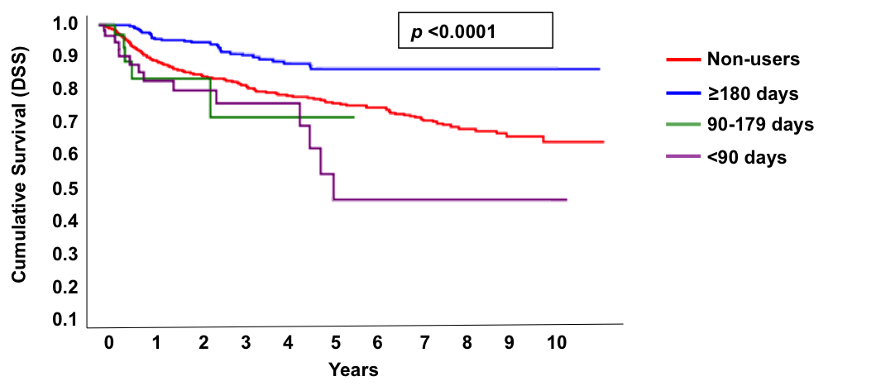

Variables |  | Cohort  n=2020 | Survival rate(%)  Years |  |  |  |  |  |  |  |  |  | p value
 |  | Cohort  n=2020 | 1 | 2 | 3 | 4 | 5 | 6 | 7 | 8 | 9 | 10 | p value
Aspirin Use
Non-Users | 1616(80.0%) |  | 90.91 | 85.28 | 82.55 | 78.59 | 76.30 | 74.85 | 71.36 | 68.39 | 65.96 | 64.27 | <0.0001
≥180 days | 304(15.05%) |  | 97.61 | 95.04 | 91.32 | 88.93 | 86.61 | 86.61 | 86.61 | 86.61 | 86.61 | 86.61 | <0.0001
90-179 days | 36(1.78%) |  | 83.77 | 83.77 | 71.80 | 71.80 | 71.80 | 71.80 |  |  |  |  | <0.0001
<90 days | 64(3.17%) |  | 82.90 | 79.90 | 76.26 | 76.26 | 54.60 | 46.80 | 46.80 | 46.80 | 46.80 | 46.80 | <0.0001

Figure S1. Kaplan-Meier survival curve of disease-specific survival (DSS) among non-users, ≥180-day, 90-179-day and <90-day aspirin users. A total of 2,020 patients diagnosed with OSCC were recruited for this study after 1:4 PSM. The estimated 5- and 10-year DSS rates of non-users were 76.307% and 64.27%, respectively. The estimated 5- and 10-year DSS rates of ≥180-day aspirin users were both 86.61%. The estimated 5-year DSS rate of 90-179-day aspirin users was 71.8%. The estimated 5- and 10-year DSS rates of <90-day aspirin-users were 54.60% and 46.80%, respectively. P-value was 0.0001 for the overall comparison among the groups using the log rank test.

Figure S2. Pie chart showing locations (%) of OSCC found in patients.
