Supplementary Information
eFigure 1. Study subject definition
eFigure 2. Overall procedure for selecting study population
eFigure 3. Propensity score distribution histogram of case and control before an
eFigure 4. Six years follow-up process

eFigure 1. Study subject definition
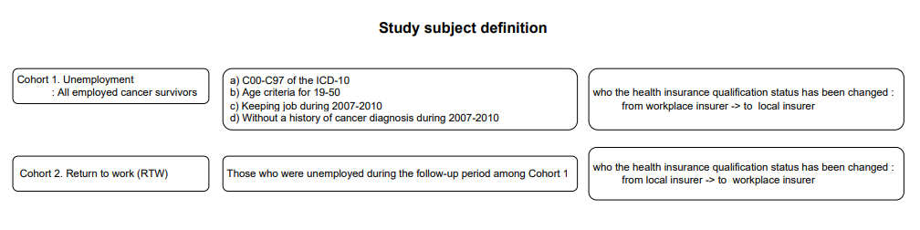

eFigure 2. Overall procedure for selecting study population
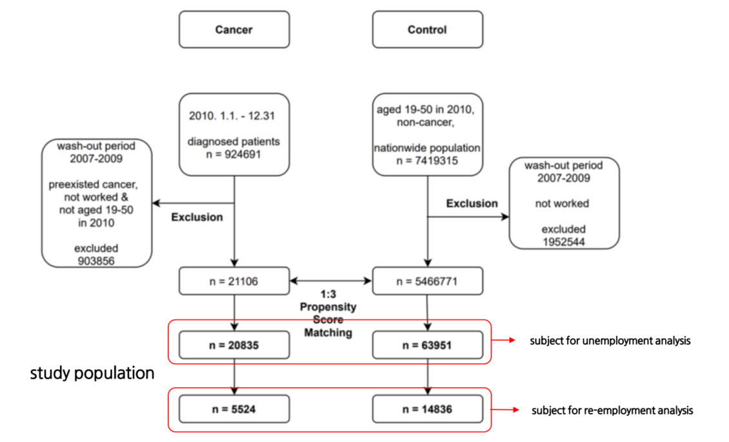

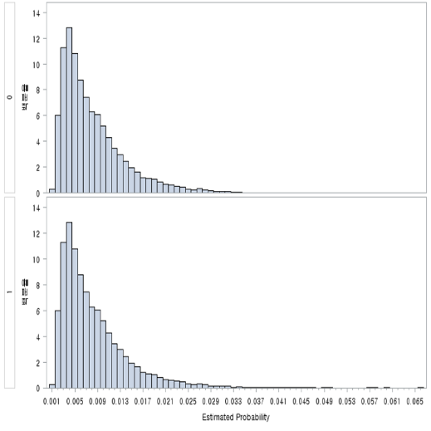
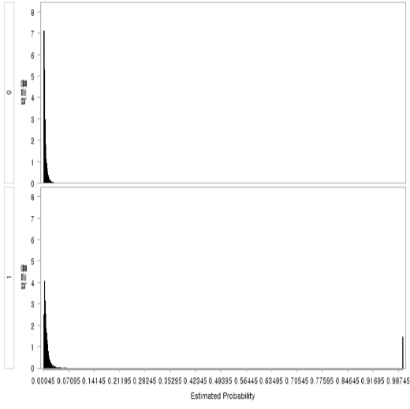
eFigure 3. Propensity score distribution histogram of case and control before an

eFigure 4. Six years follow-up process
