Supplementary Material

Construction of Deep Learning-Based Disease Detection Model in Plants

Minah Jung^{1,2†}, Jong Seob Song^{2†}, Ah-Young Shin^{3,4†}, Beomjo Choi^{3,5†}, Sangjin Go³, Suk-Yoon Kwon^{3,6}, Juhan Park², Sung Goo Park^{1,7*}, and Yong-Min Kim^{3,4,8*}

¹Department of Functional Genomics, KRIBB School of Biological Science, Korea University of Science and Technology (UST), Daejeon, Republic of Korea
²Euclidsoft Co., Ltd, Daejeon, Republic of Korea
³Plant Systems Research Center, Korea Research Institute of Bioscience and Biotechnology (KRIBB), Daejeon, Republic of Korea
⁴Department of Bioinformatics, KRIBB School of Bioscience, Korea University of Science and Technology (UST), Daejeon, Republic of Korea
⁵Department of Environmental Horticulture, University of Seoul, Seoul, Republic of Korea
⁶Biosystems and Bioengineering Program, KRIBB School of Bioscience, Korea University of Science and Technology (UST), Daejeon, Korea
⁷Disease Target Structure Research Center, Korea Research Institute of Bioscience and Biotechnology (KRIBB), Daejeon, Republic of Korea
⁸Digital Bioinnovation Center, Korea Research Institute of Bioscience and Biotechnology (KRIBB), Daejeon, Republic of Korea

Supplementary Fig. S1 Strawberry leaf images data for model evaluation.
Supplementary Fig. S2 Excluded images.
Supplementary Table S1 Hyperparameters for constructions of disease detection model.
Supplementary Table S2 Performance measurement of five pre-trained CNN models using the test dataset.
Supplementary Table S3 Disease symptoms of target diseases.
Supplementary Table S4 Results of evaluation using other crops.
Supplementary Table S5 Results of evaluation using bell pepper, potato, and tomato.
Supplementary Table S6 Raw data for constructions of disease detection model.

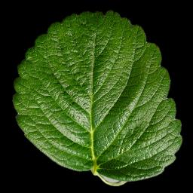
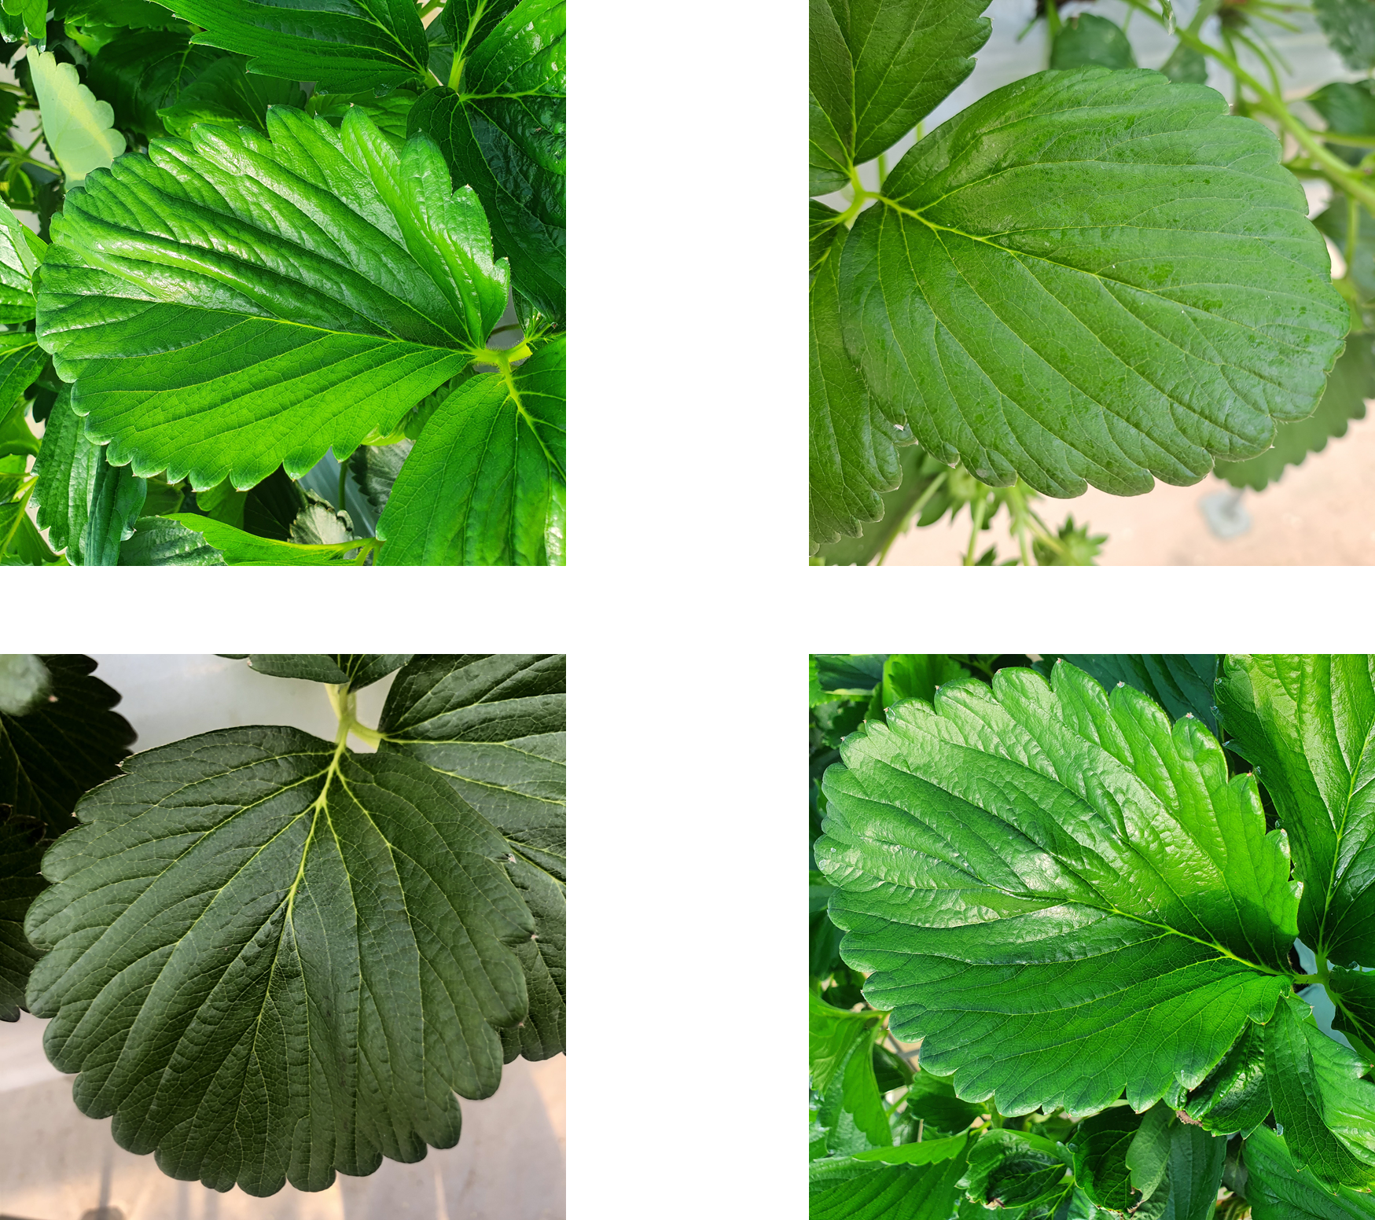
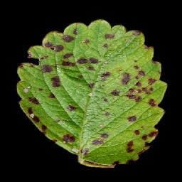
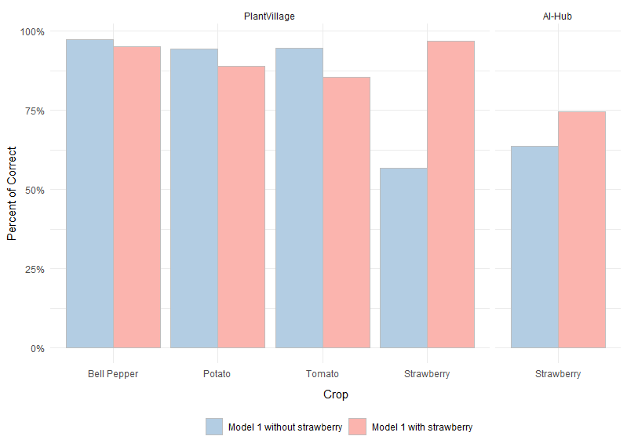
Supplementary Fig. S1 Strawberry leaf images data for model evaluation. (a) background removed images (PlantVillage) (b) field leaf images (AI-hub) (c) Results of evaluation using model 1 without strawberry and model 1 with strawberry.
a
b
c
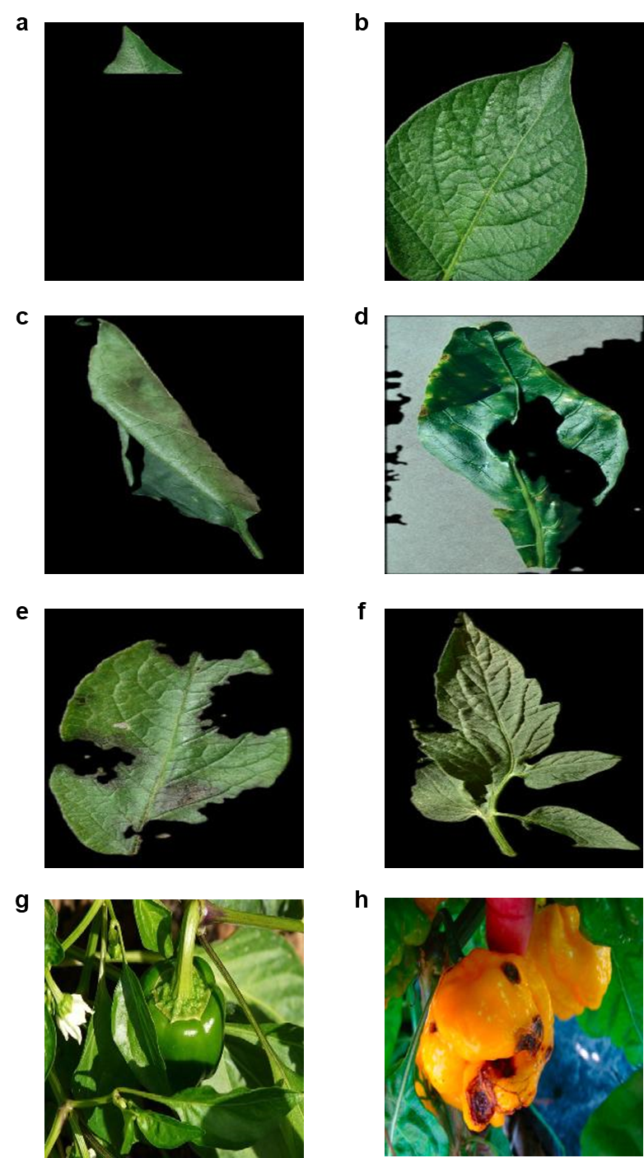
Supplementary Fig. S2 Excluded images. (a) partial image (cut off), (b) partial, (c) curled, (d) shade, (e) damage, (f) multiple leaves, (g) non-detectable and (h) fruit.
Supplementary Table S1 Hyperparameters for constructions of disease detection model.
 | ResNet50 | AlexNet | GoogLeNet | VGG19 | EfficientNet
Batch size | 2 | 2 | 2 | 2 | 2
Activation | Softmax | Softmax | Softmax | Softmax | Softmax
Optimizer | ADAM | SGD | SGD | SGD | ADAM
Learning rate | 0.0001 | 0.0001 | 0.0001 | 0.0001 | 0.0001
Epochs | 500 | 500 | 500 | 500 | 500
Early stopping | Y | Y | Y | Y | Y

Supplementary Table S2 Performance measurement of five pre-trained CNN models using the test dataset.
Step |  | Crop | Pre-trained Model | Performance
 |  | Crop | Pre-trained Model | Accuracy | Precision | Recall | F1-score
Ⅰ | Crop Classification | All | ResNet50 | 91.84% | 92.86% | 91.84% | 91.66%
Ⅰ | Crop Classification | All | AlexNet | 96.87% | 96.87% | 96.87% | 96.86%
Ⅰ | Crop Classification | All | GoogLeNet | 99.08% | 99.08% | 99.08% | 99.08%
Ⅰ | Crop Classification | All | VGG19 | 98.71% | 98.71% | 98.71% | 98.71%
Ⅰ | Crop Classification | All | EfficientNet | 99.33% | 99.33% | 99.33% | 99.32%
Ⅱ | Disease Detection | Bell Pepper | ResNet50 | 98.32% | 95.90% | 100.00% | 97.91%
Ⅱ | Disease Detection | Bell Pepper | AlexNet | 99.16% | 99.46% | 98.40% | 98.93%
Ⅱ | Disease Detection | Bell Pepper | GoogLeNet | 100.00% | 100.00% | 100.00% | 100.00%
Ⅱ | Disease Detection | Bell Pepper | VGG19 | 99.58% | 99.47% | 99.47% | 99.47%
Ⅱ | Disease Detection | Bell Pepper | EfficientNet | 99.58% | 100.00% | 98.93% | 99.46%
Ⅱ | Disease Detection | Potato | ResNet50 | 99.45% | 100.00% | 99.40% | 99.70%
Ⅱ | Disease Detection | Potato | AlexNet | 98.90% | 99.70% | 99.10% | 99.40%
Ⅱ | Disease Detection | Potato | GoogLeNet | 99.45% | 99.70% | 99.70% | 99.70%
Ⅱ | Disease Detection | Potato | VGG19 | 100.00% | 100.00% | 100.00% | 100.00%
Ⅱ | Disease Detection | Potato | EfficientNet | 99.45% | 100.00% | 99.40% | 99.70%
Ⅱ | Disease Detection | Tomato | ResNet50 | 99.75% | 99.75% | 99.75% | 99.75%
Ⅱ | Disease Detection | Tomato | AlexNet | 99.45% | 99.50% | 99.50% | 99.49%
Ⅱ | Disease Detection | Tomato | GoogLeNet | 99.62% | 99.62% | 99.62% | 99.62%
Ⅱ | Disease Detection | Tomato | VGG19 | 99.62% | 99.62% | 99.62% | 99.62%
Ⅱ | Disease Detection | Tomato | EfficientNet | 98.23% | 98.33% | 98.23% | 98.24%
Ⅲ | Disease Classification | Potato | ResNet50 | 98.80% | 99.31% | 97.96% | 98.63%
Ⅲ | Disease Classification | Potato | AlexNet | 99.40% | 99.32% | 99.32% | 99.32%
Ⅲ | Disease Classification | Potato | GoogLeNet | 99.40% | 100.00% | 98.64% | 99.32%
Ⅲ | Disease Classification | Potato | VGG19 | 99.40% | 100.00% | 98.64% | 99.32%
Ⅲ | Disease Classification | Potato | EfficientNet | 99.40% | 100.00% | 98.64% | 99.32%
Ⅲ | Disease Classification | Tomato | ResNet50 | 87.80% | 90.31% | 87.80% | 88.39%
Ⅲ | Disease Classification | Tomato | AlexNet | 95.45% | 95.32% | 95.45% | 95.35%
Ⅲ | Disease Classification | Tomato | GoogLeNet | 95.81% | 96.29% | 95.81% | 95.82%
Ⅲ | Disease Classification | Tomato | VGG19 | 95.08% | 94.92% | 95.08% | 94.96%
Ⅲ | Disease Classification | Tomato | EfficientNet | 97.09% | 97.19% | 97.09% | 97.12%

Supplementary Table S3 Disease symptoms of target diseases.
Species | Diseases | Symptoms | References
Bell Pepper | Bacterial  Spot | Symptoms begin as small, yellow-green lesions on young leaves which usually appear deformed and twisted, or as dark, water soaked, greasy-appearing lesions on older foliage. | Ritchie, D.F. 2000. Bacterial spot of pepper and tomato. The Plant Health  Instructor. DOI: 10.1094/PHI-I-2000-1027-01
Bell Pepper | Bacterial  Spot | Lesions develop rapidly to a size of 0.25 to 0.5 cm (0.1 to 0.2 in.) wide and become tan to brownish-red.
Bell Pepper | Bacterial  Spot | Lesion shape is defined by leaf veinlets, so the shape is angular rather than the round shape.
Potato | Early  Blight | Initial symptoms on leaves appear as small 1-2 mm black or brown lesions and under conducive environmental conditions the lesions will enlarge and are often surrounded by a yellow halo. | Van der Waals, J. E., L. Korsten, and T. A. S. Aveling. "A review of early  blight of potato." African Plant Protection 7.2 (2001): 91-102.
Potato | Early  Blight | Lesions greater than 10 mm in diameter often have dark pigmented concentric rings. | Kemmitt, G. 2002. Early blight of potato and tomato. The Plant Health  Instructor. DOI: 10.1094/PHI-I-2002-0809-01
Potato | Late  Blight | They consist of small, pale to dark green spots the, change into brown or black lesions. | Henfling, Jan W. Late blight of potato. Vol. 4. International Potato Center, 1987.
Potato | Late  Blight | A pale green or yellow border, a few millimeters wide, often separates dead from healthy tissue. | Schumann, G.L. and C. J. D’Arcy. 2000. Late blight of potato and tomato.  The Plant Health Instructor. DOI: 10.1094/PHI-I-2000-0724-01. Updated 2018
Potato | Late  Blight | Sporulation may be visible at the lower surface of the leaves as a white mildew surrounding the lesions. | No data was available
Tomato | Bacterial  Spot | Spots that appear on leaves and stems are small (up to 1 ⁄8 inch across), circular to irregular in shape, and have a slightly greasy feel. | Gleason, Mark Lawrence, and Brooke A. Edmunds. Tomato diseases and  disorders. Ames, IA: Iowa State University, University Extension, 2005.
Tomato | Bacterial  Spot | As lesions enlarge, they often become surrounded by a yellow halo.
Tomato | Early  Blight | Brown to black spots, 1 ⁄4 to 1 ⁄2 inch in diameter with dark edges, appear on lower leaves.
Tomato | Early  Blight | Dark, concentric rings often appear in leaf spots, resulting in the “target” appearance suggested by the common name.
Tomato | Early  Blight | Leaves turn yellow and dry up when only a few spots are present.
Tomato | Late  Blight | It first appears as water-soaked areas that enlarge rapidly, forming irregular, greenish black blotches.
Tomato | Tomato  Mosaic  Virus | ToMV causes yellow mosaic symptoms on the leaves and tomato fruits. | Mohamed, E. F. "Interaction between some viruses which attack tomato  (Lycopersicon esculentum Mill.) plants and their effect on growth and yield of tomato plants." J Amer Sci 6 (2010): 311-320.
Tomato | Tomato  Mosaic  Virus | Light and darker green mosaic leaf mottle, sometimes with distortion of younger leaves; this is the most common reaction in summer in glasshouses.

Supplementary Table S4 Results of evaluation using other crops.
Crops | Step | No. of Input Data | No. of Output Data
Crops | Step | No. of Input Data | Correct |  | Incorrect
Apple | Step 1 | 1,898 | 1,460 | (76.92%) | 438 | (23.08%)
Apple | Step 2 | 438 | 118 | (26.94%) | 320 | (73.06%)
Apple | Step 3 | 320 | 79 | (24.69%) | 241 | (75.31%)
Apple | Total | 1,898 | 1,657 | (87.30%) | 241 | (12.70%)
Corn | Step 1 | 3,023 | 2,783 | (92.06%) | 240 | (7.94%)
Corn | Step 2 | 240 | 5 | (2.08%) | 235 | (97.92%)
Corn | Step 3 | 235 | 31 | (13.19%) | 204 | (86.81%)
Corn | Total | 3,023 | 2,819 | (93.25%) | 204 | (6.75%)
Cherry | Step 1 | 1,340 | 612 | (45.67%) | 728 | (54.33%)
Cherry | Step 2 | 728 | 193 | (26.51%) | 535 | (73.49%)
Cherry | Step 3 | 535 | 0 | (0.00%) | 535 | (100.00%)
Cherry | Total | 1,340 | 805 | (60.07%) | 535 | (39.93%)
Grape | Step 1 | 3,160 | 1,104 | (34.94%) | 2,056 | (65.06%)
Grape | Step 2 | 2,056 | 145 | (7.05%) | 1,911 | (92.95%)
Grape | Step 3 | 1,911 | 1,615 | (84.51%) | 296 | (15.49%)
Grape | Total | 3,160 | 2,864 | (91.66%) | 296 | (9.37%)
Peach | Step 1 | 839 | 769 | (37.14%) | 70 | (8.34%)
Peach | Step 2 | 70 | 26 | (29.55%) | 44 | (62.86%)
Peach | Step 3 | 44 | 13 | (29.55%) | 31 | (70.45%)
Peach | Total | 839 | 808 | (96.31%) | 31 | (3.69%)
Strawberry | Step 1 | 1,079 | 612 | (56.72%) | 467 | (43.28%)
Strawberry | Step 2 | 467 | 57 | (12.21%) | 410 | (87.79%)
Strawberry | Step 3 | 410 | 22 | (5.37%) | 388 | (94.63%)
Strawberry | Total | 1,079 | 691 | (64.04%) | 388 | (35.96%)

Supplementary Table S5 Results of evaluation using bell pepper, potato, and tomato.
Crops | Step | No. of Input Data | No. of Output Data
Crops | Step | No. of Input Data | Correct |  | Incorrect
Bell Pepper | Step 1 | 2,389 | 2,325 | (97.32%) | 64 | (2.68%)
Bell Pepper | Step 2 | 2,325 | 2,274 | (97.81%) | 51 | (2.19%)
Bell Pepper | Step 3 | 2,274 | 2,274 | (100.00%) | 0 | (0.00%)
Bell Pepper | Total | 2,389 | 2,274 | (95.19%) | 115 | (4.81%)
Potato | Step 1 | 1,810 | 1,707 | (94.31%) | 103 | (5.69%)
Potato | Step 2 | 1,707 | 1,681 | (98.48%) | 26 | (1.52%)
Potato | Step 3 | 1,681 | 1,606 | (95.54%) | 75 | (4.46%)
Potato | Total | 1,810 | 1,606 | (88.73%) | 204 | (11.27%)
Tomato | Step 1 | 3,949 | 3,740 | (94.71%) | 209 | (5.29%)
Tomato | Step 2 | 3,740 | 3,321 | (88.80%) | 419 | (11.20%)
Tomato | Step 3 | 3,321 | 3,196 | (96.24%) | 125 | (3.76%)
Tomato | Total | 3,949 | 3,196 | (80.93%) | 753 | (19.07%)

Supplementary Table S6 Raw data for constructions of disease detection model.

Crops | Disease Status | Numbers
Crops | Disease Status | Raw | Excluded | Used
Apple | Healthy | 1,645 | 623 | 1,022
Apple | Apple scab | 630 | 440 | 190
Apple | Black rot | 621 | 126 | 495
Apple | Cedar apple rust | 275 | 84 | 191
Cherry | Healthy | 854 | 63 | 791
Cherry | Powdery mildew | 1,052 | 503 | 549
Corn | Healthy | 1,162 | 272 | 890
Corn | Cercospora leaf spot | 513 | 240 | 273
Corn | Common rust | 1,192 | 57 | 1,135
Corn | Northern leaf blight | 985 | 260 | 725
Grape | Healthy | 423 | 99 | 324
Grape | Black rot | 1,180 | 192 | 988
Grape | Esca (Black Measles) | 1,384 | 341 | 1,043
Grape | Leaf blight | 1,076 | 271 | 805
Peach | Healthy | 360 | 178 | 182
Peach | Bacterial spot | 2,297 | 1,640 | 657
Bell Pepper | Healthy | 1,478 | 22 | 1,456
Bell Pepper | Bacterial spot | 993 | 60 | 933
Potato | Healthy | 152 | 4 | 148
Potato | Early blight | 1,000 | 71 | 929
Potato | Late blight | 1,001 | 268 | 733
Strawberry | Healthy | 456 | 5 | 451
Strawberry | Leaf scorch | 1,109 | 481 | 628
Tomato | Healthy | 1,591 | 374 | 1,217
Tomato | Bacterial spot | 2,135 | 465 | 1,670
Tomato | Early blight | 992 | 690 | 302
Tomato | Late blight | 1,909 | 1,442 | 467
Tomato | Leaf mold | 674 | 62 | 612
Tomato | Septoria leaf spot | 1,231 | 190 | 1,041
Tomato | Spider mites | 1,676 | 322 | 1,354
Tomato | Target spot | 1,406 | 666 | 740
Tomato | Tomato mosaic virus | 373 | 92 | 281
Tomato | Tomato yellow leaf curl virus | 5,357 | 3,653 | 1,704
Subtotal | Healthy | 8,121 | 1,640 | 6,481
Subtotal | Disease | 31,061 | 12,616 | 18,445
Total |  | 39,182 | 14,256 | 24,926

