Decomplexity of Aliphatic Alcohol Derivatives via β-Fragmentation for Forging C–C Bond: An Alternative to Grignard-type Addition

Supporting Information
1. General Information 2
2. Substrate Preparation 3
2.1 Substrates 1 Preparation 4
2.2 Substrates 2 Preparation 9
3. Experimental Procedures 15
3.1 General Procedure for the Synthesis of the products 3‒60 15
3.2 Characterization Data for the product 3‒60. 15
4. Reaction Profile 31
5. Examining Functional Group Compatibility 32
6. In Vitro Antifungal Activities. 32
7. Reference 34
8. ¹H NMR and ¹³C NMR Spectra 37

General Information
All reactions were performed in dry solvents under an N₂ atmosphere and anhydrous conditions. DCM, THF, toluene, diethyl ether, and MeCN to be used in anhydrous reaction mixtures were dried by passage through activated alumina columns immediately prior to use. All other reagents were used as received from commercial sources. Reactions were monitored through thin layer chromatography (TLC) on 0.25-mm silica gel plates and visualized under UV light. Flash column chromatography (FCC) was performed using Flash silica gel (60-Å pore size, 40–63 μm). NMR spectra were recorded on Bruker Avance-400 or -600 instrument, calibrated to CD(H)Cl₃ as the internal reference (7.26 and 77.0 ppm for ¹H and ¹³C NMR spectra, respectively). ¹H NMR spectral data were reported in terms of chemical shift (δ, ppm), multiplicity, coupling constant (Hz), and integration. ¹³C NMR spectral data were reported in terms of chemical shift (δ, ppm). The following abbreviations indicated the multiplicities: s, singlet; d, doublet; t, triplet; q, quartet; m, multiplet; br, broad. High-resolution mass spectra were recorded using a SCIEX X500R LC-Q-TOF, ESI ion Source. The 15 W blue LED lamps were directly got from the supermarket. The crop pathogenic fungi, such as Botrytis cinerea (B. cinerea), Sclerotinia sclerotiorum (S. sclerotiorum), Colletotrichum orbiculare (C. orbiculare), Thanatephorus cucumeris(Frank)Donk (T. cucumeris), Alternariamali, and Ceratocystis paradoxa (C. paradoxa), were purchased from the Agricultural Culture Collection of China, which were preserved in agar slants at 4 °C.

Substrate Preparation
Starting Materials
N-aryl protected derivatives
Peptides

N-alkoxyphthalimides

Substrates 1 Preparation
Esters, amides of N-aryl-substituted glycine,¹ N-aryl tetrahydroisoquinoline,² N-pyridyl-substituted glycine,³ were all prepared according to the previous reports.

Synthesis of N-aryl protected derivatives precursors
(8R,9S,13S,14S)-13-methyl-17-oxo-7,8,9,11,12,13,14,15,16,17-decahydro-6H-cyclopenta[a]phenanthren-3-yl 2-bromoacetate (1s-1)
The titled compound was synthesized following a literature procedure from estrone.⁴ Spectra are consistent with reported literature values.
(3S,8S,9S,10R,13R,14S,17R)-10,13-dimethyl-17-((R)-6-methylheptan-2-yl)-2,3,4,7,8,9,10,11,12,13,14,15,16,17-tetradecahydro-1H-cyclopenta[a]phenanthren-3-yl 2-bromoacetate (1t-1)
The titled compound was synthesized following a literature procedure from cholesterol.⁵ Spectra are consistent with reported literature values.

Synthesis of N-aryl protected derivatives

General method
Following the literature procedure⁶ with slight modifications. The mixture of p-toluidine (1.1 g, 10 mmol), potassium carbonate (1.7 g, 12 mmol) and sodium iodide (1.8 g, 12 mmol) were treated with the corresponding bromoacetate-ester (11 mmol), in dry acetone as the solvent, at 60 ºC for 12 h. To the resulting mixture, was cooled to room temperature, and filtered through a celite pad, then concentrated in vacuo, and subjected to flash chromatography to afford the N-aryl protected derivatives.
(8R,9S,13S,14S)-13-methyl-17-oxo-7,8,9,11,12,13,14,15,16,17-decahydro-6H-cyclopenta[a]phenanthren-3-yl p-tolylglycinate (1s)
Following the general method, the reaction of 1s-1 (390 mg, 1 mmol) afforded N-aryl protected derivatives 1s as a yellow oil (0.17 g, 40% yield). ¹H NMR (400 MHz, CDCl₃) δ 7.31 (d, J = 8.4 Hz, 1H), 7.18 (d, J = 8.6 Hz, 1H), 7.06 (d, J = 7.5 Hz, 2H), 6.89 (d, J = 8.4 Hz, 1H), 6.84 (s, 1H), 6.64 (q, J = 8.5 Hz, 2H), 4.17 (s, 2H), 2.97‒2.86 (m, 2H), 2.28 (s, 3H), 2.23‒2.16 (m, 1H), 2.09‒1.98 (m, 3H), 1.65‒1.51 (m, 7H), 0.93 (s, 3H); ¹³C NMR (151 MHz, CDCl₃) δ 221.0, 170.3, 153.7, 138.0, 131.9, 129.9, 126.5, 121.3, 118.5, 115.3, 113.4, 112.9, 50.5, 48.0, 46.6, 44.0, 38.4, 38.0, 35.9, 31.6, 26.5, 25.9, 21.6, 20.4, 13.9. HRMS (ESI, m/z) calcd for C₂₇H₃₂NO₃ (M+H)⁺: 418.2377, found: 418.2372.
(3S,8S,9S,10R,13R,14S,17R)-10,13-dimethyl-17-((R)-6-methylheptan-2-yl)-2,3,4,7,8,9,10,11,12,13,14,15,16,17-tetradecahydro-1H-cyclopenta[a]phenanthren-3-yl p-tolylglycinate (1t)
Following the general method, the reaction of 1t-1 (506 mg, 1 mmol) afforded N-aryl protected derivatives 1t as a white solid (0.35 g, 70% yield). m.p. 159–161 °C; ¹H NMR (400 MHz, CDCl₃) δ 7.03 (d, J = 7.6 Hz, 2H), 6.56 (d, J = 7.6 Hz, 2H), 5.40 (s, 1H), 4.74 (d, J = 8.4 Hz, 1H), 4.17 (s, 1H), 3.88 (d, J = 4.2 Hz, 2H), 2.37 (d, J = 7.8 Hz, 2H), 2.27 (s, 3H), 2.07–1.95 (m, 2H), 1.94–1.80 (m, 3H), 1.69–1.32 (m, 7H), 1.24–0.99 (m, 17H), 0.94 (d, J = 6.2 Hz, 3H), 0.89 (d, J = 6.4 Hz, 6H), 0.70 (s, 3H); ¹³C NMR (101 MHz, CDCl₃) δ 170.7, 144.9, 139.4, 129.8, 127.4, 123.0, 113.2, 75.1, 56.7, 56.1, 50.0, 46.5, 42.3, 39.7, 39.5, 38.1, 36.9, 36.6, 36.2, 35.8, 31.9, 31.8, 28.2, 28.0, 27.7, 24.3, 23.8, 22.8, 22.6, 21.0, 20.4, 19.3, 18.7, 11.9. HRMS (ESI, m/z) calcd for C₃₆H₅₆NO₂ (M+H)⁺: 534.4306, found: 534.4298.

Synthesis of Peptides
Dipeptides and polypeptides were all prepared according to previous reports⁷ with slight modifications.
General Procedure A: methyl phenylglycyl-L-tryptophanate (1ad)
To a 100 mL round-bottom flask, N-phenyl glycine (3.5 mmol, 530 mg) and methyl L-tryptophanate hydrochloride (3.5 mmol, 891 g) were dissolved in 30 mL DCM. At 0 ºC, Et₃N (7 mmol, 0.97 mL) was added and stirred for 5 min. HBTU (7 mmol, 2.65 g) was added. The reaction mixture was warmed to room temperature and stirred overnight. Subsequently, water was added to the round-bottom flask. The resulting mixture was extracted with DCM (20 mL x 3), and the combined organic layers were dried over anhydrous Na₂SO₄ and concentrated in vacuo. The residue was purified by column chromatography and the 1ad was obtained as a pale-yellow solid. m.p. 164–165 °C;
¹H NMR (400 MHz, CDCl₃) δ 8.03 (s, 1H), 7.45 (d, J = 7.9 Hz, 1H), 7.31 (d, J = 8.1 Hz, 1H), 7.19 (q, J = 7.0 Hz, 4H), 7.07 (t, J = 7.4 Hz, 1H), 6.84 (t, J = 7.3 Hz, 1H), 6.60 (s, 1H), 6.54 (d, J = 7.7 Hz, 2H), 4.98 (m, J = 4.6 Hz, 1H), 3.74 (s, 2H), 3.69 (s, 3H), 3.29 (dq, J = 5.2, 16.2 Hz, 2H); ¹³C NMR (101 MHz, CDCl₃) δ 172.1, 170.5, 146.9, 136.1, 129.4, 127.4, 123.0, 122.2, 119.7, 119.0, 118.4, 113.3, 111.3, 109.5, 52.4, 52.2, 48.6, 27.5. HRMS (ESI, m/z) calcd for C₂₀H₂₂N₃O₃ (M+H)⁺: 352.1656, found: 352.1653.

ethyl L-phenylalanylglycinate hydrochloride (1ae-2)
Following the general procedure A, the reaction of glycine ethyl ester hydrochloride and N-(tert-butoxycarbonyl)-L-phenylalanine afforded the dipeptide 1ae-1 as a white solid. To a stirred solution of 1ae-1 (1 mmol, 350 mg) in dichloromethane (20 mL) was added 1N HCl (2 mL) and the resultant mixture was stirred for 60 min at room temperature. After completion of the reaction monitored by TLC, the reaction were dried over with Na₂SO₄, filtered and concentrated under reduced pressure The desired product 1ae-2 was afforded as yellow solid, which without further purification and used in next step directly.
phenylglycyl-L-tryptophan (1af-2)
Following the general procedure A, the reaction of N-phenyl glycine and Methyl L-phenylalaninate hydrochloride afforded the dipeptide 1af-1 as a white solid. To a stirred solution of 1af-1 (1 mmol, 312 mg) in methanol (20 mL) was added 1N LiOH (2 mL) and the resultant mixture was stirred for 8 h at room temperature. After completion of the reaction monitored by TLC, the reaction was concentrated under reduced pressure to remove methanol, and then extracted with EtOAc (30 mL). The aqueous layers were collected and the pH was adjusted to 2-3 by 2N HCl. Following extraction with EtOAc (20 mL x 2), the combined organic layers were dried over with Na₂SO₄, filtered and concentrated under reduced pressure. The desired product 1af-2 was afforded as yellow solid, which without further purification and used in next step directly.
ethyl phenylglycyl-L-phenylalanylglycinate (1ae)
Following the general procedure A, the reaction of 1ae-2 afforded polypeptide 1ae as a white solid. m.p. 135-136 °C; ¹H NMR (400 MHz, CDCl₃) δ 7.29 (d, J = 7.2 Hz, 1H), 7.20 (s, 5H), 7.08 (s, 2H), 6.83 (t, J = 7.2 Hz, 1H), 6.75 (s, 1H), 6.54 (d, J = 7.8 Hz, 2H), 4.82 (q, J = 7.2 Hz, 1H), 4.19 (q, J = 7.1 Hz, 2H), 3.94 (m, J = 9.7 Hz, 2H), 3.76 (q, J = 17.6 Hz, 2H), 3.07 (t, J = 6.4 Hz, 2H), 1.28 (t, J = 7.0 Hz, 3H); ¹³C NMR (101 MHz, CDCl₃) δ 171.2, 171.1, 169.5, 146.9, 136.2, 129.5, 129.2, 128.6, 127.0, 119.2, 113.3, 61.6, 53.8, 48.6, 41.3, 37.7, 14.1. HRMS (ESI, m/z) calcd for C₂₁H₂₆N₃O₄ (M+H)⁺: 384.1918, found: 384.1909.
ethyl phenylglycyl-L-phenylalanyl-L-phenylalanylglycinate (1af)
Following the general procedure A, the reaction of 1ae-2 and 1af-2 afforded polypeptide 1af as a white solid. m.p. 155–156 °C; ¹H NMR (600 MHz, CDCl₃) δ 7.25‒7.19 (m, 5H), 7.14 (d, J = 6.0 Hz, 3H), 7.07 (d, J = 7.2 Hz, 2H), 7.05 (d, J = 8.2 Hz, 1H), 6.97 (d, J = 5.6 Hz, 2H), 6.88 (s, 1H), 6.83 (t, J = 7.3 Hz, 1H), 6.54 (d, J = 8.0 Hz, 2H), 4.82 (q, J = 7.4 Hz, 1H), 4.77 (q, J = 7.1 Hz, 1H), 4.18 (q, J = 7.1 Hz, 2H), 4.01 (m, J = 7.9 Hz, 1H), 3.85 (m, J = 7.7 Hz, 1H), 3.70 (q, J = 16.2 Hz, 2H), 3.09 (m, J = 6.7 Hz, 1H), 2.96 (m, J = 4.3 Hz, 2H), 2.88 (m, J = 7.2 Hz, 1H), 1.28 (t, J = 7.1 Hz, 3H); ¹³C NMR (101 MHz, CDCl₃) δ 171.3, 171.1, 170.9, 169.6, 147.0, 136.6, 136.0, 129.5, 129.4, 129.3, 128.6, 128.5, 127.0, 126.8, 119.0, 113.1, 61.5, 54.1, 54.0, 48.2, 41.3, 38.0, 37.8, 14.2. HRMS (ESI, m/z) calcd for C₃₀H₃₅N₄O₅ (M+H)⁺: 531.2602, found: 531.2605.

2.2 Substrates 2 Preparation
The N-alkoxyphthalimides 2a‒d, 2f, 2k, 2m‒n,⁸ 2l,⁹ 2w,¹⁰ 2x,¹¹ 2s‒u,¹² 2v,¹³ 2ad¹⁴ were prepared using reported methods.
- methylcyclohexyl)methanol (1p-1)
The titled compound was synthesized following a literature procedure from 1-methylcyclohexanecarboxaldehyde.¹⁵ Spectra are consistent with reported literature values.
(3aR,5aS,9aS,9bR)-3a,6,6,9a-tetramethyldodecahydronaphtho[2,1-b]furan-2-ol (2aa-1)
The titled compound was synthesized following a literature procedure from sclareolide.¹⁶ Spectra are consistent with reported literature values.
((1R,5R)-6,6-dimethylbicyclo[3.1.1]heptan-2-yl)methanol (2ab-1)
The titled compound was synthesized following a literature procedure from (1S)-(1)-beta-pinene.¹⁷ Spectra are consistent with reported literature values.
1,8,8-trimethyl-3-oxabicyclo[3.2.1]octan-2-ol (2ac-1)
The titled compound was synthesized following a literature procedure from D-camphor.¹⁸ Spectra are consistent with reported literature values.
7-((4-(2-hydroxyethyl)benzyl)oxy)-4-methyl-2H-chromen-2-one (2ae-1)
The titled compound was synthesized following a literature procedure from 7-hydroxy-4-methyl-chromen-2-one.¹⁹ Spectra are consistent with reported literature values.
- (2,5-dimethylphenoxy)-2,2-dimethylpentan-1-ol (2af-1)
The titled compound was synthesized following a literature procedure from gemfibrozil.²⁰ Spectra are consistent with reported literature values.
2-cyclopropylethan-1-ol (2y-1)
The titled compound was synthesized following a literature procedure from cyclopropylacetic acid.²¹ Spectra are consistent with reported literature values.

Synthesis of N-alkoxyphthalimides

Method A
Following the literature procedure²² with slight modifications.To a solution of the alcohol (10.0 mmol), PPh₃ (3.15 g, 12.0 mmol), and N-hydroxyphthalimide (1.96 g, 12.0 mmol) in THF (30 mL) was added diisopropyl azodicarboxylate (2.4 mL, 12.0 mmol) over 10 min at room temperature. The resulting mixture was stirred for 3-24 h, taken up in EtOAc (20 mL), and washed with saturated NaHCO₃ (3 x 20 mL) and brine (2 x 30 mL). The organic layers were dried over anhydrous Na₂SO₄, concentrated in vacuo, and subjected to flash chromatography to afford the N-alkoxyphthalimides.

Method B
Following the literature procedure²³ with slight modifications. To a solution of the N-hydroxyphthalimide (1.5 g, 9.2 mmol) in DCM (30 mL) were add 1,4-dioxane (20 mL), PTSA (31.6 mg, 0.02 mmol) and dihydropyran or dihydrofuran (13.6 mmol) at room temperature. The reaction mixture was stirred for 3 h. To the resulting mixture, DCM (10 mL) and saturated Na₂CO₃ solution in H₂O (50 mL) was added. The aqueous layer was extracted with DCM (20 mL x 3), the combined organic layers were dried over anhydrous Na₂SO₄, concentrated in vacuo, and subjected to flash chromatography to afford the N-alkoxyphthalimides.

Method C
Following the literature procedure²⁴ with slight modifications. To a solution of hemiacetal (10 mmol) and N-hydroxyphthalimide (3.26 g, 20 mmol) in 70 mL wet DCM, then BF₃·OEt₂ (6.8 mL, 25 mmol) was added dropwise slowly at 0 ºC. The reaction mixture was stirred for 5 h at room temperature. To the resulting mixture, DCM (10 mL) and saturated Na₂CO₃ solution in H₂O (50 mL) was added. The aqueous layer was extracted with DCM (20 mL x 3), the combined organic layers were dried over anhydrous Na₂SO₄, concentrated in vacuo, and subjected to flash chromatography to afford the N-alkoxyphthalimides.
2-(4-methylphenethoxy)isoindoline-1,3-dione (2e)
Following the general method A, the reaction of 2-(p-Tolyl)ethanol (408 mg, 3 mmol) afforded N-alkoxyphthalimides 2e as a white solid (0.67 g, 79% yield). m.p. 82–84 °C; ¹H NMR (400 MHz, CDCl₃) δ 7.85 (m, 2H), 7.76 (m, 2H), 7.20 (d, J = 7.4 Hz, 2H), 7.13 (d, J = 7.4 Hz, 2H), 4.43 (t, J = 7.3 Hz, 2H), 3.13 (t, J = 7.3 Hz, 2H), 2.32 (s, 3H); ¹³C NMR (101 MHz, CDCl₃) δ 163.6, 136.2, 134.5, 133.6, 129.3, 128.9, 128.7, 123.5, 78.6, 34.2, 21.0. HRMS (ESI, m/z) calcd for C₁₇H₁₆NO₃ (M+H)⁺: 282.1125, found: 282.1125.
2-(2-(thiophen-2-yl)ethoxy)isoindoline-1,3-dione (2h)
Following the general method A, the reaction of 2-Thiopheneethanol (1.28 g, 10 mmol) afforded N-alkoxyphthalimides 2h as a white solid (1.53 g, 56% yield). m.p. 67–69 °C;
¹H NMR (400 MHz, CDCl₃) δ 7.86 (m, 2H), 7.77 (m, 2H), 7.18 (d, J = 4.8 Hz, 1H), 6.98 (m, 2H), 4.46 (t, J = 6.9 Hz, 2H), 3.38 (t, J = 7.1 Hz, 2H); ¹³C NMR (101 MHz, CDCl₃) δ 163.6, 138.7, 134.6, 128.9, 127.0, 125.8, 124.1, 123.6, 78.2, 29.0. HRMS (ESI, m/z) calcd for C₁₄H₁₂NO₃S (M+H)⁺: 274.0533, found: 274.0537.
2-(4-(azidomethyl)phenethoxy)isoindoline-1,3-dione (2i)
Following the general method A, the reaction of 2-(4-(bromomethyl)phenyl)ethanol afforded N-alkoxyphthalimides 2i-1, The 2i was synthesized following a literature procedure²⁵ from 2i-1 as a white solid (0.84 g, 60% yield). m.p. 112–114 °C; ¹H NMR (400 MHz, CDCl₃) δ 7.85 (m, 2H), 7.77 (m, 2H), 7.36 (d, J = 7.6 Hz, 2H), 7.28 (d, J = 7.4 Hz, 2H), 4.46 (t, J = 7.1 Hz, 2H), 4.32 (s, 2H), 3.18 (t, J = 7.2 Hz, 2H); ¹³C NMR (101 MHz, CDCl₃) δ 163.6, 137.1, 134.6, 133.8, 129.4, 128.9, 128.5, 123.6, 78.3, 54.5, 34.3. HRMS (ESI, m/z) calcd for C₁₇H₁₈N₅O₃ (M+NH₄)⁺: 340.1404, found: 340.1406.
2-(4-ethynylphenethoxy)isoindoline-1,3-dione (2j)
Following the general method A, the reaction of 2-(4-ethynylphenyl)ethanol (292 mg, 2 mmol) afforded N-alkoxyphthalimides 2j as a white solid (349 mg, 60% yield). m.p. 111–112 °C; ¹H NMR (400 MHz, CDCl₃) δ 7.85 (m, 1H), 7.78 (m, 1H), 7.46 (d, J = 7.6 Hz, 2H), 7.30 (d, J = 8.4 Hz, 2H), 4.45 (t, J = 7.0 Hz, 2H), 3.17 (t, J = 7.1 Hz, 2H), 3.07 (s, 1H); ¹³C NMR (101 MHz, CDCl₃) δ 163.6, 137.8, 134.6, 132.3, 128.9 (2C), 123.6, 120.4, 83.5, 78.1, 77.0, 34.5. HRMS (ESI, m/z) calcd for C₁₈H₁₇N₂O₃ (M+NH₄)⁺: 309.1233, found: 309.1242.
2-(2,2-diphenylethoxy)isoindoline-1,3-dione (2o)
Following the general method A, the reaction of 2,2-diphenyl ethanol (396 mg, 2 mmol) afforded N-alkoxyphthalimides 2o as a white solid (500 mg, 73% yield). m.p. 155–156 °C; ¹H NMR (400 MHz, CDCl₃) δ 7.82 (m, 2H), 7.75 (m, 2H), 7.42–7.30 (m, 8H), 7.23 (t, J = 7.0 Hz, 2H), 4.79 (d, J = 7.4 Hz, 2H), 4.65 (t, J = 7.4 Hz, 1H); ¹³C NMR (101 MHz, CDCl₃) δ 163.4, 140.5, 134.5, 128.8, 128.7, 128.3, 126.9, 123.5, 79.9, 49.8. HRMS (ESI, m/z) calcd for C₁₈H₁₇N₂O₃ (M+NH₄)⁺: 361.1546, found: 361.1544.
2-((1-methylcyclohexyl)methoxy)isoindoline-1,3-dione (2p)
Following the general method A, the reaction of 2p-1 (256 mg, 2 mmol) afforded N-alkoxyphthalimides 2p as a colorless oil (0.29 g, 51% yield). ¹H NMR (400 MHz, CDCl₃) δ 7.81 (m, 2H), 7.73 (m, 2H), 3.94 (s, 2H), 1.61‒1.31 (m, 10H), 1.12 (s, 3H); ¹³C NMR (101 MHz, CDCl₃) δ 163.4, 134.3, 129.0, 123.3, 86.5, 34.5, 34.3, 26.2, 22.9, 21.6. HRMS (ESI, m/z) calcd for C₁₆H₂₂NO₄ (M+H₂O+H)⁺: 291.1544, found: 291.1541.
2-((1-benzylcyclohexyl)methoxy)isoindoline-1,3-dione (2q)
Following the general method A, the reaction of (1-benzylcyclohexyl)methanol (817 mg, 4 mmol) afforded N-alkoxyphthalimides 2q as a white solid (0.84 g, 60% yield). m.p. 132–133 °C; ¹H NMR (400 MHz, CDCl₃) δ 7.86 (m, 1H), 7.77 (m, 1H), 7.47 (d, J = 7.4 Hz, 2H), 7.36 (t, J = 7.3 Hz, 2H), 7.26 (q, J = 6.8 Hz, 1H), 3.99 (s, 2H), 2.85 (s, 2H), 1.67‒1.37 (m, 10H); ¹³C NMR (101 MHz, CDCl₃) δ 163.5, 137.7, 134.4, 131.1, 129.1, 127.9, 126.1, 123.4, 80.8, 42.1, 37.9, 32.6, 26.1, 21.6. HRMS (ESI, m/z) calcd for C₂₂H₂₄NO₃ (M+H)⁺: 350.1751, found: 350.1749.
- (((3r,5r,7r)-adamantan-1-yl)methoxy)isoindoline-1,3-dione (2r)
Following the general method A, the reaction of 1-Adamantanemethanol (831 mg, 5 mmol) afforded N-alkoxyphthalimides 2r as a white solid (0.68 g, 44% yield). m.p. 139–140 °C; ¹H NMR (400 MHz, CDCl₃) δ 7.83 (m, 2H), 7.75 (m, 2H), 3.80 (s, 3H), 2.04 (s, 12H), 1.75 (s, 1H); ¹³C NMR (101 MHz, CDCl₃) δ 163.5, 134.3, 129.1, 123.4, 88.2, 39.0, 37.0, 34.0, 28.0. HRMS (ESI, m/z) calcd for C₁₉H₂₂NO₃ (M+H)⁺: 312.1594, found: 312.1599.
2-(((3aR,5aS,9aS,9bR)-3a,6,6,9a-tetramethyldodecahydronaphtho[2,1-b]furan-2-yl)oxy)isoindoline-1,3-dione (2aa)
Following the general method C, the reaction of 2aa-1 (250 mg, 1 mmol) afforded N-alkoxyphthalimides 2aa as a white solid (0.14 g, 36% yield). m.p. 137–138 °C; ¹H NMR (400 MHz, CDCl₃) δ 7.82 (m, 2H), 7.74 (m, 2H), 5.79 (t, J = 5.5 Hz, 1H), 2.30 (m, 1H), 2.10–1.98 (m, 2H), 1.84–1.65 (m, 2H), 0.95 (s, 3H), 1.53–1.35 (m, 5H), 1.29–0.99 (m, 5H), 0.88 (d, J = 10.0 Hz, 6H); ¹³C NMR (101 MHz, CDCl₃) δ 163.6, 134.3, 129.1, 123.3, 110.1, 84.1, 60.5, 57.0, 42.4, 39.7, 36.2, 33.5, 33.1, 28.9, 23.0, 21.0, 20.6, 18.3, 15.2. HRMS (ESI, m/z) calcd for C₂₄H₃₅N₂O₄ (M+NH₄)⁺: 415.2591, found: 415.2596.
2-(((1R,5R)-6,6-dimethylbicyclo[3.1.1]heptan-2-yl)methoxy)isoindoline-1,3-dione (2ab)
Following the general method A, the reaction of 2ab-1 (926 mg, 6 mmol) afforded N-alkoxyphthalimides 2ab as a white solid (0.90 g, 50% yield). ¹H NMR (400 MHz, CDCl₃) δ 7.84 (m, 2H), 7.76 (m, 2H), 4.19 (m, J = 7.3 Hz, 2H), 2.61 (m, 1H), 2.40 (m, 1H), 2.19–1.86 (m, 5H), 1.69 (m, J = 6.3 Hz, 1H), 1.23 (s, 3H), 1.01 (s, 3H); ¹³C NMR (101 MHz, CDCl₃) δ 163.5, 134.4, 128.9, 123.3, 83.3, 43.1, 41.1, 39.6, 38.4, 32.5, 27.7, 25.8, 23.2, 18.6. HRMS (ESI, m/z) calcd for C₁₈H₂₂NO₃ (M+H)⁺: 300.1594, found: 300.1599.
2-(((1S,2R,5S)-1,8,8-trimethyl-3-oxabicyclo[3.2.1]octan-2-yl)oxy)isoindoline-1,3-dione (2ac)
Following the general method C, the reaction of 2ac-1 (340 mg, 2 mmol) afforded N-alkoxyphthalimides 2ac as a white solid (252 mg, 40% yield). m.p. 138–139 °C; ¹H NMR (400 MHz, CDCl₃) δ 7.82 (m, 2H), 7.73 (m, 2H), 4.96 (s, 1H), 4.61 (d, J = 10.7 Hz, 1H), 3.45 (d, J = 10.7 Hz, 1H), 1.93‒1.83 (m, 1H), 1.78‒1.57 (m, 5H), 1.47 (s, 3H), 1.20 (s, 3H), 0.94 (s, 3H); ¹³C NMR (101 MHz, CDCl₃) δ 163.8, 134.2, 129.2, 123.3, 112.4, 67.8, 46.5, 45.7, 40.9, 35.4, 25.5, 24.5, 20.6, 15.4. HRMS (ESI, m/z) calcd for C₁₈H₂₁NO₄Na (M+Na)⁺: 338.1363, found: 338.1362.
2-(4-(((4-methyl-2-oxo-2H-chromen-7-yl)oxy)methyl)phenethoxy)isoindoline-1,3-dione (2ae)
Following the general method A, the reaction of 2ae-1 (472 mg, 2 mmol) afforded N-alkoxyphthalimides 2ae as a white solid (0.49 g, 65% yield). m.p. 196–200 °C; ¹H NMR (400 MHz, CDCl₃) δ 7.88–7.83 (m, 2H), 7.77 (m, 2H), 7.52 (d, J = 8.8 Hz, 1H), 7.43–7.34 (m, 4H), 6.98–6.87 (m, 2H), 6.15 (s, 1H), 5.11 (s, 2H), 4.46 (t, J = 7.4 Hz, 2H), 3.19 (t, J = 7.3 Hz, 3H), 2.41 (s, 3H); ¹³C NMR (101 MHz, CDCl₃) δ 163.6, 161.7, 161.3, 155.2, 152.5, 137.2, 134.5, 134.2, 129.3, 128.9, 127.9, 125.6, 123.6, 113.8, 112.9, 112.1, 101.9, 78.4, 70.3, 34.4, 18.7. HRMS (ESI, m/z) calcd for C₂₇H₂₂NO₆ (M+H)⁺: 456.1442, found: 456.1450.
2-((5-(2,5-dimethylphenoxy)-2,2-dimethylpentyl)oxy)isoindoline-1,3-dione (2af)
Following the general method A, the reaction of 2af-1 (472 mg, 2 mmol) afforded N-alkoxyphthalimides 2af as a colorless oil (0.49 g, 65% yield). ¹H NMR (400 MHz, CDCl₃) δ 7.85 (m, 2H), 7.76 (m, 2H), 7.03 (d, J = 7.7 Hz, 1H), 6.68 (m, 2H), 4.00 (m, 4H), 2.35 (s, 3H), 2.22 (s, 3H), 1.93 (m, J = 2.8 Hz, 2H), 1.65 (m, J = 4.2 Hz, 2H), 1.15 (s, 6H); ¹³C NMR (101 MHz, CDCl₃) δ 163.4, 157.1, 136.4, 134.4, 130.3, 129.3, 123.6, 123.4, 120.6, 112.1, 86.1, 68.4, 35.3, 34.4, 24.4, 24.1, 21.4, 15.8. HRMS (ESI, m/z) calcd for C₂₃H₂₈NO₄ (M+H)⁺: 382.2013, found: 382.2014.
2-(2-cyclopropylethoxy)isoindoline-1,3-dione (2y)
Following the general method A, the reaction of 2y-1 (517 mg, 6 mmol) afforded N-alkoxyphthalimides 2y as a white solid (1.0 g, 72% yield). m.p. 63–65 °C; ¹H NMR (400 MHz, CDCl₃) δ 7.85 (m, 2H), 7.76 (m, 2H), 4.29 (t, J = 6.9 Hz, 1H), 1.71 (q, J = 6.8 Hz, 1H), 0.89 (t, J = 6.3 Hz, 1H), 0.51 (d, J = 7.6 Hz, 1H), 0.13 (d, J = 4.6 Hz, 1H); ¹³C NMR (101 MHz, CDCl₃) δ 163.7, 134.4, 129.0, 123.5, 78.6, 33.1, 7.2, 4.3. HRMS (ESI, m/z) calcd for C₁₃H₁₄NO₃ (M+H)⁺: 232.0968, found: 232.0972.

Experimental Procedures

3.1 General Procedure for the Synthesis of the products 3‒60
The N-alkoxyphthalimides (0.1 mmol), the esters, or amides of N-aryl-substituted glycine, or N-aryl tetrahydroisoquinoline, or peptides (0.2 mmol, 2.0 equiv.), 4CzIPN (5 mol%, 0.005 mmol, 4.0 mg), and DMSO (3 mL, 0.03 M) were added sequentially to a 4 mL clear-colored glass vial equipped with a magnetic stir bar. After bubbled with nitrogen gas for 5 minutes to remove oxygen, the vial was sealed and exposed to blue LEDs at 60 ºC (Supplementary Figure 1). The reaction mixture was monitored by TLC until the starting material N-alkoxyphthalimides were consumed. Then, the reaction was quenched with water (2 mL), extracted with ethyl acetate, washed with brine, dried over anhydrous Na₂SO₄, concentrated in vacuo, and purified by column chromatography to yield the products 3-60.
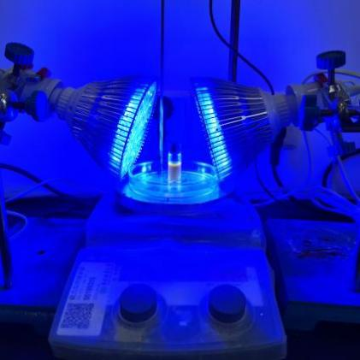
Supplementary Figure 1. Photoreactor setup

3.2 Characterization Data for the product 3‒60.
3: Yellow oil (24.3 mg, 92% yield); R_{f} = 0.40 (Petroleum ether/EtOAc, 5:1); ¹H NMR (400 MHz, CDCl₃) δ 7.00 (d, J = 7.9 Hz, 2H), 6.64 (d, J = 7.9 Hz, 1H), 6.59 (d, J = 7.9 Hz, 1H), 4.39–3.75 (m, 7H), 2.25 (s, 3H), 2.10–1.86 (m, 4H), 1.26 (t, J = 7.2 Hz, 3H); ¹³C NMR (101 MHz, CDCl₃) δ 172.7, 172.4, 145.1, 144.6, 129.8, 129.7,127.8, 127.6, 114.1, 113.9, 79.9, 79.4, 69.2, 68.7, 61.2 (2C), 61.1, 60.2, 28.4, 28.0, 26.0, 25.6, 20.4, 14.2 (2C).
4: Yellow oil (24.5 mg, 89% yield); R_{f} = 0.67 (Petroleum ether/EtOAc, 5:1); ¹H NMR (400 MHz, CDCl₃) δ 6.99 (d, J = 8.0 Hz, 2H), 6.57 (d, J = 8.0 Hz, 2H), 4.18 (q, J = 7.1 Hz 2H), 4.02 (s, 1H), 3.84 (d, J = 4.8 Hz 1H), 2.24 (s, 3H), 1.87–1.68 (m, 6H),1.29–1.15 (m, 6H); ¹³C NMR (101 MHz, CDCl₃) δ 173.9, 145.2, 129.8, 127.3, 113.7, 62.5, 60.7, 41.3, 29.6, 29.2, 26.1, 20.4, 14.3.
5: Yellow oil (46.4 mg, 89% yield); R_{f} = 0.62 (Petroleum ether/EtOAc, 5:1); ¹H NMR (400 MHz, CDCl₃) δ 6.99 (d, J = 7.9 Hz, 2H), 6.58 (d, J = 7.8 Hz, 2H), 4.17 (q, J = 7.1 Hz 2H), 4.02 (s, 1H), 3.85 (d, J = 7.8 Hz, 1H), 2.25 (s, 3H), 1.92–1.42 (m, 9H), 1.25 (t, J = 7.2 Hz, 6H); ¹³C NMR (101 MHz, CDCl₃) δ 174.4, 145.1, 129.8, 127.5, 113.7, 61.3, 60.7, 43.2, 29.4, 29.1, 25.4, 25.1, 20.4, 14.3.
6: Yellow oil (30.7 mg, 60% yield); R_{f} = 0.32 (Petroleum ether/EtOAc, 5:1); ¹H NMR (400 MHz, CDCl₃) δ 7.00 (d, J = 7.7 Hz, 2H), 6.65 (d, J = 7.6 Hz, 2H), 5.38 (s, 1H), 4.35 (s, 1H), 4.25 (q, J = 7.6 Hz, 2H), 4.15–3.91 (m, 4H), 2.25 (s, 3H), 1.29 (t, J = 6.4 Hz, 3H); ¹³C NMR (101 MHz, CDCl₃) δ 170.5, 144.7, 129.7, 127.9, 114.1, 103.5, 66.0, 65.6, 61.6, 60.7, 20.4, 14.2.
7: Yellow oil (21.7 mg, 73% yield); R_{f} = 0.68 (Petroleum ether/EtOAc, 5:1); ¹H NMR (400 MHz, CDCl₃) δ 7.11 (q, J = 7.2 Hz, 4H), 7.00 (d, J = 7.9 Hz, 2H), 6.56 (d, J = 7.8 Hz, 2H), 4.32 (t, J = 6.1 Hz, 1H), 4.14 (q, J = 6.7 Hz, 2H), 4.06 (s, 1H), 3.11 (t, J = 5.4 Hz, 2H), 2.34 (s, 3H), 2.26 (s, 3H), 1.21 (t, J = 7.1 Hz, 3H); ¹³C NMR (101 MHz, CDCl₃) δ 173.4, 144.2, 136.5, 133.3, 129.8, 129.2 (2C), 127.6, 113.8, 61.0, 58.2, 38.3, 21.1, 20.4, 14.2. HRMS (ESI, m/z) calcd for C₁₉H₂₄NO₂ (M+H)⁺: 298.1802, found: 298.1794.
8: Yellow oil (13 mg, 46% yield); R_{f} = 0.79 (Petroleum ether/EtOAc, 5:1); ¹H NMR (400 MHz, CDCl₃) δ 7.29 (q, J = 7.3 Hz, 3H), 7.21 (d, J = 7.2 Hz, 2H), 7.0 Yellow oil (13 mg, 46% yield); R_{f} = 0.79 (Petroleum ether/EtOAc, 5:1); 1 (d, J = 8.1 Hz, 2H), 6.57 (d, J = 8.2 Hz, 2H), 4.34 (t, J = 6.3 Hz, 1H), 4.14 (dq, J = 2.2, 7.0 Hz, 2H), 4.13 (s, 1H), 3.14 (d, J = 6.3 Hz, 2H), 2.26 (s, 3H), 1.19 (t, J = 7.1 Hz, 3H); ¹³C NMR (101 MHz, CDCl₃) δ 173.3, 144.1, 136.5, 129.8, 129.3, 128.5, 127.7, 126.9, 113.8, 61.0, 58.2, 38.7, 20.4, 14.1.
9: Yellow oil (13 mg, 54% yield); R_{f} = 0.55 (Petroleum ether/EtOAc, 5:1); ¹H NMR (600 MHz, CDCl₃) δ 7.44 (d, J = 8.1 Hz, 2H), 7.08 (d, J = 8.1 Hz, 2H), 7.02 (d, J = 8.0 Hz, 2H), 6.58 (d, J = 8.1 Hz, 2H), 4.33 (t, J = 6.2 Hz, 1H), 4.14 (q, J = 6.9 Hz, 2H), 3.10 (m, J = 6.4 Hz, 2H), 2.27 (s, 3H), 1.22 (t, J = 7.1 Hz, 3H); ¹³C NMR (151 MHz, CDCl₃) δ 173.0, 143.8, 135.5, 131.5, 131.1, 129.9, 127.9, 120.9, 113.9, 61.2, 58.0, 38.0, 20.4, 14.2. HRMS (ESI, m/z) calcd for C₁₈H₂₀BrNO₂ (M+H)⁺: 362.0750, found: 362.0744.
10: Yellow oil (23.7 mg, 82% yield); R_{f} = 0.58 (Petroleum ether/EtOAc, 5:1); ¹H NMR (400 MHz, CDCl₃) δ 7.19 (d, J = 4.7 Hz, 1H), 7.03 (d, J = 7.7 Hz, 2H), 6.96 (d, J = 2.8 Hz, 1H), 6.87 (s, 1H), 6.60 (d, J = 7.6 Hz, 2H), 4.36 (t, J = 5.7 Hz, 1H), 4.19 (q, J = 7.1 Hz, 2H), 3.39 (t, J = 7.3 Hz, 2H), 2.27 (s, 3H), 1.26 (t, J = 7.1 Hz, 3H); ¹³C NMR (101 MHz, CDCl₃) δ 172.7, 143.9, 138.1, 129.9, 127.8, 126.8, 126.6, 124.8, 114.0, 61.3, 58.0, 32.8, 20.5, 14.3, 14.2. HRMS (ESI, m/z) calcd for C₁₆H₂₀NO₂S (M+H)⁺: 290.1209, found: 290.1211.
11: Yellow oil (28.7 mg, 85% yield); R_{f} = 0.36 (Petroleum ether/EtOAc, 5:1); ¹H NMR (400 MHz, CDCl₃) δ 7.25 (q, J = 10.4 Hz, 4H), 7.01 (d, J = 8.1 Hz, 2H), 6.57 (d, J = 8.4 Hz, 2H), 4.34 (d, J = 6.2 Hz, 3H), 4.13 (t, J = 7.2 Hz, 2H), 3.15 (q, J = 3.4 Hz, 2H), 2.26 (s, 3H), 1.19 (t, J = 7.1 Hz, 3H); ¹³C NMR (101 MHz, CDCl₃) δ 173.2, 144.0, 136.8, 134.0, 129.9, 129.8, 128.4, 127.8, 113.9, 61.1, 58.1, 54.5, 38.4, 20.4, 14.2. HRMS (ESI, m/z) calcd for C₁₉H₂₃N₄O₂ (M+H)⁺: 339.1816, found: 339.1818.
12: Yellow oil (20 mg, 65% yield); R_{f} = 0.54 (Petroleum ether/EtOAc, 5:1); ¹H NMR (400 MHz, CDCl₃) δ 7.43 (d, J = 7.8 Hz, 2H), 7.16 (d, J = 7.8 Hz, 2H), 7.01 (d, J = 7.7 Hz, 2H), 6.58 (d, J = 7.8 Hz, 2H), 4.33 (t, J = 6.0 Hz, 1H), 4.13 (t, J = 3.5 Hz, 2H), 3.14 (d, J = 5.9 Hz, 2H), 3.08 (s, 1H), 2.26 (s, 3H), 1.19 (t, J = 7.1 Hz, 3H); ¹³C NMR (151 MHz, CDCl₃) δ 173.0, 143.9, 137.5, 132.2, 129.9, 129.4, 127.9, 120.7, 113.9, 83.5, 77.2, 61.2, 58.0, 38.5, 20.4, 14.2. HRMS (ESI, m/z) calcd for C₂₀H₂₂NO₂ (M+H)⁺: 308.1645, found: 308.1635.
13: Yellow oil (18.5 mg, 65% yield); R_{f} = 0.62 (Petroleum ether/EtOAc, 5:1); ¹H NMR (400 MHz, CDCl₃) δ 7.37–7.23 (m, 10H), 6.97 (d, J = 7.9 Hz, 4H), 6.53 (t, J = 7.9 Hz, 6H), 4.22–4.12 (m, 4H), 4.08 (s, 1H), 3.96 (q, J = 6.8 Hz, 2H), 4.08 (s, 1H), 3.32 (m, J = 6.9 Hz, 1H), 3.20 (m, J = 6.9 Hz, 1H), 2.24 (s, 6H), 1.48 (d, J = 7.1Hz, 3H), 1.43 (d, J = 7.0 Hz, 3H), 1.24 (t, J = 7.1 Hz, 3H), 1.0 (t, J = 7.12 Hz, 3H); ¹³C NMR (101 MHz, CDCl₃) δ 173.5, 173.2, 144.9, 144.8, 142.3, 141.9, 129.8, 129.7, 128.6, 128.4, 127.9 (2C), 127.7, 127.6, 127.1, 127.0, 114.1, 113.9, 63.6, 63.0, 61.0, 60.7, 43.3, 42.6, 20.4, 18.4, 17.5, 14.2, 13.9. HRMS (ESI, m/z) calcd for C₁₉H₂₄NO₂ (M+H)⁺: 298.1802, found: 298.1802.
14: Yellow oil (22.8 mg, 73% yield); R_{f} = 0.41 (Petroleum ether/EtOAc, 5:1); ¹H NMR (400 MHz, CDCl₃) δ 7.41–7.31 (m, 5H), 6.98 (d, J = 8.0 Hz, 1H), 6.92 (d, J = 7.9 Hz, 1H), 6.60 (d, J = 7.9 Hz, 1H), 6.44 (d, J = 7.9 Hz, 1H), 4.65 (dd, J = 25.1, 5.1 Hz, 1H), 4.30–4.05 (m, 3H), 3.36–3.30 (m, 3H), 2.22 (d, J = 10.4 Hz, 3H), 1.15 (dt, J = 20.6, 7.2 Hz, 3H); ¹³C NMR (101 MHz, CDCl₃) δ 171.9, 171.5, 144.8, 137.7, 137.4, 129.8, 129.6, 128.5, 128.4, 128.4, 128.3, 128.3, 127.7, 127.4, 127.1, 114.6, 114.0, 83.9, 83.8, 63.7, 63.2, 61.2, 61.0, 57.6, 57.4, 20.4, 20.4, 14.1, 14.0. HRMS (ESI, m/z) calcd for C₁₉H₂₄NO₃ (M+H)⁺: 314.1751, found: 314.1750.
15: Yellow oil (15.6 mg, 63% yield); R_{f} = 0.79 (Petroleum ether/EtOAc, 5:1); ¹H NMR (400 MHz, CDCl₃) δ 7.00 (d, J = 7.96 Hz, 2H), 6.61 (d, J = 7.96 Hz, 2H), 4.16 (q, J = 7.06 Hz, 2H), 4.09 (d, J = 5.72 Hz, 1H), 3.76 (s, 1H), 2.25 (s, 3H), 1.25 (t, J=7.13 Hz, 3H), 1.08 (s, 9H); ¹³C NMR (101 MHz, CDCl₃) δ 173.5, 145.4, 129.8, 127.6, 114.1, 66.0, 60.5, 34.4, 26.8, 20.4, 14.3.
16: Yellow oil (14.4 mg, 46% yield); R_{f} = 0.60 (Petroleum ether/EtOAc, 5:1); ¹H NMR (400 MHz, CDCl₃) δ 7.44 (d, J = 7.9 Hz, 2H), 7.35 (t, J = 7.6 Hz, 2H), 7.26 (t, J=7.9 Hz, 1 H), 6.97 (d, J = 7.9 Hz, 2H), 6.54 (d, J = 7.9 Hz, 2H), 4.14 (d, J = 6.6 Hz, 1H), 4.02–3.92 (m, 3H), 2.24 (s, 3H), 1.54 (d, J = 11.9 Hz, 6H), 1.03 (d, J = 7.1 Hz, 3H); ¹³C NMR (101 MHz, CDCl₃) δ 172.9, 145.5, 145.2, 129.7, 128.1, 127.7, 126.5 (2C), 114.2, 66.7, 60.5, 41.5, 25.7, 25.1, 20.4, 13.9.
17: Yellow oil (12.6 mg, 35% yield); R_{f} = 0.59 (Petroleum ether/EtOAc, 5:1); ¹H NMR (400 MHz, CDCl₃) δ 7.40–7.20 (m, J = 7.7 Hz, 10H), 7.00 (d, J = 7.8 Hz, 2H), 6.57 (d, J = 7.8 Hz, 2H), 4.74 (d, J = 9.1 Hz, 1H), 4.42 (d, J = 9.2 Hz, 1H), 3.94 (m, J = 5.9 Hz, 2H), 2.25 (s, 3H), 0.97 (t, J = 7.1 Hz, 3H); ¹³C NMR (101 MHz, CDCl₃) δ 173.4, 144.3, 140.8, 140.0, 129.8, 128.7, 128.6, 128.5 (2C), 127.9, 127.1 (2C), 113.8, 61.1, 60.9, 54.3, 20.4, 13.8. HRMS (ESI, m/z) calcd for C₂₄H₂₆NO₂ (M+H)⁺: 360.1958, found: 360.1956.
18: Yellow oil (12.4 mg, 43% yield); R_{f} = 0.75 (Petroleum ether/EtOAc, 5:1); ¹H NMR (400 MHz, CDCl₃) δ 6.99 (d, J = 7.8 Hz, 2H), 6.61 (d, J = 7.9 Hz, 2H), 4.15 (q, J = 7.0 Hz, 2H), 4.09 (s, 1H), 4.06 (s, 1H), 3.92 (s, 1H), 2.25 (s, 1H), 1.25 (t, J = 7.1 Hz, 3H), 1.69–1.30 (m, 10H), 1.05 (s, 3H); ¹³C NMR (101 MHz, CDCl₃) δ 173.5, 145.5, 129.8, 127.5, 114.1, 64.9, 60.5, 37.1, 34.9, 26.1, 21.8, 21.7, 20.4, 14.3. HRMS (ESI, m/z) calcd for C₁₈H₂₈NO₂ (M+H)⁺: 290.2115, found: 290.2120.
19: Yellow oil (12.8 mg, 35% yield); R_{f} = 0.69 (Petroleum ether/EtOAc, 5:1); ¹H NMR (400 MHz, CDCl₃) δ 7.34–7.22 (m, 5H), 6.98 (d, J = 7.9 Hz, 2H), 6.50 (d, J = 7.9 Hz, 2H), 4.14 (q, J = 7.1 Hz, 2H), 4.02 (s, 1H), 2.99 (d, J = 13.4 Hz, 1H), 2.86 (d, J = 13.4 Hz, 1H), 2.25 (s, 3H), 1.79–1.32 (m, 10H), 1.22 (t, J = 7.1 Hz, 3H); ¹³C NMR (101 MHz, CDCl₃) δ 173.8, 145.0, 138.2, 131.1, 129.8, 128.0, 127.6, 126.2, 114.3, 61.2, 60.5, 40.6, 31.6, 30.8, 26.0, 21.8, 21.5, 20.4, 14.3. HRMS (ESI, m/z) calcd for C₂₄H₃₂NO₂ (M+H)⁺: 366.2428, found: 366.2419.
20: Yellow oil (20.5 mg, 31% yield); R_{f} = 0.80 (Petroleum ether/EtOAc, 5:1); ¹H NMR (400 MHz, CDCl₃) δ 6.99 (d, J = 8.0 Hz, 2H), 6.60 (d, J = 8.0 Hz, 2H), 4.16 (q, J = 7.1 Hz, 2H), 4.10 (s, 1H), 3.64 (s, 1H), 2.25 (s, 3H), 2.05 (s, 3H), 1.85–1.56 (m, 15H) 1.26 (t, J =7.3 Hz, 3H); ¹³C NMR (101 MHz, CDCl₃) δ 173.0, 145.6, 129.7, 127.4, 114.0, 66.9, 60.5, 39.1, 36.9, 36.3, 28.4, 20.4, 14.4. HRMS (ESI, m/z) calcd for C₂₁H₃₀NO₂ (M+H)⁺: 328.2271, found: 328.2268.
21: Yellow oil (15.9 mg, 69% yield); R_{f} = 0.26 (Petroleum ether/EtOAc, 5:1); ¹H NMR (400 MHz, CDCl₃) δ 8.07 (s, 1H), 7.01 (d, J = 7.9 Hz, 2H), 6.57 (d, J = 7.9 Hz, 2H), 4.27–4.16 (m, 4H), 4.07 (s, 2H), 2.25 (s, 3H), 2.01–1.79 (m, 4H), 1.27 (t, J = 7.0 Hz, 3H); ¹³C NMR (101 MHz, CDCl₃) δ 173.9, 161.0, 144.4, 129.9, 127.8, 113.8, 63.4, 61.2, 56.6, 29.5, 24.8, 20.4, 14.2. HRMS (ESI, m/z) calcd for C₁₅H₂₁NO₄ (M+H)⁺: 280.1543, found: 280.1544.
22: Yellow oil (21.2 mg, 72% yield); R_{f} = 0.30 (Petroleum ether/EtOAc, 5:1); ¹H NMR (400 MHz, CDCl₃) δ 8.07 (s, 1H), 7.00 (d, J = 7.8 Hz, 2H), 6.57 (d, J = 7.9 Hz, 2H), 4.27–4.14 (m, 4H), 4.05 (t, J = 6.0 Hz, 1H), 2.25 (s, 3H), 1.95–1.67 (m, 4H), 1.62–1.49 (m, 2H), 1.27 (t, J = 7.0 Hz, 3H); ¹³C NMR (101 MHz, CDCl₃) δ 174.1, 161, 144.5, 129.8, 127.7, 113.7, 63.6, 61.1, 56.9, 32.6, 28.2, 22.0, 20.4, 14.3. HRMS (ESI, m/z) calcd for C₁₆H₂₄NO₄ (M+H)⁺: 294.1700, found: 294.1696.
23: Yellow oil (26.8 mg, 78% yield); R_{f} = 0.52 (Petroleum ether/EtOAc, 5:1); ¹H NMR (400 MHz, CDCl₃) δ 8.12 (s, 1H), 7.33 (m, 5H), 7.00 (d, J = 7.9 Hz, 2H), 6.55 (d, J = 7.9 Hz, 2H), 5.91 (m, 1H), 4.19 (m, J= 3.5 Hz, 2H), 4.02 (m, 2H), 2.26 (s, 3H), 2.14-1.60 (m, 4H), 1.25 (m, J = 4.5 Hz, 3H); ¹³C NMR (101 MHz, CDCl₃) δ 173.8, 160.3, 144.4 (2C), 139.4, 139.3, 129.9, 128.7, 128.4 (2C), 127.8 (2C), 126.6, 126.5, 113.9, 75.4, 75.3, 61.2, 56.8, 56.6, 32.3, 32.2, 29.0, 28.9, 20.4, 14.2. HRMS (ESI, m/z) calcd for C₂₁H₂₆NO₄ (M+H)⁺: 356.1856, found: 356.1850.
24: Yellow oil (7.1 mg, 23% yield); R_{f} = 0.45 (Petroleum ether/EtOAc, 5:1); ¹H NMR (400 MHz, CDCl₃) δ 7.01 (d, J = 7.6 Hz, 2H), 6.59 (d, J = 7.7 Hz, 2H), 4.28 (d, J = 6.6 Hz, 1H), 4.18 (d, J = 7.1 Hz, 2H), 4.10(s, 1H), 2.25 (d, J = 5.4 Hz, 6H), 1.92‒1.50 (m, 8H), 1.25 (t, J = 7.4 Hz, 3H), 0.90 (t, J = 6.0 Hz, 2H); ¹³C NMR (101 MHz, CDCl₃) δ 209.7, 172.7, 144.3, 129.8, 128.0, 114.0, 61.4, 58.1, 55.1, 30.1, 29.7, 27.6, 22.8, 22.7, 20.4, 14.1, 13.8. HRMS (ESI, m/z) calcd for C₁₈H₂₈NO₃ (M+H)⁺: 306.2064, found: 306.2060.
25: Yellow oil (23.8 mg, 77% yield); R_{f} = 0.54 (Petroleum ether/EtOAc, 5:1). Spectra are consistent with reported literature²⁶ values.
26: Yellow oil (20 mg, 65% yield); R_{f} = 0.43 (Petroleum ether/EtOAc, 5:1); ¹H NMR (400 MHz, CDCl₃) δ 7.44–7.30 (m Hz, 5H), 7.04 (d, J = 7.6 Hz, 2H), 6.64 (d, J = 7.5 Hz, 2H), 4.38–4.23 (m, 3H), 3.00 (d, J = 5.3 Hz, 2H), 2.27 (s, 3H), 1.31 (t, J = 7.0 Hz, 3H); ¹³C NMR (101 MHz, CDCl₃) δ 172.3, 143.9, 131.7, 129.9, 129.8, 128.2, 128.1, 128.0, 123.2, 114.2, 84.3, 83.6, 61.5, 55.9, 23.9, 20.4, 14.3, 14.2. HRMS (ESI, m/z) calcd for C₂₀H₂₂NO₂ (M+H)⁺: 308.1645, found: 308.1653.

27: Yellow oil (23.8 mg, 57% yield); R_{f} = 0.82 (Petroleum ether/EtOAc, 5:1); ¹H NMR (400 MHz, CDCl₃) δ 6.99 (d, J = 7.8 Hz, 2H), 6.61 (t, J = 7.8 Hz, 2H), 4.28–3.90 (m, 4H), 2.25 (s, 3H), 1.80–1.50 (m, 6H), 1.49–1.33 (m, 4H), 1.27‒1.19 (m, 3H), 1.07 (s, 3H), 1.04–0.96 (m, 2H), 0.94–0.87 (m, 6H), 0.84 (s, 3H), 0.83‒0.77 (m, 2H); ¹³C NMR (101 MHz, CDCl₃) δ 173.9, 173.7, 145.6, 145.3, 129.8, 129.7, 127.6, 127.5, 114.2, 114.2, 65.3, 64.1, 60.4, 60.3, 56.0, 55.9, 50.1, 47.0, 41.9, 41.9, 40.6, 40.5 (2C), 38.3, 38.2, 34.8, 33.3 (2C), 33.1, 21.7, 21.6, 20.4, 19.3, 18.6, 18.3, 18.2, 18.1, 15.7, 15.4, 14.3, 8.7, 8.3. HRMS (ESI, m/z) calcd for C₂₆H₄₀NO₂ (M–H₂O+H)⁺: 398.3054, found: 398.3044.
28: Yellow oil (16.7 mg, 53% yield); R_{f} = 0.79 (Petroleum ether/EtOAc, 5:1); ¹H NMR (400 MHz, CDCl₃) δ 7.00 (d, J = 7.8 Hz, 2H), 6.61 (d, J = 7.8 Hz, 2H), 5.69 (s, 2H), 4.12 (m, 3H), 2.25 (s, 3H), 1.98 (m, 7H), 1.24 (t, J = 7.1 Hz, 3H), 1.07 (s, 1H), 1.04 (s, 2H), 0.95 (m, 3H); ¹³C NMR (101 MHz, CDCl3) δ 173.8, 145.4, 145.2, 129.8, 127.6, 127.6, 127.0, 126.9 (3C), 114.0 (2C), 62.5, 62.4, 60.5, 40.4, 39.6, 39.2, 39.1, 26.6 (2C), 26.4, 24.1, 23.7, 20.4, 20.3, 20.2 (2C), 20.0, 14.3 (2C). HRMS (ESI, m/z) calcd for C₂₀H₃₀NO₂ (M+H)⁺: 316.2271, found: 316.2270.
29: Yellow oil (17.7 mg, 50% yield); R_{f} = 0.49 (Petroleum ether/EtOAc, 5:1); ¹H NMR (400 MHz, CDCl₃) δ 8.07 (m, 1H), 7.00 (m, 2H), 6.61 (m, 2H), 4.17 (m, 5H), 2.40–2.19 (m, 4H), 2.03–1.33 (m, 4H), 1.28–0.79 (m, 12H); ¹³C NMR (101 MHz, CDCl₃) δ 174.0, 173.7, 173.5, 173.4, 161.2 (2C), 144.5, 144.3, 144.2, 129.9, 129.8 (2C), 128.0 (2C), 127.8 (2C), 114.3, 114.0, 113.9, 66.7, 66.4, 66.1, 66.0, 62.1, 62.0, 61.7, 61.4, 60.6 (2C), 60.5, 51.4, 50.9, 49.1, 48.5, 47.7, 47.6, 46.9, 46.4, 46.2, 46.1, 45.9, 44.7, 36.1, 35.8, 35.3, 31.9, 26.9 (2C), 26.4, 25.2, 24.4, 24.0, 23.9, 22.1, 20.7 (2C), 20.4, 19.8, 18.5, 18.2, 17.4, 16.9, 16.4, 14.3 (2C), 14.2, 14.1. HRMS (ESI, m/z) calcd for C₂₁H₃₂NO₄ (M+H)⁺: 362.2326, found: 362.2329.
30: Yellow oil (33.4 mg, 74% yield); R_{f} = 0.32 (Petroleum ether/EtOAc, 5:1); ¹H NMR (400 MHz, CDCl₃) δ 8.24 (m, 1H), 7.01 (m, 2H), 6.63 (m, 2H), 5.37–5.25 (m, 8H), 4.40–3.90 (m, 8H), 2.25 (s, 1H), 1.50–1.21 (m, 15H); ¹³C NMR (101 MHz, CDCl₃) δ 171.6, 171.5, 160.5, 160.1, 144.7, 143.9, 129.9, 129.8, 128.5, 128.2, 114.5, 114.1, 110.5, 110.1, 109.8, 109.5, 78.1, 77.7, 77.1, 76.6, 75.0, 74.9, 71.8, 71.5, 71.3, 71.0, 67.3, 67.0, 66.3, 66.0, 61.5 (2C), 61.4, 60.0, 56.3, 27.2, 27.0, 26.8, 26.6, 26.5, 25.4, 25.3, 20.4 (2C), 14.2. HRMS (ESI, m/z) calcd for C₂₃H₃₄NO₈ (M+H)⁺: 452.2279, found: 452.2288.
31: Yellow oil (33.4 mg, 74% yield); R_{f} = 0.31 (Petroleum ether/EtOAc, 5:1); ¹H NMR (400 MHz, CDCl₃) δ 7.52 (d, J = 8.8 Hz, 1H), 7.37 (d, J = 7.4 Hz, 2H), 7.24 (d, J = 7.5 Hz, 2H), 7.00 (d, J = 7.6 Hz, 2H), 6.94 (d, J = 8.8 Hz, 1H), 6.90 (s, 1H), 6.56 (d, J = 7.7 Hz, 2H), 6.16 (s, 1H), 5.12 (s, 2H), 4.34 (t, J = 6.1 Hz, 1H), 4.14 (d, J = 6.9 Hz, 2H), 3.15 (t, J = 6.1 Hz, 2H), 2.42 (s, 3H), 2.25 (s, 3H), 1.19 (t, J = 7.0 Hz, 3H); ¹³C NMR (151 MHz, CDCl₃) δ 173.2, 161.7, 161.3, 155.2, 152.6, 144.0, 136.8, 134.5, 129.9, 129.7, 128.0, 127.7, 125.6, 113.9, 113.8, 113.0, 112.1, 101.9, 70.2, 61.2, 58.1, 38.3, 20.4, 18.7, 14.2. HRMS (ESI, m/z) calcd for C₂₉H₃₀NO₅ (M+H)⁺: 472.2119, found: 472.2115.
32: Yellow oil (34.2 mg, 86% yield); R_{f} = 0.81 (Petroleum ether/EtOAc, 5:1); ¹H NMR (400 MHz, CDCl₃) δ 7.02 (m, 3H), 6.67 (m, 4H), 4.17 (q, J = 7.1 Hz, 2H), 3.95 (t, J = 6.3 Hz, 2H), 3.89 (s, 1H), 2.34 (s, 3H), 2.27 (s, 3H), 2.20 (s, 3H), 1.89 (m, J = 5.9 Hz, 2H), 1.62 (m, J = 5.9 Hz, 2H), 1.26 (t, J = 7.1 Hz, 3H), 1.11 (d, J = 6.2 Hz, 6H); ¹³C NMR (101 MHz, CDCl₃) δ 173.5, 157.0, 145.3, 136.5, 130.3, 129.8, 127.7, 123.7, 120.7, 114.2, 112.0, 68.3, 64.6, 60.6, 36.8, 36.1, 24.1, 24.0, 23.6, 21.4, 20.4, 15.8, 14.3. HRMS (ESI, m/z) calcd for C₂₅H₃₆NO₃ (M+H)⁺: 398.2690, found: 398.2680.
33: Yellow oil (15.9 mg, 68% yield); R_{f} = 0.73 (Petroleum ether/EtOAc, 5:1); ¹H NMR (400 MHz, CDCl₃) δ 7.19 (t, J = 7.5 Hz, 2H), 6.75 (t, J = 7.3 Hz, 1H), 6.69 (d, J = 7.9 Hz, 2H), 4.17 (q, J = 7.1 Hz, 3H), 3.81 (s, 1H), 1.26 (t, J = 7.2 Hz, 3H), 1.10 (s, 9H); ¹³C NMR (101 MHz, CDCl₃) δ 173.4, 147.7, 129.3, 118.3, 113.8, 65.5, 60.6, 34.5, 26.8, 14.3.
34: Yellow oil (16.6 mg, 53% yield); R_{f} = 0.64 (Petroleum ether/EtOAc, 5:1); ¹H NMR (400 MHz, CDCl₃) δ 7.26 (d, J = 7.9 Hz, 2H), 6.56 (d, J = 7.9 Hz, 2H), 4.21 (s, 1H), 4.17 (q, J = 7.0 Hz, 2 H), 3.74 (d, J = 10.0 Hz, 1H), 1.26 (t, J = 7.2 Hz, 3H), 1.08 (s, 9H); ¹³C NMR (101 MHz, CDCl₃) δ 173.0, 152.8, 146.7, 132.0, 115.4, 109.9, 65.6, 60.8, 34.5, 26.7, 14.3.
35: Yellow oil (16.3 mg, 61% yield); R_{f} = 0.69 (Petroleum ether/EtOAc, 5:1); ¹H NMR (400 MHz, CDCl₃) δ 7.13 (d, J = 8.0 Hz, 2H), 6.61 (d, J = 8.0 Hz, 2H), 4.17 (q, J = 6.9 Hz, 3H), 3.74 (d, J = 10.0 Hz, 1H), 1.26 (t, J = 7.5 Hz, 3H), 1.08 (s, 9H); ¹³C NMR (101 MHz, CDCl₃) δ 173.1, 146.3, 129.1, 122.9, 115.0, 65.7, 60.7, 34.5, 26.8, 14.3.
36: Yellow oil (27.2 mg, 54% yield); R_{f} = 0.72 (Petroleum ether/EtOAc, 5:1); ¹H NMR (400 MHz, CDCl₃) δ 6.89 (t, J = 8.5 Hz, 2H), 6.63 (dd, J = 4.41, 8.3 Hz, 2H), 4.17 (q, J = 4.3 Hz, 2H), 4.06 (d, J = 8.8 Hz, 1H), 3.70 (d, J = 9.1 Hz, 1H), 1.25 (t, J = 7.1 Hz, 3H), 1.09 (s, 9H); ¹³C NMR (101 MHz, CDCl₃) δ 173.3, 156.3 (d, J = 235.9 Hz), 144.0 (d, J = 1.6 Hz), 115.7 (d, J = 22.4 Hz), 115.7 (d, J = 22.4 Hz), 115.1 (d, J = 7.4 Hz), 66.6, 60.6, 34.3, 26.8, 14.3.
37: Yellow oil (31.0 mg, 50% yield); R_{f} = 0.58 (Petroleum ether/EtOAc, 5:1); ¹H NMR (400 MHz, CDCl₃) δ 7.58 (d, J = 7.6 Hz, 2H), 7.52–7.40 (m, 4H), 7.30 (t, J = 7.5 Hz, 1H), 6.79 (d, J = 8.0 Hz, 2H), 4.33 (d, J = 10.2 Hz, 1H), 4.22 (q, J = 7.1 Hz, 2H), 3.89 (d, J = 10.0 Hz, 1H), 1.30 (t, J = 7.1 Hz, 3H), 1.15 (s, 9H); ¹³C NMR (101 MHz, CDCl₃) δ 173.3, 147.2, 141.2, 131.3, 128.7, 128.0, 126.4, 126.2, 114.1, 65.5, 60.7, 34.6, 26.8, 14.4. HRMS (ESI, m/z) calcd for C₂₀H₂₆NO₂ (M+H)⁺: 312.1958, found: 312.1955.
38: Yellow oil (38.6 mg, 73% yield); R_{f} = 0.63 (Petroleum ether/EtOAc, 5:1); ¹H NMR (400 MHz, CDCl₃) δ 6.78 (d, J = 8.8 Hz, 2H), 6.66 (d, J = 8.7 Hz, 2H), 4.20–4.10 (m, 2H), 3.92 (d, J = 4.3 Hz, 1H), 3.76 (s, 3H), 3.69 (s, 1H), 1.24 (t, J = 7.1 Hz, 3H), 1.09 (s, 9H); ¹³C NMR (101 MHz, CDCl₃) δ 173.7, 152.8, 141.8, 115.6, 114.8, 67.1, 60.5, 55.7, 34.3, 26.8, 14.3.
39: Yellow oil (16.3 mg, 55% yield); R_{f} = 0.78 (Petroleum ether/EtOAc, 5:1); ¹H NMR (400 MHz, CDCl₃) δ 6.77 (s, 2H), 4.00 (t, J = 6.7 Hz, 2H), 3.77 (s, 2H), 2.32 (s, 6H), 2.22 (s, 3H), 1.16 (s, 9H), 1.11 (t, J = 7.0 Hz, 3H); ¹³C NMR (101 MHz, CDCl₃) δ 174.1, 141.4, 130.5, 129.7, 128.2, 67.6, 60.0, 34.4, 26.6, 20.5, 18.8, 14.1. HRMS (ESI, m/z) calcd for C₁₇H₂₈NO₂ (M+H)⁺: 278.2115, found: 278.2108.
40: Yellow oil (13.5 mg, 27% yield); R_{f} = 0.68 (Petroleum ether/EtOAc, 5:1); ¹H NMR (400 MHz, CDCl₃) δ 7.08 (t, J = 7.6 Hz, 1H), 6.58 (d, J = 7.4 Hz, 1H), 6.54–6.46 (m, 2H), 4.18 (q, J = 7.1 Hz, 2H), 4.15 (s, 1H), 3.81 (d, J = 8.6 Hz, 1H), 2.29 (s, 3H), 1.27 (t, J = 7.2 Hz, 3H), 1.09 (s, 9H); ¹³C NMR (101 MHz, CDCl₃) δ 173.4, 147.7, 139.1, 129.2, 119.2, 114.7, 110.9, 65.5, 60.6, 34.5, 26.8, 21.6, 14.3. HRMS (ESI, m/z) calcd for C₁₅H₂₄NO₂ (M+H)⁺: 250.1802, found: 250.1798.
41: Yellow oil (14.3 mg, 46% yield); R_{f} = 0.69 (Petroleum ether/EtOAc, 5:1); ¹H NMR (400 MHz, CDCl₃) δ 7.40–7.29 (m, 5H), 7.19 (d, J = 8.0 Hz, 2H), 6.63 (d, J = 8.0 Hz, 2H), 5.51 (s, 2H), 4.10 (d, J = 7.5 Hz, 1H),3.86 (d, J = 8.0 Hz, 1H),2.28 (s, 3H), 1.10 (s, 9H); ¹³C NMR (101 MHz, CDCl₃) δ 173.5, 145.3, 135.6, 129.8, 128.5, 128.4, 128.3, 127.7, 114.2, 66.5, 66.1, 34.5, 26.8, 20.4. HRMS (ESI, m/z) calcd for C₂₀H₂₆NO₂ (M+H)⁺: 312.1958, found: 312.1956.
42: Yellow oil (30.6 mg, 55% yield); R_{f} = 0.66 (Petroleum ether/EtOAc, 5:1); ¹H NMR (400 MHz, CDCl₃) δ 7.00 (d, J = 7.8 Hz, 2H), 6.61 (d, J = 7.8 Hz, 2H), 4.06 (s, 1H), 3.65 (s, 1H), 2.26 (s, 3H), 1.49 (s, 9H), 1.09 (s, 9H); ¹³C NMR (101 MHz, CDCl₃) δ 172.7, 145.7, 129.7, 127.3, 114.1, 81.3, 66.5, 34.4, 28.1, 26.9, 20.4. HRMS (ESI, m/z) calcd for C₁₇H₂₈NO₂ (M+H)⁺: 278.2115, found: 278.2112.
43: Yellow oil (11.3 mg, 38% yield); R_{f} = 0.52 (Petroleum ether/EtOAc, 5:1); ¹H NMR (400 MHz, CDCl₃) δ 7.37 (t, J = 7.6 Hz, 2H), 7.23 (t, J = 7.4 Hz, 1H), 7.05 (d, J = 7.8 Hz, 2H), 6.99 (d, J = 7.7 Hz, 2H), 6.72 (d, J = 7.9 Hz, 2H), 4.15 (s, 1H), 4.03 (s, 1H), 2.29 (s, 3H), 1.22 (s, 9H); ¹³C NMR (101 MHz, CDCl₃) δ 172.3, 150.5, 145.1, 129.9, 129.4, 128.0, 125.9, 121.5, 114.2, 66.1, 34.6, 26.9, 20.4.MHz, CDCl₃) HRMS (ESI, m/z) calcd for C₁₉H₂₃NO₂ (M+H)⁺: 298.1802, found: 298.1799.
44: Yellow oil (16.4 mg, 58% yield); R_{f} = 0.61 (Petroleum ether/EtOAc, 5:1); ¹H NMR (400 MHz, CDCl₃) δ 7.21 (t, J = 7.5 Hz, 2H), 7.12 (q, J = 7.5 Hz, 4H), 6.78 (t, J = 7.2 Hz, 1H), 6.65 (d, J = 7.8 Hz, 2H), 4.37 (t, J = 6.1 Hz, 1H), 4.17 (q, J = 6.8 Hz, 2H), 3.14 (t, J = 6.7 Hz, 2H), 2.36 (s, 3H), 1.22 (t, J = 7.1 Hz, 3H); ¹³C NMR (101 MHz, CDCl₃) δ 173.2, 146.4, 136.6, 133.2, 129.4, 129.2 (2C), 118.4, 113.7, 61.1, 57.8, 38.2, 21.1, 14.2. HRMS (ESI, m/z) calcd for C₁₈H₂₂NO₂ (M+H)⁺: 284.1645, found: 284.1645.
45: Yellow oil (18.1 mg, 57% yield); R_{f} = 0.67 (Petroleum ether/EtOAc, 5:1); ¹H NMR (600 MHz, CDCl₃) δ 7.17‒7.10 (m, 4H), 7.07 (d, J = 8.0 Hz, 2H), 6.55 (d, J = 8.9 Hz, 2H), 4.30 (t, J = 6.2 Hz, 1H), 4.17 (m, J = 3.6 Hz, 2H), 3.11 (m, J = 7.5 Hz, 2H), 2.35 (s, 3H), 1.22 (t, J = 7.1 Hz, 3H); ¹³C NMR (101 MHz, CDCl₃) δ 173.0, 145.1, 136.7, 132.9, 129.3, 129.2 (2C), 122.9, 114.7, 61.3, 57.8, 38.0, 21.1, 14.2. HRMS (ESI, m/z) calcd for C₁₈H₂₁ClNO₂ (M+H)⁺: 318.1256, found: 318.1247.
46: Yellow oil (20.4 mg, 44% yield); R_{f} = 0.19 (Petroleum ether/EtOAc, 5:1); ¹H NMR (400 MHz, CDCl₃) δ 7.17 (t, J = 7.6 Hz, 2H), 6.75–6.65 (m, 3H), 4.54 (s, 1H), 4.22 (s, 1H), 3.13 (s, 3H), 2.95 (s, 3H), 1.09 (s, 9H); ¹³C NMR (101 MHz, CDCl₃) δ 173.1, 148.5, 129.3, 117.9, 114.0, 60.1, 38.2, 36.1, 35.6, 26.8. HRMS (ESI, m/z) calcd for C₁₄H₂₃N₂O (M+H)⁺: 235.1805, found: 235.1805.
47: Yellow oil (13.8 mg, 53% yield); R_{f} = 0.20 (Petroleum ether/EtOAc, 5:1); ¹H NMR (400 MHz, CDCl₃) δ 7.16 (t, J = 7.7 Hz, 2H), 6.70 (m, J = 6.5 Hz, 3H), 4.54 (s, 1H), 4.00 (s, 1H), 3.52 (m, J = 6.0 Hz, 1H), 1.94 (m, 2H), 1.85 (t, 2H), 1.10 (s, 9H); ¹³C NMR (101 MHz, CDCl₃) δ 171.4, 148.1, 129.3, 118.0, 114.1, 63.0, 47.5, 45.7, 36.0, 26.8, 26.1, 24.1. HRMS (ESI, m/z) calcd for C₁₆H₂₅N₂O (M+H)⁺: 261.1962, found: 261.1960.
48: Yellow oil (16.3 mg, 55% yield); R_{f} = 0.46 (Petroleum ether/EtOAc, 5:1); ¹H NMR (400 MHz, CDCl₃) δ 7.36 (s, 2H), 7.12 (t, J = 7.08 Hz, 2H), 6.96 (s, 2H), 6.71 (t, J = 6.98 Hz, 1H), 6.44 (d, J = 7.56 Hz, 2H), 3.26 (s, 3H), 0.95 (s, 9H); ¹³C NMR (101 MHz, CDCl₃) δ 172.9, 146.4, 143.3, 129.6, 129.2 (2C), 127.9, 118.9, 115.3, 62.5, 37.6, 36.3, 26.8. HRMS (ESI, m/z) calcd for C₁₉H₂₅N₂O (M+H)⁺: 297.1962, found: 297.1959.
49: Yellow oil (13.5 mg, 51% yield); R_{f} = 0.85 (Petroleum ether/EtOAc, 5:1). Spectra are consistent with reported literature² values.

50: Yellow oil (15.6 mg, 56% yield); R_{f} = 0.83 (Petroleum ether/EtOAc, 5:1). Spectra are consistent with reported literature² values.
51: Yellow oil (6.1 mg, 13% yield); R_{f} = 0.36 (Petroleum ether/EtOAc, 5:1); ¹H NMR (400 MHz, CDCl₃) δ 7.26 (d, J = 8.7 Hz, 1H), 7.04 (d, J = 7.6 Hz, 2H), 6.76 (d, J = 8.4 Hz, 1H), 6.70 (d, J = 8.1 Hz, 3H), 4.01 (s, 1H), 2.89 (t, J = 3.6 Hz, 2H), 2.52 (q, J = 9.1 Hz, 1H), 2.45‒2.36 (m, 1H), 2.28 (s, 3H), 2.19‒1.93 (m, 2H), 1.70‒1.41 (m, 10H), 1.20 (s, 9H), 0.92 (s, 3H); ¹³C NMR (151 MHz, CDCl₃) δ 220.9, 172.5, 148.3, 145.1, 138.0, 137.5, 129.9, 126.4, 121.4, 118.6 (2C), 114.3, 66.2, 50.4, 48.0, 44.1, 38.0, 35.9, 34.7, 31.5, 29.4, 26.9, 26.3, 25.7, 21.6, 20.4, 13.8. HRMS (ESI, m/z) calcd for C₃₁H₄₀NO₃ (M+H)⁺: 474.2930, found: 474.2996.
55: Pale solid (50.8 mg, 86% yield); m.p. 161–162 °C; R_{f} = 0.83 (Petroleum ether/EtOAc, 5:1); ¹H NMR (400 MHz, CDCl₃) δ 7.05–6.95 (m, 2H), 6.68‒6.58 (m, 2H), 5.37 (s, 1H), 4.80‒4.85 (m, 2H), 4.08 (s, 0.5H), 3.74 (s, 0.5H), 2.26 (s, 1H), 2.45‒2.19 (m, 5H), 2.13‒1.76 (m, 6H), 1.23‒1.12 (m, 6H), 1.10 (s, 7H), 1.07‒0.98 (m, 7H), 0.96‒0.87 (m, 14H), 0.71 (s, 3H); ¹³C NMR (101 MHz, CDCl₃) δ 172.8, 145.5 (2C), 139.5 (2C), 129.7, 127.5, 122.8, 114.1 (2C), 74.4, 66.0 (2C), 56.7, 56.2, 50.0, 42.3, 39.7, 39.5, 38.2, 37.0, 36.9, 36.6, 36.2, 35.8, 34.4, 31.9 (2C), 28.2, 28.0, 26.9, 24.3, 23.9, 22.8, 22.6, 21.0, 20.4, 19.3, 18.7, 14.2, 11.9. HRMS (ESI, m/z) calcd for C₄₀H₆₄NO₂ (M+H)⁺: 590.4932, found: 590.4920.
53: Yellow oil (12.8 mg, 37% yield); R_{f} = 0.85 (Petroleum ether/EtOAc, 5:1); ¹H NMR (400 MHz, CDCl₃) δ 7.16 (t, J = 7.7 Hz, 2H), 6.71 (m, J = 7.3 Hz, 3H), 4.66 (m, J = 5.4 Hz, 1H), 3.79 (s, 1H), 1.98–1.88 (m, 1H), 1.75–1.57 (m, 3H), 1.11 (s, 9H), 0.97–0.70 (m, 10H), 0.54 (q, J = 10.3 Hz, 3H); ¹³C NMR (101 MHz, CDCl₃) δ 173.2, 172.8, 147.7, 147.6, 129.2, 129.1, 118.6, 118.3, 114.5, 113.7, 75.1, 75.0, 66.1, 66.0, 46.9, 46.8, 40.9, 40.8, 34.3, 34.2, 33.9, 31.4, 26.9, 26.8, 25.9, 25.3, 22.9, 22.7, 22.0, 20.8, 15.7, 15.3. HRMS (ESI, m/z) calcd for C₂₂H₃₆NO₂ (M+H)⁺: 346.2741, found: 346.2738.
54: Yellow oil (7.1 mg, 30% yield); R_{f} = 0.48 (Petroleum ether/EtOAc, 3:1); ¹H NMR (400 MHz, CDCl₃) δ 8.04 (d, J = 5.0 Hz, 1H), 7.50 (t, J = 7.7 Hz, 1H), 6.64 (t, J = 6.1 Hz, 1H), 6.52 (d, J = 8.4 Hz, 1H), 5.75 (s, 1H), 4.29 (d, J = 9.2 Hz, 1H), 4.20 (q, J = 7.0, Hz, 2H), 1.28 (t, J = 6.6 Hz, 3H), 1.11 (s, 9H); ¹³C NMR (101 MHz, CDCl₃) δ 172.4, 157.3, 138.9, 113.3, 108.5, 63.1, 60.9, 34.5, 26.8, 14.3. HRMS (ESI, m/z) calcd for C₁₃H₂₁N₂O₂ (M+H)⁺: 237.1598, found: 237.1591.
55: Pale solid (40.3 mg, 69% yield); m.p. 93–94 °C; R_{f} = 0.35 (Petroleum ether/EtOAc, 3:1); ¹H NMR (400 MHz, CDCl₃) δ 7.21 (t, J = 7.6 Hz, 1H), 7.02 (d, J = 6.2 Hz, 1H), 6.81 (t, J = 7.3 Hz, 1H), 6.65 (t, J = 9.6 Hz, 2H), 4.61 (m, J = 6.8 Hz, 1H), 4.08 (s, 1H), 3.74 (s, 1H), 3.66 (s, 2H), 3.43 (s, 1H), 1.37 (t, J = 14.2 Hz, 2H), 1.30 (t, J = 7.4 Hz, 2H), 1.14 (d, J = 6.7 Hz, 9H); ¹³C NMR (101 MHz, CDCl₃) δ 173.0, 171.7, 147.4, 129.3, 129.3, 119.0, 114.0, 113.7, 68.4, 52.3, 47.9, 34.3, 27.2, 18.4. HRMS (ESI, m/z) calcd for C₁₆H₂₅N₂O₃ (M+H)⁺: 293.1860, found: 293.1860.
56: Pale solid (39.2 mg, 67% yield); m.p. 92–94 °C; R_{f} = 0.32 (Petroleum ether/EtOAc, 3:1); ¹H NMR (400 MHz, CDCl₃) δ 7.21 (t, J = 7.7 Hz, 2H), 7.03 (s,1 H), 6.81 (t, J = 7.3 Hz, 1H), 6.66 (d, J = 7.9 Hz, 2H), 4.21 (t, J = 3.1 Hz, 1H), 4.18 (t, J = 7.1 Hz, 2H), 4.10 (s, 1H), 3.89 (d, J = 4.7 Hz, 1H), 3.84 (d, J = 4.7 Hz, 1H), 3.47 (d, J = 2.2 Hz, 1H), 1.26 (t, J = 7.1 Hz, 3H), 1.16 (s, 1H); ¹³C NMR (101 MHz, CDCl₃) δ 172.4, 169.8, 147.3, 129.4, 119.0, 113.8, 68.4, 61.4, 41.1, 34.3, 27.2, 14.1. HRMS (ESI, m/z) calcd for C₁₆H₂₅N₂O₃ (M+H)⁺: 293.1860, found: 293.1860.
57:Pale solid (39.9 mg, 54% yield); m.p. 129–130 °C; R_{f} = 0.33 (Petroleum ether/EtOAc, 3:1); ¹H NMR (400 MHz, CDCl₃) δ 7.22 (q, J = 8.3 Hz, 6H), 7.08 (m, J = 10.3 Hz, 5H), 6.82 (m, J = 6.5 Hz, 3H), 6.73 (d, J = 7.5 Hz, 2H), 6.65 (d, J = 7.8 Hz, 2H), 6.61 (d, J = 7.9 Hz, 2H), 5.00 (m, J = 5.0 Hz, 1H), 4.90 (q, J = 6.9 Hz, 1H), 4.02 (s, 2H), 3.72 (s, 1H), 3.62 (s, 3H), 3.44 (s, 1H), 3.38 (s, 1H), 3.20 (d, J = 5.4 Hz, 0.5H), 3.16 (d, J = 5.4 Hz, 0.5H), 3.10 (d, J = 5.9 Hz, 0.5H), 3.06 (d, J = 5.8 Hz, 0.5H), 3.02 (d, J = 7.5 Hz, 0.5H), 2.98 (d, J = 7.5 Hz, 0.5H), 2.92 (d, J = 5.2 Hz, 0.5H), 2.89 (d, J = 5.2 Hz, 0.5H), 1.10 (s, 9H), 0.99 (s, 9H); ¹³C NMR (101 MHz, CDCl₃) δ 172.2, 172.0, 171.8, 171.6, 147.6, 147.2, 136.1, 135.5, 129.5, 129.3 (3C), 128.7, 128.6, 127.1, 127.0, 119.1 (2C), 114.4, 113.8, 113.7, 68.8, 68.3, 53.6, 53.1, 52.3, 38.1, 38.0, 34.2 (2C), 27.3, 27.1. HRMS (ESI, m/z) calcd for C₂₂H₂₉N₂O₃ (M+H)⁺: 369.2173, found: 369.2171.
58: Pale solid (41.4 mg, 51% yield); m.p. 139–140 °C; R_{f} = 0.30 (Petroleum ether/EtOAc, 3:1); ¹H NMR (400 MHz, CDCl₃) δ 8.15 (s, 1H), 7.88 (d, J = 2.3 Hz, 2H), 7.77 (t, J = 2.8 Hz, 1H), 7.50 (d, J = 7.9 Hz, 1H), 7.40 (d, J = 7.9 Hz, 1H), 7.33 (d, J = 8.1 Hz, 1H), 7.20 (m, J = 8.1 Hz, 8H), 7.07 (q, J = 6.6 Hz, 2H), 6.83 (m, J = 8.5 Hz, 4H), 6.63 (t, J = 9.8 Hz, 4H), 6.23 (s, 1H), 4.95 (m, J = 7.3 Hz, 2H), 4.06 (s, 2H), 3.67 (s, 3H), 3.62 (s, 3H), 3.47 (s, 1H), 3.43 (s, 1H), 3.30 (m, J = 6.4 Hz, 3H), 3.10 (q, J = 6.5 Hz, 1H), 1.10 (s, 9H), 0.99 (s, 9H); ¹³C NMR (101 MHz, CDCl₃) δ 172.4, 172.2 (2C), 171.8, 168.3, 147.7, 147.2, 136.1, 136.0, 134.3, 132.7, 129.4, 129.2, 127.5, 127.2, 123.5, 123.3, 122.9, 122.1, 122.0, 119.6, 119.5, 118.8, 118.7, 118.5, 118.4, 114.3, 113.6, 111.3, 111.2, 109.9, 109.2, 68.2 (2C), 52.7, 52.3, 52.2, 51.8, 34.4, 34.1, 27.6, 27.6, 27.2, 27.0. HRMS (ESI, m/z) calcd for C₂₄H₃₀N₃O₃ (M+H)⁺: 408.2282, found: 408.2278.
59: Pale solid (50.8 mg, 86% yield); R_{f} = 0.30 (Petroleum ether/EtOAc, 3:1); m.p. 145–147 °C; ¹H NMR (400 MHz, CDCl₃) δ 7.25‒7.09 (m, 5H), 6.98‒6.79 (m, 2H), 6.67‒6.52 (m, 2H), 6.43‒6.24 (m, 1H), 4.92‒4.68 (m, 1H), 4.27‒4.10 (m, 2H), 3.98‒3.85 (m, 1.5H), 3.72‒3.59 (m, 0.5H), 3.49‒3.36 (m, 1H), 3.31‒2.87 (m, 1.5H), 1.28 (s, 3H), 1.13‒0.83 (m, H); ¹³C NMR (101 MHz, CDCl₃) δ 172.6, 172.5, 171.0, 170.9, 169.3 (2C), 147.1, 146.9, 136.7, 136.0, 129.5, 129.4, 129.2 (2C), 128.7, 128.6, 127.0, 126.9, 119.1 (2C), 113.8, 113.6, 68.3 (2C), 61.6, 61.4, 53.8, 53.6, 41.4, 41.1, 37.6, 37.3, 34.2, 33.6, 27.2, 27.0, 14.2, 14.1. HRMS (ESI, m/z) calcd for C₂₅H₃₄N₃O₄ (M+H)⁺: 440.2544, found: 440.2531.
60: Pale solid (50.8 mg, 86% yield); R_{f} = 0.31 (Petroleum ether/EtOAc, 3:1); m.p. 159–160 °C; ¹H NMR (400 MHz, CDCl₃) δ 7.27‒7.18 (m, 6H), 7.16‒7.12 (m, 2H), 7.06‒6.99 (m, 2H), 6.95‒6.92 (m, 2H), 6.86‒6.81 (m, 1H), 6.75‒6.69 (m, 1H), 6.58 (d, J = 7.9 Hz, 1H), 6.32 (t, J = 5.1 Hz, 1H), 6.24 (d, J = 7.8 Hz, 1H), A4.72‒4.56 (m, 2H), 4.24‒4.18 (m, 2H), 4.04‒3.96 (m, 1H), 3.89‒3.80 (m, 1H), 3.45‒3.33 (m, 1H), 3.05‒2.98 (m, 2H), 2.97‒2.81 (m, 2H), 1.29 (t, J = 7.1 Hz, 3H), 0.99 (s, 7H), 0.82 (s, 2H); ¹³C NMR (101 MHz, CDCl₃) δ 172.9, 170.5, 170.4, 169.4, 136.3, 135.7, 130.3, 129.5, 129.3, 129.2, 129.0, 128.8, 128.7, 128.6, 128.5, 127.1, 127.0, 119.8, 113.9, 113.3, 68.2, 61.5, 54.5, 54.0, 41.3, 37.6, 37.5, 34.1, 27.2, 26.8, 14.2 (2C). HRMS (ESI, m/z) calcd for C₃₄H₄₃N₄O₅ (M+H)⁺: 587.3228, found: 587.3217.
61: Yellow oil (9.3 mg, 19% yield); R_{f} = 0.77 (Petroleum ether/EtOAc, 5:1); ¹H NMR (400 MHz, CDCl₃) δ 7.00 (d, J = 8.1 Hz, 2H), 6.57 (d, J = 8.2 Hz, 2H), 5.91–5.78 (m, 1H), 5.08 (d, J = 17.4 Hz, 1H), 5.04 (d, J = 10.9 Hz, 1H), 4.19 (q, J = 7.11 Hz, 1H), 4.03 (br s, 1H), 2.25 (s, 3H), 2.00–1.89 (m, 1H), 1.89–1.79 (m, 1H), 1.27 (t, J = 7.0 Hz, 3H); ¹³C NMR (101 MHz, CDCl₃) δ 174.3, 144.6, 137.3, 129.8, 127.6, 115.7, 113.8, 61.0, 56.5, 32.3, 29.7, 20.4. HRMS (ESI, m/z) calcd for C₁₅H₂₂NO₂ (M+H)⁺: 248.1645, found: 248.1645.

Reaction Profile
Time profile of the transformation with the light ON/OFF over time.
As can be seen in the time-course plot, the reaction proceeds rapidly within the first hour under the standard conditions and The yield of 15 continued to increase slowly over the next 4 hours (Supplementary Figure 2, a). From the profile of the reaction with the light ON/OFF over time, it was observed that the transformation progressed smoothly under light, but no further conversion was observed when the light is turned off, which suggested that the transformation proceeds through a photoredox catalytic pathway rather than radical chain propagation (Supplementary Figure 2, b).

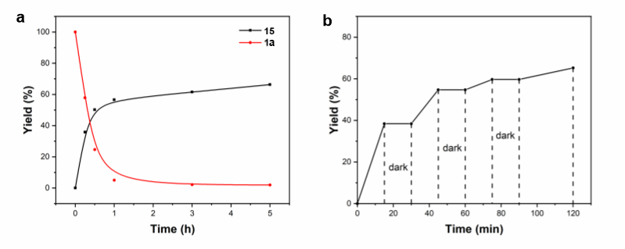
Standard conditions: 5 mol% 4CzIPN, 0.1 mmol 1a, 2.0 equiv. 2b, DMSO (0.03 M), 15 W Blue LEDs, 60 ºC, 5 h

Supplementary Figure 2. Reaction profile. a Time course of the yield of 15 and consumption of 1a during a reaction under the standard conditions. b Time course of the yield of 15 for during which the light was periodically turned on and off

Examining Functional Group Compatibility
In order to further prove the possibility of this reaction for biological application. We switched DMSO to a mixture H₂O/DMSO (1 : 4) solvent system and lowered the temperature to 37 ºC. A broad of biomolecules were selected including nucleobase, amino acid, saccharide, biotin, protein and DNA. As shown in the following figure, all reactions worked and gave desired product in the presence of these biomolecules (entries 1–9).
Supplementary Figure 3
ª Yields were determined by HPLC analysis.

Experiment procedure: The glycine 1a (0.2 mmol, 38.7 mg), N-alkoxyphthalimides 2b (0.1 mmol, 23.3 mg), 4CzIPN (5 mol%, 0.005 mmol, 4.0 mg), and DMSO (2.4 mL), H₂O (0.6 mL), were added sequentially to a 4 mL clear-colored glass vial equipped with a magnetic stir bar. After bubbled with nitrogen gas for 5 minutes to remove oxygen, the vial was sealed and exposed to blue LEDs at 37 ºC. The reaction mixture was monitored by TLC until the starting material N-alkoxyphthalimides were consumed. After the reaction was completed, 100 μL reaction mixture was diluted 100 times by sequential dilution and analyzed by HPLC with 30 μL.

In Vitro Antifungal Activities.
Each target compound was dissolved in DMSO to prepare the stock solution (10.0 g/L). The stock solution was added into the PDA medium, and the concentration of target compounds in the medium was 50.0 mg/L. Pure DMSO without the target compounds was utilized as the blank control, and boscalid was coassayed as the reference compound. Fresh dishes with a diameter of 5 mm were taken from the edge of the PDA-cultured fungi colonies and inoculated on the above three PDA media. Each treatment was tested for three replicates, and the antifungal effect was averaged. The relative inhibitory rate I (%) of all the tested compounds was calculated through the equation: I (%) = [(C − T)/(C − 5)] × 100. In this equation, I is the inhibitory rate and C and T are the colony diameter of the blank control (mm) and treatment (mm), respectively.

Mycelia growth of six crop pathogenic fungi after treating with the target compounds on PDA medium as illustrated in the figures (Supplementary Figure 4) below.

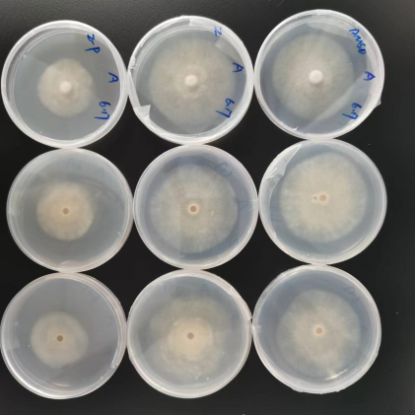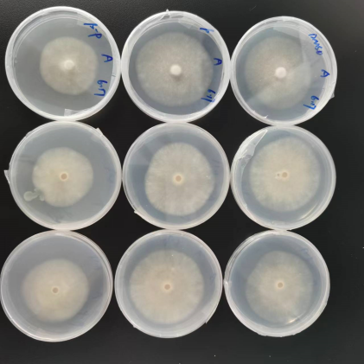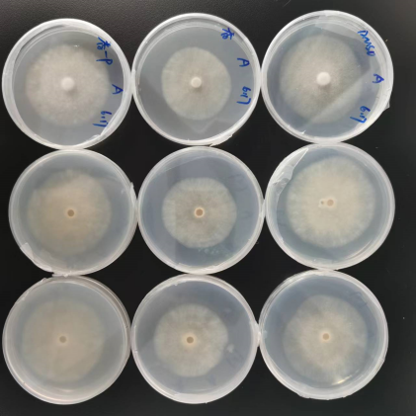
Supplementary Figure 4-1 B. cinerea

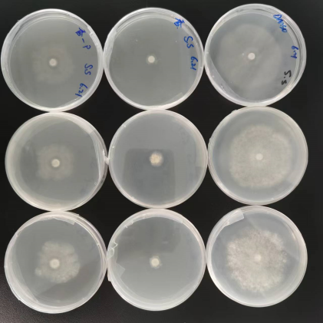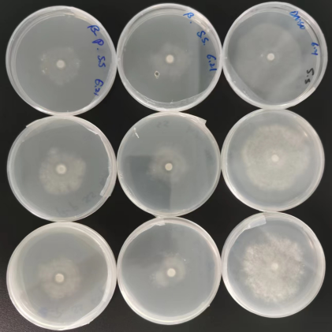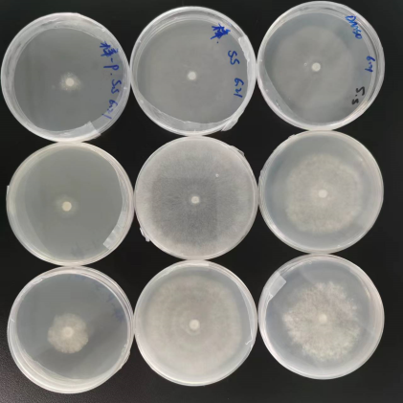
Supplementary Figure 4-2 S. sclerotiorum

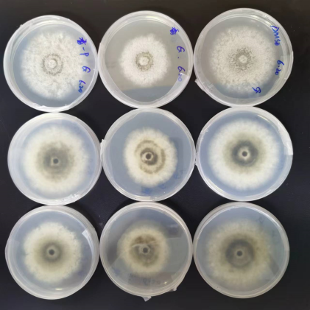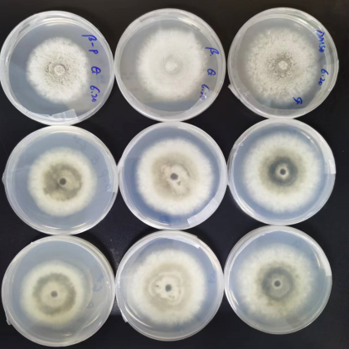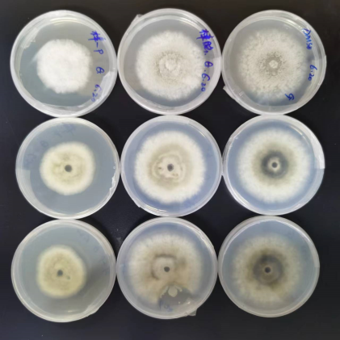
Supplementary Figure 4-3 C. orbiculare

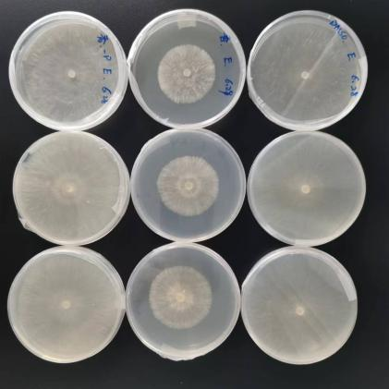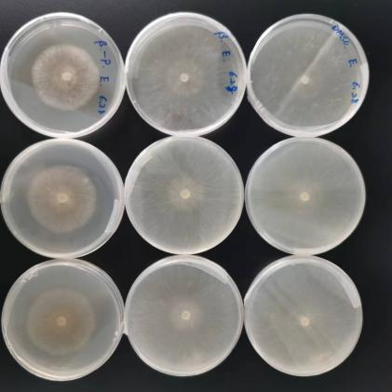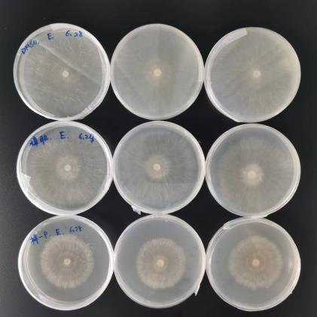
Supplementary Figure 4-4 T. cucumeris

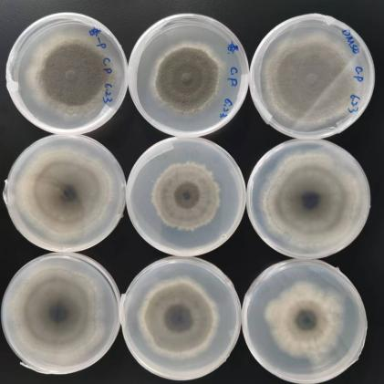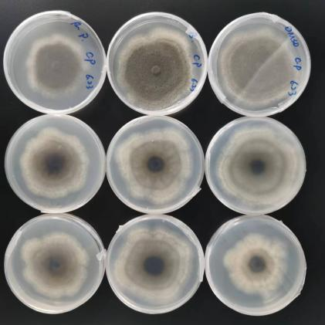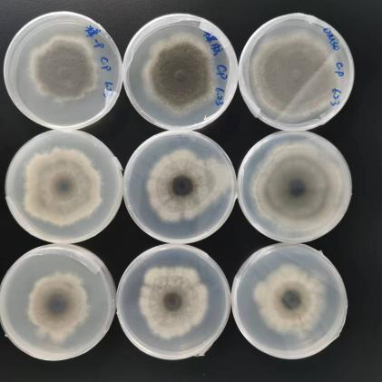
Supplementary Figure 4-5 Alternariamali

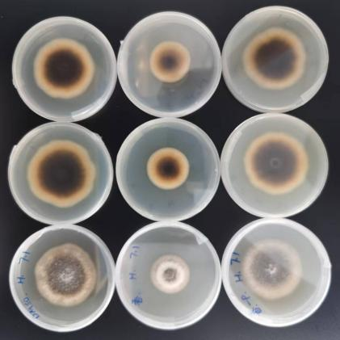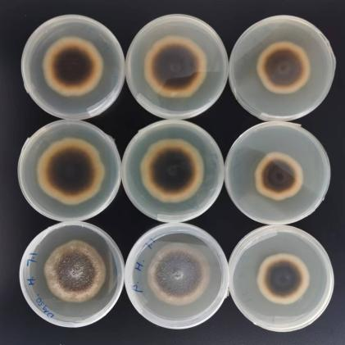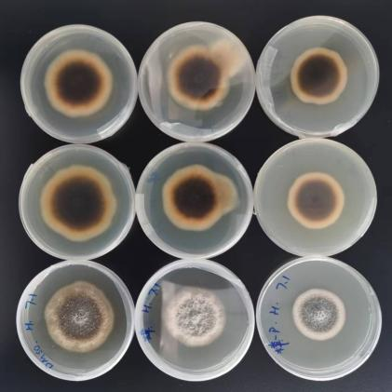
Supplementary Figure 4-6 C. paradoxa

Reference
- Wang, J. et al. Visible-light promoted α-alkylation of glycine derivatives with alkyl boronic acids. Chem. Commun. 57, 1959–1962 (2021).
- Ren, L. & Cong, H. Visible-light-driven decarboxylative alkylation of C-H bond catalyzed by dye-sensitized semiconductor. Org. Lett. 20, 3225–3228 (2018).
- Zhang, W. et al. Mesoionic pyrido[1,2-a]pyrimidinones: a novel class of insecticides inhibiting nicotinic acetylcholine receptors. Bioorganic Med. Chem. Lett. 26, 5444–5449 (2016).
- LaRochelle, M. C., Thomas, J. L. & Strickler, R. C. Reactivation of human placental 17β, 20α-hydroxysteroid dehydrogenase: affirmation of affinity labeling principles. Steroids 43, 209–217 (1984).
- Zhu, X., Lin, Y., Sun, Y., Beard, M. C. & Yan, Y. Lead-halide perovskites for photocatalytic α-alkylation of aldehydes. J. Am. Chem. Soc. 141, 733–738 (2019).
- Jerezano, A. V et al. Iodine-mediated one-pot synthesis of indoles and 3-dimethylaminoindoles via annulation of enaminones. Arkivoc 2014, 18–53 (2013).
- Wang, C. et al. Visible-light-driven, copper-catalyzed decarboxylative C(sp³)−H alkylation of glycine and peptides. Angew. Chem. Int. Ed. 57, 15841–15846 (2018).
- Zhang, J. et al. Donor–acceptor complex enables alkoxyl radical generation for metal-free C(sp³)–C(sp³) cleavage and allylation/alkenylation. Angew. Chem. In. Ed. 129, 12793–12797 (2017).
- Lei, X., Feng, J., Guo, Q., Xu, C. & Shi, J. Base-promoted formal [3 + 2] cycloaddition of α-halohydroxamates with carbon disulfide to synthesize polysubstituted Rhodanines. Org. Lett. 24, 2837–2841 (2022).
- Xu, P., Qian, B., Hu, B. & Huang, H. Palladium-catalyzed tandem hydrocarbonylative lactamization and cycloaddition reaction for the construction of bridged polycyclic lactams. Org. Lett. 24, 147–151 (2022).
- Xu, X., Liu, Y. & Park, C. M. Rhodium(III)-catalyzed intramolecular annulation through C-H activation: Total synthesis of (±)-antofine, (±)-septicine, (±)-tylophorine, and rosettacin. Angew. Chem. Int. Ed. 51, 9372–9376 (2012).
- Shi, J. L., Wang, Z., Zhang, R., Wang, Y. & Wang, J. Visible-light-promoted ring-opening alkynylation, alkenylation, and allylation of cyclic hemiacetals through β-scission of alkoxy radicals. Chem. A Eur. J. 25, 8992–8995 (2019).
- Shu, C., Madhavachary, R., Noble, A. & Aggarwal, V. K. Photoinduced fragmentation borylation of cyclic alcohols and hemiacetals. Org. Lett. 22, 7213–7218 (2020).
- Cong, F., Lv, X. Y., Day, C. S. & Martin, R. Dual catalytic strategy for forging sp²-sp³ and sp³-sp³ architectures via β-scission of aliphatic alcohol derivatives. J. Am. Chem. Soc. 142, 20594–20599 (2020).
- Haibach, M. C., Stoltz, B. M. & Grubbs, R. H. Catalytic reduction of alkyl and aryl bromides using propan-2-ol. Angew. Chem. Int. Ed. 56, 15123–15126 (2017).
- Dixon, D. D., Lockner, J. W., Zhou, Q. & Baran, P. S. Scalable, divergent synthesis of meroterpenoids via ‘borono- sclareolide’. J. Am. Chem. Soc. 134, 8432–8435 (2012).
- Braun, J. C. & Fisher, G. S. Hydroboration of β-pinene. Tetrahedron Lett. 1, 9–11 (1960).
- Dhoro, F., Kristensen, T. E., Stockmann, V., Yap, G. P. A. & Tius, M. A. Asymmetric amine-intercepted Nazarov cyclization. J. Am. Chem. Soc. 129, 7256–7257 (2007)
- Ritter, C. et al. Bioorthogonal enzymatic activation of caged compounds. Angew. Chem. Int. Ed. 54, 13440–13443 (2015).
- Ong, D. Y. et al. Controlled reduction of carboxamides to alcohols or amines by zinc hydrides. Angew. Chem. Int. Ed. 58, 4992–4997 (2019).
- Maercker, A. & Theysohn, W. Versuche zur Umlagerung von 2‐cyclopropyl‐äthyl‐anionen. Justus Liebigs Ann. Chem. 759, 132–157 (1972).
- Xia, Q. et al. Visible light-driven α-alkylation of N-aryl tetrahydroisoquinolines initiated by electron donor-acceptor complexes. Org. Lett. 22, 7290–7294 (2020).
- Nguyen, H. N. et al. Synthesis of 4-substituted chlorophthalazines, dihydrobenzoazepinediones, 2-pyrazolylbenzoic acid, and 2-pyrazolylbenzohydrazide via 3-substituted 3-hydroxyisoindolin-1-ones. J. Org. Chem. 77, 3887–3906 (2012).
- Kang, T., Kim, H., Kim, J. G. & Chang, S. Synthesis of 1,2-amino alcohols via catalytic C-H amidation of sp³ methyl C-H bonds. Chem. Commun. 50, 12073–12075 (2014).
- Dubey, N., Sharma, P. & Kumar, A. Clay-supported Cu(II) catalyst: an efficient, heterogeneous, and recyclable catalyst for synthesis of 1,4-disubstituted 1,2,3-triazoles from alloxan-derived terminal alkyne and substituted azides using click chemistry. Synth. Commun. 45, 2608–2626 (2015).
- Xuan, J. et al. Redox-neutral α-allylation of amines by combining palladium catalysis and visible-light photoredox catalysis. Angew. Chem. Int. Ed. 54, 1625–1628 (2015).

¹H NMR and ¹³C NMR Spectra
7
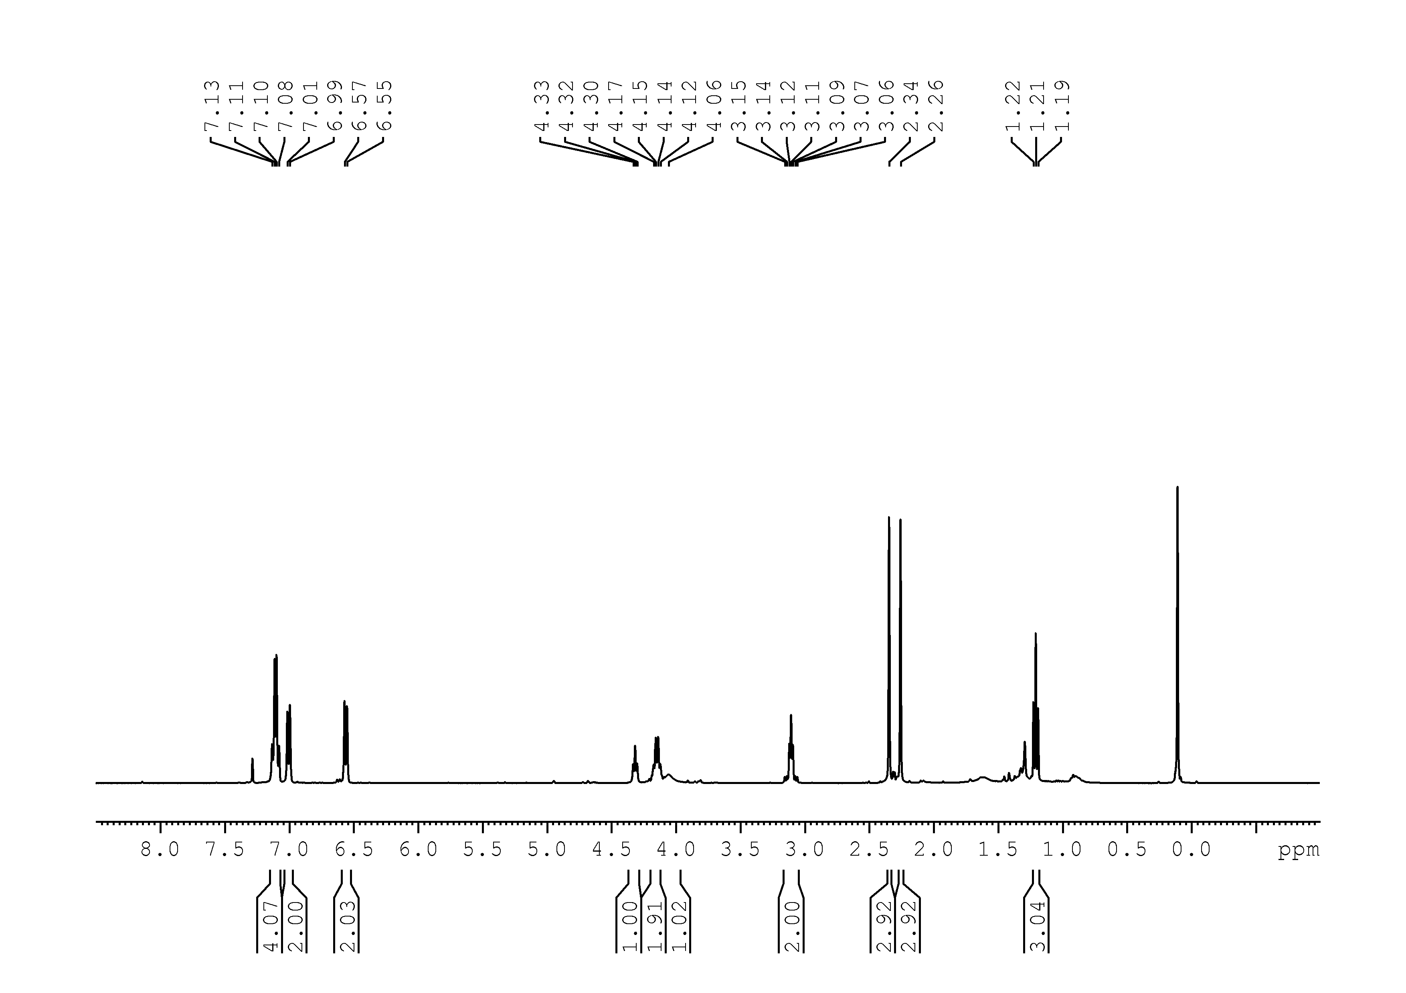
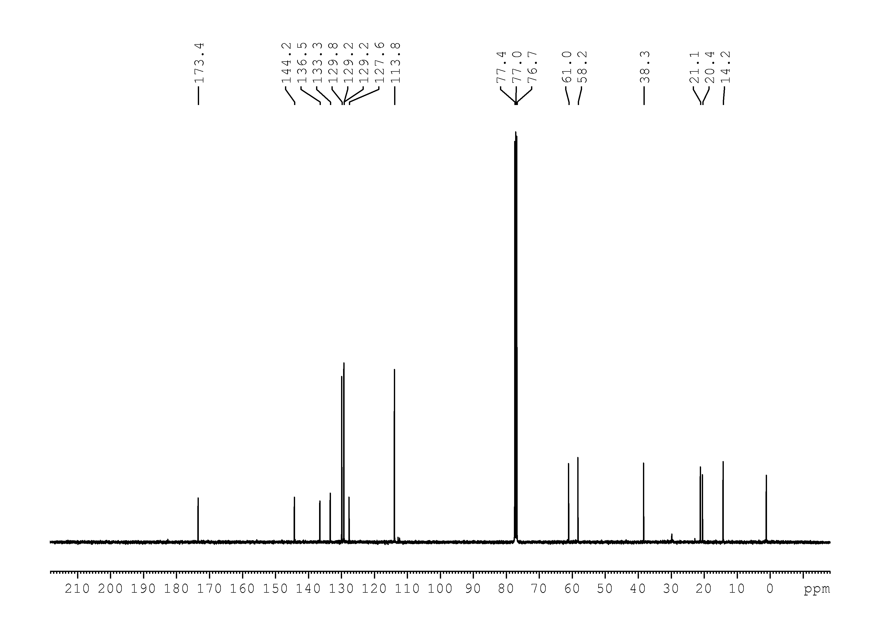
9
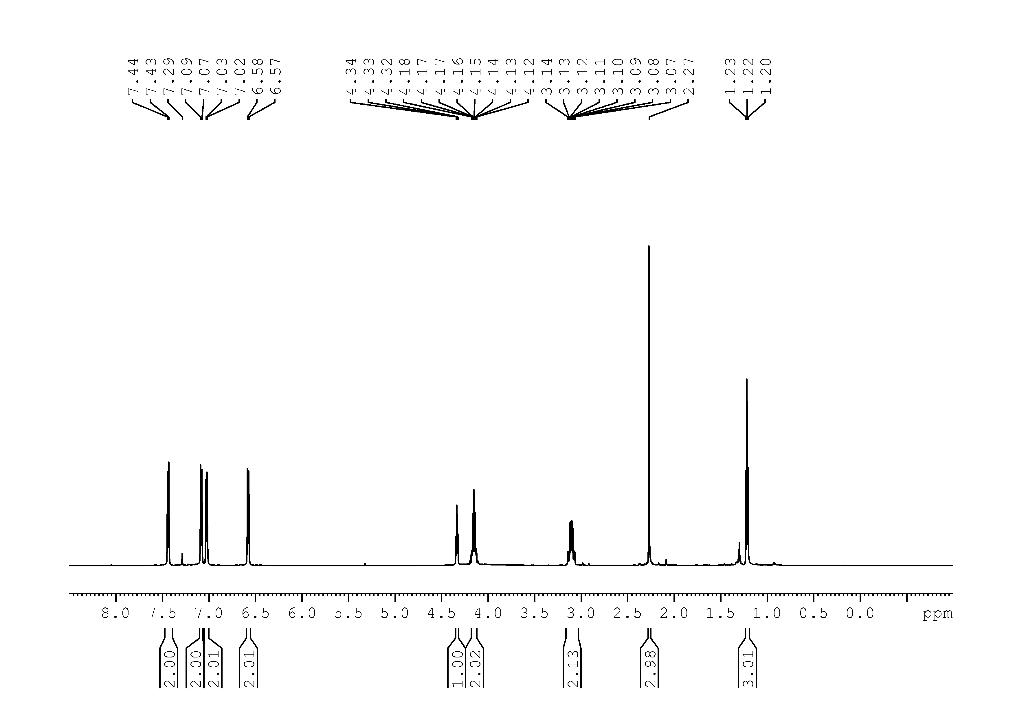
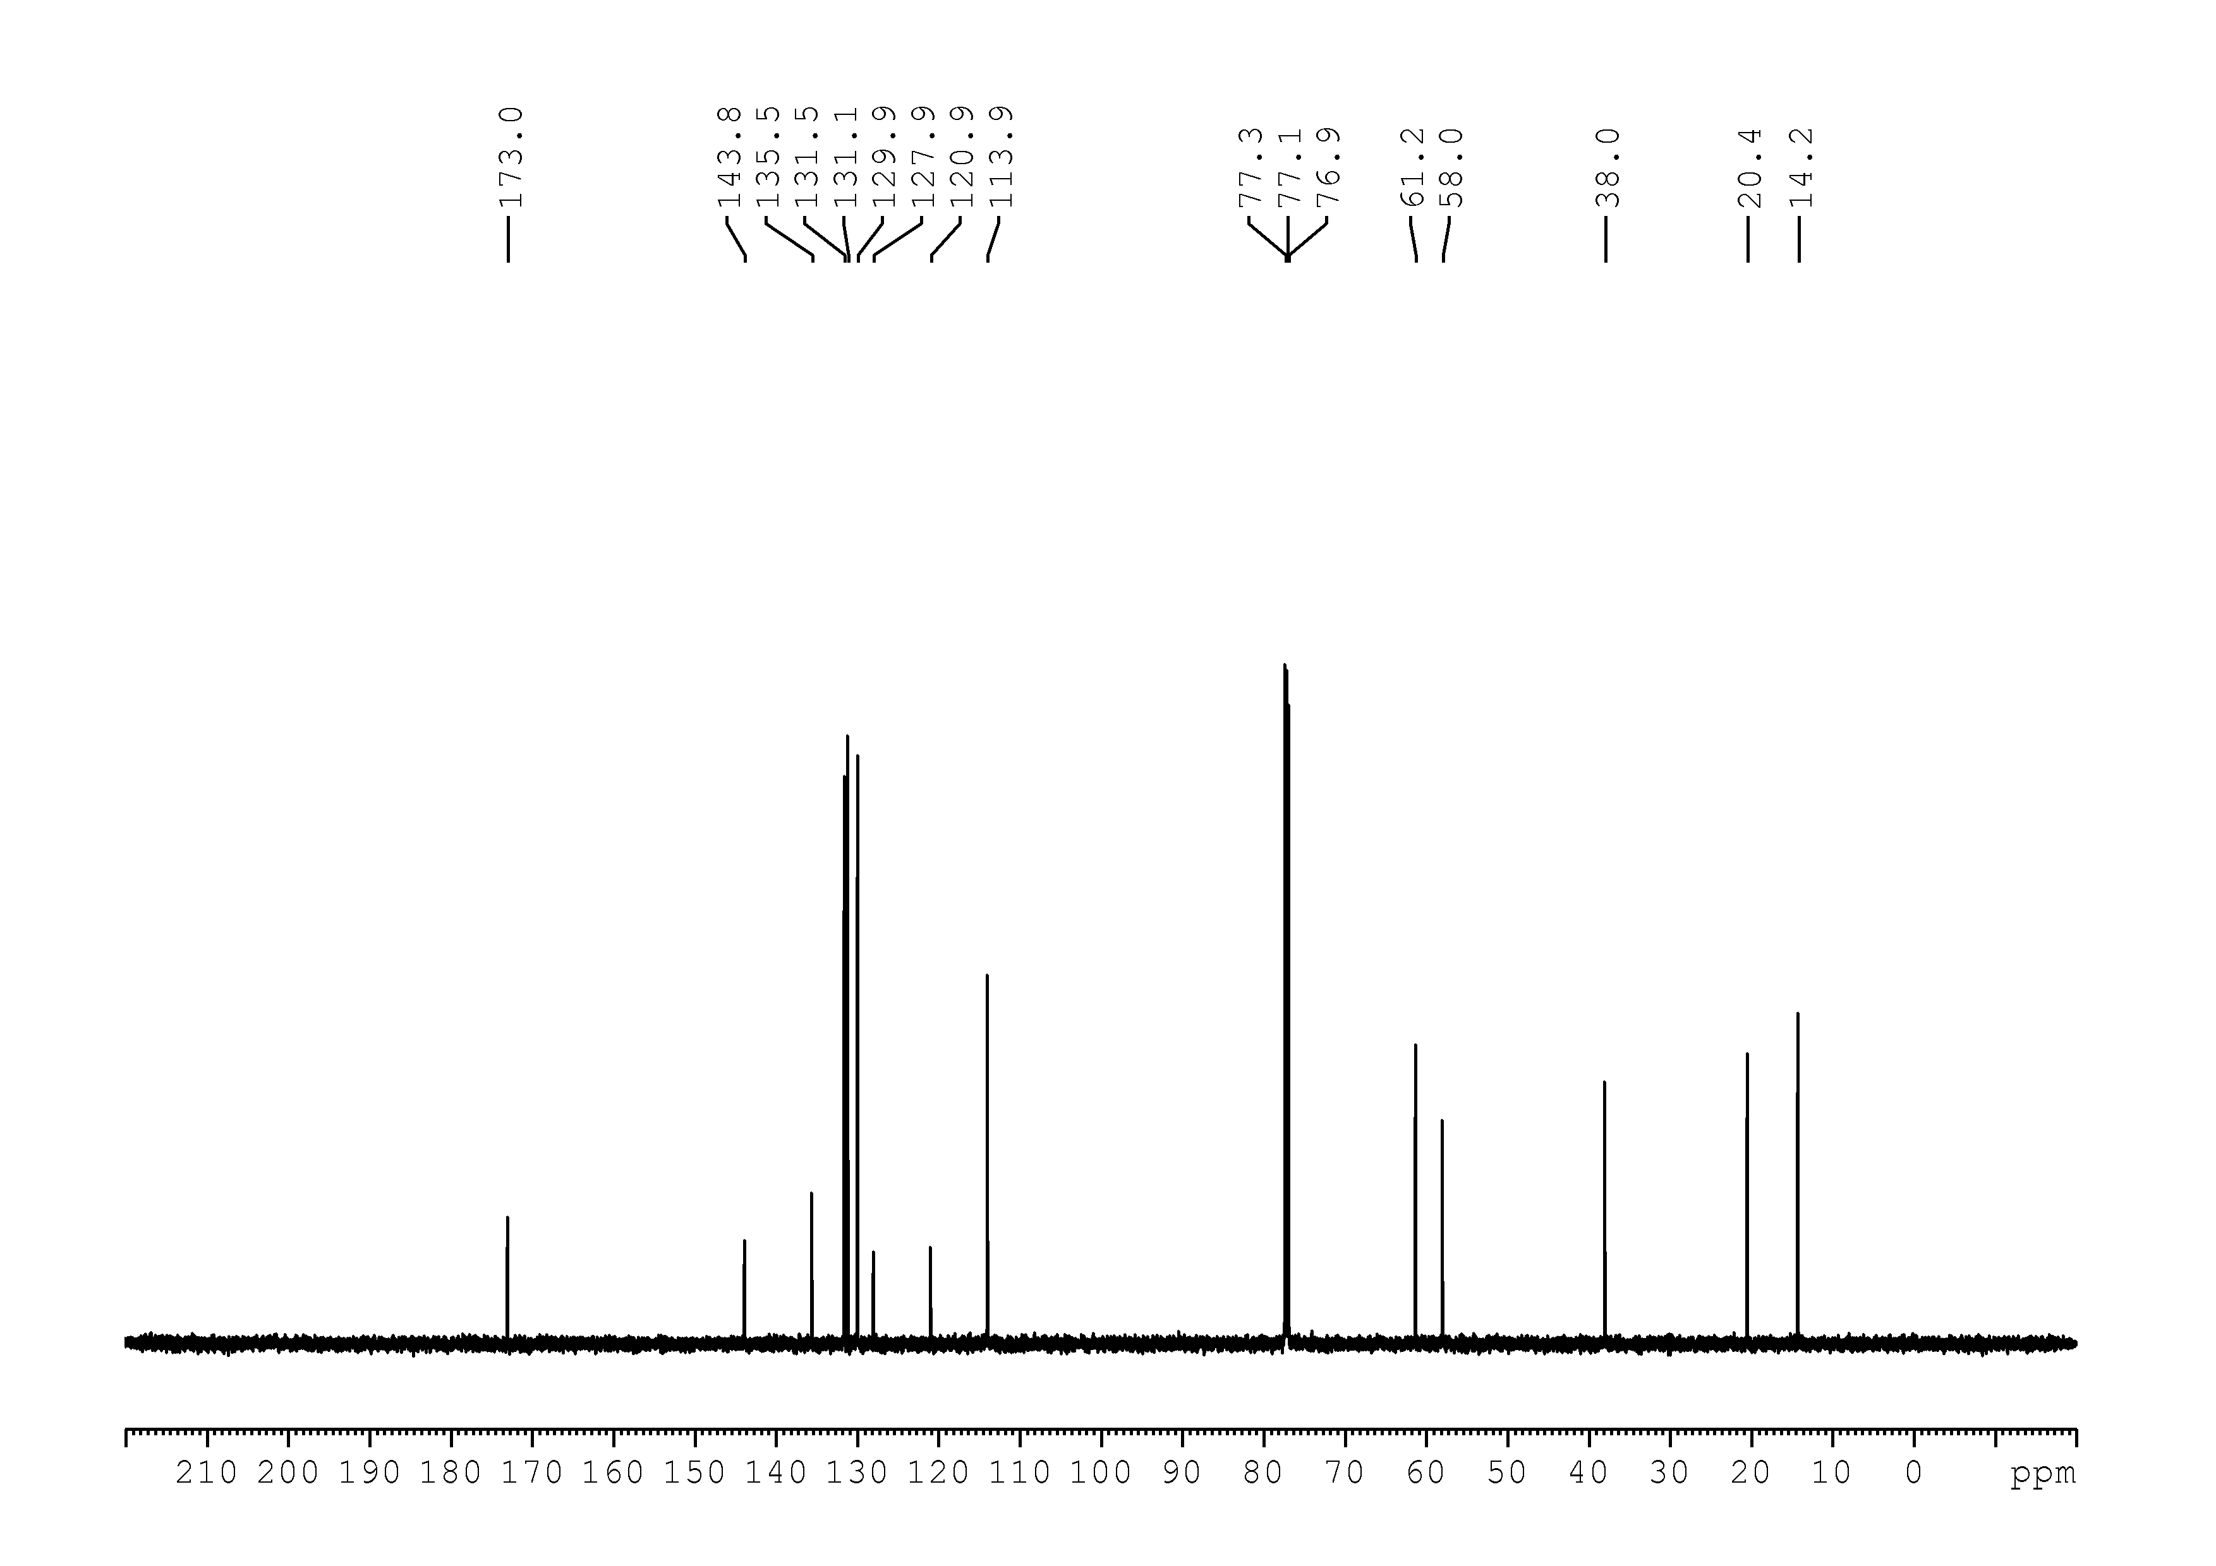
10
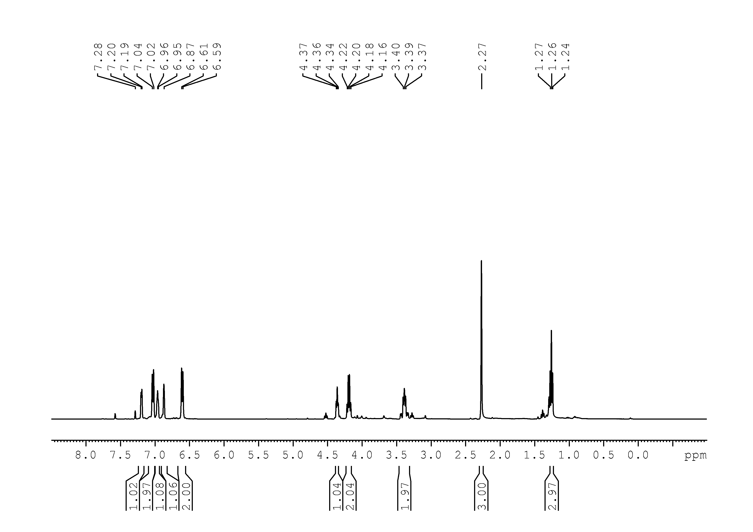
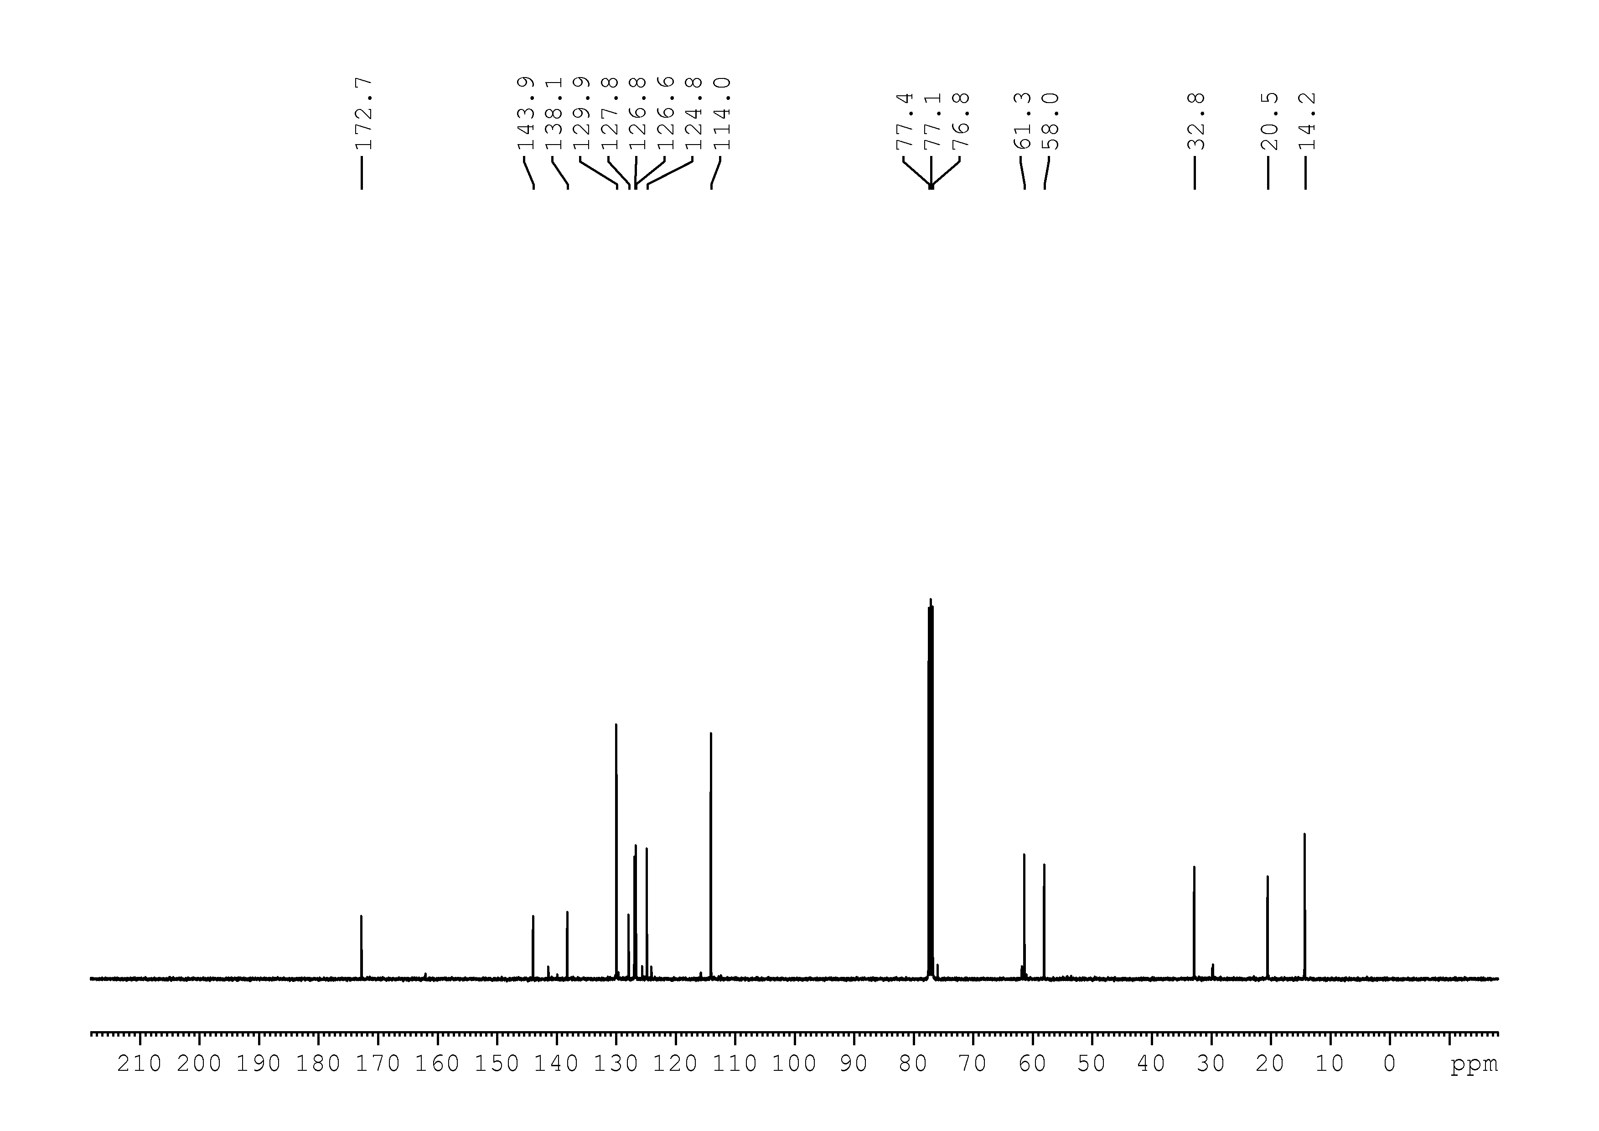
11
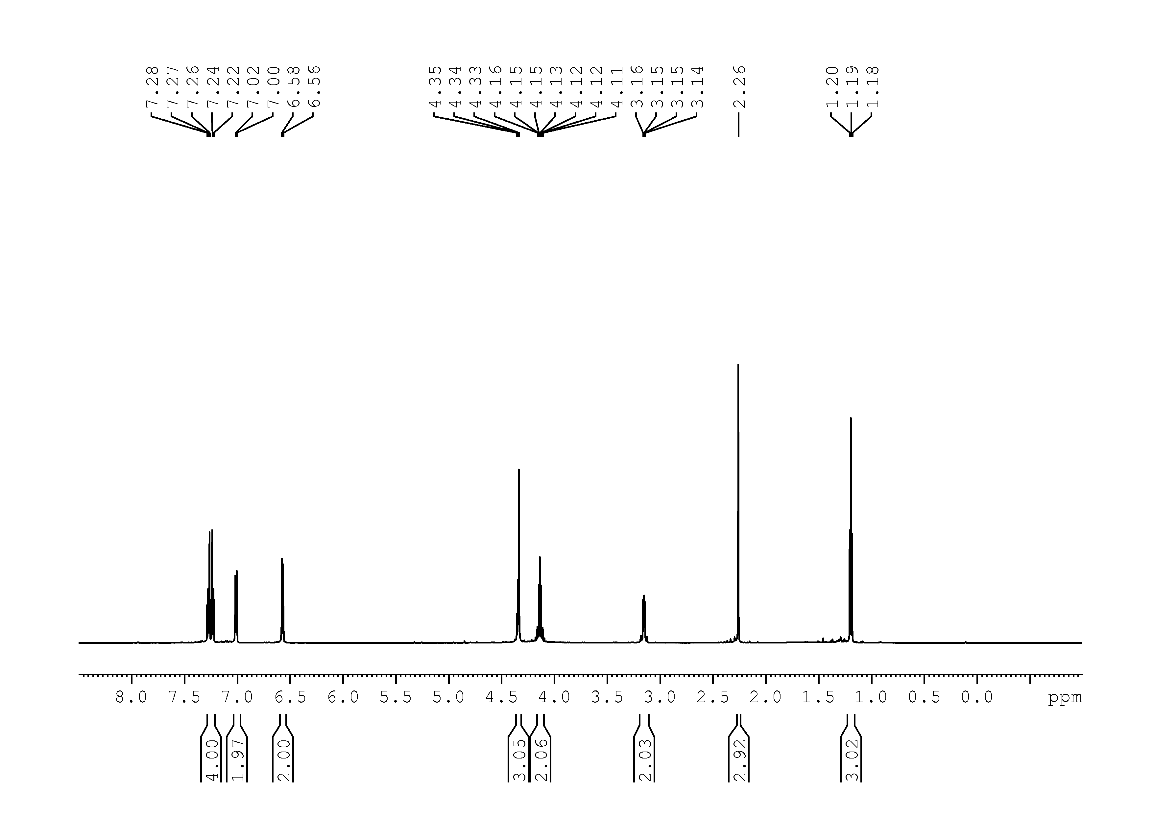
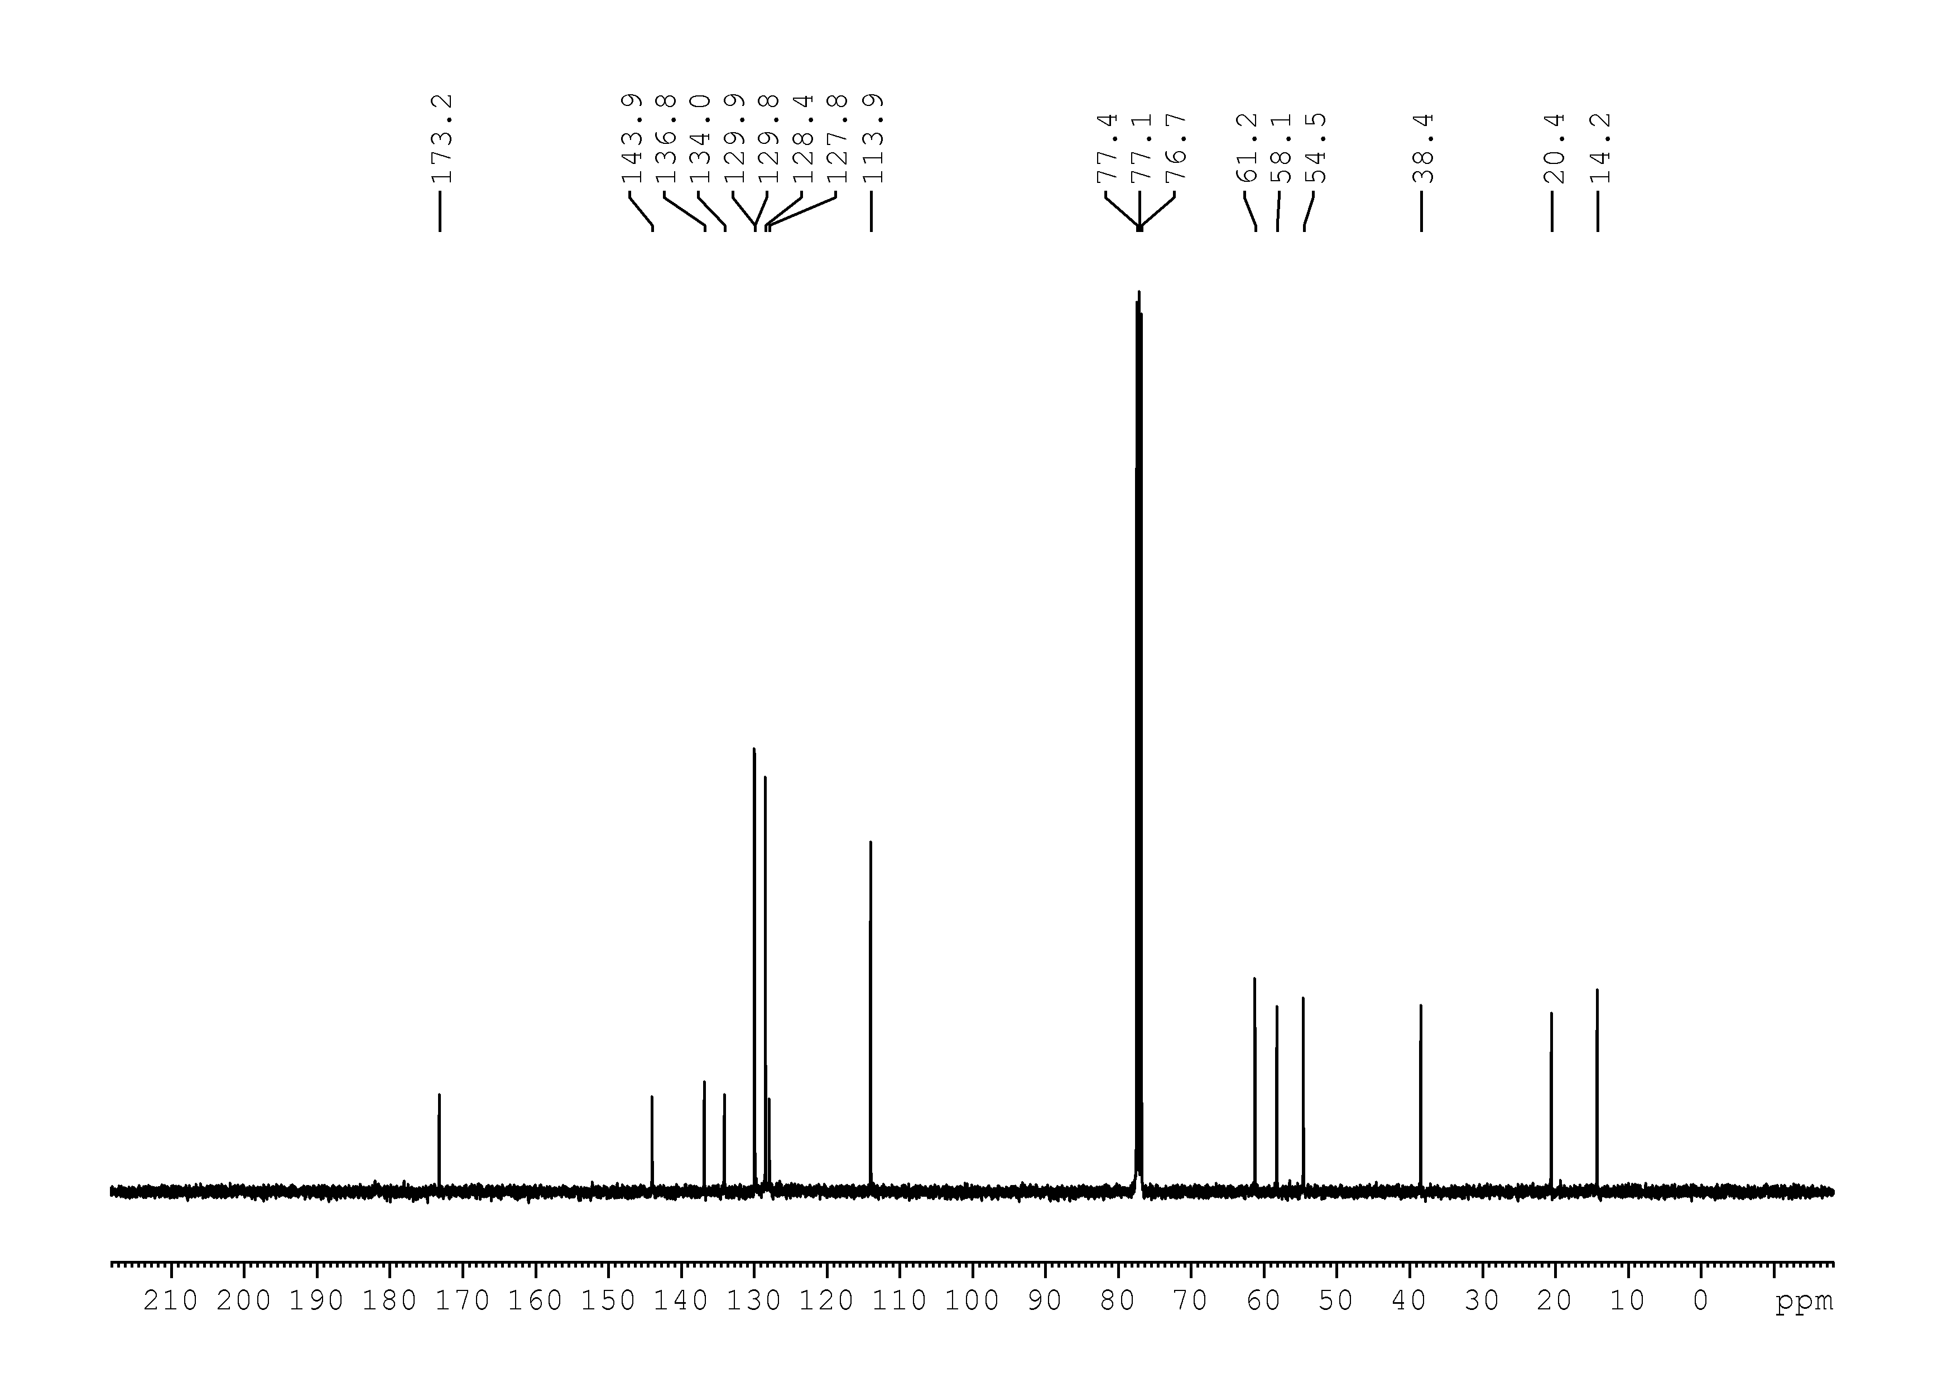
12
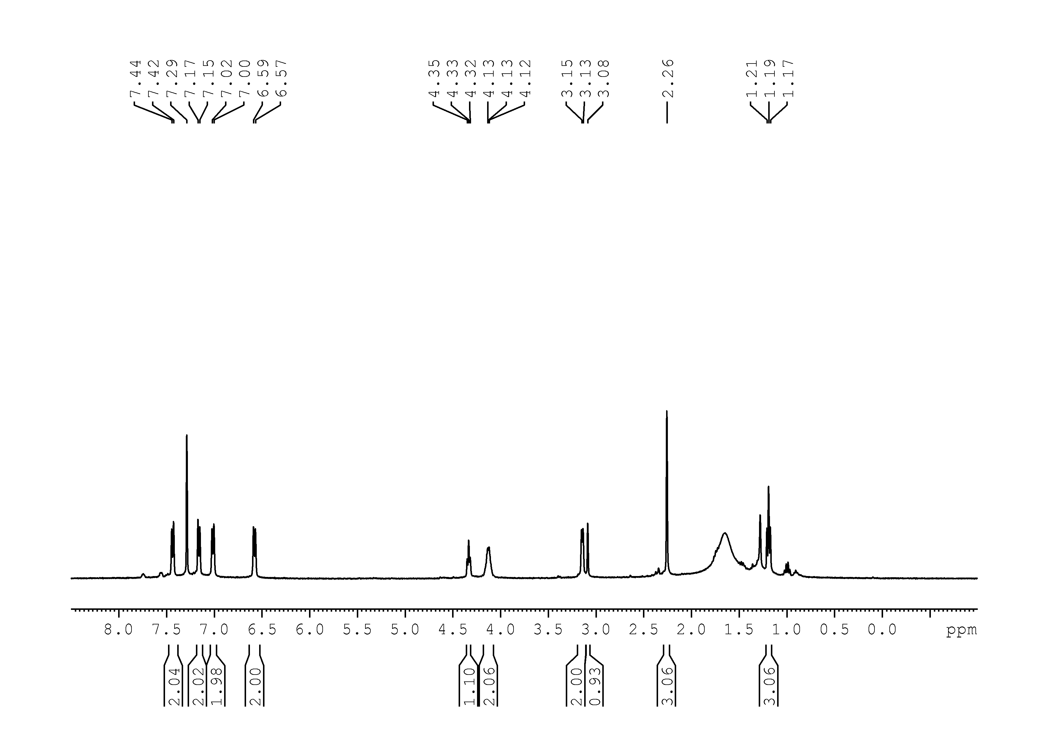
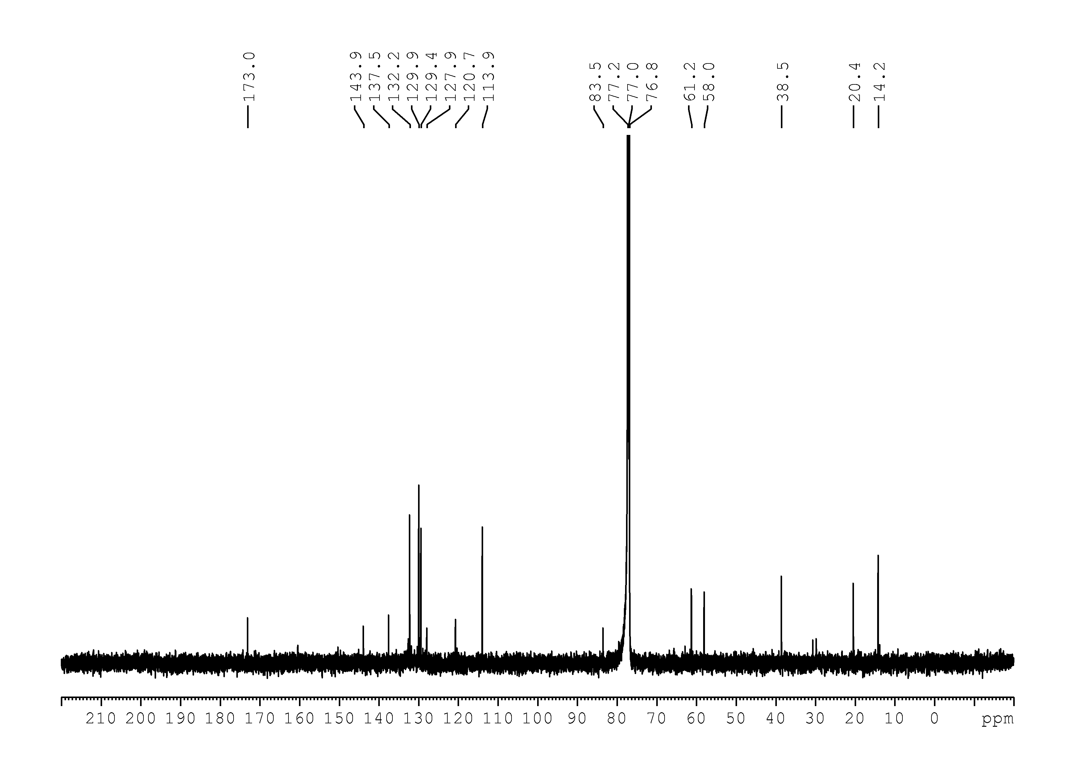
13
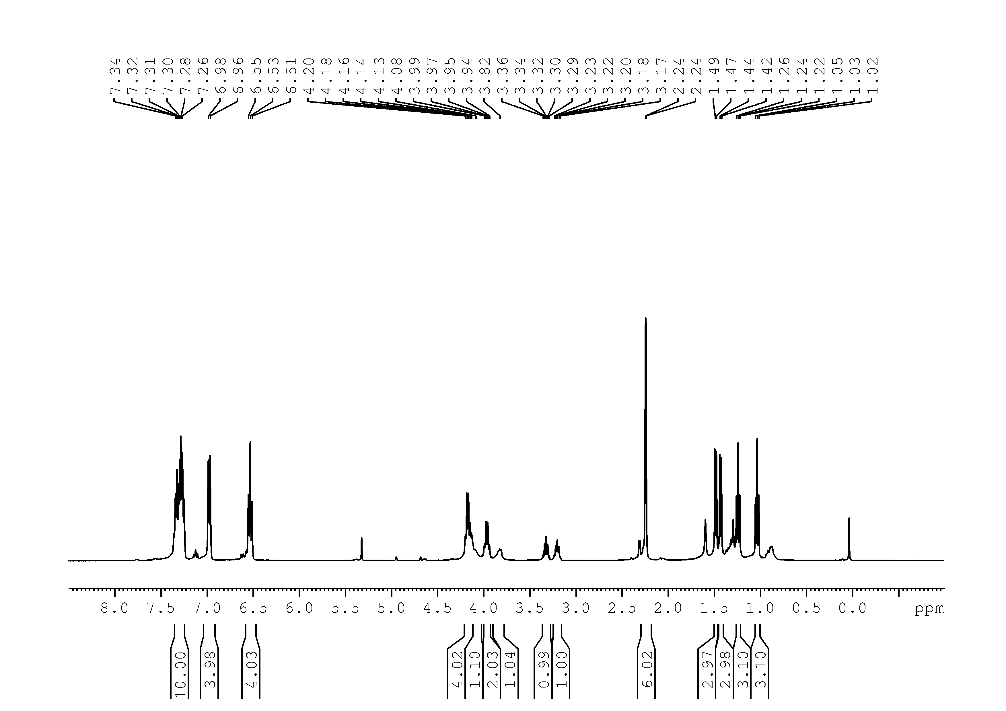
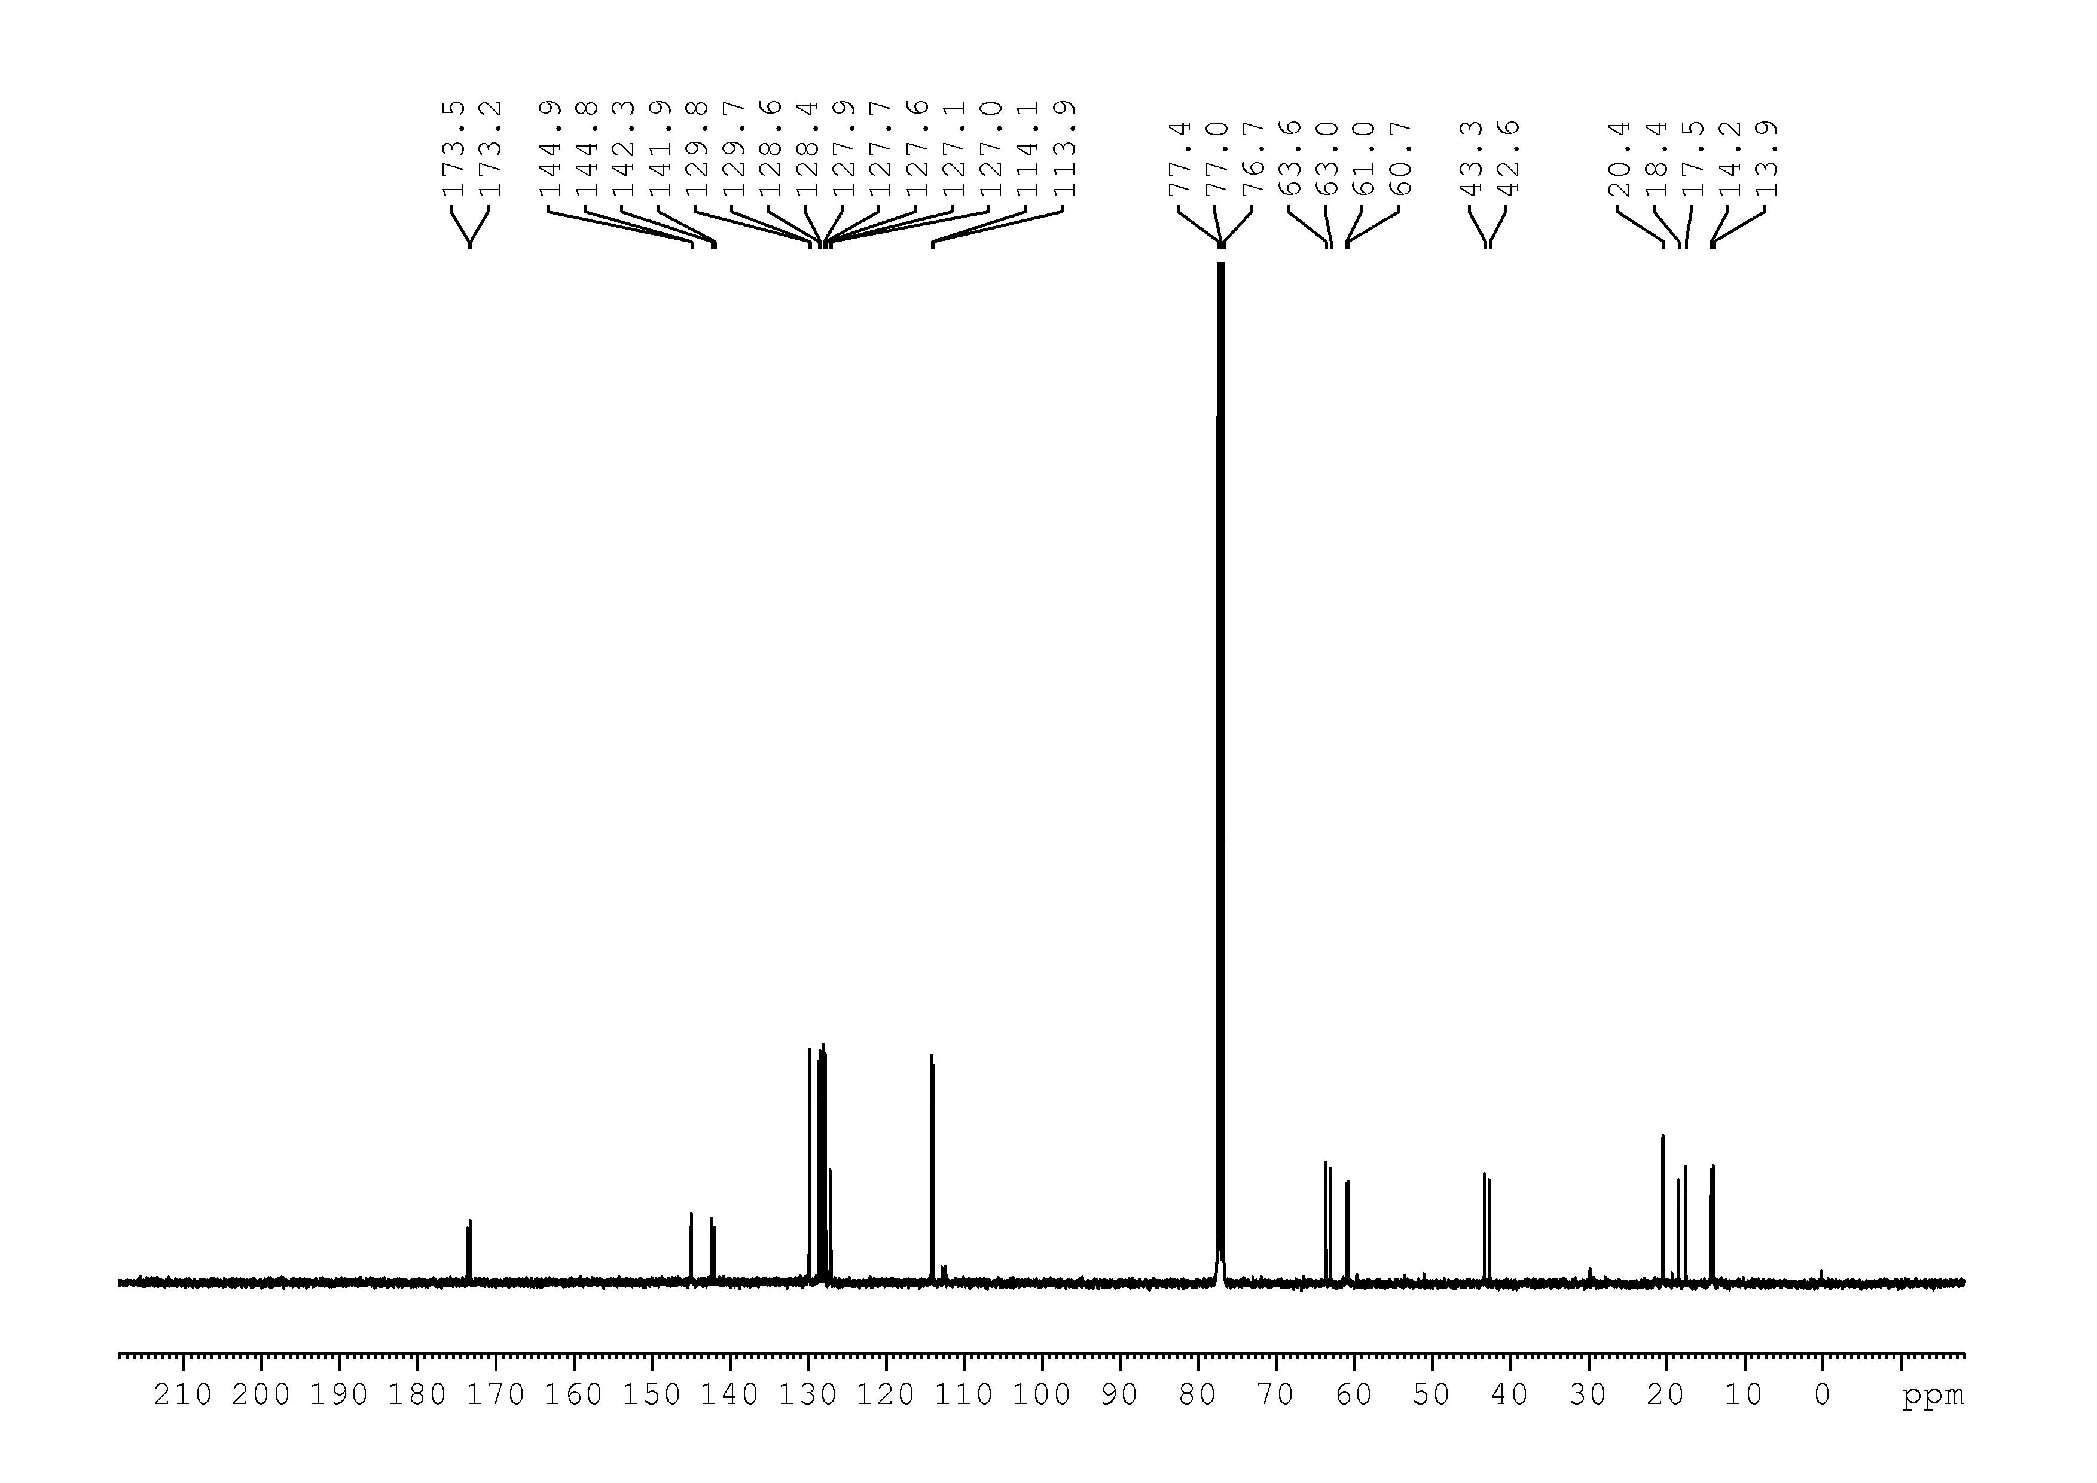
14
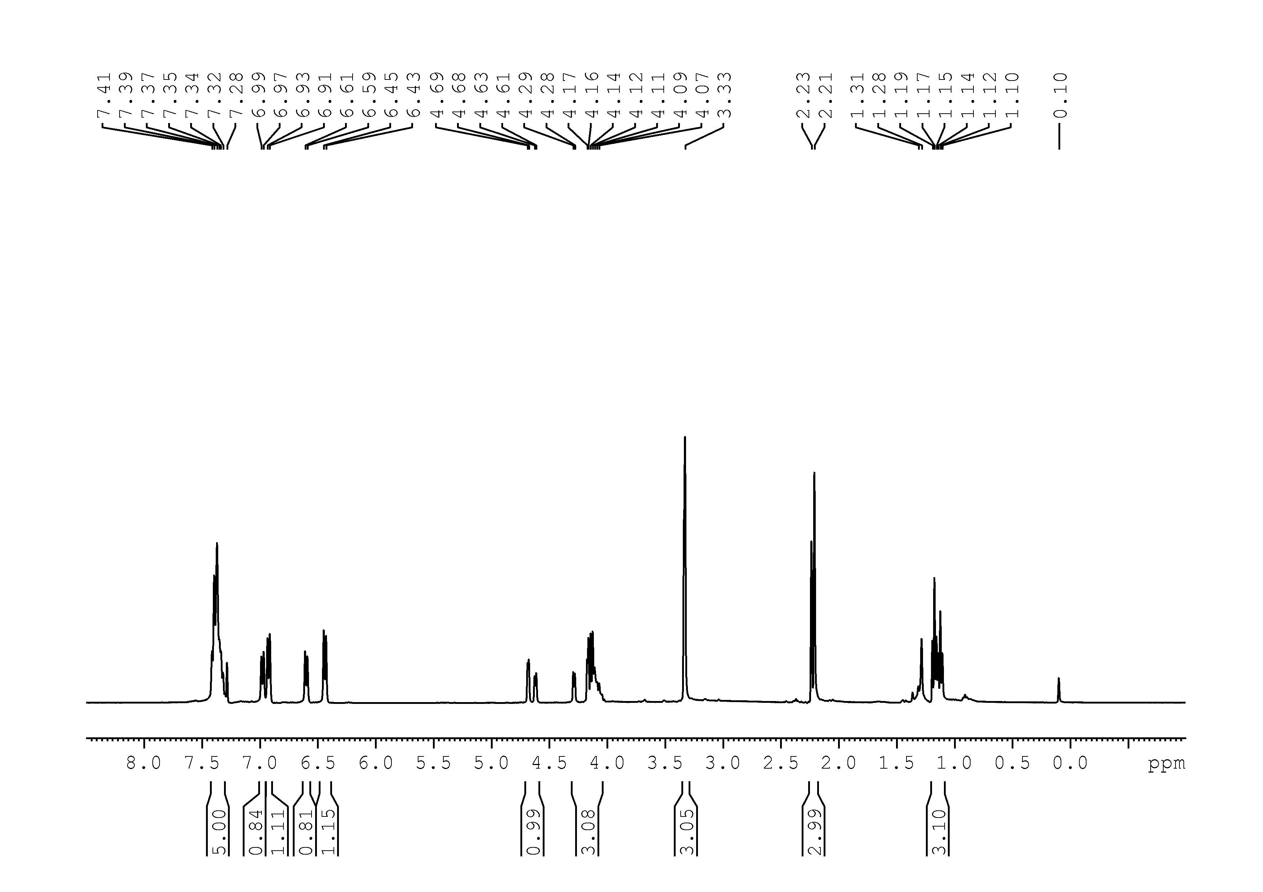
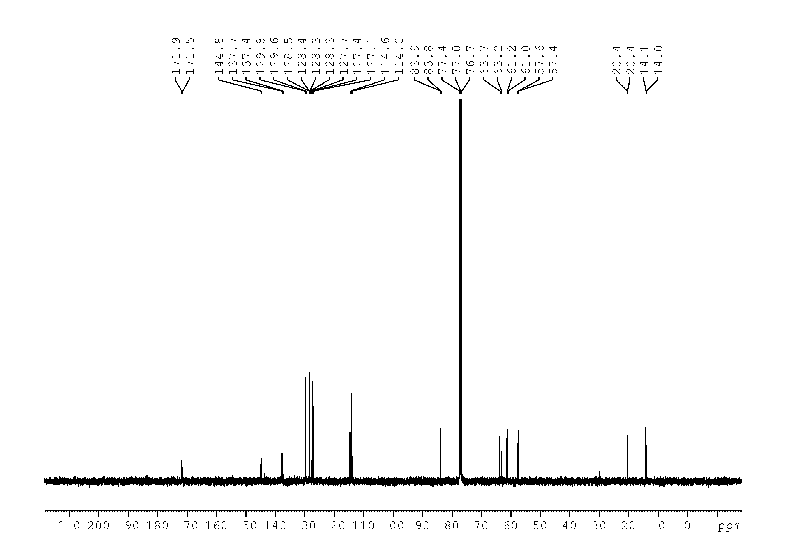

17
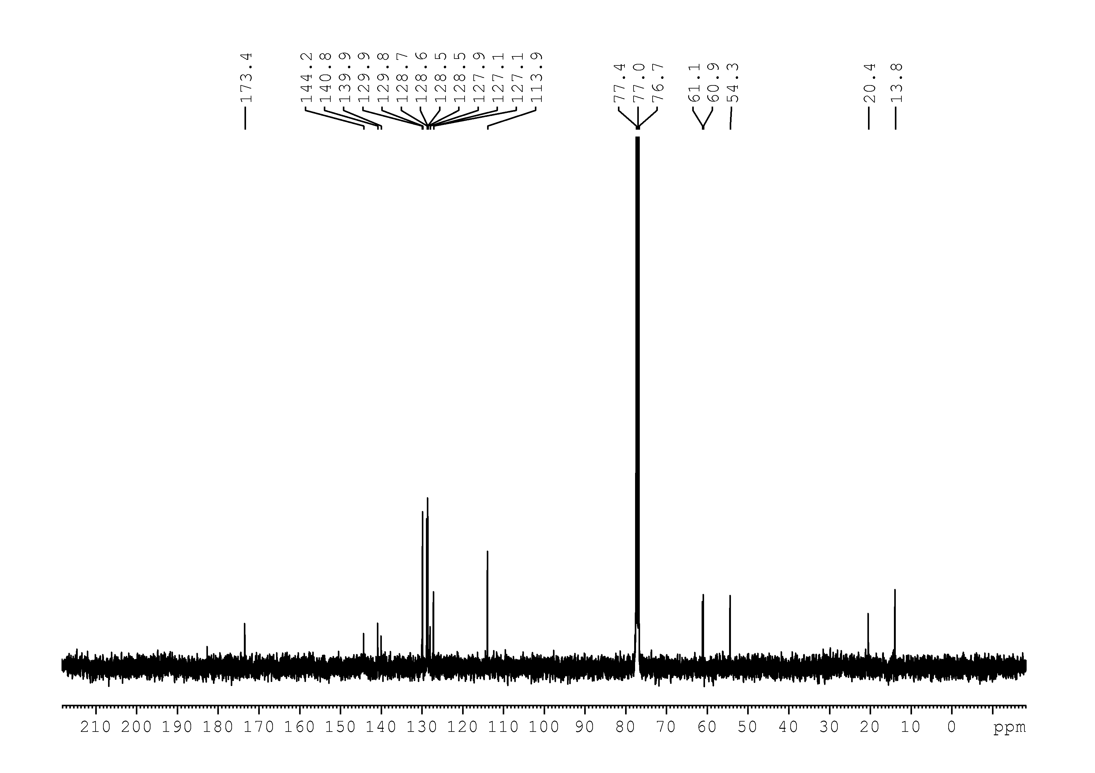
18
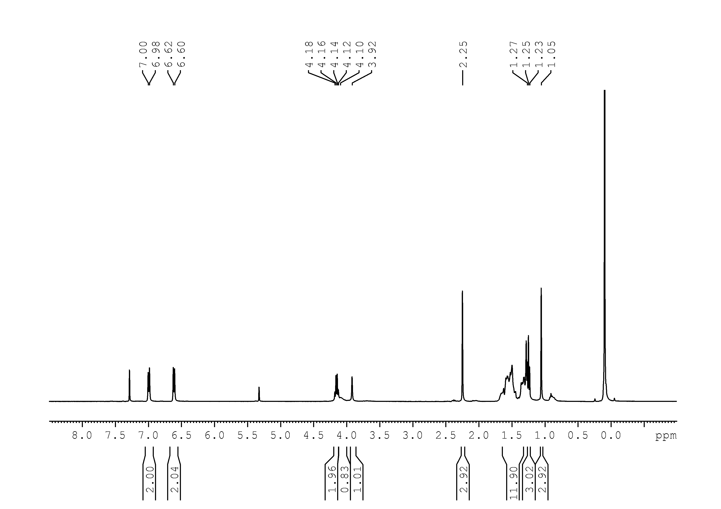
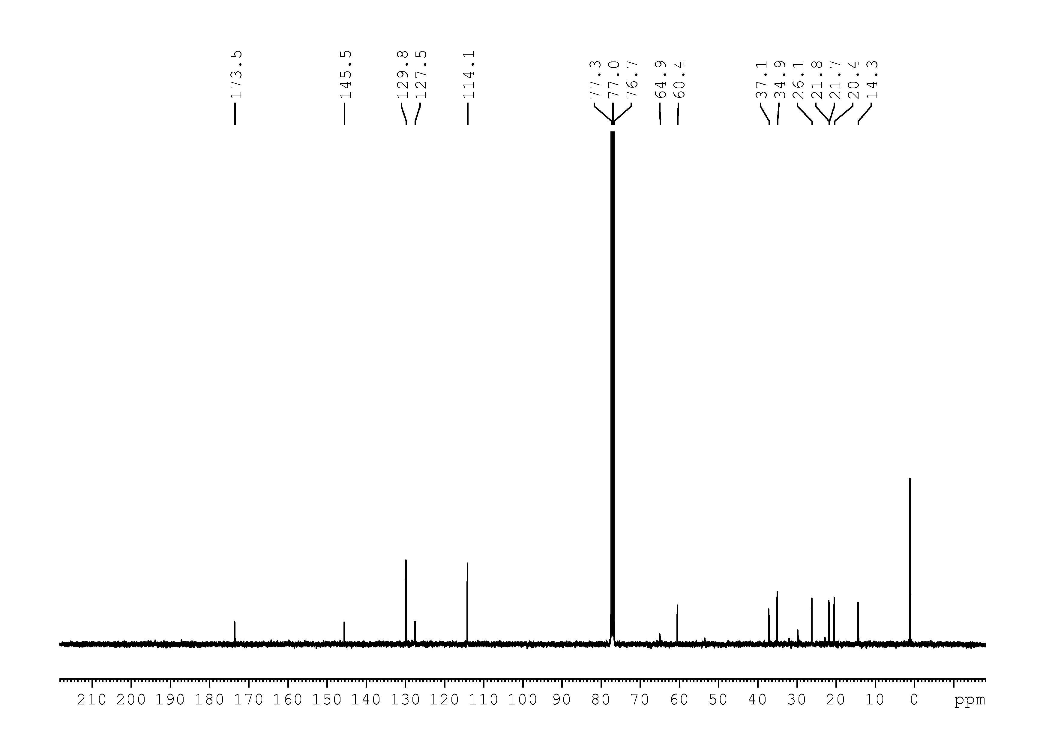
19
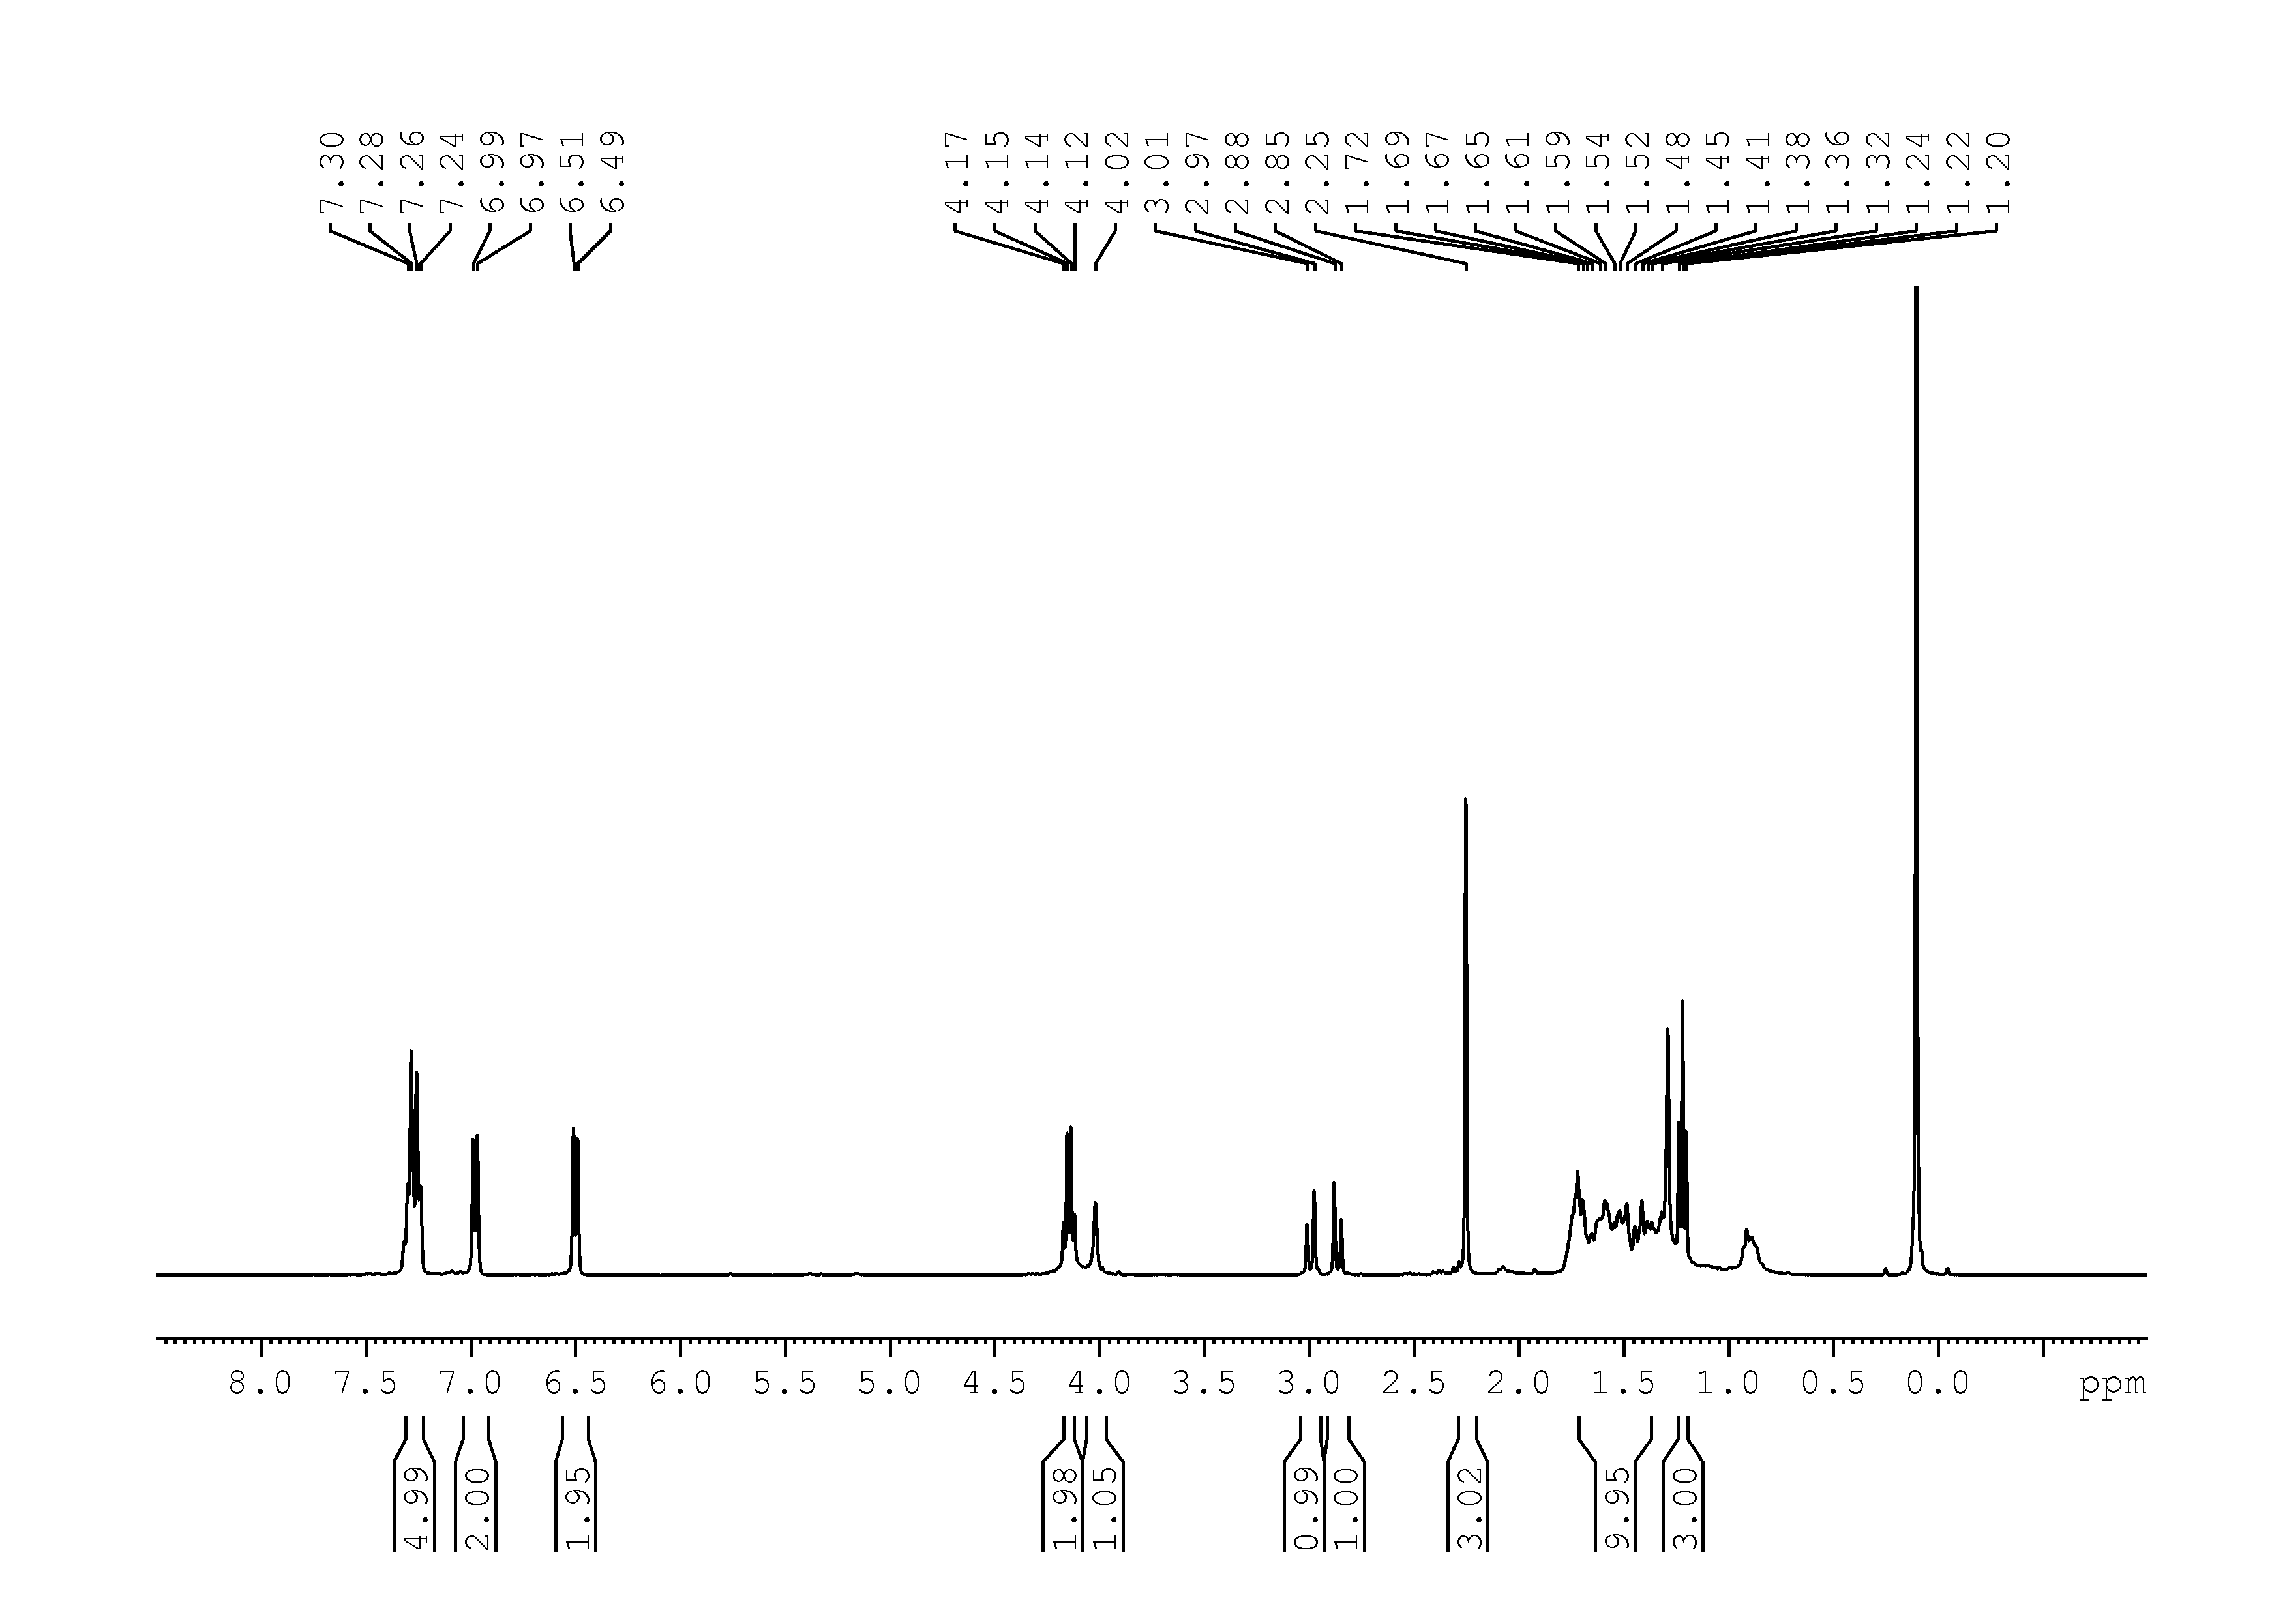
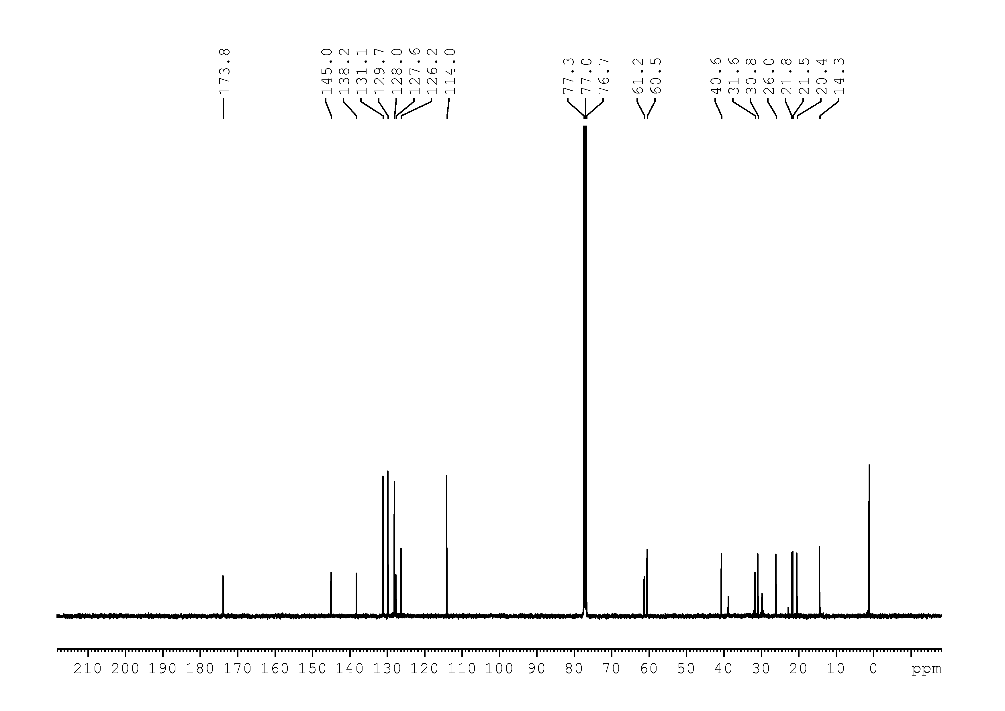
20
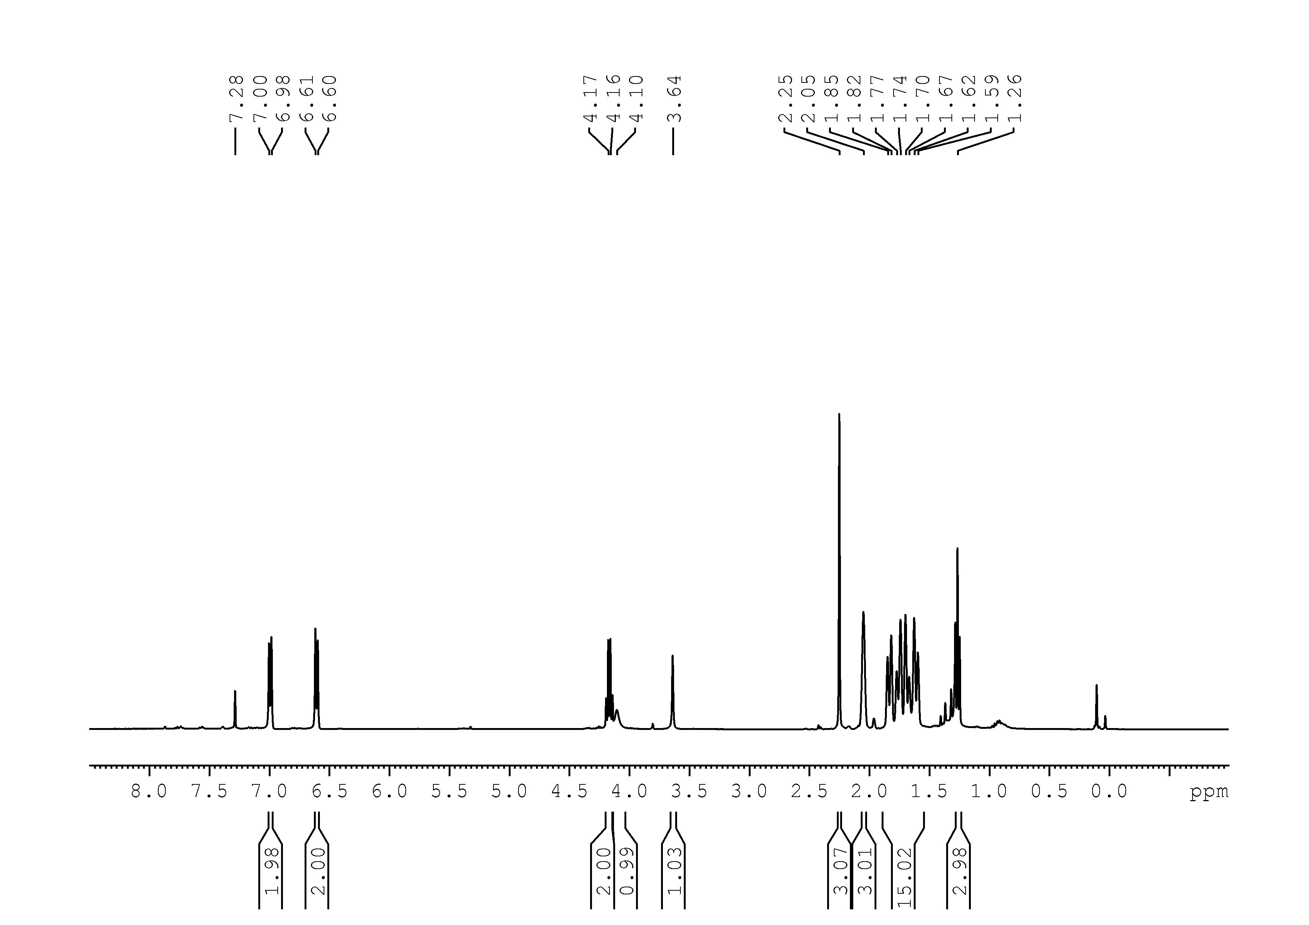
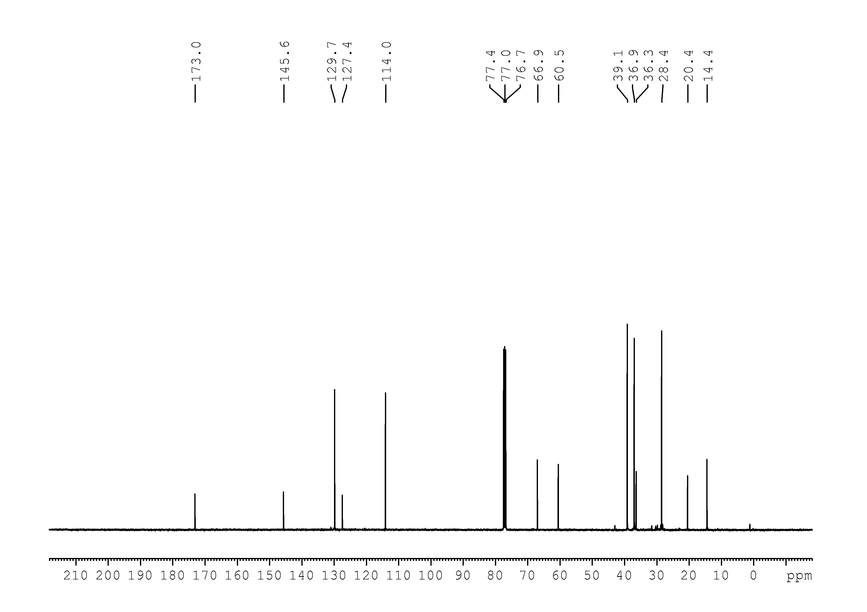

21
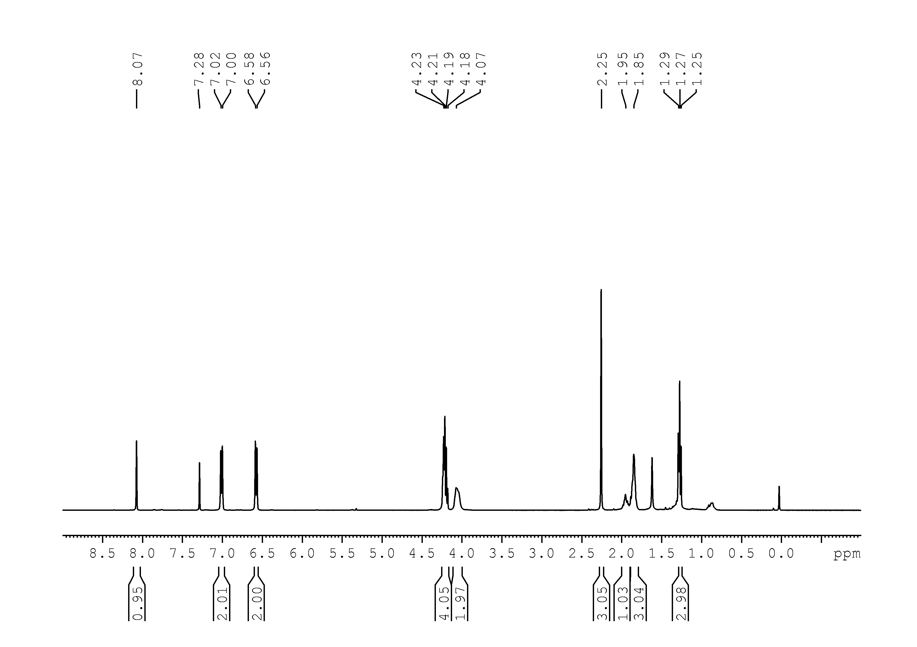
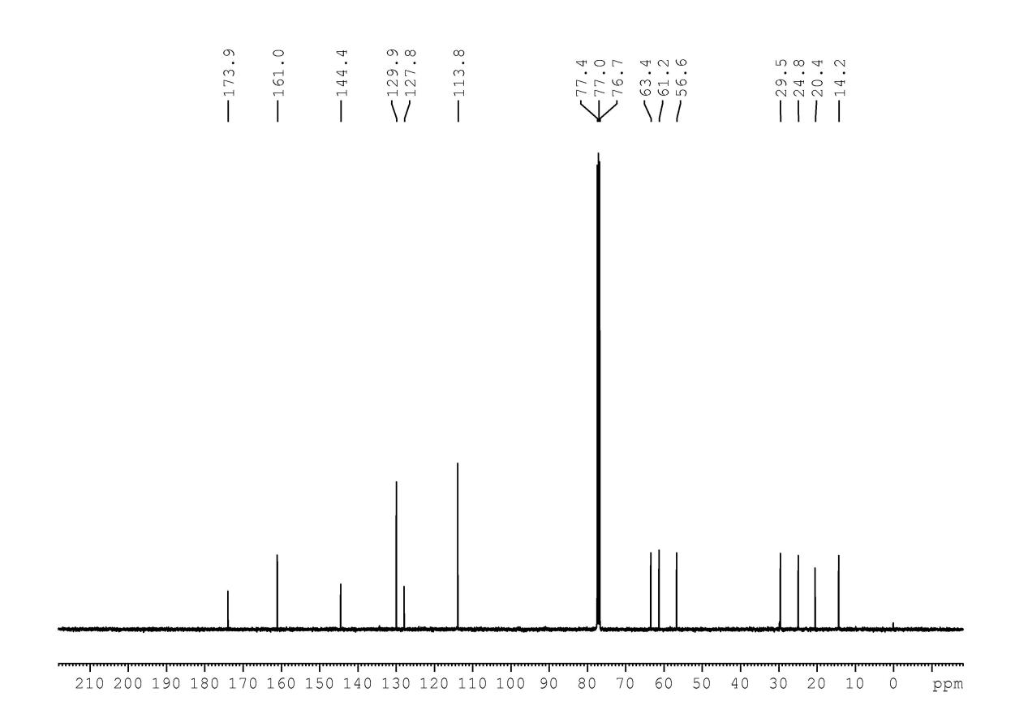

22
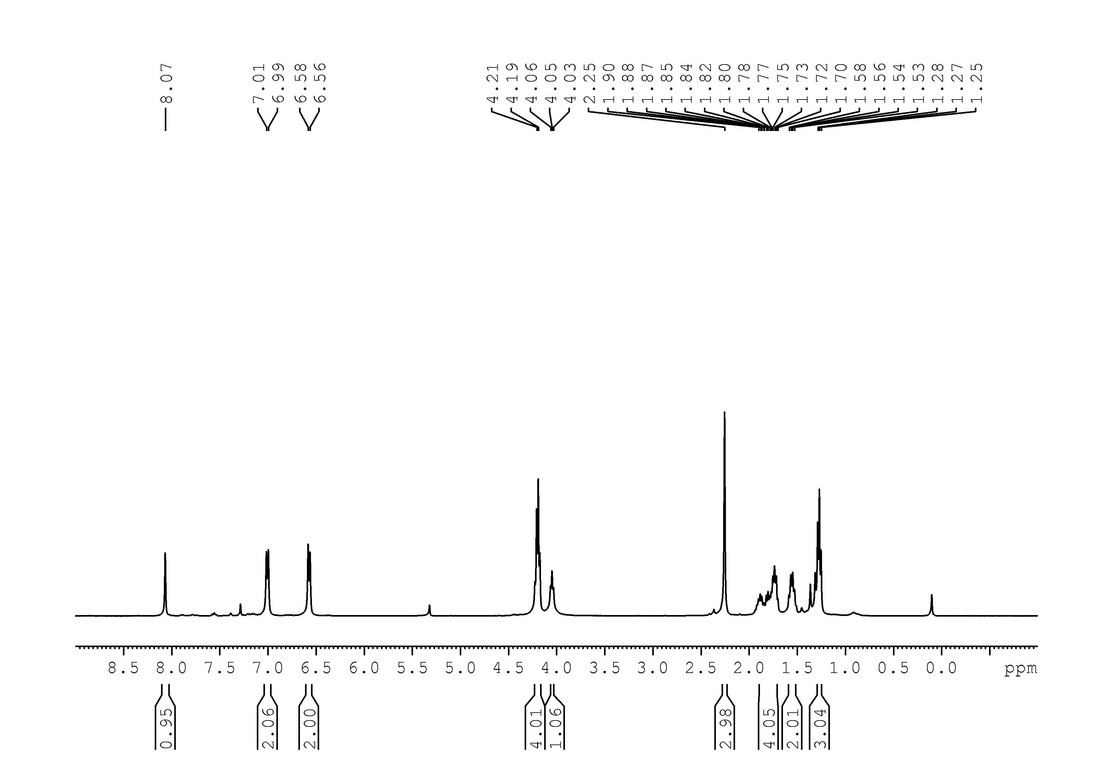

23
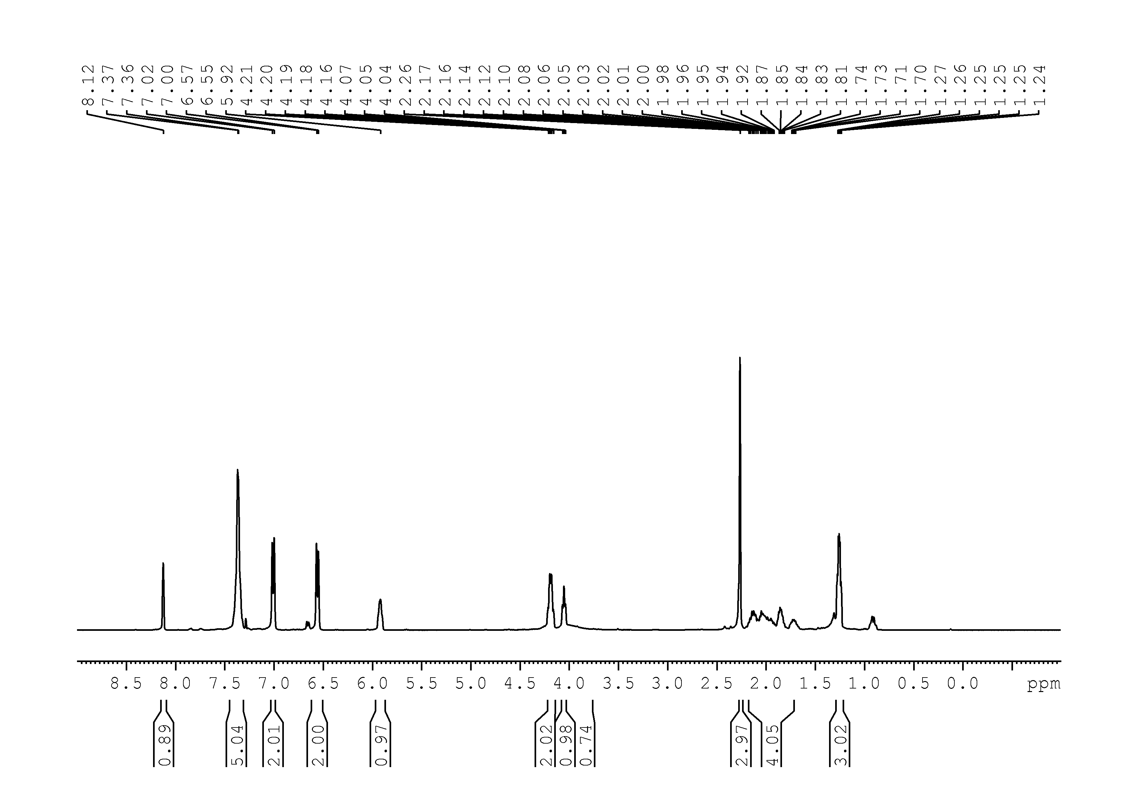
24
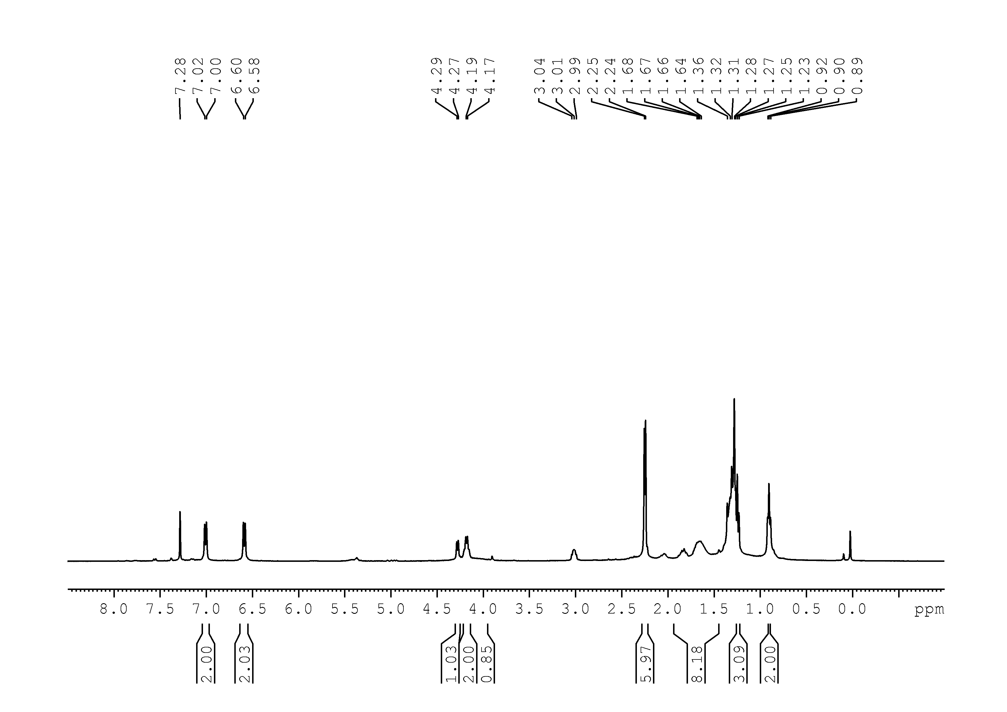

26
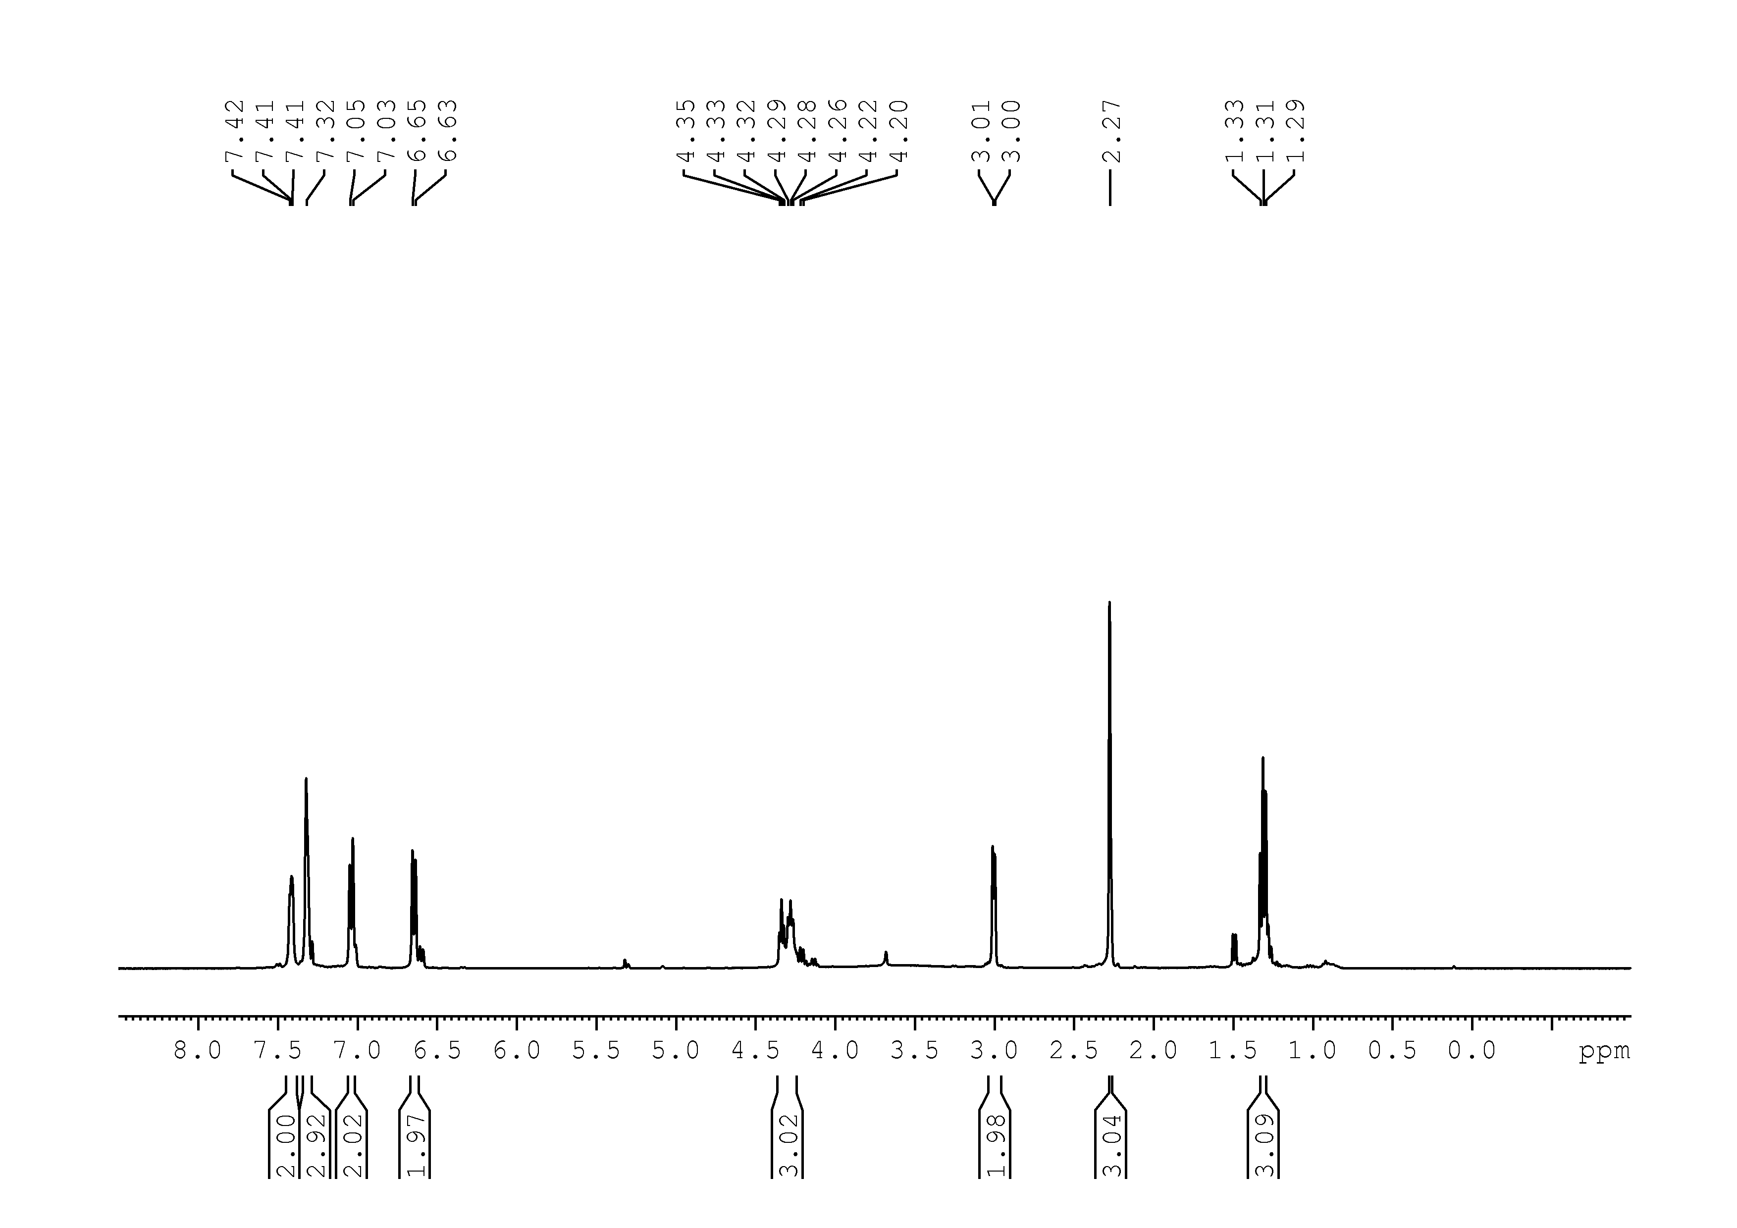

27
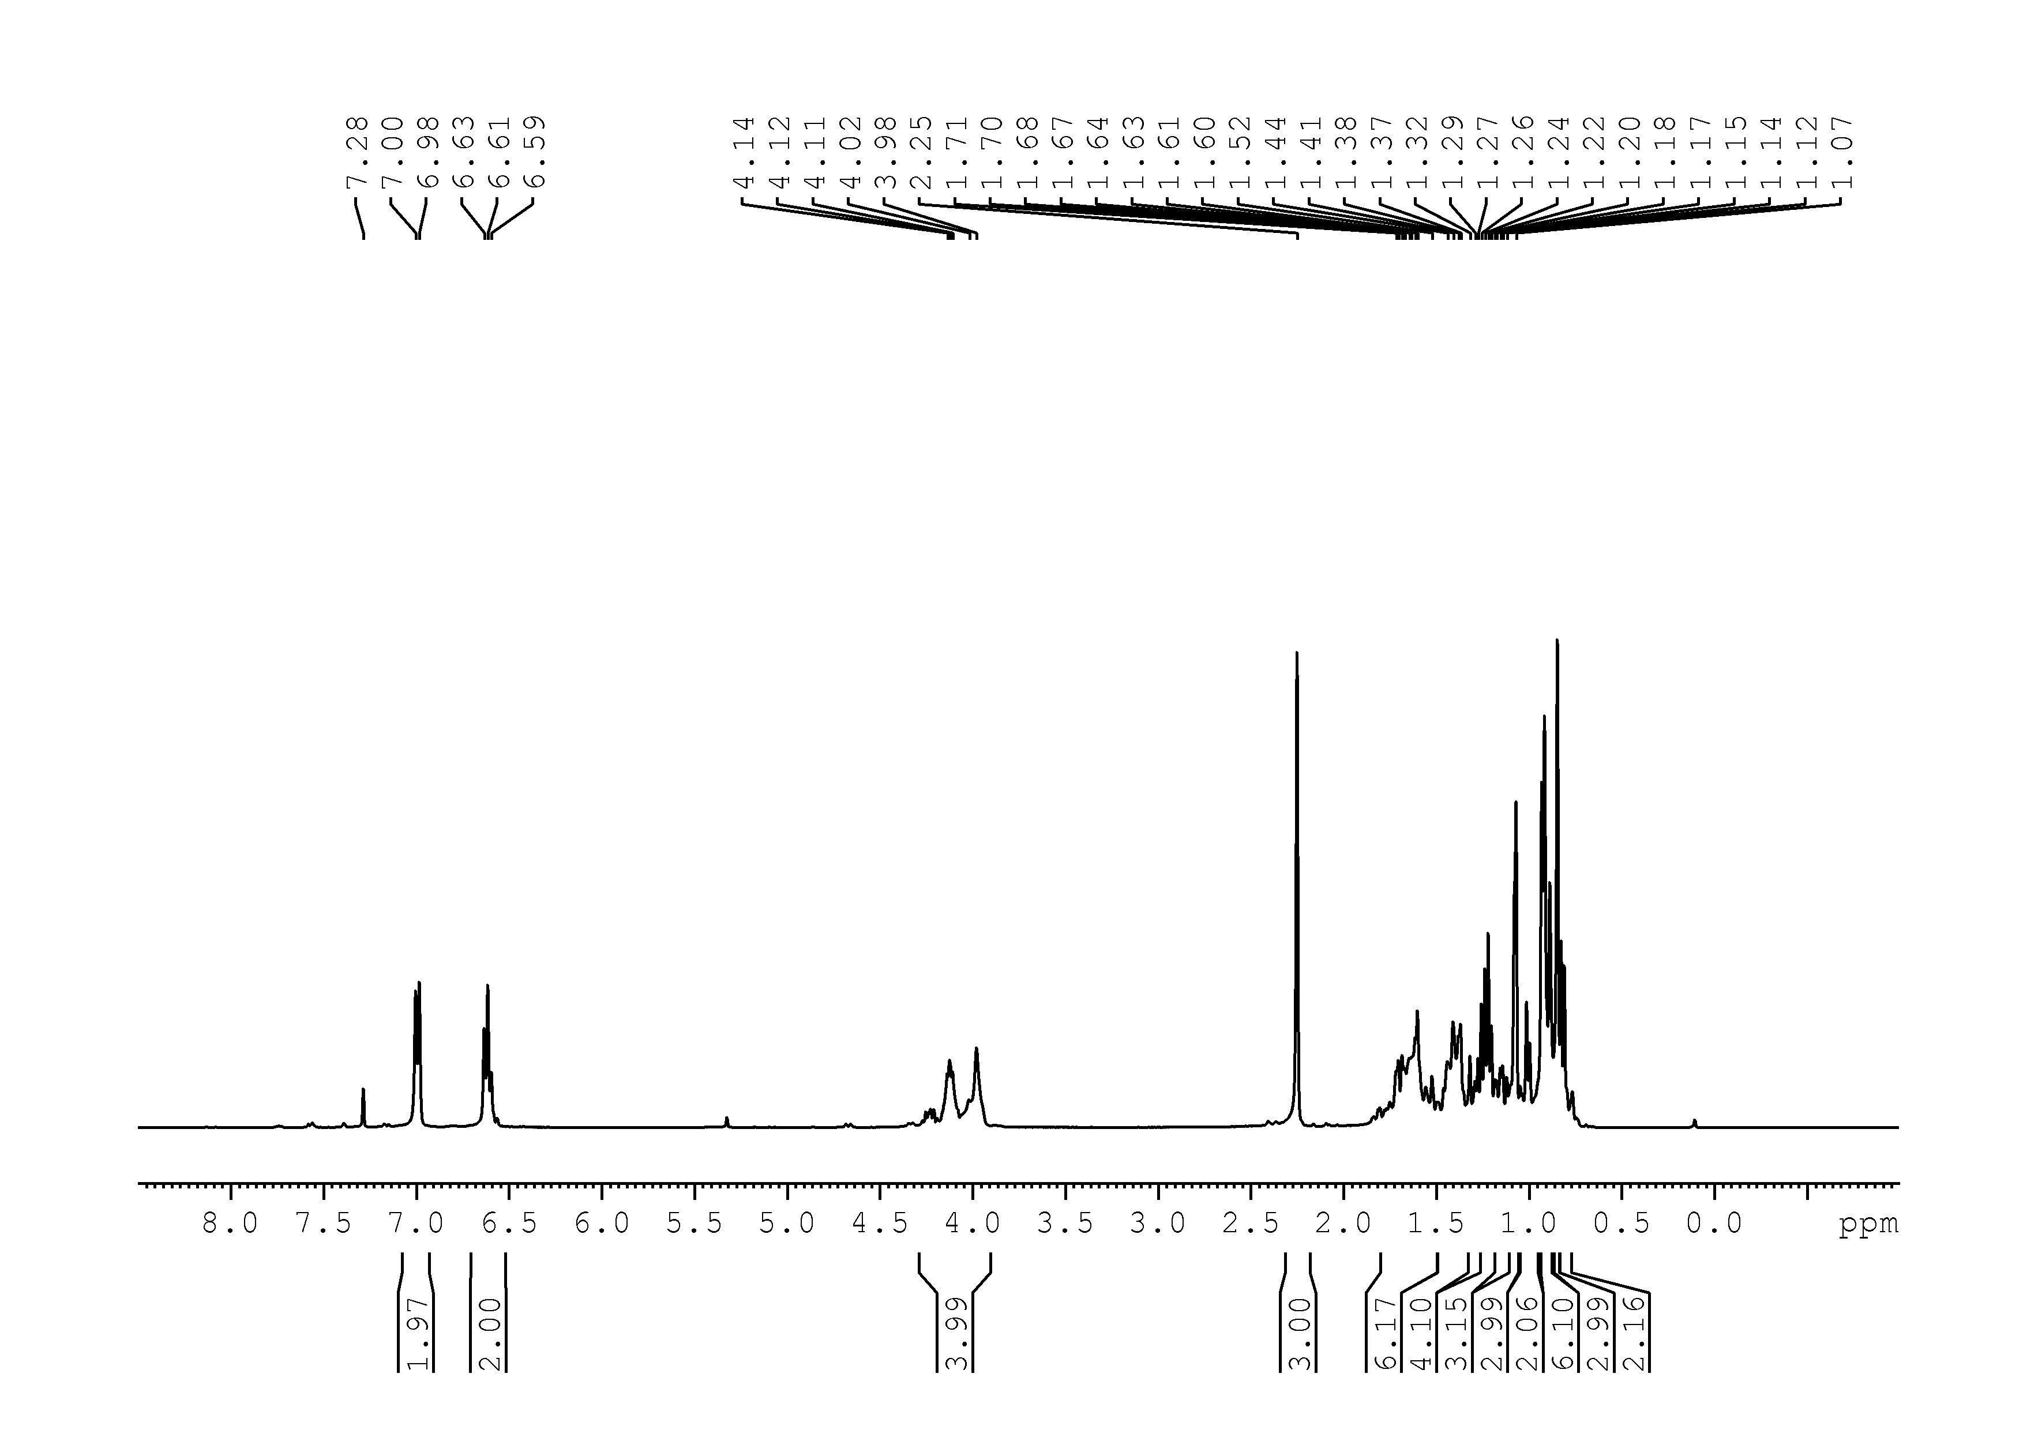
28
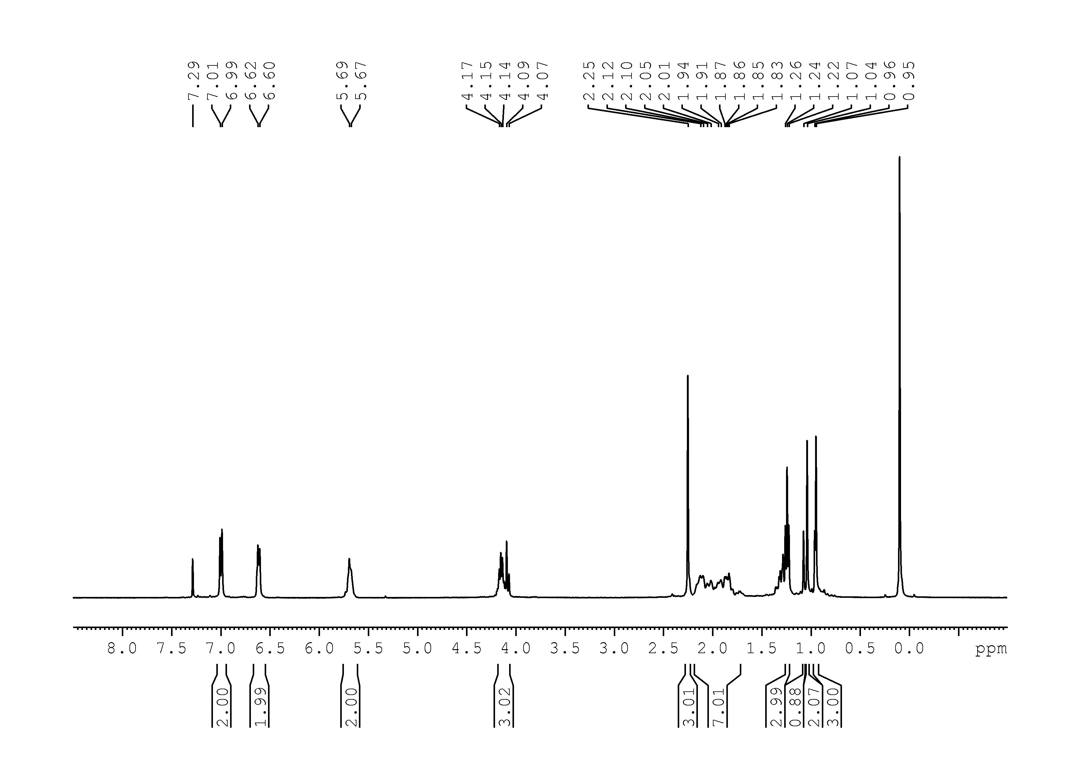

29

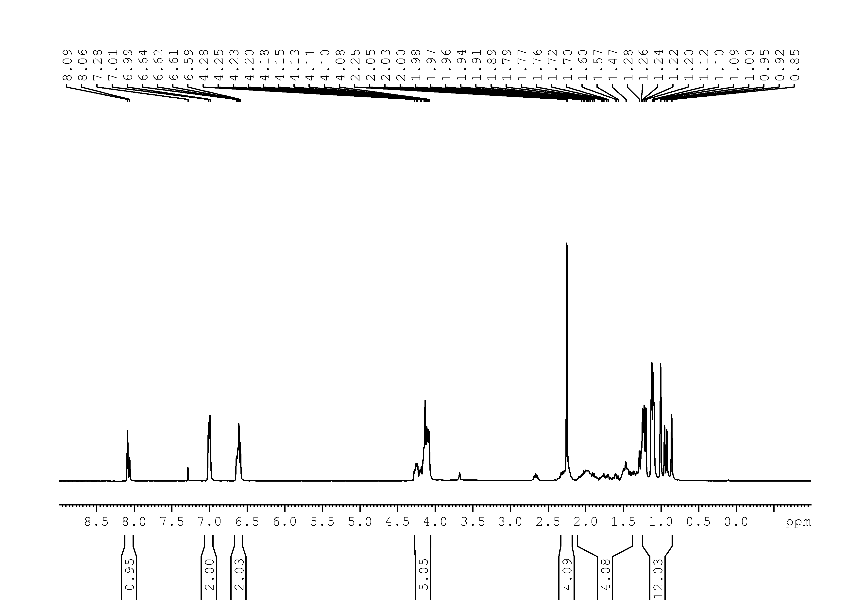

30
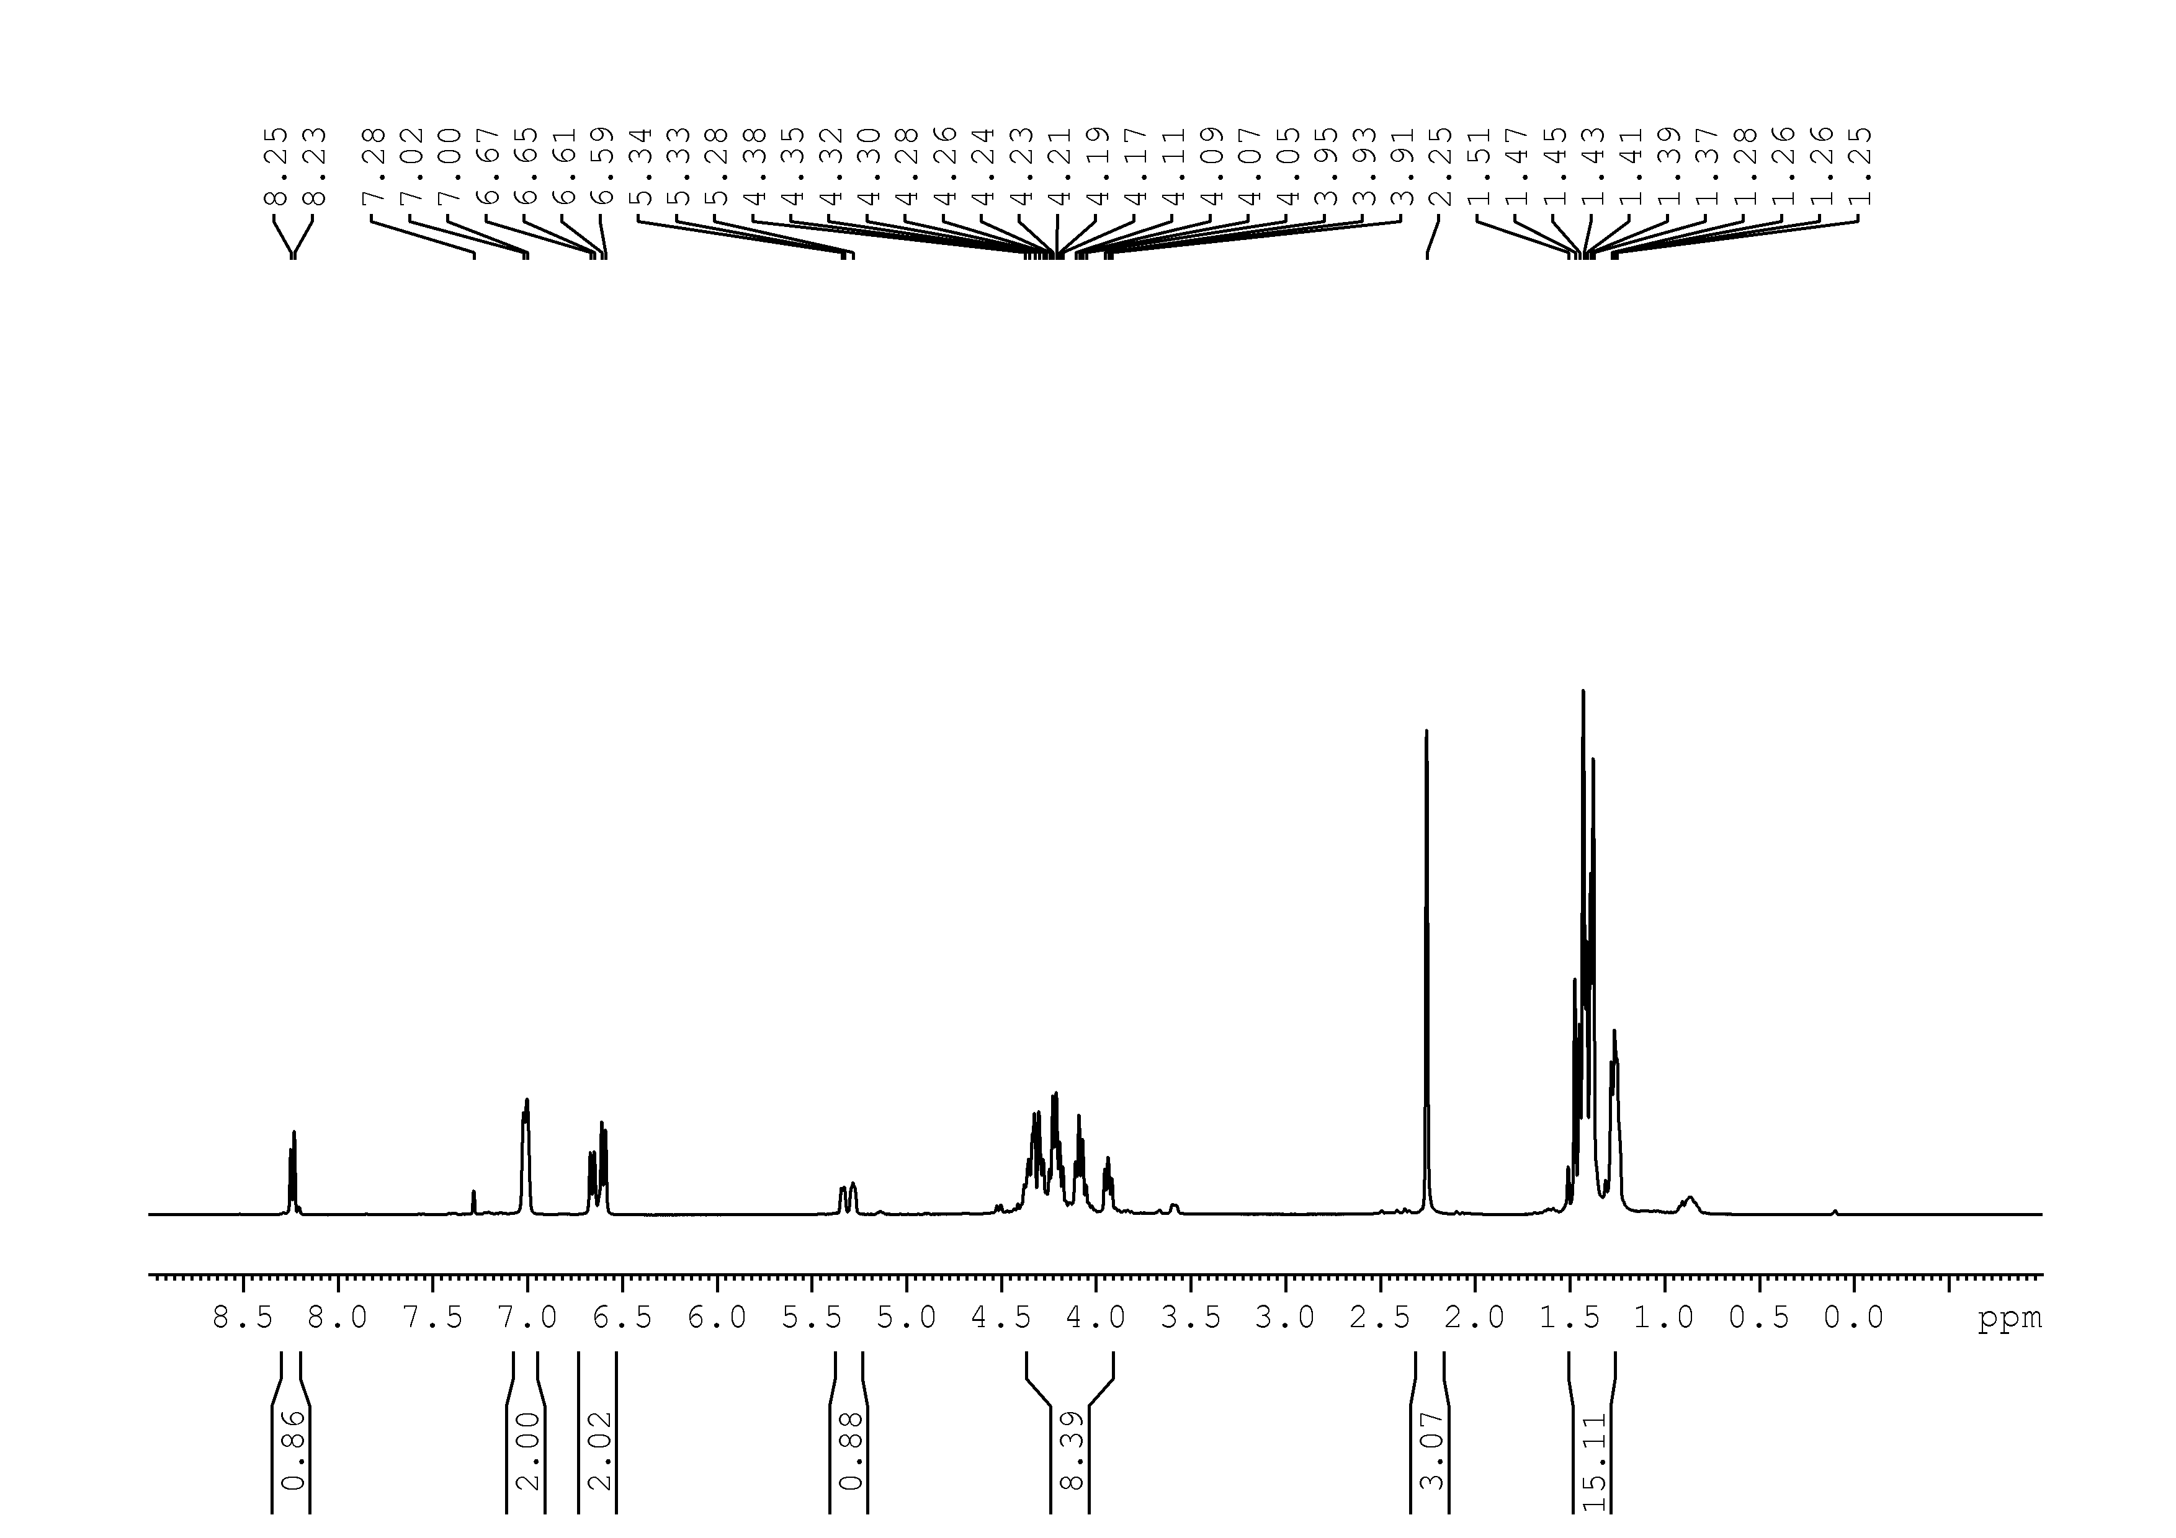
31
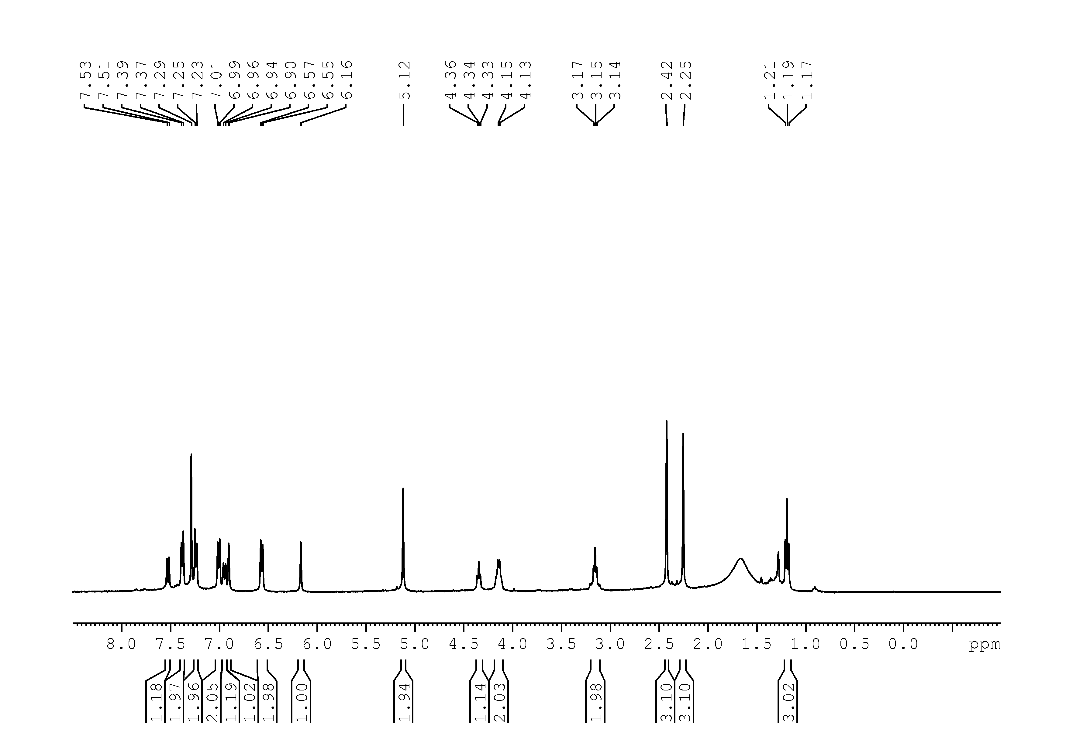
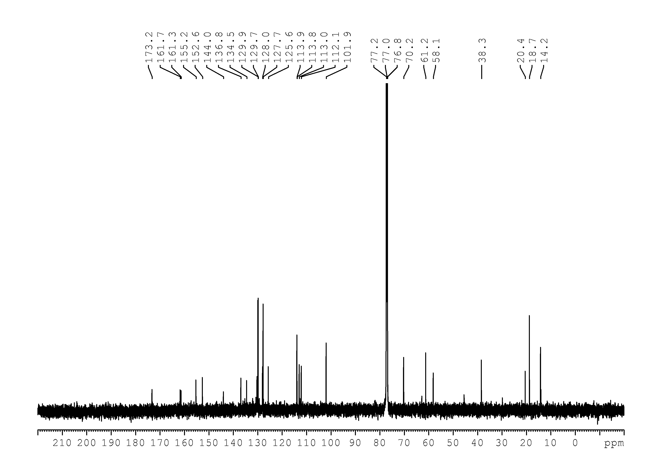
32
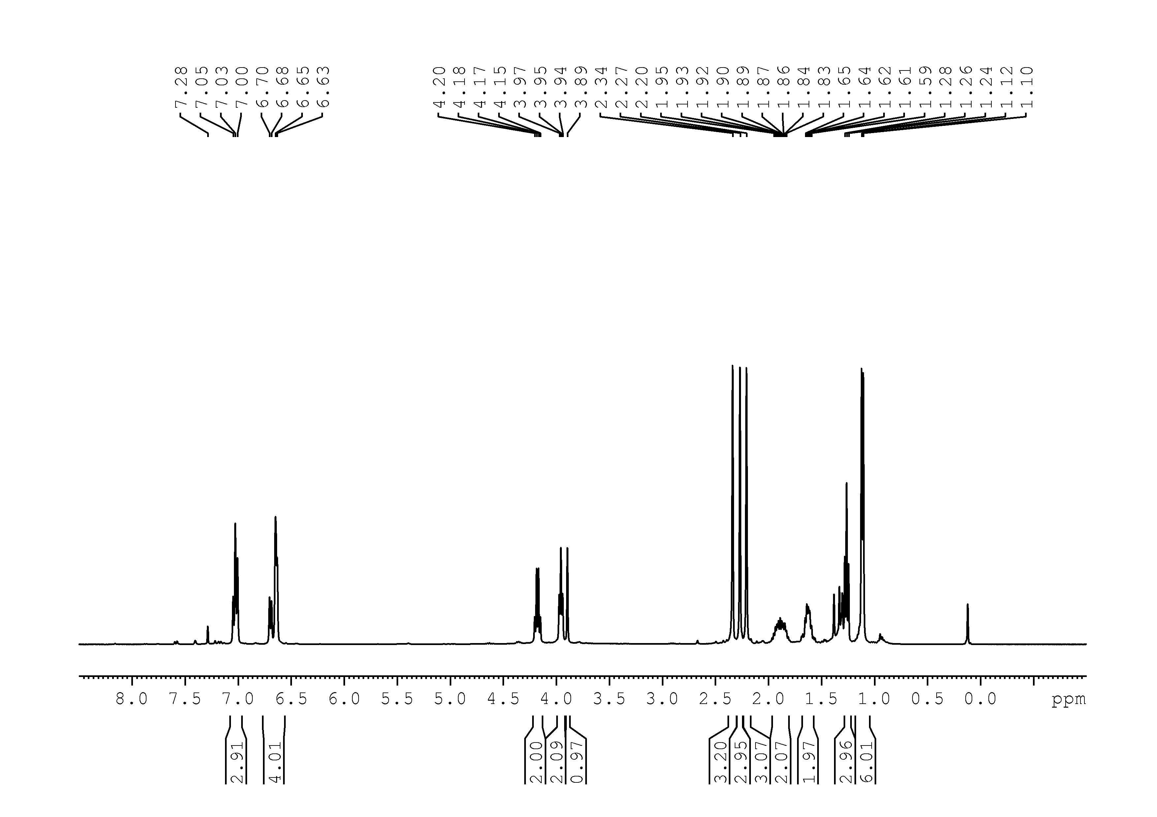
37
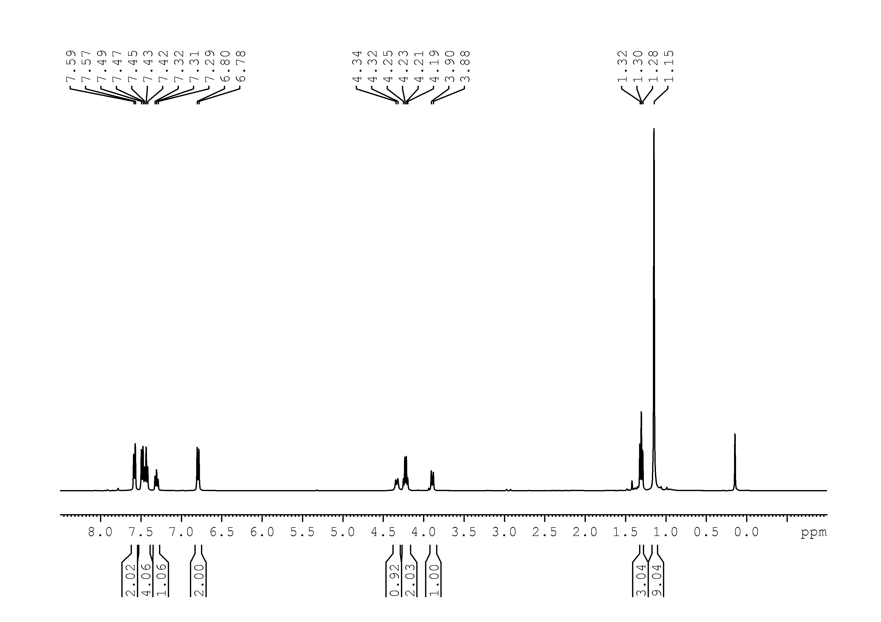
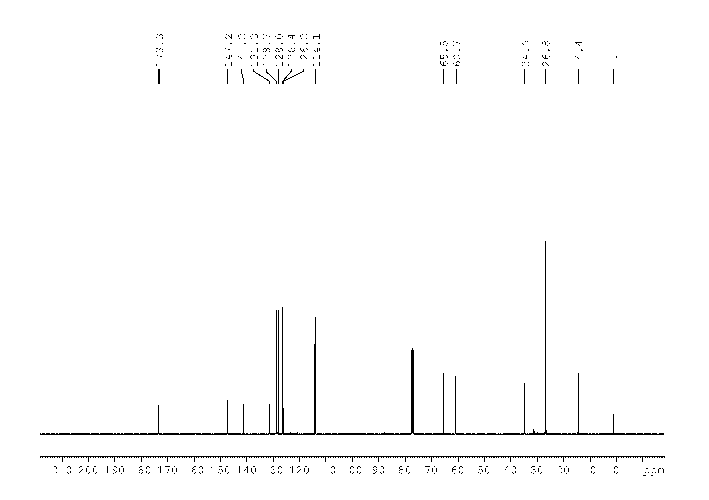

39
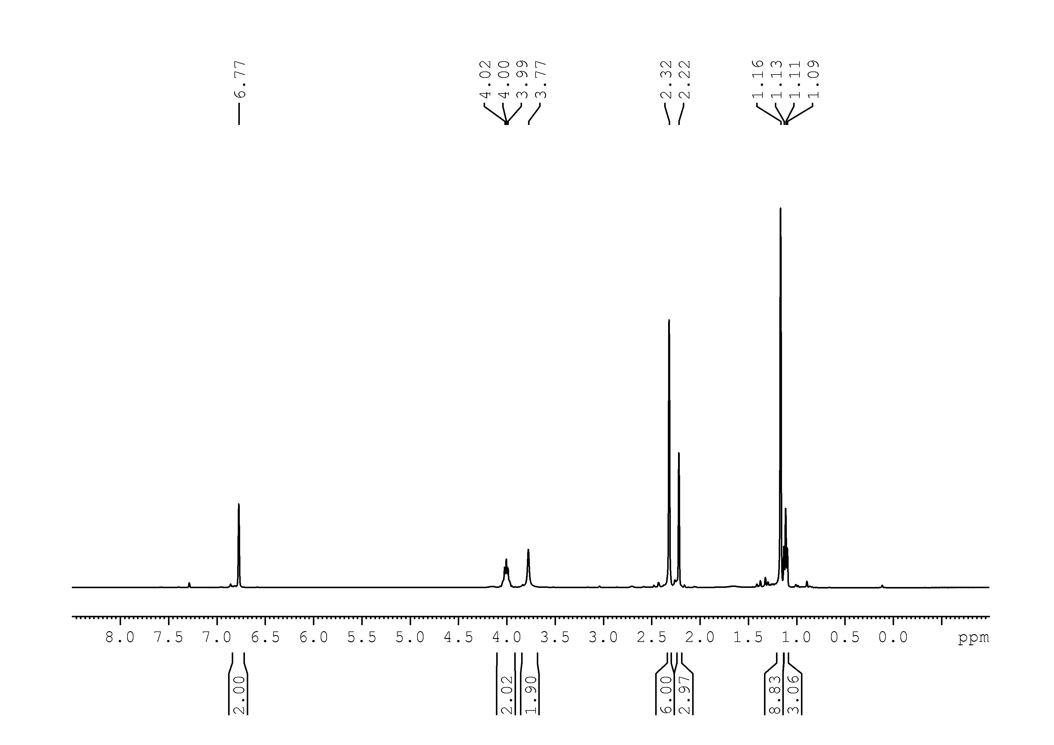
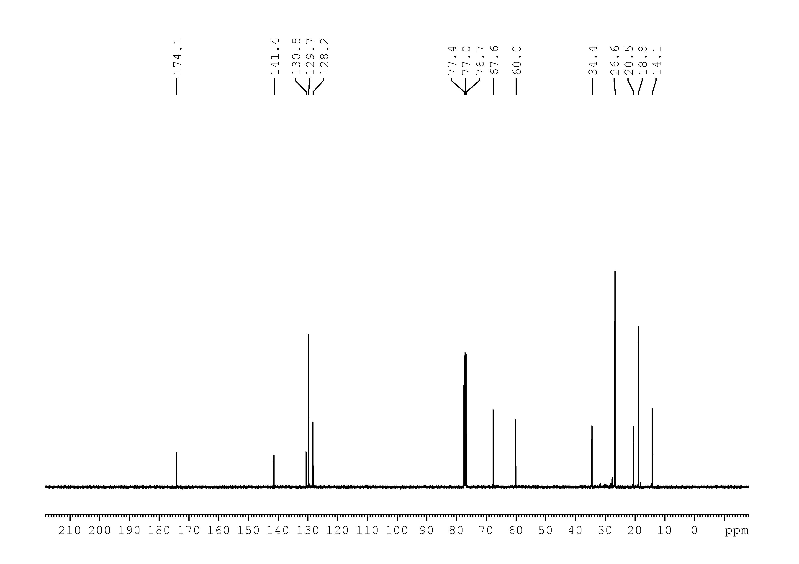

40
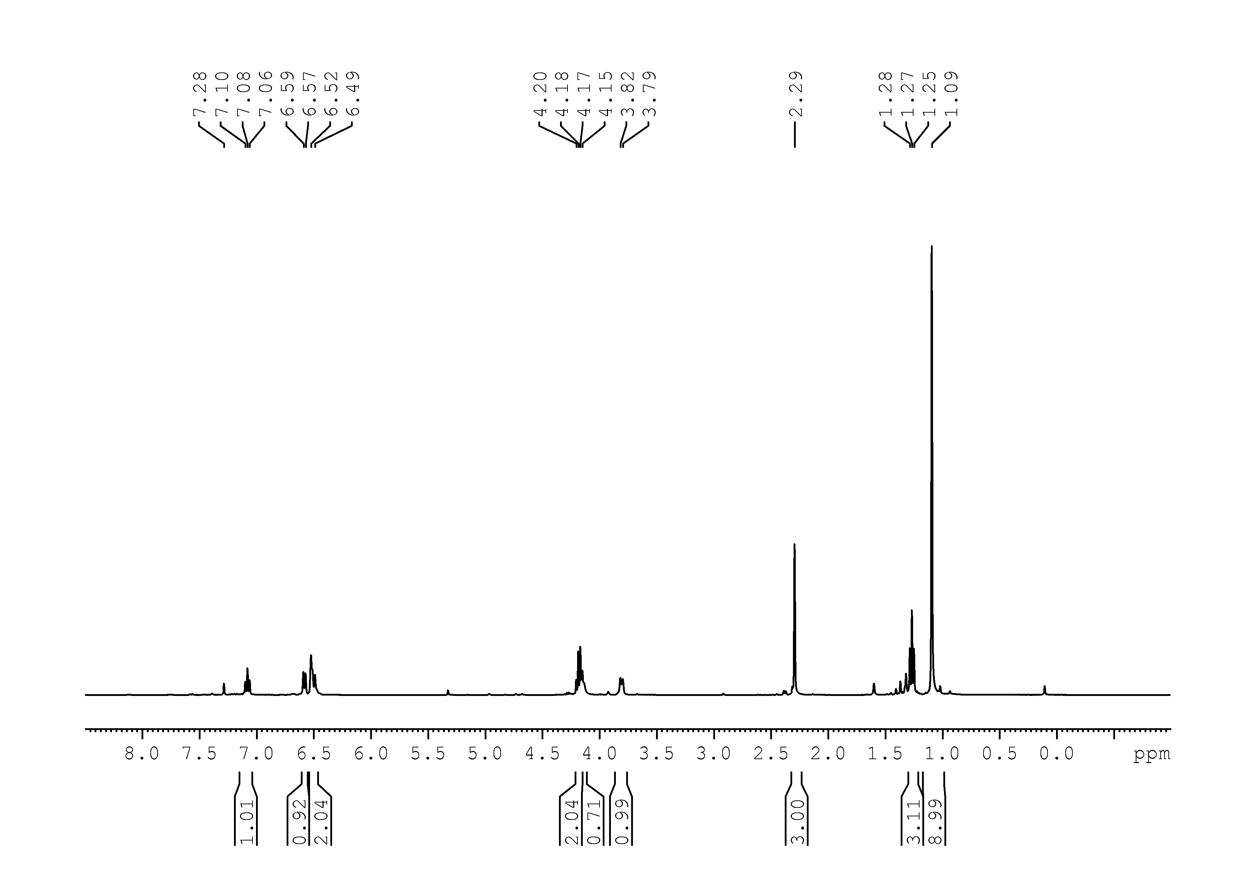
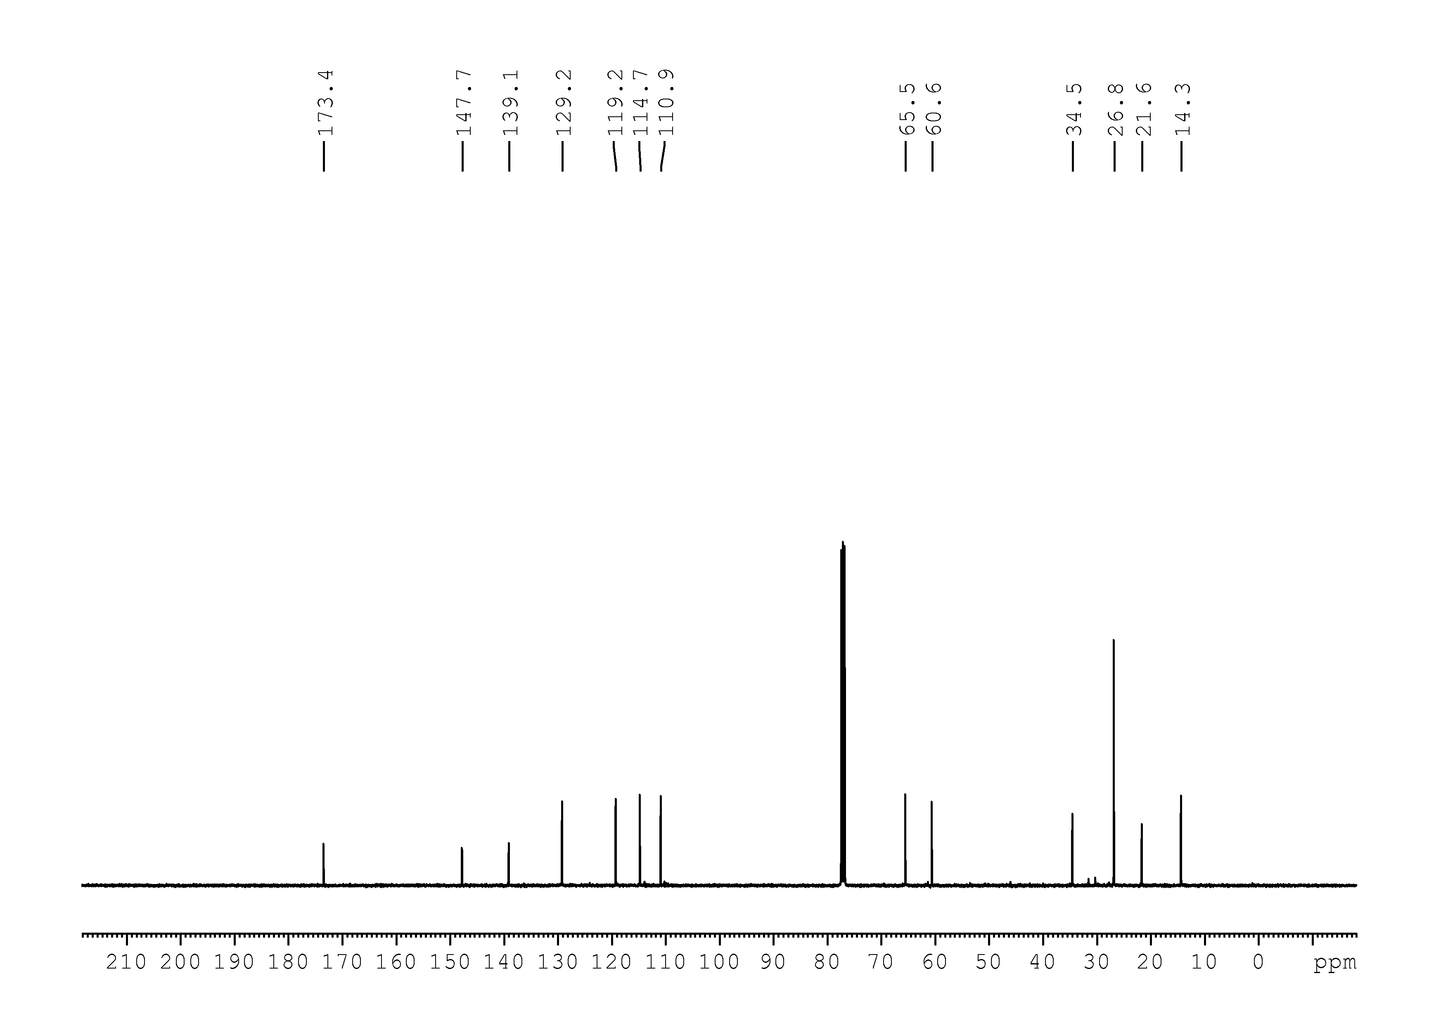

41
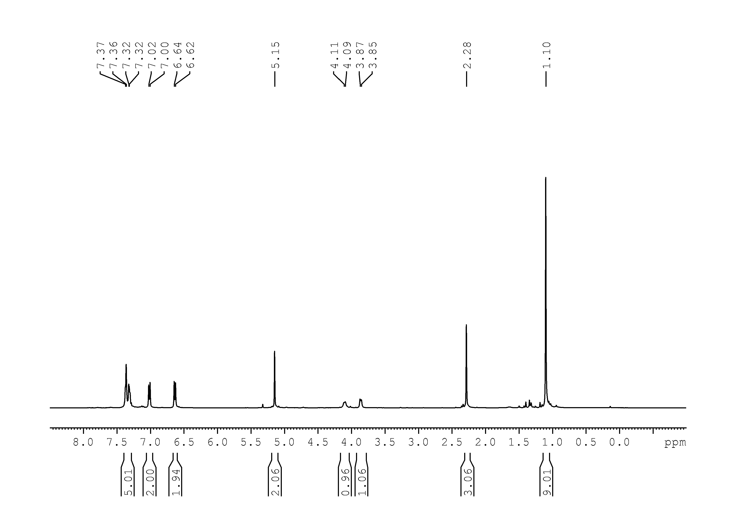
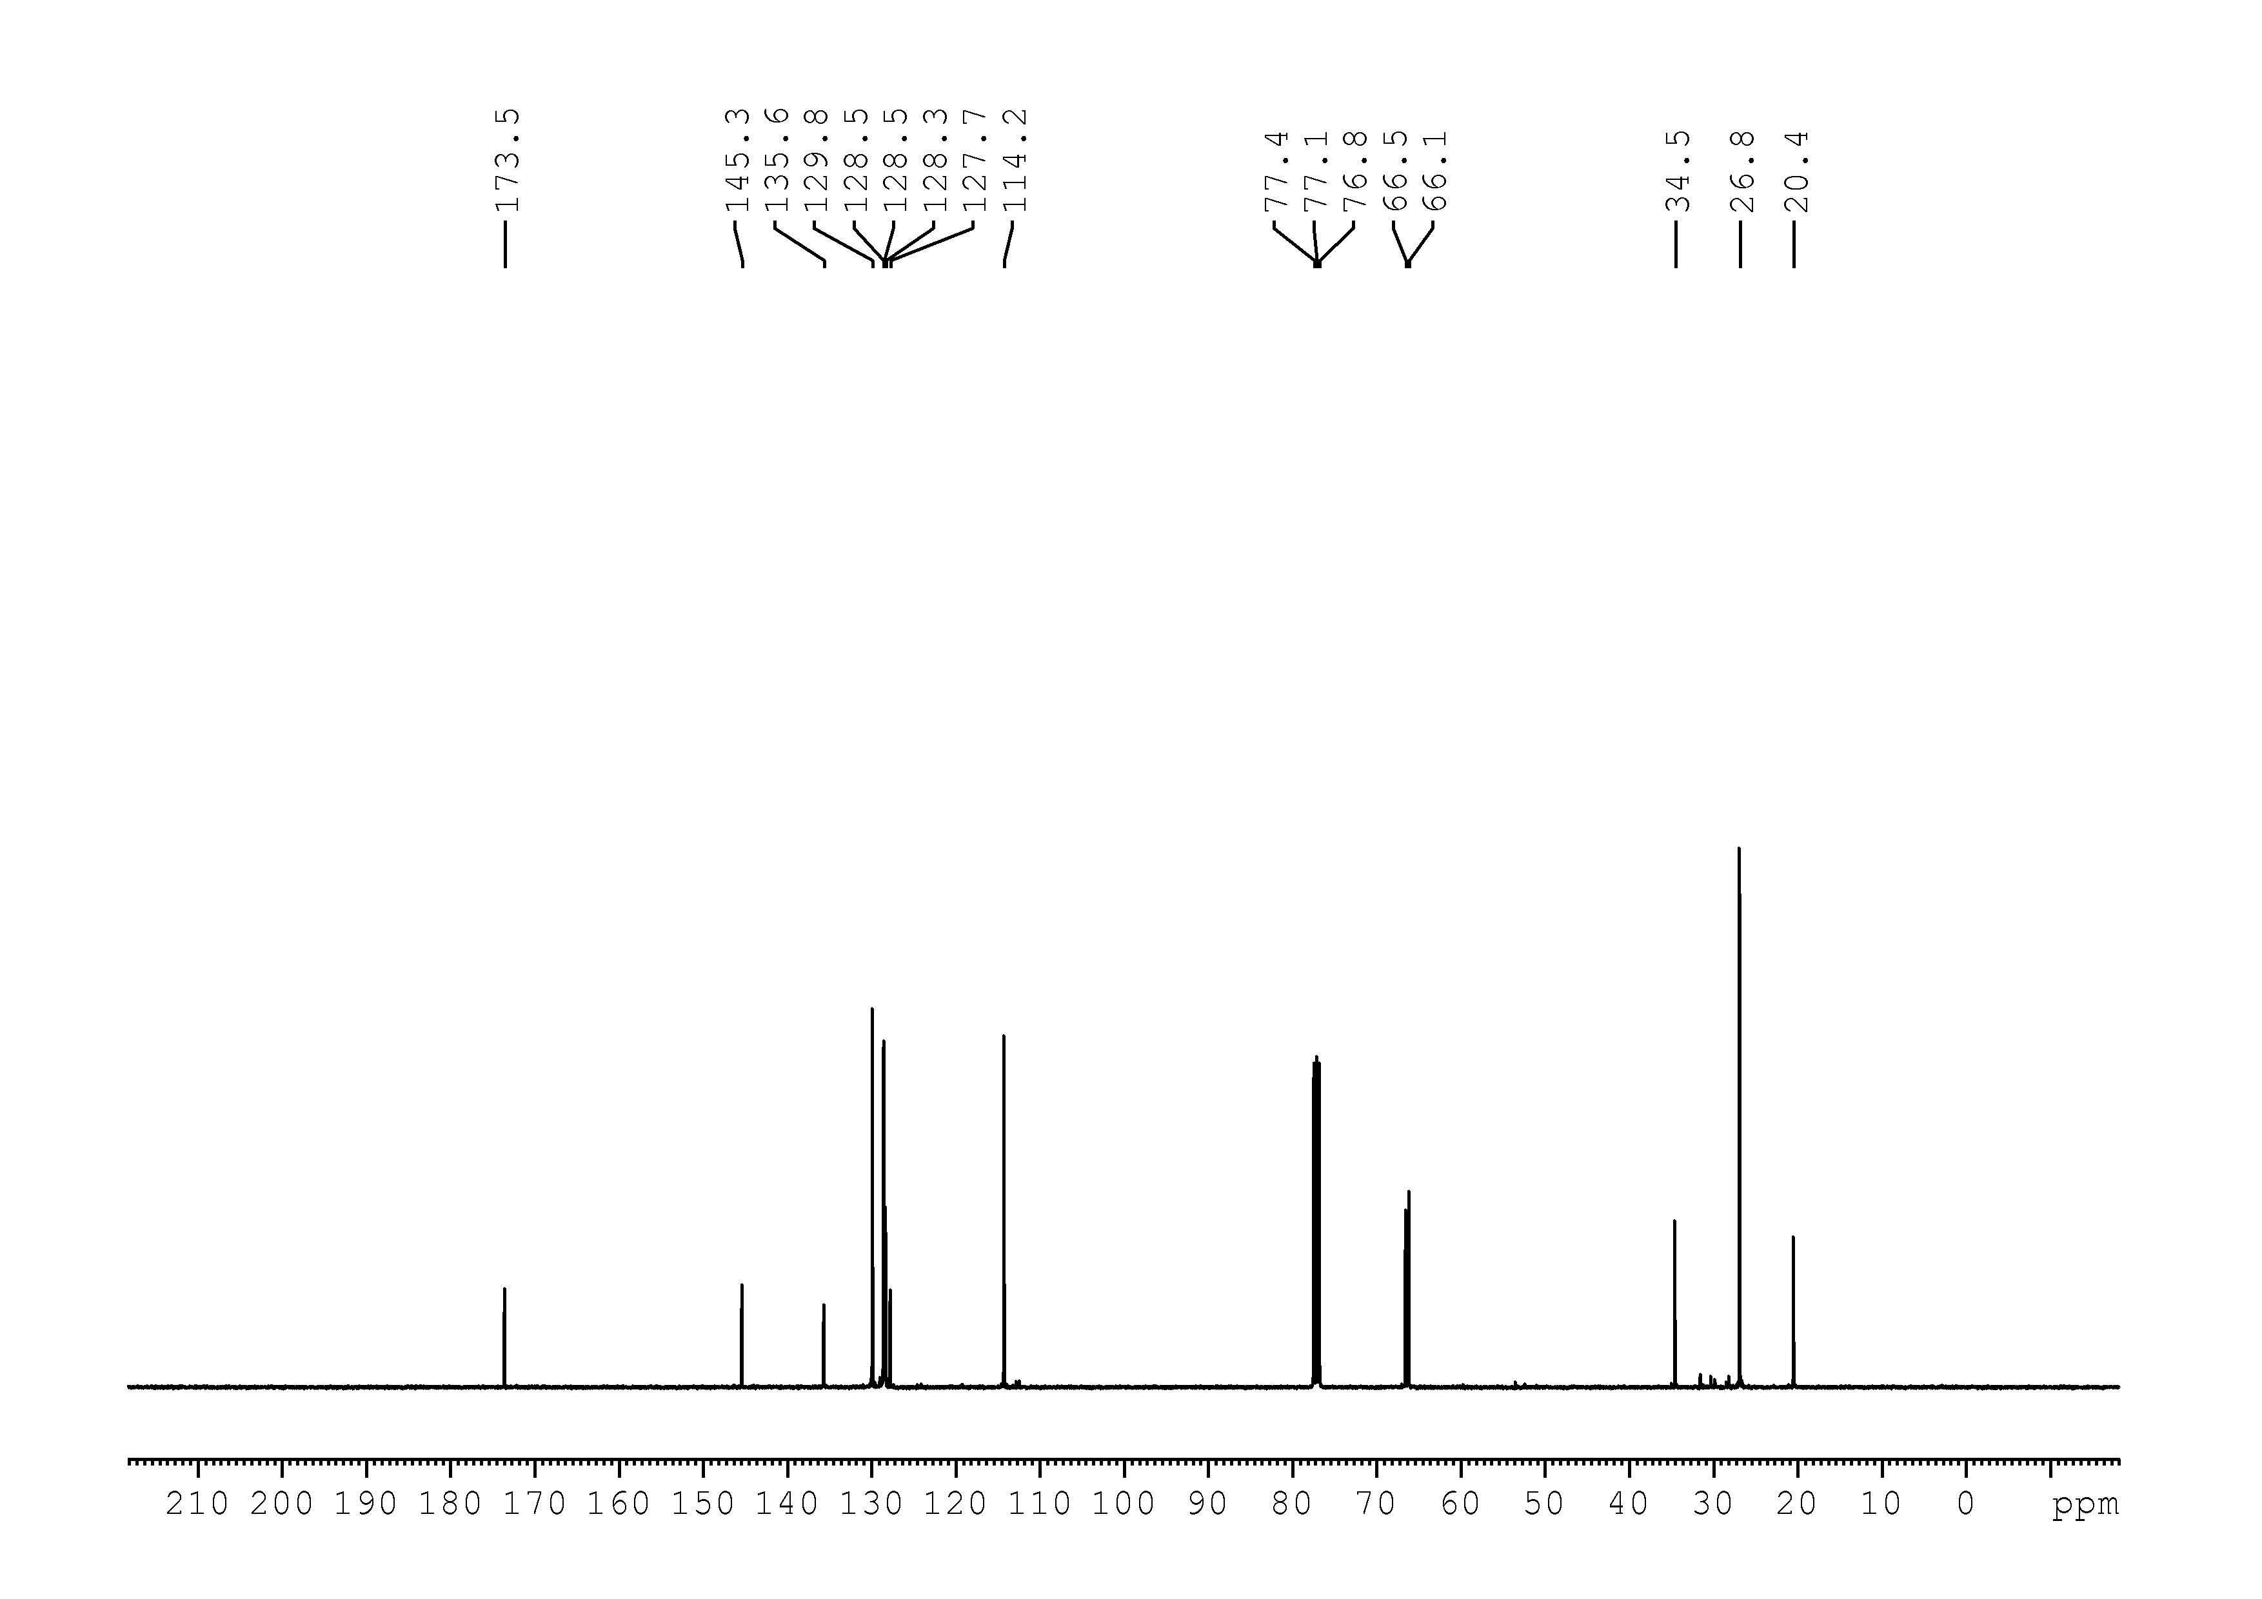

42
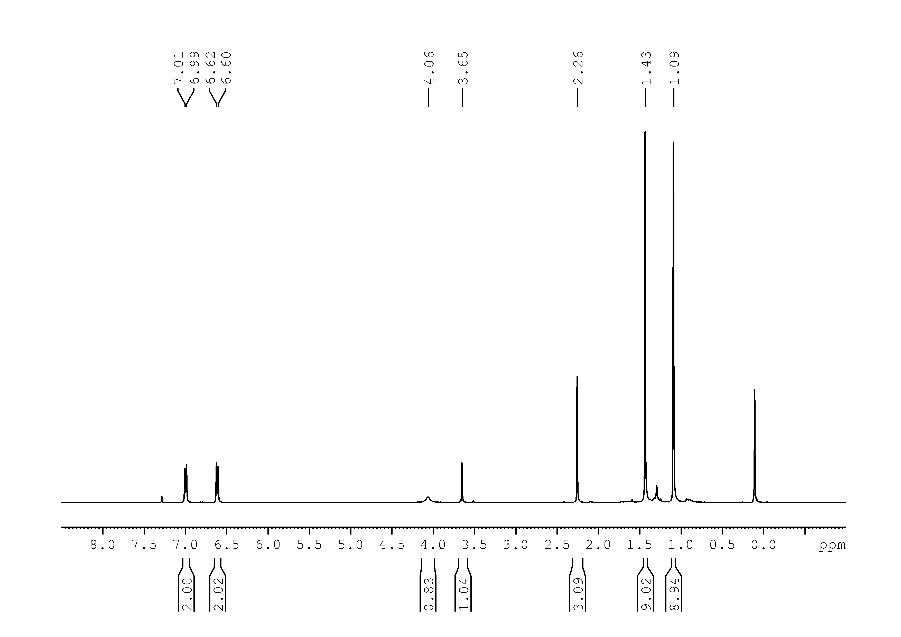
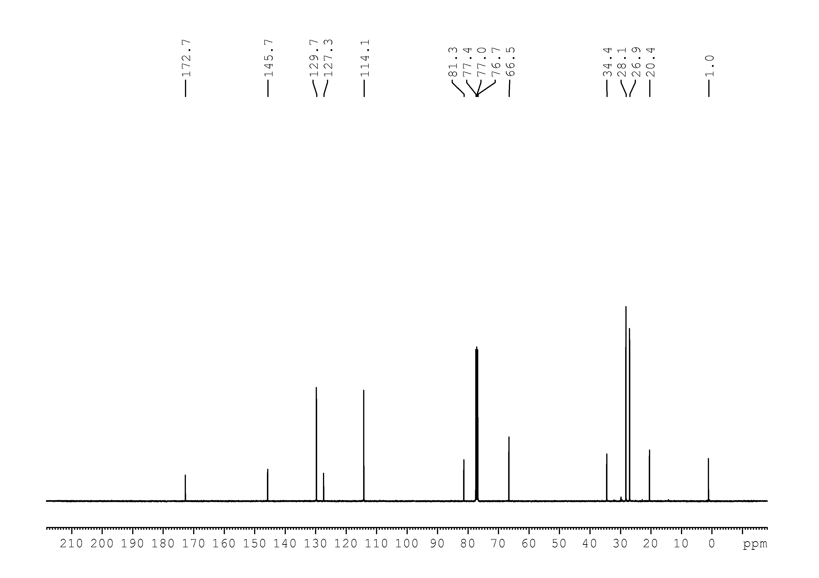

43
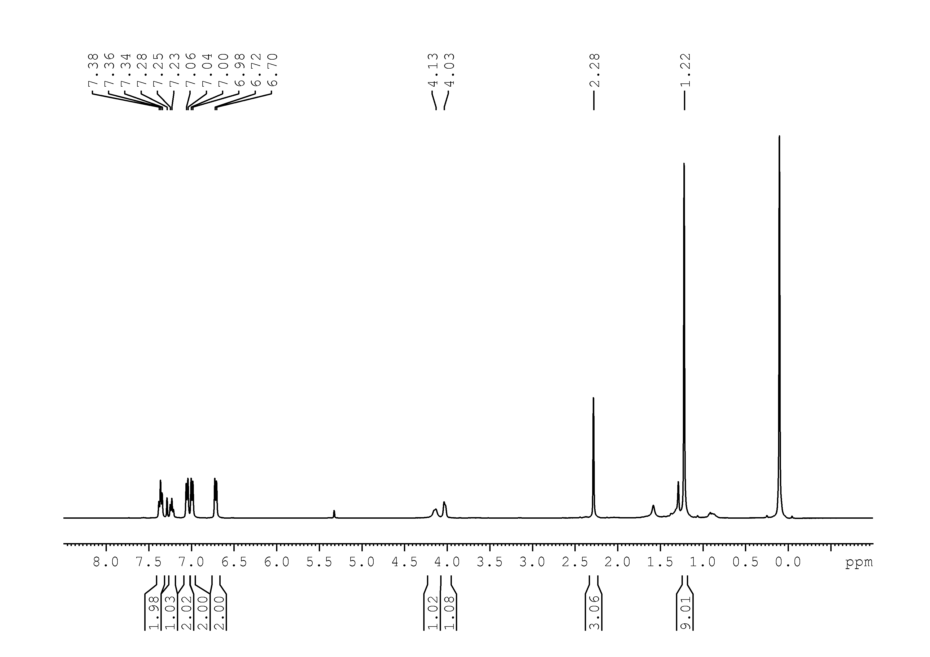
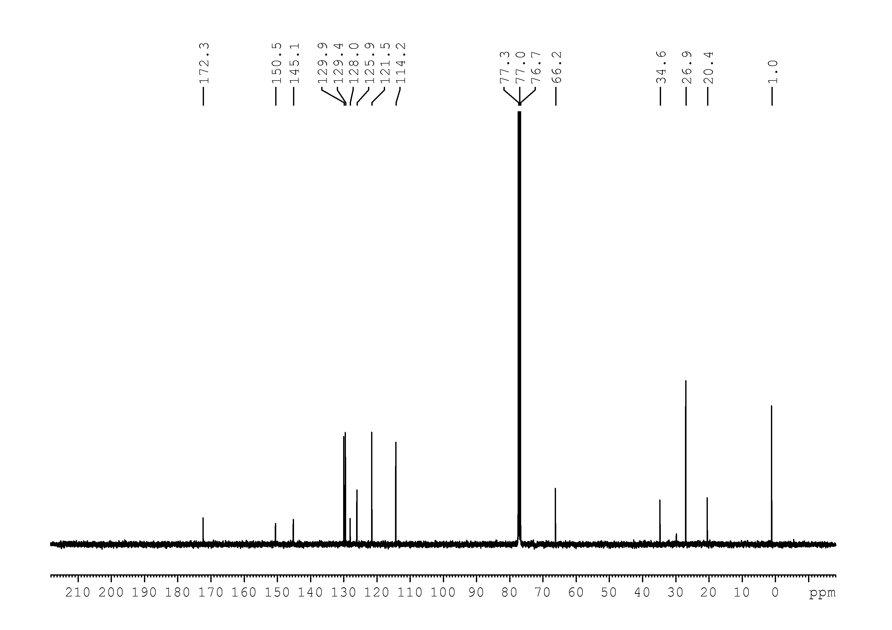

44
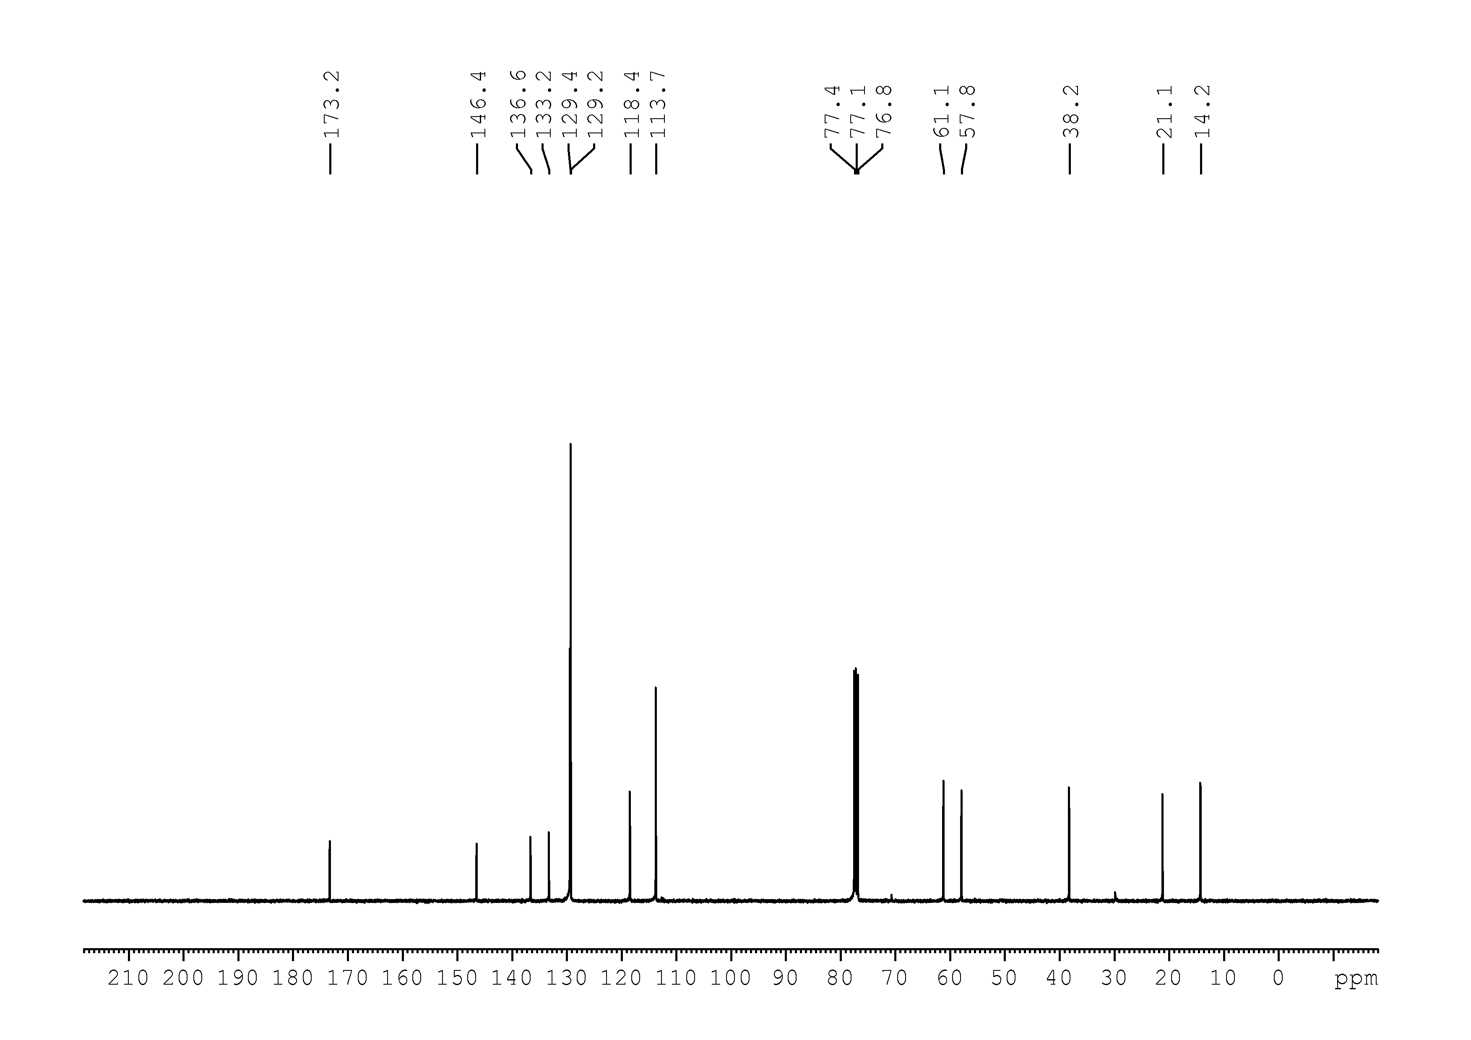

45
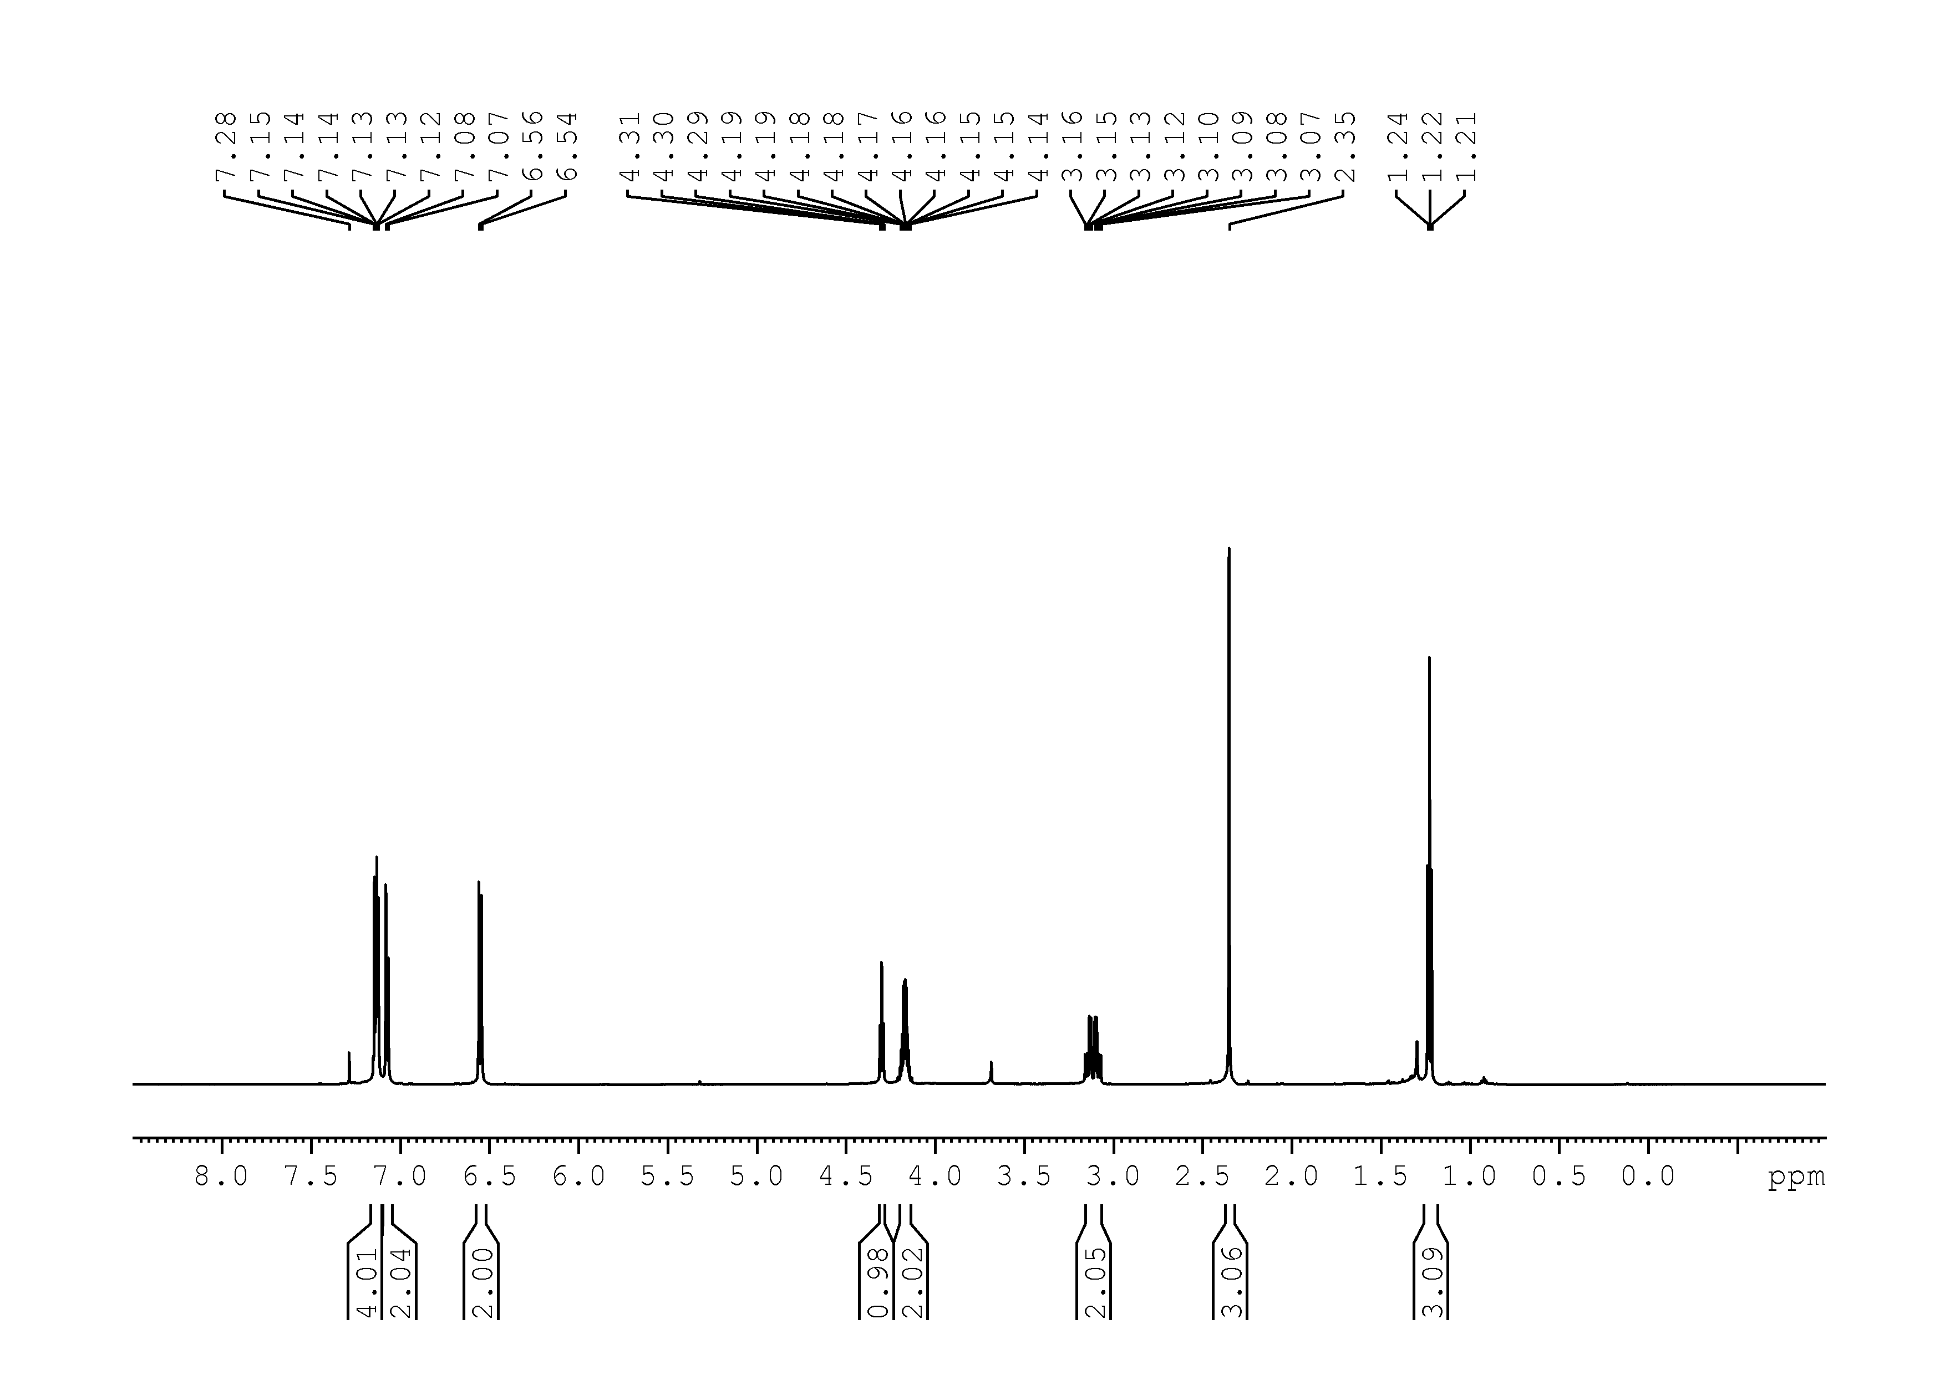
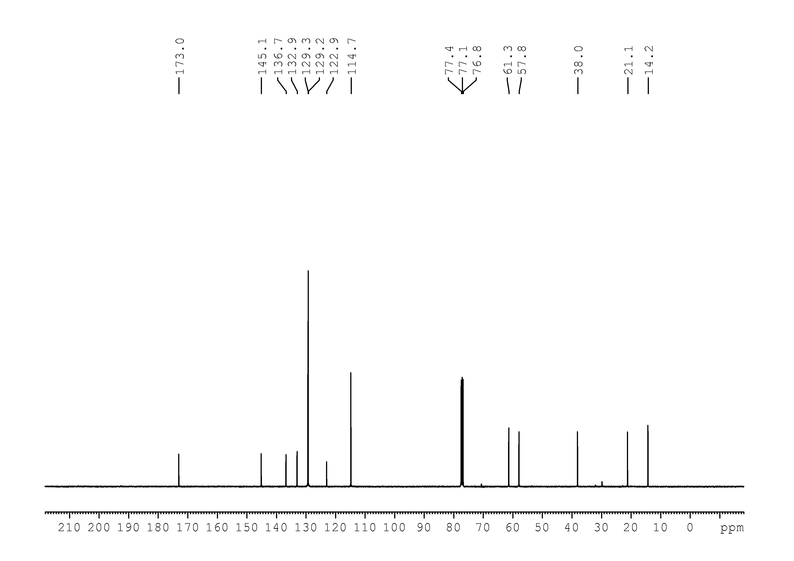

46
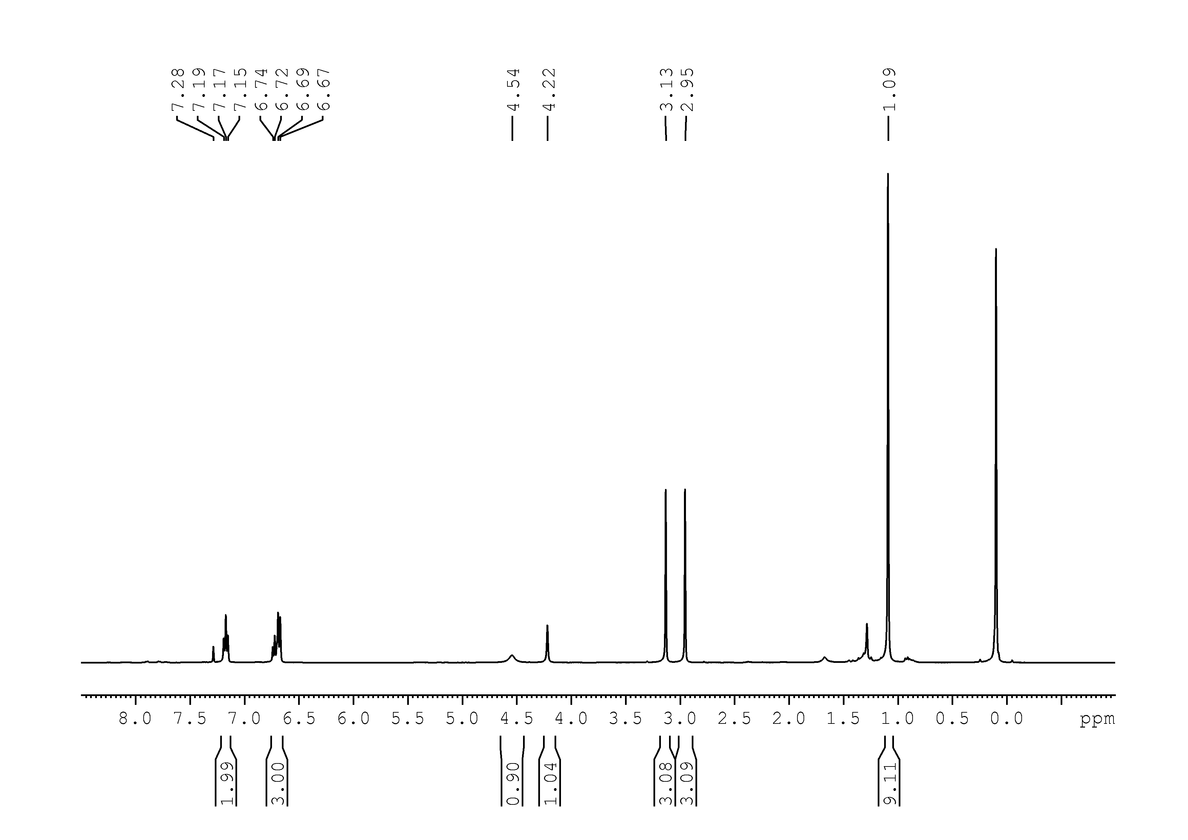

47
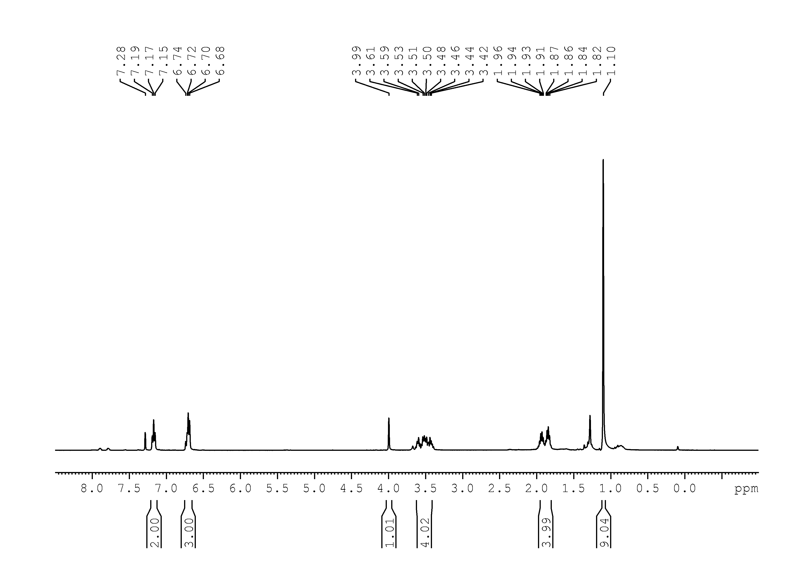
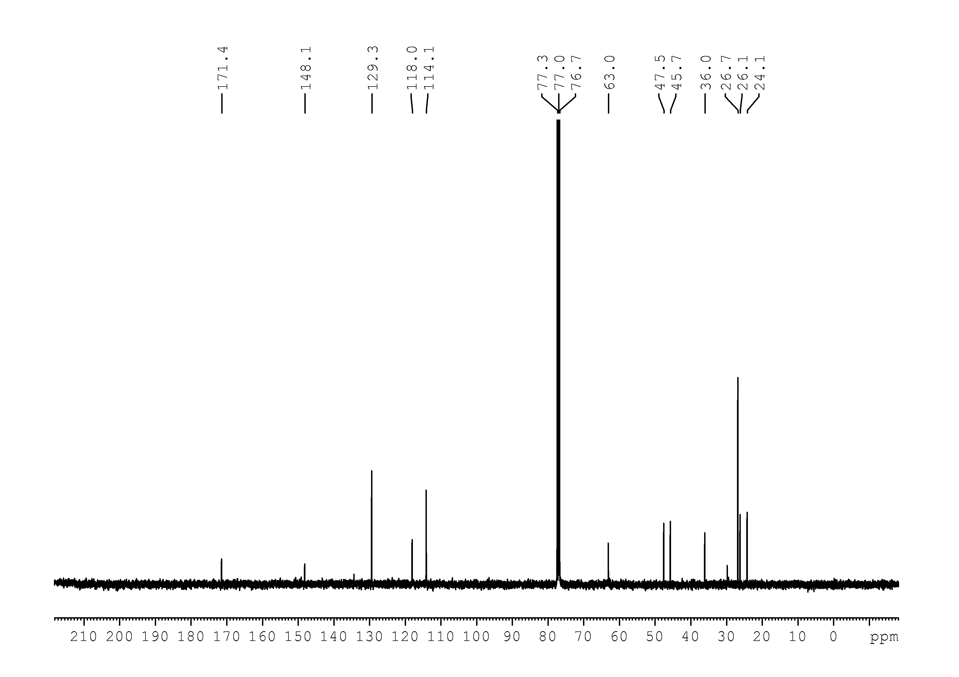

48
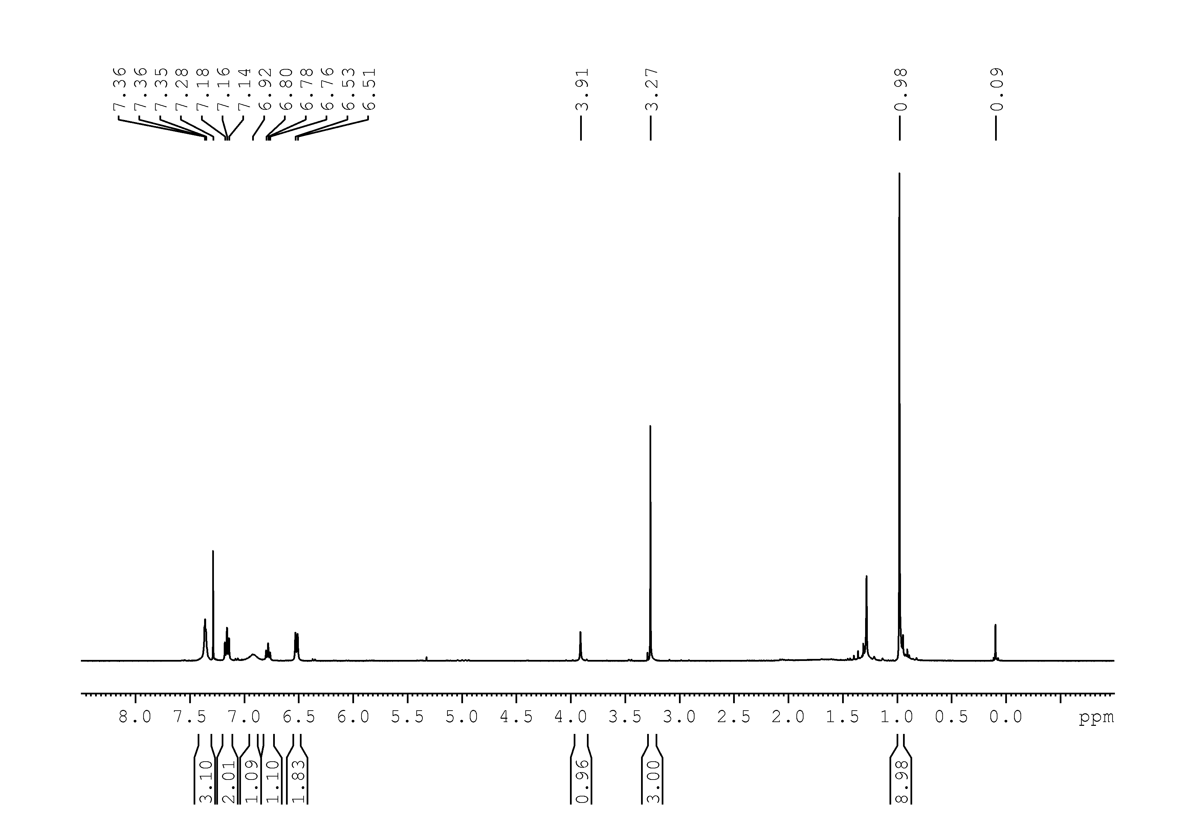
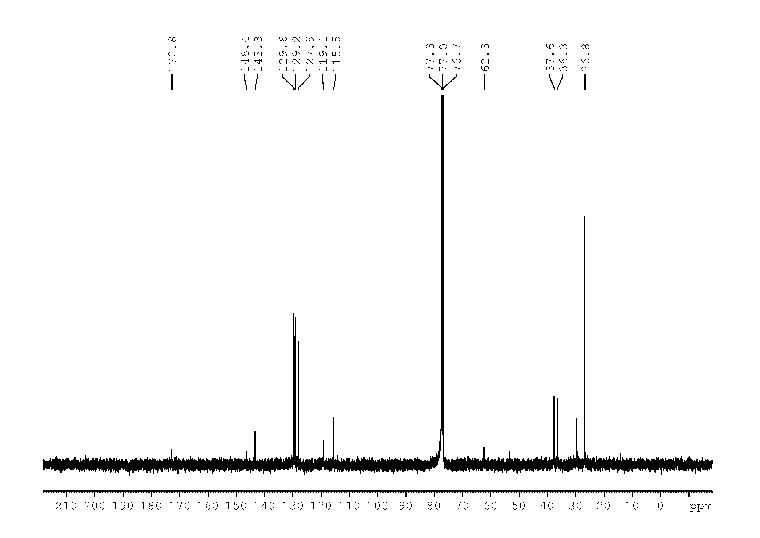
51
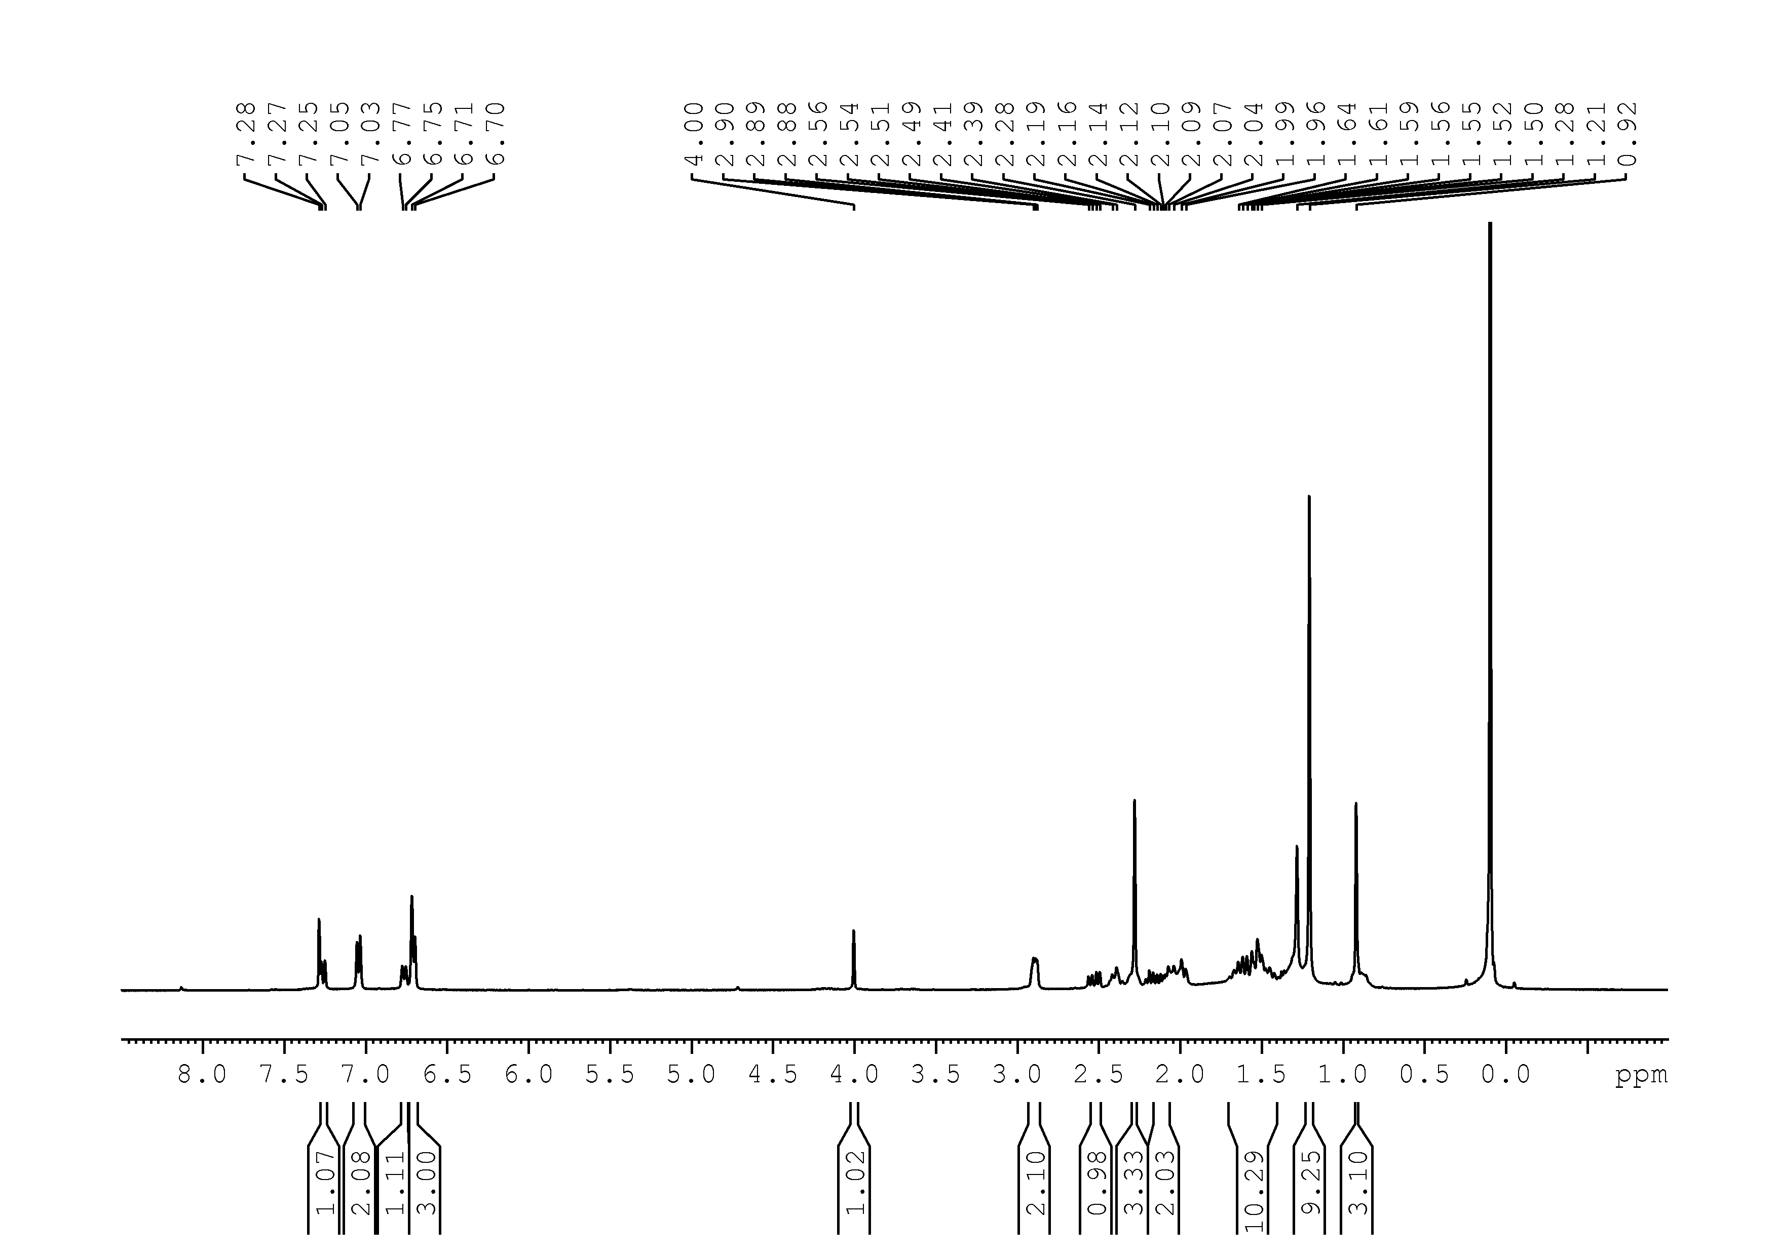
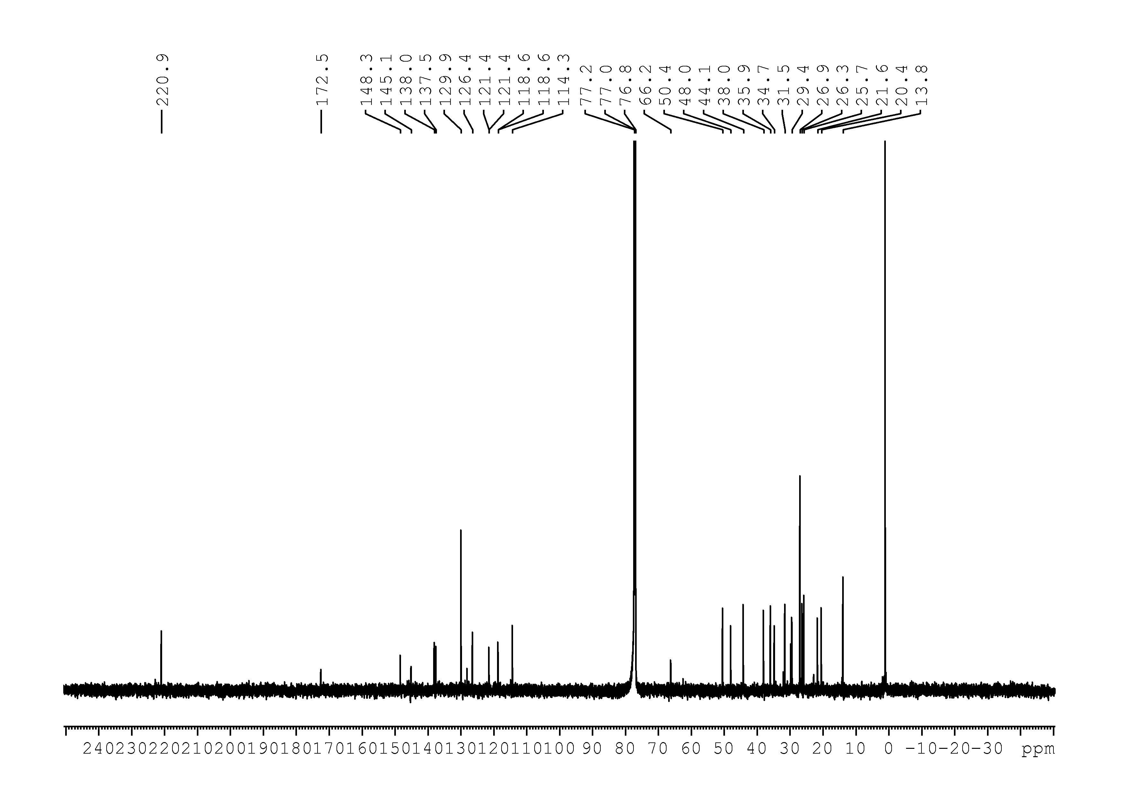

52
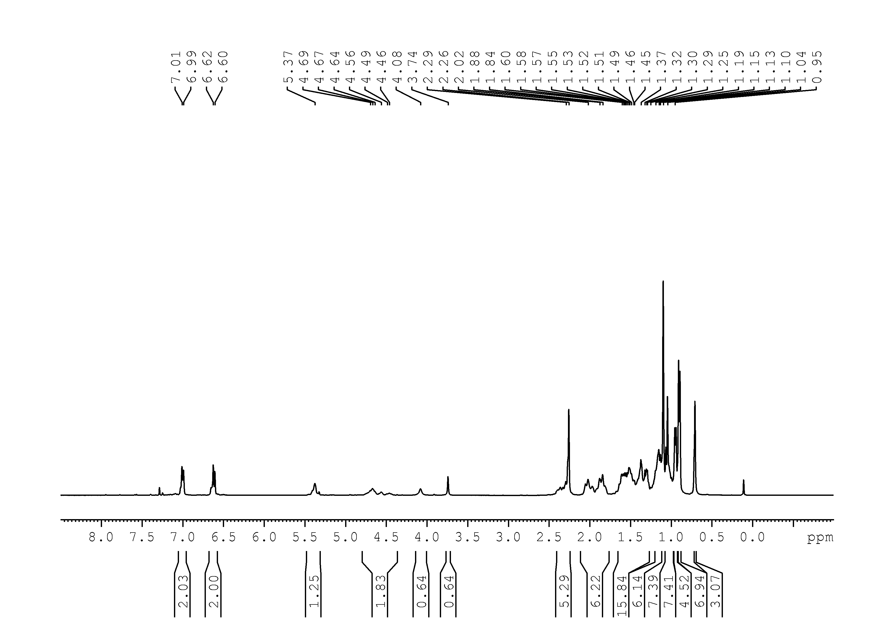
53
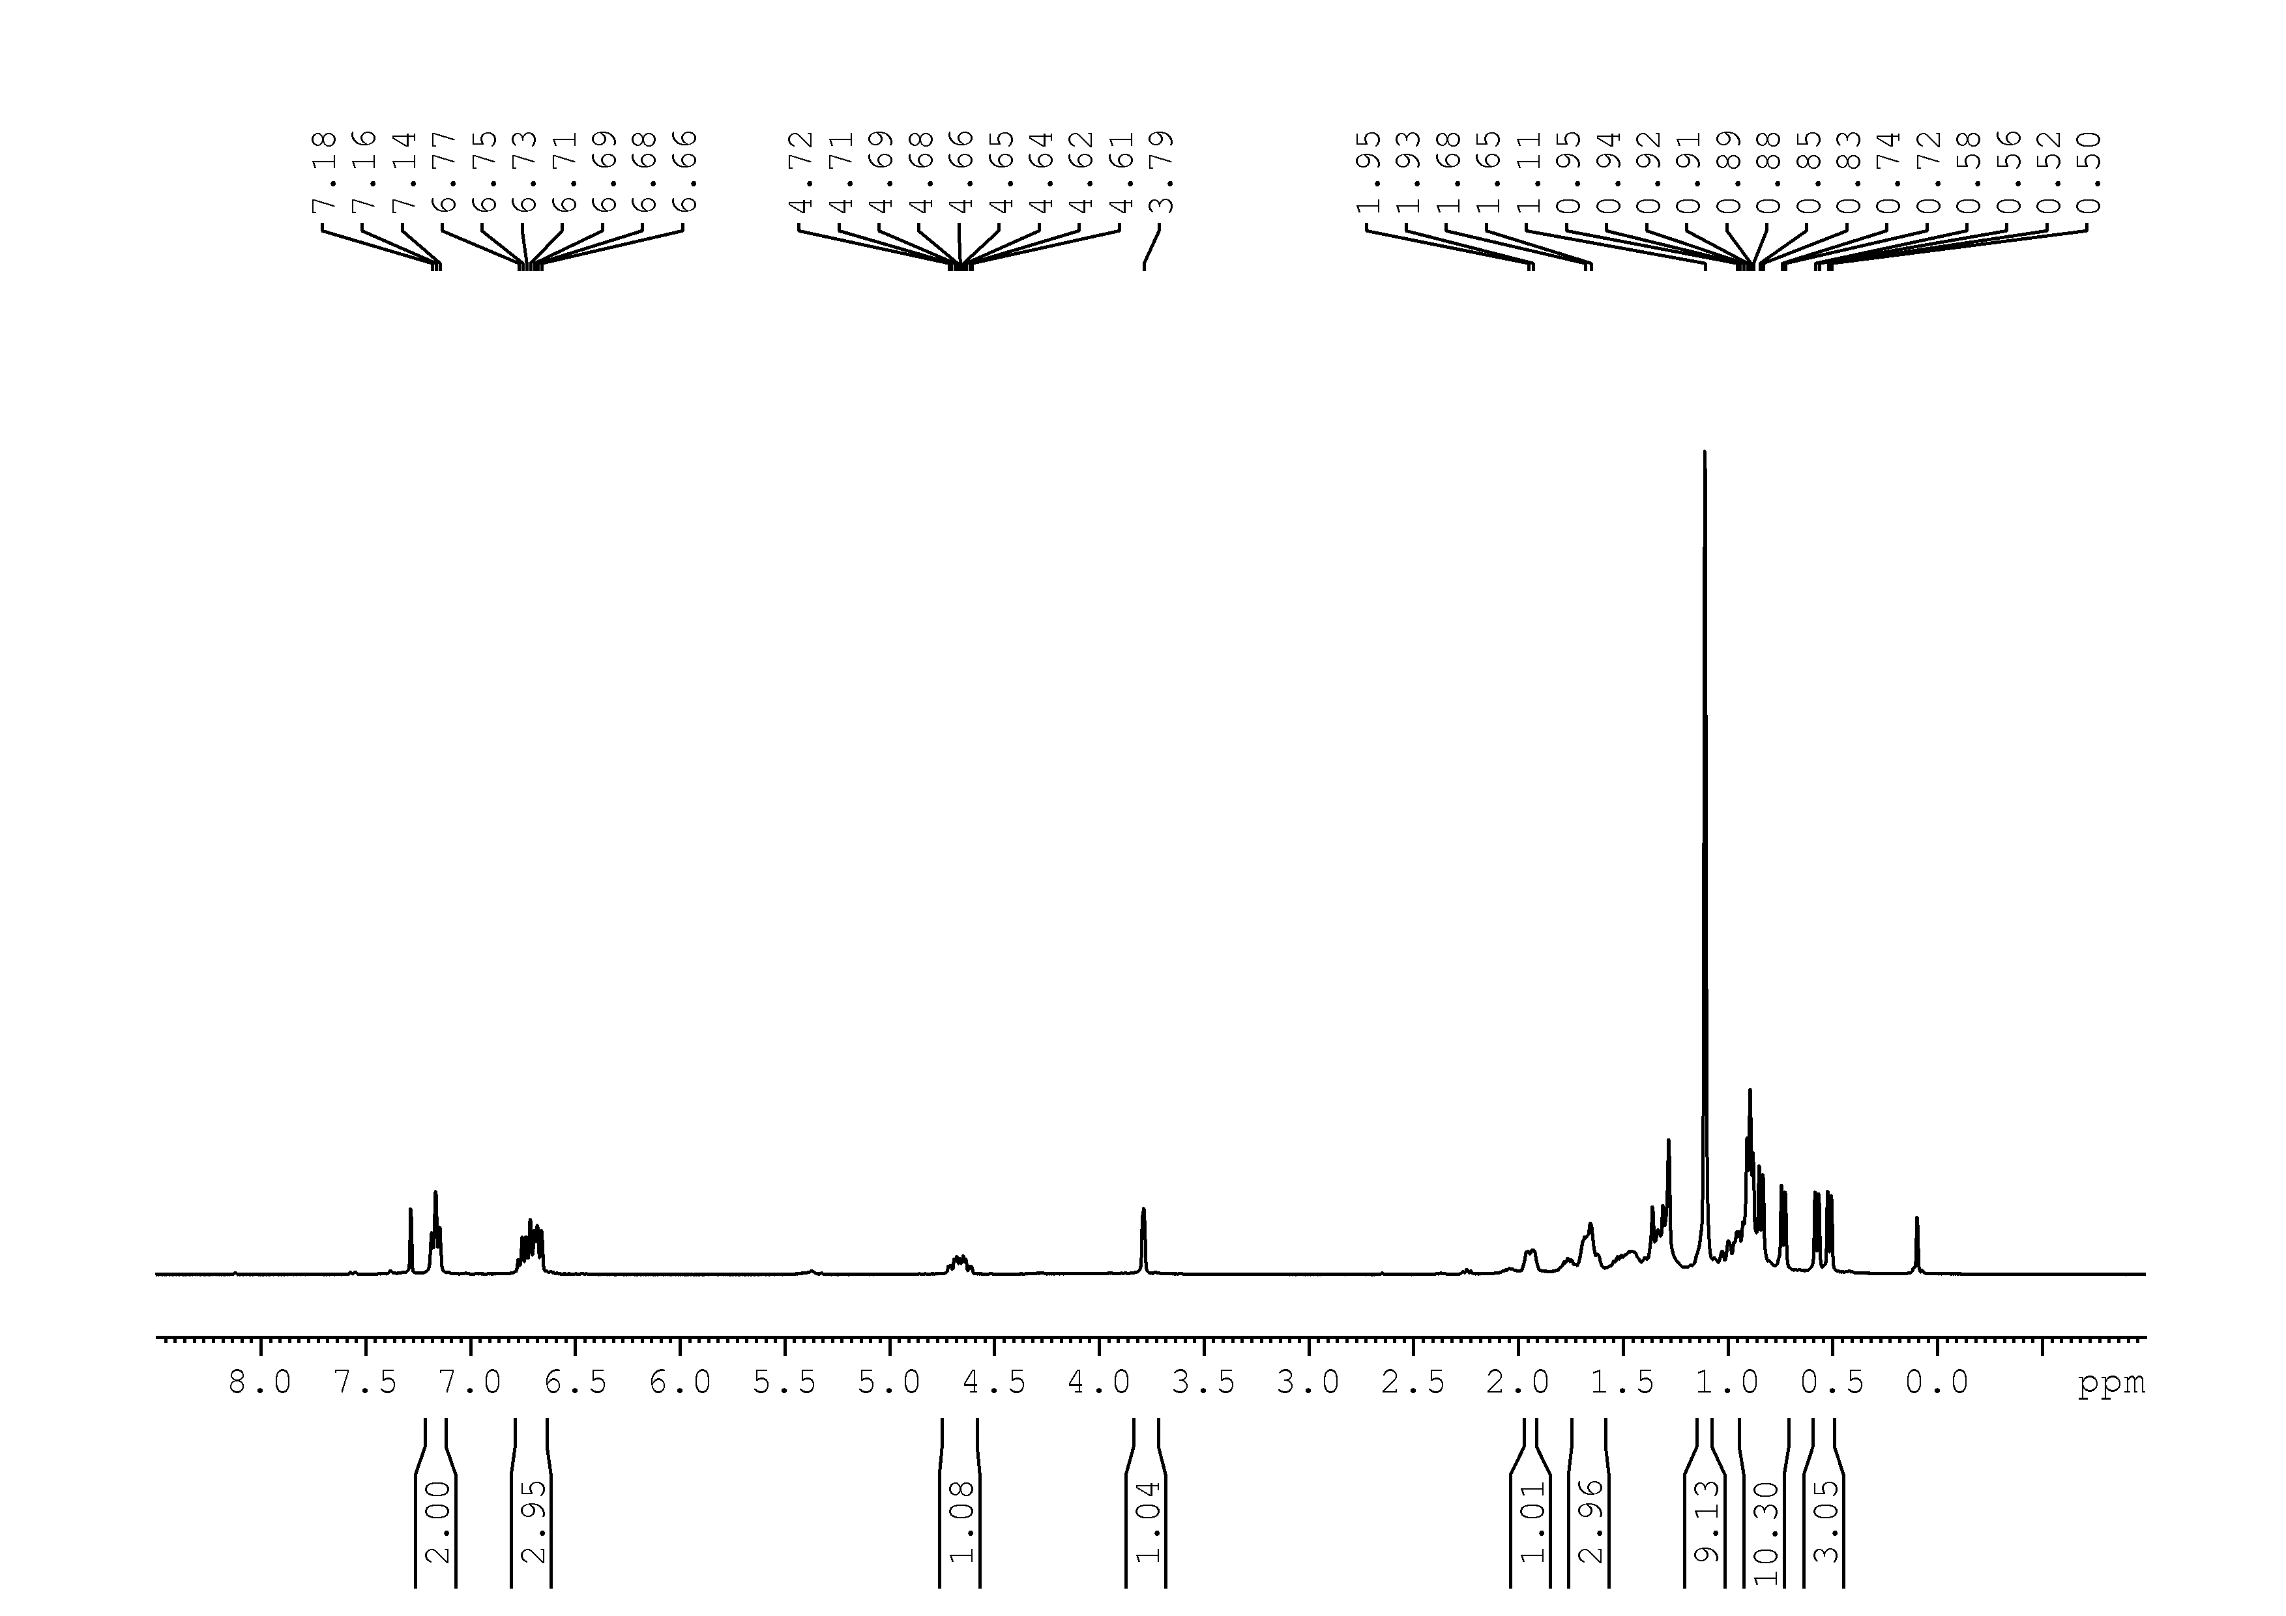

54
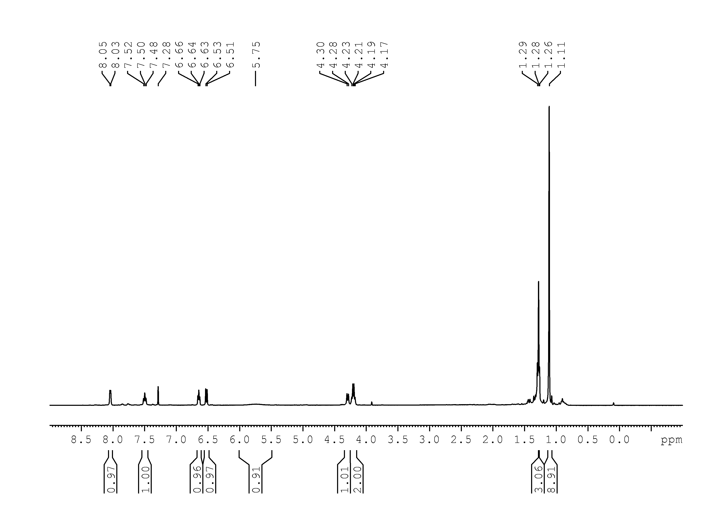
55
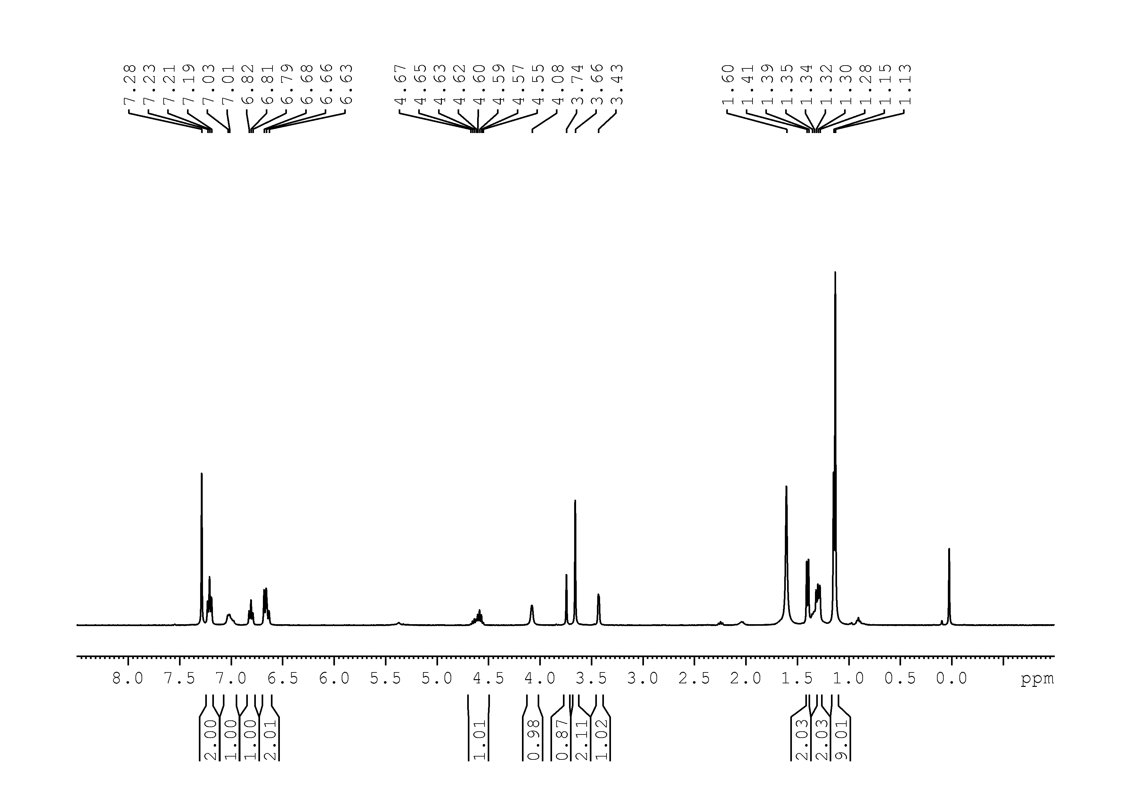

56
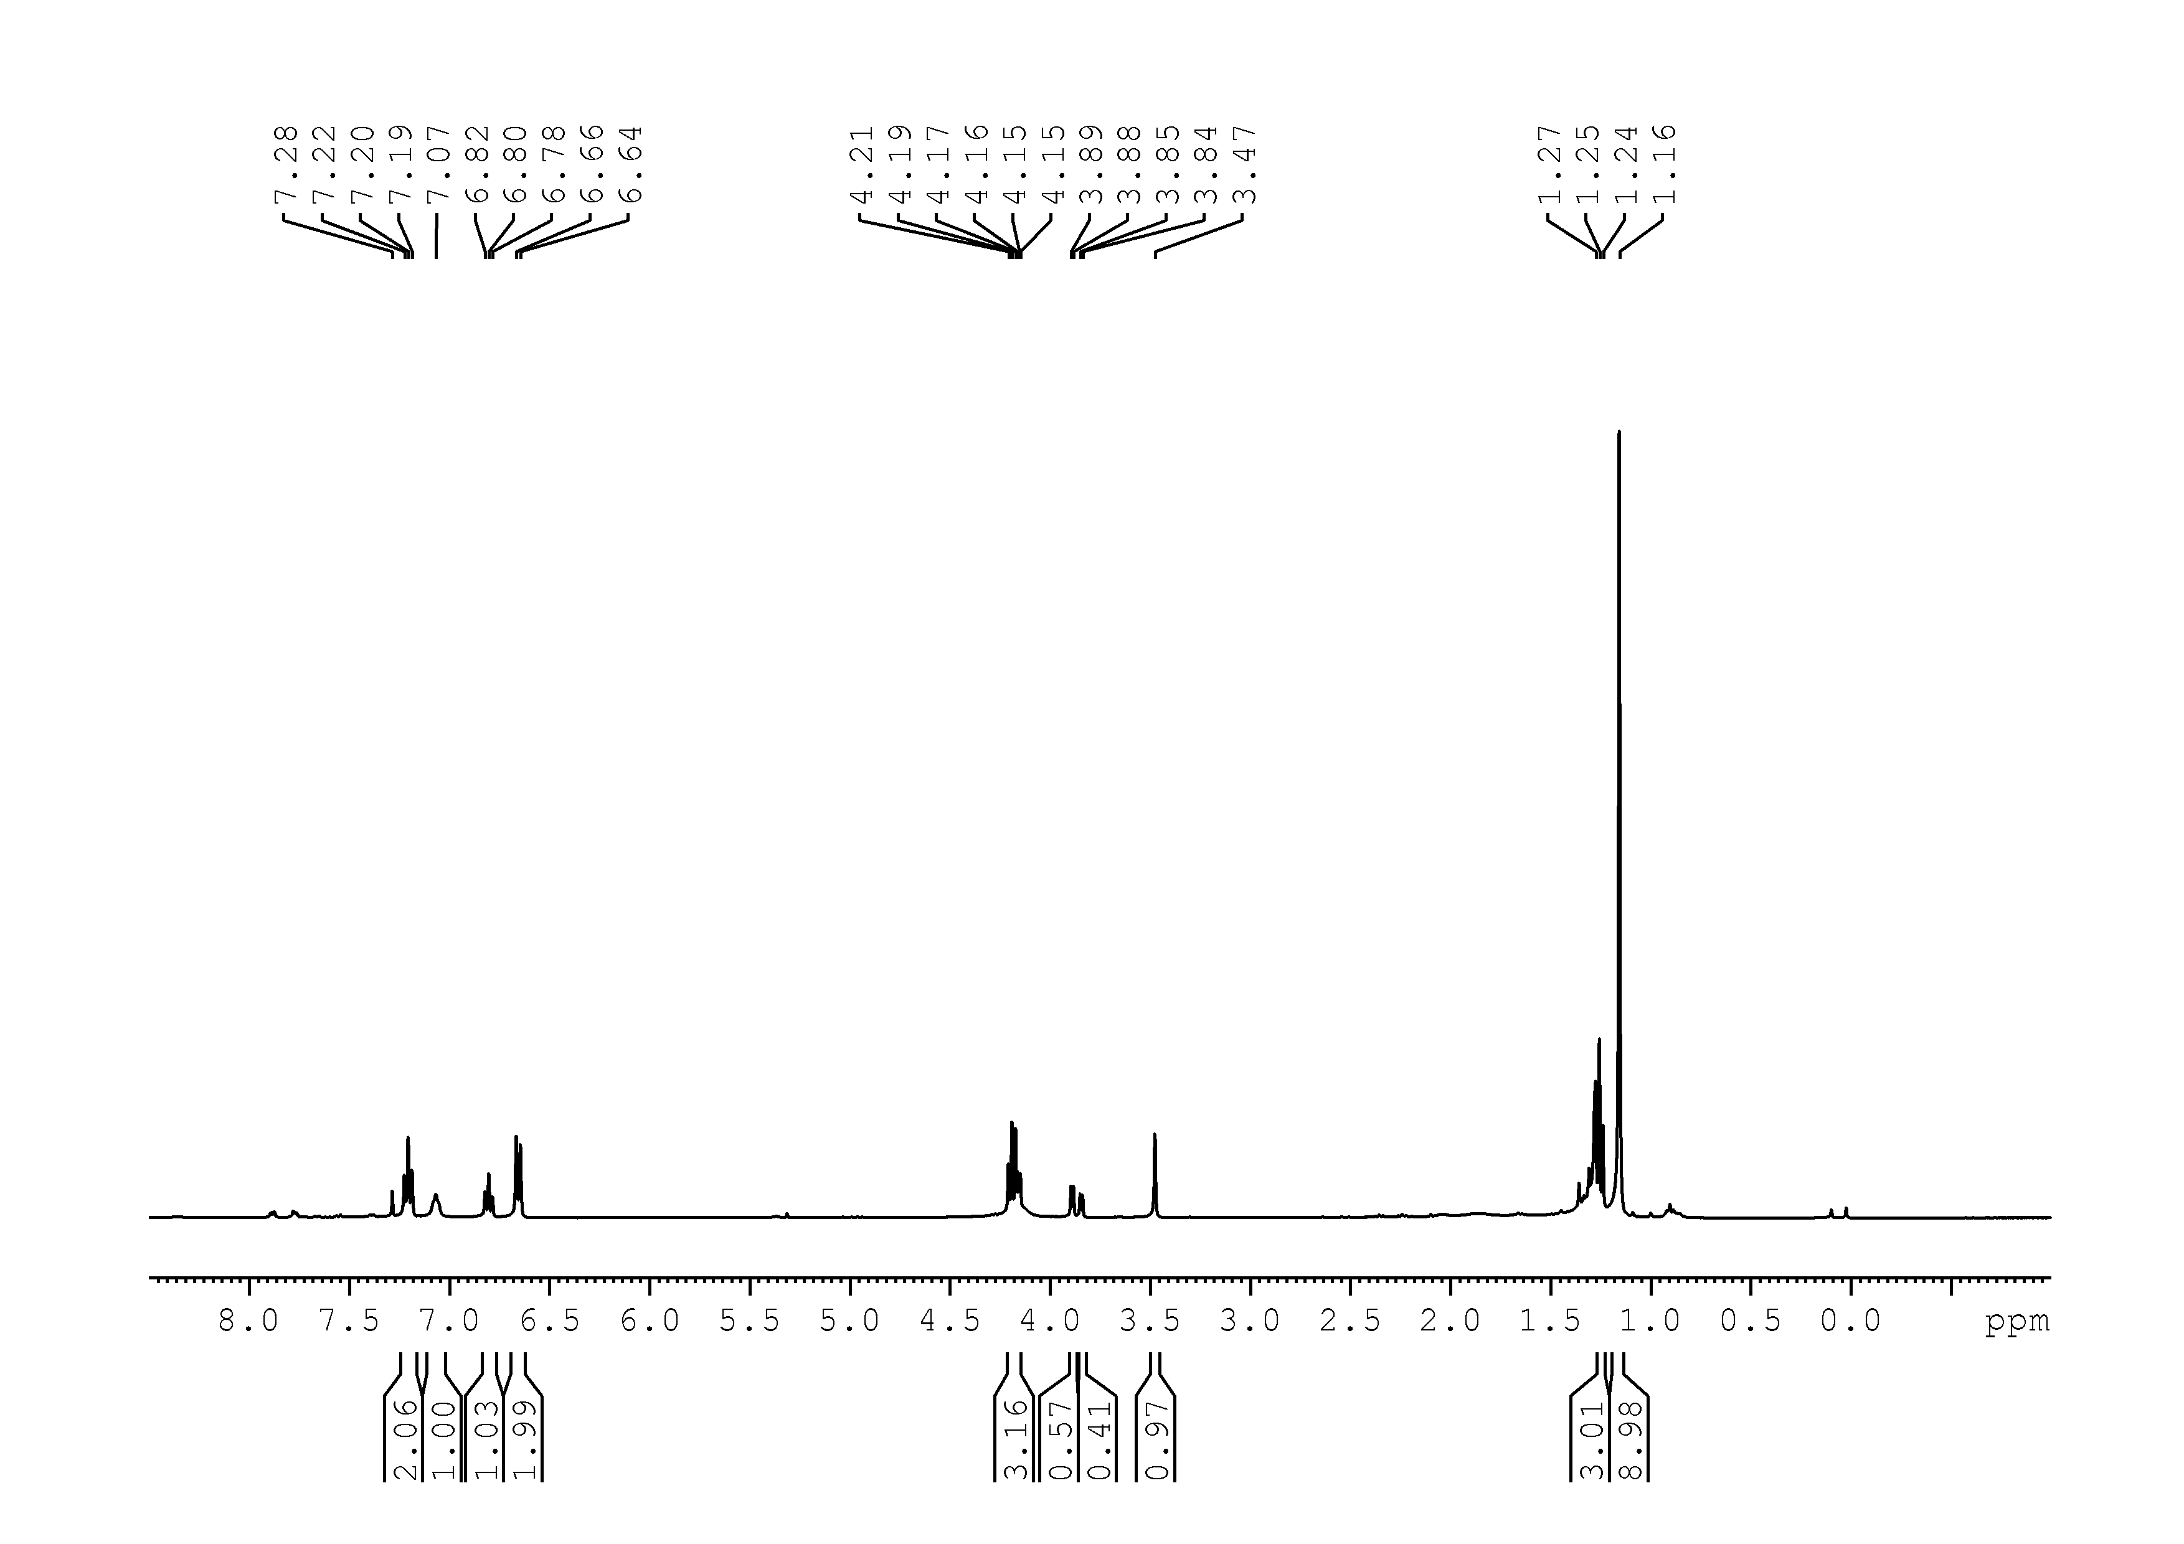
57
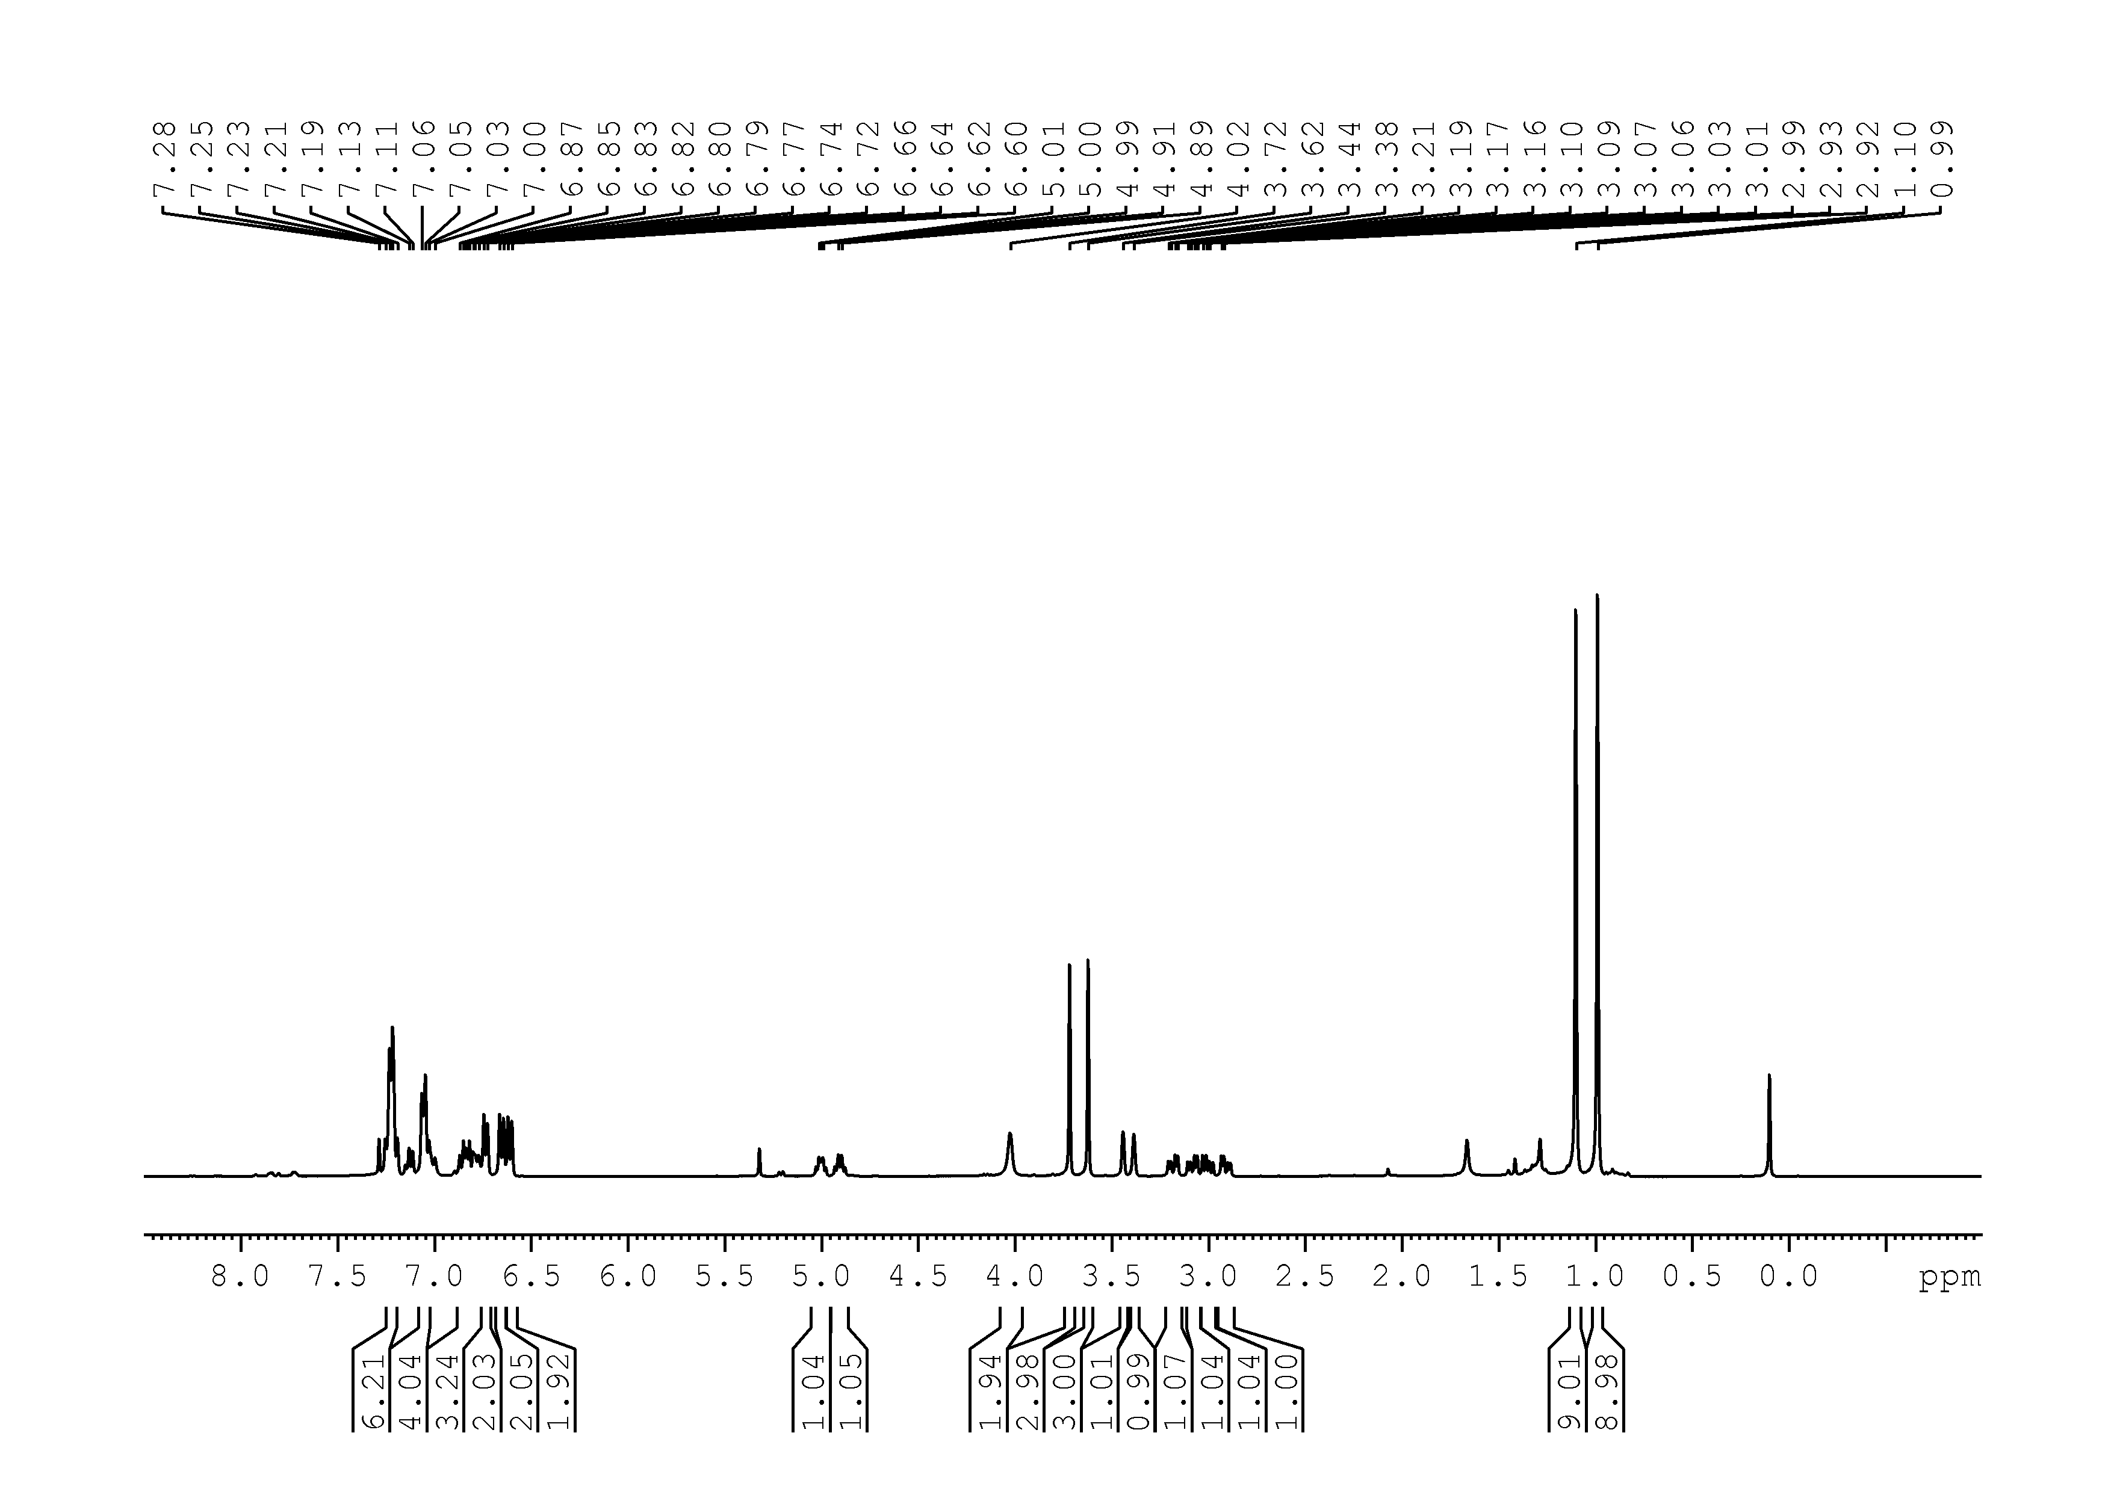

58
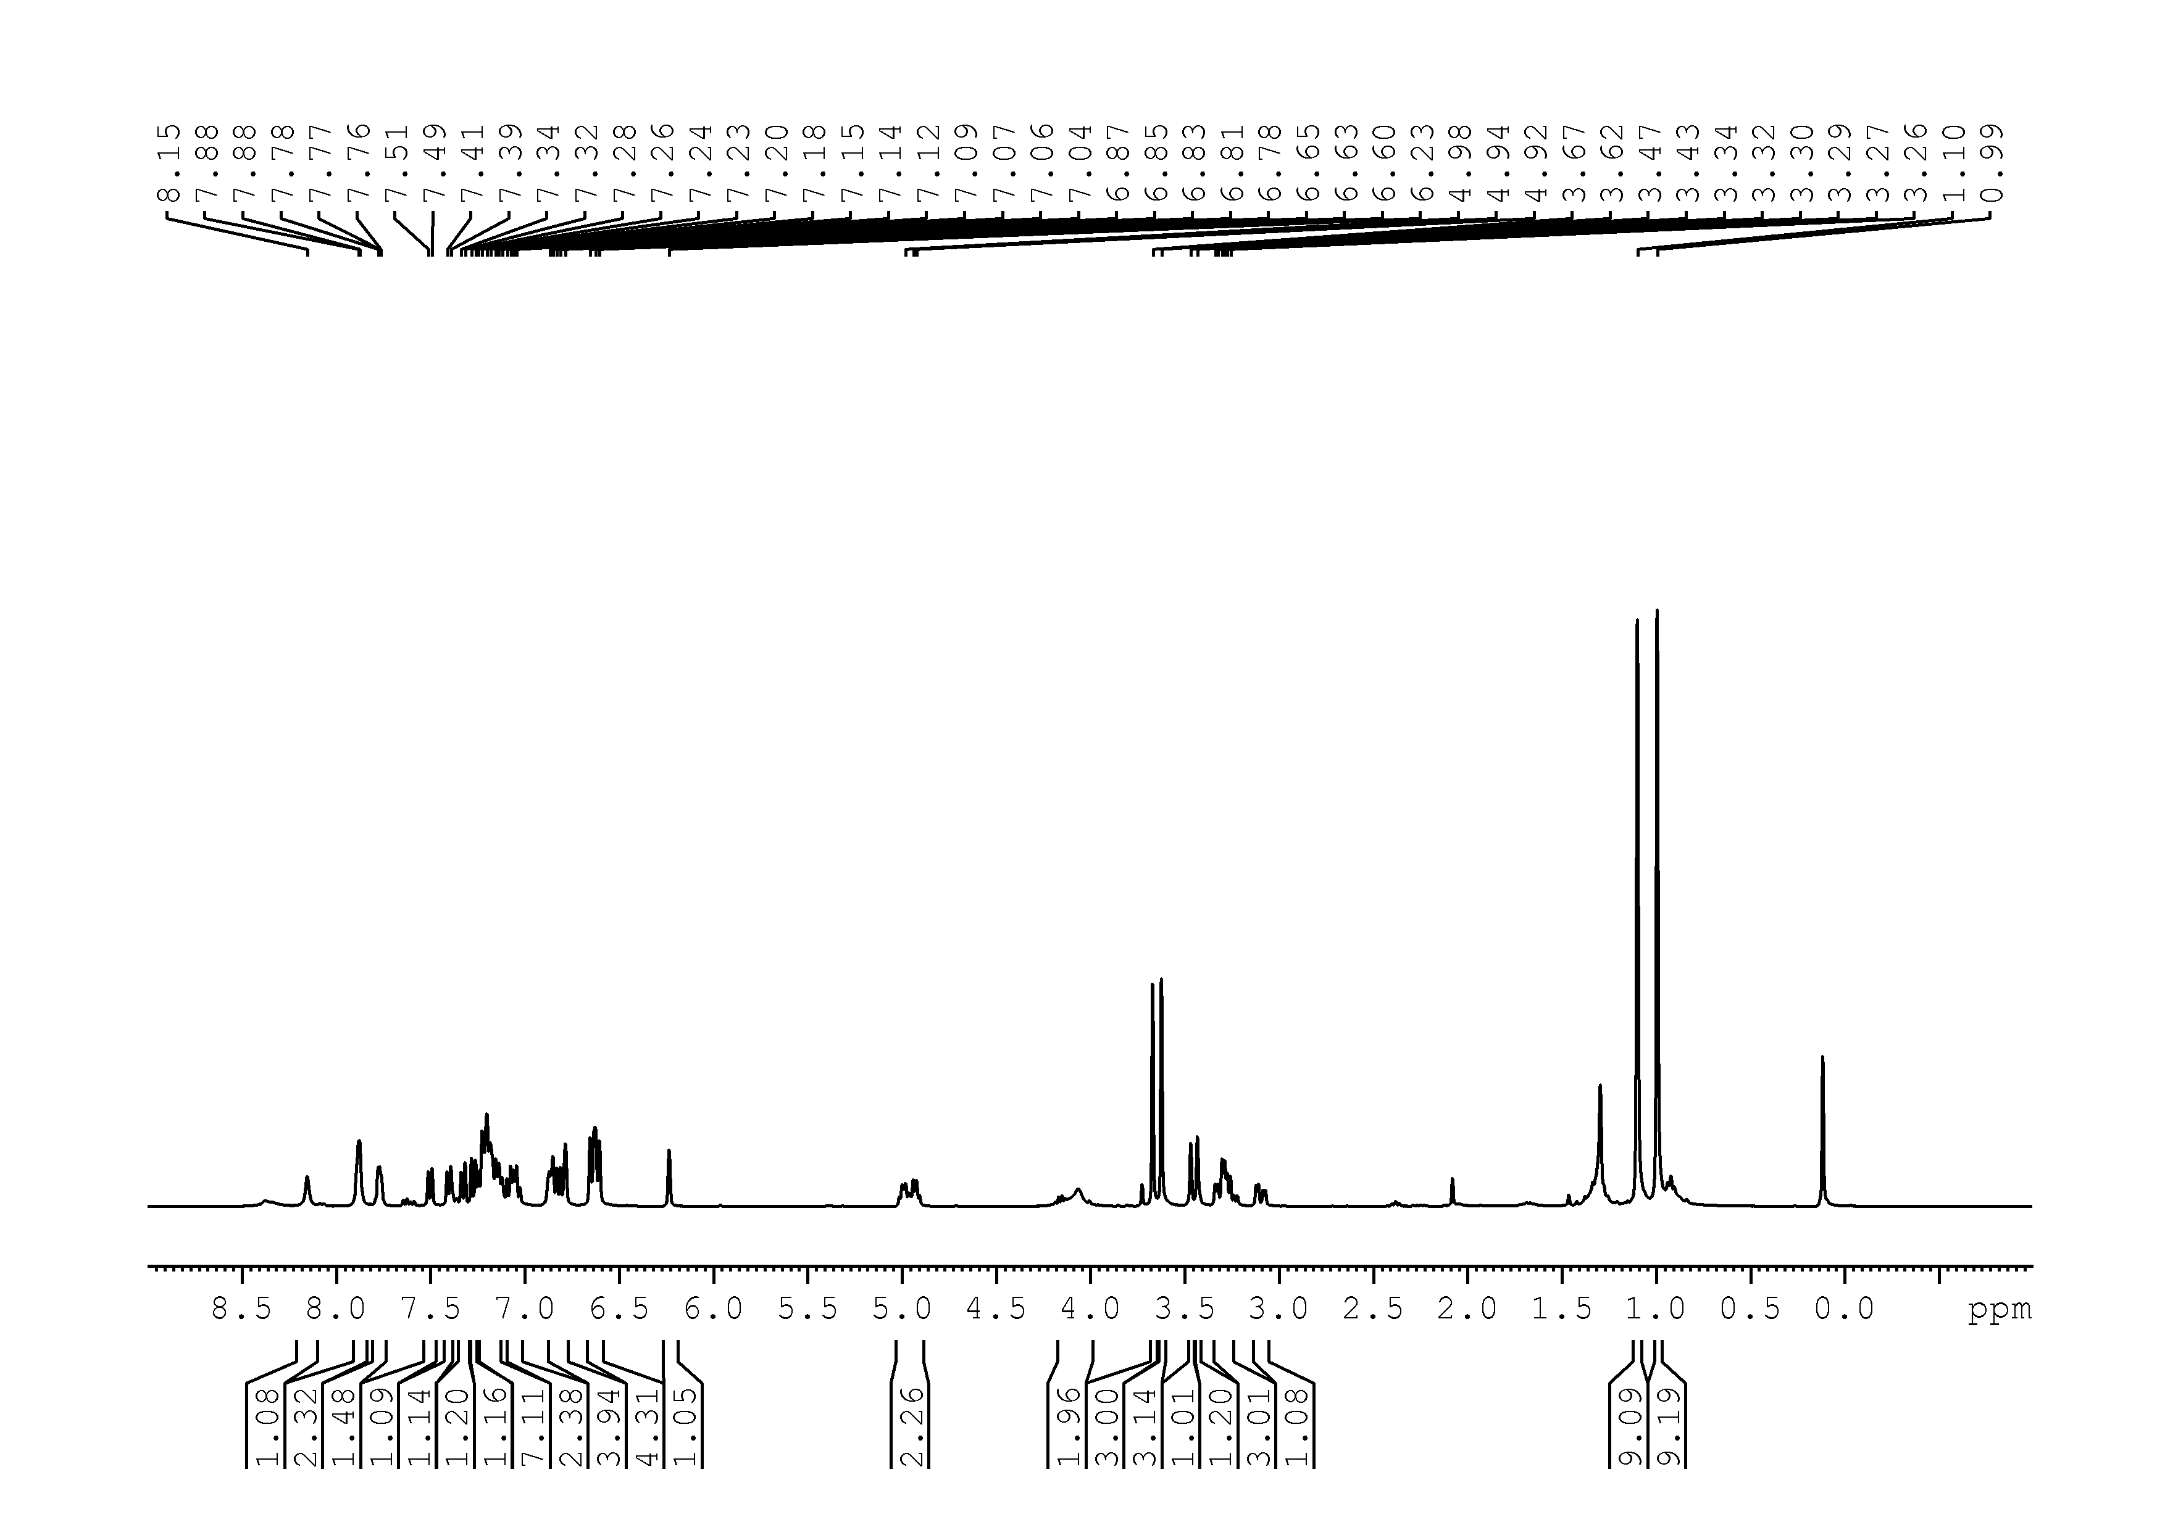
59

60
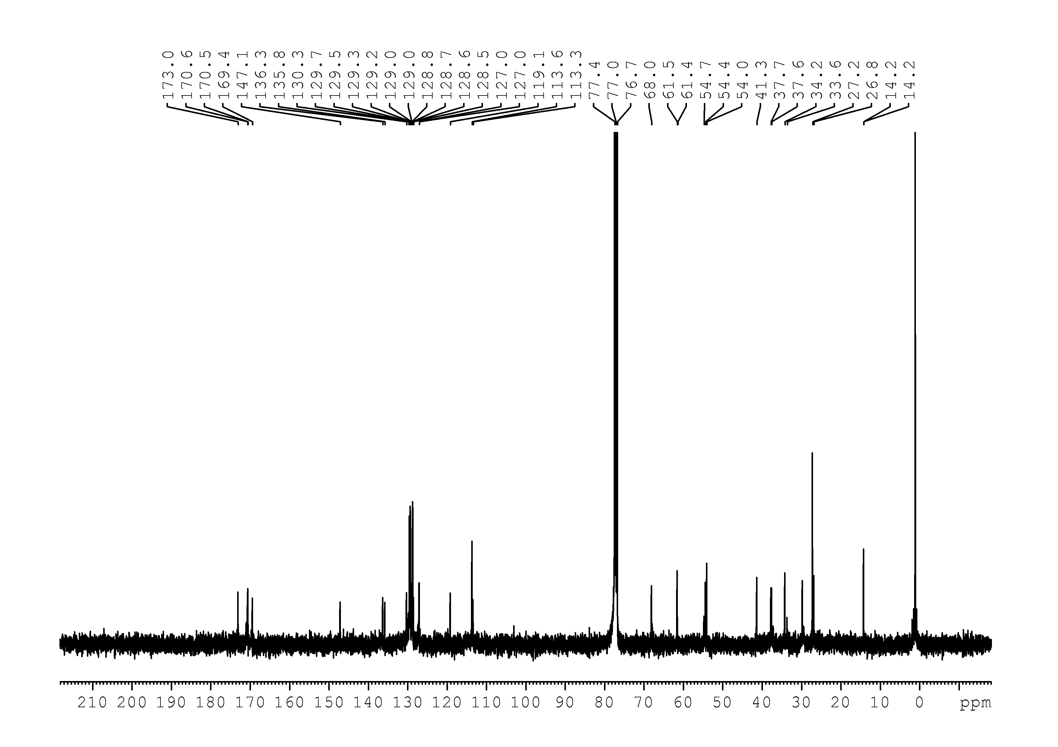
61
1s
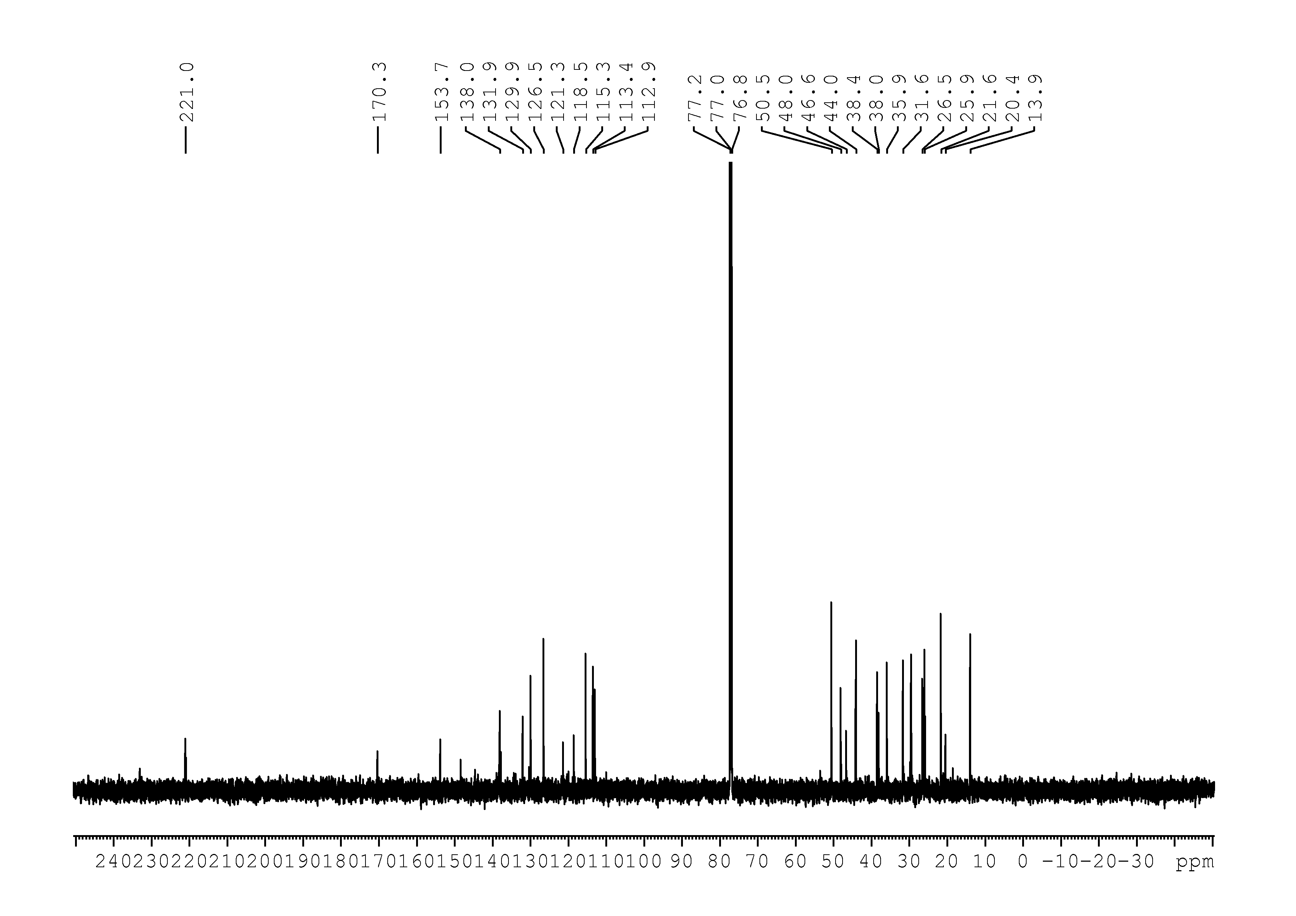

1t
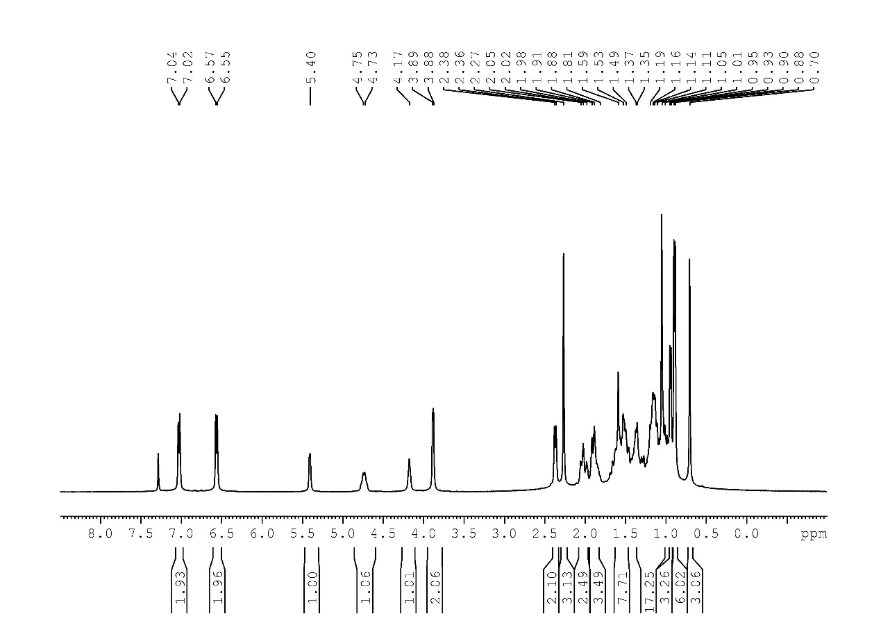
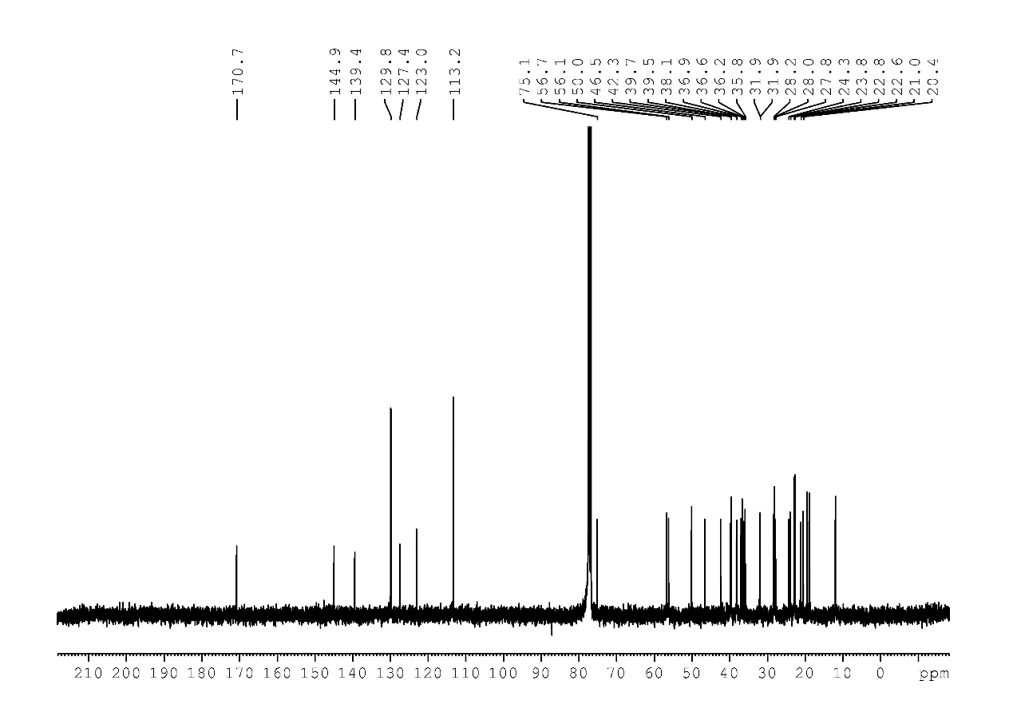
1ad
1ae

1af
2e
2h

2i
2j

2o

2p

2q

2r

2aa
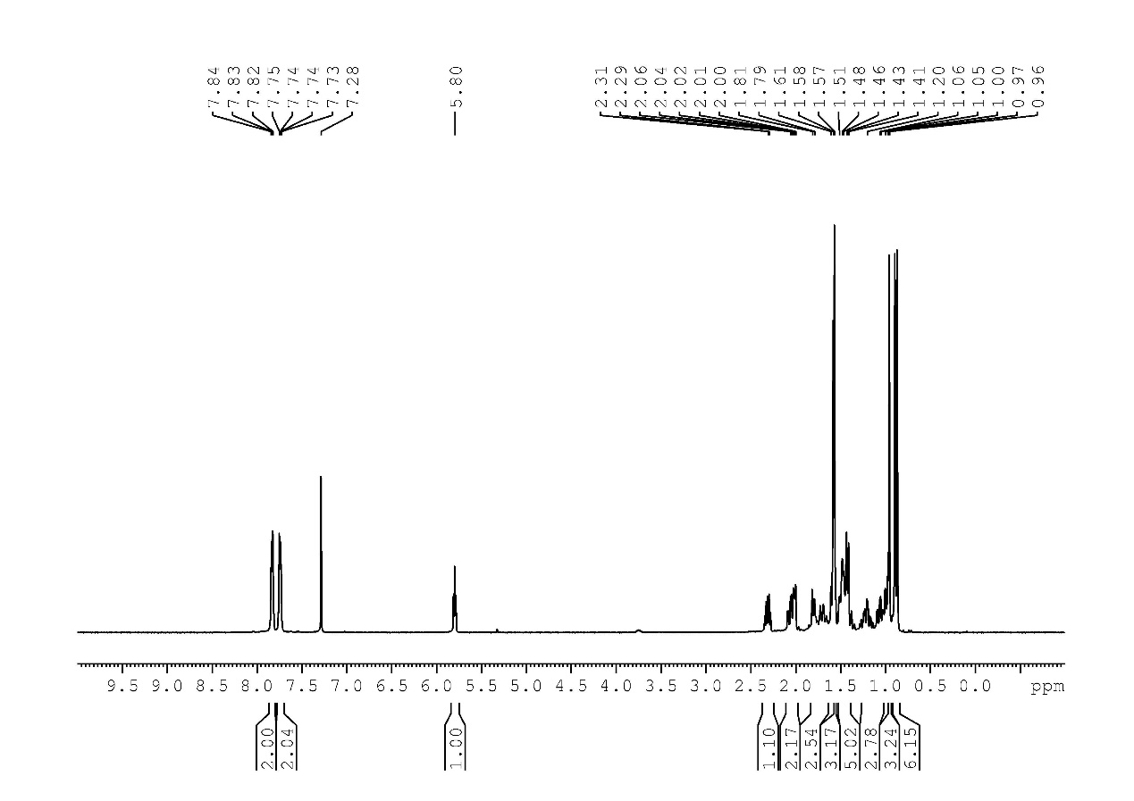
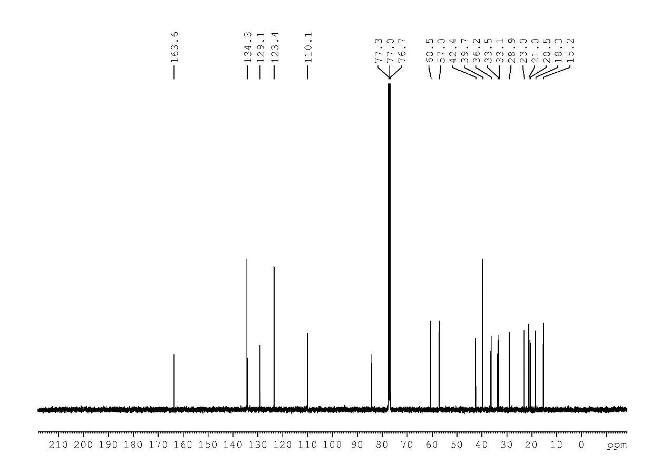
2ab

2ac
2ae
2af

2y

