Enhanced sonocatalytic performance of PEG-modified hierarchical Cu₂ZnSnS₄ microspheres in Methylene Blue degradation

Xuemei Hu^{1,2}, Junqiang Qiao^{1,2*}, Jianping Zhou^{1,2}, Jianqing Bao¹, Wei He¹
1. Gansu Natural Energy Research Institute, Lanzhou730046, China
2. Key Laboratory of Photovoltaic, Gansu Province, Lanzhou730046, China

* Corresponding author
E-mail address: qiao@gsas.ac.cn
Tel: +86 931 8386604; Fax: +86 931 8386604

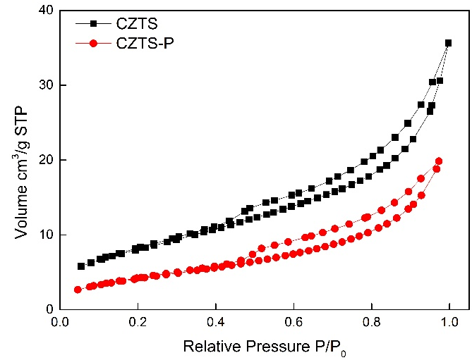

Figure S1 N₂ sorption isotherms of as-prepared CZTS samples

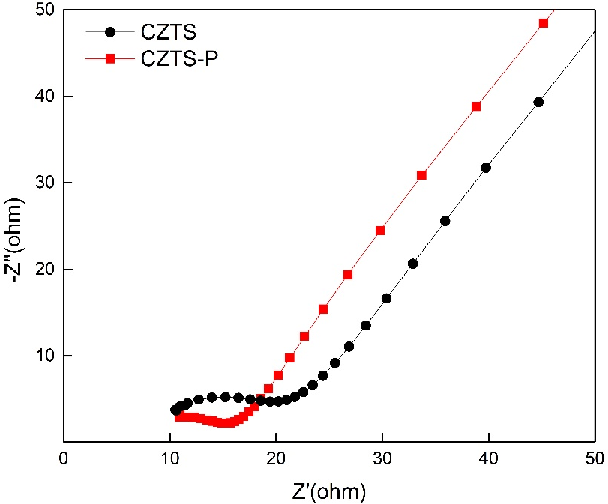
Figure S2 Nyquist plots of as-prepared CZTS samples
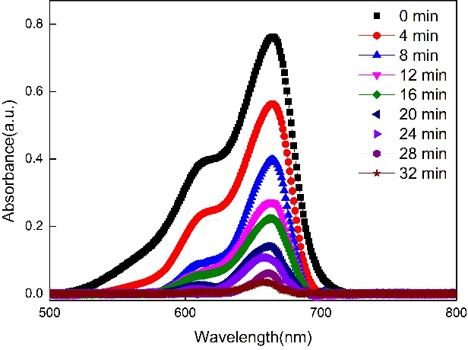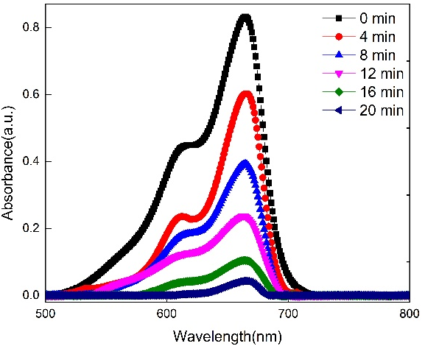
Figure S3 UV–vis absorption spectra variation of MB dye over hierarchical CZTS microspheres (a)CZTS; (b)CZTS-P

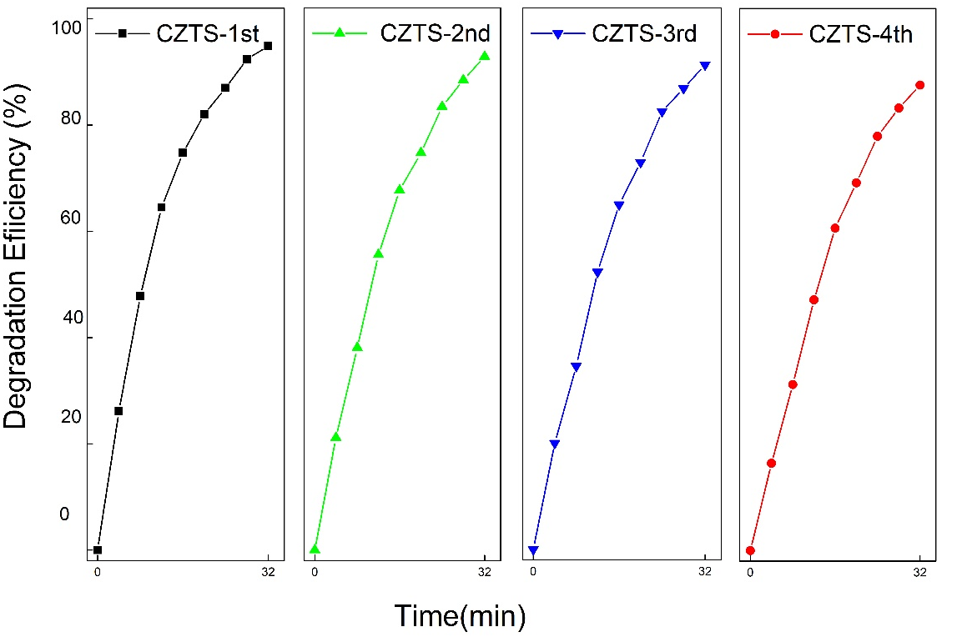

Figure S4 Reusability behavior of hierarchical CZTS sonocatalyst in degradation of MB dye

