Additional Figures for

Activity of deep low-frequency earthquakes associated with the 2018 eruptions of the Kirishima volcano
Ryo Kurihara and Aitaro Kato
Corresponding author: Ryo Kurihara (kurihara@onken.odawara.kanagawa.jp)
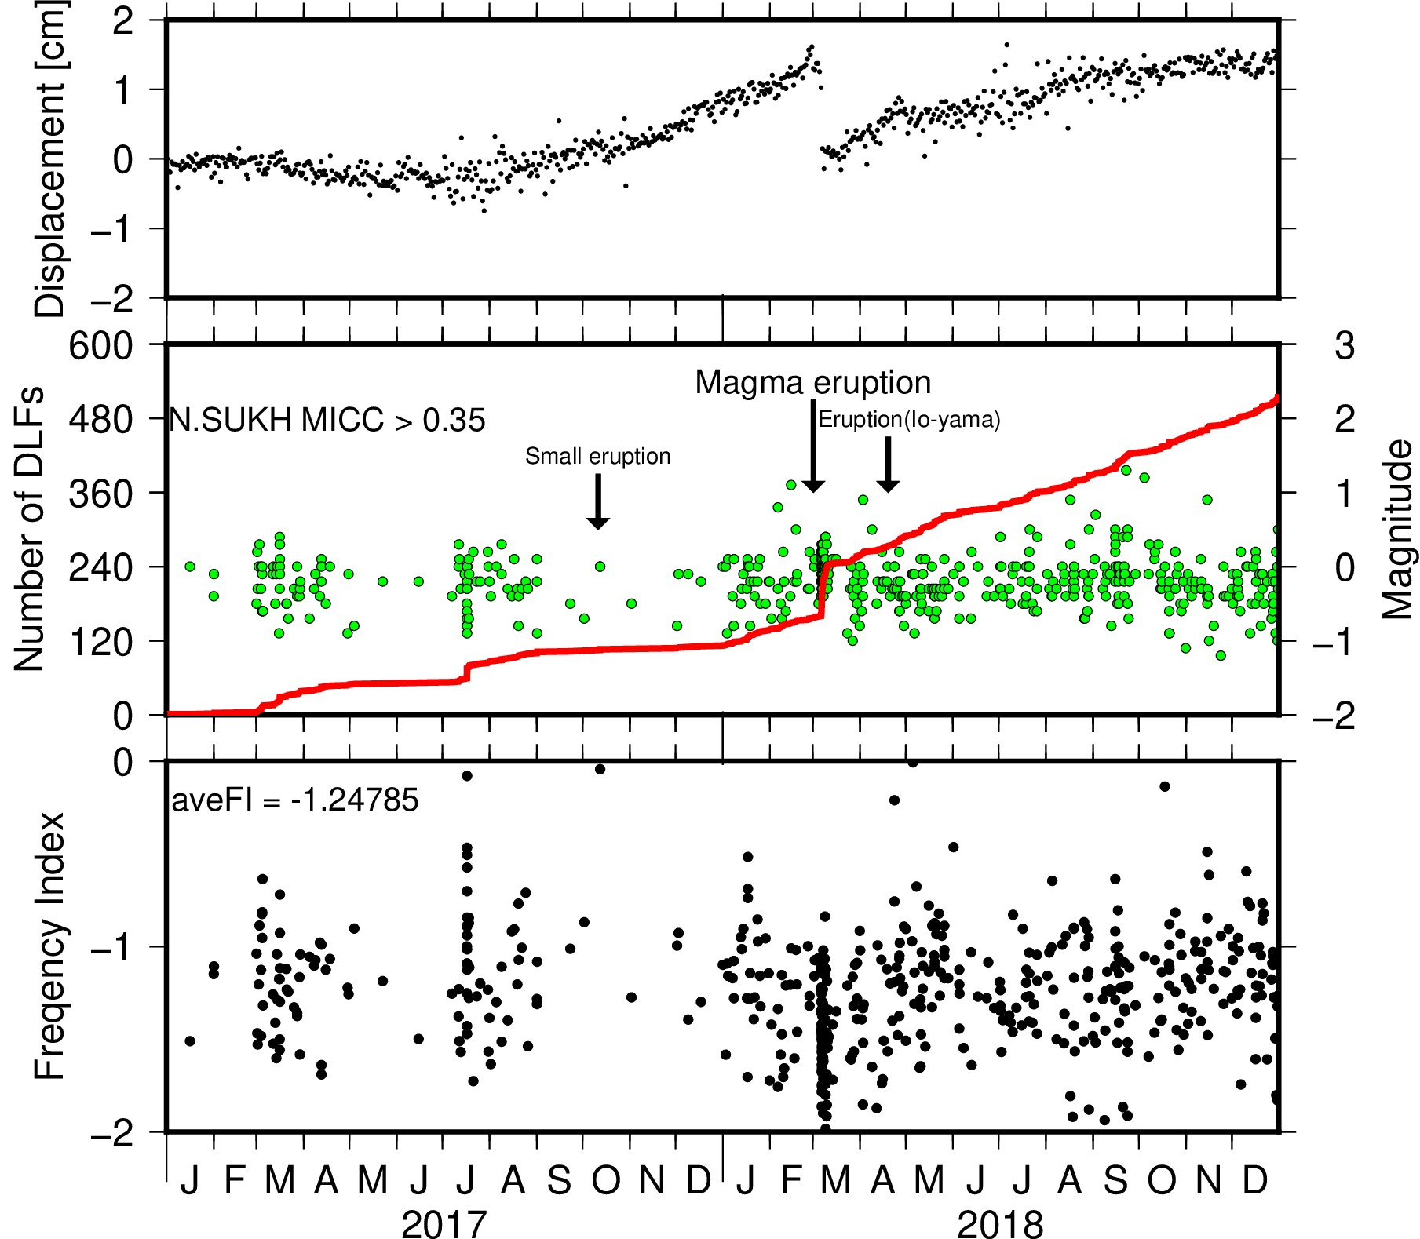
Figure S1. (a) The amount of the horizontal displacement of Ebino relative to Makizono (see Figure 1) calculated from GNSS data in 2017-18. We use F3 solutions provided by Geospatial Information Authority of Japan. (b) Cumulative number of DLF earthquakes (red line) and magnitude of DLF earthquakes (green circle) for all events automatically detected. (c) Frequency index (FI) of DLF earthquakes.

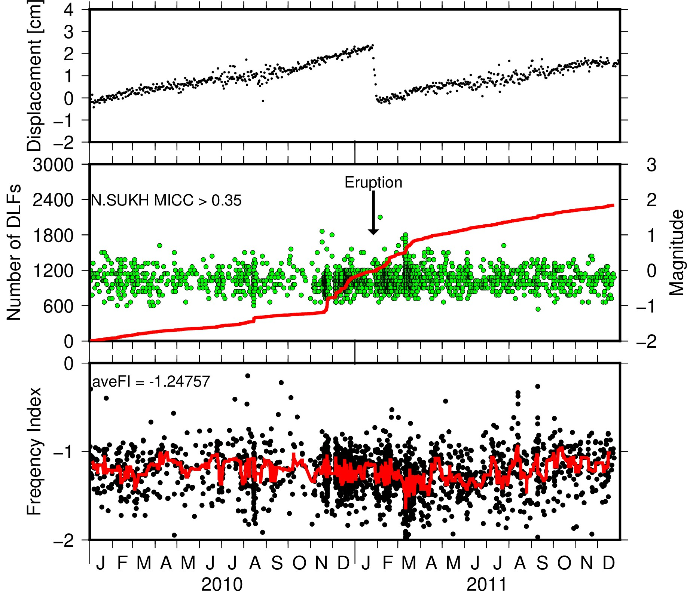
Figure S2. (a) The amount of the horizontal displacement of Ebino relative to Makizono (see Figure 1) calculated from GNSS data in 2010–2011. We use F3 solutions provided by Geospatial Information Authority of Japan. (b) Cumulative number of DLF earthquakes (red line) and magnitude of DLF earthquakes (green circle). (c) Frequency index (FI) of DLF earthquakes and median value of FI in a moving window with the 15 events (7 events before the target event and 7 events after the target event) window.

