Advanced Drug Delivery of Paclitaxel with Thermoresponsive Water-soluble Micelles for Ovarian Cancer

Ji-Hye Kang§, Ji-Young Hwang§, Young Jae Cho§, Sang-Yu Park, Jung-Joo Choi, E-Sun Paik, Jeong-Won Lee*, Ueon Sang Shin*

Ji-Hye Kang and Ueon Sang Shin
Department of Nanobiomedical Science & BK21 NBM Global Research Center for Regenerative Medicine, Dankook University, 119 Dandae-ro, Dongnam-gu, Cheonan 31116, South Korea
Institute of Tissue Regeneration Engineering (ITREN), Dankook University, 119 Dandae-ro, Dongnam-gu, Cheonan 31116, Republic of Korea

Ji-Young Hwang
Convergence Research Division, Korea Carbon Industry Promotion Agency (KCARBON), 110-11 Ballyong-ro, Deokjin-gu, Jeonju 54853, Republic of Korea

Young-Jae Cho, Jung-Joo Choi and Jeong-Won Lee
Department of Obstetrics and Gynecology, Samsung Medical Center, Sungkyunkwan University School of Medicine, 81 Irwon-ro, Gangnam-gu, Seoul 06351, Republic of Korea

E-Sun Paik
1Department of Obstetrics and Gynecology, Kangbuk Samsung Hospital, Sungkyunkwan University School of
Medicine, Seoul, Republic of Korea
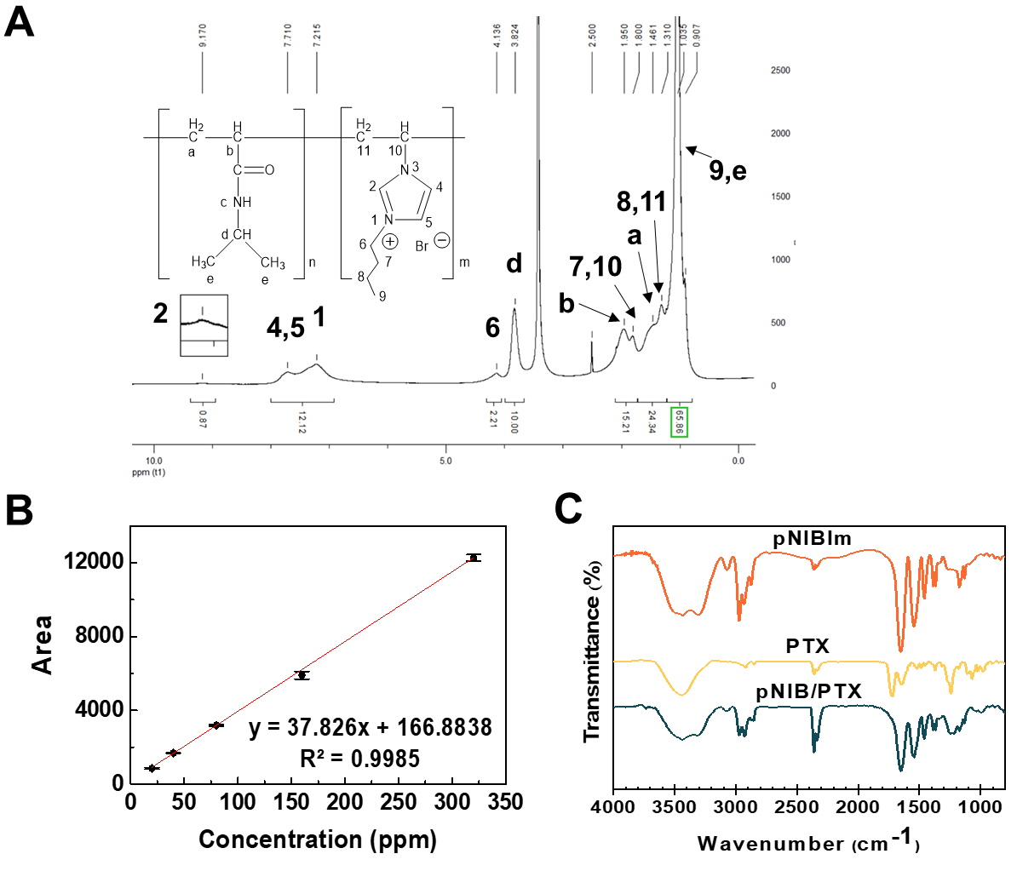
¹H-NMR (d6-DMSO): (ppm) 0.90 (bt, 3H-9), 0.97~1.17 (bd, 6H-e), 1.28~1.39 (bm + bd, 2H-8 + 2H-11), 1.40~1.71 (bd, 2H-a), 1.73~1.88 (bm + bt, 2H-7 + 1H-10), 1.89~2.45 (bt, 1H-b), 3.84 (bm, 1H-d), 4.15 (bt, 2H-6), 6.90~7.64 (bt, 1H-c or 1NH), 7.65~7.95 (bd + bd, 1H-4 + 1H-5), 9.80 (bs, 1H-2).

Fig. S1. Characteristic analysis of pNIB and pNIB complex. (A) ¹H-NMR spectrum of pNIB copolymer showed characteristic peaks and (B) Calibration curves created by plotting the known PTX concentrations on the x axis and the concentrations of PTX quantified by HPLC on the y-axis. (C) FT-IR spectra of PTX, pNIB, and pNIB/PTX-3 complex.

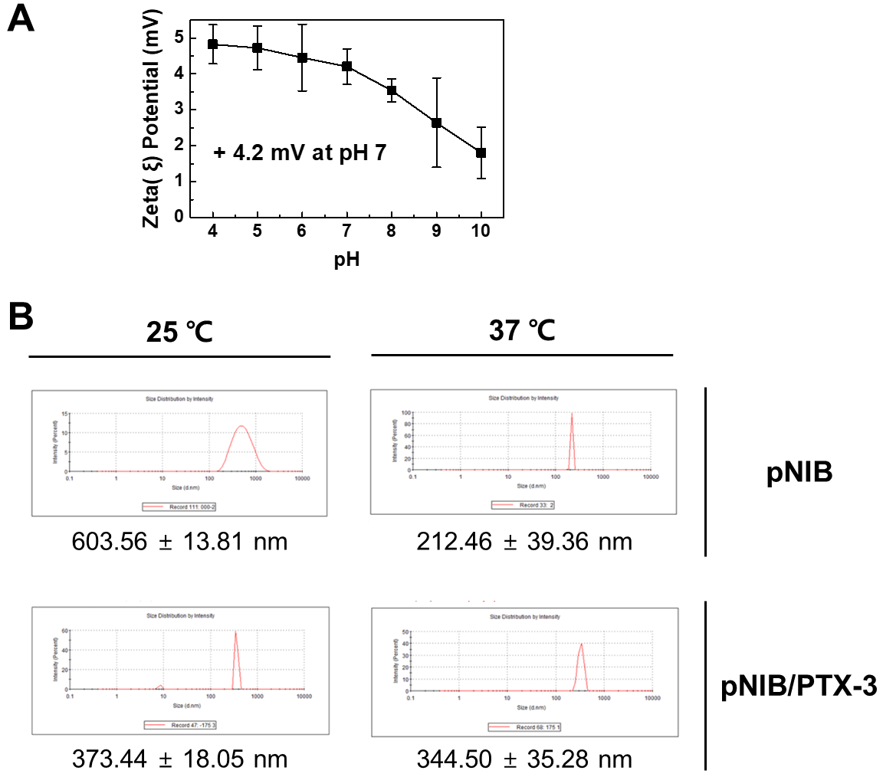
Fig. S2. Characterization of the pNIB/PTX micelle complexes. (A) The Zeta (ξ) potentials of pNIB at pH 4–10. (B) Size distribution curves for pNIB and pNIB/PTX-3 micelles samples measured by Zeta Sizer nano ZS90 (Malvern, France). The size distribution curves were almost symmetrical to the vertical line passing through the maximum, in all cases. The maximum value is the average size and the distance between the two ends at the base is reflected in the standard deviations.

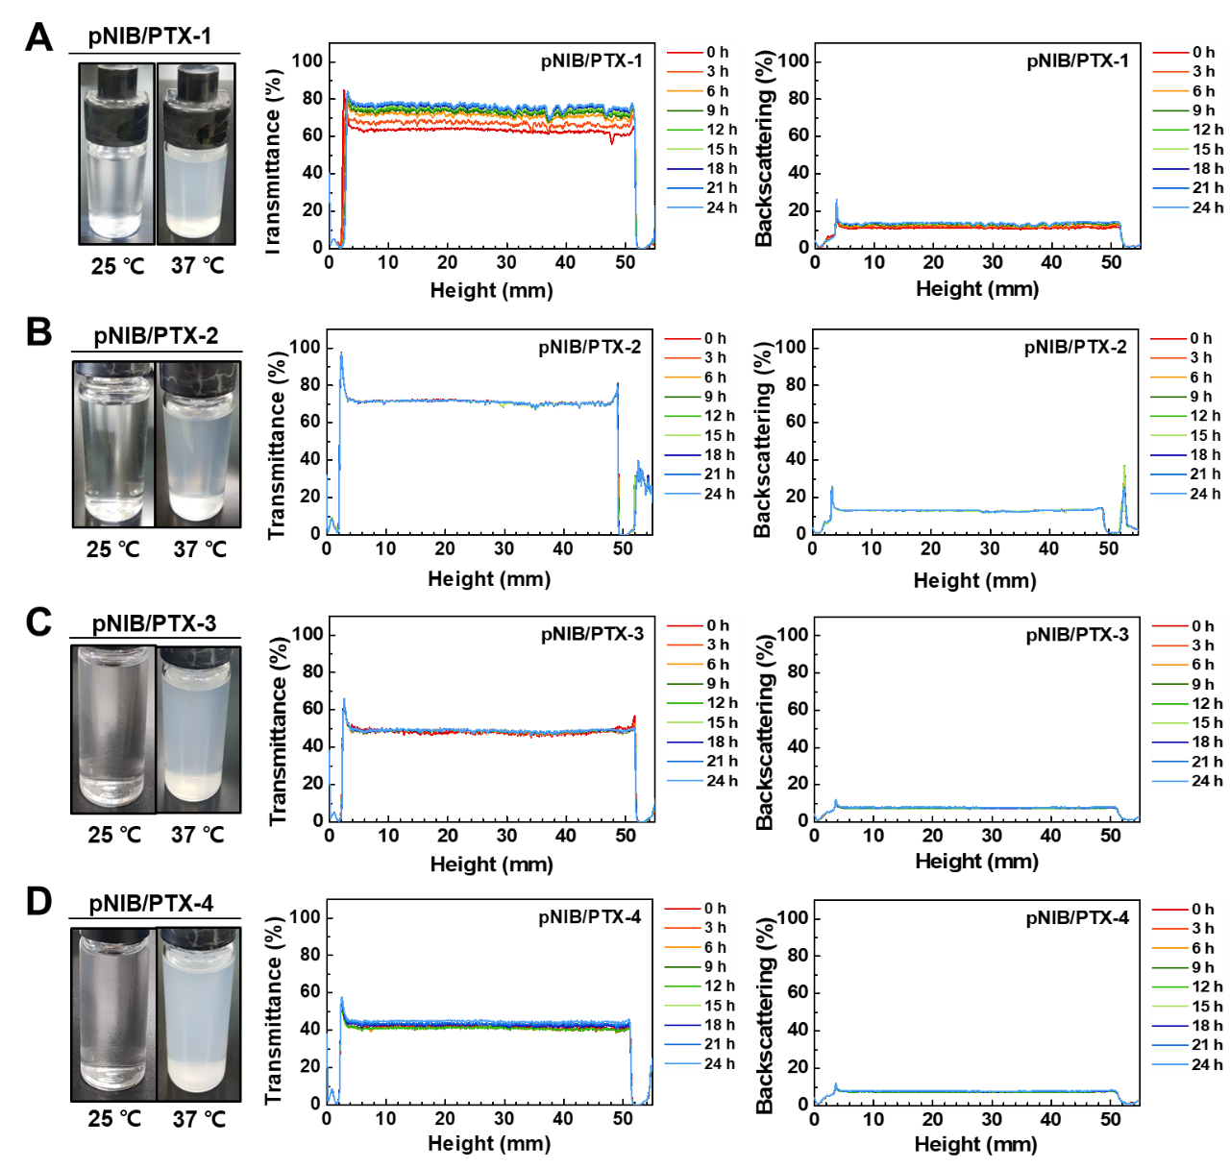
Fig. S3. Solubility analysis of temperature-responsive micelles in the aqueous solution. Colloidal stability of pNIB/PTX-1 (A), pNIB/PTX-2 (B), pNIB/PTX-3 (C), and pNIB/PTX-4 (D) complex solutions (0.25 mg/mL) in PBS at 37 ºC was conducted using TurbiScane Lab. Photographic images comparing pNIB/PTX exposed at 37 ℃ for 24 hours to a 25 ℃ control (left panel). Full spectrum of Dispersion stability test for 24 hours (C) The values are displayed as backscattering in percentage for 24 hours (right panel).

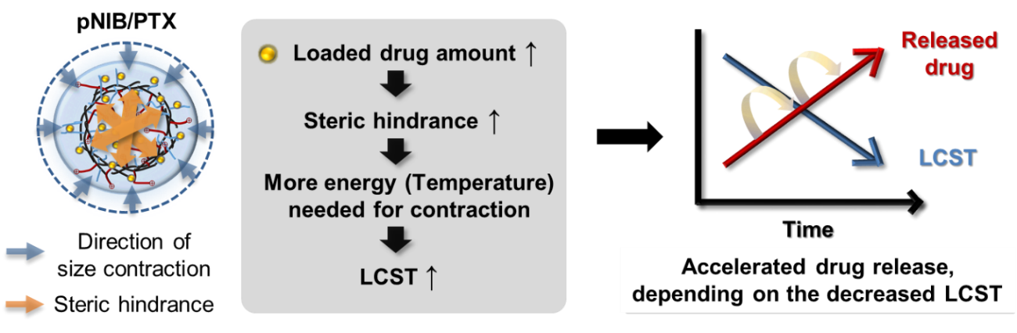
Fig. S4. Schematic illustration of drug loading and releasing according with LCST. This shows the theoretical mechanisms of increasing LCST and temperature-induced multi-step DDS, which decreases the drug loading in micelle, thereby reducing the LCST and accelerating the drug release.

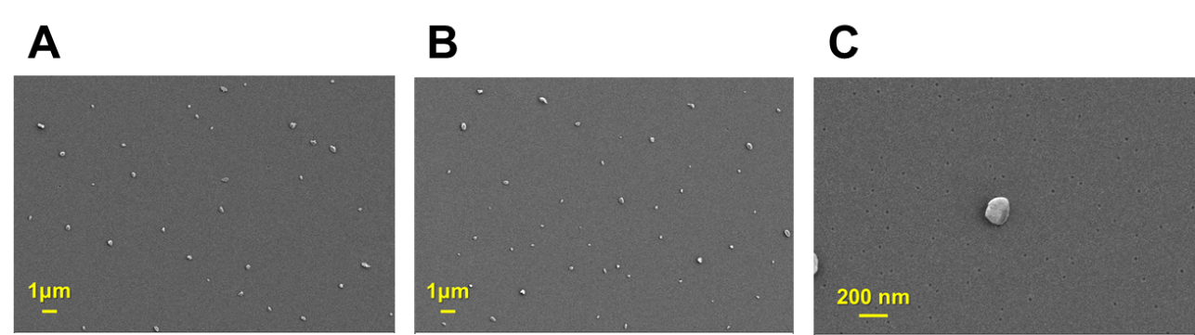
Fig. S5. Additional FE-SEM images of pNIB at 25 ℃.

Table S1. Characteristic parameters of pNIB and pNIB/PTX complex depending on different temperature.

Sample name | Temperature (℃) | Size (nm) | Contraction ratio (%)
pNIB | 25 ℃ | 279.27 ± 75.27 | 0 %
pNIB | 37 ℃ | 43.85 ± 14.49 | 84.30 %
pNIB | 40 ℃ | 41.65 ± 13.35 | 85.09 %
pNIB/PTX-3 | 25 ℃ | 87.76 ± 22.78 | 0 %
pNIB/PTX-3 | 37 ℃ | 63.24 ± 10.96 | 27.94 %
pNIB/PTX-3 | 40 ℃ | 56.13 ± 17.80 | 36.04 %

