Iontronic pressure sensor with ultra-board linearity range and high sensitivity enabled by laser-induced gradient pyramidal structures
Ruoxi Yang^{1, 2}, Ankan Dutta², Bowen Li², Naveen Tiwari², Wanqing Zhang², Zhenyuan Niu², Yuyan Gao², Daniel Erdely², Xin Xin², Tiejun Li^{1*}, Huanyu Cheng^{2*}
¹School of Mechanical Engineering, Hebei University of Technology, Tianjin, 300401, China
²Department of Engineering Science and Mechanics, The Pennsylvania State University, University Park, 16802, USA
*To whom correspondence should be addressed: E-mail: huanyu.cheng@psu.edu and li_tiejun@hebut.edu.cn

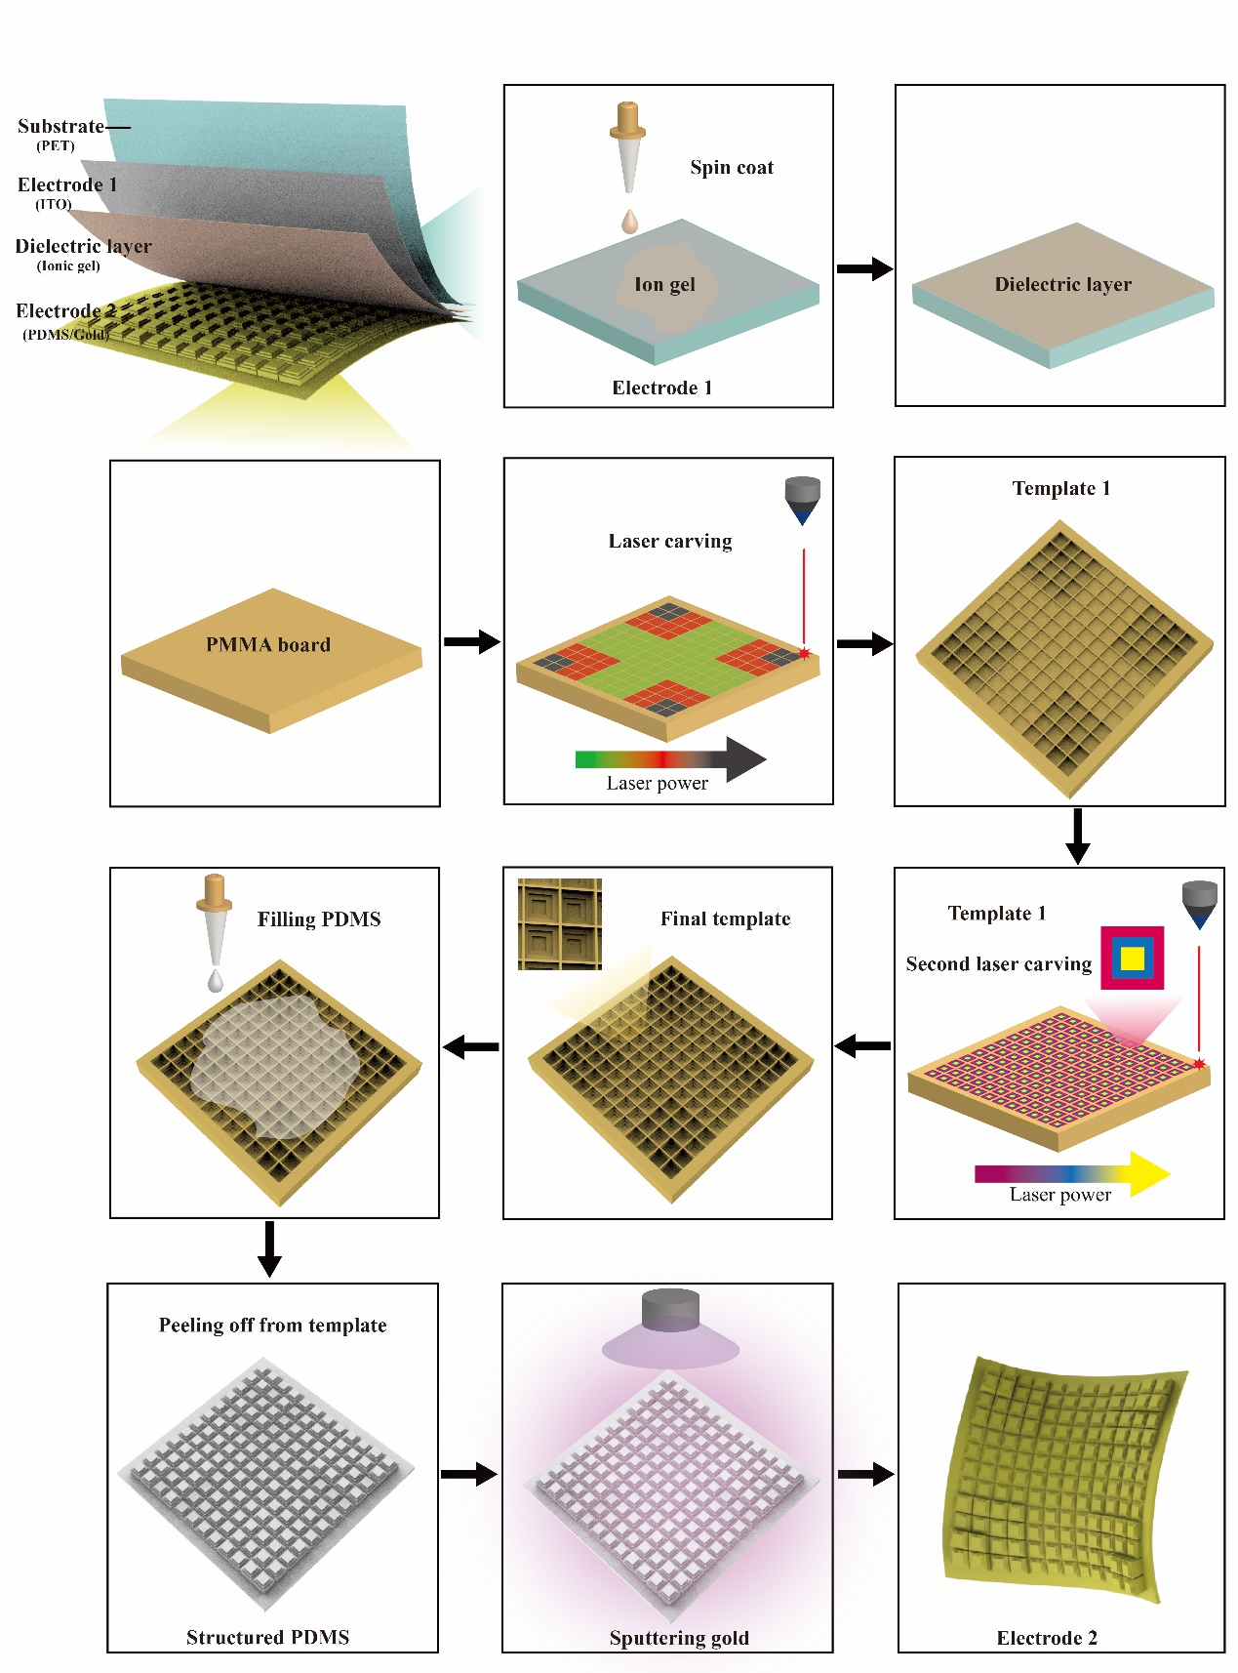
Figure S1. Schematic showing the fabrication process of the iontronic pressure sensor (color arrow indicates the increase in the laser power).
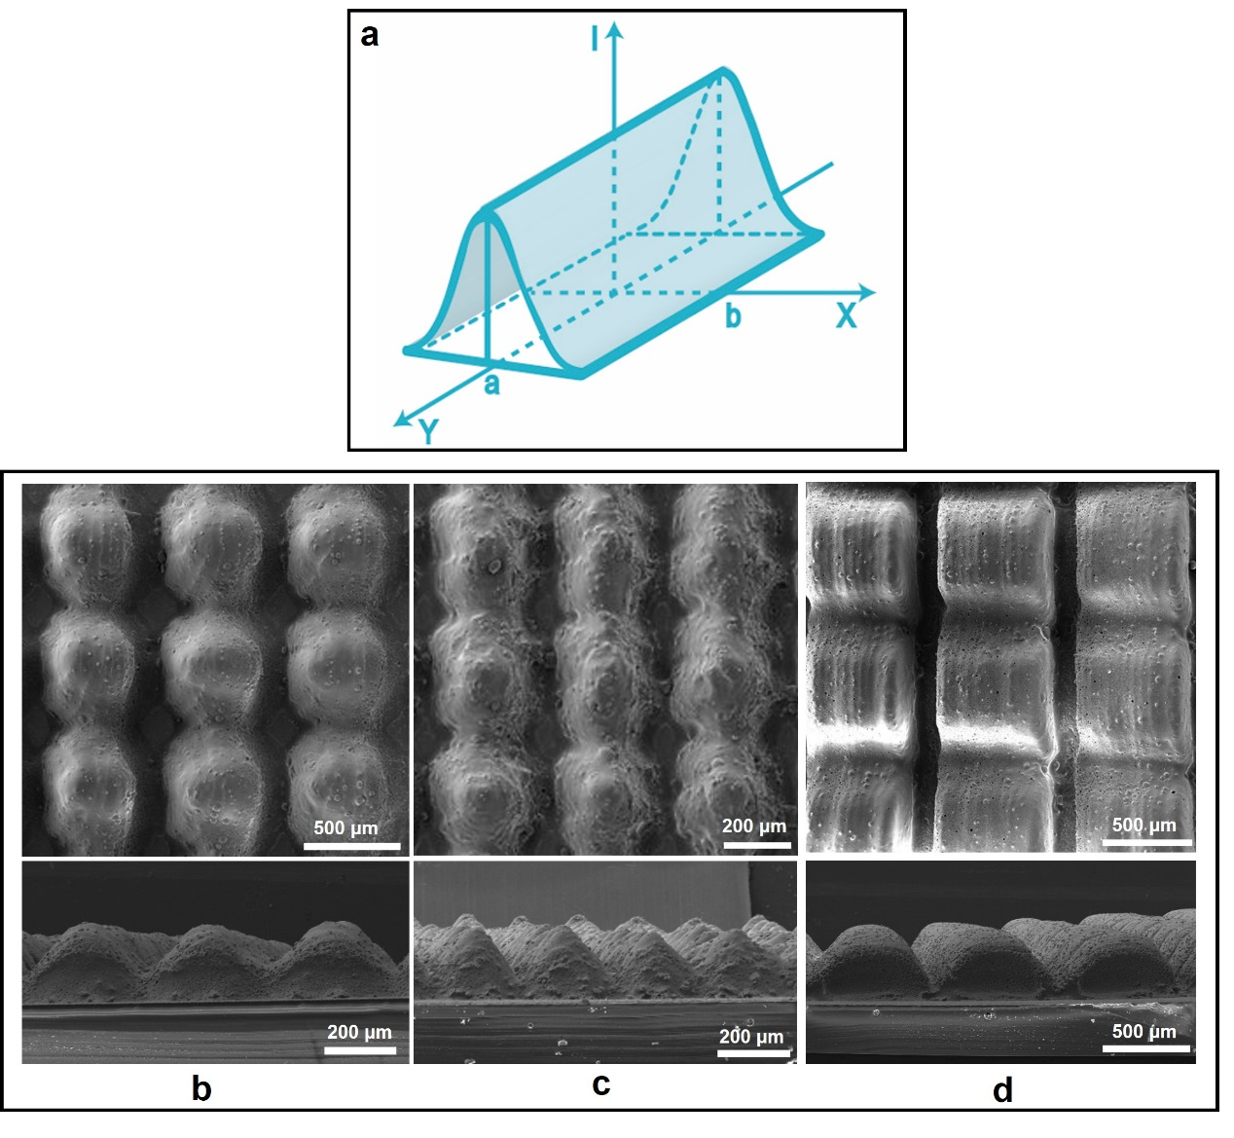
Figure S2. Different microstructures created by the laser with a Gaussian beam. a) Schematic showing the laser power distribution (I: intensity; Y: running direction). SEM images showing (b) conical frustums, (c) cone, and (d) square frustums microstructures.
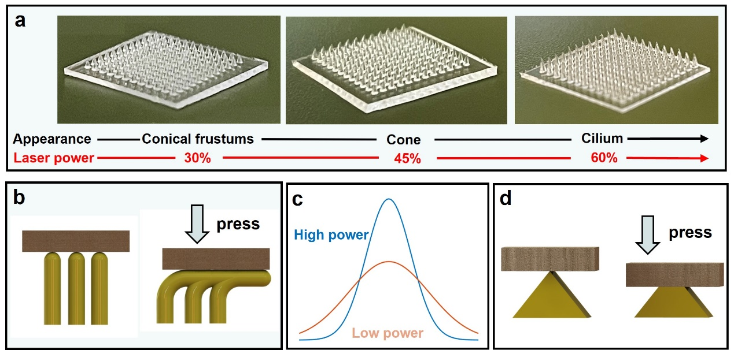
Figure S3. Fabrication of single-layered microstructures. a) Optical images showing the microstructures with higher aspect ratios as the laser power increases (fabricated with the square pattern). b) Schematic showing the buckling of the slender microstructures upon pressure loading. c) Comparison between the high (blue) and low (red) laser power with a Gaussian distribution. d) Schematic showing the deformation of a square frustum upon pressure loading.

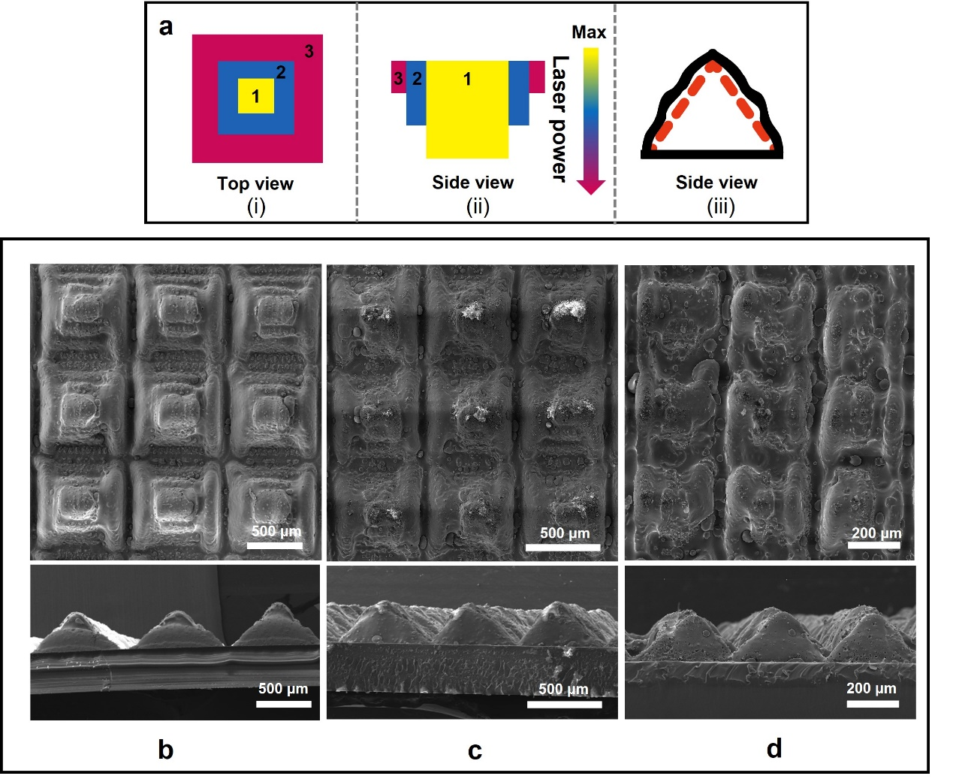
Figure S4. Fabrication of pyramidal microstructures with tri-layered patterns. a) Schematic showing the (i) top and side (ii) views of the laser-ablating patterns for creating the PMMA mold and (iii) the resulting PDMS pyramid microstructure (without shape edges because of the Gaussian distribution of the laser power) de-molded from the PMMA mold. Note: the numerical number represents the sequence of the laser ablation. SEM images showing the pyramidal structures with different sizes: b) 700 μm and c) 500 μm in the unit cell, as well as d) the failed pyramid created by three square patterns with a small difference.
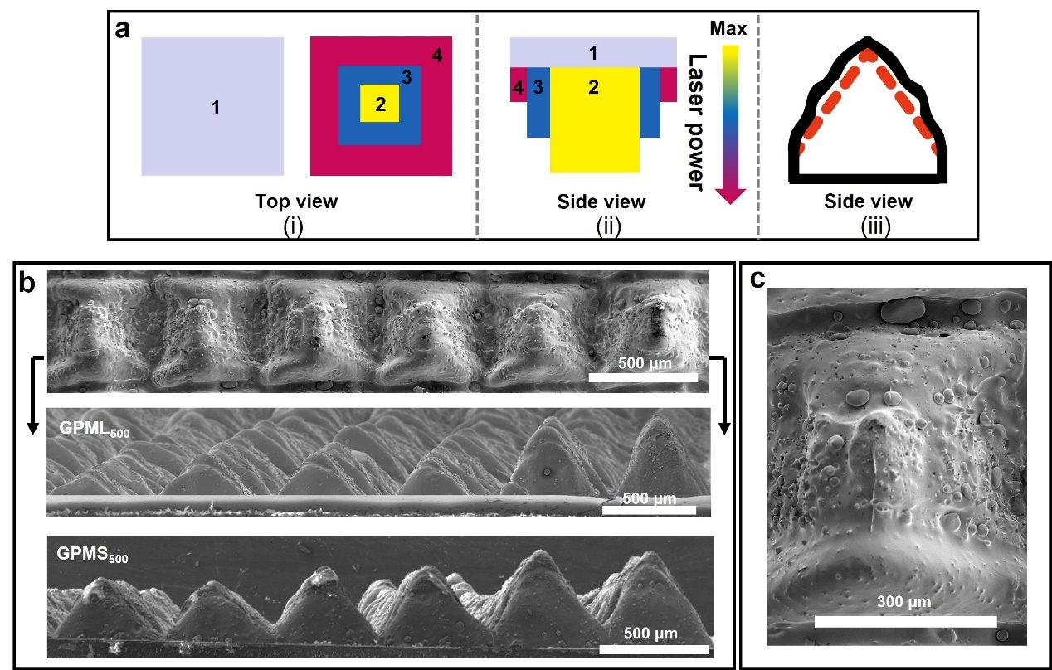
Figure S5. Fabrication of gradient pyramidal microstructures with an additional base layer. a) Schematic showing the (i) top and side (ii) views of the laser-ablating patterns for creating the PMMA mold and (iii) the resulting PDMS pyramid microstructure. Note: the numerical number represents the sequence of the laser ablation. b) SEM images showing gradient pyramidal microstructures (GPML₅₀₀) from the top and side views. c) Top-view SEM image showing the rough surface on the tip of a single pyramidal microstructure.
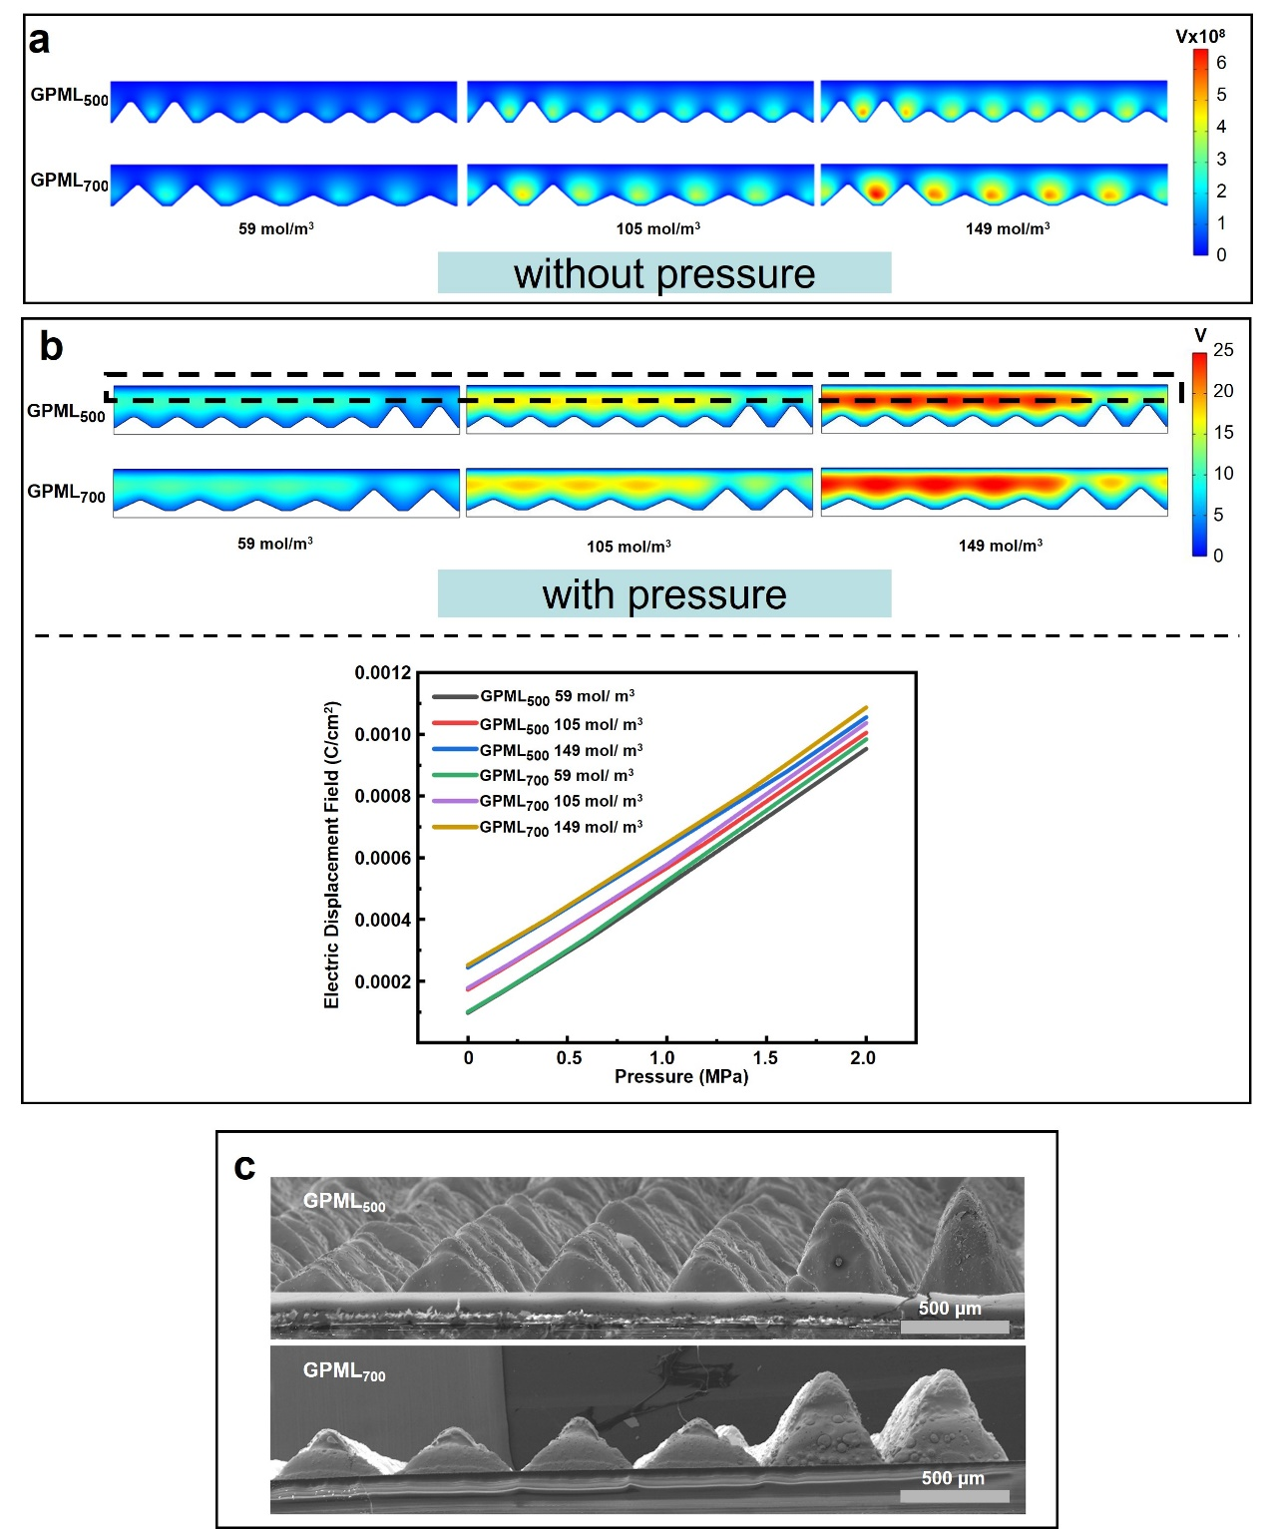
Figure S6. Nonuniform electric potential distribution in GPSL₅₀₀ and GPSL₇₀₀ a) before and b) after pressure loading. The change in the electric displacement field with the increasing pressure for varying IL concentrations is shown at the bottom (the top boundary was selected as the probe). c) Side-view SEM images showing the difference in the size of pyramids between GPSL₅₀₀ and GPSL₇₀₀.

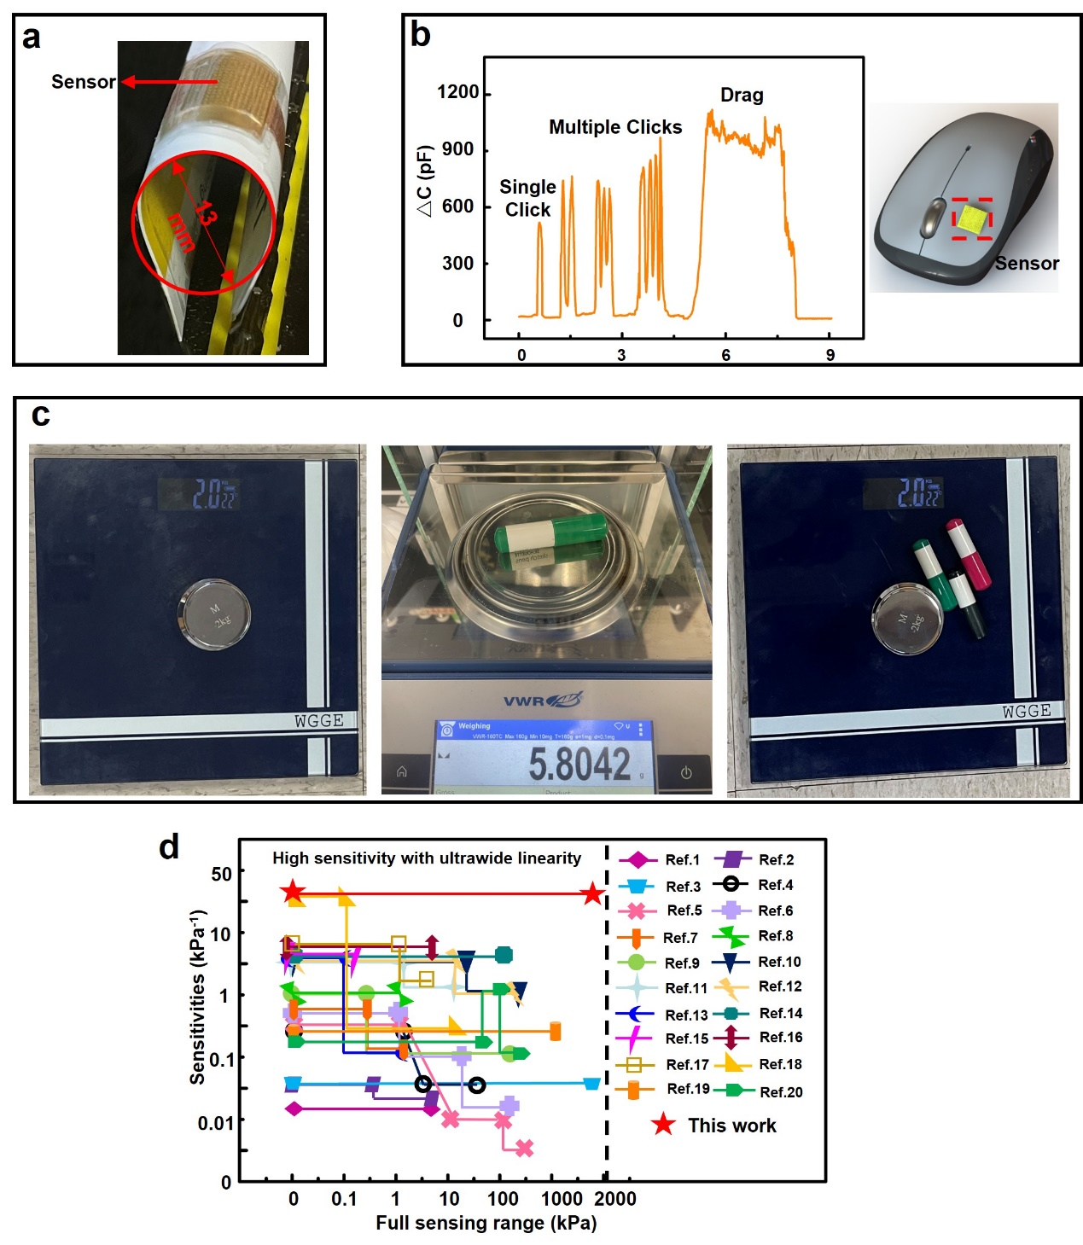
Figure S7. Demonstration of the flexible iontronic sensor. a) Optical image of the iontronic sensor bent over a diameter of 15 mm. b) Measurement of mouse movements for static and dynamic pressure detection, including single/double/triple clicks and hold-and-drag operation (IL of 35 wt%). c) Calculation of the pressure resolution of the commercial weight scale with pens. d) Performance comparison in the sensitivity and full sensing range between the flexible iontronic pressure sensor from this work and other capacitive pressure sensors. Note: The reference numbers correspond to those in Table S3.
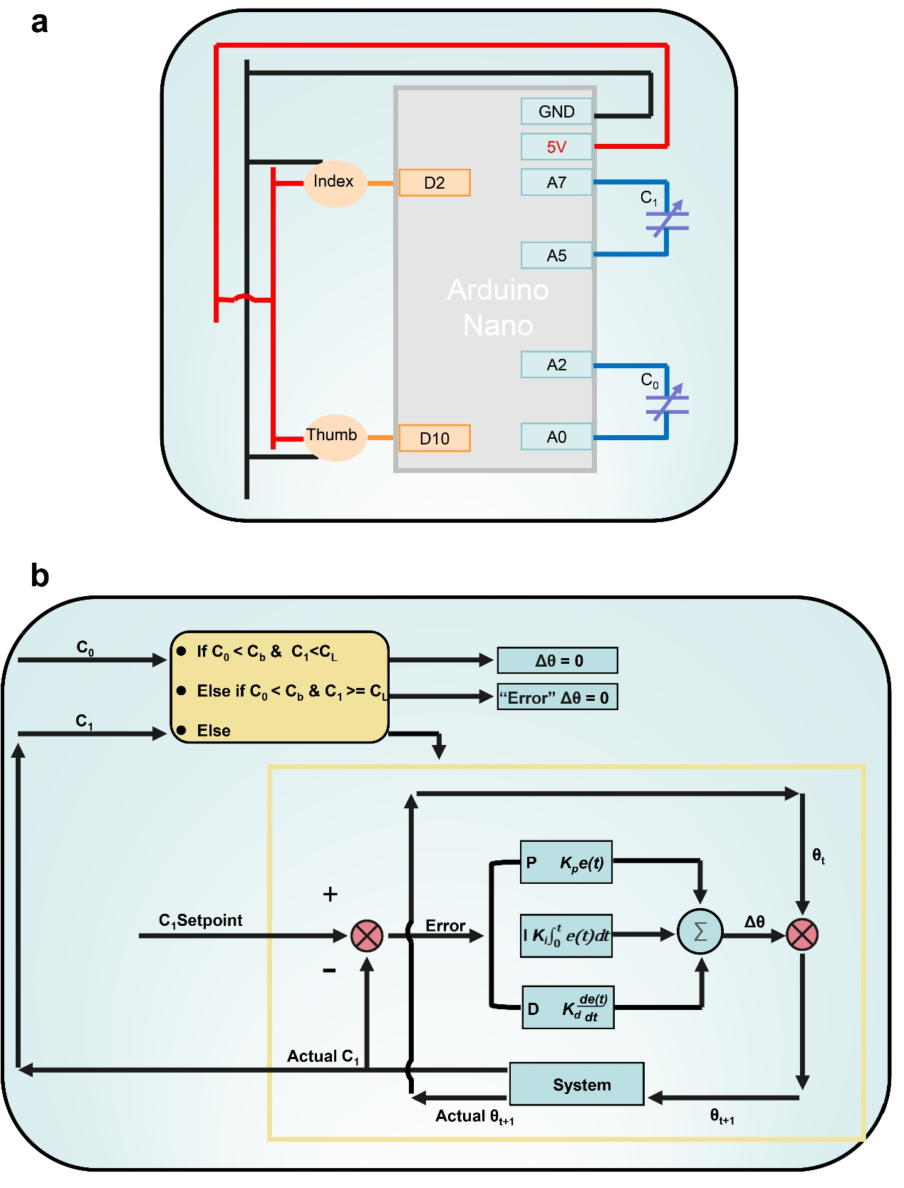
Figure S8. The operating mechanism of the robotic hand. a) Circuit diagram of the robotic hand with two iontronic pressure sensors. b) Schematic diagram showing the use of the proportion-integration-differentiation (PID) system to control the robotic hand based on the capacitance measurements C₀/C₁ from the iontronic pressure sensor on the thumb/index finger. C_{b} and C_{L} are the boot thresholds of the sensor on the thumb and index finger, respectively. θ is the rotation of the motor for the robotic finger with θ_{t} for the present value. C_{1setpoint} is the desired value and its difference with C₁ is noted as error.
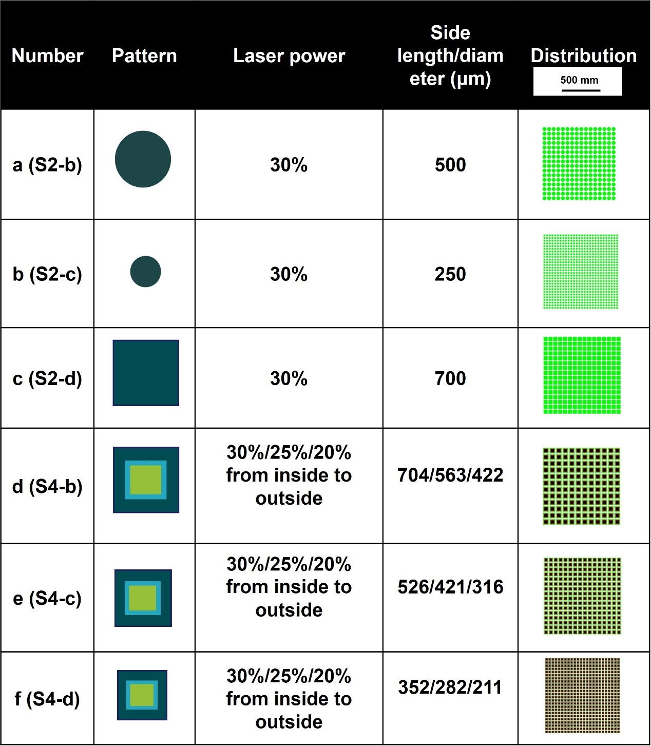
Table S1. Different designs in the laser ablation pattern for varying microstructures

wt% | m_{IL}(g) | m_{PVDF-HFP} (g) | m_{acetone} (g) | Molarity (mol/m³)
20 | 0.06 | 0.3 | 2 | 59
35 | 0.105 | 0.3 | 2 | 105
50 | 0.15 | 0.3 | 2 | 149
n_{20 wt%}=m_{IL20 wt%}/MW =0.00015 (mol)
n_{35 wt%}=m_{IL35 wt%}/MW =0.000268 (mol)
n_{50 wt%}=m_{IL50 wt%}/MW =0.00038 (mol)
v=m_{acetone}/$ρ$_{acetone}=2.55×10⁻⁶ (m³)
c_{20 wt%}=n_{20 wt%}/v≈59 (mol/m³)
c_{35 wt%}=n_{35 wt%}/v≈105 (mol/m³)
c_{50 wt%}=n_{50 wt%}/v≈149 (mol/m³)
n: amount of substance of IL; m: mass; MW: molar weight of IL; v: volume of the acetone; c: molarity; wt%: weight percent of the IL in PVDF-HFP. Density of acetone $(ρ)$: 0.784g/cm³ and MW=391.3
Table S2. Molarity calculation

Table S3. Performance comparison between this work and other capacitive pressure sensors
Number | Types (EDL/parallel plate) | Sensing range (kPa) | Sensitivities | Material | Structure | Parameters | ref
1 | parallel plate | 0-5 | 0.022 | PDMS | Pyramid (dielectric layer) | (d, $ε)$ | ¹
2 | parallel plate | 0-0.3 | 0.062 | Graphene nanoplatelets /MWCNTs /Silicone rubber | Porous structure (dielectric layer) | (d, $ε)$ | ²
2 | parallel plate | 0.3-4.5 | 0.033
3 | parallel plate | 0-1700 | 0.065 | CNT/PDMS | Different height domes (dielectric layer) | (s) | ³
4 | parallel plate | 0-1.5 | 0.42 | PDMS | Tilted micropillar (dielectric layer) | (d, $ε)$ | ⁴
4 | parallel plate | 5-14 | 0.04
5 | parallel plate | 0-1 | 0.51 | Ti₃C₂T_{x}/(PVDFTrFE) composite | Nanofibrous scaffolds (dielectric layer) | (d, $ε)$ | ⁵
5 | parallel plate | 10-150 | 0.01
5 | parallel plate | 150-400 | 0.006
6 | parallel plate | 0-1.6 | 0.73 | PU and calcium copper titanate (high permittivity) | Sponge (dielectric layer) | (d, $ε)$ | ⁶
6 | parallel plate | 1.6-22.8 | 0.135
6 | parallel plate | 22.8-120 | 0.026
7 | parallel plate | 0-0.5 | 0.854 | Boron Nitride/PDMS | Foam (dielectric layer) | (d, $ε)$ | ⁷
7 | parallel plate | 0.55-2.1 | 0.29
8 | parallel plate | 0-1 | 1.12 | PVDF and insulating PMMA | PVDF Nanofiber and PMMA microbeads (dielectric layer) | (d, $ε)$ | ⁸
9 | EDL | 0-0.5 | 1.194 | PVDF and [BMIM]PF₆ | Porous PVDF with [BMIM]PF₆ (dielectric layer) | (s) | ⁹
9 | EDL | 0.5-120 | 0.109
10 | EDL | 0-30 | 5.5 | PVA and a superhydrophilic bis(trifluoromethane)sulfonimide lithium salt (LS), and Ti₃C₂T_{x} | Copy sandpaper structure (electrodes) | (s) | ¹⁰
10 | EDL | 30-250 | 1.5
11 | parallel plate | 0-2 | 6.42 | Ecoflex−MWCNTs | Porous (dielectric layer) | (d, $ε)$ | ¹¹
11 | parallel plate | 2-10 | 1.72
12 | EDL | 0-10 | 6.5 | [BMIM]·PF₆ | Fabric (dielectric layer) | (s) | ¹²
12 | EDL | 10-175 | 13.5
13 | parallel plate | 0-0.1 | 6.583 | P(VDF-TrFE) and DMF | Interlocked asymmetric-nanocones (dielectric layer) | (d, $ε)$ | ¹³
13 | parallel plate | 0.1-1 | 0.125
14 | EDL | 0-100 | 6.94 | (PVDF-HFP) and ([EMI][TFSA]) | Copy sandpaper structure (dielectric layer) | (s) | ¹⁴
15 | parallel plate | 0-0.5 | 7.68 | Graphene | Three-dimensional microconformal graphene (electrode) | (d, $ε)$ | ¹⁵
16 | EDL | 0-7.4 | 7.7 | PVA/PANI | Cone (electrode) | (s) | ¹⁶
17 | parallel plate | 0-1 | 8.31 | TPU-dielectric layer  TPU and AgNW-electrodes | Fabric (dielectric layer) | ($d, ε, s)$ | ¹⁷
17 | parallel plate | 1-5 | 2.32
18 | parallel plate | 0-0.13 | 30.2 | PVDF (dielectric layer) and gold (electrode) | Dome (electrode) | (d and s) | ¹⁸
18 | parallel plate | 0.13-10 | 0.47
19 | parallel plate | 1000 | 0.314 | CIP/NdFeB/PDMS and CNT/PDMS | Cilia array and dome array | ($ε, s$, d) | ¹⁹
20 | EDL | 0-70 | 0.24 | Polyacrylamide-Nacl hydrogel | Fabric electrodes | (s) | ²⁰
20 | EDL | 70-150 | 1.5
20 | EDL | 150-330 | 0.13

References:
1. Ruth, S. R. A.; Beker, L.; Tran, H.; Feig, V. R.; Matsuhisa, N.; Bao, Z., Rational design of capacitive pressure sensors based on pyramidal microstructures for specialized monitoring of biosignals. Adv Funct Mater 2020, 30 (29), 1903100.
2. Qiu, J.; Guo, X.; Chu, R.; Wang, S.; Zeng, W.; Qu, L.; Zhao, Y.; Yan, F.; Xing, G., Rapid-response, low detection limit, and high-sensitivity capacitive flexible tactile sensor based on three-dimensional porous dielectric layer for wearable electronic skin. ACS applied materials & interfaces 2019, 11 (43), 40716-40725.
3. Ji, B.; Zhou, Q.; Lei, M.; Ding, S.; Song, Q.; Gao, Y.; Li, S.; Xu, Y.; Zhou, Y.; Zhou, B., Gradient Architecture-Enabled Capacitive Tactile Sensor with High Sensitivity and Ultrabroad Linearity Range. Small 2021, 17 (43), e2103312.
4. Luo, Y.; Shao, J.; Chen, S.; Chen, X.; Tian, H.; Li, X.; Wang, L.; Wang, D.; Lu, B., Flexible Capacitive Pressure Sensor Enhanced by Tilted Micropillar Arrays. ACS Appl Mater Interfaces 2019, 11 (19), 17796-17803.
5. Sharma, S.; Chhetry, A.; Sharifuzzaman, M.; Yoon, H.; Park, J. Y., Wearable capacitive pressure sensor based on MXene composite nanofibrous scaffolds for reliable human physiological signal acquisition. ACS applied materials & interfaces 2020, 12 (19), 22212-22224.
6. Chhetry, A.; Sharma, S.; Yoon, H.; Ko, S.; Park, J. Y., Enhanced sensitivity of capacitive pressure and strain sensor based on CaCu3Ti4O12 wrapped hybrid sponge for wearable applications. Adv Funct Mater 2020, 30 (31), 1910020.
7. Tay, R. Y.; Li, H.; Lin, J.; Wang, H.; Lim, J. S. K.; Chen, S.; Leong, W. L.; Tsang, S. H.; Teo, E. H. T., Lightweight, superelastic boron nitride/polydimethylsiloxane foam as air dielectric substitute for multifunctional capacitive sensor applications. Adv Funct Mater 2020, 30 (10), 1909604.
8. Jin, T.; Pan, Y.; Jeon, G.-J.; Yeom, H.-I.; Zhang, S.; Paik, K.-W.; Park, S.-H. K., Ultrathin nanofibrous membranes containing insulating microbeads for highly sensitive flexible pressure sensors. ACS applied materials & interfaces 2020, 12 (11), 13348-13359.
9. Liu, Q.; Liu, Z.; Li, C.; Xie, K.; Zhu, P.; Shao, B.; Zhang, J.; Yang, J.; Zhang, J.; Wang, Q., Highly transparent and flexible iontronic pressure sensors based on an opaque to transparent transition. Advanced Science 2020, 7 (10), 2000348.
10. Sharma, S.; Chhetry, A.; Zhang, S.; Yoon, H.; Park, C.; Kim, H.; Sharifuzzaman, M.; Hui, X.; Park, J. Y., Hydrogen-Bond-Triggered Hybrid Nanofibrous Membrane-Based Wearable Pressure Sensor with Ultrahigh Sensitivity over a Broad Pressure Range. ACS nano 2021, 15 (3), 4380-4393.
11. Choi, J.; Kwon, D.; Kim, K.; Park, J.; Orbe, D. D.; Gu, J.; Ahn, J.; Cho, I.; Jeong, Y.; Oh, Y., Synergetic effect of porous elastomer and percolation of carbon nanotube filler toward high performance capacitive pressure sensors. ACS applied materials & interfaces 2019, 12 (1), 1698-1706.
12. Lin, Q.; Huang, J.; Yang, J.; Huang, Y.; Zhang, Y.; Wang, Y.; Zhang, J.; Wang, Y.; Yuan, L.; Cai, M., Highly sensitive flexible iontronic pressure sensor for fingertip pulse monitoring. Advanced Healthcare Materials 2020, 9 (17), 2001023.
13. Niu, H.; Gao, S.; Yue, W.; Li, Y.; Zhou, W.; Liu, H., Highly Morphology‐Controllable and Highly Sensitive Capacitive Tactile Sensor Based on Epidermis‐Dermis‐Inspired Interlocked Asymmetric‐Nanocone Arrays for Detection of Tiny Pressure. Small 2020, 16 (4), 1904774.
14. Zheng, Y.; Lin, T.; Zhao, N.; Huang, C.; Chen, W.; Xue, G.; Wang, Y.; Teng, C.; Wang, X.; Zhou, D., Highly sensitive electronic skin with a linear response based on the strategy of controlling the contact area. Nano Energy 2021, 85.
15. Yang, J.; Luo, S.; Zhou, X.; Li, J.; Fu, J.; Yang, W.; Wei, D., Flexible, Tunable, and Ultrasensitive Capacitive Pressure Sensor with Microconformal Graphene Electrodes. Acs Applied Materials & Interfaces 2019, 11 (16), 14997-15006.
16. Zhou, H.; Wang, M.; Jin, X.; Liu, H.; Lai, J.; Du, H.; Chen, W.; Ma, A., Capacitive Pressure Sensors Containing Reliefs on Solution-Processable Hydrogel Electrodes. ACS Applied Materials & Interfaces 2021, 13 (1), 1441-1451.
17. Yu, P.; Li, X.; Li, H.; Fan, Y.; Cao, J.; Wang, H.; Guo, Z.; Zhao, X.; Wang, Z.; Zhu, G., All-Fabric Ultrathin Capacitive Sensor with High Pressure Sensitivity and Broad Detection Range for Electronic Skin. ACS Applied Materials & Interfaces 2021.
18. Xiong, Y.; Shen, Y.; Tian, L.; Hu, Y.; Zhu, P.; Sun, R.; Wong, C.-P., A flexible, ultra-highly sensitive and stable capacitive pressure sensor with convex microarrays for motion and health monitoring. Nano Energy 2020, 70.
19. Ji, B.; Zhou, Q.; Hu, B.; Zhong, J.; Zhou, J.; Zhou, B., Bio‐Inspired Hybrid Dielectric for Capacitive and Triboelectric Tactile Sensors with High Sensitivity and Ultrawide Linearity Range. Adv Mater 2021, 33 (27), 2100859.
20. Shen, Z.; Zhu, X.; Majidi, C.; Gu, G., Cutaneous ionogel mechanoreceptors for soft machines, physiological sensing, and amputee prostheses. Adv Mater 2021, 33 (38), 2102069.

