Appendix B: Land surface temperature derived from Landsat-7 Imageries
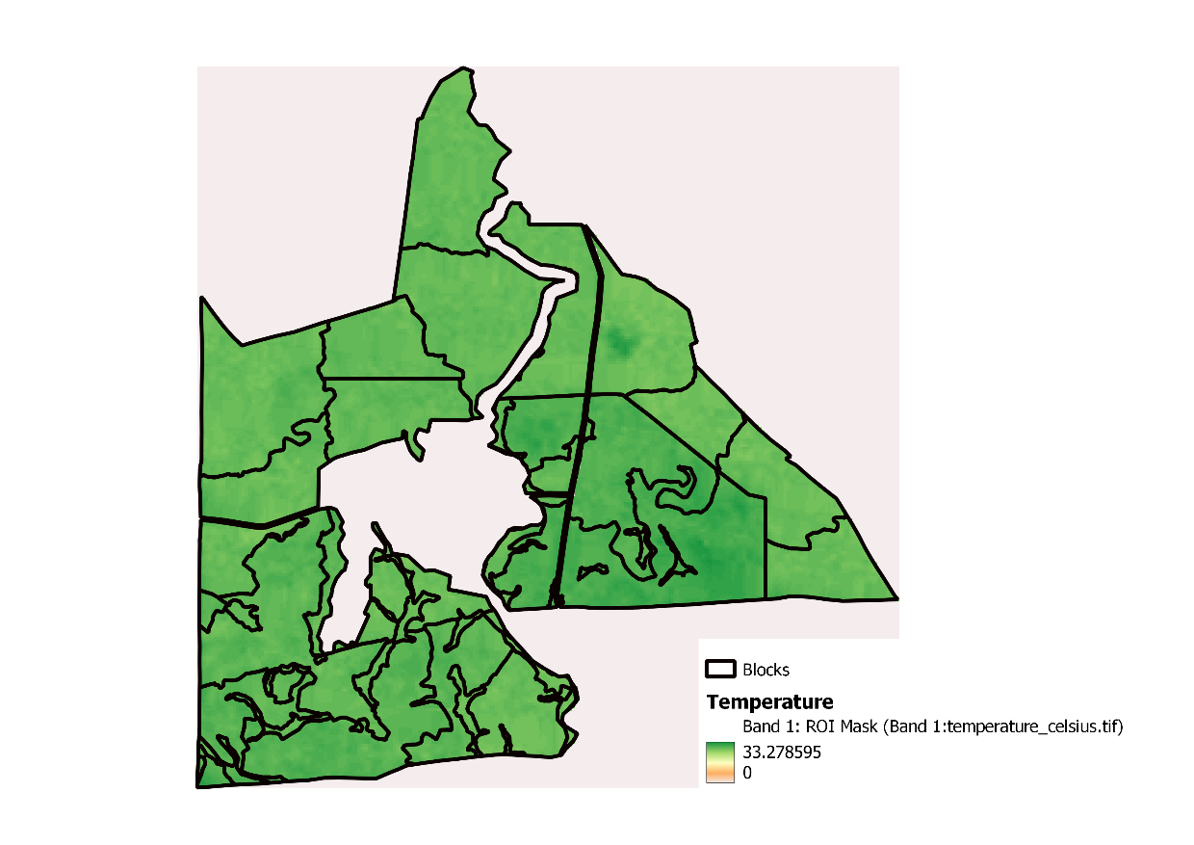
Fig. B.1 Land surface temperature for year 2005

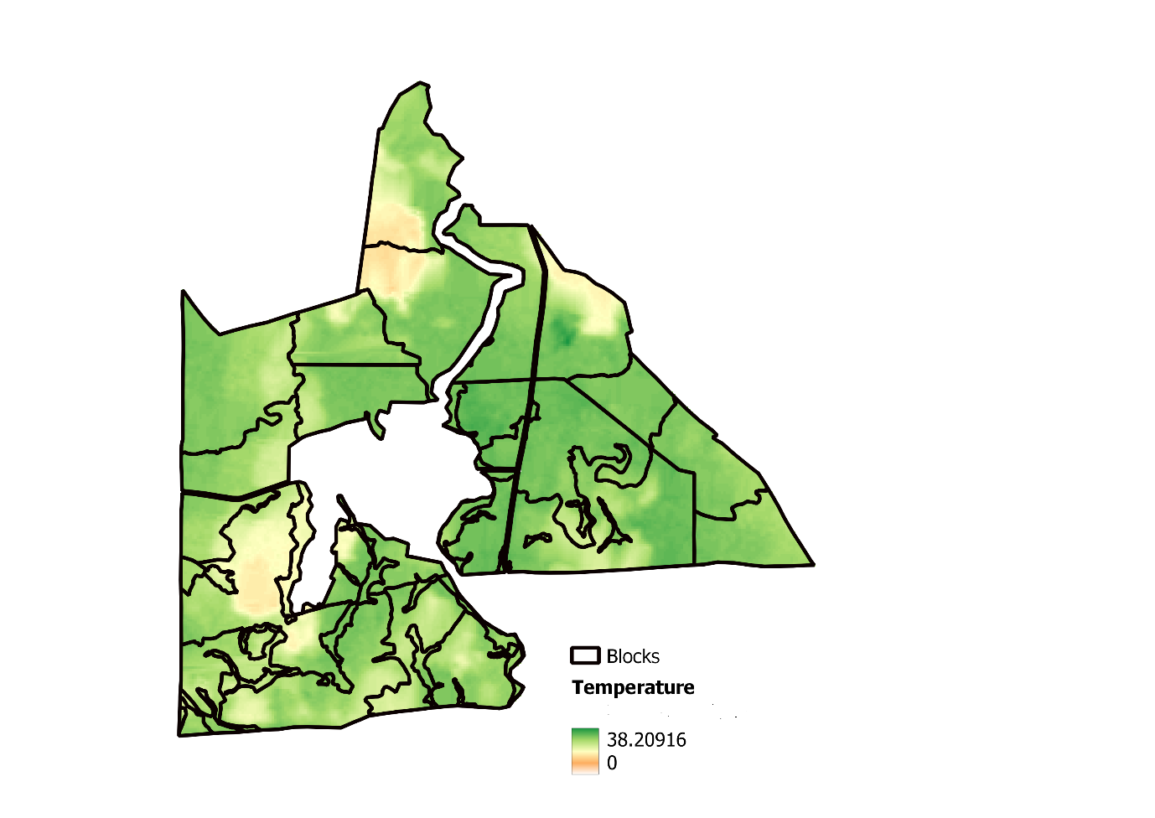
Fig. B.2 Land surface temperature for year 2006
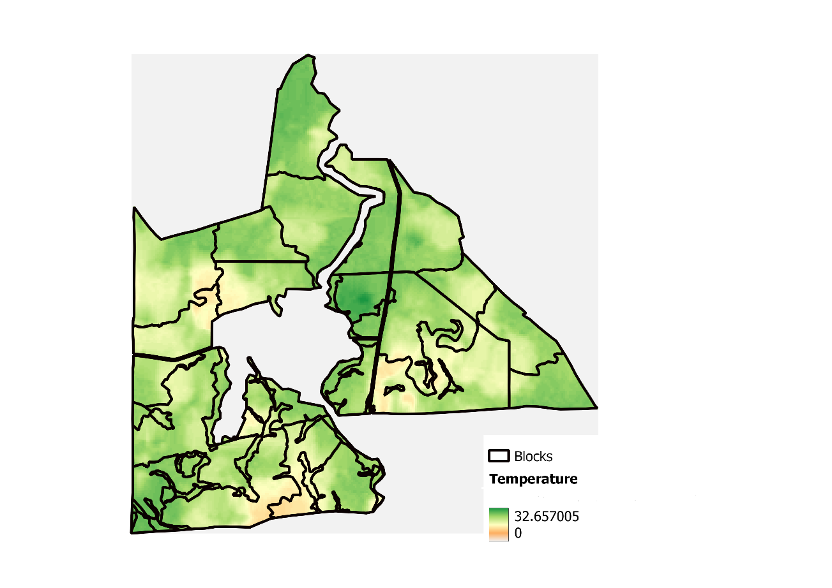
Fig. B.3 Land surface temperature for year 2007

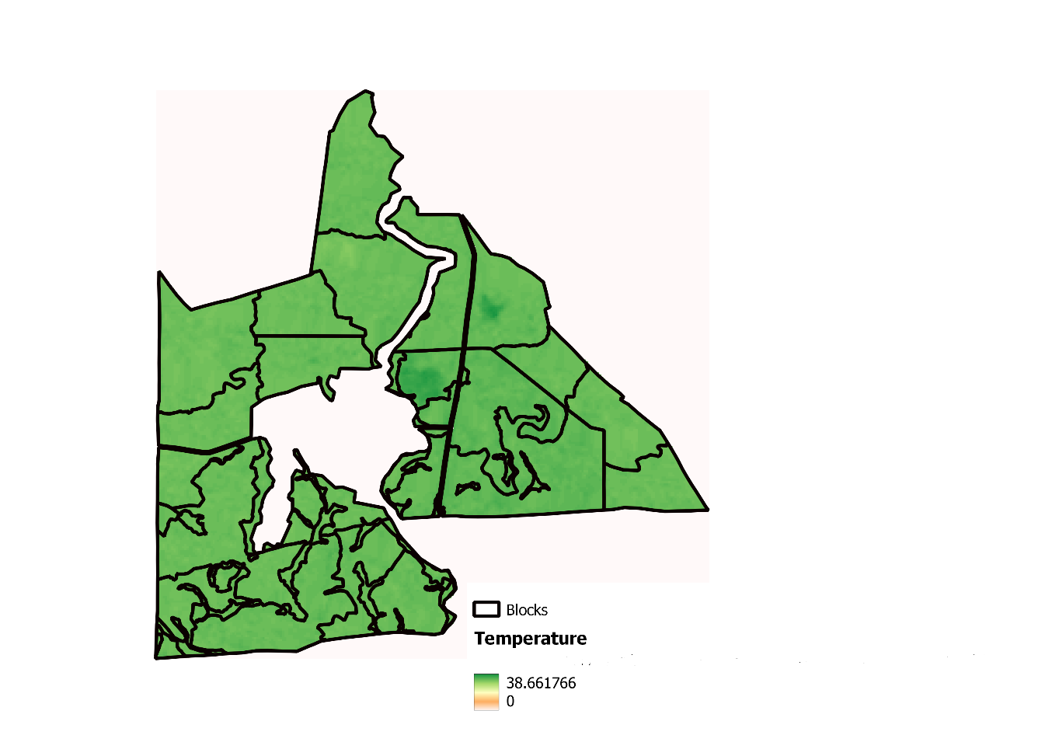
Fig. B.4 Land surface temperature for year 2008

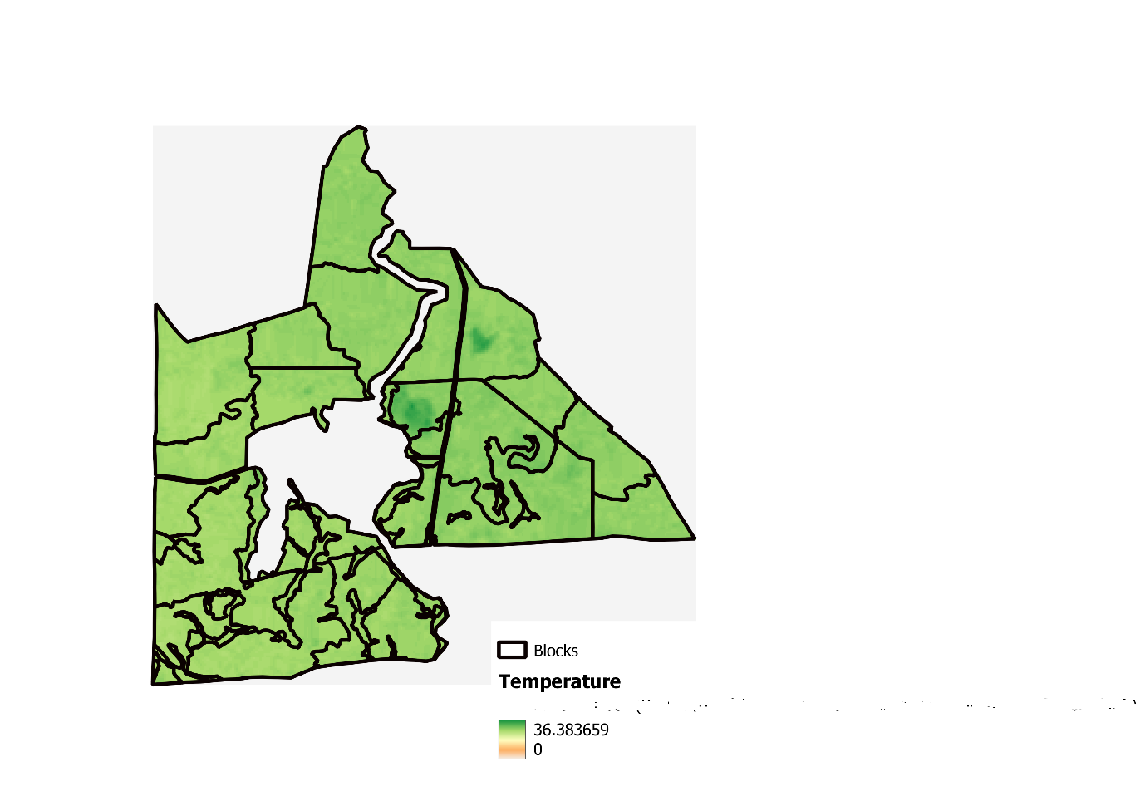
Fig. B.5 Land surface temperature for year 2009

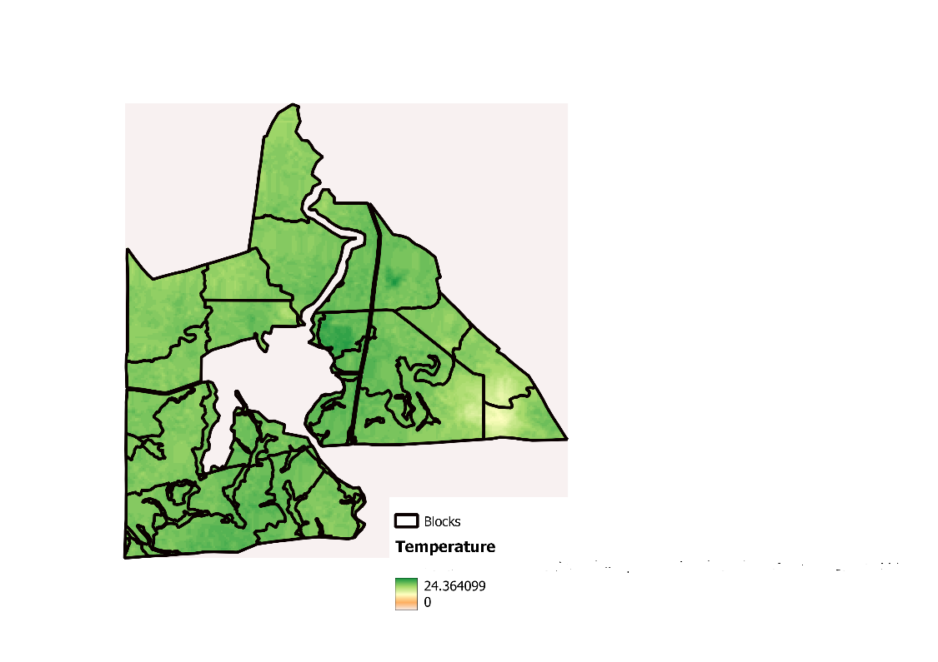
Fig. B.6 Land surface temperature for year 2010

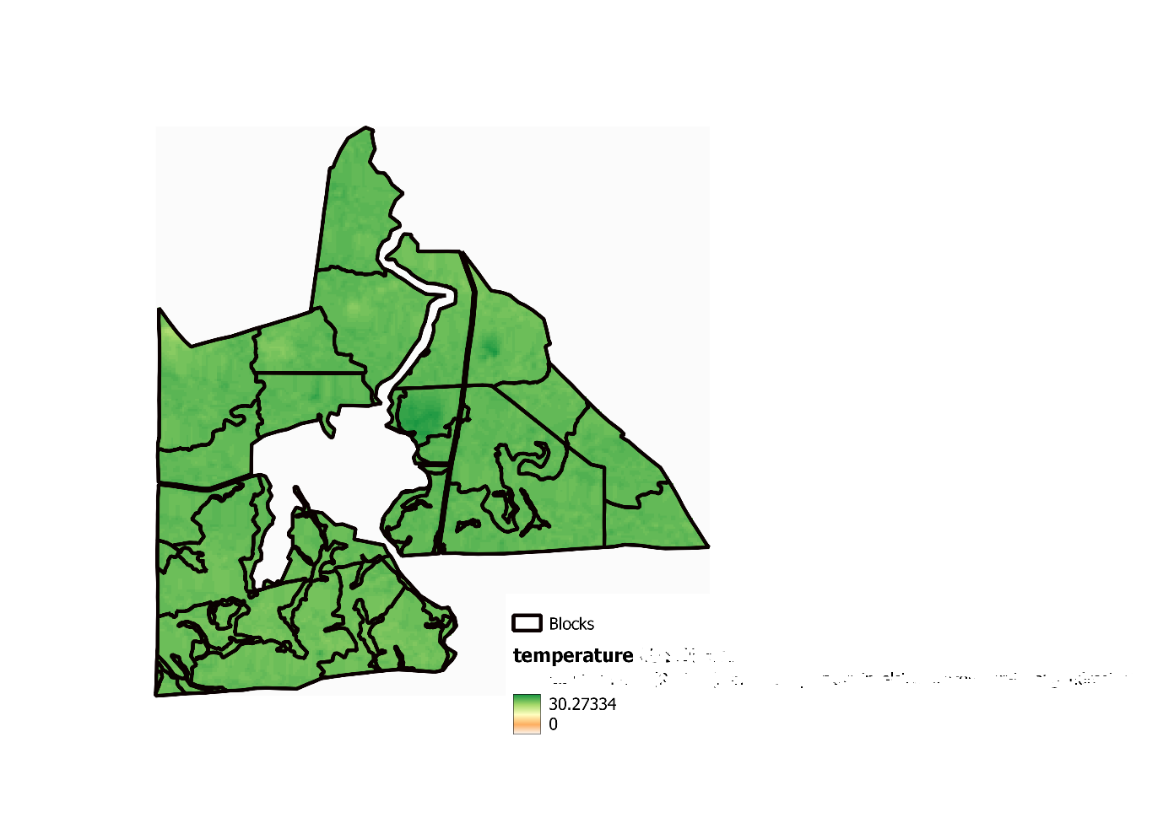
Fig. B.7 Land surface temperature for year 2011

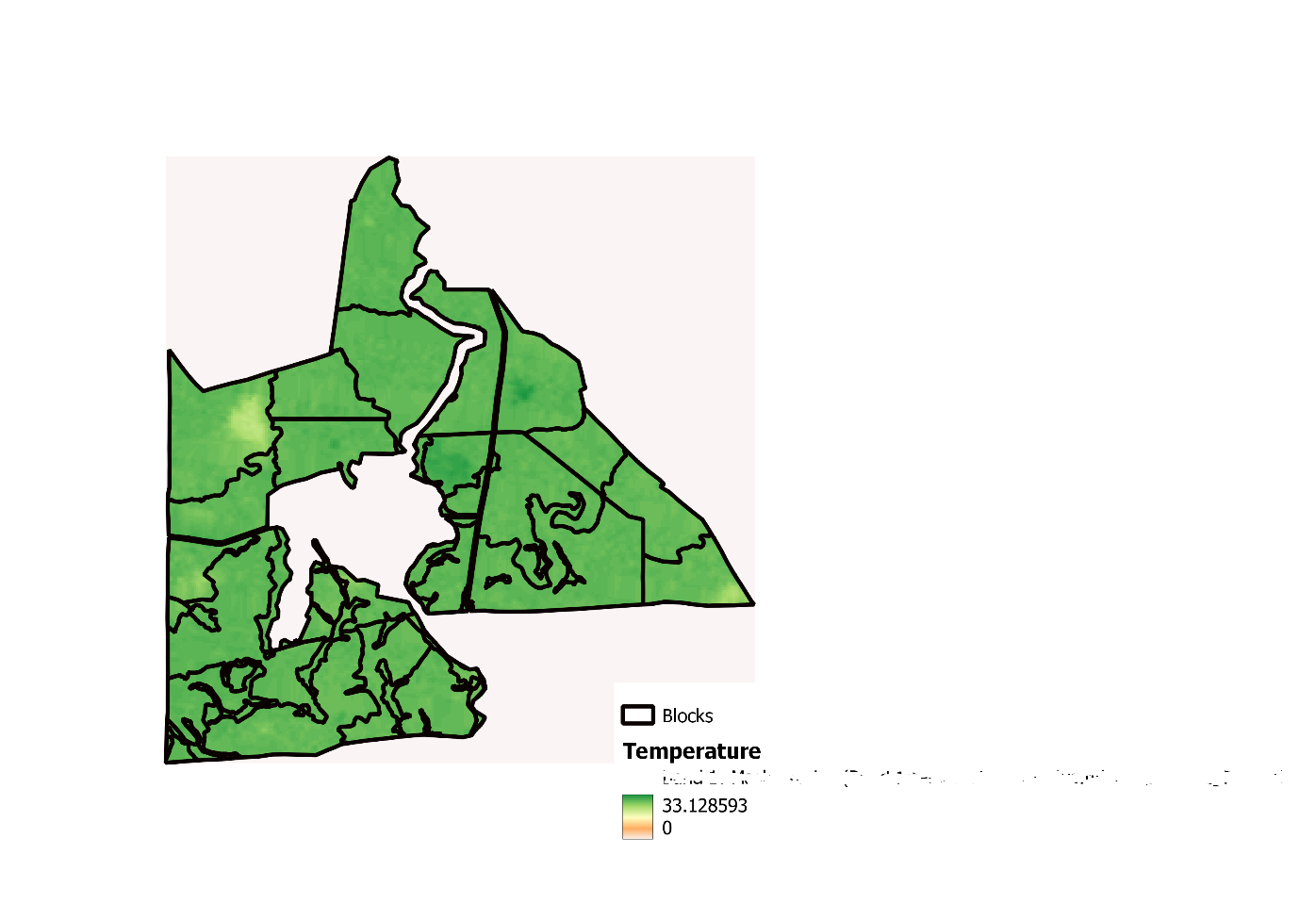
Fig. B.8 Land surface temperature for year 2012

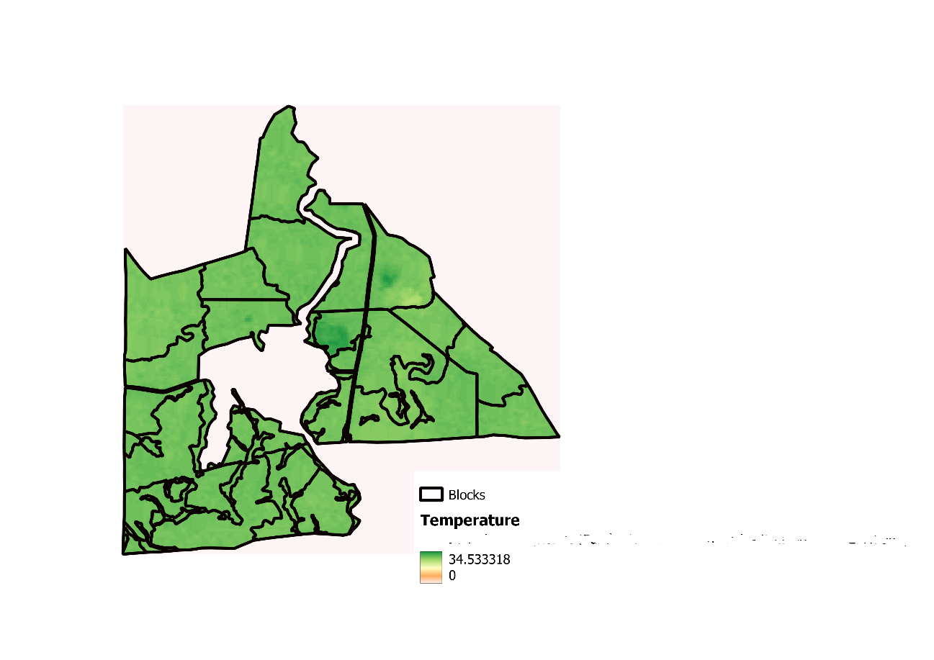
Fig. B.9 Land surface temperature for year 2013

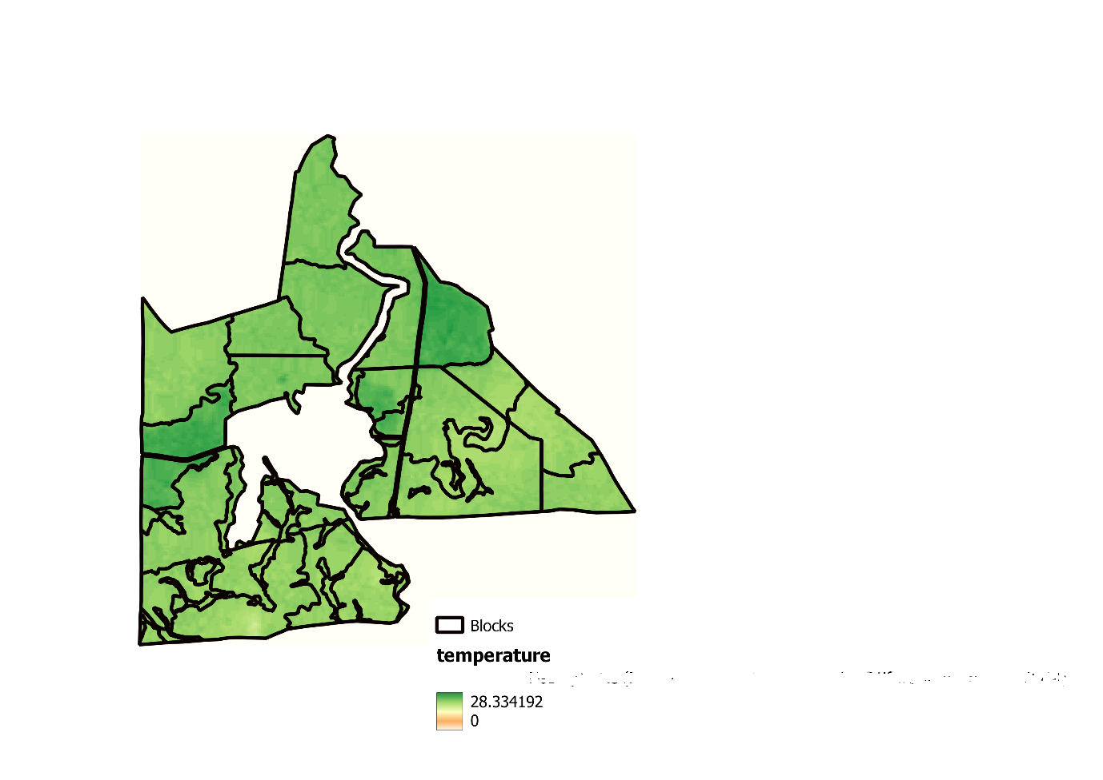
Fig. B.10 Land surface temperature for year 2014

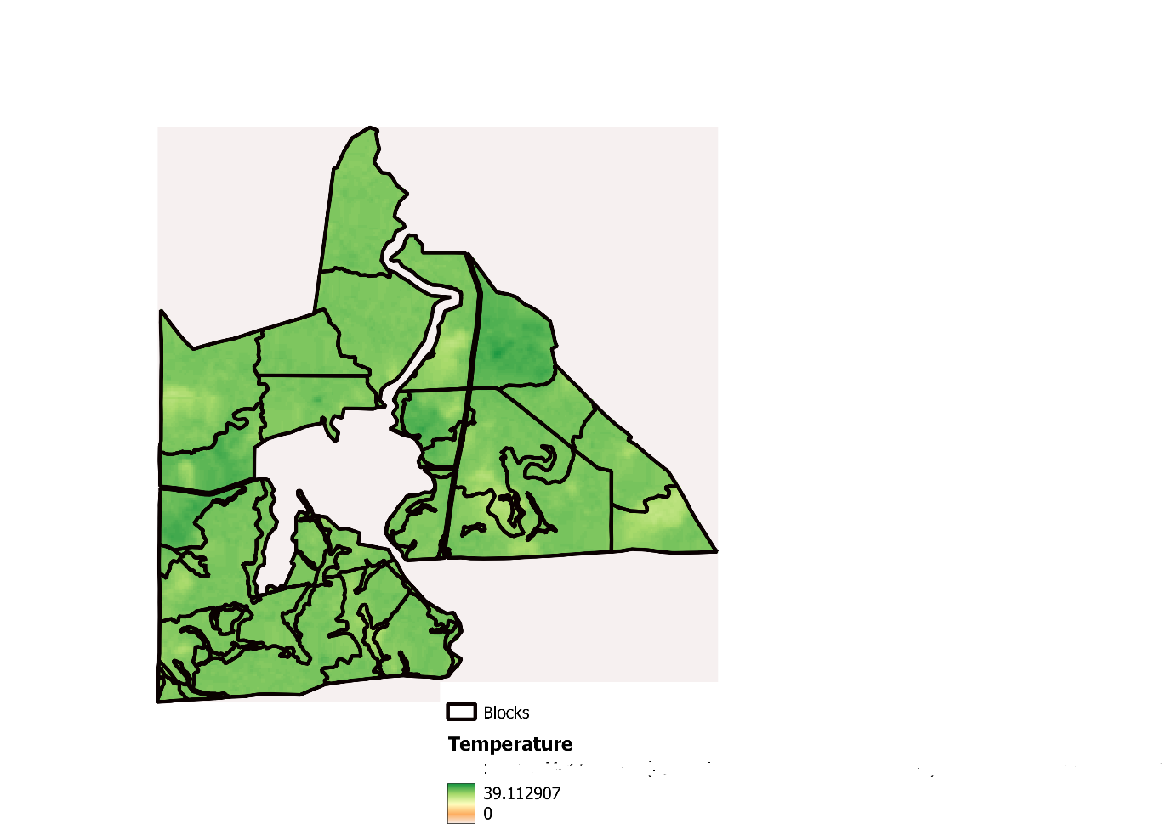
Fig. B.11 Land surface temperature for year 2015

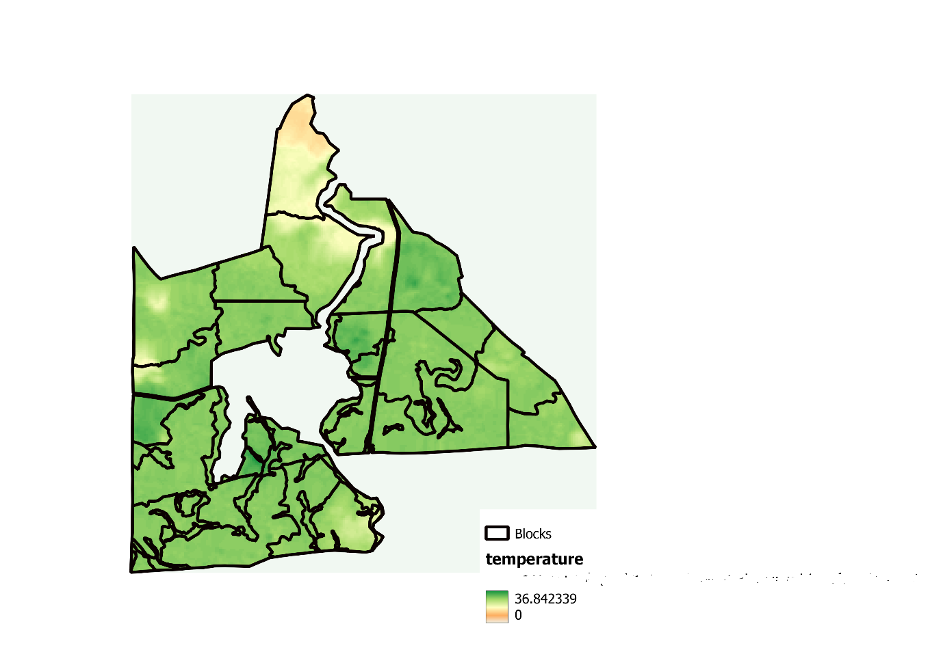
Fig. B.12 Land surface temperature for year 2016

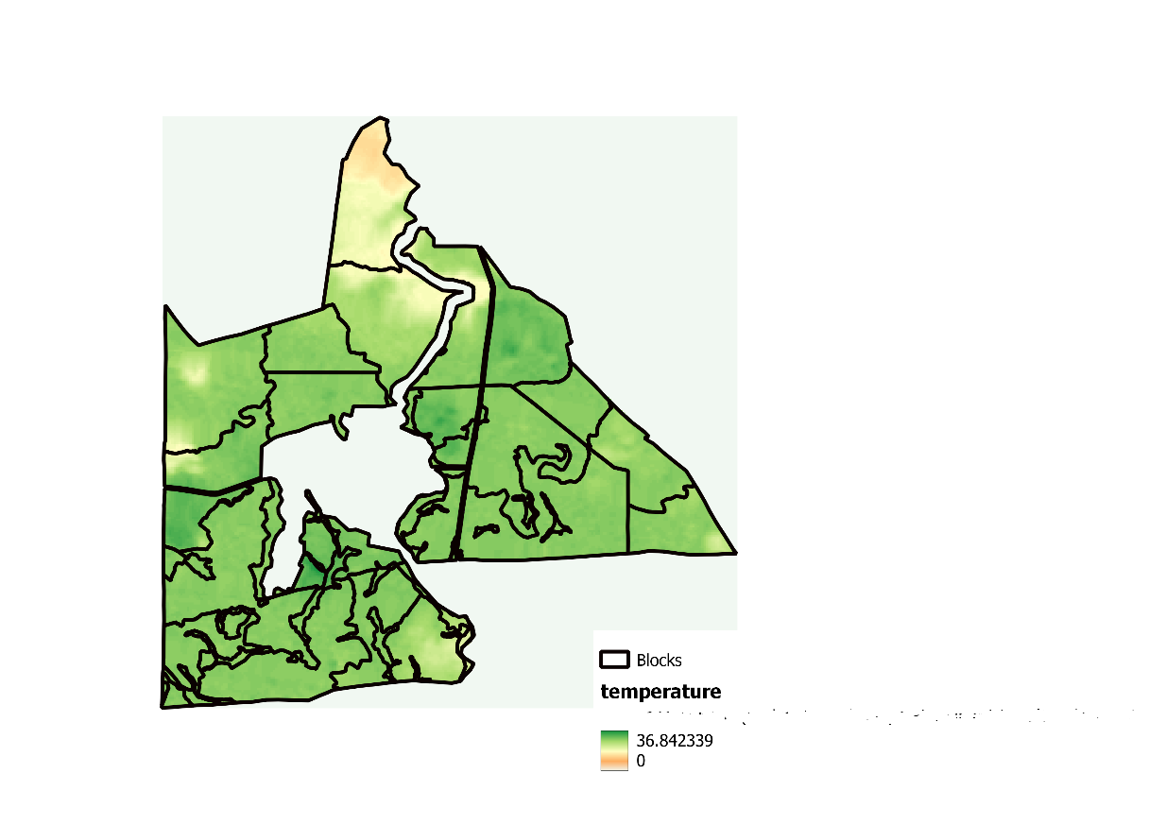
Fig. B.13 Land surface temperature for year 2017

Fig. B.14 Land surface temperature for year 2018

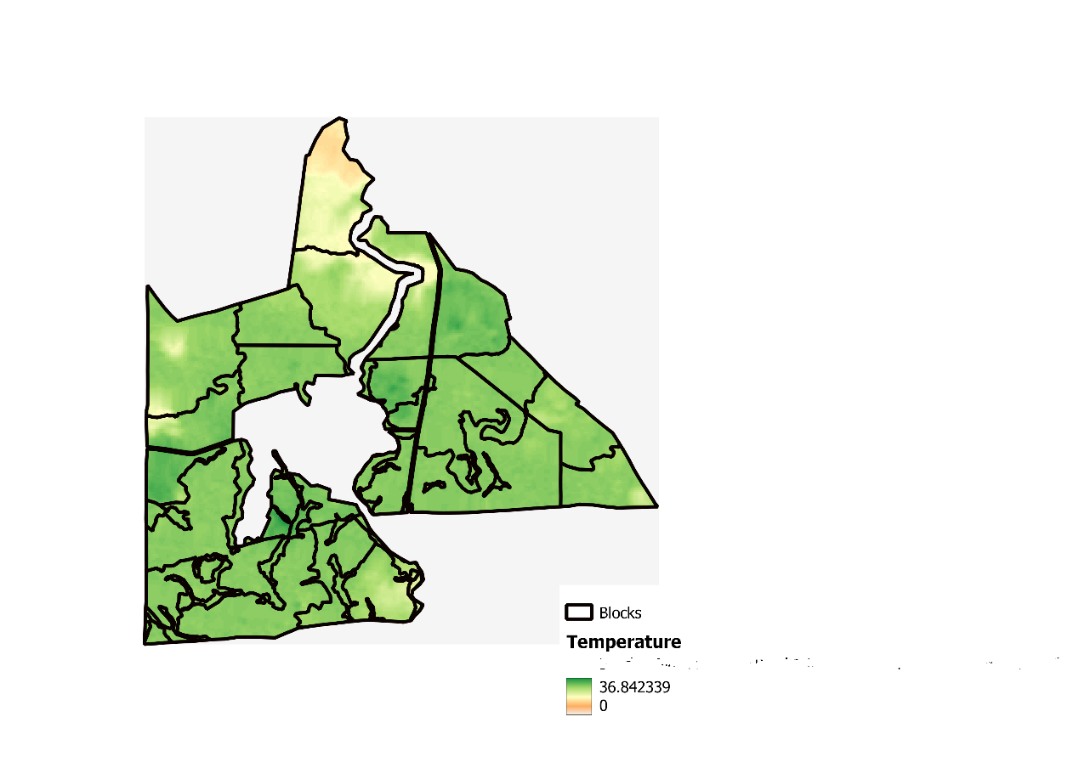
Fig. B.15 Land surface temperature for year 2019

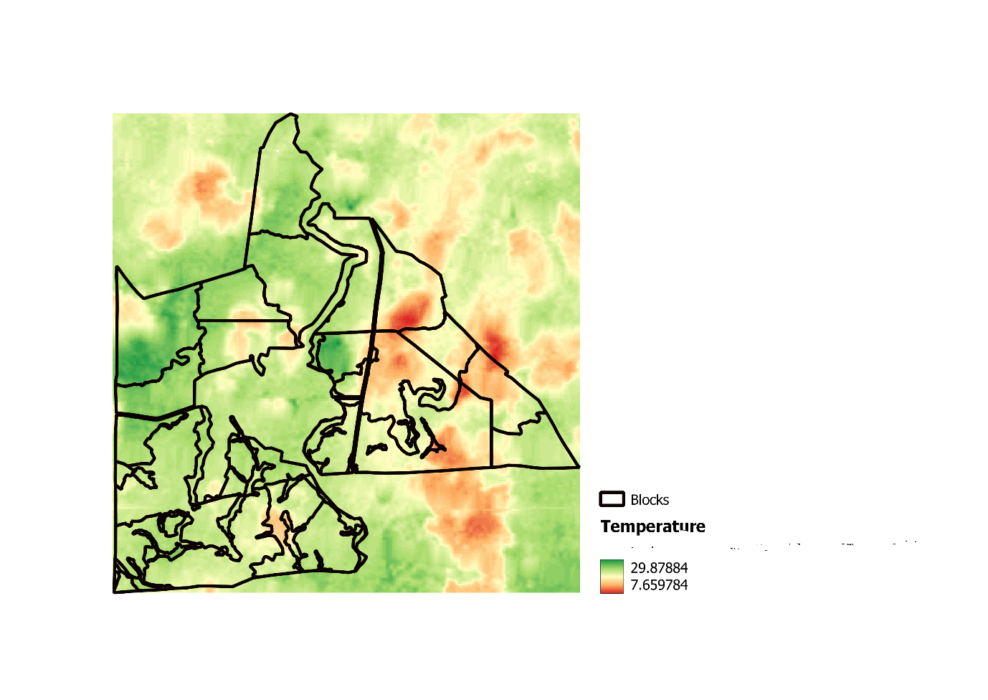
Fig. B.16 Land surface temperature for year 2020

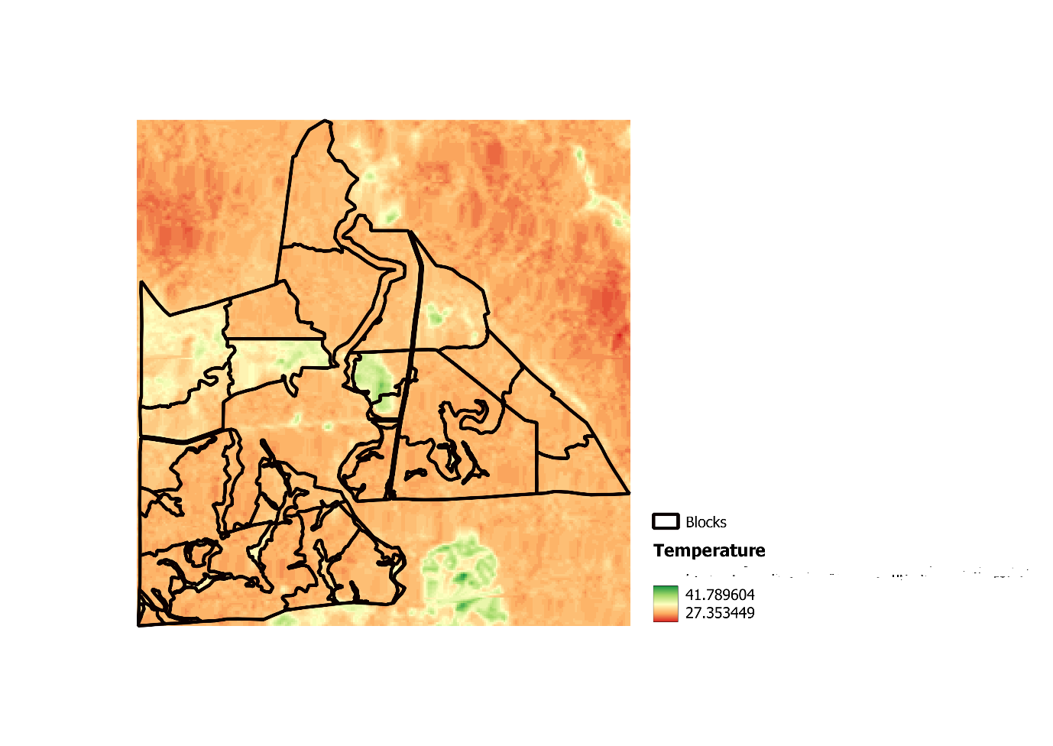
Fig. B.17 Land surface temperature for year 2021

