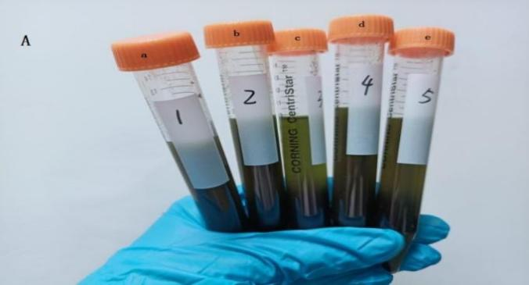
Fig.1 Optimization of the extraction: (A) effect of five extraction solvents ;(B) effects of different extraction solvents on AQ recovery;(C) standard curve and matrix matching curves of different extractants on AQ;(D) matrix effect of five extractant;(E) effect of extractant volume on the recoveries of AQ.
a) acetonitrile, b) acetone, c) n-hexane, d) n-hexane-acetone ratio (1:1), e) N-hexane-acetone ratio (3:1)

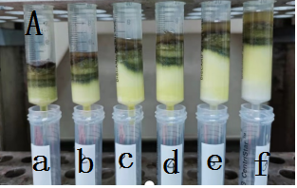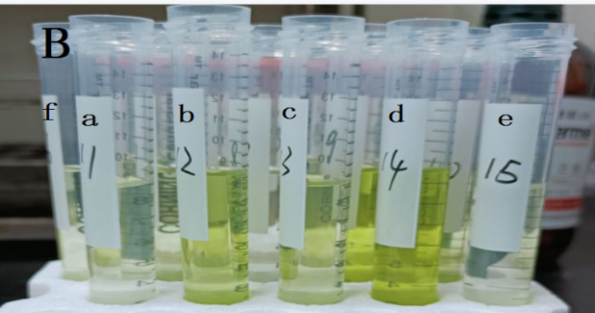Fig.2.Optimization of florisil cleaner :(A) purification process with different mass of florisil;(B)purification effects with different mass of florisil;(C)effect of cleaner mass on the recoveries of AQ.a)0.5 g,b)1.0 g,c)1.5 g,d)2.0 g,f)2.5 g,e)3.0 g

