Supporting Information for

Satellite based long- term spatio-temporal trends of wildfire in the Himalayan vegetation
Shailja Mamgain¹, Arijit Roy¹, Harish Chandra Karnatak¹, Prakash Chauhan^{1, 2}
¹Indian Institute of Remote Sensing, Indian Space Research Organisation, Dehradun, India
²National Remote Sensing Centre, Indian Space Research Organisation, Hyderabad, India
shailja309@gmail.com, arijitroy@iirs.gov.in, harish@iirs.gov.in and prakash4140@gmail.com

Table S1 Table showing the correlation coefficients (r) for the various parameters employed in each region. The correlation coefficient measures the degree of association between the burned regions and each of the parameter (total precipitation, land surface temperature, EVI, NDVI & surface soil moisture). It states the positive or negative relationship among the variable along with the degree (strong or weak).

S. no. | Location | Total Precipitation (mm/hr) | Land Surface Temperature (K) | EVI | NDVI | SSM (mm)
1 | Arunachal Pradesh | -0.37* | 0.35^ | -0.25* | 0.16^ | -0.26*
2 | Assam | -0.41** | 0.41^^ | -0.31* | -0.35* | 0.22^
3 | Bhutan | 0.44^^ | 0.18^ | -0.56** | -0.28* | 0.09^
4 | Central Nepal | -0.34* | 0.66^^^ | -0.29* | -0.45** | -0.53**
5 | East Nepal | -0.11* | 0.40^^ | -0.20* | -0.25* | -0.85***
6 | Far- west Nepal | -0.43** | 0.66^^^ | -0.07* | 0.08^ | -0.68***
7 | Garhwal region | 0.03^ | 0.65^^^ | -0.35* | -0.05* | -0.28*
8 | Himachal Pradesh | 0.23^ | 0.46^^ | -0.48** | -0.60** | -0.82***
9 | Jammu & Kashmir | -0.21* | 0.61^^^ | -0.44** | -0.23* | -0.67***
10 | Kumaon region | -0.25* | 0.36^ | -0.42** | -0.39* | -0.50**
11 | Ladakh | -0.17* | 0.60^^^ | -0.22* | -0.19* | -0.92***
12 | Manipur | -0.33* | 0.33^ | -0.06* | -0.15* | -0.66***
13 | Meghalaya | -0.41** | 0.37^ | -0.47** | -0.51** | 0.33^
14 | Midwest Nepal | -0.14* | 0.49^^ | -0.16* | -0.16* | -0.36*
15 | Mizoram | -0.33* | 0.27^ | -0.01* | -0.23* | 0.09^
16 | Nagaland | -0.37* | 0.32^ | -0.21* | -0.34* | 0.45^^
17 | Sikkim | -0.17* | 0.41^^ | 0.19^ | -0.02* | -0.69***
18 | Tripura | -0.18* | 0.26^ | -0.16* | -0.30* | -0.05*
19 | West Bengal | -0.28* | -0.02* | -0.15* | -0.14* | 0.21^
20 | West Nepal | -0.27* | 0.50^^ | -0.72*** | -0.44** | -0.63***
*- Weak negative correlation, **- Moderate negative correlation, *** - Strong negative correlation, ^^^ - Strong positive correlation, ^^ - Moderate positive correlation & ^- Weak positive correlation.

Table S2 Table shows the R square, adjusted R square, and p-value values for each region. The R-square and adjusted R-square values explain the degree of variation which can be explained by the regression model. Low p value (<0.05) states that the regression model is statistically significant in nature.

S. no. | Location | R Square value | Adjusted R Square value | p-value
1 | Arunachal Pradesh | 0.389 | 0.237 | 0.079
2 | Assam | 0.296 | 0.120 | 0.203
3 | Bhutan | 0.552 | 0.440 | 0.009*
4 | Central Nepal | 0.618 | 0.522 | 0.002*
5 | East Nepal | 0.193 | -0.009 | 0.458
6 | Far- west Nepal | 0.450 | 0.312 | 0.039*
7 | Garhwal region | 0.719 | 0.648 | 0.000*
8 | Himachal Pradesh | 0.573 | 0.466 | 0.006*
9 | Jammu & Kashmir | 0.513 | 0.392 | 0.016*
10 | Kumaon region | 0.320 | 0.149 | 0.163
11 | Ladakh | 0.454 | 0.317 | 0.037*
12 | Manipur | 0.164 | -0.045 | 0.551
13 | Meghalaya | 0.367 | 0.209 | 0.101
14 | Midwest Nepal | 0.488 | 0.360 | 0.023*
15 | Mizoram | 0.203 | 0.004 | 0.427
16 | Nagaland | 0.227 | 0.034 | 0.359
17 | Sikkim | 0.292 | 0.115 | 0.210
18 | Tripura | 0.146 | -0.068 | 0.614
19 | West Bengal | 0.141 | -0.074 | 0.632
20 | West Nepal | 0.630 | 0.538 | 0.002*
*- p-value is less than 0.05

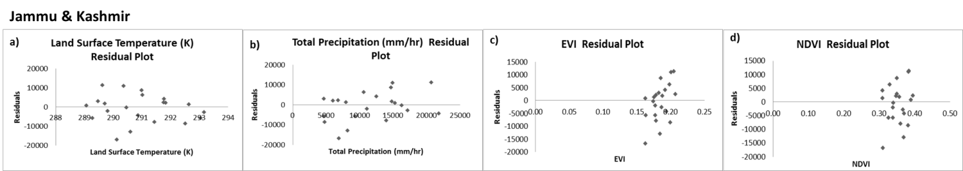
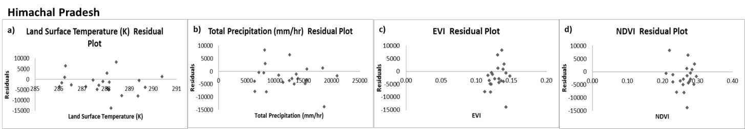
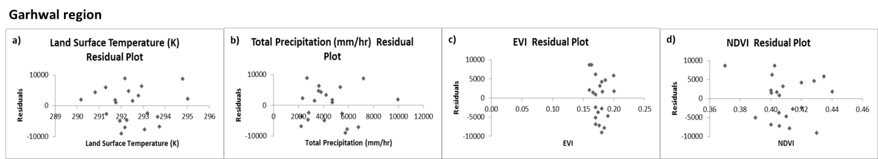
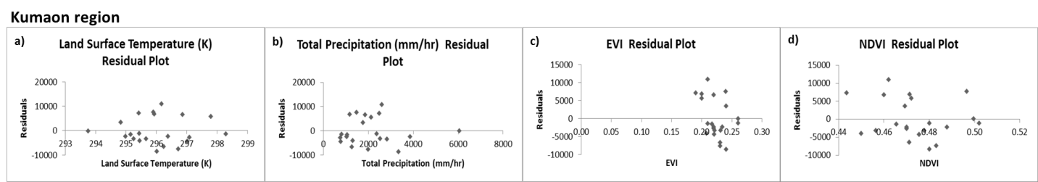
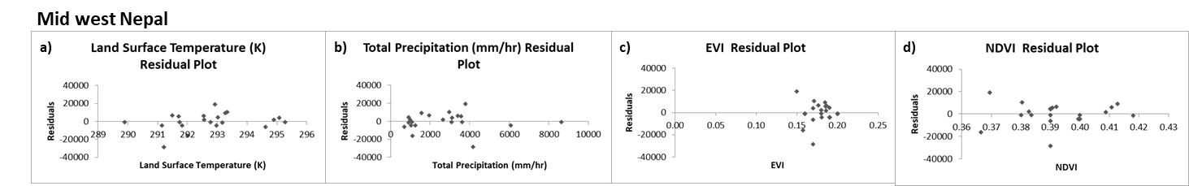
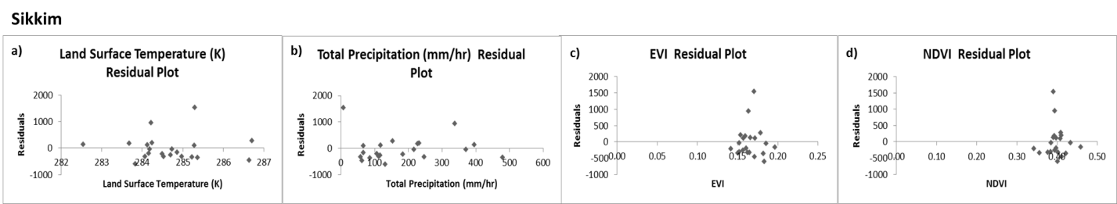
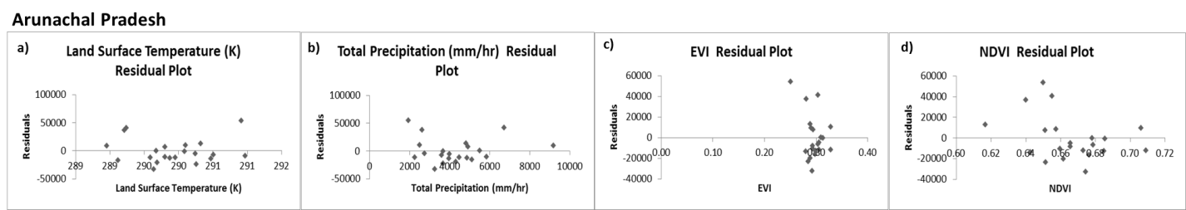
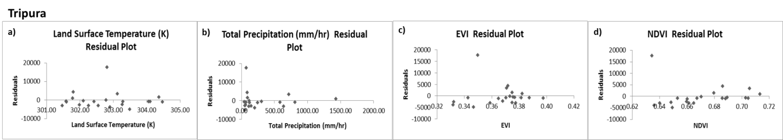
Fig. S1 For selected locations, residual plots for each parameter are shown in graphs. Residual plots are the error plots and thus there should be no discernible pattern in them and they should be random in character. These plots have a residual value or the error value, which is the difference between the predicted and observed values following the regression analysis. The plots with error value values that are randomly distributed having no discernible pattern are considered to be right.

Corresponding author

