Model validation
Funnel plot
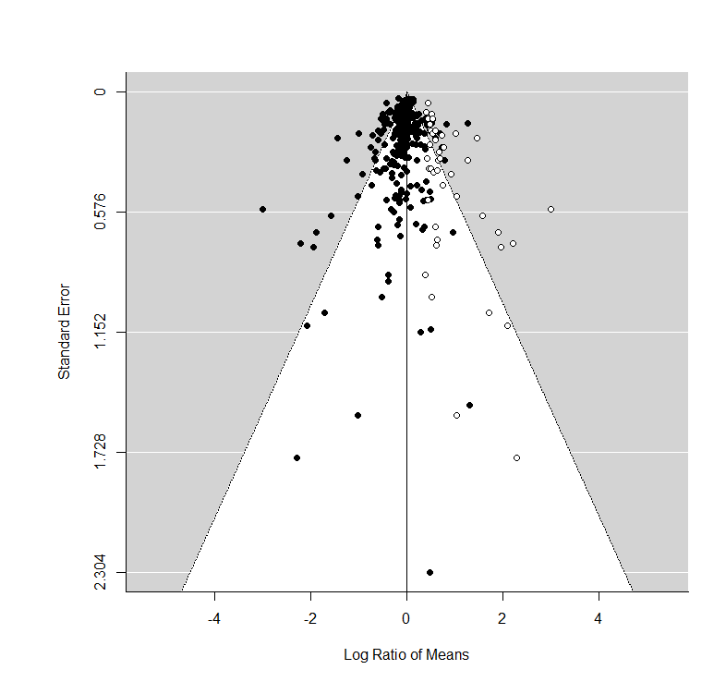
Fig 1: Funnel plot for global data
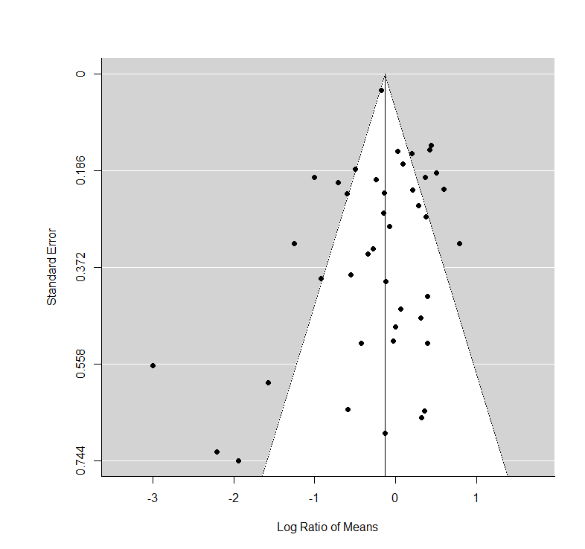
Fig 2: Funnel plot for lower-latitude data

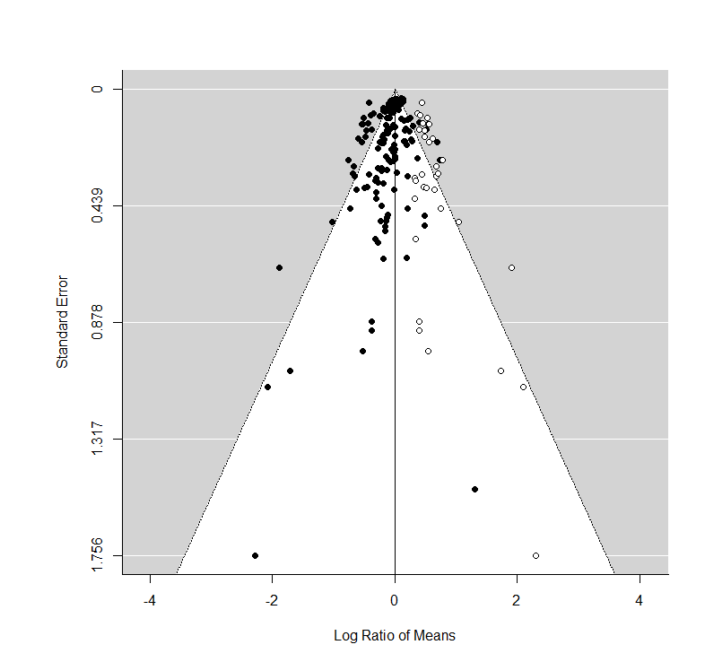
Fig 3: Funnel plot for mid-latitude data
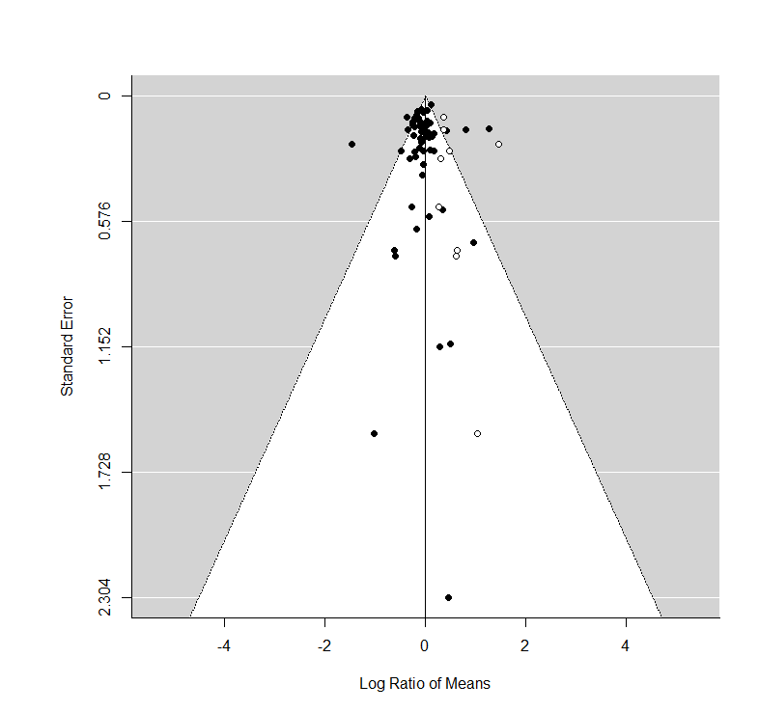
Fig 4: Funnel plot for higher-latitude data
Sensitivity analysis
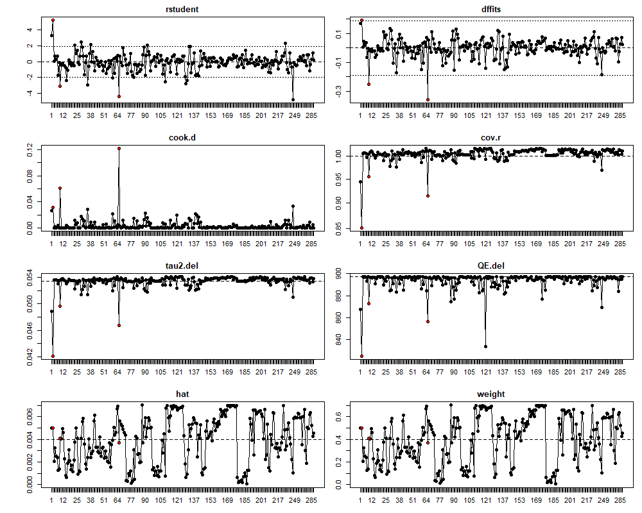
Fig 5: Plots of the externally standardized residuals, DFFITS values, Cook’s distances, covariance ratios, estimates of τ² and test statistics for (residual) heterogeneity when each study was removed in turn, hat values, and weights for 287 global Sphagnum application experiment records. The second, 9th, 65th records may be outliers.
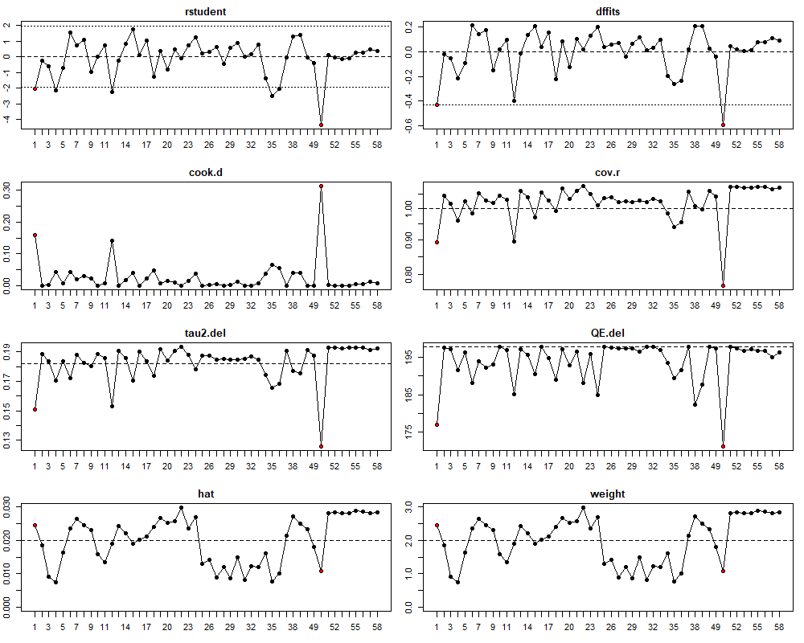
Fig 6: Plots of the externally standardized residuals, DFFITS values, Cook’s distances, covariance ratios, estimates of τ² and test statistics for (residual) heterogeneity when each study was removed in turn, hat values, and weights for 58 lower latitudinal Sphagnum application experiment records. The first and 50th records may be outliers.

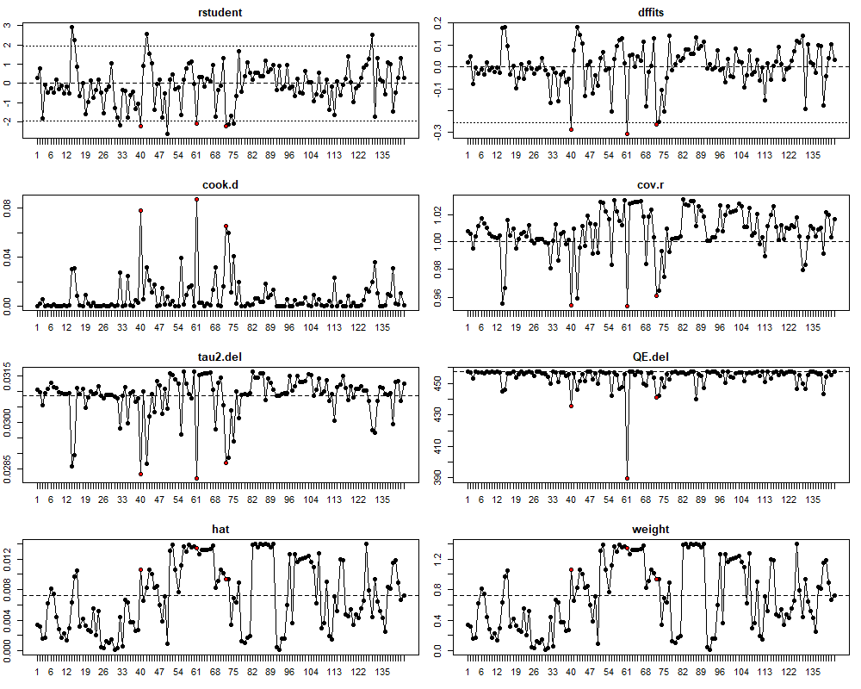
Fig 7: Plots of the externally standardized residuals, DFFITS values, Cook’s distances, covariance ratios, estimates of τ² and test statistics for (residual) heterogeneity when each study was removed in turn, hat values, and weights for 151 lower latitudinal Sphagnum application experiment records. The 40th, 61st and 72nd records may be outliers.
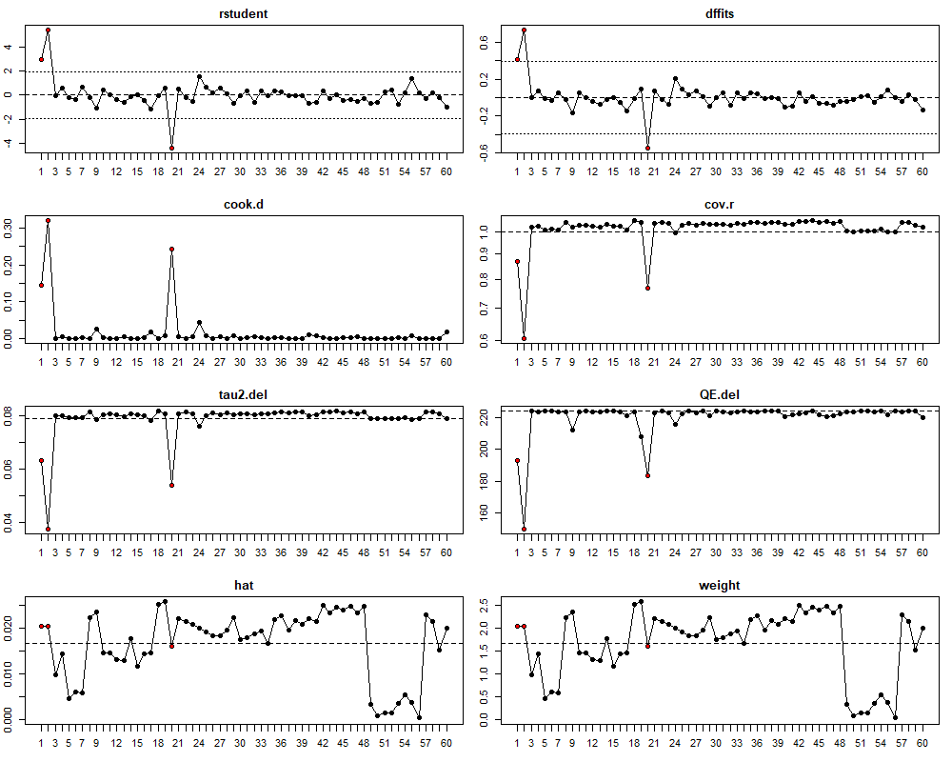
Fig 8: Plot of the externally standardized residuals, DFFITS values, Cook’s distances, covariance ratios, estimates of τ² and test statistics for (residual) heterogeneity when each study was removed in turn, hat values, and weights for 60 lower latitudinal Sphagnum application experiment records. The first, second and 20th records may be outliers.

