Supplementary Information File 1

Analysis of critical protein-protein interactions of SARS-CoV-2 capping and proofreading molecular machineries towards designing dual target inhibitory peptides

Fatemeh Arabi-Jeshvaghani¹, Fatemeh Javadi‐Zarnaghi^{1,} *, Mohamad Reza Ganjalikhany^{1,} *

¹Department of Cell and Molecular Biology & Microbiology, Faculty of Biological Science and Technology, University of Isfahan, Isfahan, Iran

Email: fa.javadi@sci.ui.ac.ir, m.ganjalikhany@sci.ui.ac.ir

Table of contents

Figure S1: Schematic depiction of the genomic organization of SARS-CoV-2.
Figure S2: Schematic illustration of an overview the study.
Figure S3: The workflow of the study.
Figure S4: Analysis of the SARS-CoV nsp16-nsp10 protein-protein interface and hotspot residues.
Figure S5: Analysis of the MERS-CoV nsp16-nsp10 protein-protein interface and hotspot residues.
Figure S6: Analysis of the HCoV-OC43 nsp16-nsp10 protein-protein interface and hotspot residues.
Figure S7: The results of computational alanine scanning (CAS) calculations for the predicted key interacting residues of the SARS-CoV-2 nsp16-nsp10 and nsp14-nsp10 complexes.
Figure S8: The interactions between the wild-type (V42, L45, and Y96 of nsp10) and mutant residues (alanine) and their nearby residues in the nsp16-nsp10 complex.
Figure S9: The interactions between the wild-type (V84, D106, and V44 of nsp16) and mutant residues (alanine) and their nearby residues in the nsp16-nsp10 complex.
Figure S10: The interactions between the wild-type (F16, H80, and Y96 of nsp10) and mutant residues (alanine) and their nearby residues in the nsp14-nsp10 complex.
Figure S11: The interactions between the wild-type (F8, P24, and F60 of nsp14) and mutant residues (alanine) and their nearby residues in the nsp14-nsp10 complex.
Figure S12: Two-dimensional residue interaction maps for the SARS-CoV-2 nsp16-nsp10 and nsp14-nsp10 complexes.
Figure S13: Two-dimensional residue interaction map for the SARS-CoV nsp16-nsp10 complex.
Figure S14: Two-dimensional residue interaction map for the MERS-CoV nsp16-nsp10 complex.
Figure S15: Two-dimensional residue interaction map for the HCoV-OC43 nsp16-nsp10 complex.
Figure S16: The distance range and the property contact maps for the SARS-CoV-2 nsp16-nsp10 and nsp14-nsp10 complexes.
Figure S17: The heat map for residue-residue pairwise interaction energies (IEs) between the predicted key interacting residues of nsp10 and nsp16 in SAR-CoV-2.
Figure S18: The heat map for residue-residue pairwise interaction energies (IEs) between the predicted key interacting residues of nsp10 and nsp14 in SAR-CoV-2.
Figure S19: The node centrality parameters in the network, including the degree centrality (DC), betweenness centrality (BC), and closeness centrality (CC) of the predicted key interacting residues of the SARS-CoV-2 nsp16-nsp10 complex.
Figure S20: The node centrality parameters in the network, including the degree centrality (DC), betweenness centrality (BC), and closeness centrality (CC) of the predicted key interacting residues of the SARS-CoV-2 nsp14-nsp10 complex.
Figure S21: The 3D networks of the residue-residue interactions for the SARS-CoV-2 nsp16-nsp10 and nsp14-nsp10 complexes.
Figure S22: The top 5 nsp16 residues with the greatest energy contributions (the lowest energy) in the interactions of OLP-13, OLP-16, OLP-17, OLP-18 and nsp16 as target protein.
Figure S23: The top 5 nsp16 residues with the greatest energy contributions (the lowest energy) in the interactions of P-16-11, P-16-12, P-16-13, P-16-14, P-16-15 and nsp16 as target protein.
Figure S24: The top 5 nsp14 residues with the greatest energy contributions (the lowest energy) in the interactions of OLP-13, OLP-16, OLP-17, OLP-18 and nsp14 as target protein.
Figure S25: The top 5 nsp14 residues with the greatest energy contributions (the lowest energy) in the interactions of P-14-11, P-14-12, P-14-13, P-14-14, P-14-15 and nsp14 as target protein.
Figure S26: Two-dimensional residue interaction maps of OLP-16 and OLP-17 peptides and the targets.
Figure S27: Two-dimensional residue interaction maps for P-16-11, P-16-12, P-16-13, P-16-14, P-16-15 and nsp16 as target protein.
Figure S28: Two-dimensional residue interaction maps for P-14-11-, P-14-12, P-14-13 and nsp14 as target protein.
Figure S29: Two-dimensional residue interaction maps for P-14-14-, P-14-15 and nsp14 as target protein.
Figure S30: The RMSF plots of the target-peptide complexes.
Figure S31: The heat maps representing the in silico saturation mutagenesis of designed peptides.
Figure S32: The conservation analysis of the nsp16 protein across coronaviruses.
Figure S33: The conservation analysis of the nsp14 protein across coronaviruses.
Figure S34: The conservation analysis of the nsp10 protein across coronaviruses.

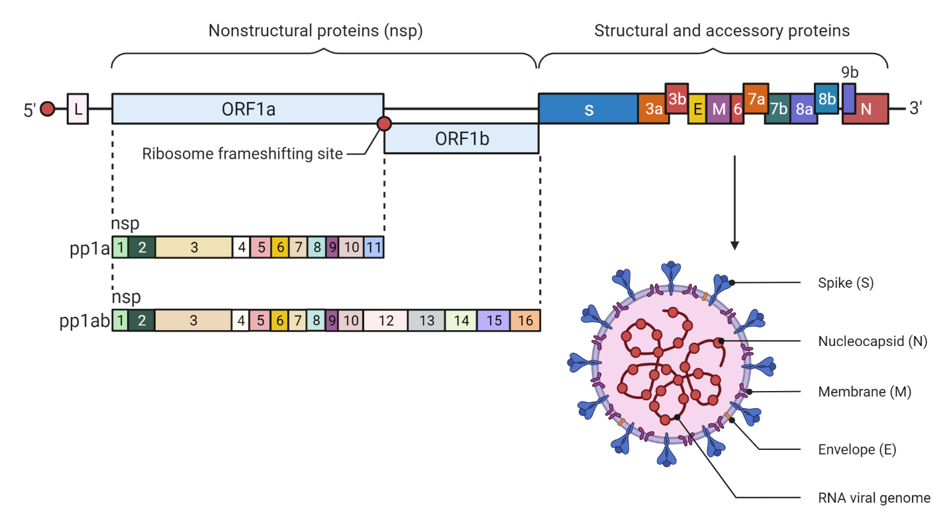
Figure S1: Schematics depiction of the genomic organization of SARS-CoV-2. The open reading frames (ORFs) at the 5′ end of the genome encode the nonstructural proteins (nsps). The structural and accessory proteins are encoded by the ORFs at the 3′ end of the genome. Created with BioRender (https://biorender.com/). Adapted from “Coronavirus Replication Cycle”, by BioRender.com (2022). Retrieved from https://app.biorender.com/biorender-templates.

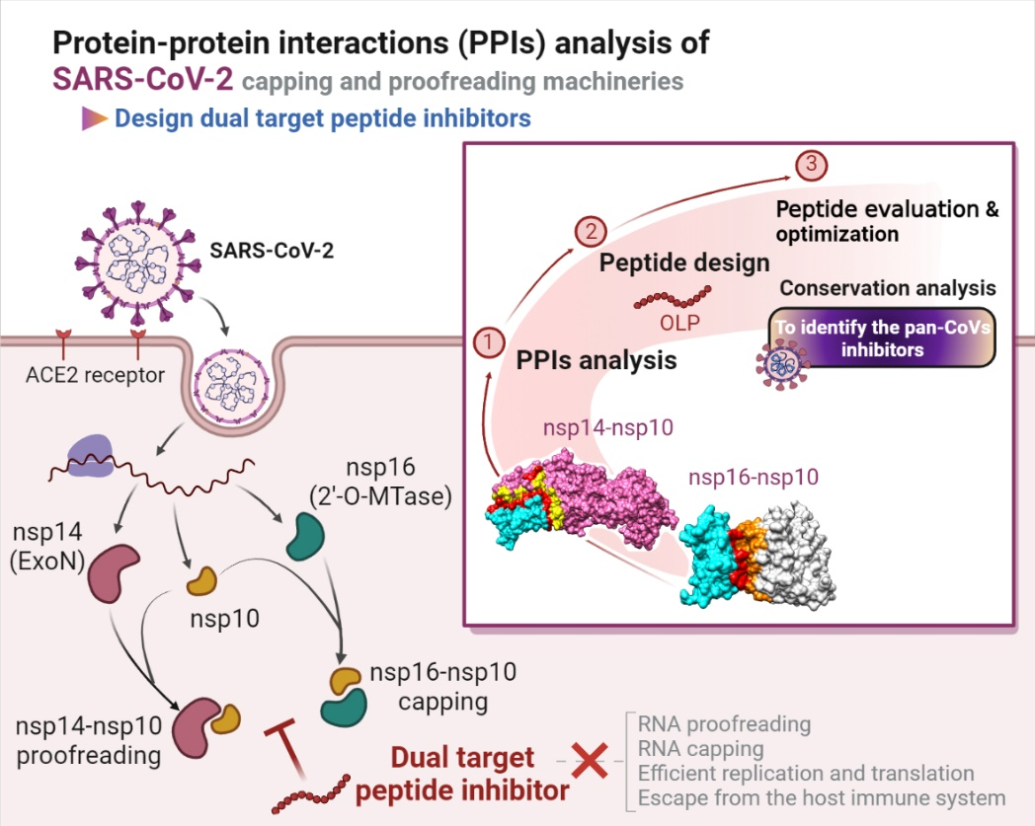
Figure S2: Schematic illustration of an overview the study. Created with BioRender (https://biorender.com/). Adapted from “Remdesivir: Potential Repurposed Drug Candidate for COVID-19 (Portrait)” by BioRender.com (2022). Retrieved from https://app.biorender.com/biorender-templates.

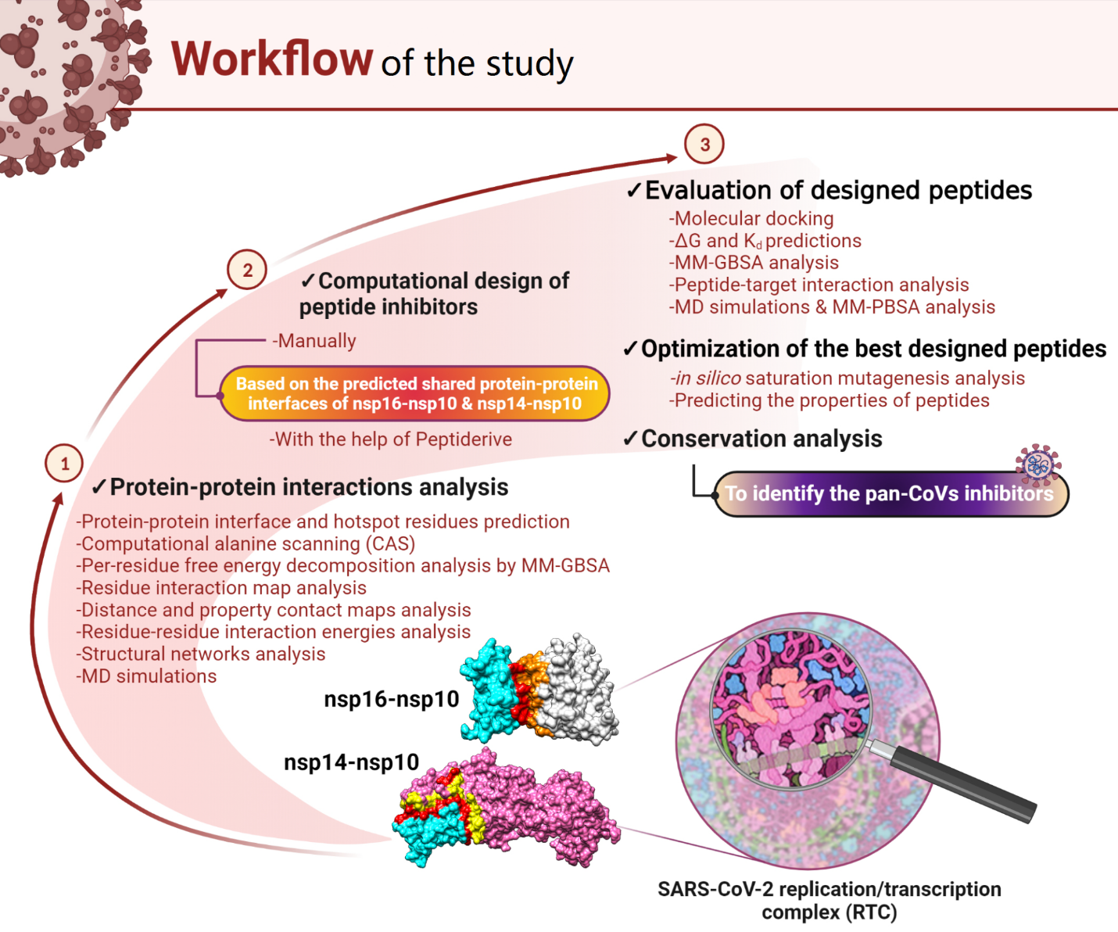
Figure S3: The workflow of the study. The methods used in this study for protein-protein-interactions (PPIs) analysis of nsp16-nsp10 and nsp14-nsp10 interactions and then peptide inhibitor design, evaluation, and optimization. Created with BioRender (https://biorender.com/). Adapted from “From the Human Body to Microfluidics”, by BioRender.com (2022). Retrieved from https://app.biorender.com/biorender-templates. Acknowledgment: David S. Goodsell, RCSB Protein Data Bank; doi: 10.2210/rcsb_pdb/goodsell-gallery-023. Integrative illustration for coronavirus outreach (2020) PLoS Biol 18: e3000815 doi: 10.1371/journal.pbio.3000815.

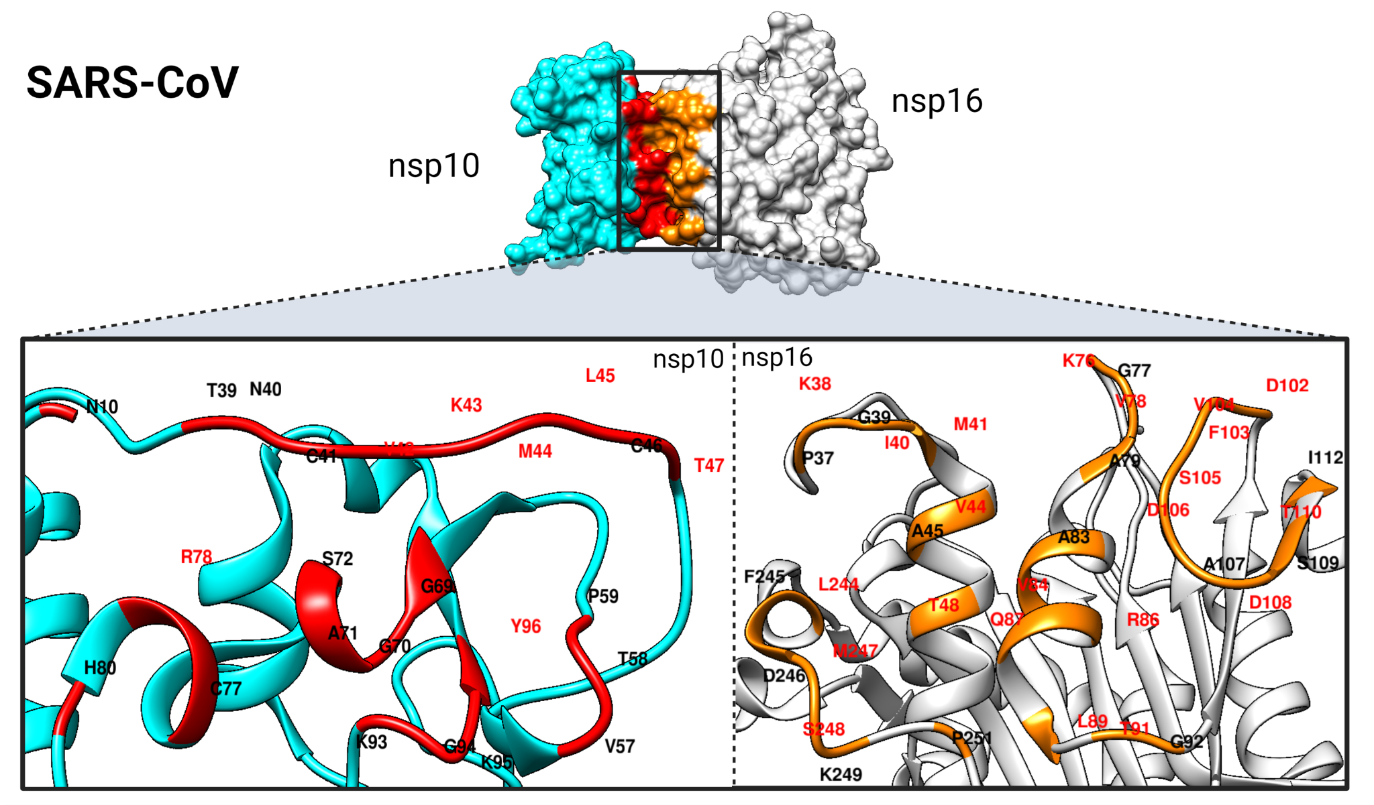
Figure S4: Analysis of the SARS-CoV nsp16-nsp10 protein-protein interface and hotspot residues. The interfaces and hotspots were mapped to the structures at the protein-protein interface of nsp16 (gray) and nsp10 (cyan), which are colored orange and red, respectively. The hotspot residues are shown in red labels.

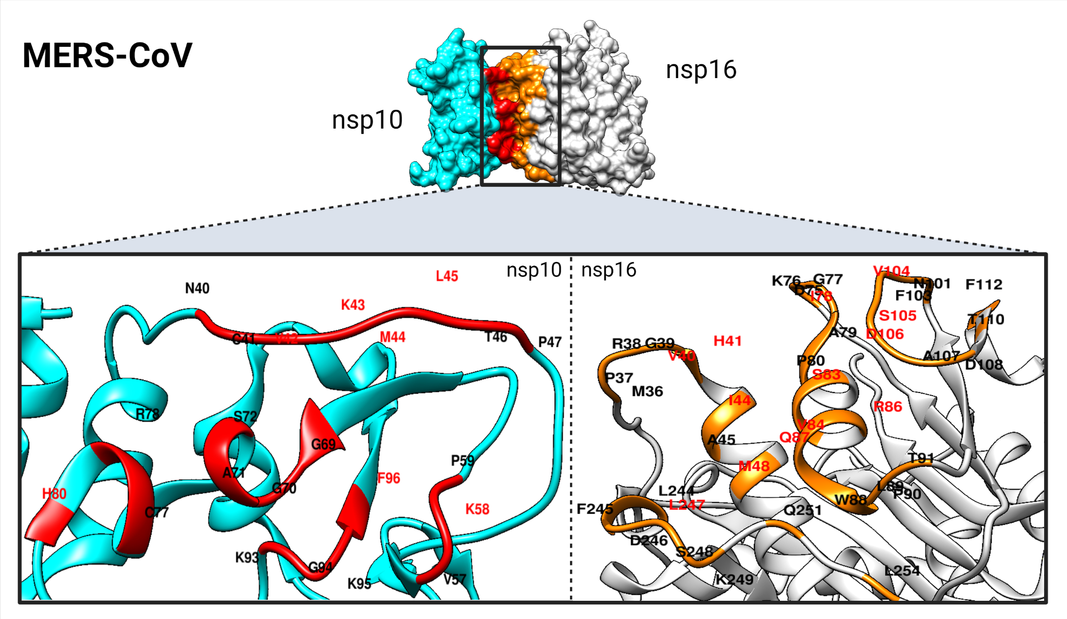Figure S5: Analysis of the MERS-CoV nsp16-nsp10 protein-protein interface and hotspot residues. The interfaces and hotspots were mapped to the structures at the protein-protein interface of nsp16 (gray) and nsp10 (cyan), which are colored orange and red, respectively. The hotspot residues are shown in red labels.

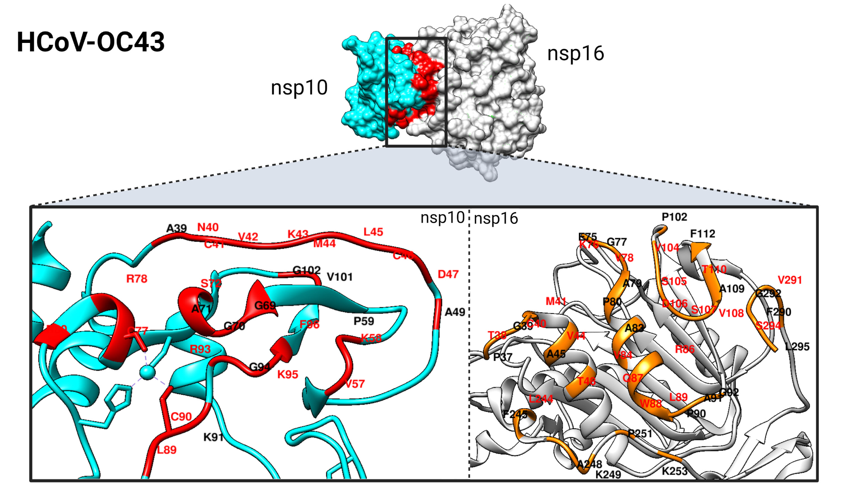
Figure S6: Analysis of the HCoV-OC43 nsp16-nsp10 protein-protein interface and hotspot residues. The interfaces and hotspots were mapped to the structures at the protein-protein interface of nsp16 (gray) and nsp10 (cyan), which are colored orange and red, respectively. The hotspot residues are shown in red labels.

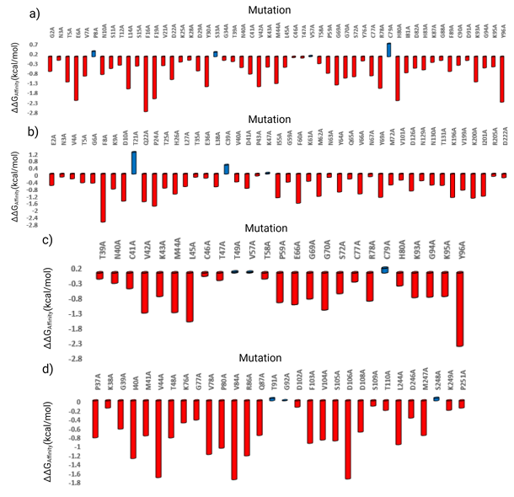Figure S7: The results of computational alanine scanning (CAS) calculations for the predicted key interacting residues of the SARS-CoV-2 nsp16-nsp10 and nsp14-nsp10 complexes. (a) the bar chart summarized the changes in binding affinity upon mutation of nsp10 key residues to alanine in nsp14-nsp10 complex, (b) the bar chart summarized the changes in binding affinity upon mutation of nsp14 key residues to alanine in nsp14-nsp10 complex, (c) the bar chart summarized the changes in binding affinity upon mutation of nsp10 key residues to alanine in nsp16-nsp10 complex, and (d) the bar chart summarized the changes in binding affinity upon mutation of nsp16 key residues to alanine in nsp16-nsp10 complex. The red and blue bars show the decreasing (the negative ΔΔG_{Affinity}) and increasing impacts (the positive ΔΔG_{Affinity}) on PPIs, respectively.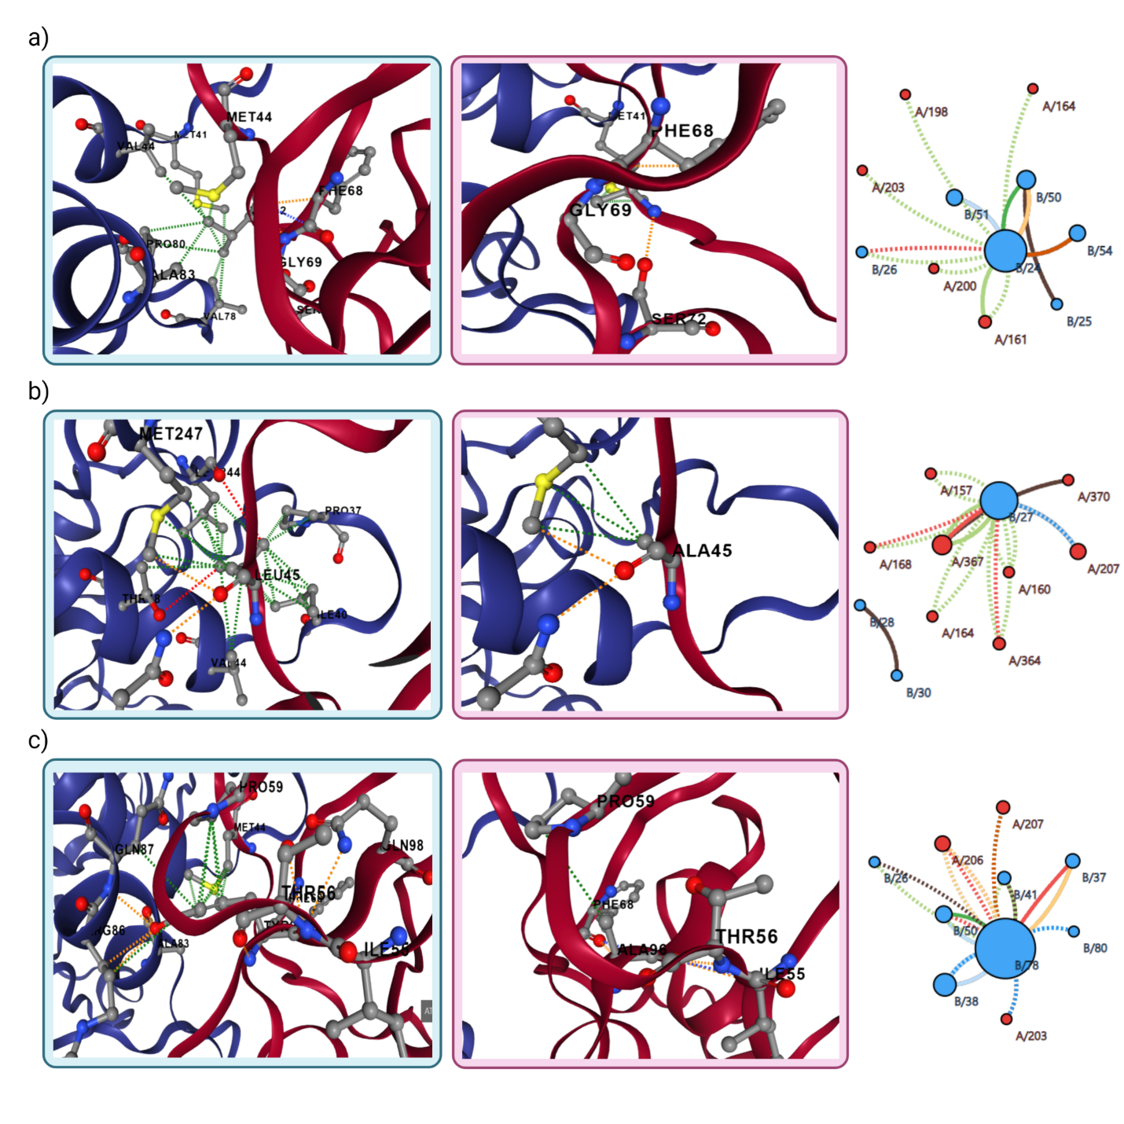Figure S8: The interactions between the wild-type (V42, L45, and Y96 of nsp10) and mutant residues (alanine) and their nearby residues in the nsp16-nsp10 complex. The interactions between the wild-type and mutant residues and their nearby residues on the left, and the inter-residue interactions of wild-type and mutant on the right for: (a) V42 of nsp10 mutated to alanine in the nsp16-nsp10 complex, (b) L45 of nsp10 mutated to alanine in the nsp16-nsp10 complex, and (c) Y96 of nsp10 mutated to alanine in the nsp16-nsp10 complex. The interactions of wild type and mutant residues are represented in the blue and purple boxes, respectively. The nsp16 protein is chain A and is represented in cartoon and blue. The nsp10 protein is chain B that is depicted in cartoon and red. The dashed lines and straight lines represent the wild type and mutant inter-residues interactions, respectively. The aromatic, carbonyl, hydrophobic, hydrogen bond, ionic, VDW, ring-ring, and polar-Hbond interactions are colored in light green, dark blue, dark green, red, yellow, light blue, black, and orange, respectively.
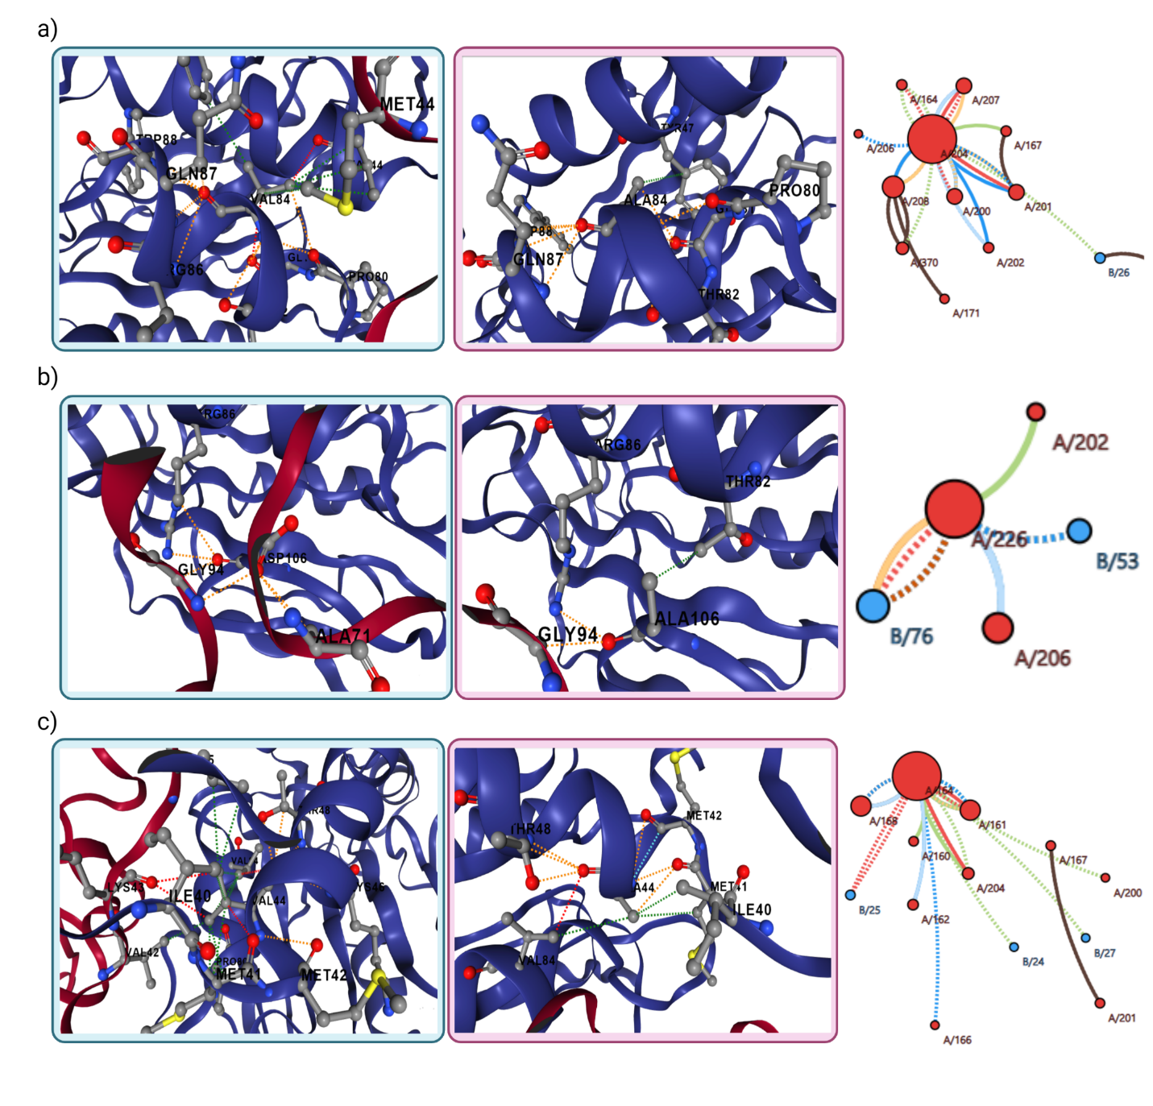Figure S9: The interactions between the wild-type (V84, D106, and V44 of nsp16) and mutant residues (alanine) and their nearby residues in the nsp16-nsp10 complex. The interactions between the wild-type and mutant residues and their nearby residues on the left, and the inter-residue interactions of wild-type and mutant on the right for: (a) V84 of nsp16 mutated to alanine in the nsp16-nsp10 complex, (b) D106 of nsp16 mutated to alanine in the nsp16-nsp10 complex, (c) V44 of nsp16 mutated to alanine in the nsp16-nsp10 complex. The interactions of wild type and mutant residues are represented in the blue and purple boxes, respectively. The nsp16 protein is chain A and represented in cartoon and blue. The nsp10 protein is chain B that is depicted in cartoon and red. The dashed lines and straight lines represent the wild type and mutant inter-residues interactions, respectively. The aromatic, carbonyl, hydrophobic, hydrogen bond, ionic, VDW, ring-ring, and polar-Hbond interactions are colored in light green, dark blue, dark green, red, yellow, light blue, black, and orange, respectively.

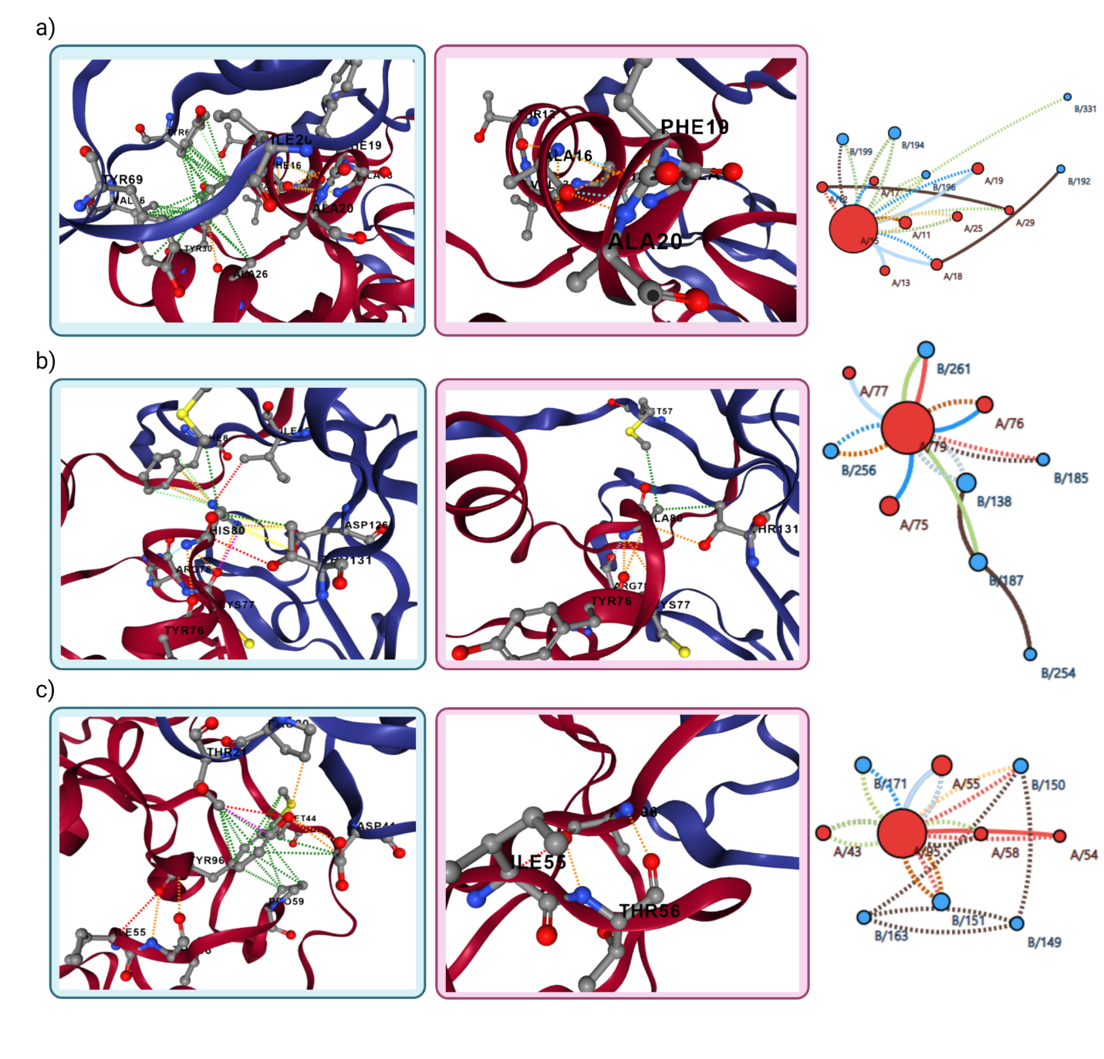Figure S10: The interactions between the wild-type (F16, H80, and Y96 of nsp10) and mutant residues (alanine) and their nearby residues in the nsp14-nsp10 complex. The interactions between the wild-type and mutant residues and their nearby residues on the left, and the inter-residue interactions of wild-type and mutant on the right for: (a) F16 of nsp10 mutated to alanine in the nsp14-nsp10 complex, (b) H80 of nsp10 mutated to alanine in the nsp14-nsp10 complex, and (c) Y96 of nsp10 mutated to alanine in the nsp14-nsp10 complex. The interactions of wild type and mutant residues are represented in the blue and purple boxes, respectively. The nsp14 protein is chain B and represented in cartoon and blue. The nsp10 protein is chain A that is depicted in cartoon and red. The dashed lines and straight lines represent the wild type and mutant inter-residues interactions, respectively. The aromatic, carbonyl, hydrophobic, hydrogen bond, ionic, VDW, ring-ring, and polar-Hbond interactions are colored in light green, dark blue, dark green, red, yellow, light blue, black, and orange, respectively.

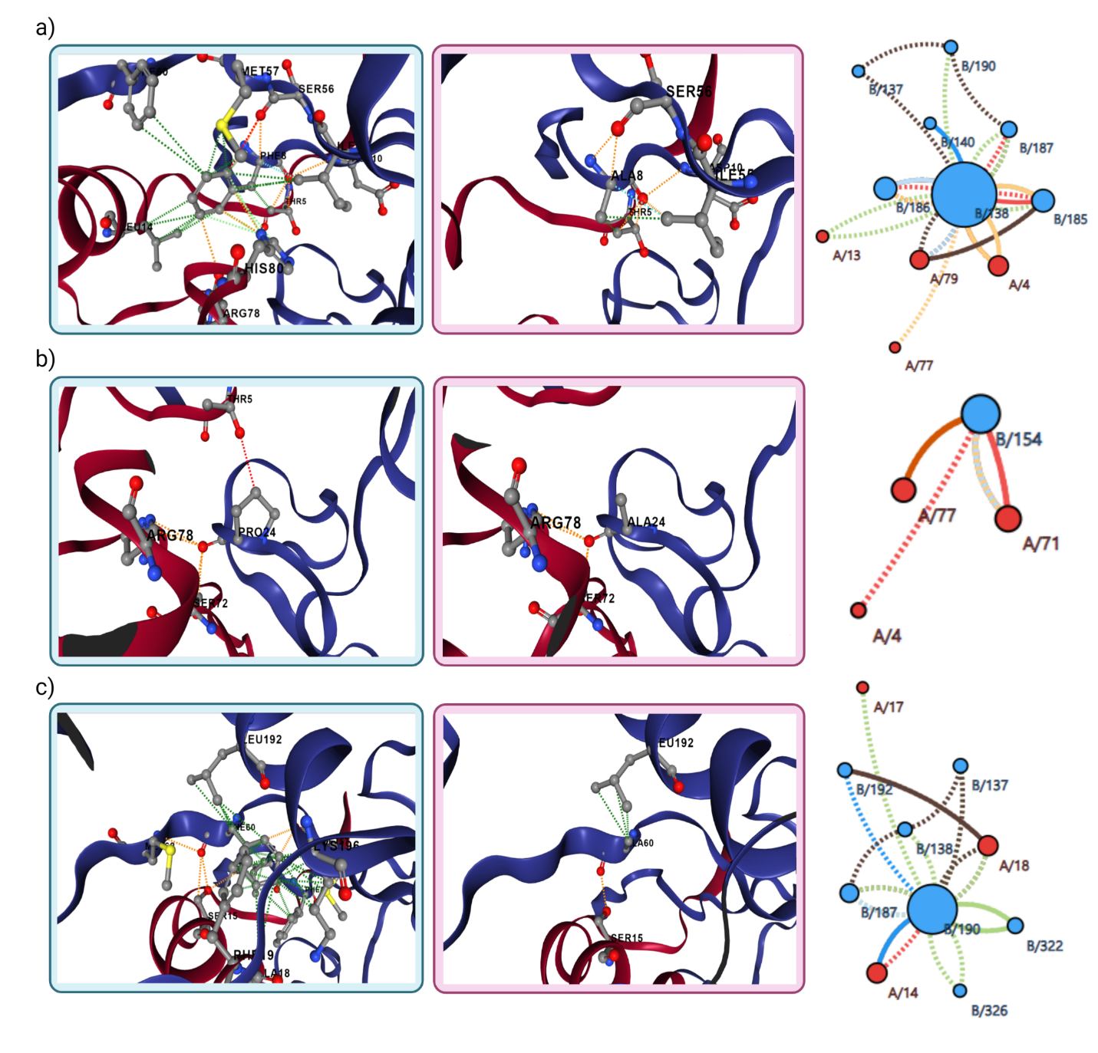Figure S11: The interactions between the wild-type (F8, P24, and F60 of nsp14) and mutant residues (alanine) and their nearby residues in the nsp14-nsp10 complex. The interactions between the wild-type and mutant residues and their nearby residues on the left, and the inter-residue interactions of wild-type and mutant on the right for: (a) F8 of nsp14 mutated to alanine in the nsp14-nsp10 complex, (b) P24 of nsp14 mutated to alanine in the nsp14-nsp10 complex, and (c) F60 of nsp14 mutated to alanine in the nsp14-nsp10 complex. The interactions of wild type and mutant residues are represented in the blue and purple boxes, respectively. The nsp14 protein is chain B and represented in cartoon and blue. The nsp10 protein is chain A that is depicted in cartoon and red. The dashed lines and straight lines represent the wild type and mutant inter-residues interactions, respectively. The aromatic, carbonyl, hydrophobic, hydrogen bond, ionic, VDW, ring-ring, and polar-Hbond interactions are colored in light green, dark blue, dark green, red, yellow, light blue, black, and orange, respectively.

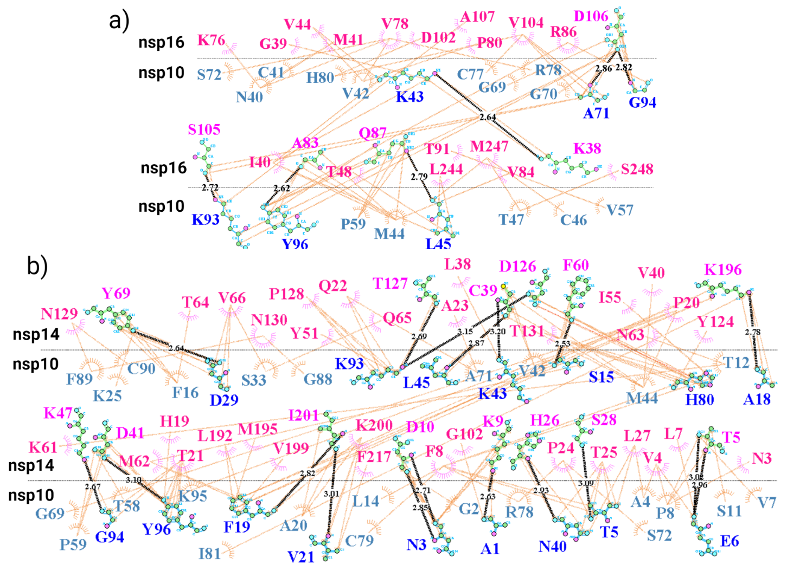
Figure S12: Two-dimensional residue interaction maps for the SARS-CoV-2 nsp16-nsp10 and nsp14-nsp10 complexes. (a) two-dimensional residue interaction map for nsp16-nsp10 complex, and (b) two-dimensional residue interaction map for nsp14-nsp10 complex. The horizontal dashed line represents the complex interface. The black dashed lines, and the pink and brown arcs with spokes represent the hydrogen bonds and hydrophobic contacts, respectively.
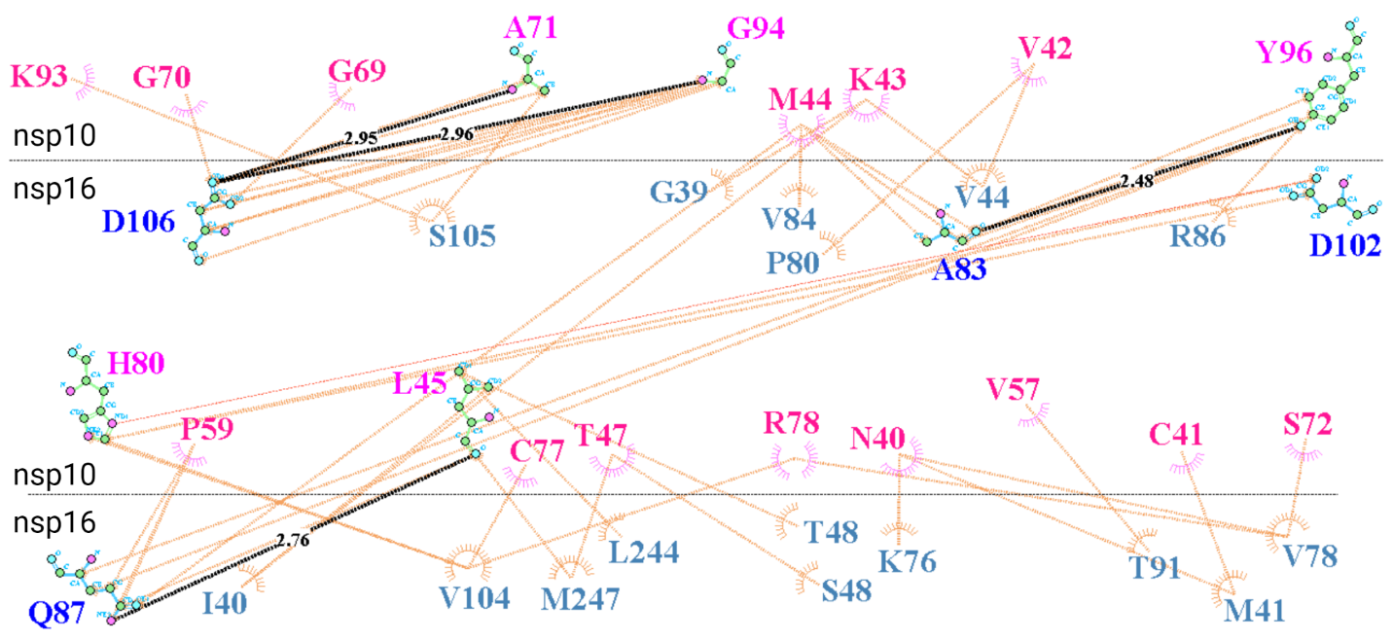
Figure S13: Two-dimensional residue interaction map for the SARS-CoV nsp16-nsp10 complex. The horizontal dashed line represents the complex interface. The black dashed lines and the pink and brown arcs with spokes represent the hydrogen bonds and the hydrophobic contacts, respectively.

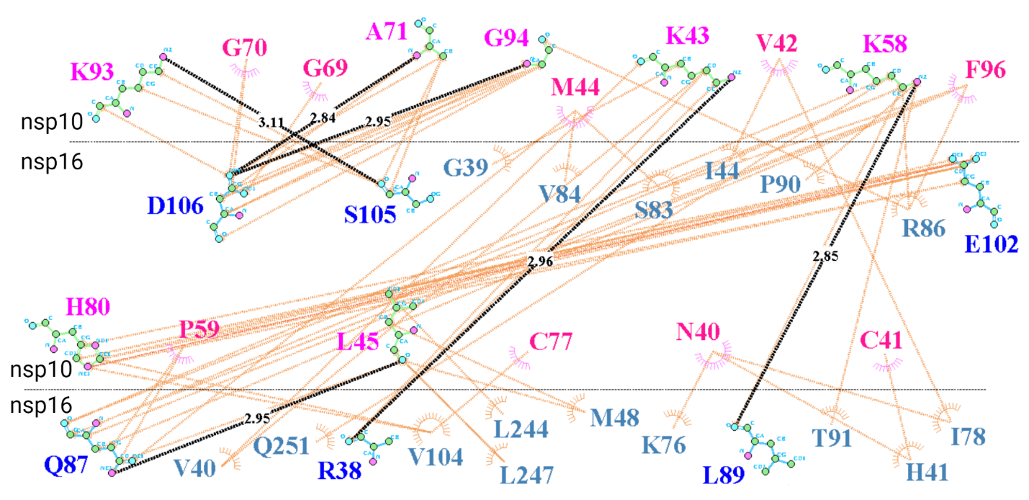
Figure S14: Two-dimensional residue interaction map for the MERS-CoV nsp16-nsp10 complex. The horizontal dashed line represents the complex interface. The black dashed lines and the pink and brown arcs with spokes represent the hydrogen bonds and the hydrophobic contacts, respectively.
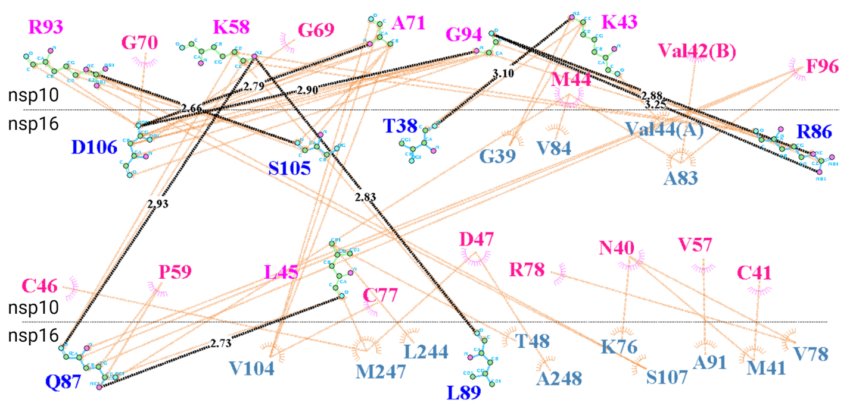Figure S15: Two-dimensional residue interaction map for the HCoV-OC43 nsp16-nsp10 complex. The horizontal dashed line represents the complex interface. The black dashed lines and the pink and brown arcs with spokes represent the hydrogen bonds and the hydrophobic contacts, respectively.

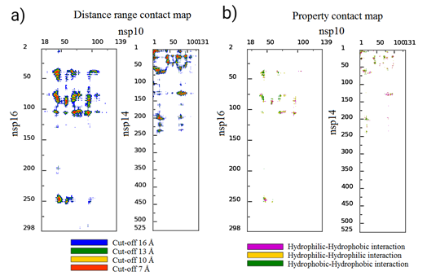
Figure S16: The distance range and the property contact maps for the SARS-CoV-2 nsp16-nsp10 and nsp14-nsp10 complexes. (a) distance range contact maps, and (b) property contact maps.

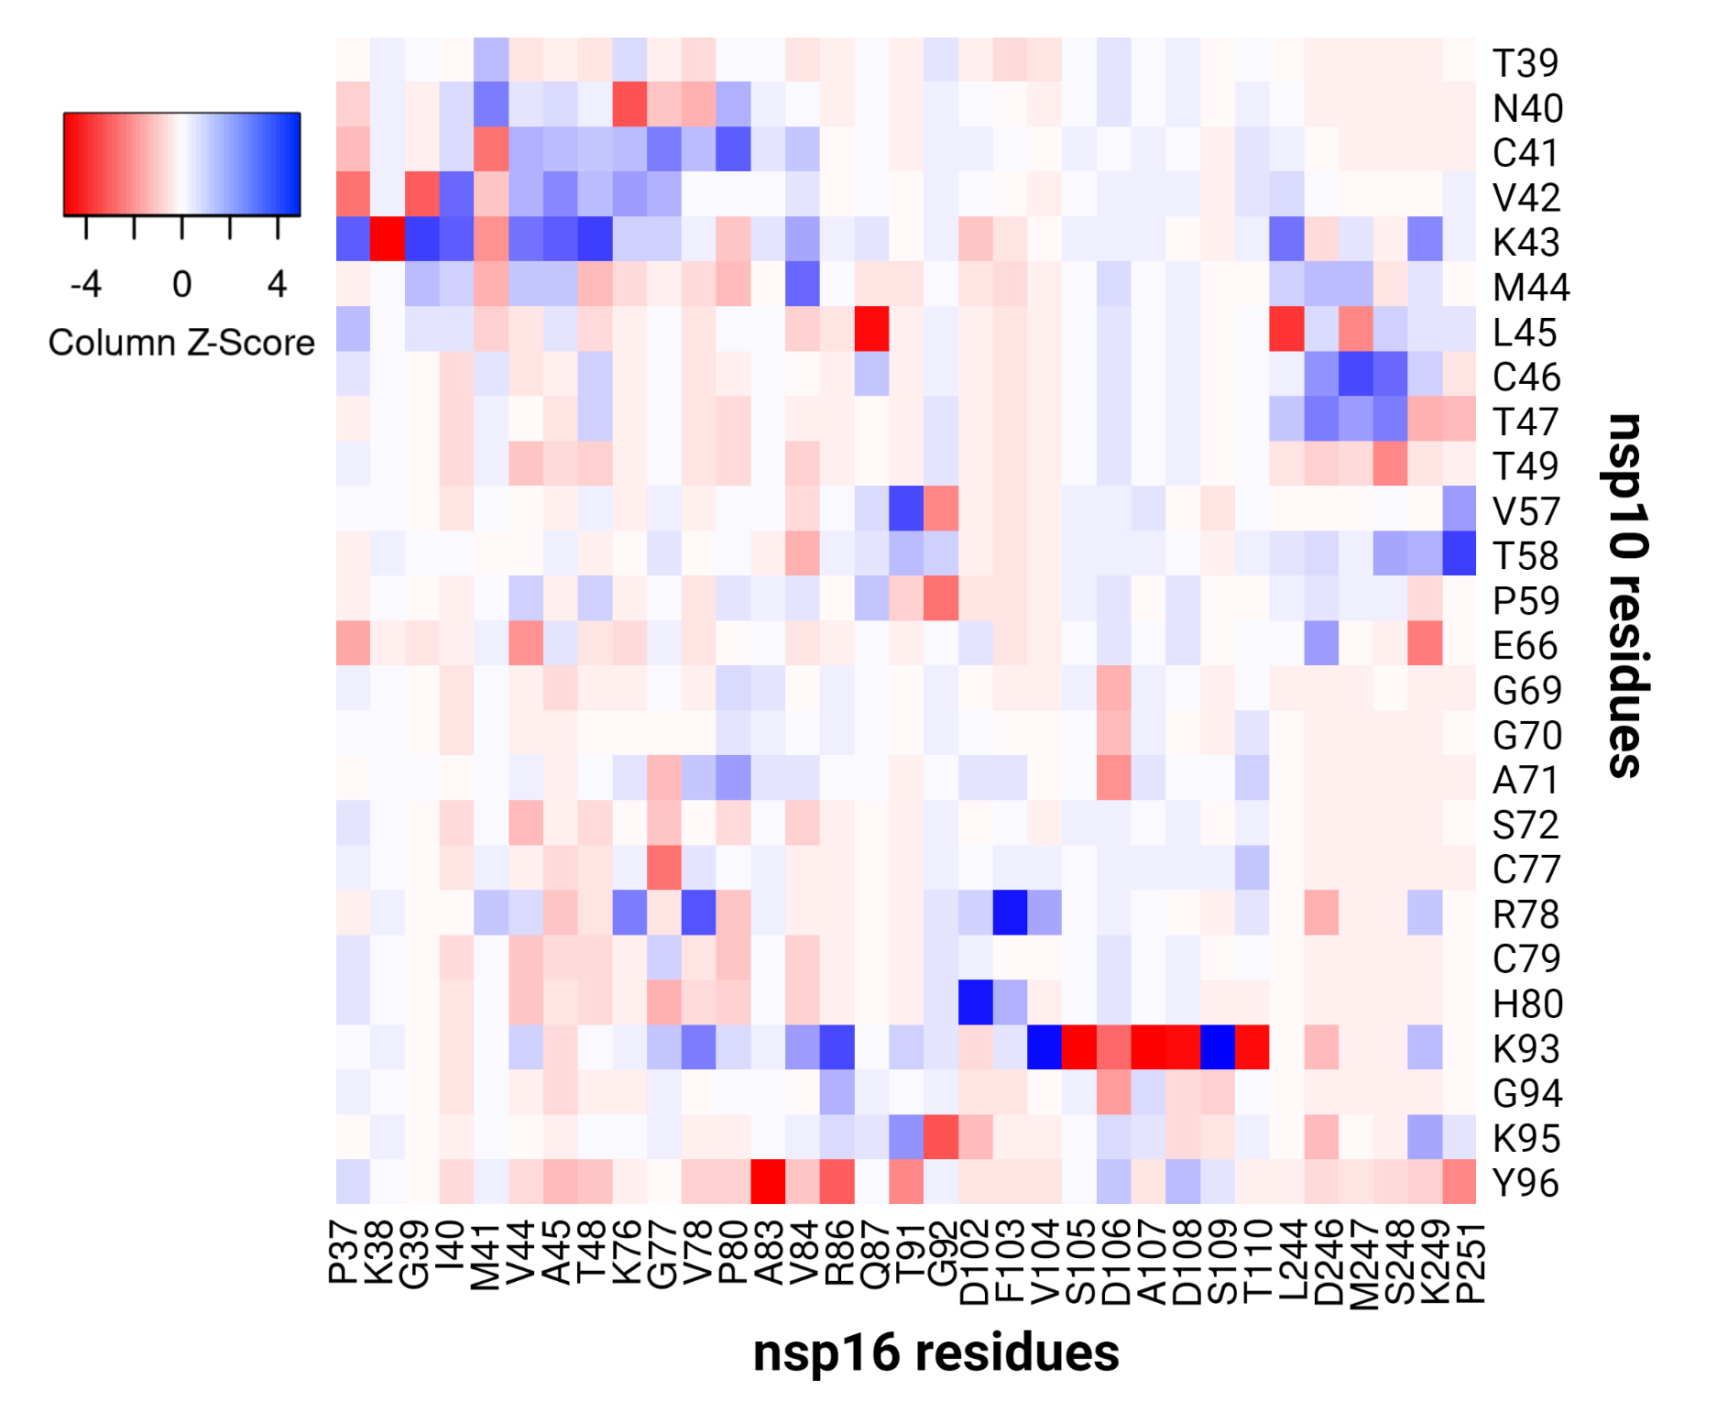Figure S17: The heat map for residue-residue pairwise interaction energies (IEs) between the predicted key interacting residues of nsp10 and nsp16 in SAR-CoV-2. The negative (with the stabilizing roles in PPIs) and positive (with the destabilizing roles in PPIs) pairwise IEs are colored in red and blue, respectively.
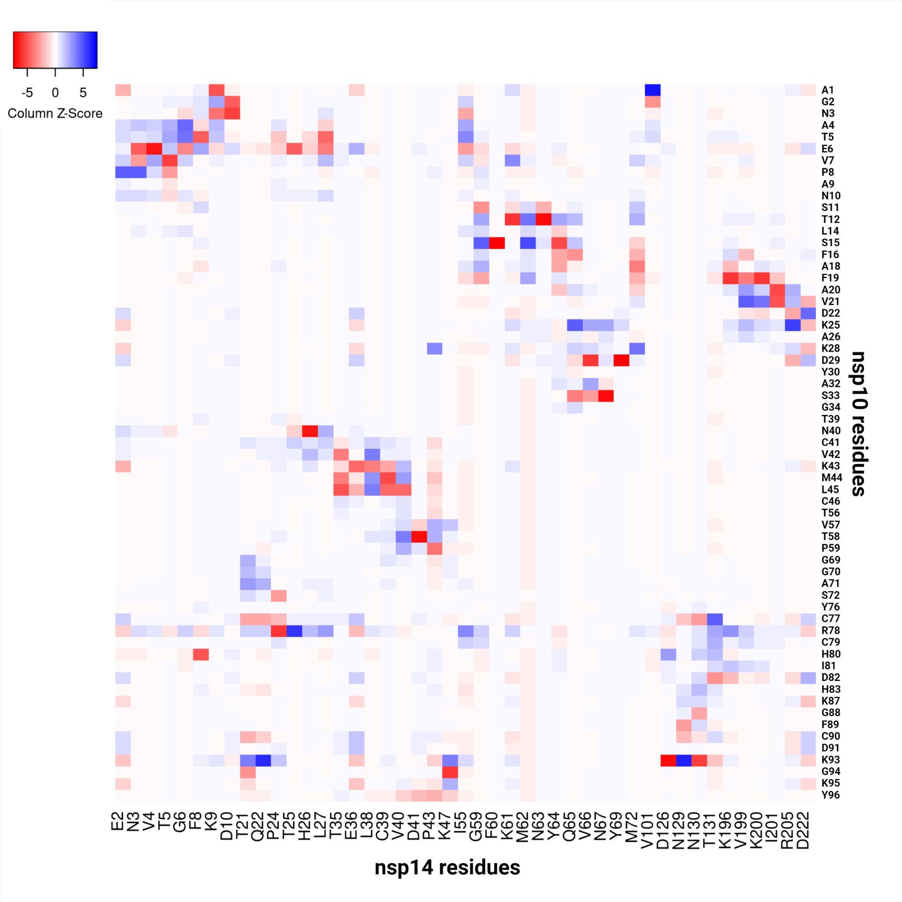Figure S18: The heat map for residue-residue pairwise interaction energies (IEs) between the predicted key interacting residues of nsp10 and nsp14 in SARS-CoV-2. The negative (with the stabilizing roles in PPIs) and positive (with the destabilizing roles in PPIs) pairwise IEs are colored in red and blue, respectively.
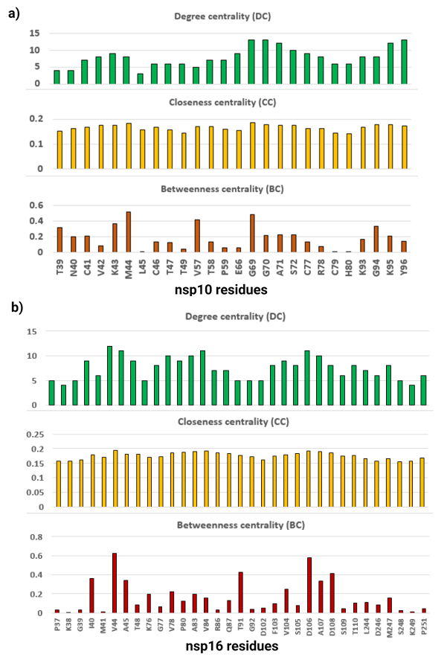
Figure S19: The node centrality parameters in the network, including the degree centrality (DC), betweenness centrality (BC), and closeness centrality (CC) of the predicted key interacting residues of the SARS-CoV-2 nsp16-nsp10 complex. (a) the node centrality parameters for the predicted key interacting residues of nsp10, and (b) the node centrality parameters for the predicted key interacting residues of nsp16.
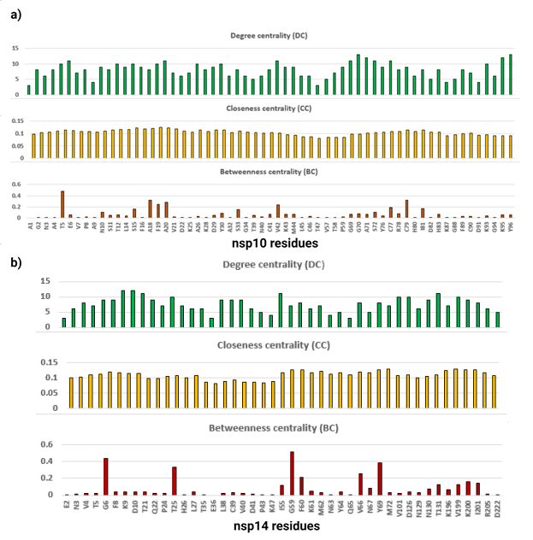Figure S20: The node centrality parameters in the network, including the degree centrality (DC), betweenness centrality (BC), and closeness centrality (CC) of the predicted key interacting residues of the SARS-CoV-2 nsp14-nsp10 complex. (a) the node centrality parameters for the predicted key interacting residues of nsp10, and (b) the node centrality parameters for the predicted key interacting residues of nsp14.
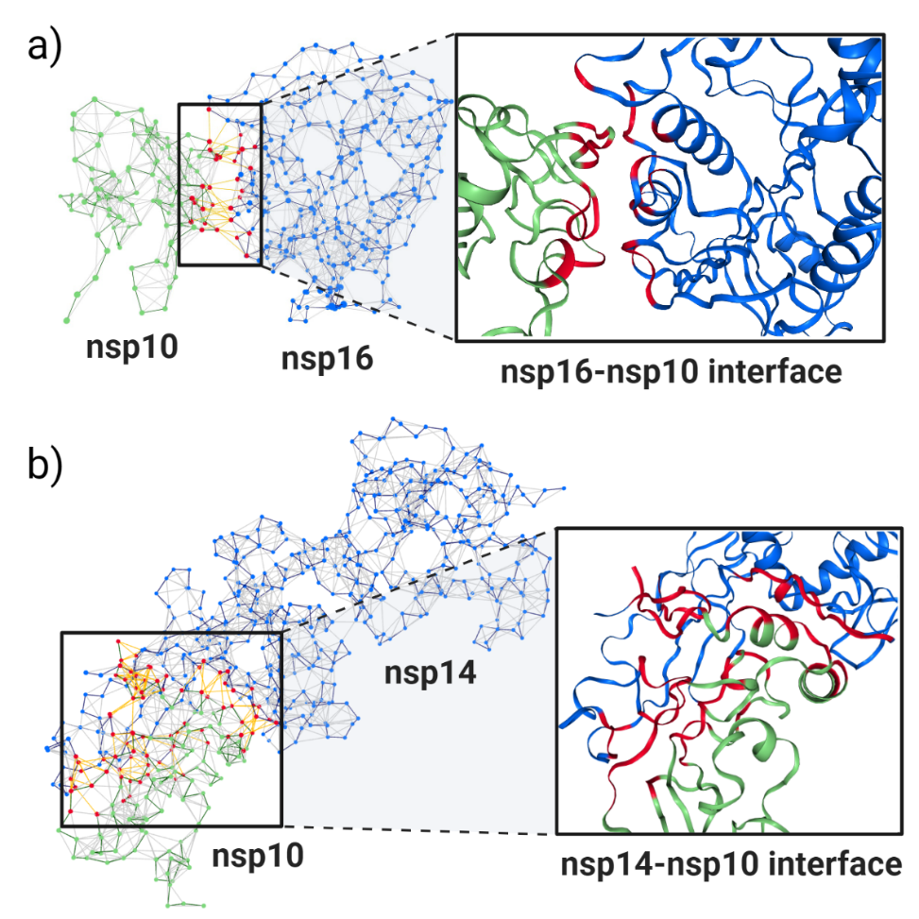Figure S21: The 3D networks of the residue–residue interactions for the SARS-CoV-2 nsp16-nsp10 and nsp14-nsp10 complexes. (a) 3D network of the nsp16-nsp10 complex, and (b) 3D network of the SARS-CoV-2 nsp14-nsp10 complex. The nodes and edges at PPIs interface are colored in red and yellow, respectively. The protein-protein interfaces are colored in red and shown in the box.

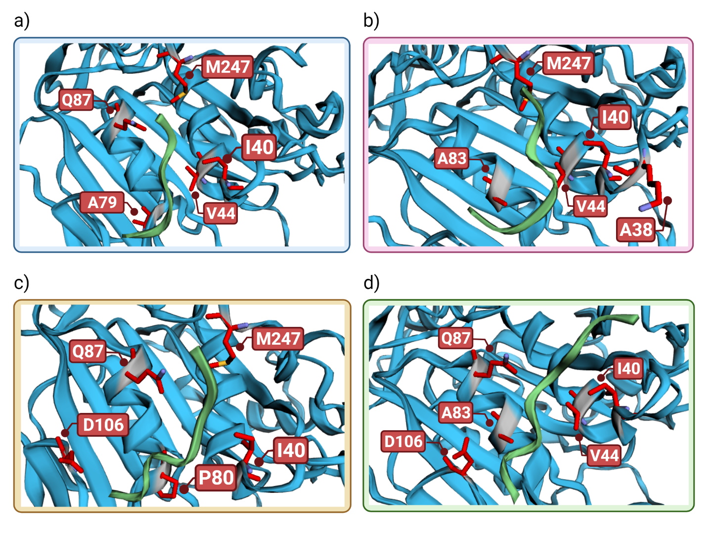Figure S22: The top 5 nsp16 residues with the greatest energy contributions (the lowest energy) in the interactions of OLP-13, OLP-16, OLP-17, OLP-18 and nsp16 as target protein. (a) OLP-13 and nsp16 complex, (b) OLP-16 and nsp16 complex, (c) OLP-17 and nsp16 complex, and (d) OLP-18 and nsp16 complex. Nsp16 and the peptides are shown in blue and green, respectively.

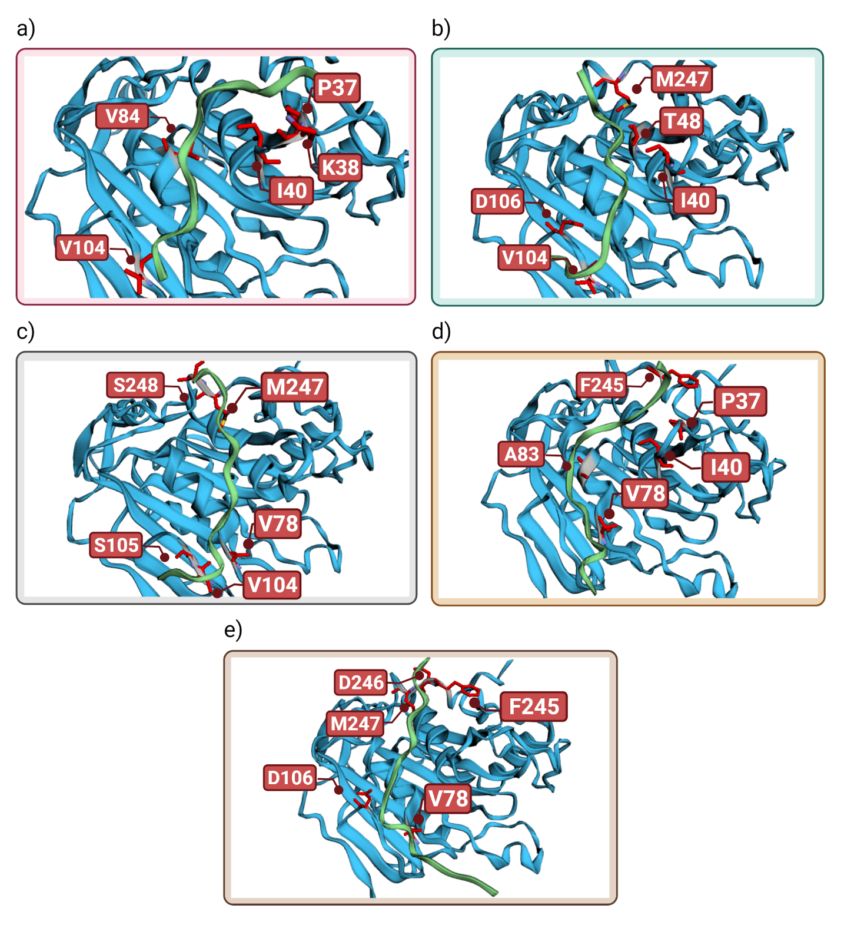Figure S23: The top 5 nsp16 residues with the greatest energy contributions (the lowest energy) in the interactions of P-16-11, P-16-12, P-16-13, P-16-14, P-16-15 and nsp16 as target protein. (a) P-16-11 and nsp16 complex, (b) P-16-12 and nsp16 complex, (c) P-16-13 and nsp16 complex, (d) P-16-14 and nsp16 complex, and (e) P-16-15 and nsp16. Nsp16 and the peptides are shown in blue and green, respectively.

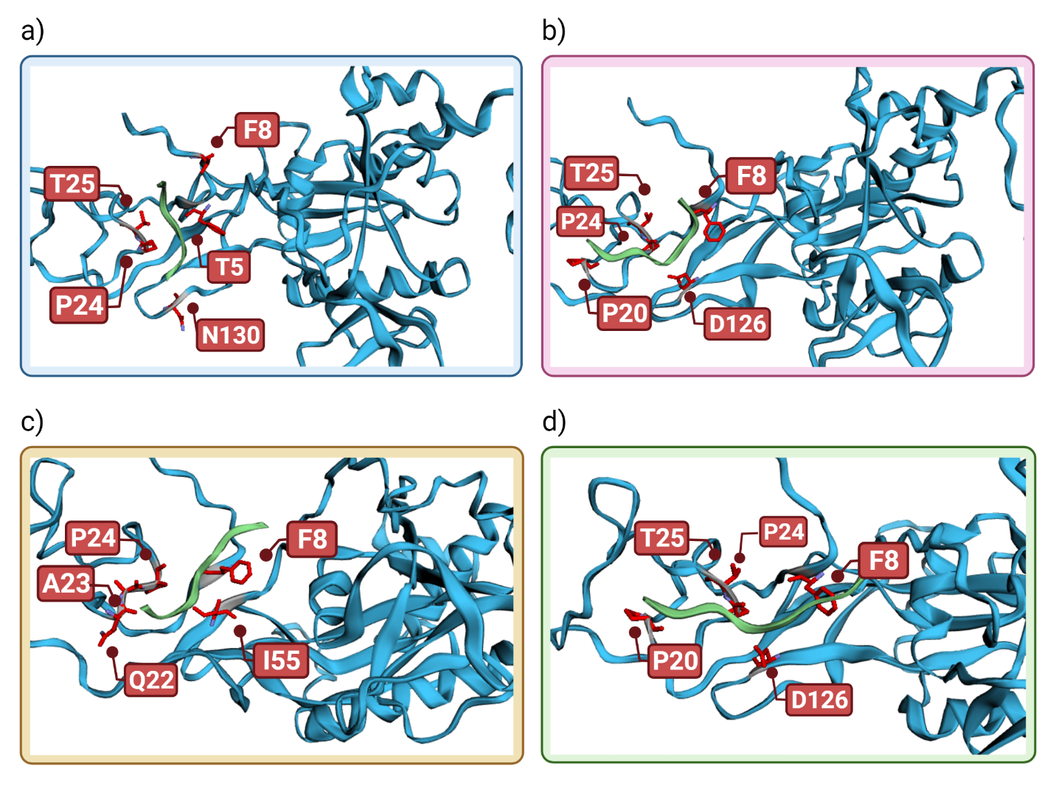Figure S24: The top 5 nsp14 residues with the greatest energy contributions (the lowest energy) in the interactions of OLP-13, OLP-16, OLP-17, OLP-18 and nsp14 as target protein. (a) OLP-13 and nsp14 complex, (b) OLP-16 and nsp14 complex, (c) OLP-17 and nsp14 complex, and (d) OLP-18 and nsp14 complex. Nsp14 and the peptides are shown in blue and green, respectively.
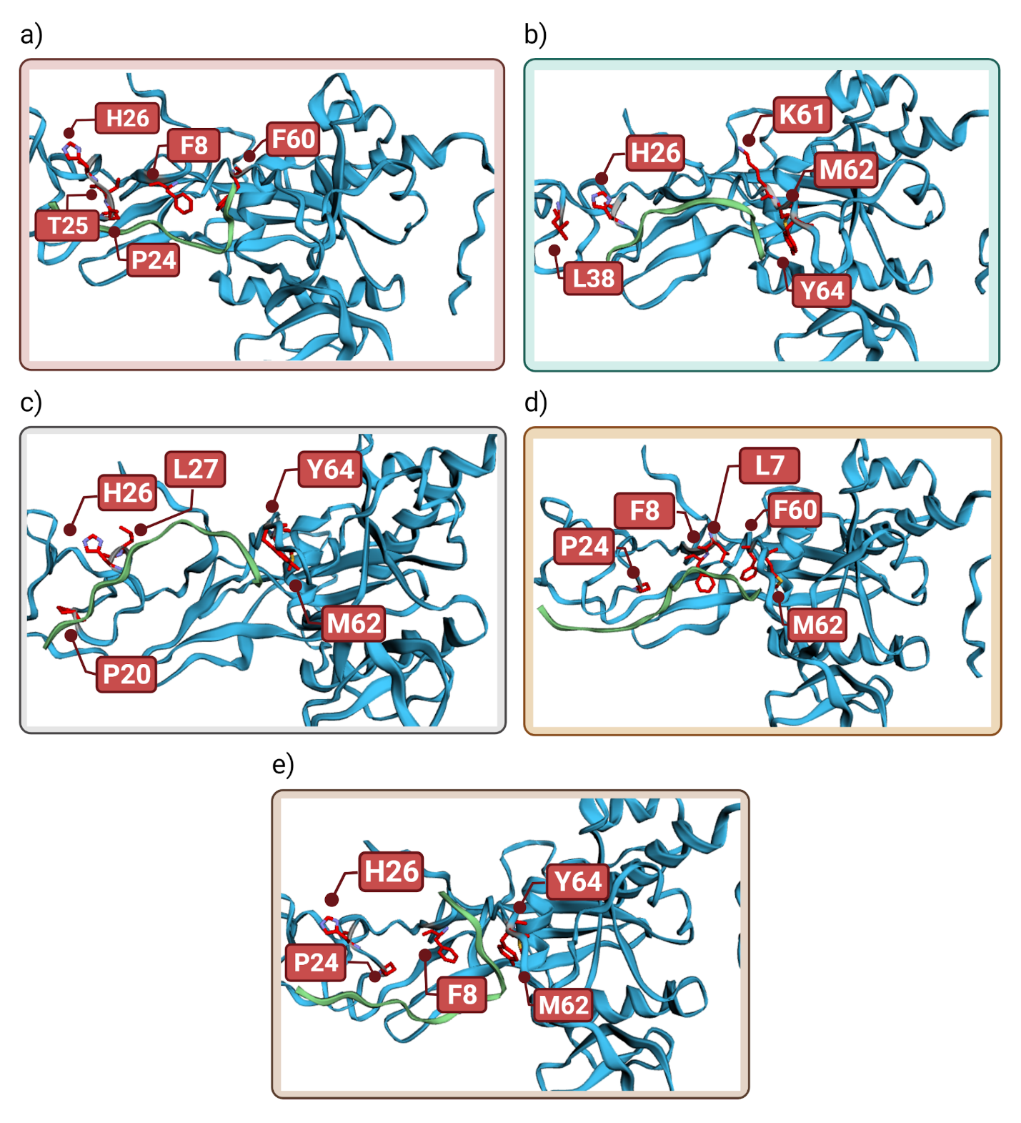Figure S25: The top 5 nsp14 residues with the greatest energy contributions (the lowest energy) in the interactions of P-14-11, P-14-12, P-14-13, P-14-14, P-14-15 and nsp14 as target protein. (a) P-14-11 and nsp14 complex, (b) P-14-12 and nsp14 complex, (c) P-14-13 and nsp14 complex, (d) P-14-14 and nsp14 complex, and (e) P-14-15 and nsp14 complex. Nsp14 and the peptides are shown in blue and green, respectively.

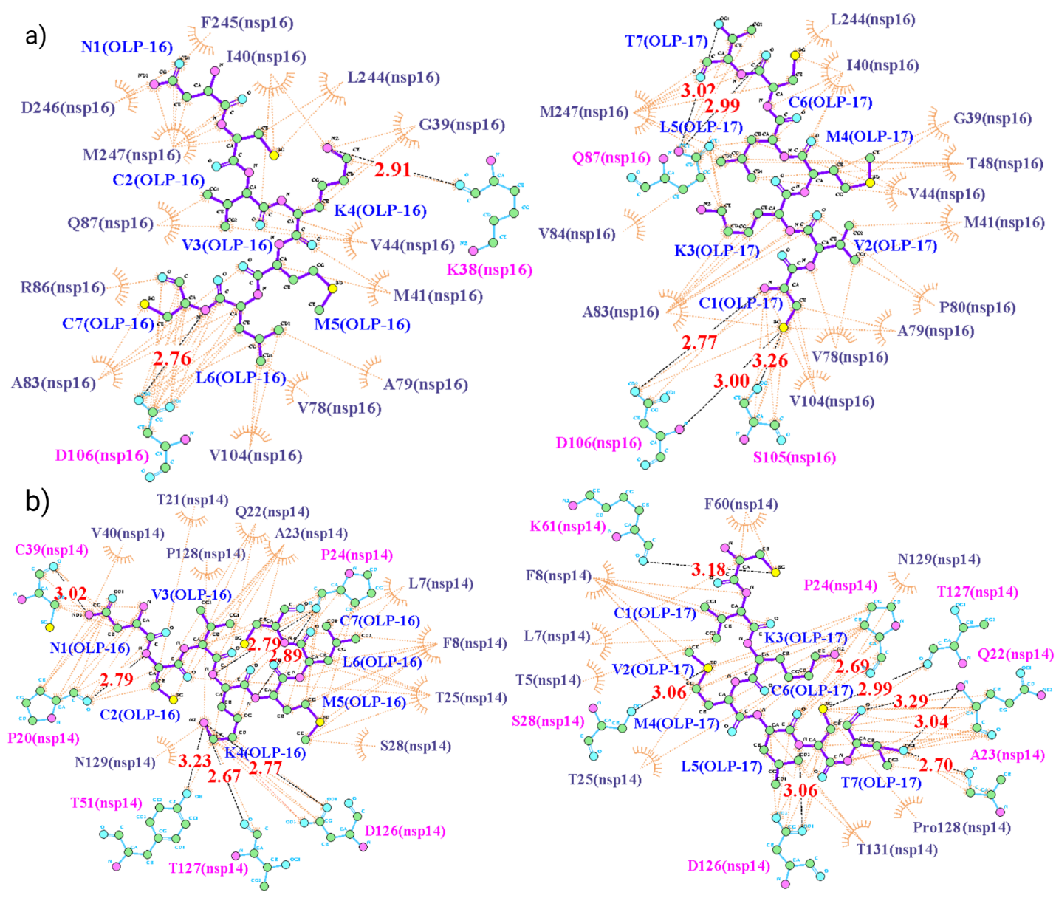Figure S26: Two-dimensional residue interaction maps of OLP-16 and OLP-17 peptides and the targets. (a) OLP-16 and OLP-17 peptide-protein interactions when target is nsp16, and (b) OLP-16 and OLP-17 peptide-protein interactions when target is nsp14. The black dashed lines and the brown arcs with spokes represent the hydrogen bonds and the hydrophobic contacts, respectively.
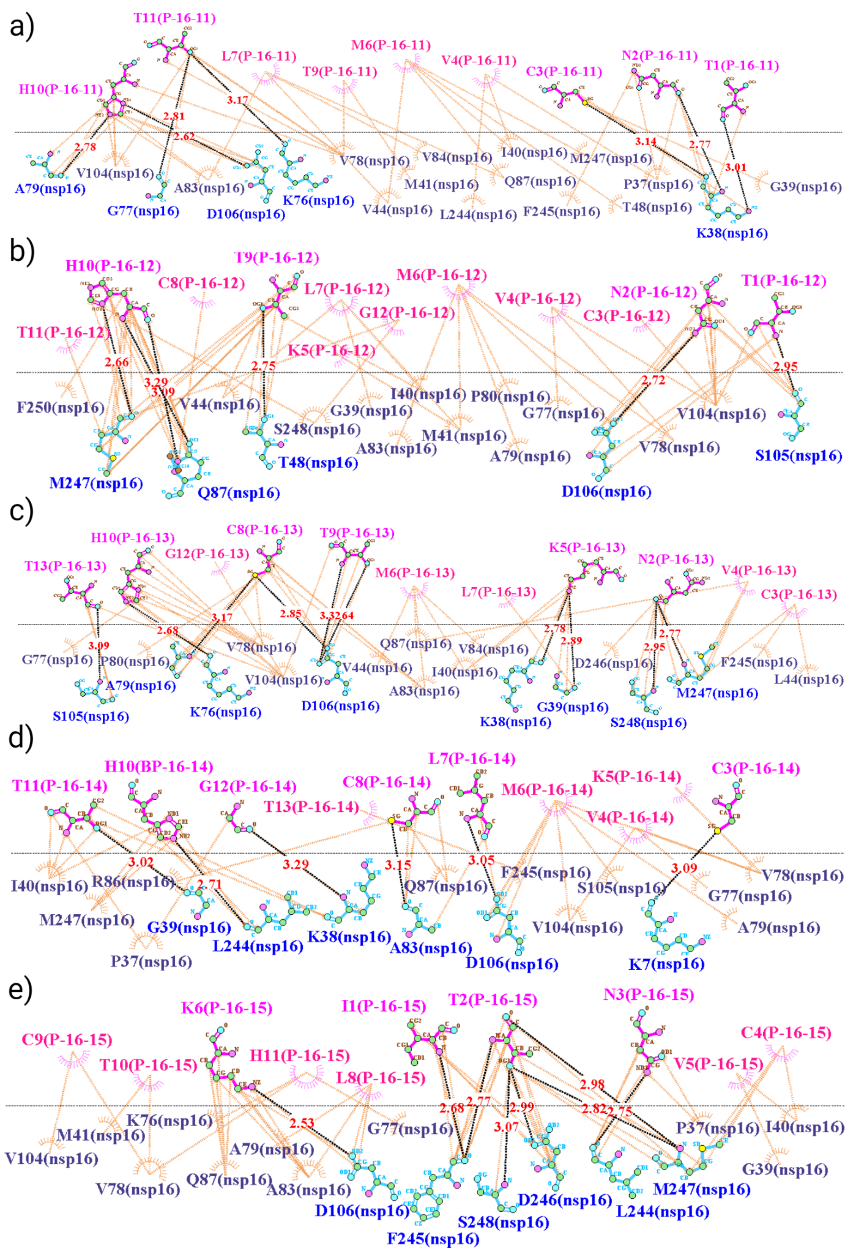
Figure S27: Two-dimensional residue interaction maps for P-16-11, P-16-12, P-16-13, P-16-14, P-16-15 and nsp16 as target protein. (a) P-16-11-nsp16 complex, (b) P-16-12-nsp16 complex, (c) P-16-13-nsp16 complex, (d) P-16-14-nsp16 complex, and (e) P-16-15-nsp16 complex. The horizontal dashed line represents the interface. The black dashed lines and the pink and brown arcs with spokes represent the hydrogen bonds and the hydrophobic contacts, respectively.

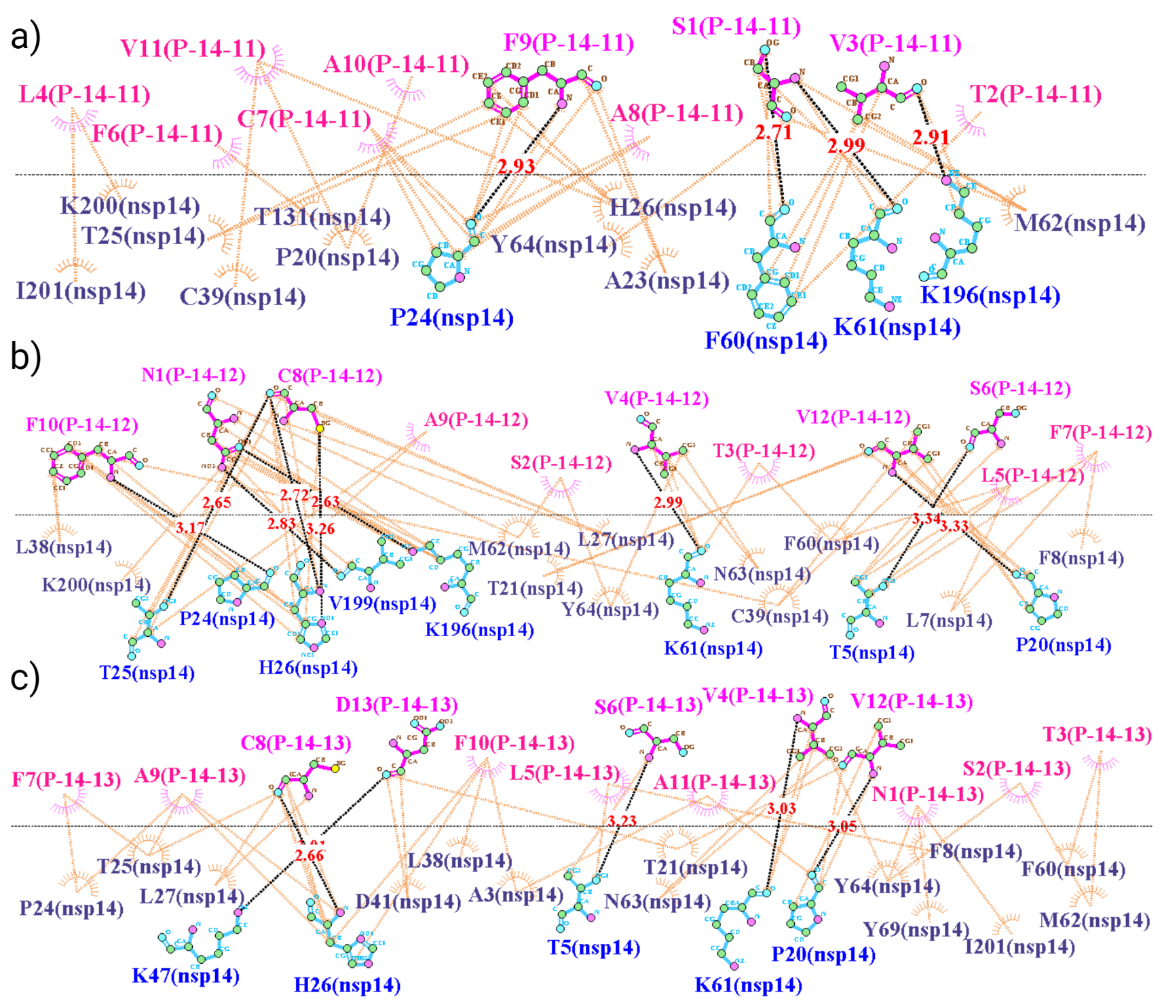Figure S28: Two-dimensional residue interaction maps for P-14-11, P-14-12, P-14-13 and nsp14 as target protein. (a) P-14-11-nsp14 complex, (b) P-14-12-nsp14 complex, and (c) P-14-13-nsp14 complex. The horizontal dashed line represents the interface. The black dashed lines and the pink and brown arcs with spokes represent the hydrogen bonds and the hydrophobic contacts, respectively.

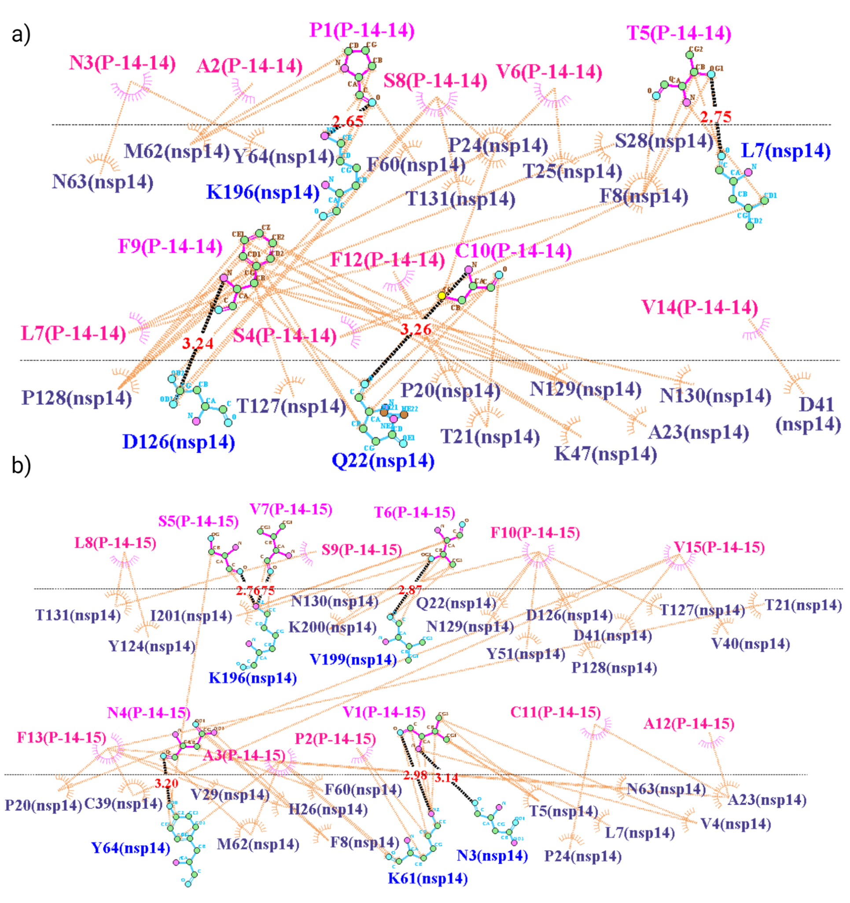Figure S29: Two-dimensional residue interaction maps for P-14-14-, P-14-15 and nsp14 as target protein. (a) P-14-14-nsp14 complex, and (b) P-14-15-nsp14 complex. The horizontal dashed line represents the interface. The black dashed lines and the pink and brown arcs with spokes represent the hydrogen bonds and the hydrophobic contacts, respectively.

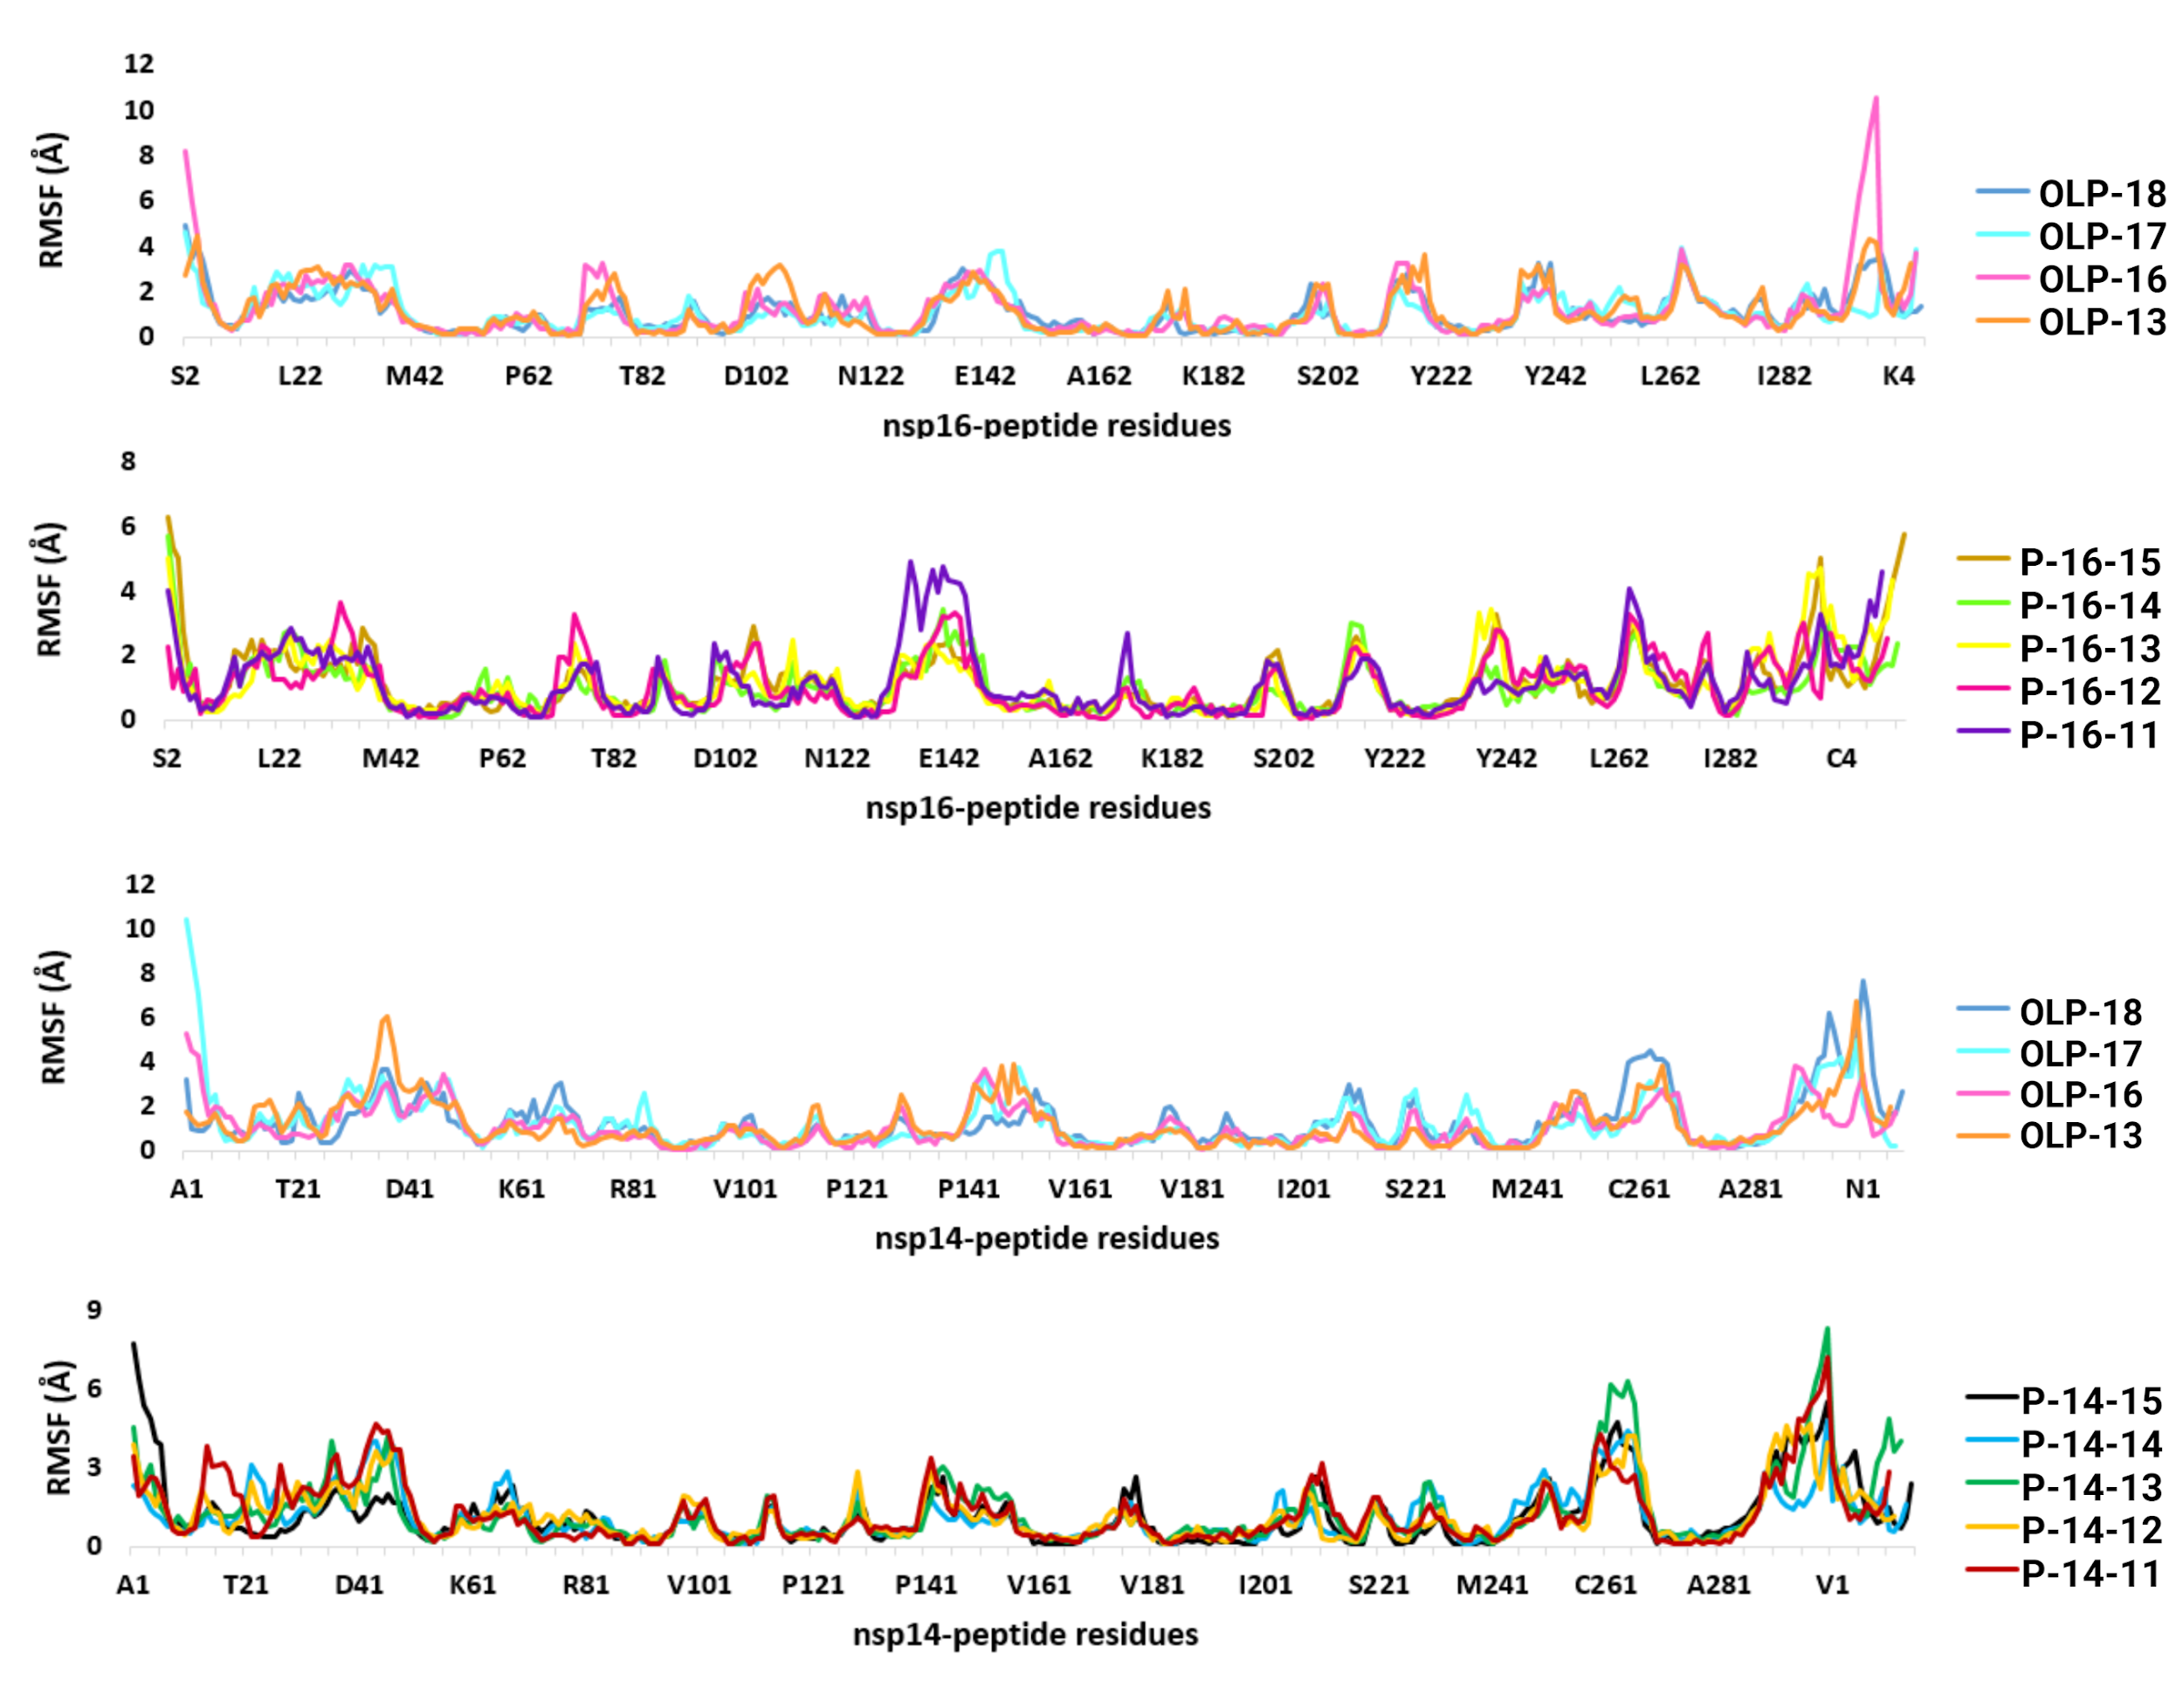
Figure S30: The RMSF plots of the target-peptide complexes. The plots represent the fluctuations of the residues of the target protein (nsp16 and nsp14) and the designed peptides (OLP-13, OLP-16, OLP-17, OLP-18, P-16-11, P-16-12, P-16-13, P-16-14, P-16-15, P-14-11, P-14-12, P-14-13, P-14-14, and P-14-15) during the simulations.

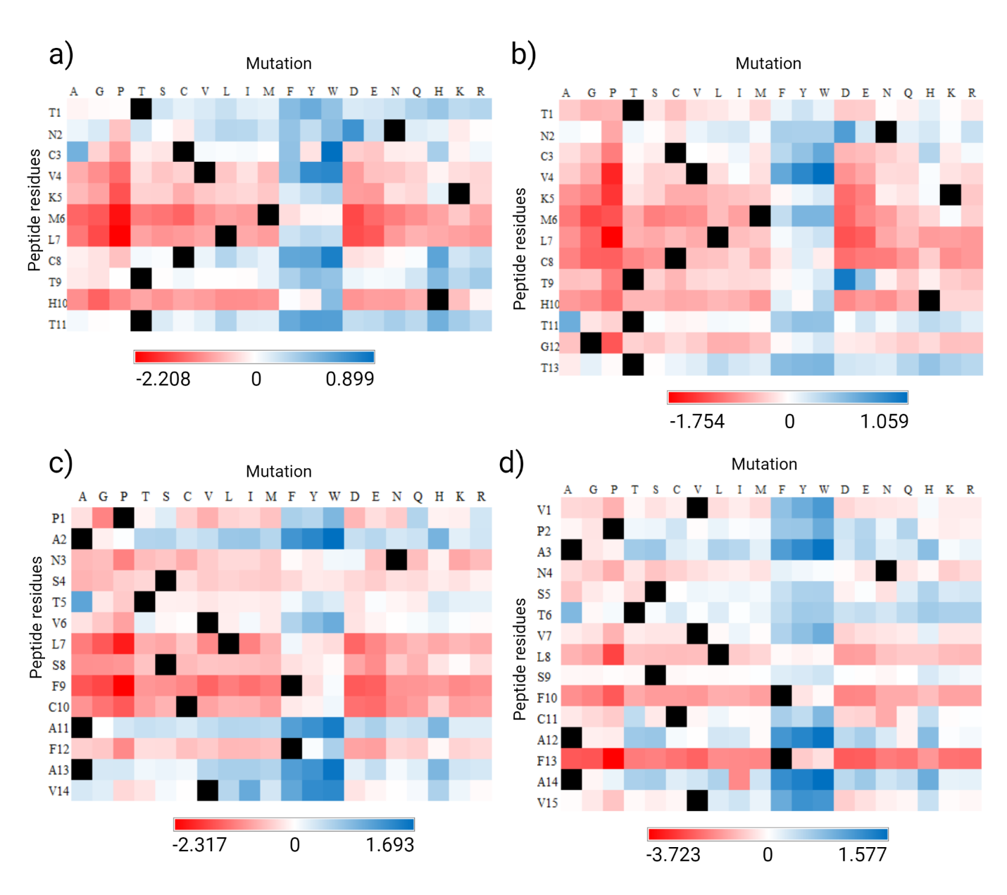Figure S31: The heat maps representing the in silico saturation mutagenesis of designed peptides. (a) P-16-11 and nsp16 interaction, (b) P-16-13 and nsp16 interaction, (c) P-14-14 and nsp14 interaction, and (d) P-14-15 and nsp14 interaction. Mutations with the improving (positive ΔΔG_{Affinity}) and decreasing (negative ΔΔG_{Affinity}) impacts on peptide-target binding affinity are shown in blue and red, respectively.
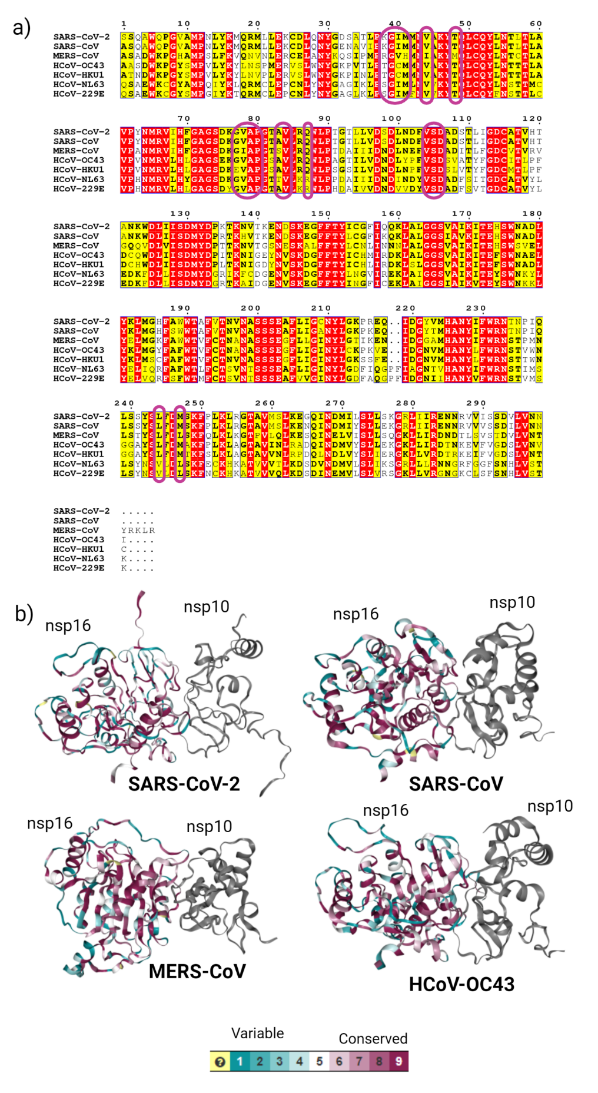
Figure S32: The conservation analysis of the nsp16 protein across coronaviruses. (a) multiple sequence alignment of nsp16 sequences from seven human CoVs, including SARS-CoV-2 (UniProt ID P0DTD1), SARS-CoV (UniProt ID P0C6X7), MERS-CoV (UniProt ID K9N7C7), HCoV-OC43 (UniProt ID P0C6X6), HCoV-HKU1 (UniProt ID P0C6X2), HCoV-NL63 (UniProt IDP0C6X5), and HCoV-229E (UniProt ID P0C6X1). The purple boxes denote the residues of nsp16 that are targeted by nsp16 designed peptides. Identical residues are written in red boxes with white characters. Similar residues are shown in bold black characters and boxed in yellow. (b) analysis of nsp16 conservation across four CoVs: SARS-CoV-2, SARS-CoV, MERS-CoV, and HCoV-OC43. The structures are colored from the most conserved in dark magenta (with a conservation score of 9) to the most variable in turquoise (with a conservation score of 1).
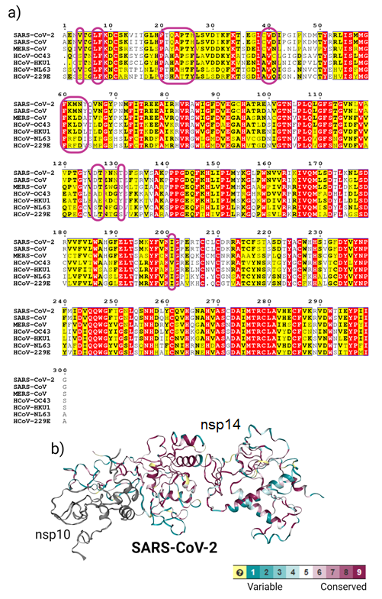
Figure S33: The conservation analysis of the nsp14 protein across coronaviruses. (a) multiple sequence alignment of nsp14 sequences from seven human CoVs, including SARS-CoV-2 (UniProt ID P0DTD1), SARS-CoV (UniProt ID P0C6X7), MERS-CoV (UniProt ID K9N7C7), HCoV-OC43 (UniProt ID P0C6X6), HCoV-HKU1 (UniProt ID P0C6X2), HCoV-NL63 (UniProt IDP0C6X5), and HCoV-229E (UniProt ID P0C6X1). The purple boxes denote the residues of nsp14 that are targeted by nsp14 designed peptides. Identical residues are written in red boxes with white characters. Similar residues are shown in bold black characters and boxed in yellow. (b) conservation analysis of SARS-CoV-2 nsp14 protein model. The structure is colored from the most conserved in dark magenta (with a conservation score of 9) to the most variable in turquoise (with a conservation score of 1).
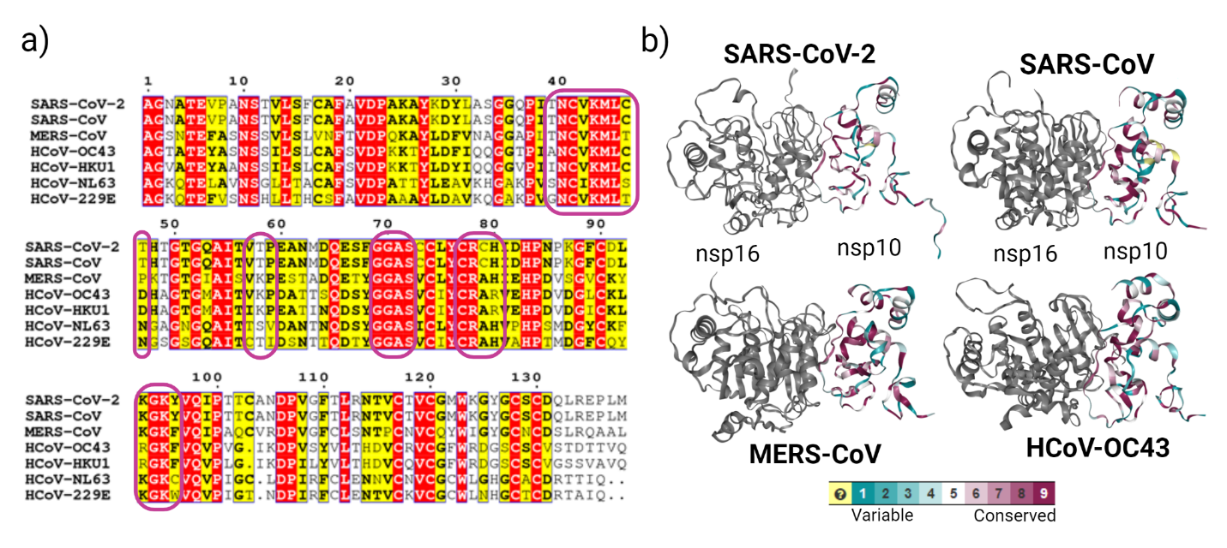Figure S34: The conservation analysis of the nsp10 protein across coronaviruses. (a) multiple sequence alignment of nsp10 sequences from seven human CoVs, including SARS-CoV-2 (UniProt ID P0DTD1), SARS-CoV (UniProt ID P0C6X7), MERS-CoV (UniProt ID K9N7C7), HCoV-OC43 (UniProt ID P0C6X6), HCoV-HKU1 (UniProt ID P0C6X2), HCoV-NL63 (UniProt IDP0C6X5), and HCoV-229E (UniProt ID P0C6X1). The purple boxes denote the overlapping key interacting residues of nsp10, which interact with both nsp16 and nsp14. Identical residues (N40, C41, K43, M44, L45, G69, G70, A71, S72, C77, R78, G94, and K95) are written in red boxes with white characters. Similar residues (V42, C46, T47, V57, P59, C79, H80, K93, and Y96) are shown in bold black characters and boxed in yellow. (b) analysis of nsp10 conservation across four CoVs: SARS-CoV-2, SARS-CoV, MERS-CoV, and HCoV-OC43. The structures are colored from the most conserved in dark magenta (with a conservation score of 9) to the most variable in turquoise (with a conservation score of 1). G69, G70, A71, S72, C77, and R78 are the most highly conserved interface residues with a conservation score of 9 (dark magenta). N40, C41, V42, K43, M44, L45, P59, C79, H80, K93, G94, K95, and Y96, are well conserved with conservation scores of 6-8 (pink). T39, C46, T47, V57, T58, are intermediately conserved or variable (from white to turquoise).

