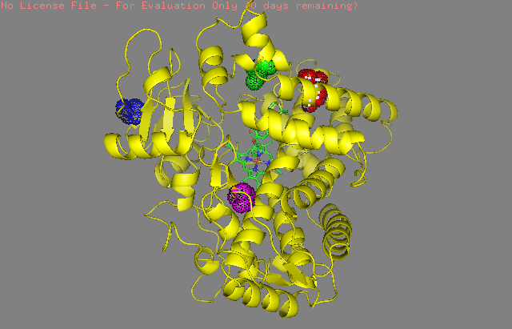
- Prediction
- of 2D6 isozyme
- spatial structure from
- a hemolytic Pv patient

