Supplementary materials
Journal:
Cellular Oncology
Title:
EBV LMP1-C terminal binding affibody molecule downregulates MEK/ERK/p90RSK pathway and inhibits the proliferation of nasopharyngeal carcinoma cells in mouse tumor xenograft models
Authors:
Yanru Guo *, Saidu Kamara*, Jing Zhang, He Wen, Maolin Zheng, Ying Liu, Luqi Zhou, Jun Chen, Shanli Zhu, Lifang Zhang
* These authors contributed equally to this work.
Institute of Molecular Virology and Immunology, Department of Microbiology and Immunology, School of Basic Medical Sciences, Wenzhou Medical University, Wenzhou 325035, Zhejiang, PR China.
Correspondence: Lifang Zhang (wenzhouzlf@126.com), +8613634286323

Table S1. Primary antibodies used for Western blotting assay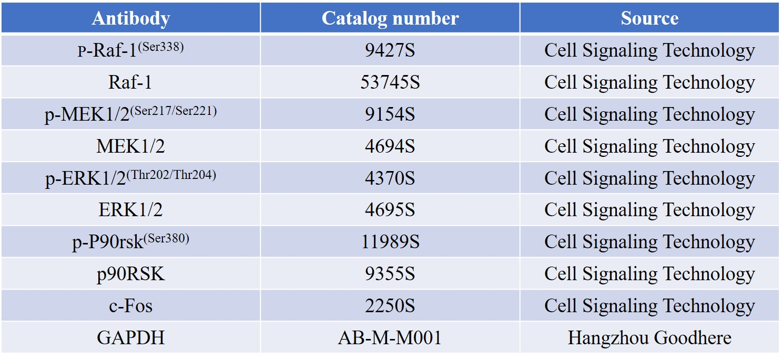
Figure S1. (a) C666-1 and (b) CNE-2Z cells were treated with different concentrations of Z_{LMP1-C} affibody for 72 h. IC50 values were calculated using graph pad prism.
Figure 1 a and b. The purified Z_{LMP1-}C affibody molecules were used for SDS-PAGE analysis and confirmed by Western blotting, respectively: M, protein marker; 1, Z_{LMP1-C}15; 2, Z_{LMP1-C}114; 3, Z_{LMP1-C}277; 4, Z_{WT}.
a 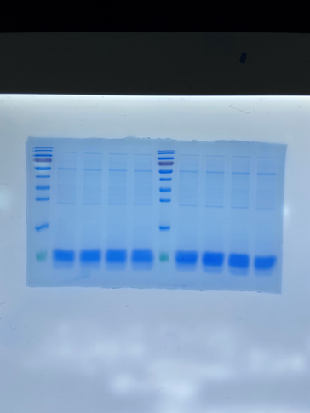 b 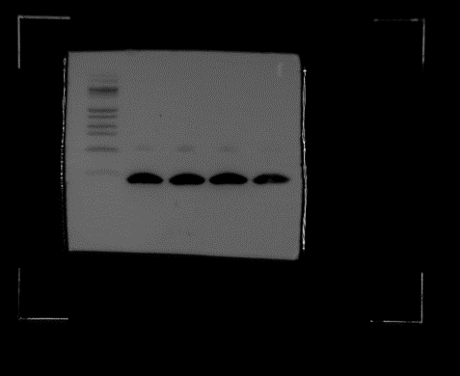
Figure 2b. The RT-PCR results were confirmed by Western blotting analysis.
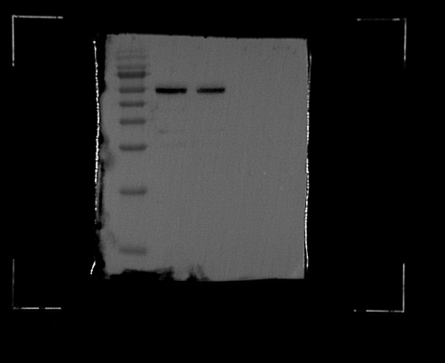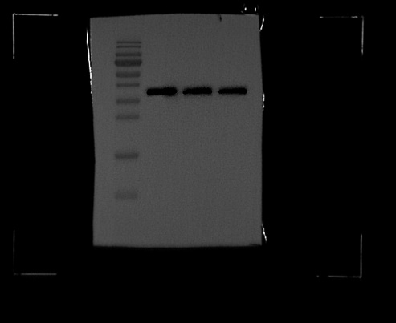
Figure 2c. Z_{LMP1-C} affibody molecules complexed with endogenously expressed LMP1 protein.
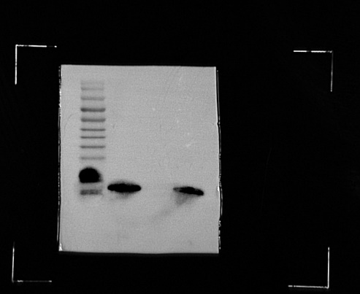 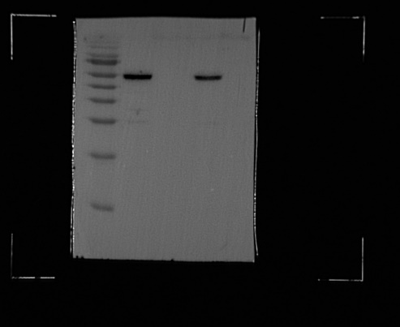 Z_{LMP1-C}15
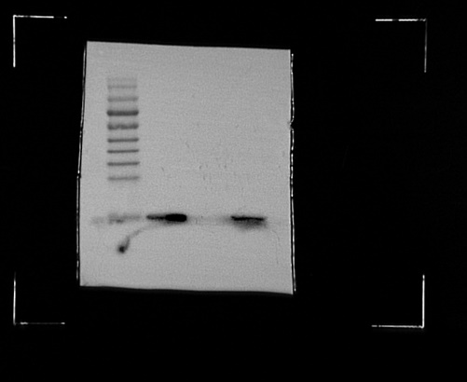 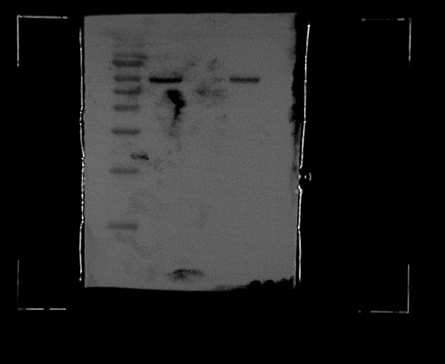 Z_{LMP1-C}114
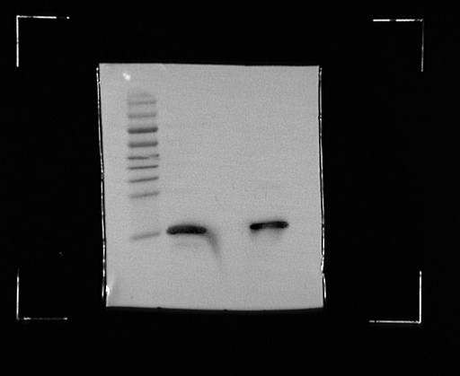 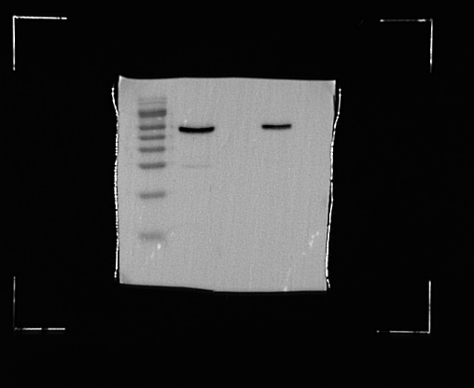 Z_{LMP1-C}277
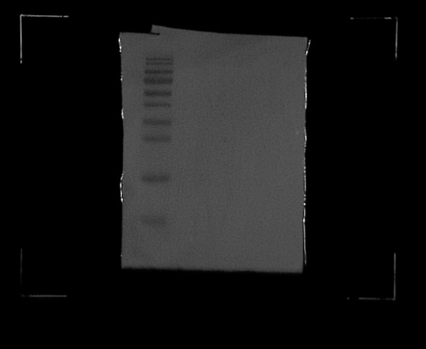 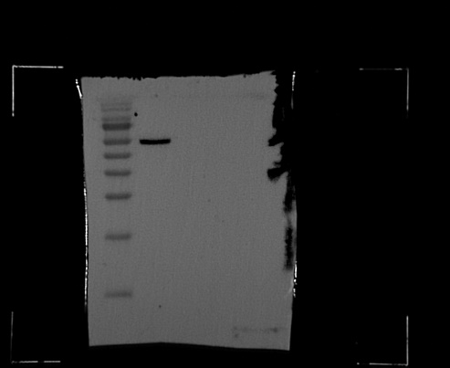 Z_{WT}
Figure 4a. The level of phospho-Raf-1^{(Ser338)} decrease in a concentration- and time-dependent manner in C666-1 and CNE-2Z cells treated with Z_{LMP1-C}277 compare to control groups mock.
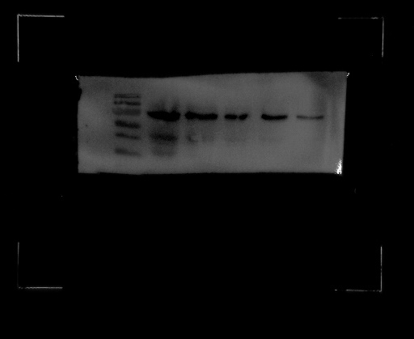 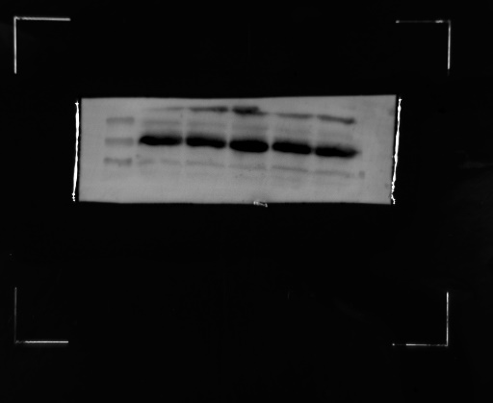 C666-1 24 H
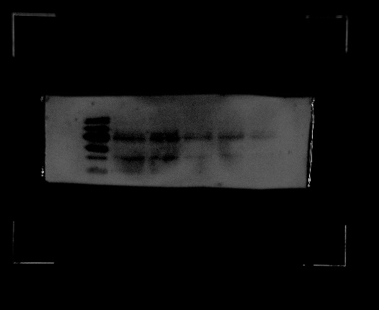 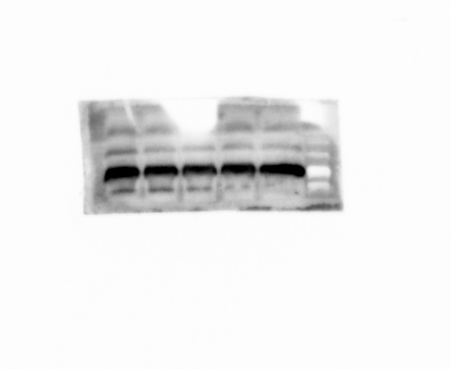 CNE-2Z 24 H
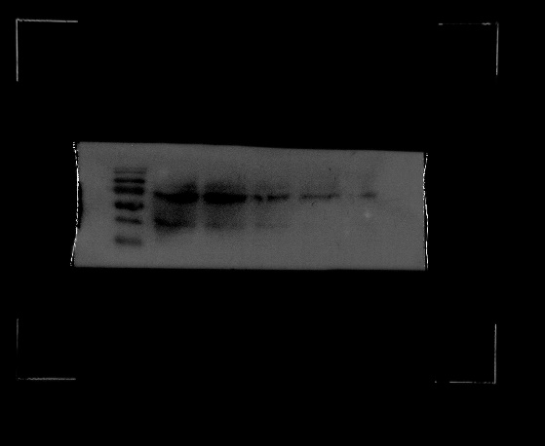 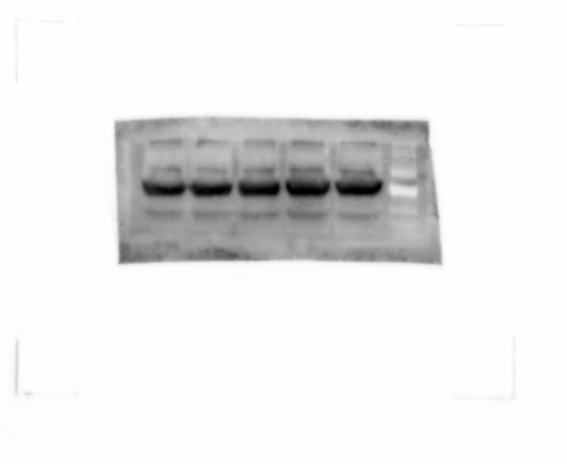 C666-1 36 H
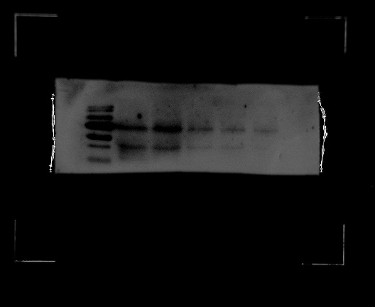 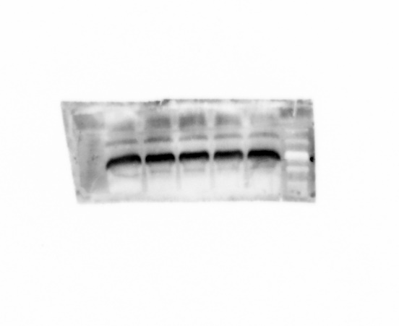 CNE-2Z 36 H

Figure 4b. Western blotting revealed that treatment with 10µM of Z_{LMP1-C}277 for 36 h decreased the expression levels of phospho-MEK1/2^{(Ser217/Ser221)}, phospho-ERK1/2^{(Thr202/Thr204)}, phospho-p90RSK^{(Ser380)} and transcription factor c-Fos in C666-1 and CNE-2Z.
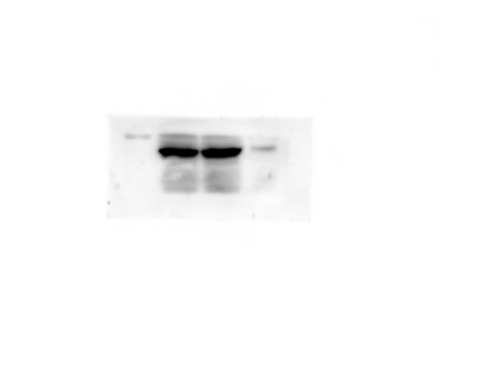 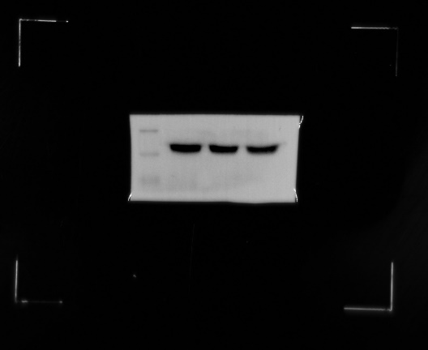 C666-1 MEK

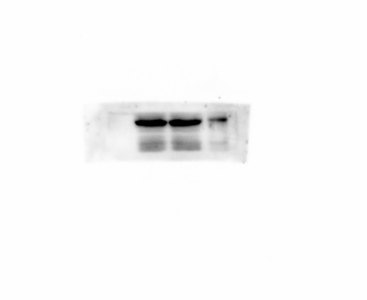 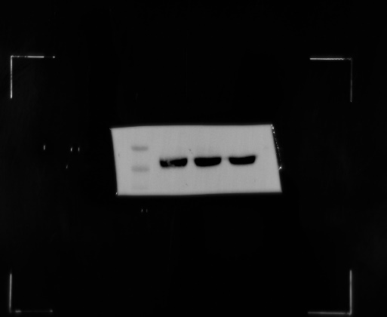 CNE-2Z MEK
C666-1 ERK
CNE-2Z ERK
C666-1 P90RSK
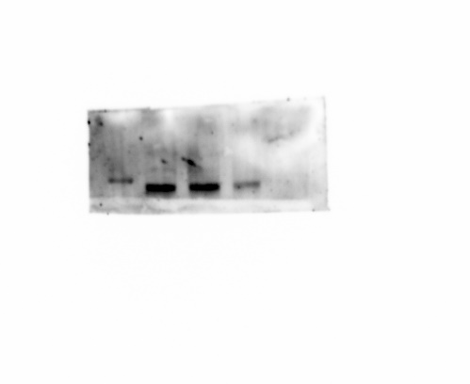 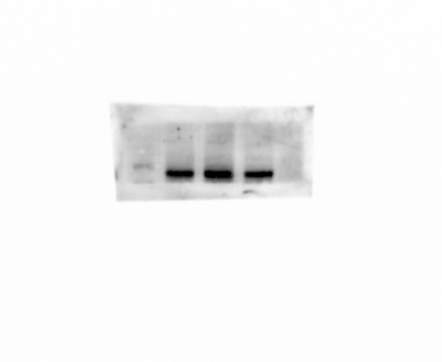CNE-2Z P90RSK
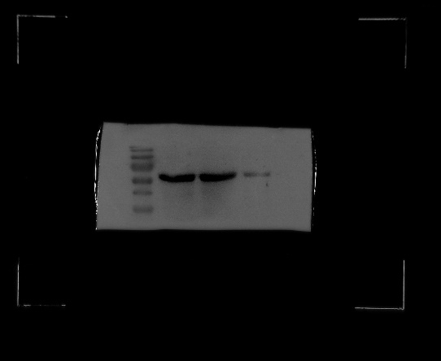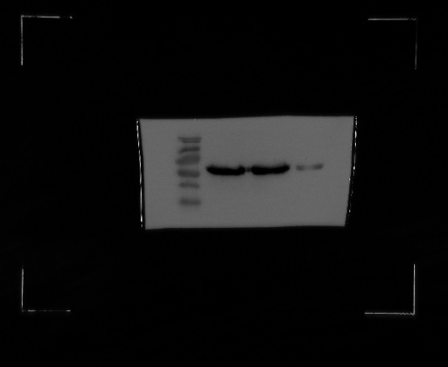
C666-1 c-Fos CNE-2Z c-Fos
C666-1 GADPH CNE-2Z GADPH

