Supplementary Materials

APPENDIX A: Situation Judgement Test design
The SJT was designed using a multi-construct approach, with the blueprint based on the 2016 targeted graduate qualities of the University of Sydney; communication, ethics, professionalism and personal and intellectual autonomy. 54 SJT scenarios were developed at an item writing workshop attended by 11 subject matter experts (SME).

The SJTs were then refined by psychologists, before being reviewed in a further workshop, with another eight SMEs. A concordance exercise was conducted to determine the consensus between 13 SMEs for 49 SJT scenarios and develop a scoring key. The 30 participants for the three phases of the SJT development were primarily from the medicine faculty (87%) rather than dentistry, slightly more than half (57%) were female and half the SMEs were aged 46-55 years. As the Multi Mini Interviews (MMIs) are conducted with the Faculty of Dentistry, they were also involved in the design of the SJT and applicants for the MD were asked to participate as some also apply for entry to the medical program.

Two non-parallel pilot forms of the SJT were developed to control item exposure(Lievens, 2013; Patterson et al., 2013), and delivered electronically using LimeSurvey. A similar number of applicants completed each SJT Form (165 Form A and 160 Form B). Form B was conducted almost exclusively online (96%) while Form A was split between online (57%) and campus-based delivery (43%). The average completion time was 36 minutes with a standard deviation (sd) of 10 minutes. An example of the rating style SJT is shown in Table A.1.

Table A.1: SJT Question Example

A student, Mia, completed a dental procedure on her patient earlier today, where she received very positive feedback from her clinical tutor. Mia therefore decided to showcase her patient’s x-rays, along with the positive feedback she received from her clinical tutor, on the student social media page. All current dental students at the University can access the page. The x-rays include the patient’s name. Jaiswal is one of Mia’s fellow students, and sees her social media post.
Response Instructions: How appropriate are each of the following responses by Jaiswal in this situation?
Option A | Inform Mia that she should not have shared the patient’s x-ray on social media
Option B | Suggest to Mia that she should have obtained consent from the patient before posting the x-ray on social media
Option C | Advise Mia to remove the social media post
Option D | Congratulate Mia on her positive feedback
Option E | Inform his clinical tutor of Mia’s social media post
Option F | Report the post as inappropriate through the social media website

Preliminary analysis was conducted prior to producing an SJT score, during which two outlying applicants were removed from the sample for each form. 12 poorly performing items were excluded from Form A, and eight items from Form B. The Cronbach alpha coefficient was 0.82 for Form A and 0.81 for Form B, indicating that both forms have a high level of internal consistency.

The item partial correlation was used to assess discrimination power as it is the degree of correlation between the item and the overall mean SJT score, excluding that item. The equivalent statistic for a dichotomously scored test would be the point biserial correlation.
As shown in Table 3, both versions had good discrimination with Version A having a slightly higher average discrimination in part due to having more items in the good range.

Table A.2: Discrimination power of the Pilot SJT

Version | Overall Mean | Good n(%) | Satisfactory n(%) | Moderate n(%) | Limited n(%)
Version | Overall Mean | Over 0.25 | 0.17-0.25 | 0.13-0.16 | <0.13
 | 0.19 (100%) | 38 (35%) | 29 (27%) | 8 (7%) | 33 (31%)
 | 0.17 (100%) | 31 (28%) | 27 (24%) | 13 (12%) | 41 (37%)

There was no evidence of any leakage over the time in that the mean test score varied above and under 320 for those dates where 9 or more applicants completed a SJT.

Figure A.1: Mean SJT Score over time

The results of the two methodological issues addressed in this pilot study provide further support for the decision to analyse the pilot SJT data as a whole. An ANOVA was conducted to assess whether the SJT results differ significantly according to whether applicants completed the test in a central location (mean 325.1 sd 22.2) or online (mean 321.7 sd 27.6), the result was no significant with F=0.03, df=1,319, p>0.05 and Partial Eta squared=0.003.

It should be noted that the Pilot SJT psychometric data included 28 local applicants to the DMD who had not also applied for the medical program and 24 international applicants to the MD. A random sample of international applicants were invited to participate in the interviews to assess the validity of the SJT questions and process for international applicants. The data from both these groups have been excluded from the research data presented in this article.
Appendix B: Acceptability of the SJT
The brief evaluation survey at the end of the SJT forms our evidence for the acceptability of the SJT Pilot for applicants to the MD and DMD. As shown in Figure 3, over 4 in 5 participants gave positive responses to the SJT evaluation, reporting them be relevant, appropriate in content and difficulty level and fair. In addition, our SJT pilot had clear instructions and was enjoyable to participate in according to our sample.
Figure B.1: Evaluation of the SJT

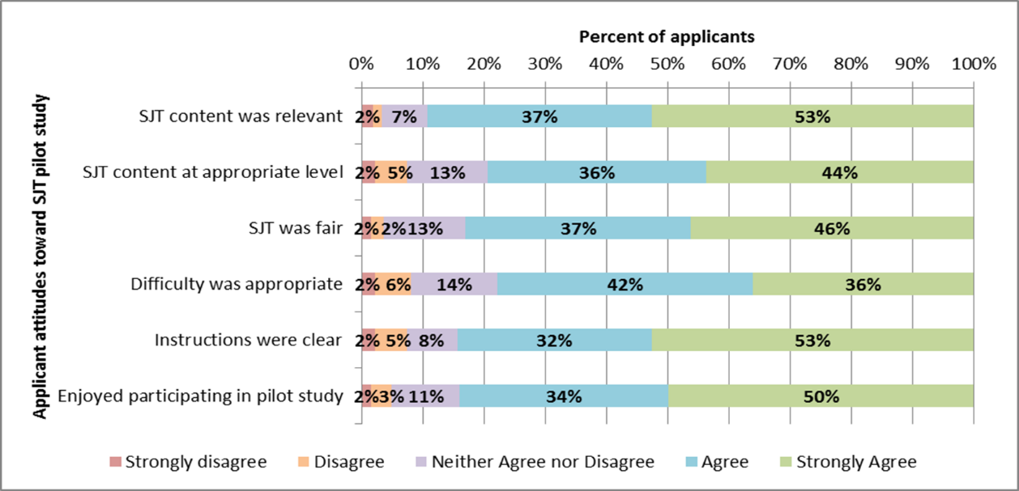

Almost all applicants took the opportunity to provide open ended comments and most commented at length on the SJT.

Positive comments covered the following issues:
• Fair assessment
• Applicable to both medical and dentistry programs
• Realistic scenarios
• Intellectually stimulating
• Good range of scenarios that were appropriate for non-medical undergrads
• Good addition to selection assessment, but should not be used in isolation
• Less intimidating than interviews

An example of a positive open ended comment was as follows:
“I thought it was very effective to have multiple independent actions to rate for a given scenario. All of these questions were ethics based, which while appropriate does not gauge aptitude for a medical student specifically. If this test is standalone I feel it lacks a component in getting to know the applicant on a personal level. However if this is an additional test to an interview I believe it is very appropriate.”

Negative open ended comments tended to be about specific question content:
• Both scenarios and questions lack the nuance that is missing in ‘real life’
• Desire for applicants to justify answers
• Many applicants felt the 5-option answers were too limiting
• Ambiguity between some of the answers, particularly when distinguishing between very and slightly appropriate.
• Some relationships, such as between applicant and clinical tutor, are unclear
• Not a sensitive assessment measure
• Concern that limited experience (eg not having experienced racial discrimination) places applicant at disadvantage
• Some answers could be more specific. Avoid using vague language such as ‘discuss’

An example of a negative comment was as follows:
“Certain questions seem to be too reductionist for real-world situations that may be exceptionally complex and unique. Consequently, I have some reservation regarding the extent to which certain questions would be able to model a applicants overall judgment. I.e. It seems certain lines of questioning could be answered with a 'fail-safe' response and may not encompass the breadth of situations future doctors may face. Having said that the test is clear, to the point, easy to take and should, with some caution being taken to how students may be able to prepare for like-minded judgment tests, be included in the admissions process.”

An example of a more neutral though thoughtful comment was as follows:
“I thought the test was fair, sometimes it was ambiguous though about what "slightly" differed from "very" and then even further clarification on top of the e-mail regarding a true definition of "appropriate." Perhaps other terminology could sometimes have been used? Most questions were very fair though!”

Overall, the evidence on acceptability of the SJT was overwhelmingly positive.

APPENDIX C: Additional statistical results

Table C.1: Estimated marginal means for diversity indicators SJT and GAMSAT
SJT |  | 95% Confidence Interval
Diversity indicator | Marginal means | Lower Bound | Upper Bound | Std. Error
Female | 0.24 | 0.06 | 0.42 | 0.09
Male | 0.11 | -0.06 | 0.29 | 0.09
1st generation Aust. | 0.04 | -0.18 | 0.26 | 0.11
2nd generation Aust. | 0.17 | -0.02 | 0.36 | 0.10
3rd generation Aust. | 0.33 | 0.10 | 0.56 | 0.12
0 parents with degree | 0.39 | 0.14 | 0.63 | 0.12
1 parent with degree | 0.19 | -0.07 | 0.46 | 0.13
2 parents with degree | -0.04 | -0.20 | 0.12 | 0.08
Top 50% income group | 0.13 | -0.05 | 0.30 | 0.09
Lower 50% income group | 0.23 | 0.05 | 0.41 | 0.09
Not Med science major | 0.30 | 0.10 | 0.50 | 0.10
Med science related major | 0.06 | -0.10 | 0.21 | 0.08
GAMSAT | Marginal means | Lower Bound | Upper Bound | Std. Error
Female | 65.47 | 64.47 | 66.46 | 0.51
Male | 68.55 | 67.58 | 69.52 | 0.49
1st generation Aust. | 67.53 | 66.32 | 68.74 | 0.61
2nd generation Aust. | 66.52 | 65.45 | 67.59 | 0.54
3rd generation Aust. | 66.96 | 65.70 | 68.23 | 0.64
0 parents with degree | 65.70 | 64.36 | 67.03 | 0.68
1 parent with degree | 67.90 | 66.44 | 69.36 | 0.74
2 parents | 67.43 | 66.53 | 68.32 | 0.45
Top 50% income group | 67.88 | 66.91 | 68.86 | 0.49
Lower 50% income group | 66.13 | 65.12 | 67.14 | 0.51
Not Med science related | 66.03 | 64.91 | 67.16 | 0.57
Med science related major | 67.98 | 67.12 | 68.85 | 0.44

