Supplementary Information
Effective CO₂ Capture and Selective Photocatalytic Conversion into CH₃OH by Hierarchical Nanostructured Photocatalysts GO-TiO₂-Ag₂O and GO-TiO₂-Ag₂O-Arg
Aliakbar Nosrati ª, Shahrzad Javanshir ^{a,}*, Farzaneh Feyzi ^{b}
ªHeterocyclic Chemistry Research Laboratory, Department of Chemistry, Iran University of Science and Technology, Tehran 16846-13114, Iran
^{b}Thermodynamics Research Laboratory, School of Chemical Engineering, Iran University of Science and Technology, Tehran 1684613114, Iran

Content:

1. Figures S1-S11

a
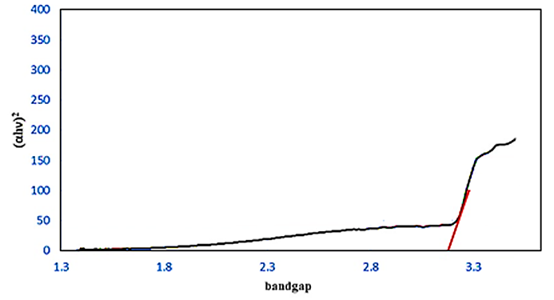
b
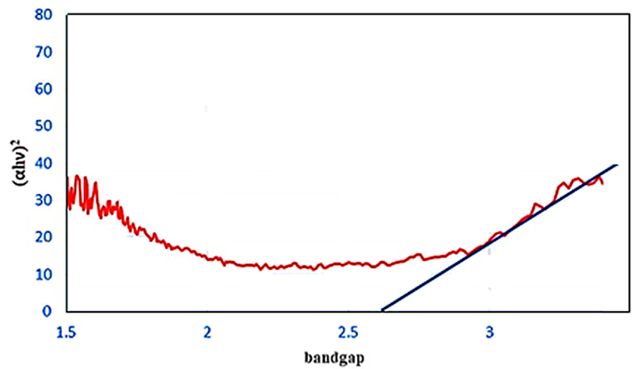
c
Figure S1. UV–vis (DRS mode) spectrum of the samples a), Tauc plot diagrams for b) GO-TiO₂-Ag₂O, c) GO-TiO₂-Ag₂O-Arg
Figure S2. CO₂ absorption in DMF at 40°C under UV light for a) GO-TiO₂-Ag₂O and b) GO-TiO₂-Ag₂O-Arg.
Figure S3. CO₂ absorption in DMF at 40 °C under Vis light for a) GO-TiO₂-Ag₂O-Arg catalyst absorption, b) GO-TiO₂-Ag₂O

Figure S4. CO₂ absorption under visible light using a) GO-TiO₂-Ag₂O-Arg, b) GO-TiO₂-Ag₂O; CO₂ absorption in darkness in the presence of c) GO-TiO₂-Ag₂O-Arg in darkness, d) Absorption of GO-TiO₂-Ag₂O catalyst in the dark

Figure S5. CO₂ absorption for b) of GO-TiO₂-Ag₂O-Arg d) Arginine

Figure S6. CO₂ absorption for a) fresh GO-TiO₂-Ag₂O-Arg and b) reused GO-TiO₂-Ag₂O-Arg

Figure S7. Comparison of CO₂ absorption for a) fresh GO-TiO₂-Ag₂O and b) reused GO-TiO₂-Ag₂O

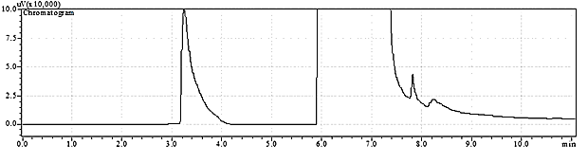
Figure S8. GC analysis with GO-TiO₂-Ag₂O-Arg catalyst

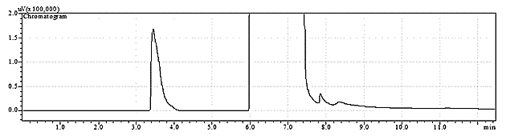
Figure S9. GC analysis with GO-TiO₂-Ag₂O catalyst
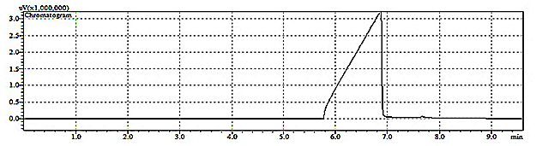
Figure S10. GC analysis for solvent (DMF)
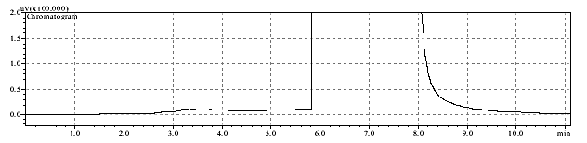
Figure S11. GC analysis with Arginine amino acid

