Supporting Information
CuFe₂O₄@SiO₂@l-arginine@Cu(I) as a new magnetically retrievable heterogeneous nanocatalyst with high efficiency for triazole synthesis
Fatemeh Salehzadeh¹, Maryam Esmkhani¹, Mahsa Zallaghi¹, Shahrzad Javanshir^{1*}, Mohammad G. Dekamin¹
¹ Pharmaceutical and Heterocyclic Compounds Research Laboratory, Department of Chemistry, Iran University of Science and Technology, Tehran, 16846-13114, Iran

Figure S 1. FT-IR spectra of the a) CuFe2O4, b) CuFe2O4@SiO2, and c) CuFe2O4@SiO2@arginine@Cu(I). 2
Figure S 2. VSM analysis of CuFe2O4, CuFe2O4@SiO2 and CuFe2O4@SiO2@l-arginine@Cu (I). 2
Figure S 3. XRD pattern of: a) CuFe2O4, b) CuFe2O4@SiO2, c) CuFe2O4@SiO2@l-arginine@Cu (I). 3
Figure S 4. Recyclability of CuFe2O4@SiO2@l-arginine@Cu(I). 3
Table S 1. Investigation of the prepared catalyst in different conditions in model reaction. 3
Table S 2. Optimization of the type of catalyst. 4

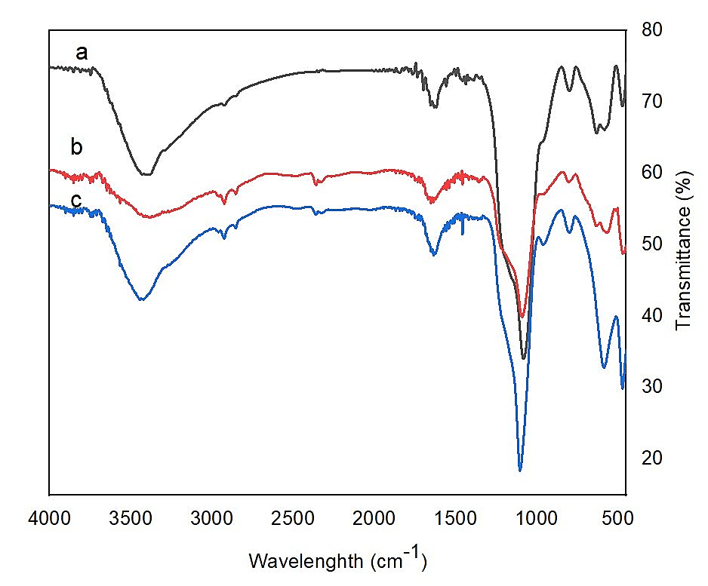
Figure S 1. FT-IR spectra of the a) CuFe2O4, b) CuFe2O4@SiO2, and c) CuFe2O4@SiO2@arginine@Cu(I).

Figure S 2. VSM analysis of CuFe2O4, CuFe2O4@SiO2 and CuFe2O4@SiO2@l-arginine@Cu (I).
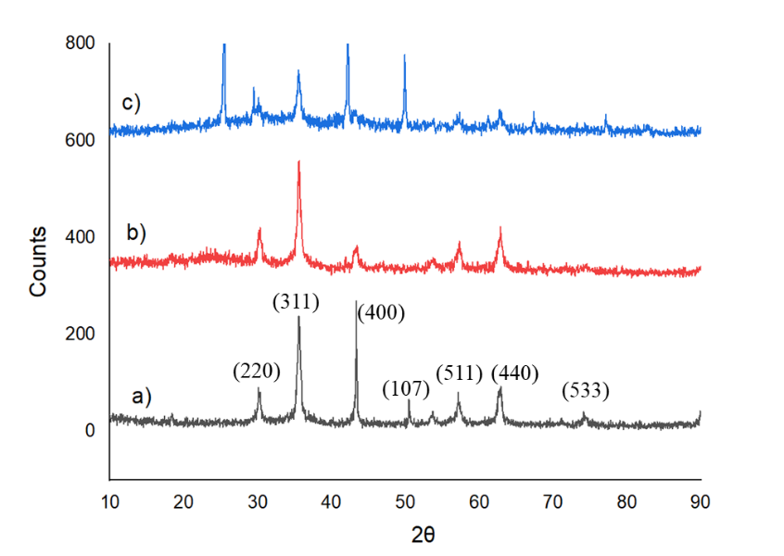
Figure S 3. XRD pattern of: a) CuFe₂O₄, b) CuFe₂O₄@SiO₂, c) CuFe₂O₄@SiO₂@l-arginine@Cu (I).

Figure S 4. Recyclability of CuFe₂O₄@SiO₂@l-arginine@Cu(I).

Table S 1. Investigation of the prepared catalyst in different conditions in model reaction.
Entry | Solvent | Catalyst (mg) | Condition | Time (min) | Yield %
1 | H₂O | 10 | Reflux | 45 | 52
2 | EtOH | 10 | Reflux | 45 | 42
3 | H₂O:EtOH(1:1) | 10 | Reflux | 45 | 35
4 | Toluene | 10 | Reflux | 45 | Trace
5 | H₂O | 10 | Ultrasonic | 25 | 55
6 | EtOH | 10 | Ultrasonic | 25 | 52
7 | Chloroform | 10 | Ultrasonic | 25 | 40
8 | MeCN | 10 | Ultrasonic | 25 | 45
9 | H₂O:EtOH(1:1) | 10 | Ultrasonic | 25 | 65
10 | H₂O:EtOH(1:2) | 10 | Ultrasonic | 25 | 60
011 | H₂O:EtOH(1:1) | - | Ultrasonic | 25 | -
12 | H₂O:EtOH(1:1) | 5 | Ultrasonic | 25 | 69
13 | H₂O:EtOH(1:1) | 10 | Ultrasonic | 25 | 65
14 | H₂O:EtOH(1:1) | 15 | Ultrasonic | 25 | 87
15 | H₂O:EtOH(1:1) | 20 | Ultrasonic | 25 | 79
16 | H₂O:EtOH(1:1) | 30 | Ultrasonic | 25 | 89

Table S 2. Optimization of the type of catalyst.
Entry | Catalyst (15 mg) | Time (min) | Yield %
1 | CuFe₂O₄ | 25 | 73
2 | CuFe₂O₄@SiO₂ | 25 | 65
3 | CuFe₂O₄@SiO₂@l-arginine | 25 | 68
4 | CuFe₂O₄@SiO₂@l-arginine-Cu(I) | 25 | 87

