High-harmonic generation in polycrystalline CdTe nano-films via macroscopic investigations
Supplementary Information
Zhe Long¹, Hang Yang¹, Kan Tian¹, Sen Lin², Linzhen He¹, Dewei Zhao², Han Wu¹, Zi-Yu Chen³, Lili Wu²*, and Houkun Liang¹*
¹School of Electronics and Information Engineering, Sichuan University, Chengdu, Sichuan 610064, China
² College of Materials Science and Engineering and Institute of New Energy and Low-Carbon Technology, Sichuan University, Chengdu Sichuan 610064, China
³Key Laboratory of High Energy Density Physics and Technology (MoE), College of Physics, Sichuan University, Chengdu 610064, China

- Atomic and electronic structures of pristine CdTe (111) crystals

The atomic and electronic structures of the pristine CdTe crystal are investigated to understand the high harmonic generation (HHG) characteristics from CdTe polycrystalline thin films. CdTe crystal, a prototypical group II-VI crystalline compound semiconducting material, has a cubic zinc blende structure, the same as that of the tetrahedral bonding configuration of diamond with each Cd (Te) surrounded by four Te (Cd) atoms as shown in Supplementary Figure 1(a). Supplementary Figure 1(b) and 1(c) are the band structure and density of states (DOS), respectively, calculated by density functional theory (DFT). There is a relatively flat shape of band dispersion around the top of valence band maximum and thus a large DOS around the Fermi level. Supplementary Figure 1(c) compares the DOS per atom of CdTe and silicon, a commonly used HHG material. CdTe has the largest DOS in the valence bands near the Fermi level, albeit large peaks of DOS are located at higher energy levels above the Fermi level in the conduction bands. CdTe is direct band gap material while silicon is indirect. This implies that CdTe may offer superior number of excited carriers to silicon. Besides, CdTe also possesses a high carrier mobility of about 1100 cm²/(V·s)¹. These electronic properties are beneficial for HHG.

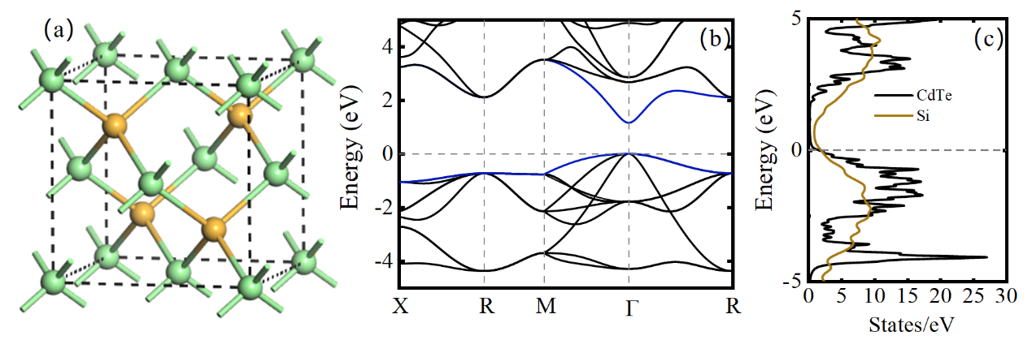
Supplementary Figure 1: (a) Crystal structure of the pristine CdTe (111) crystal. The balls with different colors represent either the Cd or the Te atoms. (b) The calculated electronic band structure of CdTe. The blue curves are the valence band maximum and the conduction band minimum. The flat shape of band dispersion is revealed. At the Γ-point, a moderate direct band gap of about 1.2 eV is obtained. This is lower than the experimental value of 1.44 eV², because in the DFT calculations we employ the local density approximation (LDA) for the exchange and correlation functional and do not consider spin-orbit coupling (SOC). However, as demonstrated by previous results, the underestimated bandgap³ and neglected SOC⁴ do not affect the HHG spectra significantly. (c) The comparison of the calculated density of states (DOS) of the single crystal CdTe and silicon obtained by first-principles DFT calculations. The gray dashed lines indicate the Fermi level. Note that the DOS of CdTe is several times larger at an energy level slightly below the Fermi level.

- Surface morphology

The CdTe nano films are prepared by magnetron sputtering, deposited at a temperature of 235 C° in the Argon-filled environment, on fused silica substrates. The surface morphology of CdTe nano-films with thicknesses of 30 nm to 4 μm sprayed with gold particles for better electric conductance is shown in Supplementary Figure 2(a-j), measured by SEM at a magnification of 20000 times. Randomly distributed grains and voids are exhibited in all the thickness of CdTe films, revealing the polycrystalline nature. As the film thickness gradually increases, the grain cluster grows from few-tens to hundreds of nanometers.
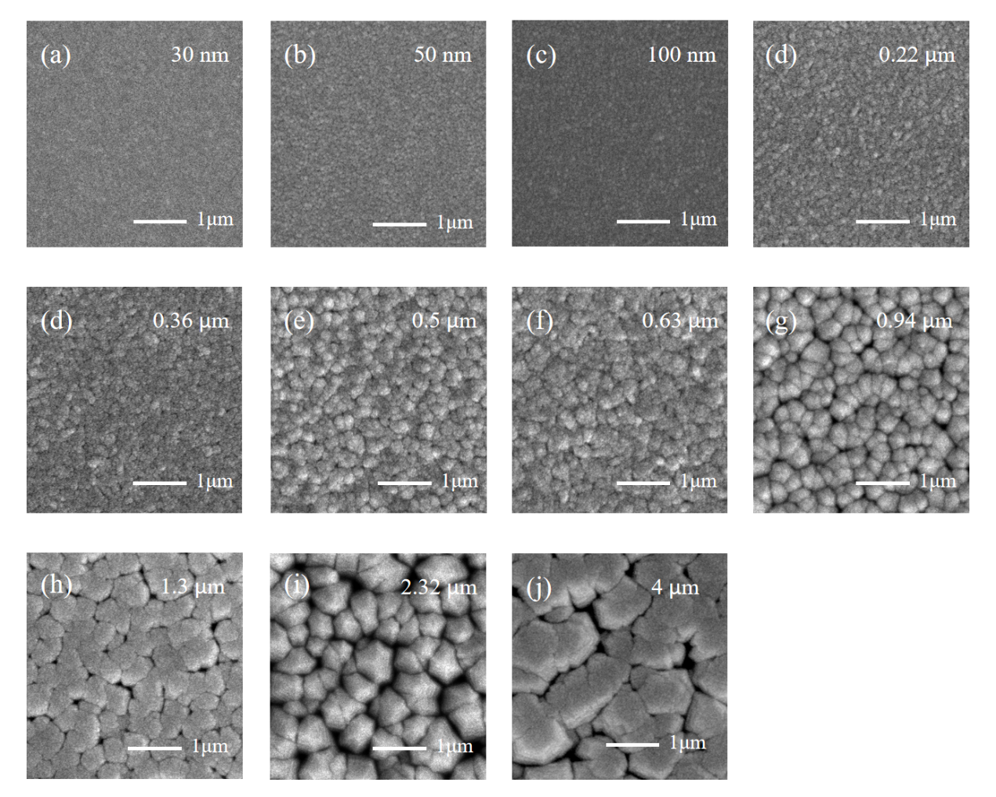
Supplementary Figure 2: SEM images of polycrystalline CdTe films with various thicknesses at 20,000 times magnification. (a-j) Correspond to the film thickness of 30 nm, 50 nm, 100 nm, 220 nm, 360 nm, 500 nm, 630 nm, 940 nm, 1300 nm, 2320 nm and 4000 nm respectively.

- The thickness measurement

The thickness of CdTe nano films is measured by atomic force microscopy (AFM) at the edge of films shielded by a mask. Two typical edge profiles of CdTe films with thicknesses of 6 nm and 100 nm are shown in Supplementary Figure 3(a, c). The film thickness is obtained from the height difference measured between the averaged film surface and the silica substrate. The bump at the edge of the 6-nm thick film is the residual mask. Supplementary Figure 3(b, d) display the top-view boundary profiles of CdTe films with thicknesses of 6 nm and 100 nm, respectively.
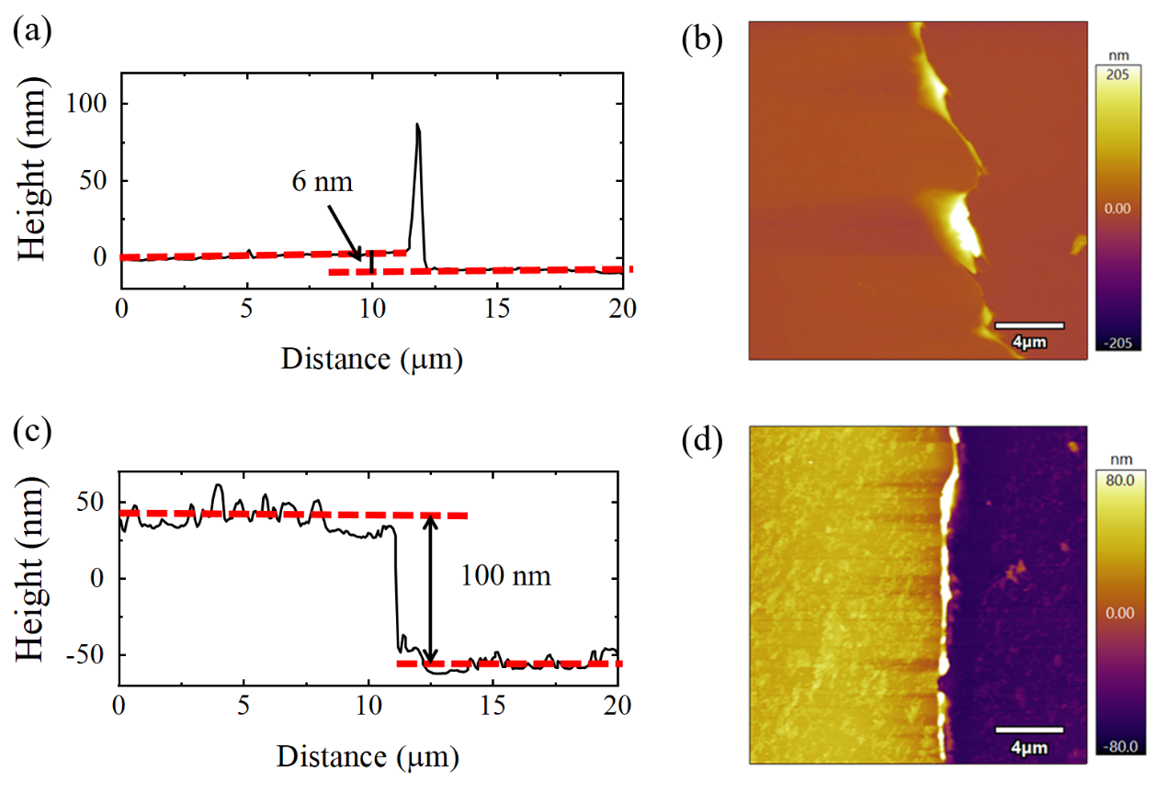
Supplementary Figure 3: AFM images of CdTe films with two representative thicknesses. Edge profiles of CdTe films with thicknesses of 6 nm (a) and 100 nm (c). Top-view AFM images of CdTe nano films with thicknesses of 6 nm (b) and 100 nm (d)

- Transmission measurement of CdTe films with different thicknesses

The dependence of bandgap with the CdTe film thickness can be reflected from the measured transmission spectrum as shown in Supplementary Figure 5. A broadband light source (lambda 950) with the wavelength range covering ultra-violet (250 nm) to near infrared (2500 nm) is used to measure the transmitted spectra of CdTe films with different thicknesses. As shown in Supplementary Figure 4, the band edge of the 4-μm-thick polycrystalline CdTe film is at 817 nm which is the same as that of the bulk material. As the film thickness decreases, the band edge gradually moves to shorter wavelengths. Here, the absorption coefficients at the wavelengths corresponding to each harmonic are calculated based on the measured transmission curves by:
$α_{n}=\ln\left(T_{n}\right)/l$(1)
where α is the absorption coefficient of the n^{th}-order harmonic, T_{n} is the transmittance of the n^{th}-order harmonic, and l is the thickness of the film.
Supplementary Figure 4: The transmission spectra of CdTe films with thicknesses of 10 nm to 4 μm

- Experimental description
The experimental schematics of HHG in transmission and reflection are shown in Supplementary Figure 5. It includes the mid-infrared optical parametric amplifier, the characterization of the mid-infrared beam profile and the temporal profile, the harmonics generation in CdTe thin films, and the harmonics spectral detection using multiple spectrometers.
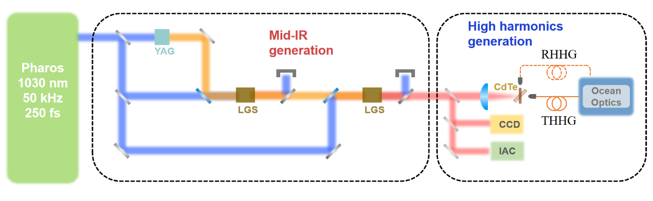
Supplementary Figure 5: The experimental schematic of the HHG in CdTe pumped by the mid-infrared femtosecond pulses. It starts with the two-stage mid-infrared optical parametric amplifiers (OPA). The commercial pump source (Pharos, Light Conversion) delivers 20 W, 250 fs pulses at 1030 nm wavelength and 50 kHz repetition rate. The near-infrared seed pulses are obtained by white light continuum generation in a 10-mm-thick YAG crystal. A 2 W fraction of the pump power is used to drive the first OPA stage, which employs an 8-mm-thick LiGaS₂ crystal cut for Type I phase matching ($θ={51}^{°}$) and produces 200 mW signal pulses centered at a wavelength of 1205 nm. The signal pulses are subsequently injected into the second OPA stage, which ultimately produces up to 210 mW 7.1 μm mid-infrared output in another 8-mm-thick LiGaS₂ crystal with Type I phase matching ($θ={51}^{°}$) under 10 W pump power. The mid-infrared power is measured by OPHIR powermeter (StarLite). An infrared camera (Dataray, WinCamD-IR-BB-7.5 system) is employed to measure the mid-infrared beam profile and estimate the focused beam size as shown in Figure S6. The temporal duration of the mid-infrared pulse is measured by a home-built interferometric autocorrelator (IAC). More details of the IAC measurement are shown in Figure S6 (b) and (c). The mid-infrared laser is focused by a zinc selenide (ZnSe) lens with a focal length of 100 mm to generate an intensity varying from 0.3 TW/cm² to 1.2 TW/cm². The HHG spectra spanning in the visible and ultraviolet region are measured by two different Ocean Optics spectrometers (USB 2000+ and Maya 2000 Pro). The long-term stability of generated harmonics signals from the CdTe nano films with representative thicknesses of 50 nm, 630 nm and 2.32 μm are measured by Ocean Optics spectrometers (USB 2000+) for 10 minutes by recording the harmonics spectra once per 20 seconds. More details of the long-term measurement are shown in Section 8.

- Spectral, temporal and beam profile characterization of the mid-infrared OPA
The spectrum, the measured and retrieved IAC traces, the retrieved temporal profile, and the measured beam profile of the mid-infrared OPA are shown in Supplementary Figure 6
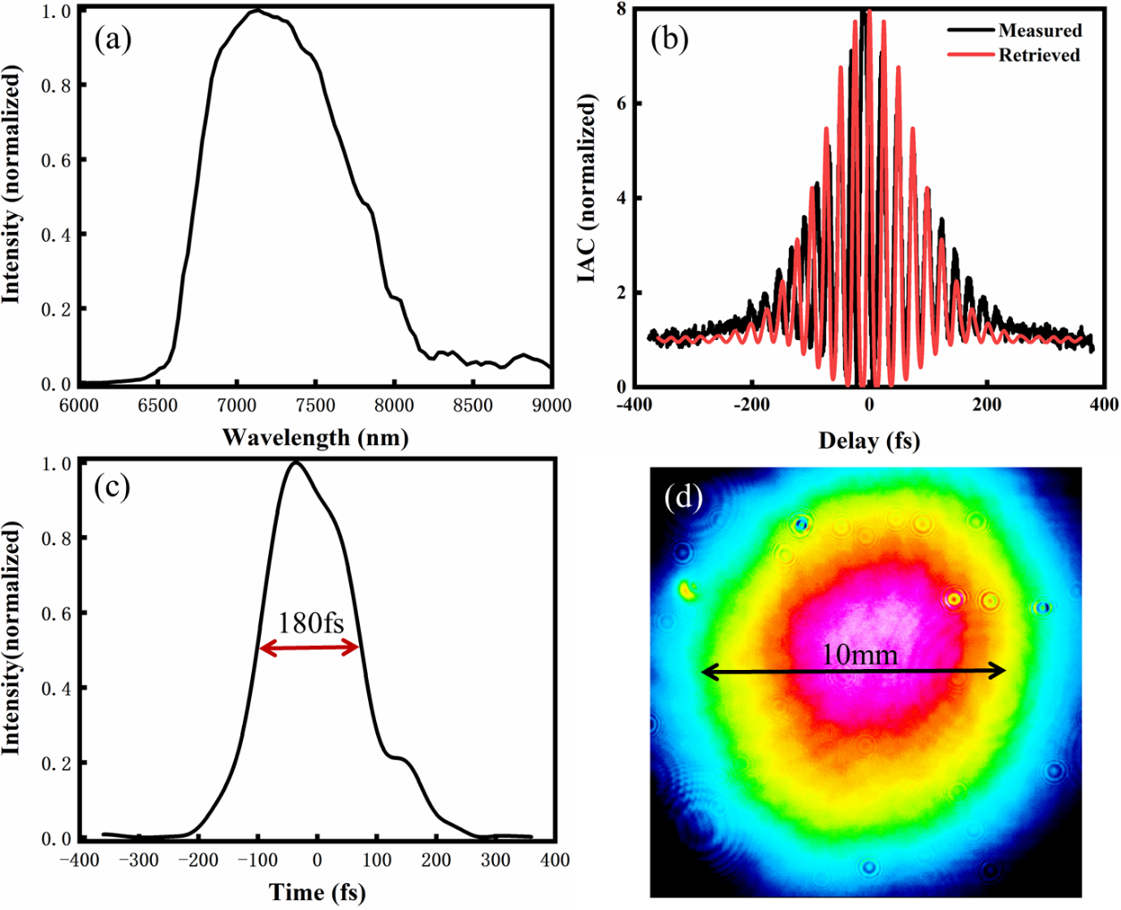

Supplementary Figure 6: (a) The spectrum of the mid-IR OPA with 7.1 μm central wavelength. (b) The measured (black) and retrieved (red) interferometric autocorrelation (IAC) traces of the mid-infrared OPA output. The IAC trace is reconstructed through a genetic algorithm based on so-called “evolutionary phase retrieval from IAC (EPRIAC)” algorithm⁵. In the Taylor expansion of the reconstructed spectral phase, dispersion terms up to 7th order are considered. (c) The retrieved temporal profile of the mid-infrared OPA based on the IAC measurement, revealing a 180-fs pulse width. (d) The measured beam profile of the mid-infrared OPA before the ZnSe focusing lens. A beam diameter of 10 mm is recorded.

- Calculation of THHG strength without absorption

The THHG intensities of 11th-17th orders generated from CdTe nano-films of different thicknesses are compared on histogram in Supplementary Figure 7(b-e). However, the absorption of each harmonic should be deducted to reveal the true THHG strength. Here, in the nano films it is reasonable to assume that the THHG from each layer of unit cell is identical, and the absorption of harmonics above the bandgap is dominated by the linear absorption for the low harmonics intensity. The absorption coefficient α of CdTe films with different thicknesses at wavelengths corresponding to each harmonic order can be obtained based on the measured transmission spectra as shown in Section 4. As shown in Supplementary Figure 7(a), the process of THHG and absorption of harmonics are decomposed into slices of unit cell with a thickness of dl. I_{s} is the harmonic signal generated by each single unit cell without absorption. The generated harmonic signal would then experience amount of absorption (with an absorption confident of α) in the next unit cell. Therefore, we would obtain the harmonics intensities from the subsequent unit cells as:

Exit from the 1st unit cell: $I_{1}=I_{s}$
Exit from the 2nd unit cell: $I_{2}=I_{s}+I_{s}{∙e}^{-α∙dl}$
Exit from the 3rd unit cell:${ I}_{3}=I_{s}+I_{2}{∙e}^{-α∙dl}=I_{s}+I_{s}{∙e}^{-α∙dl}+I_{s}{∙e}^{-2∙α∙dl}$
Exit from the 4th unit cell: $I_{4}=I_{s}+I_{3}{∙e}^{-α∙dl}=I_{s}+I_{s}{∙e}^{-α∙dl}+I_{s}{∙e}^{-2∙α∙dl}+I_{s}{∙e}^{-3∙α∙dl}$
…
Exit from the m^{th} unit cell: $I_{m}=I_{s}+I_{m-1}{∙e}^{-α∙dl}{=I}_{s}+I_{s}{∙e}^{-α∙dl}+I_{s}{∙e}^{-2∙α∙dl}+I_{s}{∙e}^{-3∙α∙dl}+∙∙∙+I_{s}{∙e}^{-\left(m-1\right)∙α∙dl}=I_{s}∙(1-e^{-α∙L})/({1-e}^{-α∙dl})$
where L denotes the thickness of film, m represents the total layers of unit cell, and I_{m} is the experimentally measured harmonics intensity with absorption. Therefore, I_{s} and true THHG strength without absorption which is $I=m∙I_{s}$ are calculated by:

$$I_{s}=I_{m}∙(1-e^{-α∙dl})/(1-e^{-α∙L})$$
$I=m∙I_{s}=m∙I_{m}∙(1-e^{-α∙dl})/(1-e^{-α∙L})$

The Supplementary Figure 7(f-i) present the true THHG strengths of 11th-17th orders without absorption.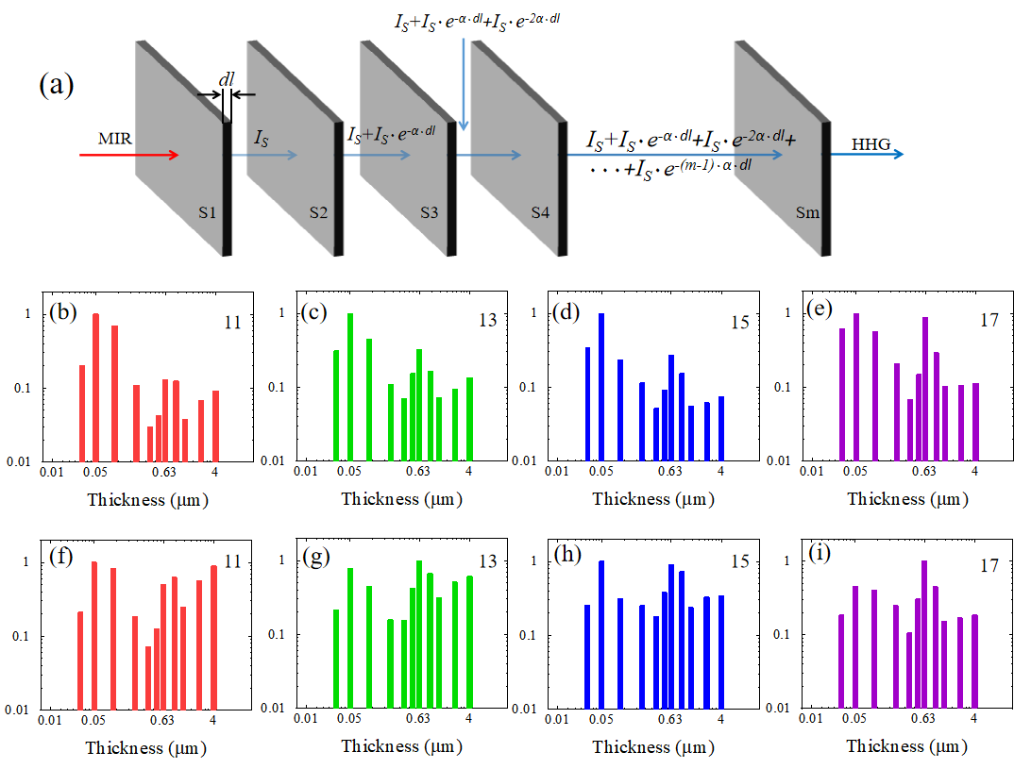
Supplementary Figure 7: The comparison of THHG strength from polycrystalline CdTe films of 11th-17th orders with and without absorption as a function of film thickness. (a) Schematic diagram of the calculation principle in acquiring the harmonics strength from a single unit cell without absorption and the true harmonics strength from CdTe nano-films without absorption. Comparison of the measured THHG strength (b-e) and the true THHG strength without absorption (f-i).

- Long-term stability

To investigate the stability of harmonics intensity in polycrystalline CdTe films, we excite the CdTe nano films with thicknesses of 50 nm, 630 nm, and 2320 nm at a MIR laser intensity of 1 TW/cm² as shown in Supplementary Figure 8.
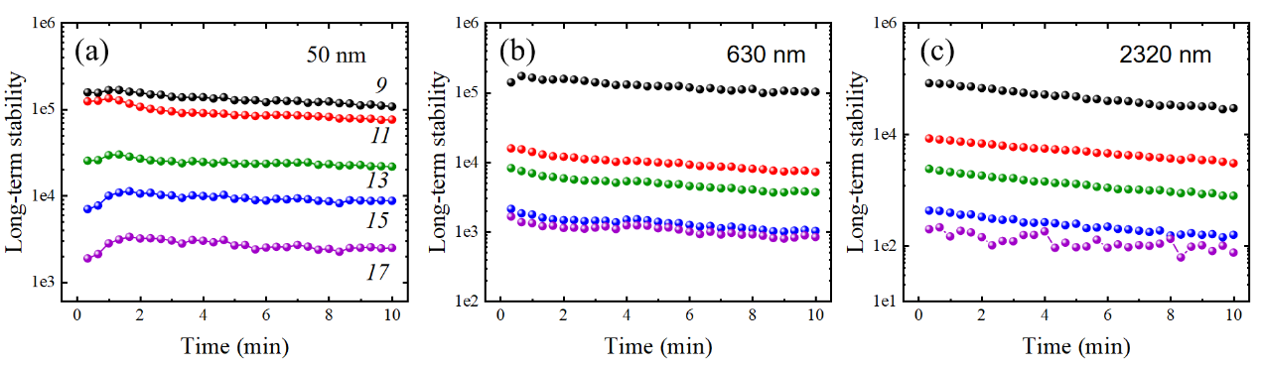
Supplementary Figure 8: The long-term measurement of the THHG intensity from the CdTe nano-films. (a-c) The harmonics signals of 9th to 17th orders are recorded for 10 minutes with stable strengths from CdTe films of 50 nm, 630 nm and 2320 nm, respectively. All the harmonics signals are directly extracted from the measured spectra.

Supplementary References
- Canali, C., Martini, M., Ottaviani, G. & Zanio, K. R. Transport properties of CdTe. Phys. Rev. B, 4, 422 (1971).
- Takahashi, T. & Watanabe, S. Recent progress in CdTe and CdZnTe detectors. IEEE Trans. Nucl. Sci. 48, 950–959 (2001).
- Chen, Z. Y. & Qin, R. Strong-field nonlinear optical properties of monolayer black phosphorus. Nanoscale 11, 16377–16383 (2019).
- Chen, Z. Y. & Qin, R. Probing structural chirality of crystals using high-order harmonic generation in solids. Phys. Rev. A 101, 053423 (2020).
- Hong, K. H., Lee, Y. S. & Nam, C. H. Electric-field reconstruction of femtosecond laser pulses from interferometric autocorrelation using an evolutionary algorithm. Opt. Commun. 271, 169–177 (2007).

