Table 6: Comparison between the results of porous medium-based experimental studies
No. | Reference | Temperature reduction | Remarks | Image
1 | Hasan andFarhan (2019) | 5.25 ˚C | Irradiance: 950 W/m²  Air flow: 3.6 m/s  Ambient temperature: 28 °C  Fin: 10 longitudinal copper porous media | 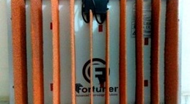
2 | Kim et al. (2020) | 1.49 °C | Irradiance: 1000 W/m²  Air flow: 0.5 m/s  Ambient temperature: 25 °C  Heat sink: metallic mesh | 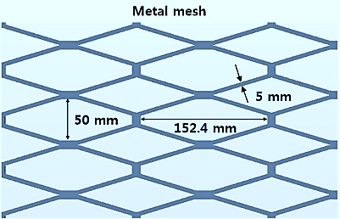
3 | Hasan andFarhan (2020) | 3˚C | Irradiance: 1050 W/m²  Air flow: 4 m/s  Ambient temperature: 39 °C  Fin: Copper porous media | 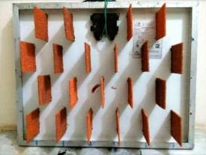
4 | Selimefendigil et al. (2018) | 1.5 ˚C | Irradiance (max): 906 W/m²  Air flow (average): 2.7 m/s  Ambient temperature: 24 °C  Fin: Aluminum foam | 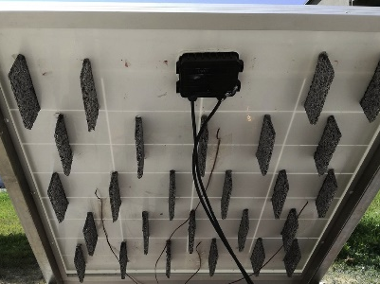
5 | Shastry andArunachala (2020) | 4.5˚C | Irradiance: 800 W/m²  Air flow: 0 m/s  Ambient temperature: not mentioned  Fin: Aluminum mesh | 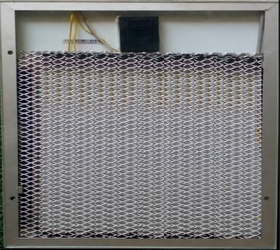
6 | Essa et al. (2021) | 9.5 ˚C | Irradiance: 900 W/m²  Air flow: 0 m/s  Ambient temperature: not mentioned  Heat sink: Copper porous medium + PCM | 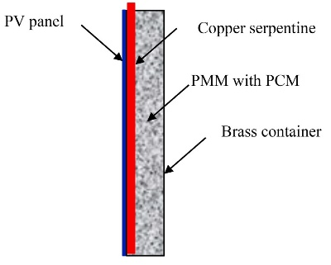
7 | Firoozzadeh andShiravi (2022) | 21.5 ˚C | Irradiance: 630 W/m²  Air flow: 0 m/s  Ambient temperature: 35 °C  Heat sink: Aluminum porous medium + PCM | 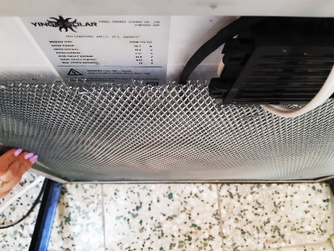
8 | Vaziri Rad et al. (2021) | 24 ˚C | Irradiance: 997 W/m²  Air flow: 0.5 m/s  Ambient temperature: 25 °C  Heat sink: Aluminum shaving + PCM + water circulation | 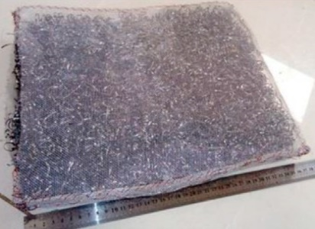
9 | The present study | 18.3 ˚C | Irradiance: 630 W/m²  Air flow: 0.56 m/s (2 km/h)  Ambient temperature: 35 °C  Heat sink: Aluminum porous medium | 