Supplementary Information

Supplementary Figures 1-5
Supplementary Data Files 1-7

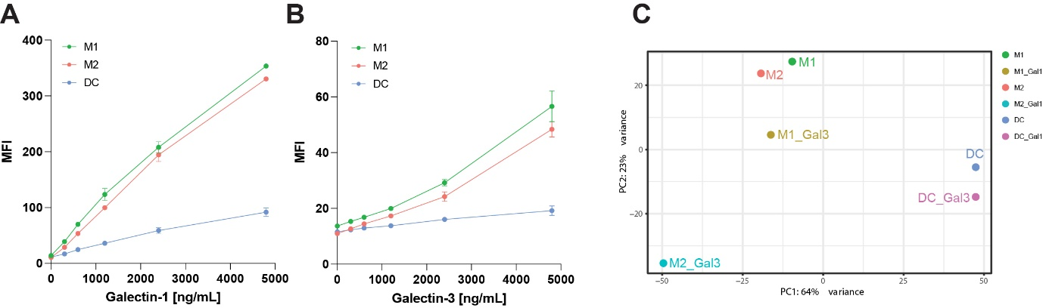

Supplementary Figure 1 | Galectin binding to M1s, M2s and DCs.
Flow cytometry analysis of cell surface binding of (a) gal-1 (0-4800 ng/mL) and (b) gal-3 (0-4800 ng/mL) to M1s (green), M2s (red) and DCs (blue). (c) Principal component analysis of transcriptomic data in unstimulated or gal-3-stimulated M1s, M2s, and DCs.

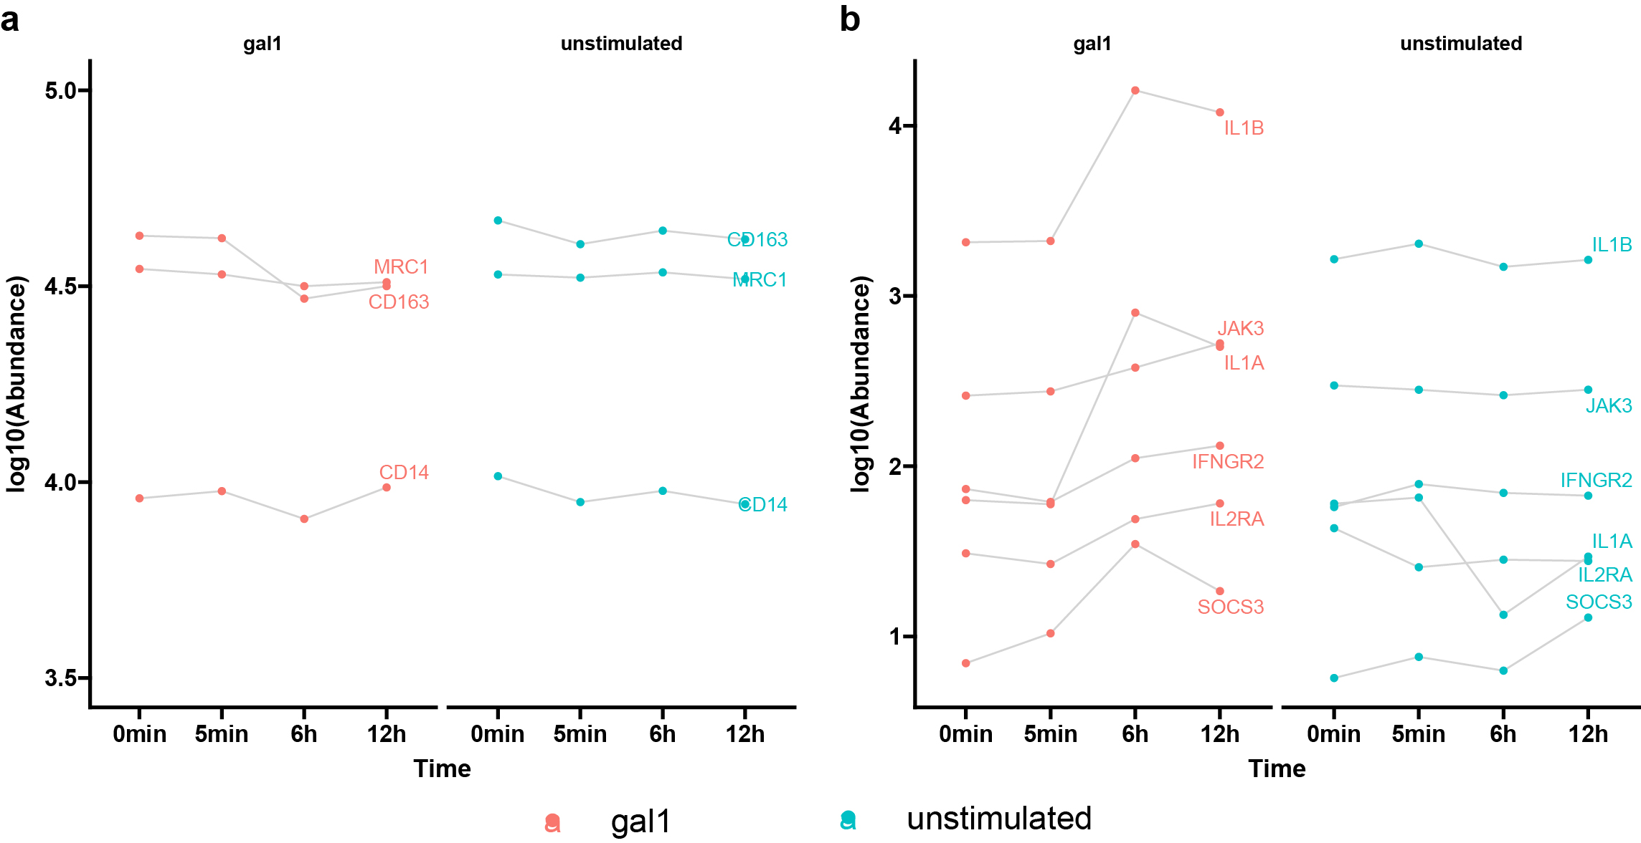
Supplementary Figure 2 | Dynamic production levels of M2 lineage markers and immunomodulatory proteins.
(a) Dynamic protein levels of the lineage markers MRC1/CD206, CD163 and CD14 and (b) immunomodulatory proteins IL-1B, IL1-A, JAK3, IFNGR2, IL2RA and SOCS3 in M2s stimulated with or without gal-1. Protein quantification was calculated from mean values of replicates in TMT-pro labeled samples.

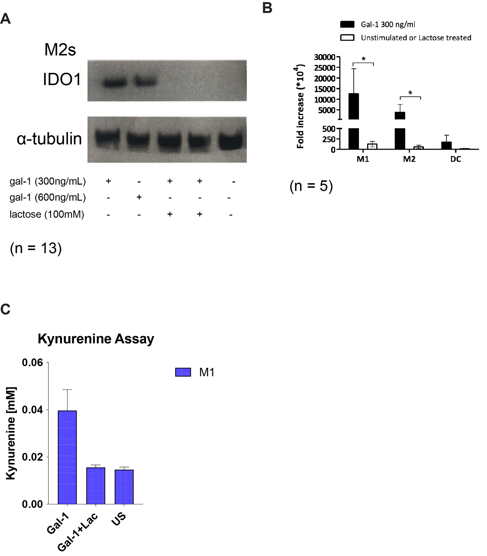
Supplementary Figure 3 | a) IDO1 protein expression in M2s stimulated with gal-1, 300ng/mL or 600ng/mL, ± Lactose (100mM). One representative result is shown (n = 13 donors). b) IDO1 gene expression in M2s stimulated with gal-1, 300ng/mL. (n = 5 donors). c) Kynurenine formation in M1s stimulated ± gal-1 and lactose (100mM).

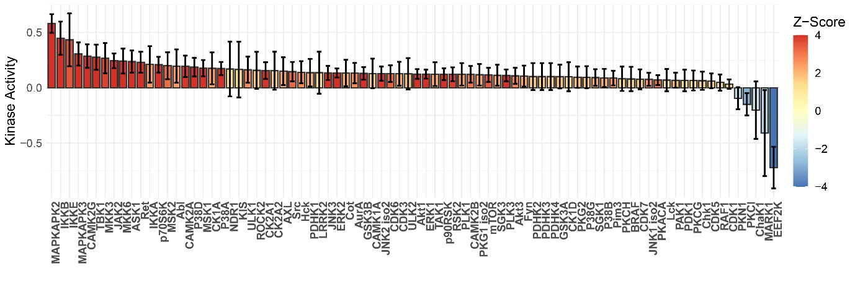
Supplementary Figure 4 | Kinase enrichment analysis of all the phosphosites. All the identified phosphosites were submitted to the kinase enrichment analysis. Quantification values were the log2 ratios of 6h against 0min in gal1 stimulated samples.

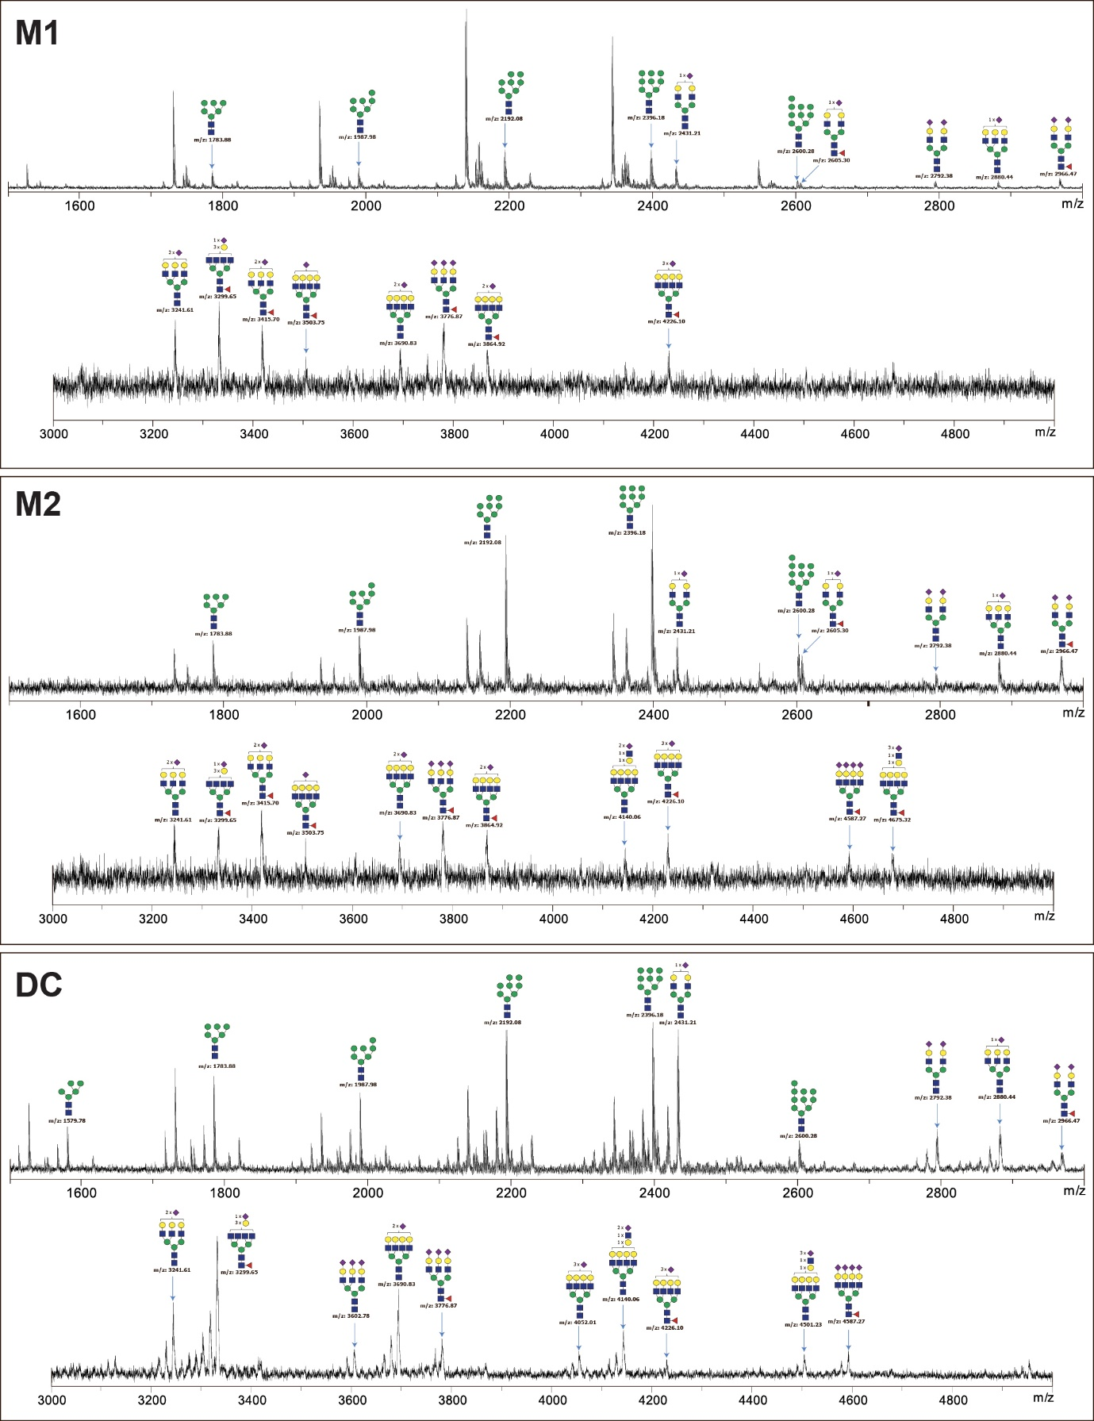
Supplementary Figure 5 | N-glycoprofiling of M1s, M2s and DCs by MALDI-TOF-MS. Mass/charge (m/z) peaks of key identified structures are annotated.

Supplementary Data 1 | Transcriptomes identified in the M1, M2 and DC cell lines. Transcripts Per Million (TPM) reads were calculated to represent a relative expression level across the samples.
Supplementary Data 2 | Functional enrichment terms in differentially expression genes.
Supplementary Data 3 | Quantified proteins in the TMTpro-based proteomic analysis.
Supplementary Data 4 | Functional enrichment terms with proteins in Cluster 4 and Cluster 6.
Supplementary Data 5 | Quantified proteins in the data independent acquisition-based proteomic analysis.
Supplementary Data 6 | Quantified phosphosites in the TMTpro-based proteomic analysis.
Supplementary Data 7 | Functional enrichment terms with phosphoproteins in Cluster 4.

