Supplementary Table 1. List of all traits which are not included in differential phenotypic characteristics table 1 of Rothia santali AR01^{T} (MCC 4800), and its closest phylogenetic relative, Rothia halotolerans YIM90716^{T} (KCTC 19172).
Method | All strains tested positive for | All strains tested negative for
Biolog GEN III tests: | Dextrin, D-Trehalose, Sucrose, D-Turanose, D-Fructose, Inosine, D-Sorbitol, D-Mannitol, D-Arabitol, myo-Inositol, Glycerol, L-Pyroglutamic Acid, Pectin, D-Gluconic Acid, D-Glucuronic Acid, Glucuronamide, Quinic Acid, L-Lactic Acid, Citric Acid, L-Malic Acid, Bromo-Succinic Acid, Acetic Acid and Formic Acid | D-Cellobiose, Gentiobiose, α-D-Lactose, N-Acetyl-D-Galactosamine, N-Acetyl Neuraminic Acid, D-Mannose, 3-Methyl Glucose, D-Fucose, L-Fucose, L-Rhamnose, D-Glucose-6-PO₄, D-Aspartic Acid, Gelatin, Glycyl-L-Proline, L-Alanine, L-Aspartic Acid, L-Histidine, Mucic Acid, D-Saccharic Acid, p-Hydroxy-Phenylacetic Acid, D-Lactic Acid Methyl Ester, α-Keto-Glutaric Acid, D-Malic Acid, Tween 40, γ-Amino-Butyric Acid, α-Hydroxy-Butyric Acid, β-Hydroxy-D, L-Butyric Acid, α-Keto-Butyric Acid, Acetoacetic Acid
Chemical Sensitivity | 1% NaCl,4% NaCl,8% NaCl, Tetrazolium Violet, Tetrazolium Blue, Lithium Chloride, Potassium Tellurite, Sodium Butyrate | D-Serine, Troleandomycin, Minocycline, Niaproof 4
API 20 NE | D-glucose, D-mannitol, D-maltose, malic acid, trisodium citrate | Indole production (Tryptophane), Glucose fermentation, Arginine Di Hydrolase, Urease, Gelatin hydrolysis (protease), β-galactosidase (Para-Nitro Phenyl-ß-D-Galacto pyranosidase), assimilation (CAPric acid), assimilation (ADIpic acid), assimilation (PhenylAcetic acid), oxidase.
API ZYM test for enzyme activity | Cystine arylamidase, Acid phosphatase, Napthol-AS-BI-phosphohydrolase, β-glucosidase | Esterase Lipase (C8), Lipase (C 14), Lecinearyl amidase, Valine arylamidase, Valine arylamidase, Tripsin,α-chymotrypsin,β- glucuronidase, α-glucosidase, β-glucosidase, N-acetyl- β-glucosaminidase,α-mannosidase,α-fucosidase

Supplementary Table 2. Cellular fatty acid content (%) of Rothia santali AR01^{T} (MCC 4800), and its closest phylogenetic relative, Rothia halotolerans YIM90716^{T} (KCTC 19172). All data were obtained from this study.
Fatty acids | AR01^{T} | KCTC 19172^{T}
Saturated
C_{14:00:00} | 0.71 | 0.63
C_{16:00:00} | 5.68 | 10.22
C_{17:00:00} | 0.23 | 0.39
C_{18:00:00} | 0.51 | 0.27
Branched
C_{14:0 iso} | 1.24 | 0.54
C_{15:0 iso} | 2.12 | 1.13
C_{16:0 iso} | 30.04 | 13.91
C_{17:0 iso} | 0.63 | 0.61
C_{18:0 iso} | 0.19 | -
C_{15:0 anteiso} | 37.42 | 41.73
C_{17:0 anteiso} | 21.78 | 30.57

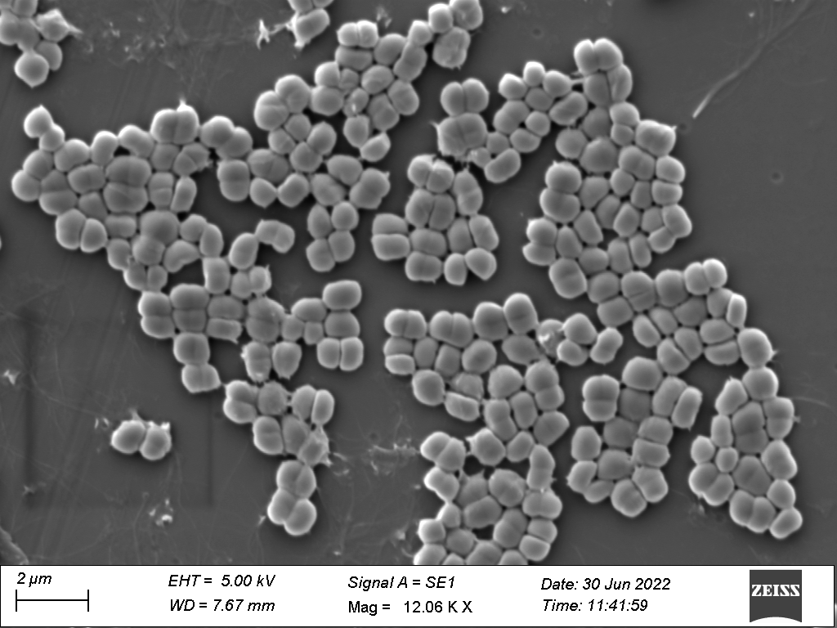
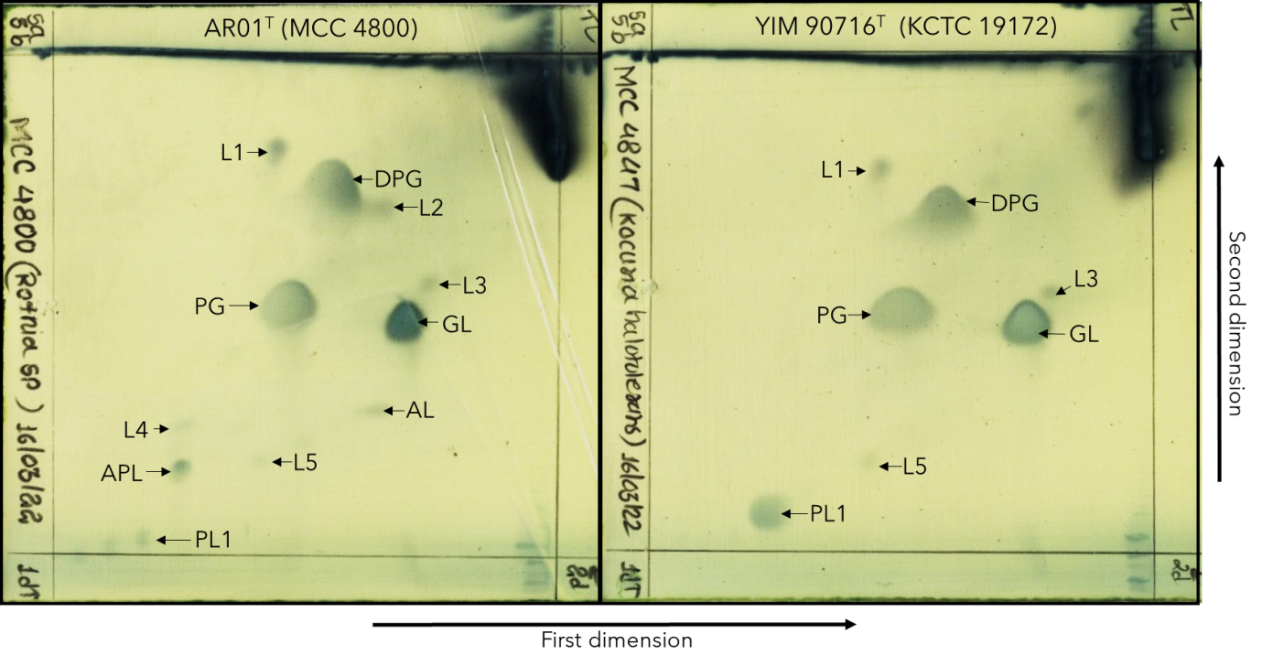
Supplementary Figure 1. Scanning Electron Micrograph of Rothia santali strain AR01^{T} (MCC 4800) obtained using Carl Zeiss EVO18 (Germany) at the magnification of 12,000X showing the typical surface morphology of the Rothia cells.
Supplementary Figure 2. Polar lipids content of Rothia santali strain AR01^{T} (MCC 4800) and its closest phylogenetic neighbor Rothia halotolerans YIM 90716^{T} (KCTC 19172). DPG, Diphosphotidylglycerol; PG, Phosphatidylglycerol; PL, Unidentified phospholipid lipid; APL, Unidentified amino phospholipid; AL, Unidentified amino lipid; GL, Unidentified glycolipid; L, Unidentified lipid. All data were obtained from this study.

