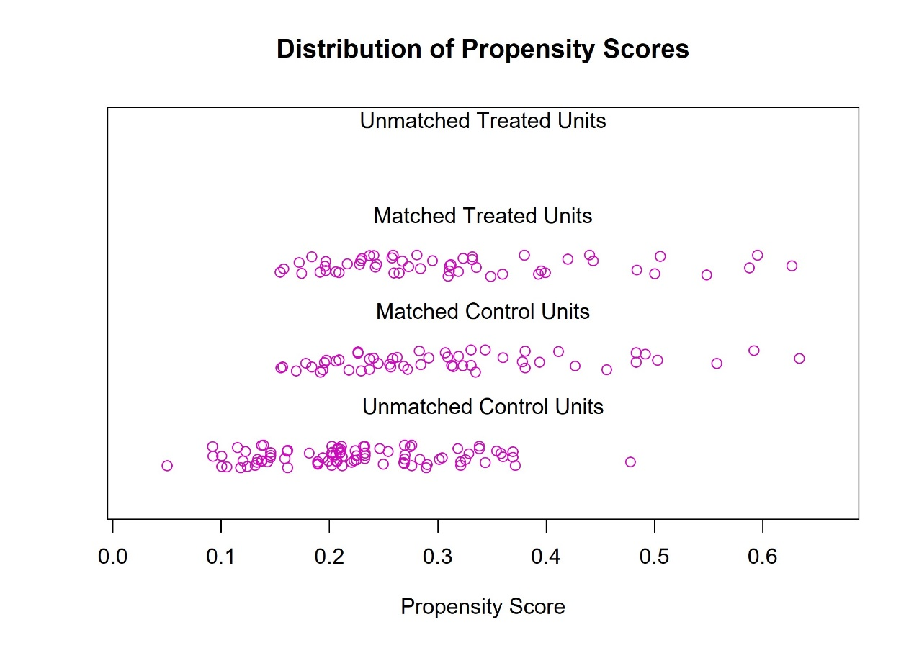
Figure S1. Distribution of Propensity Scores

