Supplementary Figure

Title: Transcriptome analysis provides insights into the stress response in cultivated peanut (Arachis hypogaea L.) subjected to drought-stress.
Srutiben A. Gundaraniya,ª Padma S. Ambalam,^{b} Roli Budhwar,^{d} Shital M. Padhiyar,^{c} and Rukam S. Tomar^{c}*
a Department of Biosciences, Saurashtra University Rajkot, Gujarat 360005, India
b Christ Campus, Vidya Niketan, Saurashtra University, Rajkot, Gujarat 360005, India
c Department of Biotechnology and Biochemistry, Junagadh Agricultural University, Junagadh, Gujarat 362001, India
d Bionivid Technology Private Limited, Bengaluru, Karnataka, India
* Correspondence: rukam@jau.in, (Junagadh agricultural university) (+91 94260 37195), ORCiD: 0000-0001-9156-5311

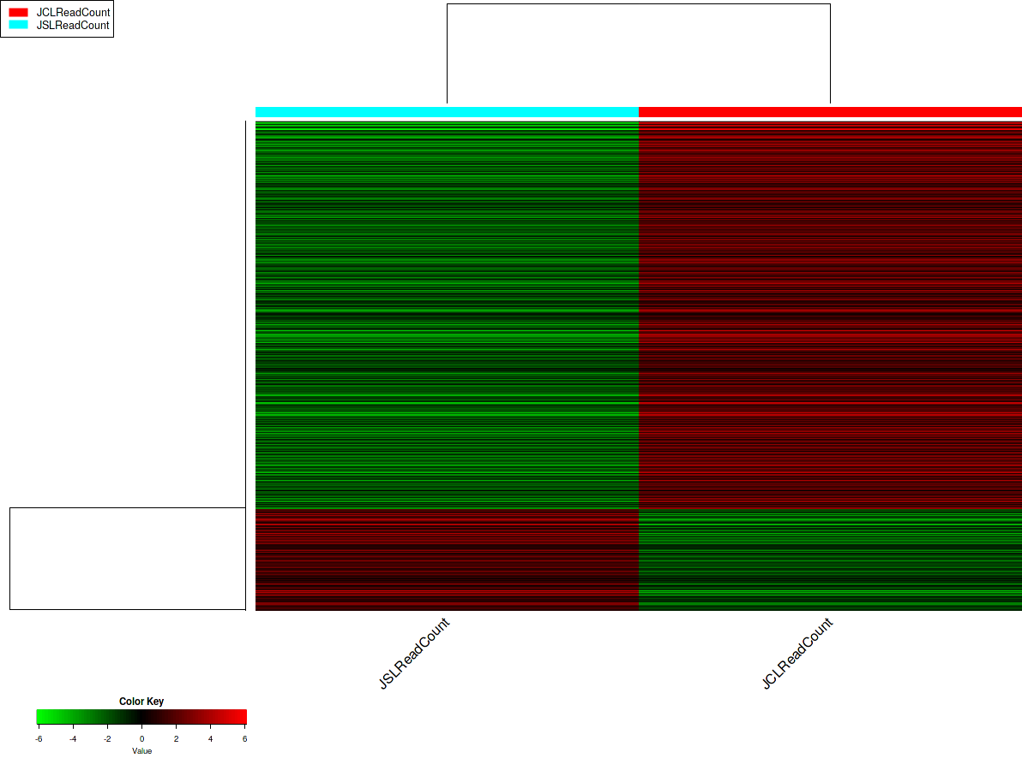
(A)

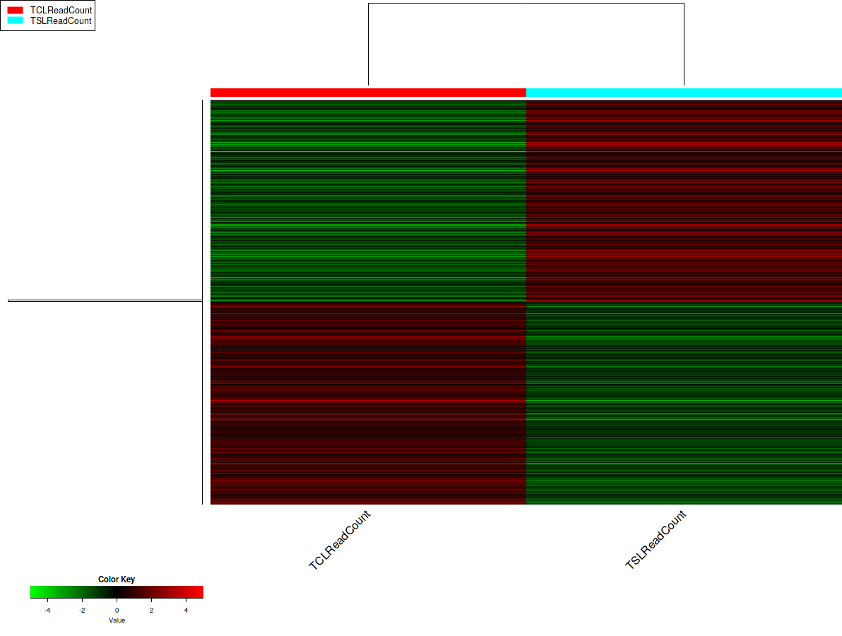
(B)

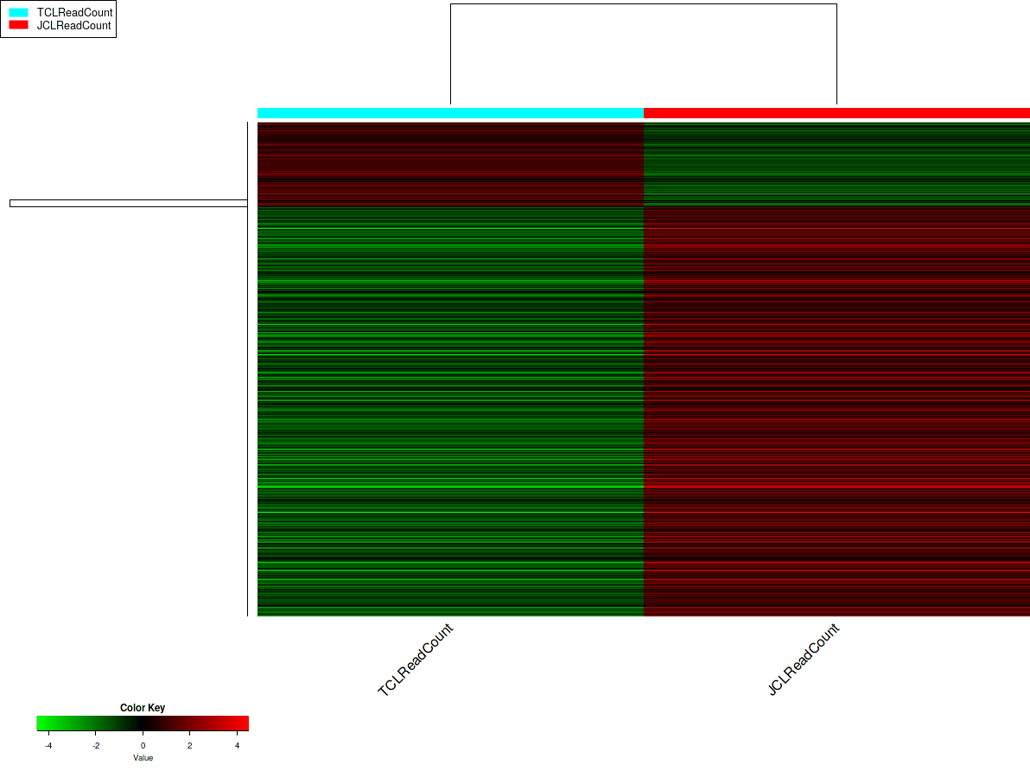
(C)

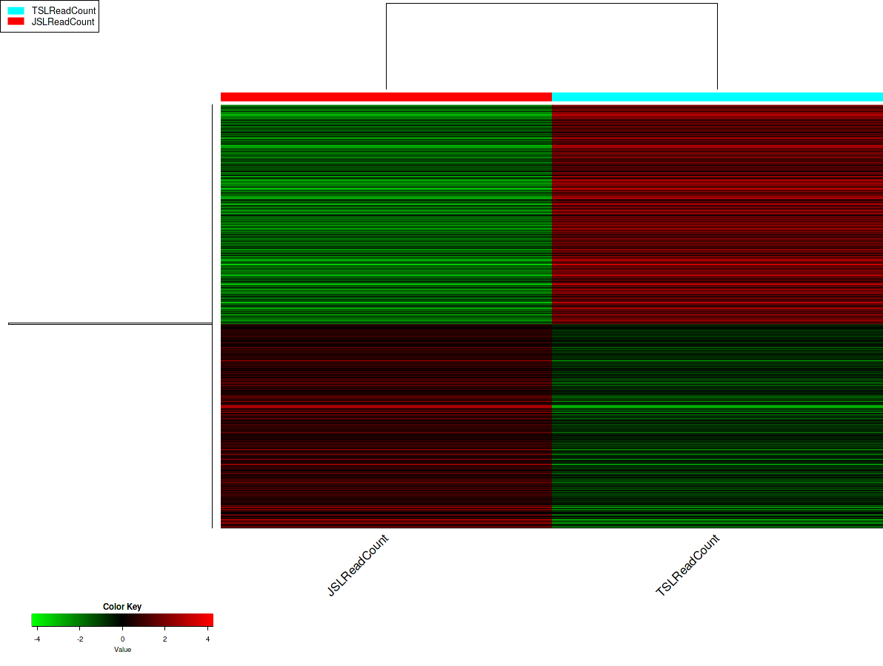
(D)

Supplementary Figure 1: Heat map of differentially expressed genes between different combinations JSL vs JCL (A); TCL vs TSL (B); TCL vs JCL (C); and TSL vs JSL (D).

