Supplementary Material
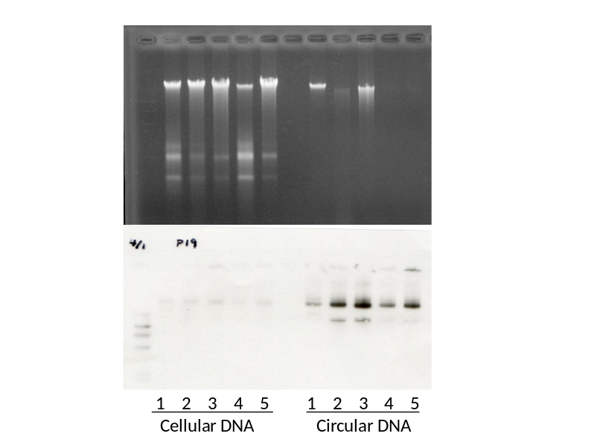
S Fig. 1. Enhanced signal density of mitochondrial DNA reveals enrichment of the circular DNA fraction.
Whole cellular DNA (left part of panels) and alkaline-SDS-extracted-circular DNA fraction (right part of panels) of P19C6 cells under neuronal differentiation by retinoic acid (RA) stimulation. Upper panel shows the electrophoresis of cellular whole DNA and the circular DNA–enriched fraction stained with ethidium bromide. Lower panel shows the Southern blot result of the upper panel with a mitochondrial DNA probe. The signal of mitochondrial DNA as a representative of the circular DNA molecule turns out to be enhanced after the alkaline-SDS DNA extraction procedure. Each lane contains 500 ng of DNA. The probe was prepared by PCR amplification of whole cellular DNA with mitochondrial DNA-specific primers MitMOF and MitMOR. The number assigned to each lane corresponds to the same number introduced in Fig. 1 (the stage of the RA-stimulated differentiation process, as follows: 1: before adding RA; 2: 2 days after RA supplementation; 3: 4 days after RA supplementation; 4: 13 days after RA supplementation; and 5: 18 days after RA supplementation).
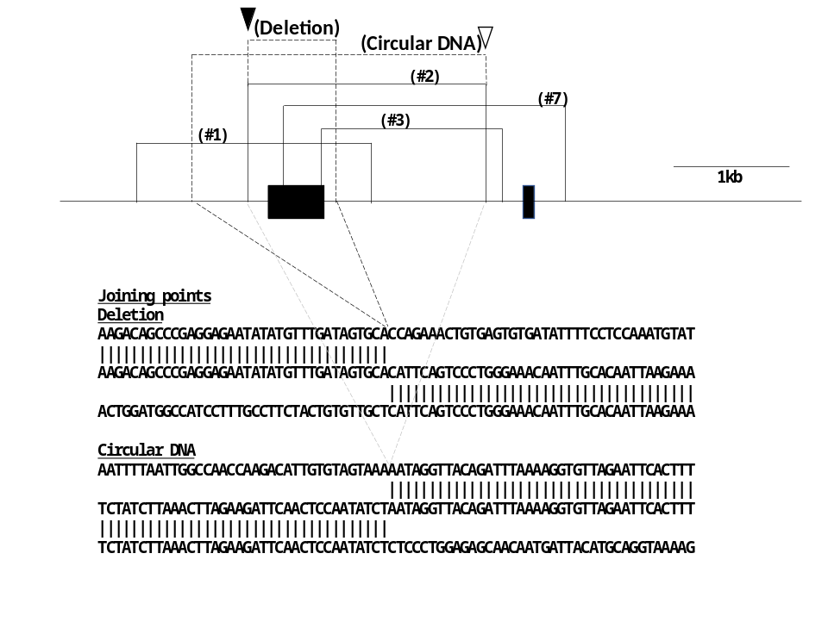
S Fig. 2 The description of DNA deletion and circular DNA production reported previously in mouse embryonic brain tissue.
Main structure of the upper part of this figure corresponds to that of Fig. 1c.
Broken lines and bracketed explanatory descriptions depict a DNA deletion in a circular DNA and a region of a circular DNA identified in mouse embryonic brain tissue. Such a circular DNA containing deletion implied sequential deletions with circular DNA production. The brain circular DNA without deletion was identified commonly in different embryonic age (day 15 and day 16). These previous results motivated the present study.
The lower part shows DNA sequence around the joining points. A part of this figure originated from our previous report, but is presented with modification. Black and gray broken lines under map describe the link between the location of joining events and genomic DNA sequence.

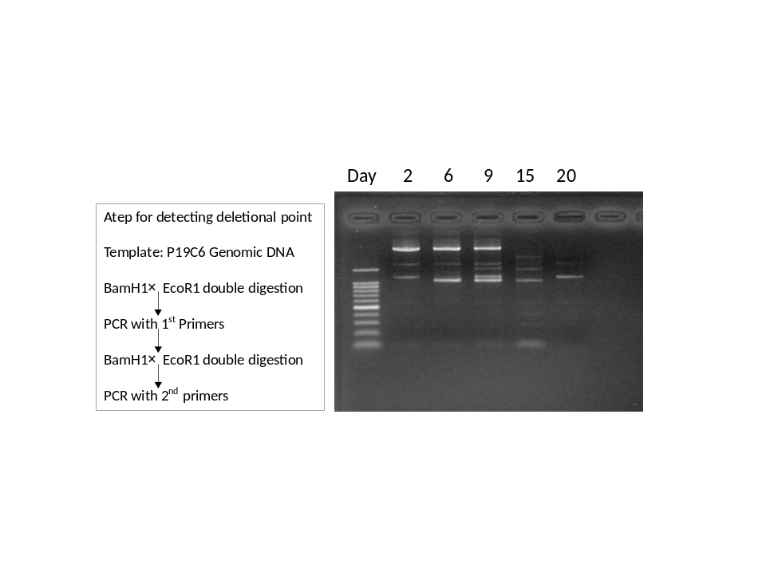
Fig. S3. Trial for detecting a joining point on genomic DNA corresponding to a DNA deletion, leading to circular DNA production.
On the map of Fig. 1c, Eco RI and Bam HI cut the genomic DNA unless genomic deletion occurred, which may lead to circular DNA production of band (#2) in Fig 1. However, none of the polymerase chain reaction (PCR) amplified fragments turned out to contain a deletional joining point. Amplified fragments seemed to be derived from genomic DNA left uncut by restriction enzymes.

(#1)
GGTAACAAGACAGAGAGGAGATGATAATGGAAATGAAACAATTGAAGTATATTGCATGTAGGGATATATGAAAGATATTTTAAAAGAT
|||||||||||||||||||||||||||||||||||||||||
GTTCTGGTTGGTTGTCTTATTAGTTAGTTGAGAATTTCTATATGTTTTATATTGCATGTAGGGATATATGAAAGATATTTTAAAAGAT
||||||||||||||||||||||||||||||||||||||||||||||
GTTCTGGTTGGTTGTCTTATTAGTTAGTTGAGAATTTCTATATGTTATATCATATTAATCTTCTCTAACTCTTACTAAATCCATTCCT

(#2)
AGAAGATCAATTTTAATTGGCCAACCAAGACATTGTGTAGTAAAAATAGGTTACAGATTTAAAAGGTGTTAGAATTCACTTTTGTGAA
||||||||||||||||||||||||||||||||||||||||||
ATAGCCCATTACTGGATGGCCATCCTTTGCCTTCTACTGTGTTGCTTAGGTTACAGATTTAAAAGGTGTTAGAATTCACTTTTGTGAA
||||||||||||||||||||||||||||||||||||||||||||||
ATAGCCCATTACTGGATGGCCATCCTTTGCCTTCTACTGTGTTGCTCATTCAGTCCCTGGGAAACAATTTGCACAATTAAGAAATGAA

(#3)
TGGAGGATGCCATGAGAGAGTTCAAGGTTAGTTCAATTTCTTACGATGCTAAACAGAATTGGGCACAGAATAAACAAGTTTCCTCCAA
||||||||||||||||||||||||||||||||||||||||||
TTATTGCTTAAGAAGAATATTTTCCAGCTGTGCTTTTGCATTGAAGTGCTAAACAGAATTGGGCACAGAATAAACAAGTTTCCTCCAA
||||||||||||||||||||||||||||||||||||||||||||||
TTATTGCTTAAGAAGAATATTTTCCAGCTGTGCTTTTGCATTGAAGGAAATGAATCCATTAGTATAAAGCAGTCTGCTGTTAAACCCC

(#4)
CAATTTTAAATGTTGAAAAGTATTGACCATCTTTTGCGAGGCACTACACAATGCCAGTTACCTAAATATGCAAATGTCACACAAAAAT
||||||||||||||||||||||||||||||||||||||||||
CAATTTTAAATGTTGAAAAGTATTGACCATCTTTTGCGAGGCCTCGGGGGCCAAACTGTGATCGGGATATTTTCCCGGG-ATGTATGG
| ||||||||| | |||||||||| ||||||||
AAAGATGATAAAAGACAGCCCGAGGAGAATATATGTTTGATAGTGCACCAGAAACTGTGAGTGTGATATTTTCCTCCAAATGTATGG

CTCCAAATGTATGGATAAAAGTGAATCTTCATTCTAGAATTGTGAATATAGAAATCAATGTGTGCTTTGATAAGTTCTTTAAAATTGC
| | ||||||||| |||||||||||||| || ||||| ||||||
CCCGGGATGTATGGAAAAAAGTGAATCTTCCCTCCGCAATTGCGAATATCTGCGGCGGTGGCCGCTTT-GCTGCTGCTGCCGCCATTG
|||||||||| ||||| ||||||||||||||| ||
TCCGGGTCTTCCTCCTCCTCCTCCTCGTCCGCCTCCGCCACCTCGGCCTCTGCGGCGGCCGCCGCCGCCGCTGCTGCTGCCGCCGCTG

GGAGGGACGCGCGCCTTGCCTGTACCCCCCGTGAGTACTATGGGAGGGGAGGGTGGGTCCCTGCCTTCTAAGTCTGCTCTCGGGTCCT
| | |||||||||||||||||||||||||||||||||||||||||||| | |
GTATGGACGCGCGCCTTGCCTGTACCCCCCGTGAGTACTATGGGAGGGTAACATCAAAACAAATACCACAACTGTAAACTCATGTGTA
||| | |||||||||||||||||||||| |||||||||||||| |
TTCTTTTTTTTTCTTTCTTTCTCTCATCTATAGACTTGTGTGGTCGCCTAACATCAAAACAAATACCACAGCTGTAAACTCATGTCTT

(5)
ATAATGACTATTTTAAATATATGCATTTTAAGTGAAGAGTGAACTAGAATAAAACCTAGCATATACTTTAAACTCAAAGTTCCTTCTG
|||||||||||||||||||||||||||||||||||||||||||
CACAAACTTTAGCATCTCCCCCATGTCCCAATGGTAGGTGAGAGGAGAATAAAACCTAGCATATACTTTAAACTCAAAGTTCCTTCTG
|||||||||||||||||||||||||||||||||||||||||||||
CACAAACTTTAGCATCTCCCCCATGTCCCAATGGTAGGTGAGAGGGATGAATTCTTAAAAAACTAGCTTCTCGTGAGGAAATCACAGC

(6)
TGTGAATATAGAAATCAATGTGTGCTTTGATAAGTTCTTTAAAATTGCATTTCAGTAGATATACTTTTATAATGACTATTTTAAATAT
||||||||||||||||||||||||||||||||||||||||||
TTTTACCTCTGTTGTTTATTGTTATATAACTTTTGGAACATGAACCGCATTTCAGTAGATATACTTTTATAATGACTATTTTAAATAT
||||||||||||||||| ||||||||||||||||||||||||||||
TTTTACCTCTGTTGTTT-TTGTTATATAACTTTTGGAACATGAACCAATTTTAAATGTTGAAAAGTATTGACCATCTTTTGCGAGGCA

(7)
TACATATAATATATTATAATTTCTACCTCCAGCATATTATTTCACTTCAAATTAGATATGTATGACTGA-CTTTGTAAAGTAGCATAT
|||||||||||||||||||||||||||||||||||||||||||||
CCTCAAGCTGGCAAACAAAATTCAGCAGATGCTCCCCCAGATGACTTCAAATTAGATATGTATGACTGAACTTTGTAAAGTAGCATAT
||||||||||||||||||||||||||||||||||||||||||||||
CCTCAAGCTGGCACACAAAATTCAGCAGATGCTCCCCCAGATGACTCCACACTGATGAGCATTATATATGCAATCTATCTCATATGAT

(8)=(9)
ACTCTGTGTTTGGAGGATGCCATGAGAGAGTTCAAGGTTAGTTCAATTTCTTACGATGCTAAACAGAATTGGGCACAGAATAAACANG
||||||||||||||||||||||||||||||||||||||||||||
AAACTCATGTCTTTGGGAGTACTTGTCATATGCATGCTTTGATGAATTTCTTACGATGCTAAACAGAATTGGGCACAGAATAAACAAG
||||||||||||||||||||||||||||||||||||||||||||
AAACTCATGTCTTTGGGAGTACTTGTCATATGCATGCTTTGATGGTCTTATTGCTTAAGAAGAATATTTTCCAGCTGTGCTTTTGCAT

(10)
GGATGAGGTGTGGGTGGGGAGTTGAGGAGTGGAGACCAGGAAGGGGGACAACATTTGAAATGTAAATAAATAAAATAACTGATTTTAA
|||||||||||||||||||||||||||||||||||||||||||
TGTGTGCTTTGATAAGTTTCTTTAAAATTGCATTTCAGTAGATATGGACAACATTTGAAATGTAAATAAATAAAATAACTGATTTTAA
||||||||||||||||| |||||||||||||||||||||||||||
TGTGTGCTTTGATAAGT-TCTTTAAAATTGCATTTCAGTAGATATACTTTTATAATGACTATTTTAAATATATGCATTTTAAGTGAAG

S Fig. 4. The DNA sequence of joining points detected in circular DNAs.
Each joining point is presented as introduced in Fig. 1d.
(#1) Note that one nucleotide is inserted at the joining point, which is underlined.
(#2) One end is just 2 bp apart from a joining point of circular DNA extracted from the fetal mouse brain (open vertical triangle), and the other end is identical to one end of deletion in a fetal mouse brain circular DNA (closed vertical triangle) in our previous report (reference 8).

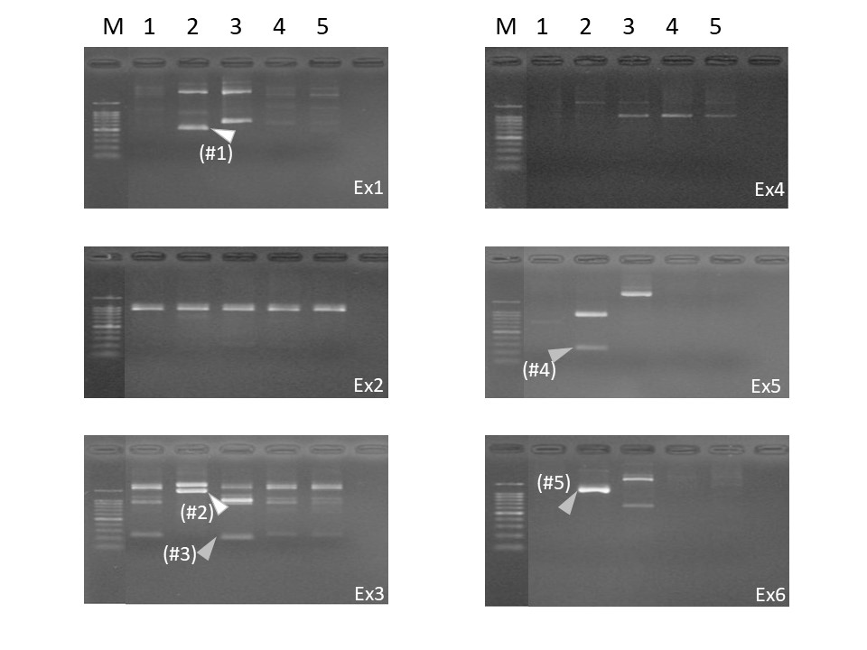
a.

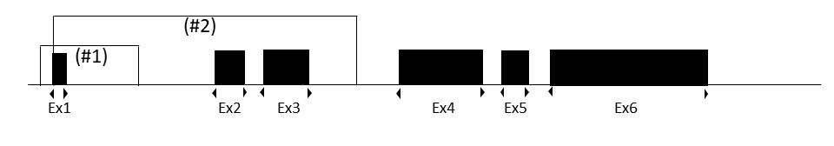
b.

(#1)
TGCGGCGAGGCCGGTGAGTGAGCGACGCGGAGCCAATCAGCGCCCGCCGTTCCGAAAGTTGCCTTTTATGGCTCGAGTGGCCGC
||||||||||||||||||||||||||||||||||||||||||||
CGGGCGGGCGGGCGGGCGGGCGGGCGCGGCAGGGCCGGCTCGGCCGCCGTTCCGAAAGTTGCCTTTTATGGCTCGAGTGGCCGC
||||||||||||||||||||||||||||||||||||||||||||||
CGGGCGGGCGGGCGGGCGGGCGGGCGCGGCAGGGCCGGCTCGGCCGGGTGGGGGCTGGGATGCCACTGCGCGTGCGCTCTCTAT
(#2)
GGCGCAACGCGCAGCCACTGTCGAGTCGCGTCCACCCGCGAGCACAGCTTCTTTGCAGCTCCTTCGTTGCCGGTCCACACCCGCC
||||||||||||||||||||||||||||||||||||||||
TAACAATGGCTCGTGTGACAAAGCTAATGAGGCTGGTGATAAGTGAGCTTCTTTGCAGCTCCTTCGTTGCCGGTCCACACCCGCC
|||||||||||||||||||||||||||||||||||||||||||||
TAACAATGGCTCGTGTGACAAAGCTAATGAGGCTGGTGATAAGTGGCCTTGGAGTGTGTATTGAGTAGATGCACAGTAGGTCTAA
(#3)
GCAAAGGCAGCCTCGCGGCCGATGCTCCCTGGGCCGTCATCCCCTCCATCGTGGGCTGCCCTGGGCACTAGGATGTGATGGTGGG
|||||||||||||||||||||||||||||||||||||||||||
TTGTCTCTATATGTCTCTGGTCCTACTACTGGCATTGCAATGCCTCCATCGTGGGCTGCCCTGGGCACTAGGATGTGATGGTGGG
||||||||||||||||||||||||||||||||||||||||||
TTGTCTCTATATGTCTCTGGTCCTACTACTGGCATTGCAATGGACTCTGGAGACAGGGTCACCCACACTGTGCCTATCTGTGAGG

(#4)
GAAATCGTGCGTGACATCAAAGAGAAGCTGTGCTATGTTGCCCTAGACTTCGAGCAGGAGATGGCCACGGCCGCATCCTCTTCTT
||||||||||||||||||||||||||||||||||||||||||||||
TTGCTCCTCCTGANCGCAAGTACTCTGTGTGGATCGATGGCCCTAGACTTCGAGCAGGAGATGGCCACGGCCGCATCCTCTTCTT
|||||||||||||||||||||||||||||||||||||||||
TTGCTCCTCCTGAGCGCAAGTACTCTGTGTGGATCGATGGCTCCATCCTGGCCTCACTGTCCACCTTCCAGCAGATCGGCTCAGC

(#5)
GGAAATCGTGCGTGACATCAAAGAGAAGCTGTGCTATGTTGCCCTAGACTTCGAGCAGGAGATGGCCACGGCCGCATCCTCTTC
||||||||||||||||||||||||||||||||||||||||||
AGAGTTTCGTGGCTGCAGTTGTGAAACGCTGCTATAGTGAGTCCTAGACTTCGAGCAGGAGATGGCCACGGCCGCATCCTCTTC
||||||||||||||||||||||||||||||||||||||||||||
AGAGTTTCGTGGCTGCAGTTGTGAAACGCTGCTATAGTGAGTCCCCTTACCTTTCCCTCGGAATAGTGTAGTAAGATTATTTTT

S Fig. 5 Detection of circular DNA derived from the β-actin gene region in P19C6 cells under retinoic acid stimulation for neuronal differentiation.
- Nested inverse PCR amplification using inverse primers set adjacent to the exon/intron border in each of six exons of the β-actin gene, indicated as Ex1–6. Each lane number is similar to Fig. 1a. M: size marker; the number of each lane corresponds to one in Fig. 1. The fragments found to contain a joining point for circularization are indicated by arrowheads. White arrowheads indicate that the fragment is derived from the genomic β-actin gene. Gray arrowheads are for the fragments derived from other genomic regions. Parenthesized numbers correspond to those in b and c.
- The map of the mouse beta-actin gene. Black boxes are exons (Ex). Two arrowheads toward the external region at each exon are primers used to amplify fragments containing a joining point of circular DNA encompassing the exon.
- DNA sequence around the joining point of the β-actin gene or β-actin homologous region. (#1), (#2) The β-actin gene DNA sequence shown refers to Sequence ID AC144818 on chromosome 5.
(#3) The sequence detected is derived from the β-actin-pseudogene on chromosome X (Gen Bank accession No. AL713920).
(#4) The sequence detected is derived from the β-actin-pseudogene on chromosome 16 (GenBank accession No. AC161268).
(#5) Note that one end of the joining point of #5 is located 2 bp apart from an end of #4.

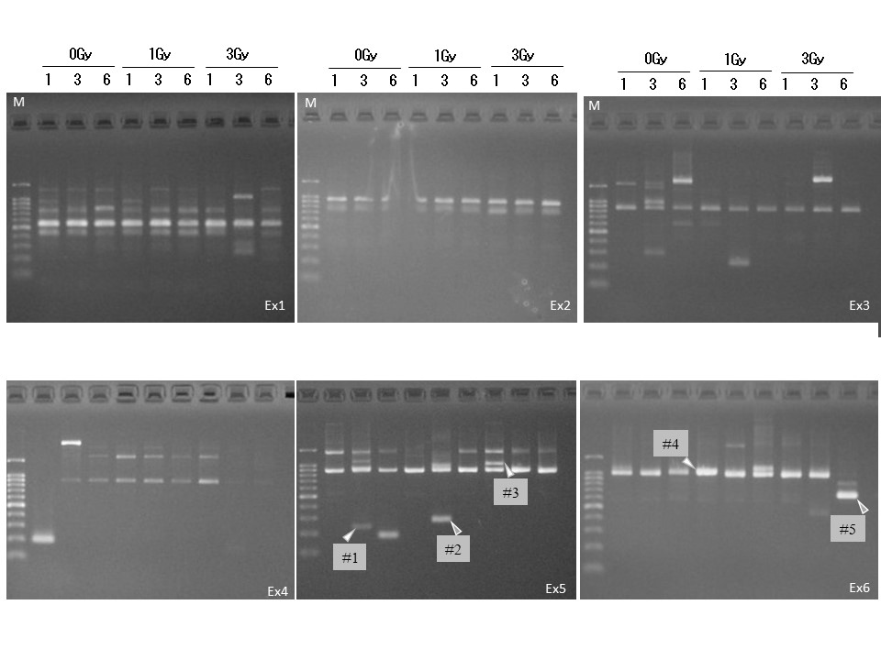
a.

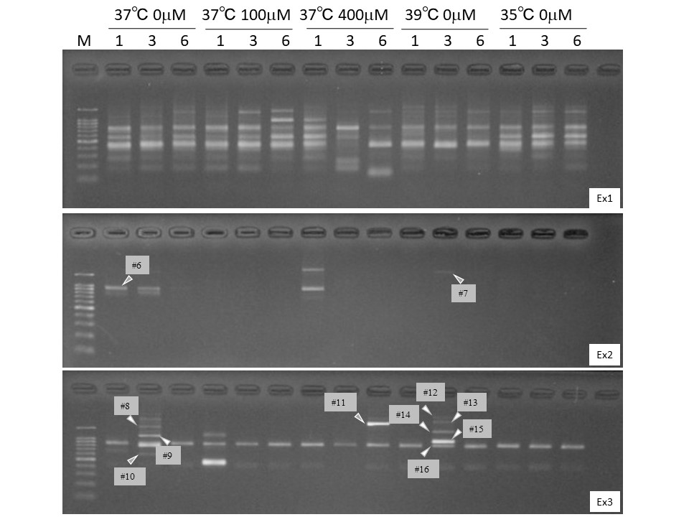
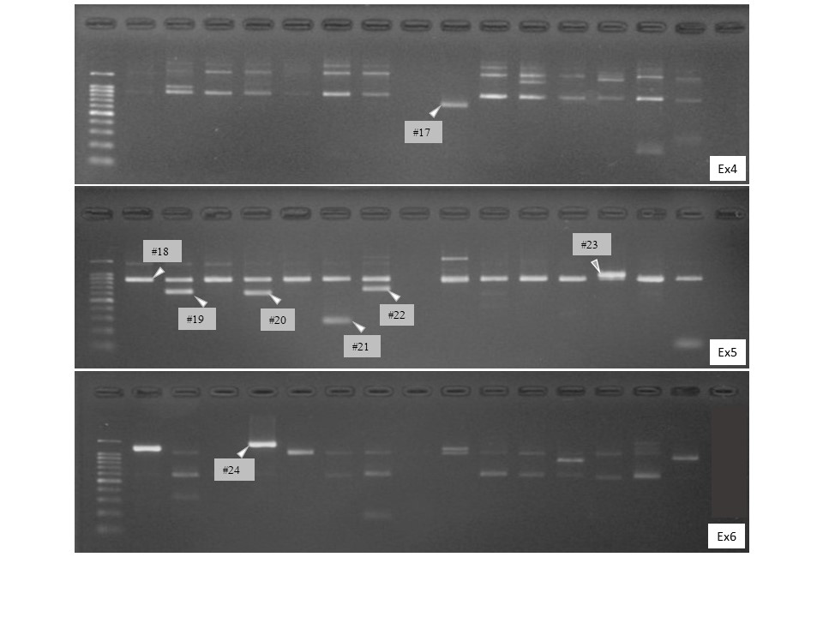
b.

#1
GTGGATTGGCGGCTCCATCCTGGCCTCGCTGTCCACCTTCCAGCAGATGTGGATCAGCAAGCAGGAGTATGATGAGTCCGGCTCCATC
||||||||||||||||||||||||||||||||||||||||||||||
GTGGATTGGCGGCTCCATCCTGGCCTCGCTGTCCACCTTCCAGCAGGACTGACGGCCAGGTCATCACCATCGGCAACGAGCAGTTCTG
||||||||||||||||||||||||||||||||||||||||||
TGGCCATGGCGGCTTCCAGCTCCTCCCTGGAGAAGAGCTATGAGCTGACTGACGGCCAGGTCATCACCATCGGCAACGAGCAGTTCTG

#2
CCCTGAGGCACTCTTCCAGCCTTCCTTCCTGGGTGAGTGGAGACTGTCTCCCGGCTCTGCCTGACATGAGGGTTACCCCTCGGGGCTG
||||||||||||||||||||||||||||||||||||||||||||
CATCCAGGGTCCTCACTGCCTGTCCCCTTCCCTCCTCAGATCATTGTCTCCCGGCTCTGCCTGACATGAGGGTTACCCCTCGGGGCTG
||||||||||||||||||||||||||||||||||||||||||||||
CATCCAGGGTCCTCACTGCCTGTCCCCTTCCCTCCTCAGATCATTGCTCCTCCTGAGCGCAAGTACTCCGTGTGGATCGGCGGCTCCA

#3
GGACTCCCATGTGGGCGACGAGGCCTAGAGCAAGAGAGGCATCCTGACCCTGAAGTGCCTCATCGAGCATGGCATCATTACCAACTGG
||||||||||||||||||||||||||||||||||||||||||||
AAAACTGGAACGGTGAAGGTGACAGCAGTCGGTTGGAGTGAACATGACCCTGAAGTGCCTCATCGAGCATGGCATCATTACCAACTGG
|||||||||||||||||||||||||||||||||||||||||||||
AAAACTGGAACGGTGAAGGTGACAGCAGTCGGTTGGAGTGAACATCCCCCAAATTTCTGCAGTGTGGCTGAGGACTCTATTTCTTGTT

#4
CCCCAGGTACCCCAGTTTTTCTGGGTTCACCCAGAGTGCAGATGCTTGAGGAGGTGGGAAGGGACTATTTGGGGGTGTCTGGCTCAGG
||||||||||||||||||||||||||||||||||||||||||||||
CCCCAGGTACCCCAGTTTTTCTGGGTTCACCCAGAGTGCAGATGCTATGCCCTCCCCCATGCCATCCTGCGTCTGGACCTGGCTGGCC
|||||||||||||||||||||||||||||||||||||||||||
GACTCCGGTGACGGGGTCACCCACACTGTGCCCATCTACGAGGGGTATGCCCTCCCCCATGCCATCCTGCGTCTGGACCTGGCTGGCC

#5
TTTTCTGGGTTCACCCAGAGTGCAGATGCTTGAGGAGGTGGGAAGGGACTATTTGGGGGTGTCTGGCTCAGGTGCCATGCTCACTGGG
||||||||||||||||||||||||||||||||||||||||||||||
TTTTCTGGGTTCACCCAGAGTGCAGATGCTTGAGGAGGTGGGAAGGACCTTCAACTCCATCATGAAGTGTGACGTGGACATCCGCAAA
||||||||||||||||||||||||||||||||||||||||||
CCTCATTTCCCTCTCAGGCATGGAGTCCTGTGGCATCCACGAAACTACCTTCAACTCCATCATGAAGTGTGACGTGGACATCCGCAAA

#6
CTCTCTTCTCTGACCTGAGTCTCCTTTGGAACTCTGCAGGTTCTATTTGCTTTTTCCCAGATGAGCTCTTTTTCTGGTGTTTGTCTCT
|||||||||||||||||||||||||||||||||||||||||||||
CTCTCTTCTCTGACCTGAGTCTCCTTTGGAACTCTGCAGGTTCTAGGCTCGGCCGGAAGGGGTGGGGTCGCCGCGGCTCCCGGGCGCT
|||||||||||||||||||||||||||||||||||||||||||
CGTTCTGGGGCCCGGGGTGCCGCGGCCTGGGCTGGGGCGAAGGCGGGCTCGGCCGGAAGGGGTGGGGTCGCCGCGGCTCCCGGGCGCT

#7
GAGGCCGCGCTCGGGAGGCGCGCTCCGGGGGTGCCGCTCTCGGGGCGGGGGCAACCGGCGGGGTCTTTGTCTGAGCCGGGCTCTTGCC
||||||||||||||||||||| |||| | ||||| ||| | | ||
AGCTGTGCTACGTCGCCCTGGACTTCGAGCAAGAGATGGCCACGGCGGGGGCAACCGGCGGGGTTTTTATATGAGCTGGGATATTCCC
||||||||||||||||||||||||||||||||||||||||||||||
AGCTGTGCTACGTCGCCCTGGACTTCGAGCAAGAGATGGCCACGGCTGCTTCCAGCTCCTCCCTGGAGAAGAGCTACGAGCTGCCTGA

#8
GGTGGCACCACCATGTACCCTGGCATTGCCCACAGGATGCAGAAGGAGATCGCTGCCCTGGCGCCTAGCACGATGAAGATCAAGATTG
||||||||||||||||||||||||||||||||||||||||||||||
GGTGGCACCACCATGTACCCTGGCATTGCCCACAGGATGCAGAAGGTTATTTTTTAATTTCAGAAGAAATCATGATATATCAATCTAT
|||||||||||||||||||||||||||||||||||||||||||
GTTAAATATCCACTATGGGGATTCTTTCATTATACAAATACAGATGTTATTTTTTAATTTCAGAAGAAATCATGGTATATCAATCTAT

#9
ATAAATCACTAGAGGATTTTTAAGAATCTCAGAATTAAAAAAGCCTTTCTCTGAGTTACAAAAAACCCAGAGGCACAAAATATAAGAT
||||||||||||||||||||||||||||||||||||||||||||
ATAAATCACTAGAGGATTTTTAAGAATCTCAGAATTAAAAAAGCTGGGGTGTTGAAGGTCTCAAACATGATCTGGGTCATCTTCTCAT
||||||||||||||||||||||||||||||||||||||||||||||
GAGGTGTACAAGGACAGCACGGCTTGGATGGCCACGTACATGGCTGGGGTGTTGAAGGTCTCAAACATGATCTGGGTCATCTTCTCAC

#10
GCGCCCGTGCTCAGGGCTTCTTGTCCTTTCCTTCCCAGGGCGTGATGGTGGGCATGGGTCAGAAGGATTCCTATGTGGGCGACGAGGC
||||||||||||||||||||||||||||||||||||||||||||||||
CTGTGCTATCCCTGTACGCCTCTGGCCGTACCACTGGCATCGTGATGGTGGGCATGGGTCAGAAGGATTCCTATGTGGGCGACGAGGC
||||||||||||||||||||||||||||||||||||||||||||||||
CTGTGCTATCCCTGTACGCCTCTGGCCGTACCACTGGCATCGTGATGGACTCCGGTGACGGGGTCACCCACACTGTGCCCATCTACGA

#11
GGGCAGTTGCTCTGAAGTCGGCAAGGGGGAGTGACTGCCTGGCCACTCCATGCCCTCCAAGAGCTCCTTCTGCAGGAGCGTACAGAAC
|||||||||||||||||||||||||||||||||||||||||||||
TCTGACTAGGTGTCTAAGACAGTGTTGTGGGTGTAGGTACTAACACTCCATGCCCTCCAAGAGCTCCTTCTGCAGGAGCGTACAGAAC
|||||||||||||||||||||||||||||||||||||||||||||||
TCTGACTAGGTGTCTAAGACAGTGTTGTGGGTGTAGGTACTAACACTGGCTCGTGTGACAAGGCCATGAGGCTGGTGTAAAGCGGCCT

#12 #13 #14 #15 #16
CTCGTCATTGACAACGGCTCTGGCATGTGCAAGGCCGGCTTTGCAGGTGACGATGCCCCCCGGGCTGTCTTCCCTTCCATCGTGGGGT
||||||||||||||||||||||||||||||||||||||||||||||||||
GACTTAGTTGCATTACACCCTTTCTTGACAAAACCAAACTTTGCAGGTGACGATGCCCCCCGGGCTGTCTTCCCTTCCATCGTGGGGT
||||||||||||||||||||||||||||||||||||||||| ||||
GACTTAGTTGCATTACACCCTTTCTTGACAAAACCAAACTTCGCAGAAAGCCACATGAGATTGGTATGGCTTTAATTGTTTTCTTATT

#17
CAGACTCATCATACTCCTGGCTTGCTGACCCACATCTGCTGGAAGGTGGACAGCAAGGCCAGGATGGAGCTGCCCATCCACACCAGAG
||||||| |||||||||||||||||||||||||||||||||||||||||||||
ACGACAAGCACAGCAATATCATTATCCATGGTGAACTGGTGGCAGGTGGACAGCAAGGCCAGGATGGAGCCGCCGATCCACACCAGAG
||||||||||||||||||||||||||||||||||||||||||||||||
ACGACAAGCACAGCAATATCATTATCCATGGTGAACTGGTGGCAGGTGTGGATGGGCGGCAGAGTGGTGAGGGTGAGGCTCTGTGCTT

#18
CCAAAAAAAAAACCATAAAAAACAAAAAAGCAAATAAAGCCATGCCAATCTCATCTTGTTTTCTGCTCAGGTTAGGTTTTGTCAAGAG
|||||||||||||||||||||||||||||||||||||||||||||||
CCCGTAGATGGGCACAGTGTGGGTGAACCCATCACCAGAGTATGCCAATCTCATCTTGTTTTCTGCTCAGGTTAGGTTTTGTCAAGAG
|||||||||||||||||||||||||||||||||||||||||
CCCGTAGATGGGCACAGTGTGGGTGAACCCATCACCAGAGTCCATCACGATGCCAGTGGTATGGCCAGAGGCTTACAGGGACAGCAAG

#19
CAATGTACAGTCAAAGTCCTCGGCCACATTGTAGAACTTTGGGGGATGCTCGCTGCAACCAACTGCTGTCTCCTTCACTGTTCCAGTT
|||| ||||||||||||| ||||||||||||||||||||||||||
TTCCCGCTCGGCCGTGGTGTGAAGCTGTAGCCGTGCTCAGTGAGGATCCTCGCTGCAACCAGCTGCTGTCTCCTTCACTGTTCCAGTT
||||||||||||||||||||||||||||||||||||||||||||||||
TTCCCGCTCGGCCGTGGTGTGAAGCTGTAGCCGTGCTCAGTGAGGATCTCCATGAGGTAGTCAGTCAGGTCCCGGCCAGCCAGGTCCA

#20
ACTGAGGCTCTTCTGAACCCCAAGGCCAACTGCGAGAAGATGACCCAGATCATGTTTGAGACCTTCAACACCCCTGCCATATATGTGC
||||||||||||||||||||||||||||||||||||||||||||
GGCTCCATCCTGGCCTCGCTGTCCACCTTCCAGCAGATGTGGATCCAGATCATGTTTGAGACCTTCAACACCCCTGCCATATATGTGC
|||||||||||||||||||||||||||||||||||||||||||||
GGCTCCATCCTGGCCTCGCTGTCCACCTTCCAGCAGATGTGGATCAGCAGGCAGGAATACGAGTCCCACTTCTCTCGCCCCCATCTTC

#21
TGCTGATCCACATCTGCTGGAAGGTGGACAGCGAGGCCAGGATGGAGCCAATGATACACATGGAGTATTTGCACTCAGCAGGAGCAAT
||||||||||||||||||||||||||||||||||||||||||||
CTGGAGGACATGGTGGCCATCTCCTACTTGAAGTCCAGGGCAATGAGCCAATGATACACATGGAGTATT-GCACTCAGCAGGAGCAAT
|||||||||||||||||||||||||||||||||||||||||||||
CTGGAGGACATGGTGGCCATCTCCTACTTGAAGTCCAGGGCAATGTAGTGCAGCTTCTTCTTGATGTCACTCATGATTTCCTGCTGGG

#22
GCAATGCTATGATCTCCCCTGTGTGGACTAGGGAAAGGACCGGGCCATTCTCCTTAGAGAGAAGTGGGGTGGCTTTTAGGAGGGCAAG
||||||||||||||||||||||||||||||||||||||||||||||
GCCATCGAGCAGCTTGTAGCTCTTCTCCAGGGAGGAGCTGGAGGCCATTCTCCTTAGAGAGAAGTGGGGTGGCTTTTAGGAGGGCAAG
|||||||||||||||||||||||||||||||||||||||||||||||
GCCATCGAGCAGCTTGTAGCTCTTCTCCAGGGAGGAGCTGGAGGCCACCATGGCCATCTCCCGCTCGAAGTCCAGGGCGACGTAGCAC

#23
TTTGTCTCTCTGACTAGGTGTCTAAGACAGTGTTGTGGGTGTAGGTACTAACACTGGCTCGTGTGACAAGGCCATGAGGCTGGTGTAA
||||||||||||||||||||||||||||||||||||||||||||||
CTCAGATCATTGCTCCTCCTGAGCGCAAGTACTCCGTGTGGAAGGTACTAACACTGGCTCGTGTGACAAGGCCATGAGGCTGGTGTAA
||||||||||||||||||||||||||||||||||||||||||
CTCAGATCATTGCTCCTCCTGAGCGCAAGTACTCCGTGTGGATCGGCGGCTCCATCCTGGCCTCGCTGTCCACCTTCCAGCAGATGTG

#24
CATGATCTGGGTCATCTTCTCACAGTTGGCTTTGGGGTTCAGGGGGGCCTCGGTCAGCAGCACAGGGTGCTCCTCGGGAGCCACATGC
|||||||||||||||||||||||||||||||||||||||||||||
CATGATCTGGGTCATCTTCTCACAGTTGGCTTTGGGGTTCAGGGGCATGCACCTGTGGTCCCAGCTACTCAGGAAGCTGAGGTGGGAG
|||||||||||||||||||||||||||||||||||||||||||||
TGTTTCTAATAGAACAAAAATGGAAAACCTAGCTAGGCTTGGTGGCATGCACCTGTGGTCCCAGCTACTCAGGAAGCTGAGGTGGGAG

c.

S Fig. 6 The detection of circular DNA production by inverse PCR using primers for the β-actin gene in HUVECs.
a. The detection of circular DNA production from the β-actin gene region or its homologous region in HUVECs after X-ray irradiation.
b. The detection of circular DNA production from the β-actin gene region or its homologous region in HUVECs after supplementation with Ara-C or a 24-hour-temperature shift.
c. DNA sequence around the joining point of the β-actin gene or β-actin homologous region.
#1 and #3 are derived from the ACTG1P (actin gamma 1P pseudo gene) region located on chromosome 9.
The sequences #8, #9, #12, #13, #14, #15, and #16 are derived from sequences located commonly on chromosomes 14 and 22.
Note that #12, #13, #14, #15, and #16 share an identical joining point.
#17 Sequence is derived from ACTBP4 on chromosome 5.
#18 Sequence is derived from ACTBP9 on chromosome 18.
#19 Sequence is the β-actin-homolog on chromosome 22.
#20 and #21 Sequences are derived from ACTG1P15 on chromosome 15.
#22 and #24 ACTBP15 on chromosome 22.

