Supplementary Materials

Functionalized chitosan-powder activated carbon and chitosan-cellulose nanocomposites as novel green biodegradable clarifying agents in sugar refining process

Ahmed S. Ibrahimª, Ahmed N. Gad^{b}, Hemat M. Dardeer^{c}, Abdel-Aal M. Gaber∗^{d}

ª Faculty of Sugar and Integrated Industries Technology, Assiut University, Egypt
^{b} Research and Development Center of ESIIC, Quos, Egypt
^{c} Chemistry Department, Faculty of Science, South Valley University, Qena, Egypt
^{d} Chemistry Department, Faculty of Science, Assiut University, Assiut 71516, Egypt

Corresponding Author: gaber@aun.edu.eg

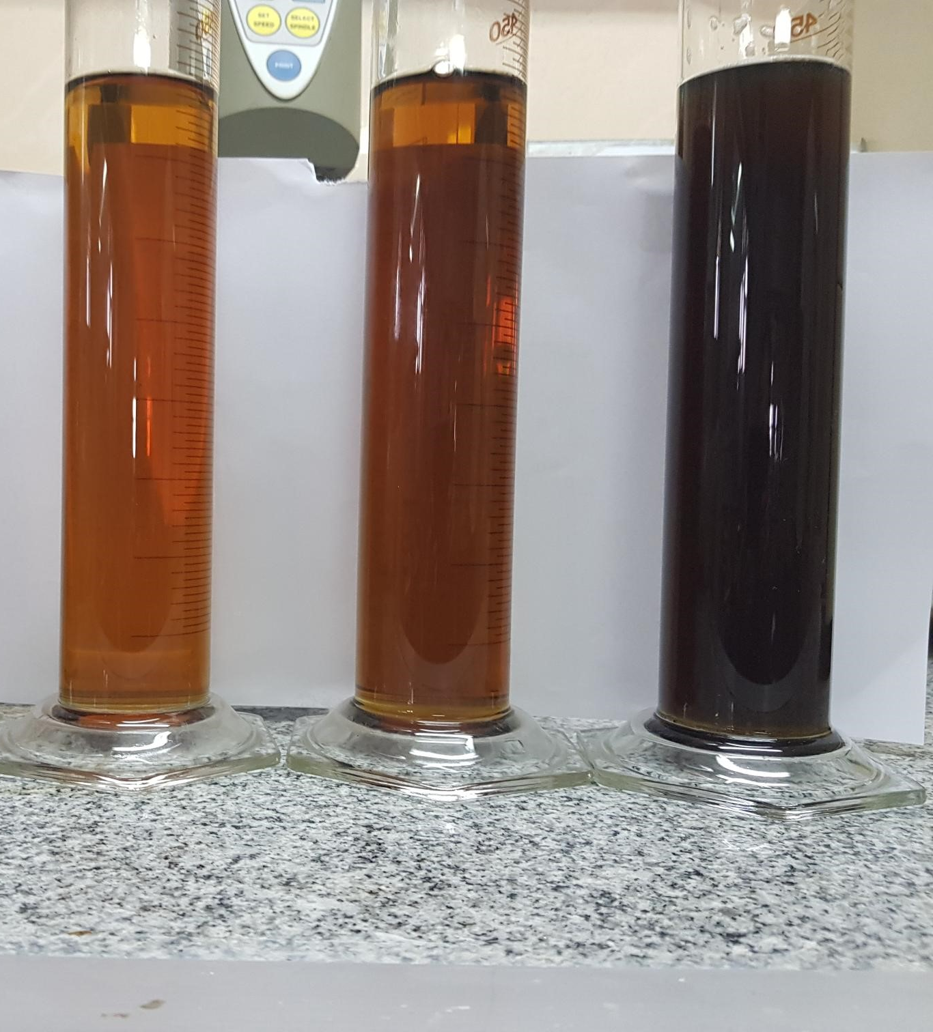
Figure S1. Camera image for untreated syrup with treated syrup with CS-CEL and CS-PAC nanocomposites

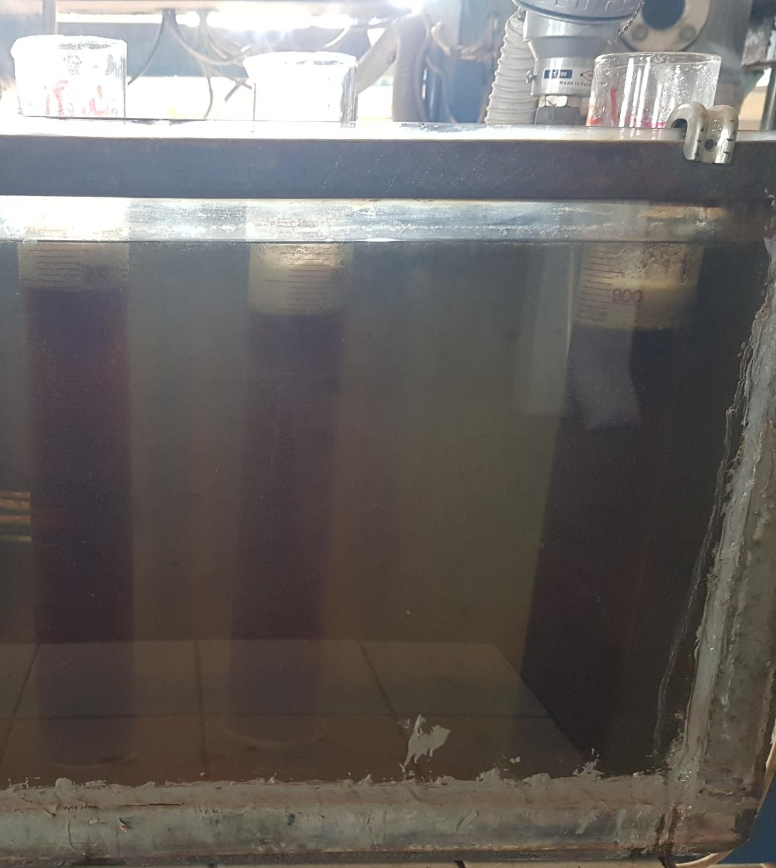
Figure S2. Flotation process using jar test for control, CS-CEL and CS-PAC nanocomposites on sugar syrup

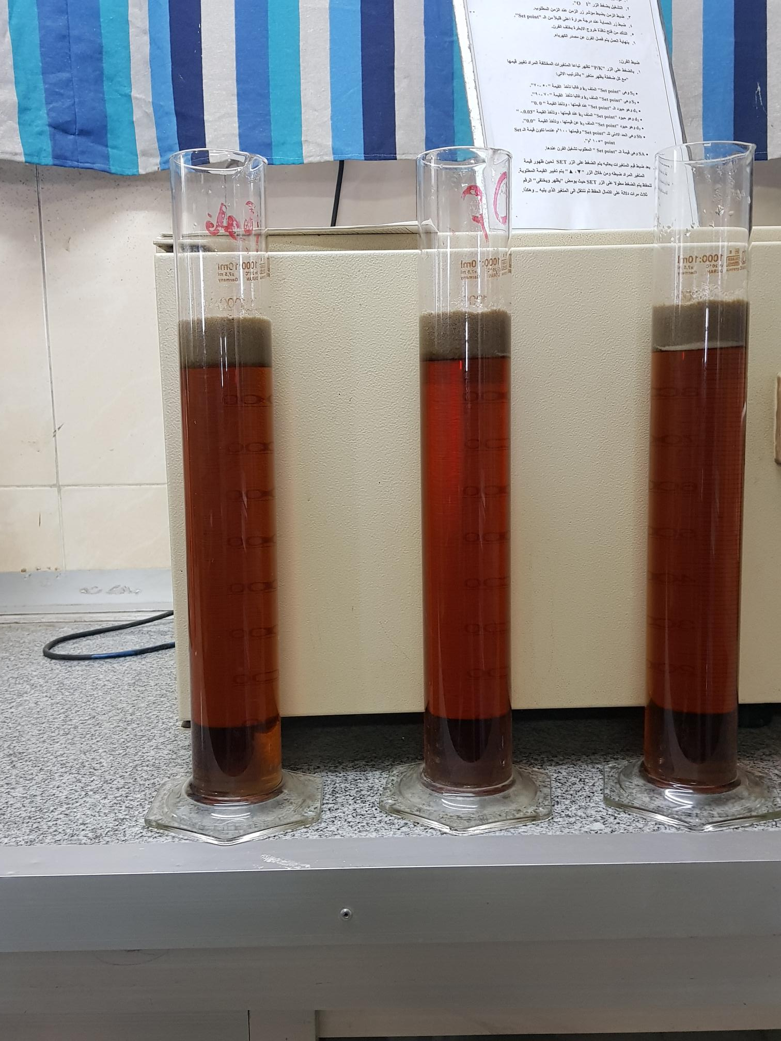
Figure S3. Final mud volume for control, CS-CEL and CS-PAC nanocomposites on clarified sugar syrup

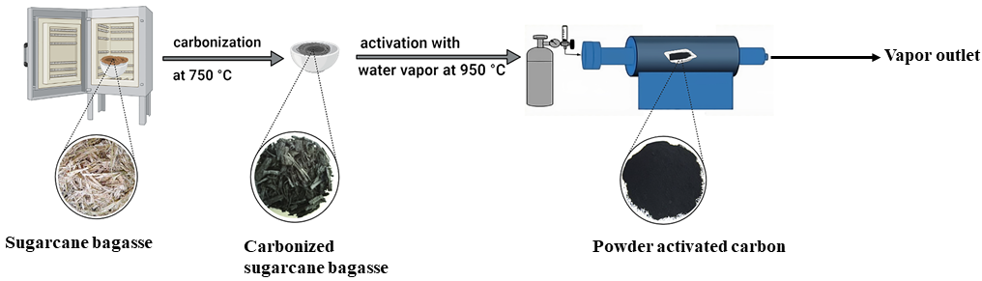Figure S4. Schematic illustration for the preparation of PAC

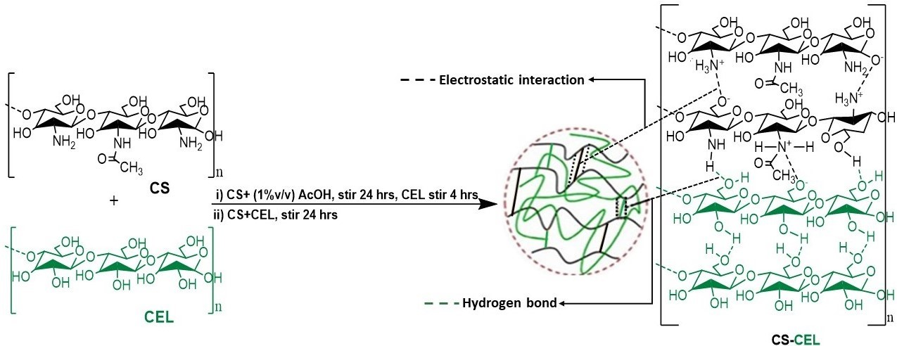 Figure S5. Schematic illustration for the preparation of CS-CEL nanocomposite

Figure S6. Preparation mechanism for CS-PAC

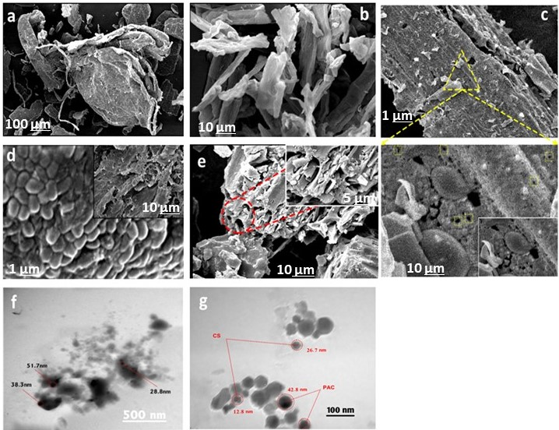
Figure S7. (a) SEM image of CS, (b) SEM image of CEL, (c) SEM image of PAC, (d) SEM image of CS-
CEL, (e) SEM image of CS-PAC, (f) TEM image of CS-CEL composite and (g) TEM image of CS-PAC

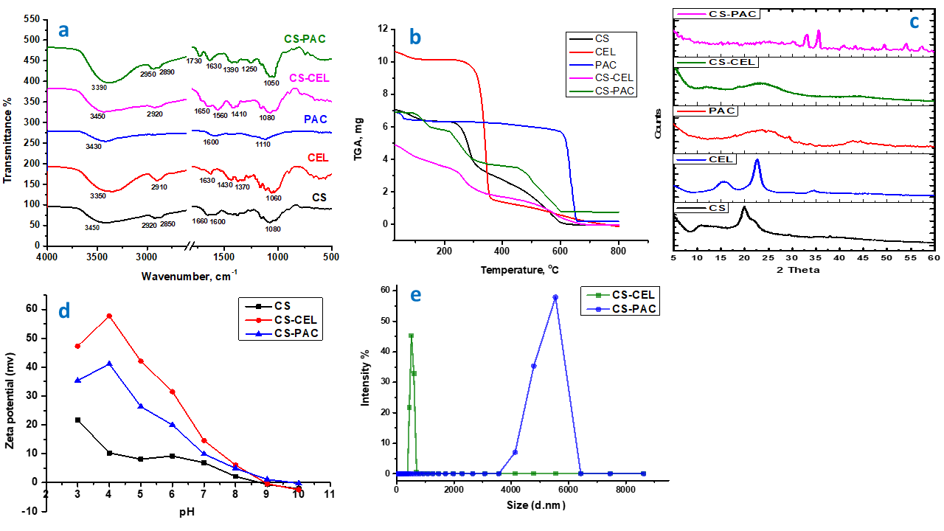
Figure S8. (a) FT-IR spectra of CS, CEL, PAC, CS-CEL and CS-PAC composites, (b) Thermogravimetric curves for CS, CEL, PAC, CS-CEL and CS-PAC composites, (c) XRD patterns of CS, CEL, PAC, CS-CEL and CS-PAC composites, (d) Zeta potential curves for CS, CS-CEL and CS-PAC composites and (e) Particle size distribution of CS-CEL and CS-PAC composites.

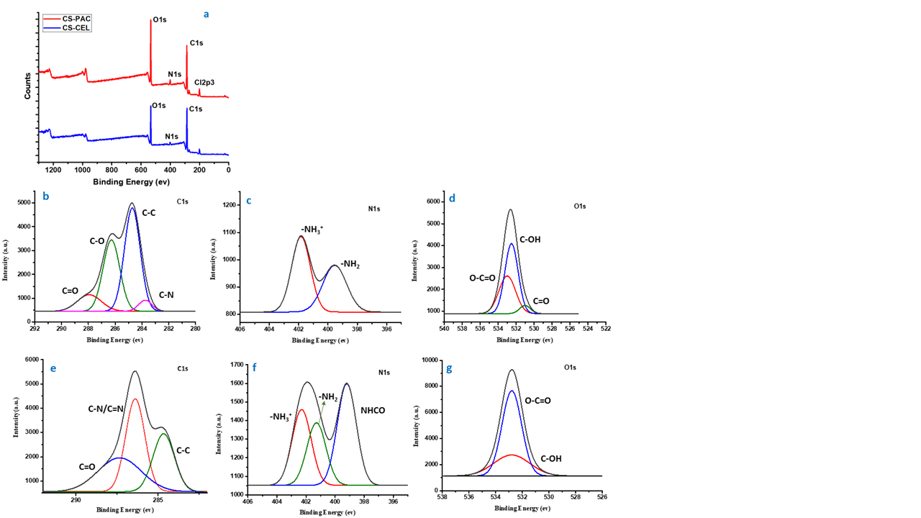
Figure S9. (a) XPS survey scan for CS-CEL and CS-PAC composites, (b) C1s spectrum of CS-CEL composite, (c) N1s spectrum of CS-CEL composite, (d) O1s spectrum of CS-CEL composite, (e) C1s spectrum of CS-PAC composite, (f) N1s spectrum of CS-PAC composite and (g) O1s spectrum of CS-PAC composite.

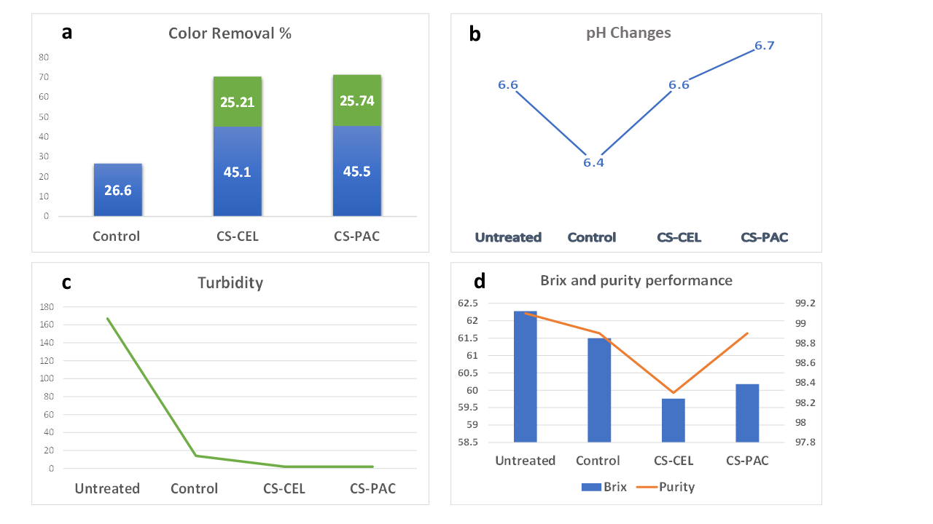
Figure S10. (a) Comparison between control, CS-CEL and CS-PAC in color removal %, (b) pH Changes for untreated, control, CS-CEL and CS-PAC, (c) Turbidity curve for untreated syrup, control, CS-CEL and CS-PAC, (d) Brix and purity performance for untreated syrup, control, CS-CEL and CS-PAC

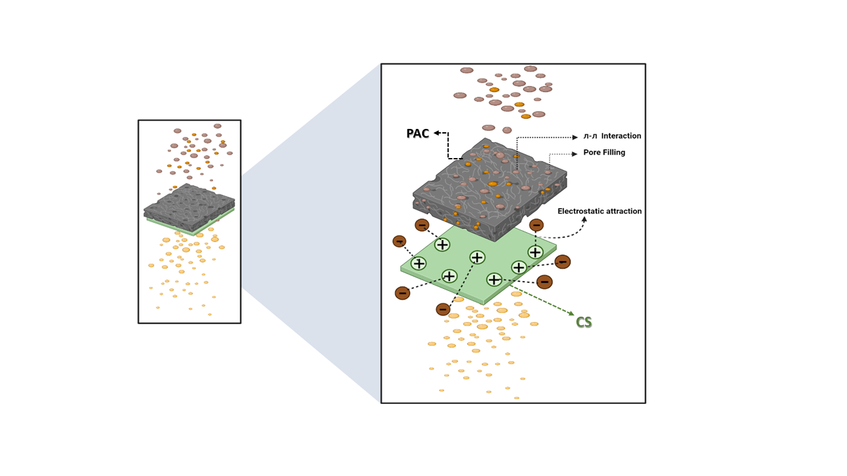
Figure S11. Possible adsorption mechanism for coloring matters and impurities

Table S1 Comparison between traditional clarification, CS-CEL and CS-PAC of sugar syrup
Parameter | Untreated | Control | CS-CEL | CS-PAC
Brix | 62.28 | 61.50 | 59.76 | 60.18
Purity | 99.1 | 98.9 | 98.3 | 98.9
Color% Brix | 3324 | 2439 | 1824 | 1811
pH | 6.6 | 6.4 | 6.6 | 6.7
Color removal % | - | 26.6 | 45.1 | 45.5
Color removal % (with control) | - | - | 25.21 | 25.74
Turbidity (IU) | 167 | 14 | 2 | 2

