Supplementary materials

Table S1. Plasmids used in this study
Name | Relevant characteristics | Reference/Source
pMD18-T | Amp^{R} | Sangon Biotech
pMD0168 | Amp^{R}, Upstream gene and downstream gene of slr0168 were cloned into the SphI/MluI and XbaI/KpnI site of pMD18-T | This study
pBE406 | Sp^{R}, spectinomycin gene was cloned it into the XhoI/XbaI site of pMD0168. | This study
pBE407 | Sp^{R}, PpetE was cloned into the BamHI/SalI site of pBE406 and TrbcL was cloned into the SalI/HindIII site. | This study
pBE407-pdc | Sp^{R}, pdc gene was amplified and double-digested with pBE407 by NdeI/BamHI. Ligated and transferred into E. coli DH5α to obtain the vector pBE407-pdc. | This study
pBE01 | Sp^{R}, yqhD gene was amplified and double-digested with pBE407-pdc by XbaI/KpnI. Ligated and transferred into E. coli DH5α to obtain the vector pBE01. | This study
pBE408 | Sp^{R}, PpsbA2s was cloned into the BamHI/SalI site of pBE406 and TrbcL was cloned into the SalI/HindIII site. | This study
pBE408-pdc | Sp^{R}, pdc gene was amplified and double-digested with pBE408 by BglII/PstI. Ligated and transferred into E. coli DH5α to obtain the vector pBE408-pdc. | This study
pBE02 | Sp^{R}, yqhD gene was amplified and double-digested with pBE408-pdc by XhoI/PstI. Ligated and transferred into E. coli DH5α to obtain the vector pBE02. | This study
pMD0301 | Amp^{R}, Upstream gene and downstream gene of slr0301 were cloned into the SphI/MluI and XbaI/KpnI site of pMD18-T | This study
pMD-slr0301-Ω | Sp^{R}, spectinomycin gene was cloned it into the MluI/XbaI site of pMD0301. | This study
pBE409 | Sp^{R}, PpsbA2s was cloned into the BamHI/SalI site of pMD-slr0301-Ωand TrbcL was cloned into the SalI/HindIII site. | This study
pBE409-pdc | Sp^{R}, pdc gene was amplified and double-digested with pBE409 by BglII/PstI. Ligated and transferred into E. coli DH5α to obtain the vector pBE409-pdc. | This study
pBE03 | Sp^{R}, YqhD gene was amplified and double-digested with pBE409-pdc by XhoI/PstI. Ligated and transferred into E. coli DH5α to obtain the vector pBE03. | This study
pMD1176 | Amp^{R}, Upstream gene and downstream gene of slr1176 were cloned into the SphI/MluI and XbaI/KpnI site of pMD18-T | This study
pMD-slr1176-Ω | Cm^{R}, spectinomycin gene was cloned it into the MluI/XbaI site of pMD0301. | This study
pBE503 | Cm^{R}, PpsbA2s was cloned into the BamHI/SalI site of pMD-slr0301-Ωand TrbcL was cloned into the SalI/HindIII site. Ligated and transferred into E. coli DH5α to obtain the vector pBE503. | This study
pBE09 | Cm^{R}, maeB gene was amplified and double-digested with pBE503 by BglII/PstI. Ligated and transferred into E. coli DH5α to obtain the vector pBE09. | This study

Table S2. Primers used in this study
Primers sequence (5’ - 3’) | size
SP-F: 5‘-CCACGCGTAAGCTTGGATCCGCTCACGCAACTGGTCCAGAA-3’  SP-R: 5’-CGGGAGCTCGAATTCTAGAGTGCTTAGTGCATCTAACGC-3’ | 1.1kb
Ppsb-F：5’-GCTCTAGACCGCCAGGTAAACTCTTCTCA-3’  Ppsb-R:5’-GGGTACCGCGGACGCGTTTCTCCTCTTTAATTTGGTTATAATTCCTTATGTATTTGTCG-3’ | 250bp
PetE-F: 5’-GCTCTAGACAAGGATTCATAGCGGTTGCCCAATC-3’  PetE-R: 5’-GCTGCCTAGGATTCTGGCGAAAGGGGGATGTG-3’ | 200bp
TrbcL-F: 5’-CGCGTCGACCGGTGTTTGGATTGTCGGAGT-3‘  TrbcL-R: 5’-CCGACGCGTAAGCTTCCGGTAATTGGTAAATTGCTGTC-3‘ | 250bp
Pdc-F: 5’-CCGAGATCTCATATGTCCTACACCGTGGGCACCT-3’  Pdc-R: 5’-CGCGGATCCTGCAGCTCGAGTCTAGATTACAACAATTTGTTCACGGGT-3’ | 1.7kb
YqhD-F: 5’-CAAACTCGAGTCTAGATGAACAACTTTAACTTGCACACCCCCAC-3’  YqhD-R: 5’-CGGGGTACCTGCAGTTAGCGGGCGGCTTCGTATATACGGC-3’ | 1.2kb
slr0168Up-F: 5’-GGCATGCCGAGCGGCACCACGGGGCACCACCGC-3’  slr0168Up-R: 5’-GACGCGTCGGCGCACAGCAGCGTGCGACGTGTG-3’ | 600bp
slr0168Dw-F: 5’-CTCTAGAGTGCCACTACCTGGCGTGCCGCTACC-3’  slr0168Dw-F: 5’-GGGGTACCCCGCATGACCAGCTGCCGCCCCAGC-3’ | 600bp
slr0301Up-F: 5’-ACATGCATGCATTAACTCCCGCAGAAAGGGA-3’  slr0301Up-R: 5’-CGACGCGTCGACATCATGGGTGCCCACCTCTTCA-3’ | 600bp
slr0301Dw-F: 5’-CTAGTCTAGACGGCTTCTCCATTGGCTCCAAT-3’  slr0301Dw-R: 5’-CGAGCTCGGTACCGCCCTCAACCTCTCCATTTCC-3’ | 600bp
slr1176Up-F: 5’-ACATGCATGCCAGTTAGCCTAGGCAGTGGTTC-3’  slr1176Up-R: 5’-CGACGCGTCGACCGCCCCCTAAATCCCCCAATA-3’ | 600bp
slr1176Dw-F: 5’-CTAGTCTAGAGTCGACCATTGCCGCAACGACACTG-3’  slr1176Dw-R: 5’-CGAGCTCGGTACCACCAAAGAGTTATTGGCGGCTA-3’ | 600bp
MaeB-F:5’-AGGAGATTAATTCAAAAGAGGAGAAAATGGATGACCAGTTAAAACAAAGTGC-3’  MaeB-R: 5’-ATCCAAACACCGGTCGACTGCAGTTACAGCGGTTGGGTTTGCGCT-3’ | 2.1kb
CamF: 5’-ACCGGCATGCGTTGATCGGCACGTAAGAGGT-3’  CamR: 5’-CAACTGCAGTTACGCCCCGCCCTGCCACTCATC-3’ | 750bp
Quantitative PCR primers
PDC-qF: TGCAAATTGGCTTGAAACATC
PDC-qR: GGCATAGCCTTCGGCACTAAA
YqhD-qF: AGGTGGCTAACGGCGTAGTGG
YqhD-qR: CTTTCAGGGCTTTCGGACCAT
16s-RTF: AGTTCTGACGGTACCTGATGA
16s-RTR: GTCAAGCCTTGGTAAGGTTCT
MaeB-F: CGTTGCCGCACCTTGTCTTG
MaeB-R: AACGCCCTTGCCTTCCATCA

Table S3. RT-qPCR analysis of the exogenous genes. The higher the ^{△CT} value is, the less abundant the corresponding mRNA.
Gene | Strain | 16S | C_{T1} | C_{T2} | C_{T3} | Mean C_{T} | ∆C_{T} | S. D
Pdc | SYN001 | 22.85 | 22.87 | 22.83 | 22.88 | 23.15 | 0.1 | 0.0265
 | SYN002 | 22.85 | 21.85 | 21.87 | 21.89 | 21.87 | -0.98 | 0.0200
 | SYN003 | 22.85 | 21.82 | 21.80 | 21.84 | 21.82 | -1.03 | 0.0200
 | SYN007 | 22.85 | 21.74 | 21.70 | 21.65 | 21.70 | -1.15 | 0.0451
 | SYN009 | 22.85 | 21.53 | 21.57 | 21.53 | 21.54 | -1.31 | 0.0231
YqhD | SYN001 | 22.85 | 24.42 | 24.46 | 24.32 | 24.4 | 0.55 | 0.0721
 | SYN002 | 22.85 | 22.63 | 22.67 | 22.56 | 22.62 | -0.23 | 0.0557
 | SYN003 | 22.85 | 22.43 | 22.47 | 22.52 | 22.47 | -0.38 | 0.0451
 | SYN007 | 22.85 | 22.38 | 22.32 | 22.34 | 22.35 | -0.50 | 0.0306
 | SYN009 | 22.85 | 22.29 | 22.33 | 21.36 | 22.33 | -0.52 | 0.0351
MaeB | SYN009 | 22.85 | 21.06 | 21.07 | 21.12 | 21.08 | -1.77 | 0.0321
∆C_{T} is equal to the difference in threshold cycles for target and reference. The mean fold change in expression of the target gene was calculated using 2^{-∆∆C}_{T}.

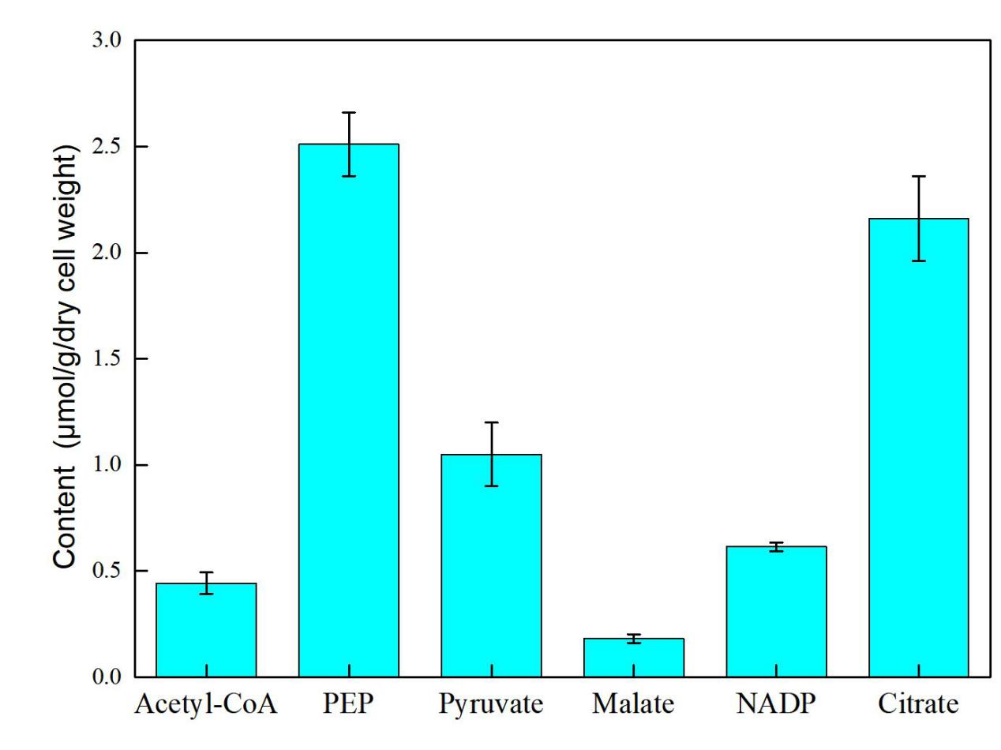
Fig. S1. The content of the selected metabolites in Synechocystis 6803

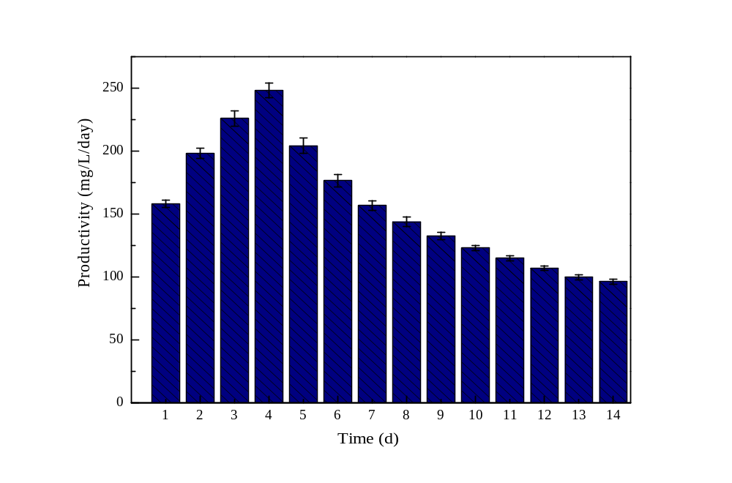
Time (days)
Ethanol productivity (mg/L/day)

Fig. S2. The ethanol productivity of SYN009 under photoautotrophic condition.

