Supplemental Information

Sugimoto E et al. Hyperactive NK cells in Rag2 knockout mice inhibit the development of acute myeloid leukemia

Supplemental Table 2, 3. ……………………………………………………………………... 1

Supplemental Figure 1, 2. ...………………………………………………………………… 2-3

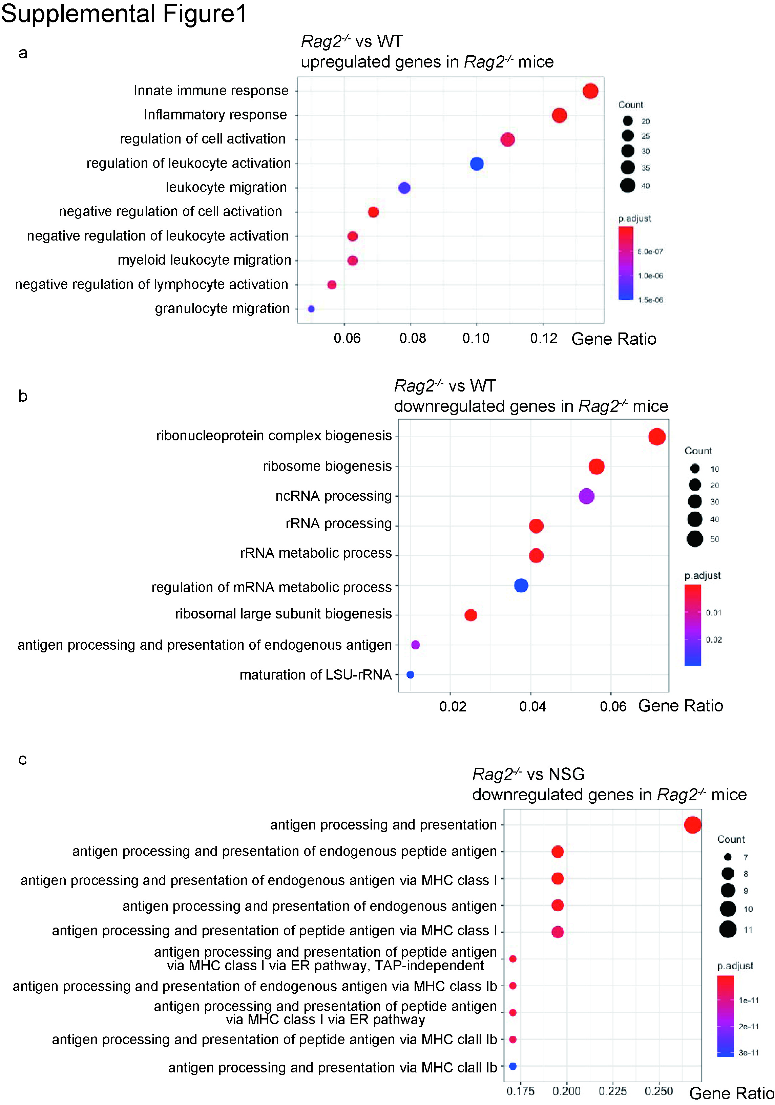
(Relates to Figure 2b)
a. GO analysis of upregulated genes in MLL-AF9 AML cells collected from Rag2^{-/-} mice compared with those from wild-type (WT) C57BL/6 mice. Inflammation- and immune-related genes were upregulated in MLL-AF9 cells collected from Rag2^{-/-} mice. b, c. GO analysis of downregulated genes in MLL-AF9 AML cells collected from Rag2^{-/-} mice compared with those from WT (b) or NSG (c) mice.
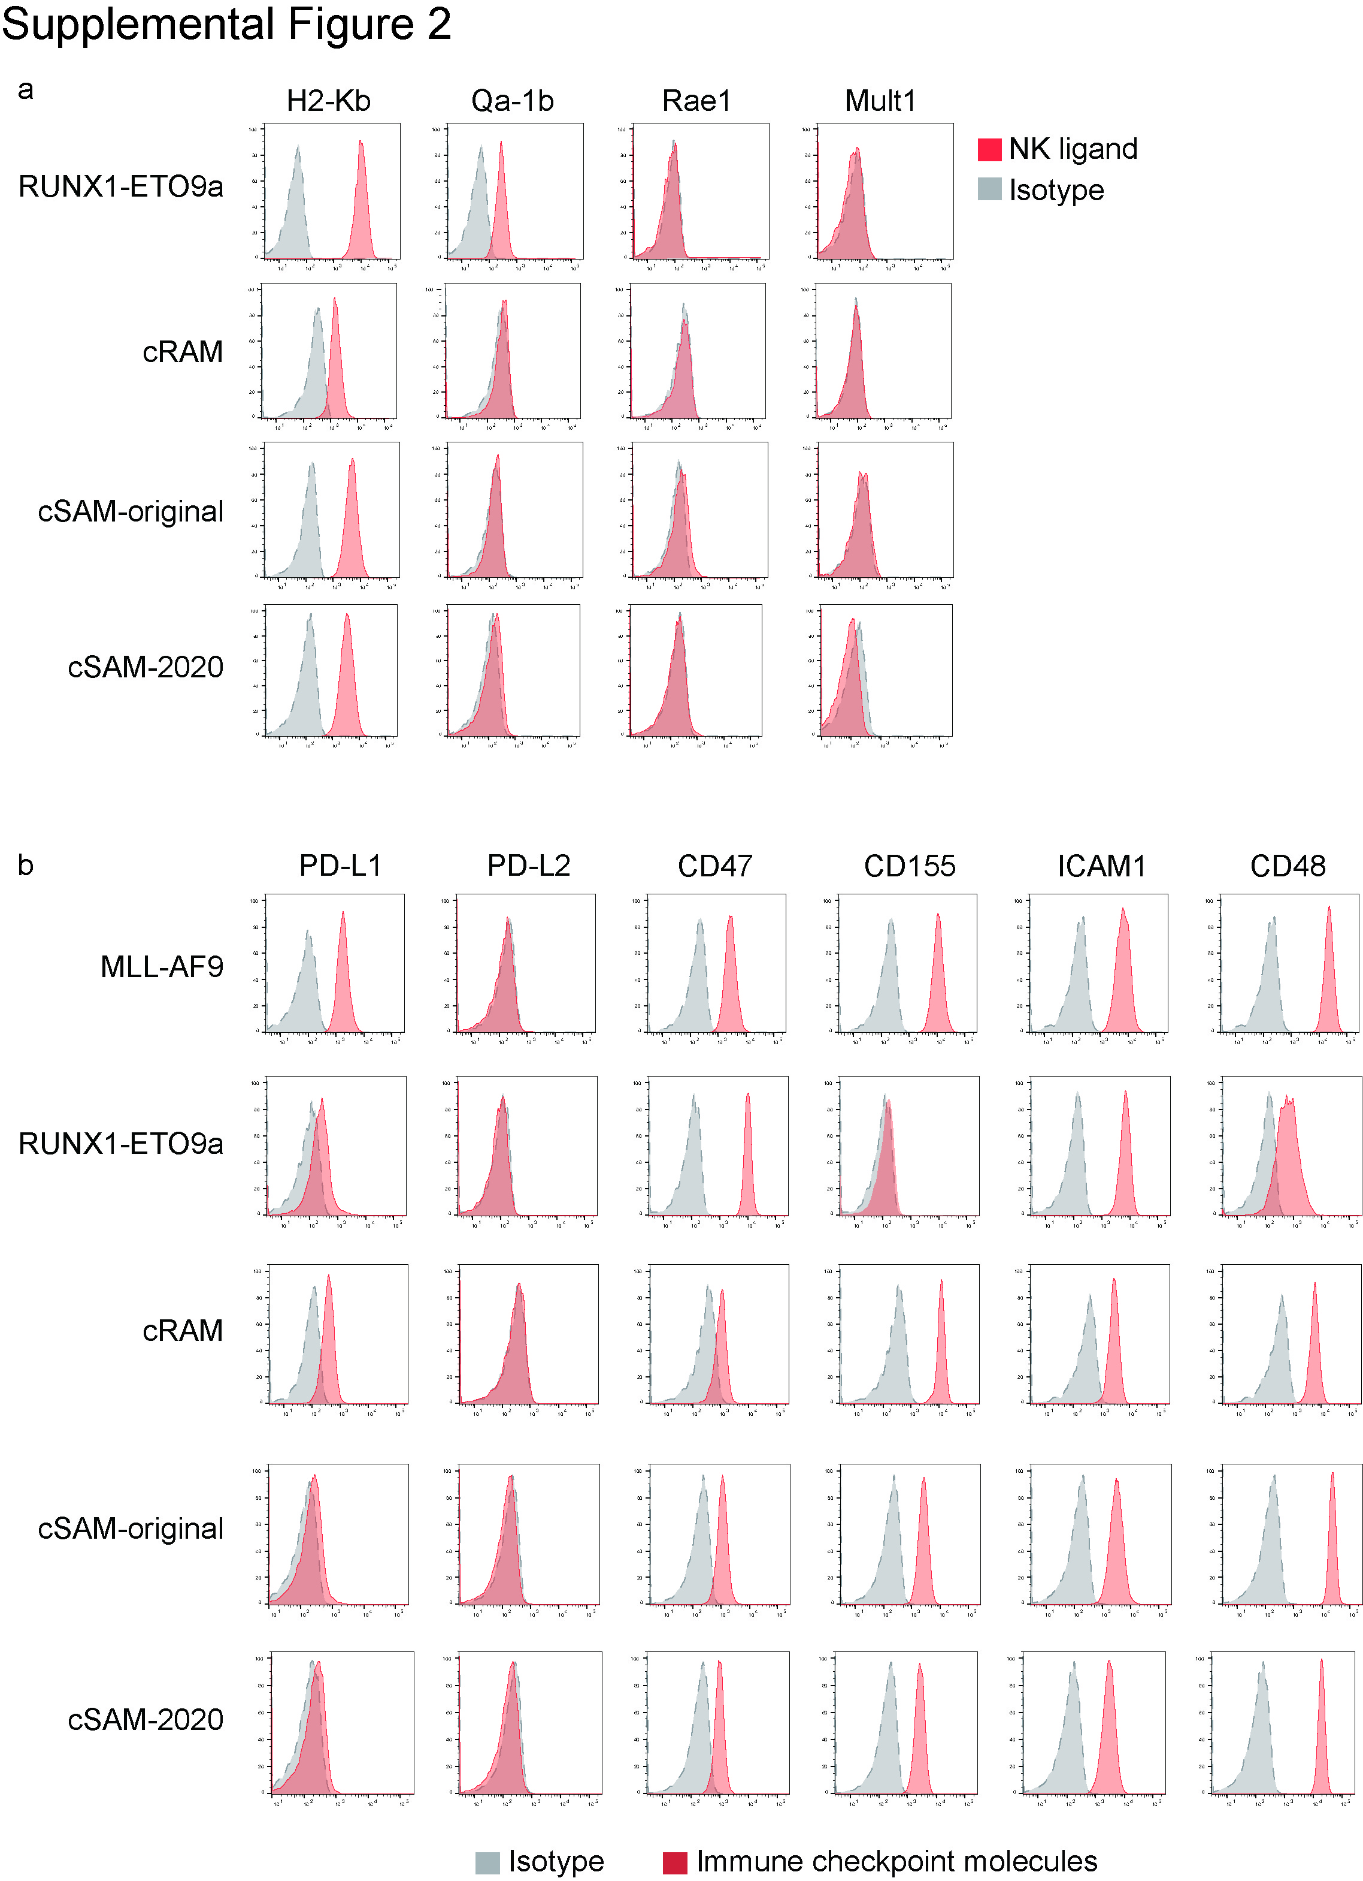
a. Flow cytometric analysis of MHC Class I molecules (H2-Kb and Qa-1b) and NKG2D ligands (Rae1 and Mult1) in myeloid neoplasms. Representative histograms are shown. b. Flow cytometric analysis of immune checkpoint molecules (PD-L1, PD-L2, CD47, CD155, ICAM1, CD48) in myeloid neoplasms. Representative histograms are shown.

