Supplementary Information for
Collision Cross Section of a Small Molecule Determined by its Polarizability rather than its Mass and Shape
Pattipong Wisanpitayakorn^{1,2}, Sitanan Sartyoungkul^{1,2}, Alongkorn Kurilung^{1,2}, Yongyut Sirivatanauksorn^{1,2}, Wonnop Visessanguan³, Nuankanya Sathirapongsasuti^{4,5}, Sakda Khoomrung^{1,2,4,*}

¹Metabolomics and Systems Biology, Department of Biochemistry, Faculty of Medicine Siriraj Hospital, Mahidol University, Bangkok 10700, Thailand
²Siriraj Metabolomics and Phenomics Center, Faculty of Medicine Siriraj Hospital, Mahidol University, Bangkok 10700, Thailand
³National Center for Genetic Engineering and Biotechnology (BIOTEC), Pathumthani 12120, Thailand
⁴Section of Translational Medicine, Faculty of Medicine Ramathibodi Hospital, Mahidol University, Bangkok 10400, Thailand
⁵Research Network of NANOTEC - MU Ramathibodi on Nanomedicine, Bangkok 12120, Thailand
⁶Center of Excellence for Innovation in Chemistry (PERCH-CIC), Faculty of Science, Mahidol University, Bangkok 10400, Thailand

Sakda Khoomrung: https://orcid.org/0000-0001-9461-8597
*Correspondence: sakda.kho@mahidol.edu
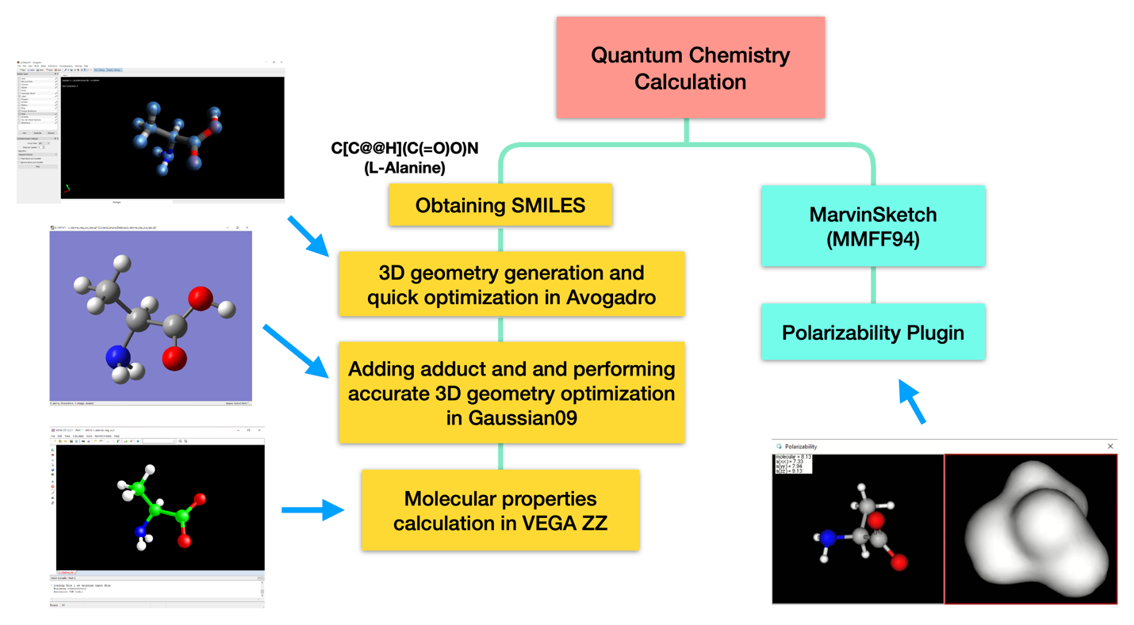

Supplementary Figure 1: Flowchart illustrates molecular property calculation process via Gaussian09 and MarvinSketch software. The process is also assisted by three other software: Avogadro, GaussView5.0, and VEGA ZZ.

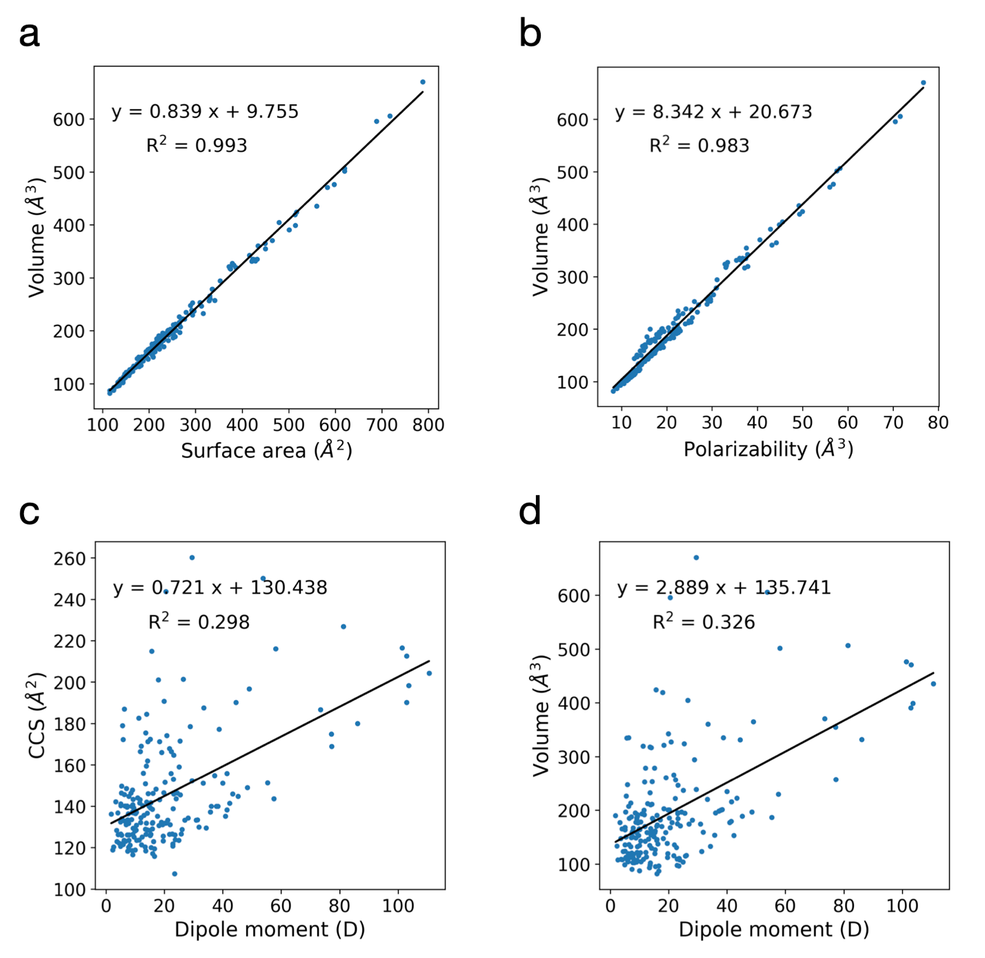
Supplementary Figure 2: Linear correlations used to support our analysis. a-b, Linear correlations between the VdW volumes and a, VdW surface areas and b, polarizabilities. c-d, Linear correlations between the dipole moments and c, CCS values and d, VdW volumes. The plots were constructed based on 197 adduct compounds from our TWIMS experiment.

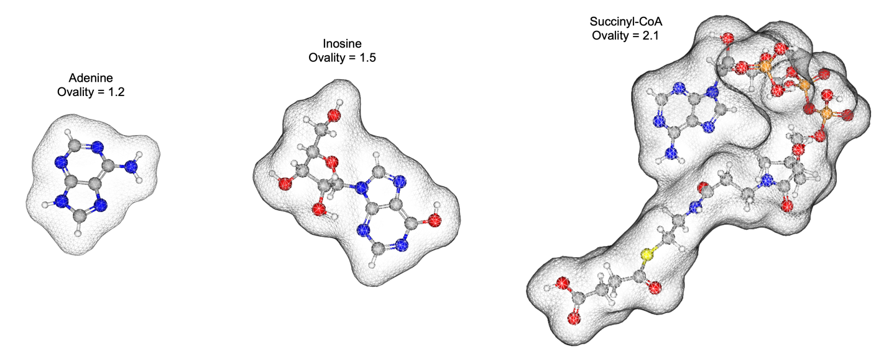
Supplementary Figure 3: Illustration of molecular geometries of various ovalities

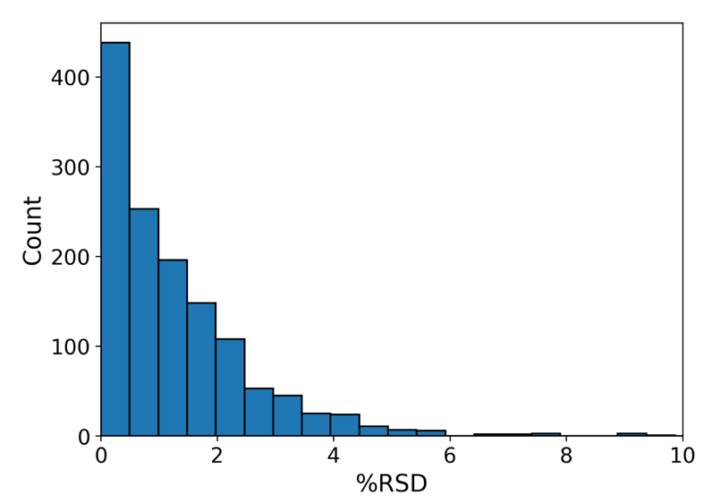
Supplementary Figure 4: Deviation in experimental CCS values across different experiments. Histogram shows the percent relative standard deviations (%RSD) of CCS values of the same adduct compounds reported by two or more experiments on CCSbase’s experimental database.

Supplementary Table 1: Calculated molecular properties and measured CCS values from our TWIMS experiment
Name | HMDB ID | Adduct | MW | m/z | Our TWIMS CCS  (Å²) | VdW volume  (Å³) | VdW surface area (Å²) | Gyration radius  (Å) | Polariza-  bility (Å³) | Dipole moment (D) | Ovality
2-Aminobenzoic acid | HMDB01123 | [M+H]⁺ | 137.14 | 138.06 | 132.38 | 123.60 | 156.90 | 2.16 | 13.72 | 5.04 | 1.31
Adenine | HMDB00034 | [M+H]⁺ | 135.13 | 136.06 | 125.13 | 113.20 | 145.50 | 2.03 | 12.82 | 12.43 | 1.29
Adenosine | HMDB00050 | [M+H]⁺ | 267.24 | 268.11 | 155.89 | 222.00 | 276.00 | 3.32 | 25.61 | 22.28 | 1.56
AMP | HMDB00045 | [M+H]⁺ | 347.22 | 348.07 | 167.89 | 265.80 | 330.30 | 3.63 | 30.27 | 21.74 | 1.65
Arachidonic acid | HMDB01043 | [M+H]⁺ | 304.47 | 305.24 | 178.98 | 334.30 | 426.20 | 4.06 | 37.42 | 5.68 | 1.83
Ascorbic acid | HMDB00044 | [M+H]⁺ | 176.12 | 177.04 | 134.39 | 142.20 | 182.90 | 2.32 | 15.16 | 12.01 | 1.39
a-tocopherol | HMDB01893 | [M+H]⁺ | 430.71 | 431.39 | 216.53 | 476.40 | 597.30 | 7.03 | 56.75 | 101.35 | 2.02
Biotin | HMDB00030 | [M+H]⁺ | 244.31 | 245.10 | 148.62 | 213.70 | 264.60 | 3.20 | 25.35 | 7.08 | 1.53
Carnosine | HMDB00033 | [M+H]⁺ | 226.23 | 227.11 | 151.65 | 200.70 | 251.40 | 2.77 | 22.68 | 20.21 | 1.52
cGMP | HMDB01314 | [M+H]⁺ | 345.21 | 346.06 | 171.22 | 253.10 | 309.10 | 3.51 | 29.64 | 14.31 | 1.60
Creatine | HMDB00064 | [M+H]⁺ | 131.13 | 132.08 | 122.23 | 123.10 | 164.60 | 2.05 | 12.62 | 4.46 | 1.38
Creatinine | HMDB00562 | [M+H]⁺ | 113.12 | 114.07 | 120.17 | 102.30 | 138.70 | 1.92 | 11.19 | 7.75 | 1.31
Dopamine | HMDB00073 | [M+H]⁺ | 153.18 | 154.09 | 139.55 | 149.10 | 195.30 | 2.70 | 16.56 | 7.25 | 1.44
Eicosapentaenoic acid | HMDB01999 | [M+H]⁺ | 302.45 | 303.23 | 177.23 | 334.90 | 432.10 | 6.72 | 36.04 | 38.79 | 1.85
FAD | HMDB01248 | [M+H]⁺ | 785.55 | 786.16 | 250.07 | 605.90 | 717.00 | 5.36 | 71.54 | 53.79 | 2.07
Folic acid | HMDB00121 | [M+H]⁺ | 441.40 | 442.15 | 196.77 | 364.90 | 449.50 | 5.97 | 44.15 | 49.06 | 1.82
Glutathione | HMDB00125 | [M+H]⁺ | 307.32 | 308.09 | 166.01 | 260.70 | 330.90 | 4.45 | 29.55 | 19.06 | 1.68
Guanine | HMDB00132 | [M+H]⁺ | 151.13 | 152.06 | 128.49 | 121.00 | 157.10 | 2.20 | 13.85 | 10.30 | 1.33
Hydroxyproline | HMDB00725 | [M+H]⁺ | 131.13 | 132.07 | 125.85 | 119.10 | 156.80 | 2.12 | 12.67 | 15.22 | 1.34
Inosine | HMDB00195 | [M+H]⁺ | 268.23 | 269.09 | 155.86 | 215.80 | 264.90 | 3.14 | 24.94 | 41.48 | 1.52
L-Arginine | HMDB00517 | [M+H]⁺ | 174.20 | 175.12 | 136.63 | 165.50 | 221.90 | 3.17 | 18.34 | 9.88 | 1.52
L-Cystathionine | HMDB00099 | [M+H]⁺ | 222.26 | 223.08 | 144.00 | 193.30 | 252.10 | 3.51 | 22.52 | 10.89 | 1.56
L-Cystine | HMDB00192 | [M+H]⁺ | 240.30 | 241.03 | 146.43 | 196.60 | 249.80 | 2.88 | 22.95 | 5.27 | 1.53
L-Histidine | HMDB00177 | [M+H]⁺ | 155.15 | 156.08 | 131.08 | 138.40 | 179.60 | 2.59 | 15.12 | 19.45 | 1.39
L-Isoleucine | HMDB00172 | [M+H]⁺ | 131.17 | 132.10 | 131.15 | 135.60 | 179.30 | 2.09 | 14.57 | 21.97 | 1.40
L-Kynurenine | HMDB00684 | [M+H]⁺ | 208.21 | 209.09 | 146.07 | 185.00 | 227.90 | 3.11 | 20.90 | 14.49 | 1.45
L-Leucine | HMDB00687 | [M+H]⁺ | 131.17 | 132.10 | 132.88 | 136.40 | 180.30 | 2.24 | 14.63 | 6.46 | 1.41
L-Lysine | HMDB00182 | [M+H]⁺ | 146.19 | 147.11 | 131.69 | 150.00 | 208.50 | 2.99 | 16.32 | 7.77 | 1.53
L-Phenylalanine | HMDB00159 | [M+H]⁺ | 165.19 | 166.09 | 137.14 | 158.20 | 201.20 | 2.75 | 17.49 | 9.10 | 1.42
L-Proline | HMDB00162 | [M+H]⁺ | 115.13 | 116.07 | 123.70 | 108.60 | 144.70 | 1.95 | 11.79 | 11.37 | 1.31
L-Tryptophan | HMDB00929 | [M+H]⁺ | 204.23 | 205.10 | 147.76 | 183.70 | 227.80 | 3.01 | 21.47 | 9.14 | 1.46
L-Tyrosine | HMDB00158 | [M+H]⁺ | 181.19 | 182.08 | 141.09 | 163.70 | 207.40 | 3.01 | 18.51 | 5.08 | 1.43
L-Valine | HMDB00883 | [M+H]⁺ | 117.15 | 118.09 | 123.49 | 119.40 | 158.00 | 2.00 | 12.58 | 6.18 | 1.35
m-Cresol | HMDB02048 | [M+H]⁺ | 108.14 | 109.07 | 126.19 | 110.50 | 145.20 | 2.00 | 12.33 | 23.59 | 1.30
Methyl nonanoate | HMDB31264 | [M+H]⁺ | 172.26 | 173.16 | 148.93 | 196.40 | 265.90 | 3.84 | 21.93 | 48.49 | 1.63
Niacinamide | HMDB01406 | [M+H]⁺ | 122.12 | 123.06 | 123.01 | 112.10 | 146.80 | 2.13 | 12.15 | 6.76 | 1.31
Nicotinic acid | HMDB01488 | [M+H]⁺ | 123.11 | 124.04 | 122.92 | 108.50 | 138.60 | 2.10 | 11.51 | 3.78 | 1.26
Oxidized glutathione | HMDB03337 | [M+H]⁺ | 612.63 | 613.16 | 226.92 | 506.60 | 620.00 | 5.46 | 58.24 | 81.33 | 2.02
Pantothenic acid | HMDB00210 | [M+H]⁺ | 219.24 | 220.12 | 145.63 | 207.20 | 267.10 | 3.26 | 22.29 | 6.33 | 1.58
Phenylacetylglycine | HMDB00821 | [M+H]⁺ | 193.20 | 194.08 | 142.08 | 177.00 | 225.30 | 3.37 | 19.55 | 3.37 | 1.48
Pyroglutamic acid | HMDB00267 | [M+H]⁺ | 129.11 | 130.05 | 126.02 | 112.70 | 148.80 | 2.14 | 11.89 | 5.36 | 1.32
Riboflavin | HMDB00244 | [M+H]⁺ | 376.36 | 377.14 | 182.66 | 319.30 | 386.40 | 3.79 | 37.91 | 11.30 | 1.71
Spermidine | HMDB01257 | [M+H]⁺ | 145.25 | 146.17 | 135.15 | 169.50 | 231.70 | 3.36 | 18.92 | 17.68 | 1.56
Spermine | HMDB01256 | [M+H]⁺ | 202.34 | 203.22 | 150.86 | 232.50 | 316.40 | 4.74 | 26.74 | 13.58 | 1.73
Succinyl-CoA | HMDB01022 | [M+H]⁺ | 867.61 | 868.13 | 260.23 | 670.30 | 787.60 | 5.57 | 76.67 | 29.47 | 2.13
Taurine | HMDB00251 | [M+H]⁺ | 125.15 | 126.02 | 126.38 | 102.20 | 143.80 | 1.93 | 11.17 | 13.74 | 1.36
Thymine | HMDB00262 | [M+H]⁺ | 126.11 | 127.05 | 120.81 | 109.30 | 145.40 | 2.05 | 11.84 | 22.92 | 1.32
Uracil | HMDB00300 | [M+H]⁺ | 112.09 | 113.04 | 120.27 | 92.80 | 124.30 | 1.86 | 9.77 | 13.42 | 1.25
Uric acid | HMDB00289 | [M+H]⁺ | 168.11 | 169.04 | 133.36 | 123.10 | 160.20 | 2.41 | 14.04 | 31.31 | 1.34
Uridine | HMDB00296 | [M+H]⁺ | 244.20 | 245.08 | 146.30 | 196.70 | 240.80 | 2.89 | 22.18 | 24.44 | 1.47
Vitamin D3 | HMDB00876 | [M+H]⁺ | 384.64 | 385.35 | 214.88 | 424.20 | 516.90 | 4.44 | 49.94 | 15.67 | 1.89
Xanthurenic acid | HMDB00881 | [M+H]⁺ | 205.17 | 206.05 | 136.81 | 165.20 | 200.50 | 2.76 | 19.24 | 4.02 | 1.38
3-Hydroxyphenylacetic acid | HMDB00440 | [M+Na]⁺ | 152.15 | 175.04 | 139.98 | 177.90 | 215.20 | 2.93 | 16.56 | 8.83 | 1.41
3-Hydroxyphenyllacetate | HMDB29232 | [M+Na]⁺ | 182.17 | 205.05 | 141.60 | 199.90 | 239.90 | 3.08 | 16.28 | 11.55 | 1.45
3-Methyladipic acid | HMDB00555 | [M+Na]⁺ | 160.17 | 183.06 | 136.22 | 190.00 | 232.50 | 2.59 | 17.70 | 1.80 | 1.45
3-Methylglutaconic acid | HMDB00522 | [M+Na]⁺ | 144.13 | 167.03 | 132.11 | 169.80 | 209.10 | 2.94 | 15.09 | 11.86 | 1.41
4-Hydroxyphenyl acetate | HMDB60390 | [M+Na]⁺ | 152.15 | 175.04 | 138.25 | 179.40 | 216.80 | 2.92 | 16.60 | 41.40 | 1.41
Adenine | HMDB00034 | [M+Na]⁺ | 135.13 | 158.04 | 134.02 | 150.10 | 177.80 | 2.26 | 14.30 | 5.43 | 1.30
Allantoin | HMDB00462 | [M+Na]⁺ | 158.12 | 181.03 | 136.32 | 160.80 | 193.80 | 2.54 | 14.79 | 7.62 | 1.36
Arachidic acid | HMDB02212 | [M+Na]⁺ | 312.53 | 335.29 | 198.31 | 399.10 | 513.90 | 7.66 | 44.83 | 103.60 | 1.96
Azelaic acid | HMDB00784 | [M+Na]⁺ | 188.22 | 211.09 | 145.99 | 222.50 | 271.50 | 3.01 | 22.40 | 43.43 | 1.53
Behenic acid | HMDB00944 | [M+Na]⁺ | 340.58 | 363.32 | 204.26 | 435.40 | 559.80 | 7.27 | 49.15 | 110.61 | 2.02
Betaine | HMDB00043 | [M+Na]⁺ | 118.15 | 140.07 | 132.22 | 158.40 | 194.60 | 2.33 | 14.07 | 19.02 | 1.37
Capric acid | HMDB00511 | [M+Na]⁺ | 172.26 | 195.14 | 143.53 | 229.60 | 293.50 | 4.27 | 23.53 | 57.54 | 1.62
Carnosine | HMDB00033 | [M+Na]⁺ | 226.23 | 249.10 | 152.28 | 238.80 | 291.30 | 3.18 | 24.20 | 29.50 | 1.56
cGMP | HMDB01314 | [M+Na]⁺ | 345.21 | 368.04 | 178.55 | 294.40 | 352.70 | 3.84 | 31.09 | 28.91 | 1.65
cis-Aconitic | HMDB00072 | [M+Na]⁺ | 174.11 | 197.01 | 139.19 | 176.70 | 212.60 | 2.63 | 15.89 | 9.53 | 1.40
Creatinine | HMDB00562 | [M+Na]⁺ | 113.12 | 136.05 | 129.07 | 144.20 | 182.30 | 2.50 | 12.80 | 15.93 | 1.37
D-Arabinose | HMDB29942 | [M+Na]⁺ | 150.13 | 173.04 | 131.78 | 170.50 | 206.00 | 2.57 | 15.22 | 15.93 | 1.39
D-Arabitol | HMDB00568 | [M+Na]⁺ | 152.15 | 175.06 | 133.34 | 174.50 | 213.80 | 2.59 | 16.30 | 30.94 | 1.42
D-Fructose | HMDB00660 | [M+Na]⁺ | 180.16 | 203.05 | 140.11 | 184.90 | 216.30 | 2.34 | 18.23 | 6.53 | 1.38
D-Galactose | HMDB00143 | [M+Na]⁺ | 180.16 | 203.05 | 138.53 | 190.70 | 221.10 | 2.51 | 17.92 | 15.95 | 1.38
D-Glucose | HMDB00122 | [M+Na]⁺ | 180.16 | 203.05 | 143.24 | 188.90 | 225.20 | 2.55 | 17.95 | 9.35 | 1.41
Diethyl methylsuccinate | HMDB59814 | [M+Na]⁺ | 188.22 | 211.09 | 151.23 | 220.10 | 269.00 | 2.99 | 21.94 | 33.30 | 1.53
D-Lactose | HMDB00186 | [M+Na]⁺ | 342.30 | 365.11 | 171.29 | 321.00 | 371.40 | 3.42 | 33.16 | 18.40 | 1.64
D-Maltose | HMDB00163 | [M+Na]⁺ | 342.30 | 365.10 | 175.45 | 317.90 | 373.30 | 3.51 | 33.00 | 13.59 | 1.66
D-Mannose | HMDB00169 | [M+Na]⁺ | 180.16 | 203.05 | 140.11 | 187.90 | 220.40 | 2.42 | 17.93 | 7.28 | 1.39
D-Ribose | HMDB00283 | [M+Na]⁺ | 150.13 | 173.04 | 131.78 | 167.50 | 205.10 | 2.33 | 14.58 | 20.48 | 1.40
D-Tagalose | HMDB03418 | [M+Na]⁺ | 180.16 | 203.05 | 136.93 | 185.90 | 218.30 | 2.43 | 17.88 | 9.07 | 1.39
D-Xylitol | HMDB02917 | [M+Na]⁺ | 152.15 | 175.06 | 133.34 | 174.10 | 213.10 | 2.55 | 16.18 | 27.01 | 1.41
D-Xylose | HMDB00098 | [M+Na]⁺ | 150.13 | 173.04 | 131.78 | 166.10 | 200.30 | 2.40 | 15.28 | 13.86 | 1.37
Erythritol | HMDB02994 | [M+Na]⁺ | 122.12 | 145.05 | 128.38 | 150.70 | 184.50 | 2.24 | 13.39 | 14.98 | 1.35
Folic acid | HMDB00121 | [M+Na]⁺ | 441.40 | 464.13 | 201.44 | 404.80 | 479.40 | 6.28 | 45.53 | 26.55 | 1.81
Fructose 6-phospahte | HMDB00124 | [M+Na]⁺ | 260.14 | 283.02 | 151.18 | 234.60 | 279.70 | 3.07 | 22.46 | 39.99 | 1.52
Galactitol | HMDB00107 | [M+Na]⁺ | 182.17 | 205.07 | 140.03 | 199.80 | 240.80 | 2.98 | 18.85 | 37.80 | 1.46
Heptanoic acid | HMDB00666 | [M+Na]⁺ | 130.18 | 153.09 | 134.35 | 181.40 | 230.20 | 3.27 | 17.35 | 28.12 | 1.49
Hippuric acid | HMDB00714 | [M+Na]⁺ | 179.17 | 202.05 | 146.37 | 195.70 | 229.20 | 2.97 | 19.31 | 23.10 | 1.41
Inosine | HMDB00195 | [M+Na]⁺ | 268.23 | 291.07 | 166.42 | 252.70 | 293.50 | 3.33 | 26.08 | 11.77 | 1.52
Linoleic acid | HMDB00673 | [M+Na]⁺ | 280.45 | 303.23 | 174.95 | 354.80 | 450.10 | 6.08 | 37.58 | 77.16 | 1.86
L-Kynurenine | HMDB00684 | [M+Na]⁺ | 208.21 | 231.07 | 149.75 | 226.30 | 264.80 | 3.37 | 22.65 | 5.44 | 1.47
L-Methionine | HMDB00696 | [M+Na]⁺ | 149.21 | 172.04 | 135.16 | 177.20 | 216.40 | 2.55 | 17.41 | 40.96 | 1.42
L-Proline | HMDB00162 | [M+Na]⁺ | 115.13 | 138.05 | 130.65 | 147.30 | 177.80 | 2.10 | 13.42 | 18.14 | 1.32
L-Tyrosine | HMDB00158 | [M+Na]⁺ | 181.19 | 204.06 | 143.20 | 202.70 | 245.50 | 3.41 | 20.29 | 18.36 | 1.47
Maltitol | HMDB02928 | [M+Na]⁺ | 344.31 | 367.12 | 174.13 | 327.00 | 378.90 | 3.48 | 33.42 | 20.81 | 1.65
Mannitol | HMDB00765 | [M+Na]⁺ | 182.17 | 205.07 | 140.03 | 195.20 | 229.60 | 2.62 | 18.81 | 36.05 | 1.41
myo-Inositol | HMDB00211 | [M+Na]⁺ | 180.16 | 203.05 | 146.00 | 184.60 | 216.30 | 2.40 | 17.94 | 23.23 | 1.38
Nicotinic acid | HMDB01488 | [M+Na]⁺ | 123.11 | 146.02 | 128.31 | 147.10 | 174.60 | 2.51 | 13.22 | 3.61 | 1.30
Nonadecanoic acid | HMDB00772 | [M+Na]⁺ | 298.50 | 321.28 | 190.13 | 390.80 | 500.50 | 6.78 | 42.88 | 102.88 | 1.94
Oxoadipic acid | HMDB00225 | [M+Na]⁺ | 160.12 | 183.03 | 136.98 | 178.10 | 222.00 | 3.26 | 16.09 | 10.47 | 1.45
Palmitic acid | HMDB00220 | [M+Na]⁺ | 256.42 | 279.23 | 179.96 | 331.70 | 428.40 | 5.66 | 36.27 | 86.16 | 1.85
Pectin | HMDB03402 | [M+Na]⁺ | 194.14 | 217.05 | 145.43 | 194.50 | 234.20 | 2.78 | 18.31 | 25.52 | 1.44
Ribitol | HMDB00508 | [M+Na]⁺ | 152.15 | 175.06 | 133.34 | 177.10 | 219.10 | 2.71 | 16.09 | 21.13 | 1.44
Sorbitol | HMDB00247 | [M+Na]⁺ | 182.17 | 205.07 | 140.03 | 200.90 | 241.40 | 2.75 | 18.93 | 38.34 | 1.46
Stearic acid | HMDB00827 | [M+Na]⁺ | 284.48 | 307.26 | 186.65 | 370.30 | 464.70 | 6.60 | 40.55 | 73.48 | 1.86
Sucrose | HMDB00258 | [M+Na]⁺ | 342.30 | 365.10 | 171.56 | 323.80 | 382.00 | 3.51 | 32.85 | 25.38 | 1.68
Sumiki's acid | HMDB02432 | [M+Na]⁺ | 142.11 | 165.02 | 129.97 | 158.90 | 195.40 | 2.82 | 14.86 | 31.85 | 1.38
trans-Aconitic acid | HMDB00958 | [M+Na]⁺ | 174.11 | 197.00 | 138.79 | 174.80 | 206.00 | 2.75 | 16.03 | 22.96 | 1.36
trans-Ferulic acid | HMDB00954 | [M+Na]⁺ | 194.18 | 217.05 | 161.96 | 211.00 | 252.00 | 3.19 | 21.43 | 14.20 | 1.47
Tropic acid | HMDB62590 | [M+Na]⁺ | 166.17 | 189.05 | 140.74 | 192.40 | 230.00 | 2.76 | 18.54 | 9.24 | 1.43
2-Aminobenzoic acid | HMDB01123 | [M-H]⁻ | 137.14 | 136.04 | 126.13 | 118.40 | 147.90 | 2.15 | 12.85 | 7.95 | 1.27
2-Aminobutyric acid | HMDB00452 | [M-H]⁻ | 103.12 | 102.06 | 121.74 | 97.70 | 134.60 | 1.91 | 10.00 | 22.85 | 1.31
2-Ethylhydracrylic acid | HMDB00396 | [M-H]⁻ | 118.13 | 117.05 | 123.21 | 111.80 | 149.60 | 1.89 | 11.50 | 19.56 | 1.33
2-Hydroxybutyric acid | HMDB00008 | [M-H]⁻ | 104.11 | 103.04 | 119.98 | 95.10 | 130.90 | 1.89 | 9.56 | 15.45 | 1.30
3-Hydroxyanthranilic acid | HMDB01476 | [M-H]⁻ | 153.14 | 152.03 | 126.47 | 126.80 | 158.40 | 2.29 | 13.73 | 15.35 | 1.30
3-Hydroxybutyric acid | HMDB00011 | [M-H]⁻ | 104.10 | 103.04 | 107.41 | 96.30 | 133.60 | 1.96 | 9.55 | 23.55 | 1.32
3-Hydroxyphenyllacetate | HMDB29232 | [M-H]⁻ | 182.17 | 181.05 | 140.26 | 158.30 | 198.40 | 2.70 | 16.85 | 12.58 | 1.40
3-Methyladipic acid | HMDB00555 | [M-H]⁻ | 160.17 | 159.07 | 131.84 | 185.70 | 232.20 | 2.95 | 15.55 | 20.18 | 1.48
4-Hydroxyphenyl acetate | HMDB60390 | [M-H]⁻ | 152.15 | 151.04 | 129.47 | 133.00 | 170.90 | 2.62 | 14.42 | 34.33 | 1.36
Adenine | HMDB00034 | [M-H]⁻ | 135.13 | 134.05 | 126.29 | 108.40 | 138.30 | 1.99 | 12.03 | 4.15 | 1.26
Adenosine | HMDB00050 | [M-H]⁻ | 267.24 | 266.09 | 155.95 | 212.40 | 256.60 | 3.22 | 24.77 | 12.77 | 1.49
Allantoin | HMDB00462 | [M-H]⁻ | 158.12 | 157.04 | 126.16 | 120.40 | 158.90 | 2.36 | 12.52 | 7.32 | 1.35
Arachidonic acid | HMDB01043 | [M-H]⁻ | 304.47 | 303.23 | 186.98 | 335.00 | 422.60 | 3.63 | 36.70 | 6.33 | 1.81
Arginosuccinic acid | HMDB00052 | [M-H]⁻ | 290.27 | 289.11 | 164.65 | 246.70 | 312.40 | 4.26 | 27.02 | 23.21 | 1.64
Ascorbic acid | HMDB00044 | [M-H]⁻ | 176.12 | 175.02 | 122.95 | 137.50 | 174.60 | 2.41 | 14.58 | 16.35 | 1.36
α-Tocopherol | HMDB01893 | [M-H]⁻ | 430.71 | 429.37 | 212.59 | 470.50 | 582.60 | 7.07 | 55.97 | 102.95 | 1.99
ATP | HMDB00538 | [M-H]⁻ | 507.18 | 505.99 | 190.77 | 342.10 | 415.80 | 4.39 | 37.85 | 19.90 | 1.76
Azelaic acid | HMDB00784 | [M-H]⁻ | 188.22 | 187.10 | 139.96 | 181.70 | 241.00 | 3.62 | 20.03 | 14.74 | 1.55
Capric acid | HMDB00511 | [M-H]⁻ | 172.26 | 171.14 | 151.28 | 186.40 | 251.30 | 3.89 | 21.14 | 55.32 | 1.59
Caprylic acid | HMDB00482 | [M-H]⁻ | 144.21 | 143.11 | 141.36 | 152.70 | 207.30 | 2.98 | 16.95 | 42.39 | 1.50
Carnosine | HMDB00033 | [M-H]⁻ | 226.23 | 225.10 | 154.88 | 198.20 | 251.10 | 3.11 | 21.84 | 37.25 | 1.53
cGMP | HMDB01314 | [M-H]⁻ | 345.21 | 344.04 | 172.34 | 247.40 | 288.80 | 3.27 | 28.84 | 5.93 | 1.52
Creatinine | HMDB00562 | [M-H]⁻ | 113.12 | 112.05 | 120.56 | 98.90 | 133.30 | 1.90 | 10.45 | 5.01 | 1.29
D-Arabitol | HMDB00568 | [M-H]⁻ | 152.15 | 151.06 | 126.54 | 135.50 | 180.70 | 2.40 | 14.28 | 5.06 | 1.42
D-Lactose | HMDB00186 | [M-H]⁻ | 342.30 | 341.11 | 172.39 | 278.40 | 335.60 | 3.25 | 30.95 | 15.20 | 1.63
D-Mannose | HMDB00169 | [M-H]⁻ | 180.16 | 179.05 | 132.14 | 145.70 | 177.60 | 2.13 | 15.96 | 16.03 | 1.33
Dopamine | HMDB00073 | [M-H]⁻ | 153.18 | 152.07 | 130.85 | 142.90 | 187.10 | 2.69 | 15.84 | 10.42 | 1.42
D-Ribose | HMDB00283 | [M-H]⁻ | 150.13 | 149.04 | 121.34 | 121.80 | 153.50 | 1.99 | 13.12 | 12.17 | 1.29
D-Xylitol | HMDB02917 | [M-H]⁻ | 152.15 | 151.06 | 128.01 | 134.50 | 175.20 | 2.40 | 13.99 | 9.97 | 1.38
Eicosapentaenoic acid | HMDB01999 | [M-H]⁻ | 302.45 | 301.22 | 190.11 | 331.10 | 420.40 | 6.85 | 35.37 | 44.55 | 1.82
Epinephrine | HMDB00068 | [M-H]⁻ | 183.20 | 182.08 | 140.21 | 168.30 | 214.20 | 2.83 | 18.56 | 5.06 | 1.45
FAD | HMDB01248 | [M-H]⁻ | 785.55 | 784.15 | 243.71 | 595.60 | 688.50 | 5.61 | 70.46 | 20.53 | 2.01
Folic acid | HMDB00121 | [M-H]⁻ | 441.40 | 440.13 | 187.54 | 360.50 | 434.00 | 6.00 | 43.19 | 33.51 | 1.77
Fructose 1,6-bisphosphate | HMDB01058 | [M-H]⁻ | 340.12 | 339.00 | 159.01 | 237.20 | 296.50 | 3.19 | 25.44 | 25.07 | 1.60
Fructose 6-phosphate | HMDB00124 | [M-H]⁻ | 260.14 | 259.02 | 146.38 | 195.20 | 246.00 | 2.88 | 20.56 | 8.61 | 1.51
Gentisic acid | HMDB00152 | [M-H]⁻ | 154.12 | 153.02 | 126.41 | 121.70 | 151.20 | 2.33 | 13.33 | 9.19 | 1.27
Glutathione | HMDB00125 | [M-H]⁻ | 307.32 | 306.08 | 166.50 | 256.90 | 328.80 | 4.27 | 28.86 | 22.38 | 1.68
Guanine | HMDB00132 | [M-H]⁻ | 151.13 | 150.04 | 125.12 | 115.70 | 148.40 | 2.17 | 12.96 | 9.67 | 1.29
Hippuric acid | HMDB00714 | [M-H]⁻ | 179.17 | 178.05 | 139.07 | 158.50 | 199.50 | 2.99 | 17.14 | 15.31 | 1.41
Hydroxyproline | HMDB00725 | [M-H]⁻ | 131.13 | 130.05 | 126.62 | 114.70 | 150.10 | 2.07 | 11.87 | 25.78 | 1.32
Indoleacetic acid | HMDB00197 | [M-H]⁻ | 175.18 | 174.06 | 141.98 | 154.10 | 192.80 | 2.57 | 17.36 | 13.95 | 1.39
Inosine | HMDB00195 | [M-H]⁻ | 268.23 | 267.07 | 159.47 | 210.20 | 252.40 | 3.15 | 24.07 | 13.87 | 1.48
Isobutyric acid | HMDB01873 | [M-H]⁻ | 88.11 | 87.04 | 118.84 | 87.40 | 123.40 | 1.66 | 8.70 | 10.06 | 1.30
Isovaleric acid | HMDB00718 | [M-H]⁻ | 102.13 | 101.06 | 123.48 | 103.90 | 143.50 | 1.98 | 10.59 | 24.92 | 1.34
L-Alanine | HMDB00161 | [M-H]⁻ | 89.09 | 88.04 | 117.06 | 82.00 | 115.60 | 1.64 | 8.13 | 16.04 | 1.27
L-Arginine | HMDB00517 | [M-H]⁻ | 174.20 | 173.10 | 136.62 | 160.00 | 212.90 | 3.19 | 17.58 | 14.11 | 1.49
L-Asparagine | HMDB00168 | [M-H]⁻ | 132.12 | 131.04 | 123.48 | 110.90 | 147.50 | 2.28 | 11.38 | 7.84 | 1.32
L-Aspartic acid | HMDB00191 | [M-H]⁻ | 133.10 | 132.03 | 120.30 | 107.70 | 143.40 | 2.06 | 10.99 | 2.64 | 1.31
L-Cystine | HMDB00192 | [M-H]⁻ | 240.30 | 239.02 | 143.16 | 191.50 | 241.40 | 2.93 | 22.11 | 11.70 | 1.50
L-Histidine | HMDB00177 | [M-H]⁻ | 155.15 | 154.06 | 129.28 | 132.50 | 174.00 | 2.60 | 14.37 | 9.33 | 1.38
L-Leucine | HMDB00687 | [M-H]⁻ | 131.17 | 130.09 | 131.10 | 132.50 | 179.20 | 2.20 | 13.80 | 6.99 | 1.43
L-Lysine | HMDB00182 | [M-H]⁻ | 146.19 | 145.10 | 135.63 | 146.30 | 198.00 | 2.99 | 15.56 | 13.07 | 1.47
L-Phenylalanine | HMDB00159 | [M-H]⁻ | 165.19 | 164.07 | 138.51 | 152.90 | 191.40 | 2.50 | 16.74 | 9.67 | 1.38
L-Proline | HMDB00162 | [M-H]⁻ | 115.13 | 114.06 | 116.46 | 107.00 | 143.70 | 1.97 | 11.01 | 9.23 | 1.32
L-Serine | HMDB00187 | [M-H]⁻ | 105.09 | 104.03 | 118.21 | 90.00 | 124.40 | 1.88 | 9.03 | 7.42 | 1.28
L-Threonine | HMDB00167 | [M-H]⁻ | 119.12 | 118.05 | 121.54 | 106.80 | 142.10 | 1.91 | 10.75 | 5.91 | 1.31
L-Tryptophan | HMDB00929 | [M-H]⁻ | 204.23 | 203.08 | 148.33 | 182.10 | 226.70 | 3.02 | 20.72 | 17.10 | 1.46
L-Tyrosine | HMDB00158 | [M-H]⁻ | 181.19 | 180.07 | 141.65 | 161.50 | 204.30 | 3.03 | 17.74 | 15.37 | 1.42
L-Valine | HMDB00883 | [M-H]⁻ | 117.15 | 116.07 | 126.43 | 115.70 | 156.40 | 1.98 | 11.83 | 21.79 | 1.36
Malic acid | HMDB00156 | [M-H]⁻ | 134.09 | 133.01 | 118.53 | 103.80 | 137.20 | 2.12 | 10.49 | 9.02 | 1.28
m-Cresol | HMDB02048 | [M-H]⁻ | 108.14 | 107.05 | 122.73 | 104.10 | 134.90 | 1.96 | 11.52 | 6.07 | 1.26
Methyl heptanoate | HMDB31478 | [M-H]⁻ | 144.21 | 143.11 | 137.20 | 153.60 | 206.90 | 3.19 | 17.12 | 35.74 | 1.49
Methyl nonanoate | HMDB31264 | [M-H]⁻ | 172.26 | 171.14 | 144.80 | 188.60 | 255.60 | 3.64 | 21.31 | 45.26 | 1.61
Myo-Inositol | HMDB00211 | [M-H]⁻ | 180.16 | 179.05 | 133.54 | 148.40 | 181.80 | 2.16 | 15.78 | 8.83 | 1.34
Myristic acid | HMDB00806 | [M-H]⁻ | 228.37 | 227.20 | 168.91 | 257.30 | 341.20 | 5.51 | 29.63 | 77.28 | 1.74
Nicotinic acid | HMDB01488 | [M-H]⁻ | 123.11 | 122.02 | 121.16 | 102.40 | 132.20 | 2.08 | 10.86 | 8.27 | 1.25
Oxidized glutathione | HMDB03337 | [M-H]⁻ | 612.63 | 611.14 | 216.04 | 501.50 | 619.60 | 5.13 | 57.56 | 58.12 | 2.03
Oxoadipic acid | HMDB00225 | [M-H]⁻ | 160.12 | 159.03 | 128.96 | 134.60 | 183.00 | 3.09 | 13.74 | 13.56 | 1.44
Pantothenic acid | HMDB00210 | [M-H]⁻ | 219.24 | 218.10 | 146.44 | 200.70 | 258.20 | 3.40 | 21.56 | 19.82 | 1.56
Phenylacetylglycine | HMDB00821 | [M-H]⁻ | 193.20 | 192.07 | 146.28 | 172.60 | 221.50 | 3.26 | 18.70 | 16.13 | 1.48
Pyroglutamic acid | HMDB00267 | [M-H]⁻ | 129.11 | 128.03 | 123.74 | 107.80 | 143.20 | 2.12 | 11.15 | 23.78 | 1.31
Quinolinic acid | HMDB00232 | [M-H]⁻ | 167.12 | 166.02 | 128.56 | 129.70 | 164.20 | 2.31 | 13.92 | 14.17 | 1.33
Ribitol | HMDB00508 | [M-H]⁻ | 152.15 | 151.06 | 126.54 | 130.80 | 170.10 | 2.23 | 14.06 | 22.69 | 1.37
Riboflavin | HMDB00244 | [M-H]⁻ | 376.36 | 375.13 | 184.43 | 316.80 | 375.00 | 3.71 | 37.20 | 13.99 | 1.67
Sorbitol | HMDB00247 | [M-H]⁻ | 182.17 | 181.07 | 133.44 | 158.10 | 201.70 | 2.50 | 16.83 | 7.45 | 1.43
Succinic acid | HMDB00254 | [M-H]⁻ | 118.09 | 117.02 | 118.44 | 98.20 | 136.30 | 2.32 | 9.76 | 13.59 | 1.32
Sucrose | HMDB00258 | [M-H]⁻ | 342.30 | 341.11 | 169.11 | 278.40 | 335.80 | 3.27 | 30.87 | 12.11 | 1.63
Sumiki's acid | HMDB02432 | [M-H]⁻ | 142.11 | 141.02 | 128.72 | 115.90 | 154.80 | 2.35 | 12.55 | 26.13 | 1.35
Taurine | HMDB00251 | [M-H]⁻ | 125.15 | 124.01 | 119.39 | 96.60 | 135.80 | 1.91 | 10.49 | 16.64 | 1.33
trans-Aconitic | HMDB00958 | [M-H]⁻ | 174.11 | 173.00 | 118.87 | 133.50 | 166.70 | 2.41 | 13.61 | 2.31 | 1.32
trans-Ferulic acid | HMDB00954 | [M-H]⁻ | 194.18 | 193.05 | 143.64 | 170.80 | 212.70 | 2.84 | 18.84 | 24.02 | 1.43
Uracil | HMDB00300 | [M-H]⁻ | 112.09 | 111.02 | 115.77 | 86.80 | 115.40 | 1.84 | 8.99 | 16.58 | 1.22
Uric acid | HMDB00289 | [M-H]⁻ | 168.11 | 167.02 | 125.59 | 119.50 | 154.s00 | 2.40 | 13.24 | 19.66 | 1.31
Uridine | HMDB00296 | [M-H]⁻ | 244.20 | 243.06 | 153.03 | 193.70 | 239.40 | 3.10 | 21.34 | 23.12 | 1.48
Valeric acid | HMDB00892 | [M-H]⁻ | 102.13 | 101.06 | 123.48 | 104.10 | 144.10 | 2.30 | 10.80 | 10.55 | 1.35
Vanillylmandelic acid | HMDB00291 | [M-H]⁻ | 198.17 | 197.05 | 144.75 | 167.00 | 206.80 | 2.79 | 18.00 | 7.87 | 1.41
Vitamin D3 | HMDB00876 | [M-H]⁻ | 384.64 | 383.33 | 201.16 | 419.30 | 513.40 | 4.44 | 49.27 | 17.91 | 1.89
Xanthurenic acid | HMDB00881 | [M-H]⁻ | 205.17 | 204.03 | 136.52 | 163.90 | 197.50 | 2.76 | 18.58 | 10.14 | 1.36

Supplementary Table 2: Calculated molecular properties and CCS values only for the adducts found in both our experiment and CCSbase’s DTIMS experimental database
Name | Adduct | m/z | CCSbase DTIMS CCS (Å²) | Our TWIMS CCS (Å²) | VdW volume  (Å³) | VdW surface area (Å²) | Gyration radius  (Å) | Polarizability (Å³) | Dipole moment (D) | Ovality
Adenine | [M+H]⁺ | 136.06 | 125.97 | 125.13 | 113.20 | 145.50 | 2.03 | 12.82 | 12.43 | 1.29
Adenosine | [M+H]⁺ | 268.11 | 157.42 | 155.89 | 222.00 | 276.00 | 3.32 | 25.61 | 22.28 | 1.56
Ascorbic acid | [M+H]⁺ | 177.04 | 138.60 | 134.39 | 142.20 | 182.90 | 2.32 | 15.16 | 12.01 | 1.39
Carnosine | [M+H]⁺ | 227.11 | 151.33 | 151.65 | 200.70 | 251.40 | 2.77 | 22.68 | 20.21 | 1.52
cGMP | [M+H]⁺ | 346.06 | 172.80 | 171.22 | 253.10 | 309.10 | 3.51 | 29.64 | 14.31 | 1.60
Creatinine | [M+H]⁺ | 114.07 | 123.60 | 120.17 | 102.30 | 138.70 | 1.92 | 11.19 | 7.75 | 1.31
Dopamine | [M+H]⁺ | 154.09 | 133.77 | 139.55 | 149.10 | 195.30 | 2.70 | 16.56 | 7.25 | 1.44
FAD | [M+H]⁺ | 786.16 | 249.00 | 250.07 | 605.90 | 717.00 | 5.36 | 71.54 | 53.79 | 2.07
Glutathione | [M+H]⁺ | 308.09 | 167.40 | 166.01 | 260.70 | 330.90 | 4.45 | 29.55 | 19.06 | 1.68
Guanine | [M+H]⁺ | 152.06 | 131.72 | 128.49 | 121.00 | 157.10 | 2.20 | 13.85 | 10.30 | 1.33
Inosine | [M+H]⁺ | 269.09 | 159.25 | 155.86 | 215.80 | 264.90 | 3.14 | 24.94 | 41.48 | 1.52
Arginine | [M+H]⁺ | 175.12 | 136.61 | 136.63 | 165.50 | 221.90 | 3.17 | 18.34 | 9.88 | 1.52
Cystine | [M+H]⁺ | 241.03 | 149.63 | 146.43 | 196.60 | 249.80 | 2.88 | 22.95 | 5.27 | 1.53
Histidine | [M+H]⁺ | 156.08 | 132.17 | 131.08 | 138.40 | 179.60 | 2.59 | 15.12 | 19.45 | 1.39
Isoleucine | [M+H]⁺ | 132.10 | 134.59 | 131.15 | 135.60 | 179.30 | 2.09 | 14.57 | 21.97 | 1.40
Kynurenine | [M+H]⁺ | 209.09 | 149.77 | 146.07 | 185.00 | 227.90 | 3.11 | 20.90 | 14.49 | 1.45
Leucine | [M+H]⁺ | 132.10 | 135.17 | 132.88 | 136.40 | 180.30 | 2.24 | 14.63 | 6.46 | 1.41
Phenylalanine | [M+H]⁺ | 166.09 | 140.59 | 137.14 | 158.20 | 201.20 | 2.75 | 17.49 | 9.10 | 1.42
Proline | [M+H]⁺ | 116.07 | 125.58 | 123.70 | 108.60 | 144.70 | 1.95 | 11.79 | 11.37 | 1.31
Tryptophan | [M+H]⁺ | 205.10 | 151.54 | 147.76 | 183.70 | 227.80 | 3.01 | 21.47 | 9.14 | 1.46
Tyrosine | [M+H]⁺ | 182.08 | 145.98 | 141.09 | 163.70 | 207.40 | 3.01 | 18.51 | 5.08 | 1.43
Valine | [M+H]⁺ | 118.09 | 127.59 | 123.49 | 119.40 | 158.00 | 2.00 | 12.58 | 6.18 | 1.35
Nicotinic acid | [M+H]⁺ | 124.04 | 128.35 | 122.92 | 108.50 | 138.60 | 2.10 | 11.51 | 3.78 | 1.26
Pantothenic acid | [M+H]⁺ | 220.12 | 150.17 | 145.63 | 207.20 | 267.10 | 3.26 | 22.29 | 6.33 | 1.58
Pyroglutamic acid | [M+H]⁺ | 130.05 | 130.60 | 126.02 | 112.70 | 148.80 | 2.14 | 11.89 | 5.36 | 1.32
Spermine | [M+H]⁺ | 203.22 | 148.40 | 150.86 | 232.50 | 316.40 | 4.74 | 26.74 | 13.58 | 1.73
Taurine | [M+H]⁺ | 126.02 | 131.20 | 126.38 | 102.20 | 143.80 | 1.93 | 11.17 | 13.74 | 1.36
Thymine | [M+H]⁺ | 127.05 | 123.38 | 120.81 | 109.30 | 145.40 | 2.05 | 11.84 | 22.92 | 1.32
Uracil | [M+H]⁺ | 113.04 | 122.74 | 120.27 | 92.80 | 124.30 | 1.86 | 9.77 | 13.42 | 1.25
Uric acid | [M+H]⁺ | 169.04 | 131.00 | 133.36 | 123.10 | 160.20 | 2.41 | 14.04 | 31.31 | 1.34
Xanthurenic acid | [M+H]⁺ | 206.05 | 140.50 | 136.81 | 165.20 | 200.50 | 2.76 | 19.24 | 4.02 | 1.38
Adenine | [M+Na]⁺ | 158.04 | 137.20 | 134.02 | 150.10 | 177.80 | 2.26 | 14.30 | 5.43 | 1.30
Allantoin | [M+Na]⁺ | 181.03 | 143.91 | 136.32 | 160.80 | 193.80 | 2.54 | 14.79 | 7.62 | 1.36
Arachidic acid | [M+Na]⁺ | 335.29 | 199.97 | 198.31 | 399.10 | 513.90 | 7.66 | 44.83 | 103.60 | 1.96
Betaine | [M+Na]⁺ | 140.07 | 134.38 | 132.22 | 158.40 | 194.60 | 2.33 | 14.07 | 19.02 | 1.37
Carnosine | [M+Na]⁺ | 249.10 | 154.70 | 152.28 | 238.80 | 291.30 | 3.18 | 24.20 | 29.50 | 1.56
Creatinine | [M+Na]⁺ | 136.05 | 133.07 | 129.07 | 144.20 | 182.30 | 2.50 | 12.80 | 15.93 | 1.37
Arabinose | [M+Na]⁺ | 173.04 | 139.91 | 131.78 | 170.50 | 206.00 | 2.57 | 15.22 | 15.93 | 1.39
Arabitol | [M+Na]⁺ | 175.06 | 135.80 | 133.34 | 174.50 | 213.80 | 2.59 | 16.30 | 30.94 | 1.42
Fructose | [M+Na]⁺ | 203.05 | 141.61 | 140.11 | 184.90 | 216.30 | 2.34 | 18.23 | 6.53 | 1.38
Galactose | [M+Na]⁺ | 203.05 | 142.15 | 138.53 | 190.70 | 221.10 | 2.51 | 17.92 | 15.95 | 1.38
Glucose | [M+Na]⁺ | 203.05 | 147.72 | 143.24 | 188.90 | 225.20 | 2.55 | 17.95 | 9.35 | 1.41
Lactose | [M+Na]⁺ | 365.11 | 176.83 | 171.29 | 321.00 | 371.40 | 3.42 | 33.16 | 18.40 | 1.64
Maltose | [M+Na]⁺ | 365.10 | 178.73 | 175.45 | 317.90 | 373.30 | 3.51 | 33.00 | 13.59 | 1.66
Mannose | [M+Na]⁺ | 203.05 | 141.37 | 140.11 | 187.90 | 220.40 | 2.42 | 17.93 | 7.28 | 1.39
Xylitol | [M+Na]⁺ | 175.06 | 137.16 | 133.34 | 174.10 | 213.10 | 2.55 | 16.18 | 27.01 | 1.41
Xylose | [M+Na]⁺ | 173.04 | 134.75 | 131.78 | 166.10 | 200.30 | 2.40 | 15.28 | 13.86 | 1.37
Erythritol | [M+Na]⁺ | 145.05 | 129.90 | 128.38 | 150.70 | 184.50 | 2.24 | 13.39 | 14.98 | 1.35
Hippuric acid | [M+Na]⁺ | 202.05 | 154.06 | 146.37 | 195.70 | 229.20 | 2.97 | 19.31 | 23.10 | 1.41
Inosine | [M+Na]⁺ | 291.07 | 172.29 | 166.42 | 252.70 | 293.50 | 3.33 | 26.08 | 11.77 | 1.52
Kynurenine | [M+Na]⁺ | 231.07 | 152.95 | 149.75 | 226.30 | 264.80 | 3.37 | 22.65 | 5.44 | 1.47
Tyrosine | [M+Na]⁺ | 204.06 | 143.78 | 143.20 | 202.70 | 245.50 | 3.41 | 20.29 | 18.36 | 1.47
Mannitol | [M+Na]⁺ | 205.07 | 140.90 | 140.03 | 195.20 | 229.60 | 2.62 | 18.81 | 36.05 | 1.41
Myo-Inositol | [M+Na]⁺ | 203.05 | 148.20 | 146.00 | 184.60 | 216.30 | 2.40 | 17.94 | 23.23 | 1.38
Palmitic acid | [M+Na]⁺ | 279.23 | 190.11 | 179.96 | 331.70 | 428.40 | 5.66 | 36.27 | 86.16 | 1.85
Ribitol | [M+Na]⁺ | 175.06 | 136.25 | 133.34 | 177.10 | 219.10 | 2.71 | 16.09 | 21.13 | 1.44
Stearic acid | [M+Na]⁺ | 307.26 | 191.83 | 186.65 | 370.30 | 464.70 | 6.60 | 40.55 | 73.48 | 1.86
Sucrose | [M+Na]⁺ | 365.10 | 173.94 | 171.56 | 323.80 | 382.00 | 3.51 | 32.85 | 25.38 | 1.68
2-Hydroxybutyric acid | [M-H]- | 103.04 | 124.67 | 119.98 | 95.10 | 130.90 | 1.89 | 9.56 | 15.45 | 1.30
3-Methyladipic acid | [M-H]- | 159.07 | 129.01 | 131.84 | 185.70 | 232.20 | 2.95 | 15.55 | 20.18 | 1.48
Adenine | [M-H]- | 134.05 | 120.57 | 126.29 | 108.40 | 138.30 | 1.99 | 12.03 | 4.15 | 1.26
Adenosine | [M-H]- | 266.09 | 159.87 | 155.95 | 212.40 | 256.60 | 3.22 | 24.77 | 12.77 | 1.49
Allantoin | [M-H]- | 157.04 | 126.95 | 126.16 | 120.40 | 158.90 | 2.36 | 12.52 | 7.32 | 1.35
Arachidonic acid | [M-H]- | 303.23 | 181.60 | 186.98 | 335.00 | 422.60 | 3.63 | 36.70 | 6.33 | 1.81
Ascorbic acid | [M-H]- | 175.02 | 130.67 | 122.95 | 137.50 | 174.60 | 2.41 | 14.58 | 16.35 | 1.36
Azelaic acid | [M-H]- | 187.10 | 137.38 | 139.96 | 181.70 | 241.00 | 3.62 | 20.03 | 14.74 | 1.55
Capric acid | [M-H]- | 171.14 | 146.87 | 151.28 | 186.40 | 251.30 | 3.89 | 21.14 | 55.32 | 1.59
Caprylic acid | [M-H]- | 143.11 | 139.46 | 141.36 | 152.70 | 207.30 | 2.98 | 16.95 | 42.39 | 1.50
Carnosine | [M-H]- | 225.10 | 152.71 | 154.88 | 198.20 | 251.10 | 3.11 | 21.84 | 37.25 | 1.53
Creatinine | [M-H]- | 112.05 | 119.13 | 120.56 | 98.90 | 133.30 | 1.90 | 10.45 | 5.01 | 1.29
Arabitol | [M-H]- | 151.06 | 124.90 | 126.54 | 135.50 | 180.70 | 2.40 | 14.28 | 5.06 | 1.42
Lactose | [M-H]- | 341.11 | 173.57 | 172.39 | 278.40 | 335.60 | 3.25 | 30.95 | 15.20 | 1.63
Dopamine | [M-H]- | 152.07 | 132.22 | 130.85 | 142.90 | 187.10 | 2.69 | 15.84 | 10.42 | 1.42
Xylitol | [M-H]- | 151.06 | 125.04 | 128.01 | 134.50 | 175.20 | 2.40 | 13.99 | 9.97 | 1.38
Eicosapentaenoic acid | [M-H]- | 301.22 | 178.53 | 190.11 | 331.10 | 420.40 | 6.85 | 35.37 | 44.55 | 1.82
FAD | [M-H]- | 784.15 | 238.70 | 243.71 | 595.60 | 688.50 | 5.61 | 70.46 | 20.53 | 2.01
Fructose 6-phosphate | [M-H]- | 259.02 | 144.10 | 146.38 | 195.20 | 246.00 | 2.88 | 20.56 | 8.61 | 1.51
Gentisic acid | [M-H]- | 153.02 | 122.67 | 126.41 | 121.70 | 151.20 | 2.33 | 13.33 | 9.19 | 1.27
Glutathione | [M-H]- | 306.08 | 164.24 | 166.50 | 256.90 | 328.80 | 4.27 | 28.86 | 22.38 | 1.68
Hippuric acid | [M-H]- | 178.05 | 143.97 | 139.07 | 158.50 | 199.50 | 2.99 | 17.14 | 15.31 | 1.41
Inosine | [M-H]- | 267.07 | 159.95 | 159.47 | 210.20 | 252.40 | 3.15 | 24.07 | 13.87 | 1.48
Asparagine | [M-H]- | 131.04 | 124.51 | 123.48 | 110.90 | 147.50 | 2.28 | 11.38 | 7.84 | 1.32
Aspartic acid | [M-H]- | 132.03 | 120.27 | 120.30 | 107.70 | 143.40 | 2.06 | 10.99 | 2.64 | 1.31
Cystine | [M-H]- | 239.02 | 143.70 | 143.16 | 191.50 | 241.40 | 2.93 | 22.11 | 11.70 | 1.50
Histidine | [M-H]- | 154.06 | 129.52 | 129.28 | 132.50 | 174.00 | 2.60 | 14.37 | 9.33 | 1.38
Leucine | [M-H]- | 130.09 | 134.40 | 131.10 | 132.50 | 179.20 | 2.20 | 13.80 | 6.99 | 1.43
Lysine | [M-H]- | 145.10 | 136.32 | 135.63 | 146.30 | 198.00 | 2.99 | 15.56 | 13.07 | 1.47
Phenylalanine | [M-H]- | 164.07 | 142.40 | 138.51 | 152.90 | 191.40 | 2.50 | 16.74 | 9.67 | 1.38
Proline | [M-H]- | 114.06 | 126.83 | 116.46 | 107.00 | 143.70 | 1.97 | 11.01 | 9.23 | 1.32
Serine | [M-H]- | 104.03 | 136.66 | 118.21 | 90.00 | 124.40 | 1.88 | 9.03 | 7.42 | 1.28
Threonine | [M-H]- | 118.05 | 130.78 | 121.54 | 106.80 | 142.10 | 1.91 | 10.75 | 5.91 | 1.31
Tryptophan | [M-H]- | 203.08 | 148.72 | 148.33 | 182.10 | 226.70 | 3.02 | 20.72 | 17.10 | 1.46
Tyrosine | [M-H]- | 180.07 | 145.88 | 141.65 | 161.50 | 204.30 | 3.03 | 17.74 | 15.37 | 1.42
Valine | [M-H]- | 116.07 | 128.59 | 126.43 | 115.70 | 156.40 | 1.98 | 11.83 | 21.79 | 1.36
Myristic acid | [M-H]- | 227.20 | 159.21 | 168.91 | 257.30 | 341.20 | 5.51 | 29.63 | 77.28 | 1.74
Nicotinic acid | [M-H]- | 122.02 | 124.50 | 121.16 | 102.40 | 132.20 | 2.08 | 10.86 | 8.27 | 1.25
Pantothenic acid | [M-H]- | 218.10 | 149.87 | 146.44 | 200.70 | 258.20 | 3.40 | 21.56 | 19.82 | 1.56
Phenylacetylglycine | [M-H]- | 192.07 | 147.23 | 146.28 | 172.60 | 221.50 | 3.26 | 18.70 | 16.13 | 1.48
Quinolinic acid | [M-H]- | 166.02 | 130.03 | 128.56 | 129.70 | 164.20 | 2.31 | 13.92 | 14.17 | 1.33
Ribitol | [M-H]- | 151.06 | 125.80 | 126.54 | 130.80 | 170.10 | 2.23 | 14.06 | 22.69 | 1.37
Sorbitol | [M-H]- | 181.07 | 130.52 | 133.44 | 158.10 | 201.70 | 2.50 | 16.83 | 7.45 | 1.43
Succinic acid | [M-H]- | 117.02 | 119.84 | 118.44 | 98.20 | 136.30 | 2.32 | 9.76 | 13.59 | 1.32
Sucrose | [M-H]- | 341.11 | 168.34 | 169.11 | 278.40 | 335.80 | 3.27 | 30.87 | 12.11 | 1.63
Taurine | [M-H]- | 124.01 | 118.40 | 119.39 | 96.60 | 135.80 | 1.91 | 10.49 | 16.64 | 1.33
Uracil | [M-H]- | 111.02 | 112.90 | 115.77 | 86.80 | 115.40 | 1.84 | 8.99 | 16.58 | 1.22
Uric acid | [M-H]- | 167.02 | 127.01 | 125.59 | 119.50 | 154.00 | 2.40 | 13.24 | 19.66 | 1.31
Uridine | [M-H]- | 243.06 | 152.42 | 153.03 | 193.70 | 239.40 | 3.10 | 21.34 | 23.12 | 1.48
Xanthurenic acid | [M-H]- | 204.03 | 132.51 | 136.52 | 163.90 | 197.50 | 2.76 | 18.58 | 10.14 | 1.36

Supplementary Table 3: Calculated molecular properties and CCS values only for the adducts found in both our experiment and CCSbase’s TWIMS experimental database
Name | Adduct | m/z | CCSbase TWIMS CCS (Å²) | Our TWIMS CCS (Å²) | VdW volume  (Å³) | VdW surface area (Å²) | Gyration radius  (Å) | Polarizability (Å³) | Dipole moment (D) | Ovality
Adenine | [M+H]⁺ | 136.06 | 120.70 | 125.13 | 113.20 | 145.50 | 2.03 | 12.82 | 12.43 | 1.29
Adenosine | [M+H]⁺ | 268.11 | 153.95 | 155.89 | 222.00 | 276.00 | 3.32 | 25.61 | 22.28 | 1.56
AMP | [M+H]⁺ | 348.07 | 167.00 | 167.89 | 265.80 | 330.30 | 3.63 | 30.27 | 21.74 | 1.65
Creatinine | [M+H]⁺ | 114.07 | 120.20 | 120.17 | 102.30 | 138.70 | 1.92 | 11.19 | 7.75 | 1.31
Folic acid | [M+H]⁺ | 442.15 | 196.80 | 196.77 | 364.90 | 449.50 | 5.97 | 44.15 | 49.06 | 1.82
Glutathione | [M+H]⁺ | 308.09 | 165.35 | 166.01 | 260.70 | 330.90 | 4.45 | 29.55 | 19.06 | 1.68
Guanine | [M+H]⁺ | 152.06 | 124.00 | 128.49 | 121.00 | 157.10 | 2.20 | 13.85 | 10.30 | 1.33
Inosine | [M+H]⁺ | 269.09 | 153.00 | 155.86 | 215.80 | 264.90 | 3.14 | 24.94 | 41.48 | 1.52
Arginine | [M+H]⁺ | 175.12 | 133.00 | 136.63 | 165.50 | 221.90 | 3.17 | 18.34 | 9.88 | 1.52
Cystine | [M+H]⁺ | 241.03 | 146.55 | 146.43 | 196.60 | 249.80 | 2.88 | 22.95 | 5.27 | 1.53
Histidine | [M+H]⁺ | 156.08 | 127.00 | 131.08 | 138.40 | 179.60 | 2.59 | 15.12 | 19.45 | 1.39
Isoleucine | [M+H]⁺ | 132.10 | 129.00 | 131.15 | 135.60 | 179.30 | 2.09 | 14.57 | 21.97 | 1.40
Kynurenine | [M+H]⁺ | 209.09 | 146.00 | 146.07 | 185.00 | 227.90 | 3.11 | 20.90 | 14.49 | 1.45
Leucine | [M+H]⁺ | 132.10 | 128.00 | 132.88 | 136.40 | 180.30 | 2.24 | 14.63 | 6.46 | 1.41
Phenylalanine | [M+H]⁺ | 166.09 | 135.00 | 137.14 | 158.20 | 201.20 | 2.75 | 17.49 | 9.10 | 1.42
Proline | [M+H]⁺ | 116.07 | 118.00 | 123.70 | 108.60 | 144.70 | 1.95 | 11.79 | 11.37 | 1.31
Tryptophan | [M+H]⁺ | 205.10 | 145.00 | 147.76 | 183.70 | 227.80 | 3.01 | 21.47 | 9.14 | 1.46
Tyrosine | [M+H]⁺ | 182.08 | 139.00 | 141.09 | 163.70 | 207.40 | 3.01 | 18.51 | 5.08 | 1.43
Niacinamide | [M+H]⁺ | 123.06 | 119.85 | 123.01 | 112.10 | 146.80 | 2.13 | 12.15 | 6.76 | 1.31
Nicotinic acid | [M+H]⁺ | 124.04 | 115.00 | 122.92 | 108.50 | 138.60 | 2.10 | 11.51 | 3.78 | 1.26
Pantothenic Acid | [M+H]⁺ | 220.12 | 145.00 | 145.63 | 207.20 | 267.10 | 3.26 | 22.29 | 6.33 | 1.58
Taurine | [M+H]⁺ | 126.02 | 124.00 | 126.38 | 102.20 | 143.80 | 1.93 | 11.17 | 13.74 | 1.36
Thymine | [M+H]⁺ | 127.05 | 115.00 | 120.81 | 109.30 | 145.40 | 2.05 | 11.84 | 22.92 | 1.32
Uracil | [M+H]⁺ | 113.04 | 115.00 | 120.27 | 92.80 | 124.30 | 1.86 | 9.77 | 13.42 | 1.25
Uridine | [M+H]⁺ | 245.08 | 152.00 | 146.30 | 196.70 | 240.80 | 2.89 | 22.18 | 24.44 | 1.47
Xanthurenic acid | [M+H]⁺ | 206.05 | 137.70 | 136.81 | 165.20 | 200.50 | 2.76 | 19.24 | 4.02 | 1.38
Fructose | [M+Na]⁺ | 203.05 | 135.00 | 140.11 | 184.90 | 216.30 | 2.34 | 18.23 | 6.53 | 1.38
Galactose | [M+Na]⁺ | 203.05 | 136.00 | 138.53 | 190.70 | 221.10 | 2.51 | 17.92 | 15.95 | 1.38
Glucose | [M+Na]⁺ | 203.05 | 138.00 | 143.24 | 188.90 | 225.20 | 2.55 | 17.95 | 9.35 | 1.41
Lactose | [M+Na]⁺ | 365.11 | 173.00 | 171.29 | 321.00 | 371.40 | 3.42 | 33.16 | 18.40 | 1.64
Mannose | [M+Na]⁺ | 203.05 | 138.00 | 140.11 | 187.90 | 220.40 | 2.42 | 17.93 | 7.28 | 1.39
Mannitol | [M+Na]⁺ | 205.07 | 138.30 | 140.03 | 195.20 | 229.60 | 2.62 | 18.81 | 36.05 | 1.41
Sucrose | [M+Na]⁺ | 365.10 | 170.00 | 171.56 | 323.80 | 382.00 | 3.51 | 32.85 | 25.38 | 1.68

