Biodiversity and Conservation

Global change explains the neotropical rattlesnake Crotalus durissus (Serpentes: Viperidae) range expansion in South America

Gabriela Ferreira Campos Guerra^{a,b}, Mariana Moncassim Vale^{c}, Rodrigo Tardin^{c}, Daniel Silva Fernandes^{e}

ª Graduate Program in Zoology, National Museum, Rio de Janeiro, Federal University of Rio de Janeiro (UFRJ), Rio de Janeiro, Brazil
^{b} Current address: Graduate Program in Biodiversity and Health, Oswaldo Cruz Institute, Oswaldo Cruz Foundation (FIOCRUZ), Rio de Janeiro, Brazil
^{c} Ecology Department, Federal University of Rio de Janeiro (UFRJ), Rio de Janeiro, Brazil
^{e} Zoology Department, Federal University of Rio de Janeiro (UFRJ), Rio de Janeiro, Brazil

E-mails:
Gabriela Ferreira Campos Guerra (corresponding author)
guerra.gfc@gmail.com
+5521994386928

SUPPLEMENTARY INFORMATION

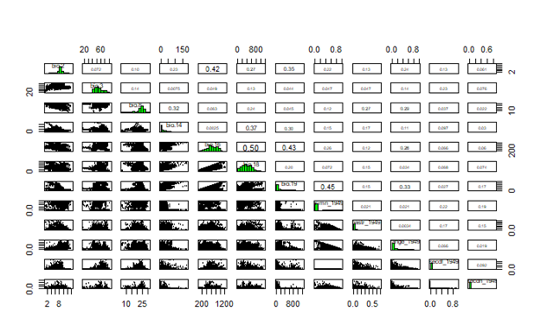
Fig. S1 Scatter plot correlation between explanatory variables. Numbers indicate correlation values and scaterplots displays the strength, direction, and form of the relationship between two quantitative variables. Variables correlated above 0.7 were removed.

Table S1 Variance Inflation Factors of explanatory variables after removing collinear and correlated variables
Variables | VIF
Precipitation of wettest quarter | 2.39
Precipitation of coldest quarter | 2.15
Precipitation of warmest quarter | 1.89
Precipitation of driest month | 1.68
Mean Diurnal Range | 1.57
Non-Forested Primary Land | 1.53
Rangeland | 1.56
Mean Temperature of wettest quarter | 1.52
Pasture | 1.38
Secondary forested land | 1.21
Non-Forested secondary land | 1.16

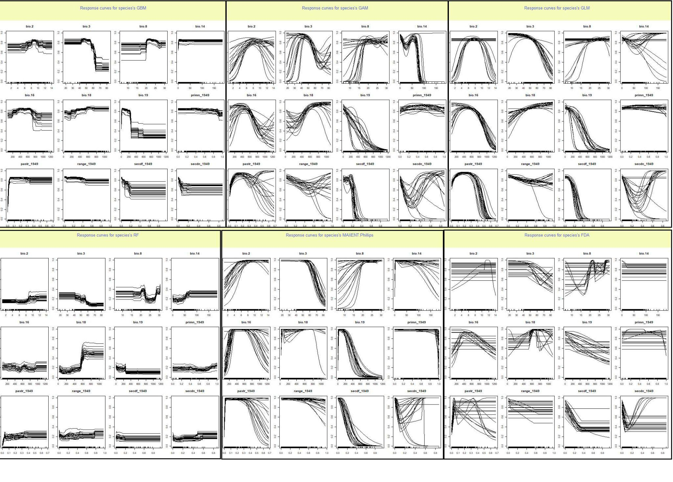
Fig. S2 Response curves of explanatory variables for each algorithm used in the “climate plus land-use land-cover” ecological niche model for Crotalus durissus. Bioclimatic and land-use land-cover variables used in the models: mean diurnal range (bio.2), isothermality (bio.3), mean temperature of wettest quarter (bio.8), precipitation of driest month (bio.14), precipitation of wettest quarter (bio.16), precipitation of warmest quarter (bio.18), precipitation of coldest quarter (bio.19), non-forested primary land (primn_1949), rangeland (range_1949), managed pasture (pastr_1949), potentially forested secondary land (secdf_1949), potentially non-forested secondary land (secdn_1949)

Table S2 Summary of mean algorithm performance, variable importance and the number of models considered in the final weighted mean ensemble model for Crotalus durissus.
Algorithms | Model | pAUC | Models in ENM | Variable Importance
 |  |  |  | Bio  2 | Bio  3 | Bio  8 | Bio 14 | Bio 16 | Bio 18 | Bio 19 | Primn | Pasture | Rangeland | Secdf | Secdn
Ensemble | Climate-only | 0.92 | 175 | 0.06 | 0.23 | 0.08 | 0.08 | 0.14 | 0.14 | 0.31 | - | - | - | - | -
Ensemble | Land-use only | 0.82 | 103 | - | - | - | - | - | - | - | 0.06 | 0.38 | 0.07 | 0.07 | 0.06
Ensemble | Climate + land-use | 0.95 | 116 | 0.04 | 0.24 | 0.11 | 0.06 | 0.22 | 0.2 | 0.39 | 0.13 | 0.75 | 0.11 | 0.16 | 0.09
GLM | Climate only | 0.77 | 25 | 0.04 | 0.27 | 0.01 | 0.04 | 0.27 | 0.1 | 0.58 | - | - | - | - | -
GLM | Land-use only | 0.76 | 15 | - | - | - | - | - | - | - | 0.009 | 0.16 | 0.05 | 0.08 | 0.04
GLM | Climate + land-use | 0.77 | 20 | 0.03 | 0.24 | 0.009 | 0.024 | 0.19 | 0.09 | 0.47 | 0.01 | 0.63 | 0.14 | 0.13 | 0.02
GAM | Climate-only | 0.77 | 30 | 0.03 | 0.31 | 0.03 | 0.14 | 0.3 | 0.23 | 0.5 | - | - | - | - | -
GAM | Land-use only | 0.68 | 10 | - | - | - | - | - | - | - | 0.28 | 0.31 | 0.19 | 0.13 | 0.13
GAM | Climate + land-use | 0.72 | 20 | 0.26 | 0.56 | 0.27 | 0.4 | 0.43 | 0.46 | 0.64 | 0.38 | 0.61 | 0.13 | 0.19 | 0.16
RF | Climate-only | 0.86 | 30 | 0.05 | 0.12 | 0.16 | 0.11 | 0.13 | 0.3 | 0.21 | - | - | - | - | -
RF | Land-use only | 0.78 | 20 | - | - | - | - | - | - | - | 0.03 | 0.29 | 0.03 | 0.008 | 0.016
RF | Climate + land-use | 0.84 | 20 | 0.02 | 0.07 | 0.05 | 0.04 | 0.03 | 0.11 | 0.07 | 0.14 | 0.65 | 0.25 | 0.19 | 0.13
GBM | Climate-only | 0.83 | 30 | 0.06 | 0.02 | 0.03 | 0.008 | 0.04 | 0.01 | 0.17 | - | - | - | - | -
GBM | Land-use only | 0.82 | 23 | - | - | - | - | - | - | - | 0.02 | 0.41 | 0.02 | 0.11 | 0.08
GBM | Climate + land-use | 0.82 | 20 | 0.02 | 0.25 | 0.09 | 0.01 | 0.17 | 0.05 | 0.4 | 0.09 | 0.77 | 0.01 | 0.16 | 0.13
MaxEnt | Climate-only | 74 | 30 | 0.05 | 0.33 | 0.07 | 0.02 | 0.26 | 0.07 | 0.4 | - | - | - | - | -
MaxEnt | Land-use only | 0.76 | 15 | - | - | - | - | - | - | - | 0.02 | 0.05 | 0.1 | 0.11 | 0.08
MaxEnt | Climate + land-use | 0.8 | 18 | 0.05 | 0.23 | 0.04 | 0.03 | 0.13 | 0.16 | 0.5 | 0.04 | 0.09 | 0.04 | 0.15 | 0.07
FDA | Climate-only | 0.73 | 30 | 0.02 | 0.15 | 0.29 | 0.05 | 0.17 | 0.37 | 0.14 | - | - | - | - | -
FDA | Land-use only | 0.77 | 20 | - | - | - | - | - | - | - | 0.01 | 0.61 | 0.02 | 0.07 | 0.08
FDA | Climate + land-use | 0.77 | 18 | 0.0001 | 0.07 | 0.08 | 0.0001 | 0.04 | 0.11 | 0.08 | 0.01 | 0.92 | 0.02 | 0.11 | 0.06
Bio 2 = Mean Diurnal Range, Bio 3 = Isothermality, Bio 8 = Mean Temperature of wettest quarter, Bio 14 = Precipitation of driest month, Bio 16 = Precipitation of wettest quarter, Bio 18 = Precipitation of warmest quarter, Bio 19 = Precipitation of coldest quarter, primn = Non-Forested Primary Land, Secdf = Secondary forested land, Secdn = Non-Forested secondary land
Table S3 Performance scores of the three sets of final ensemble ecological niche models given by the partial Area Under the Curve (pAUC) for Crotalus durissus. Cutoff values indicate the probability of occurrence used to transform into binary (suitable vs unsuitable). Best model is in bold, selected by the highest pAUC and sensitivity values
Models | pAUC | Cutoff | Sensitivity | Specificity
Climate-only | 0.93 | 476.5 | 85.2 | 85.8
Land-use only | 0.82 | 338.5 | 83.9 | 70.2
Climate + land-use | 0.95 | 352.5 | 93.8 | 84.7

Committee Averaging maps indicating uncertainty in weighted mean ensemble models predictions for Crotalus durissus for pre-1950 and post-1950 time periods.
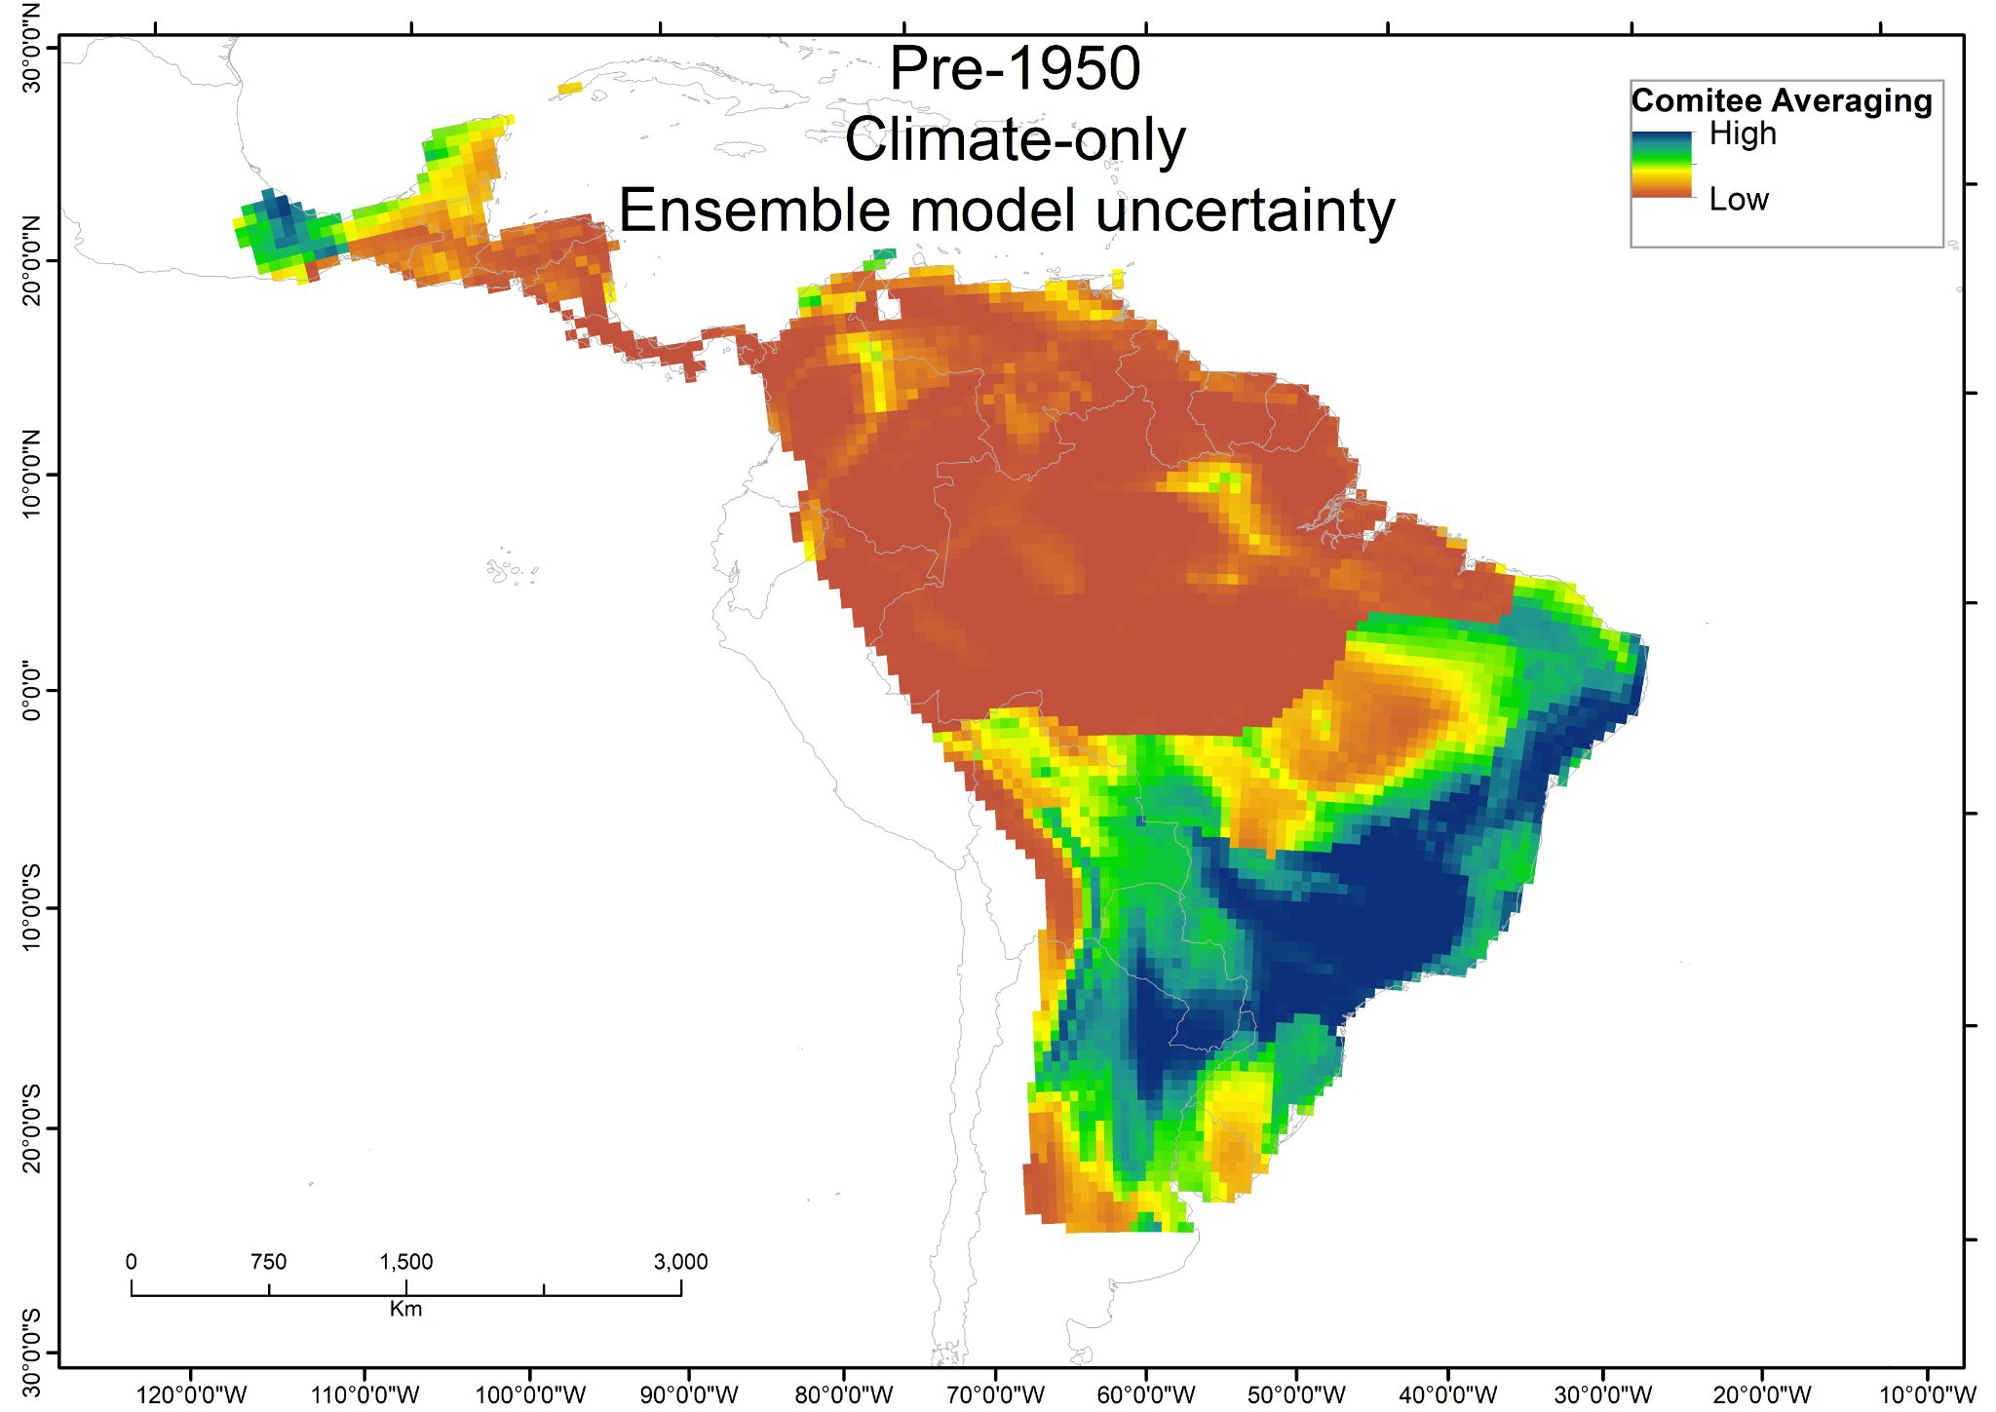
Fig. S3 Uncertainty derived from weighted mean ensemble models using only Climate variables for Crotalus durissus. Blue colors indicate models converge to indicate presence. Brown colors indicate models converge to indicate absence. Yellow and green colors indicate models diverge indicating presence or absence

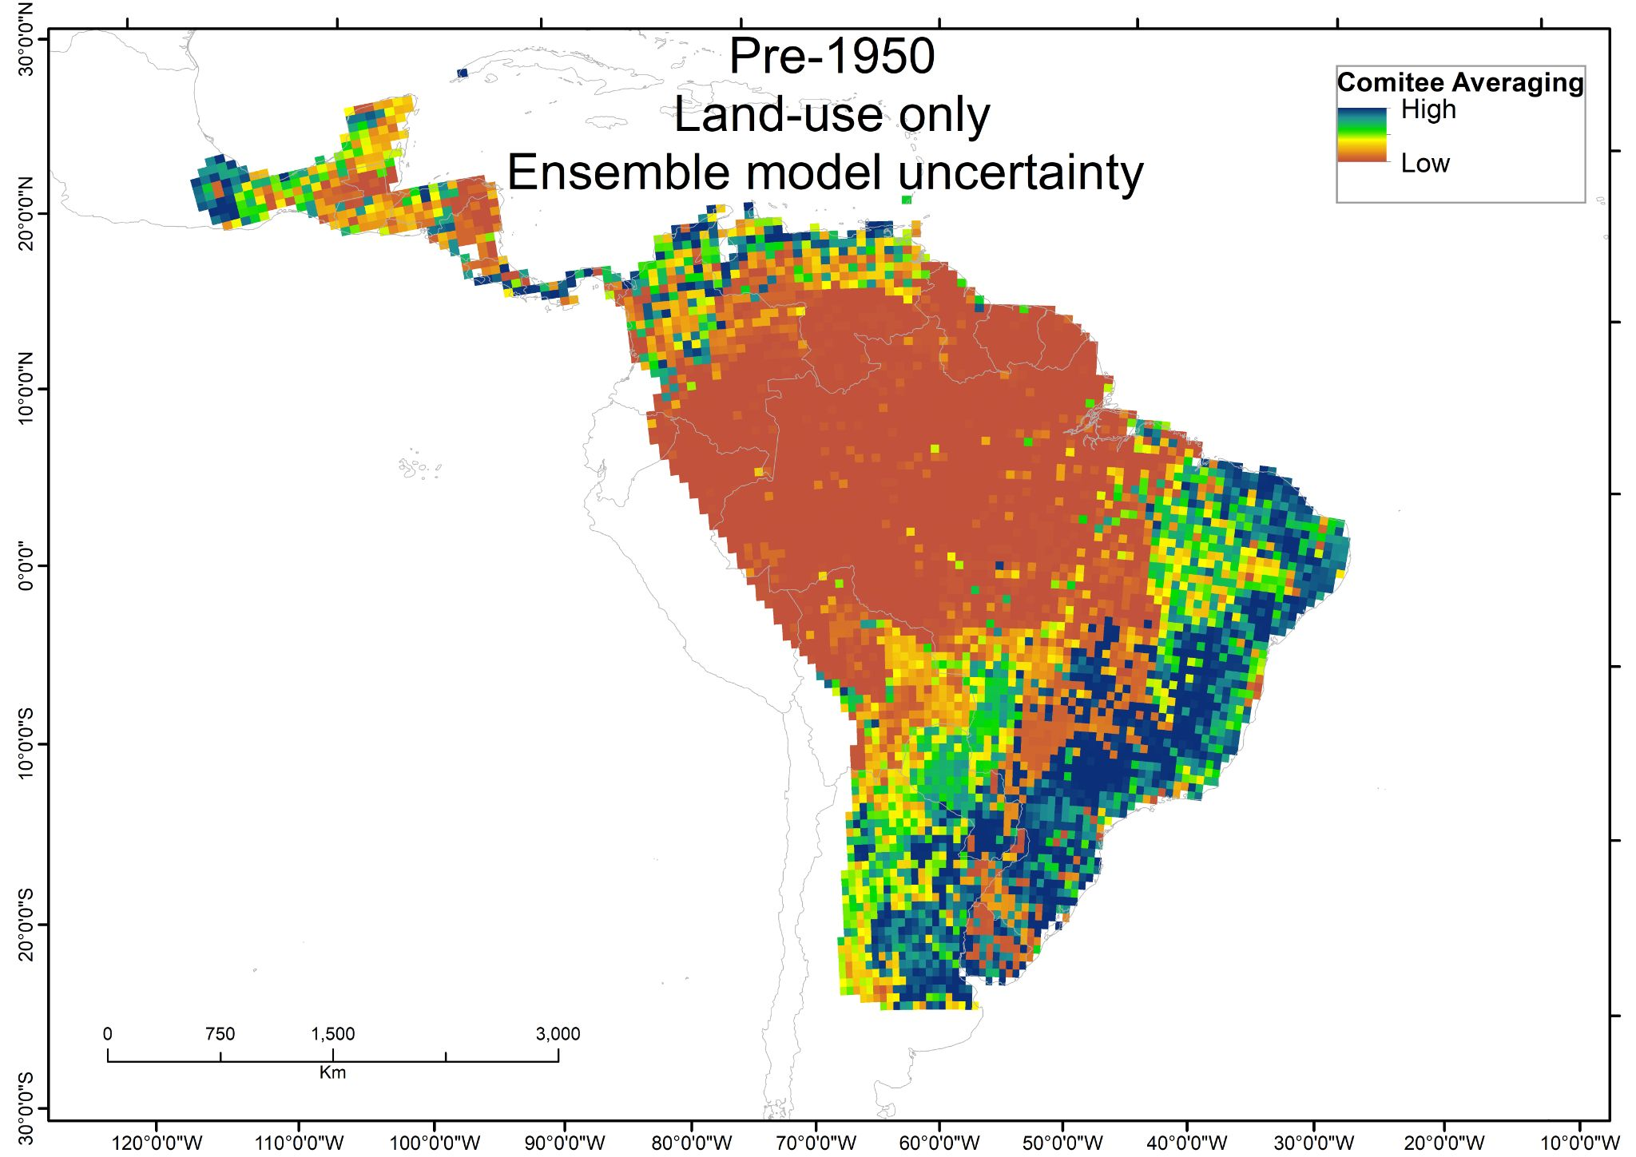
Fig. S4 Uncertainty derived from weighted mean ensemble models using only Land Use/Cover variables for Crotalus durissus. Blue colors indicate models converge to indicate presence. Brown colors indicate models converge to indicate absence. Yellow and green colors indicate models diverge indicating presence or absence

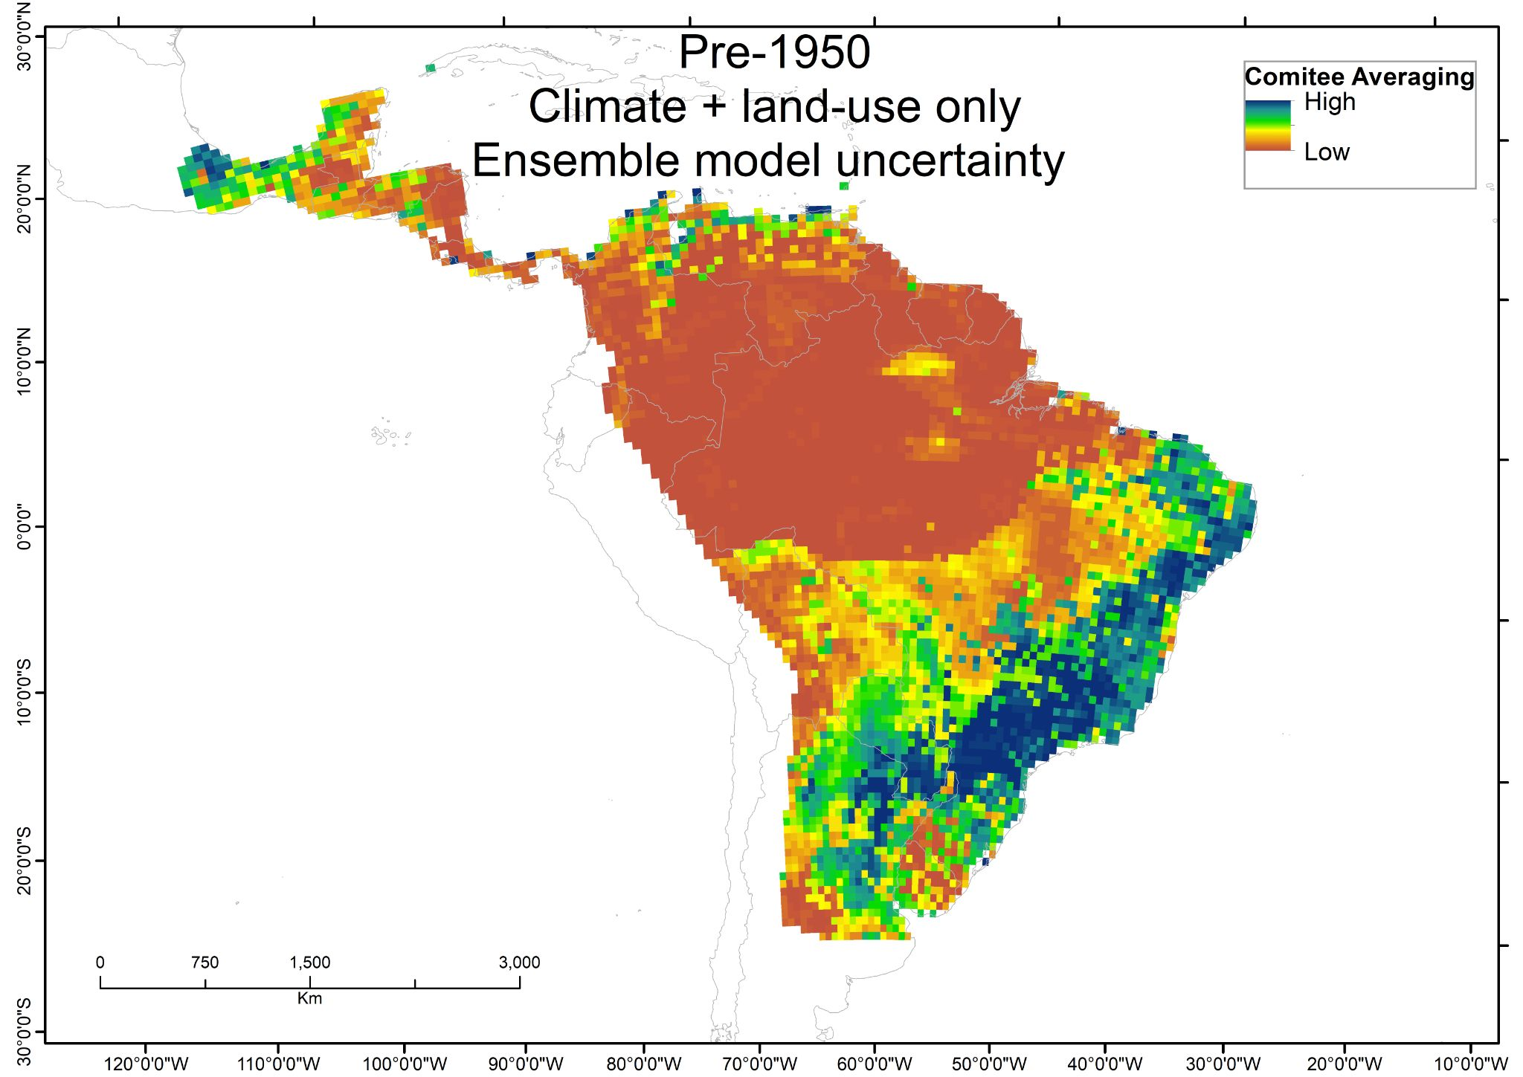
Fig. S5 Uncertainty derived from weighted mean ensemble models using both Climate and Land Use/Cover variables for Crotalus durissus. Blue colors indicate models converge to indicate presence. Brown colors indicate models converge to indicate absence. Yellow and green colors indicate models diverge indicating presence or absence

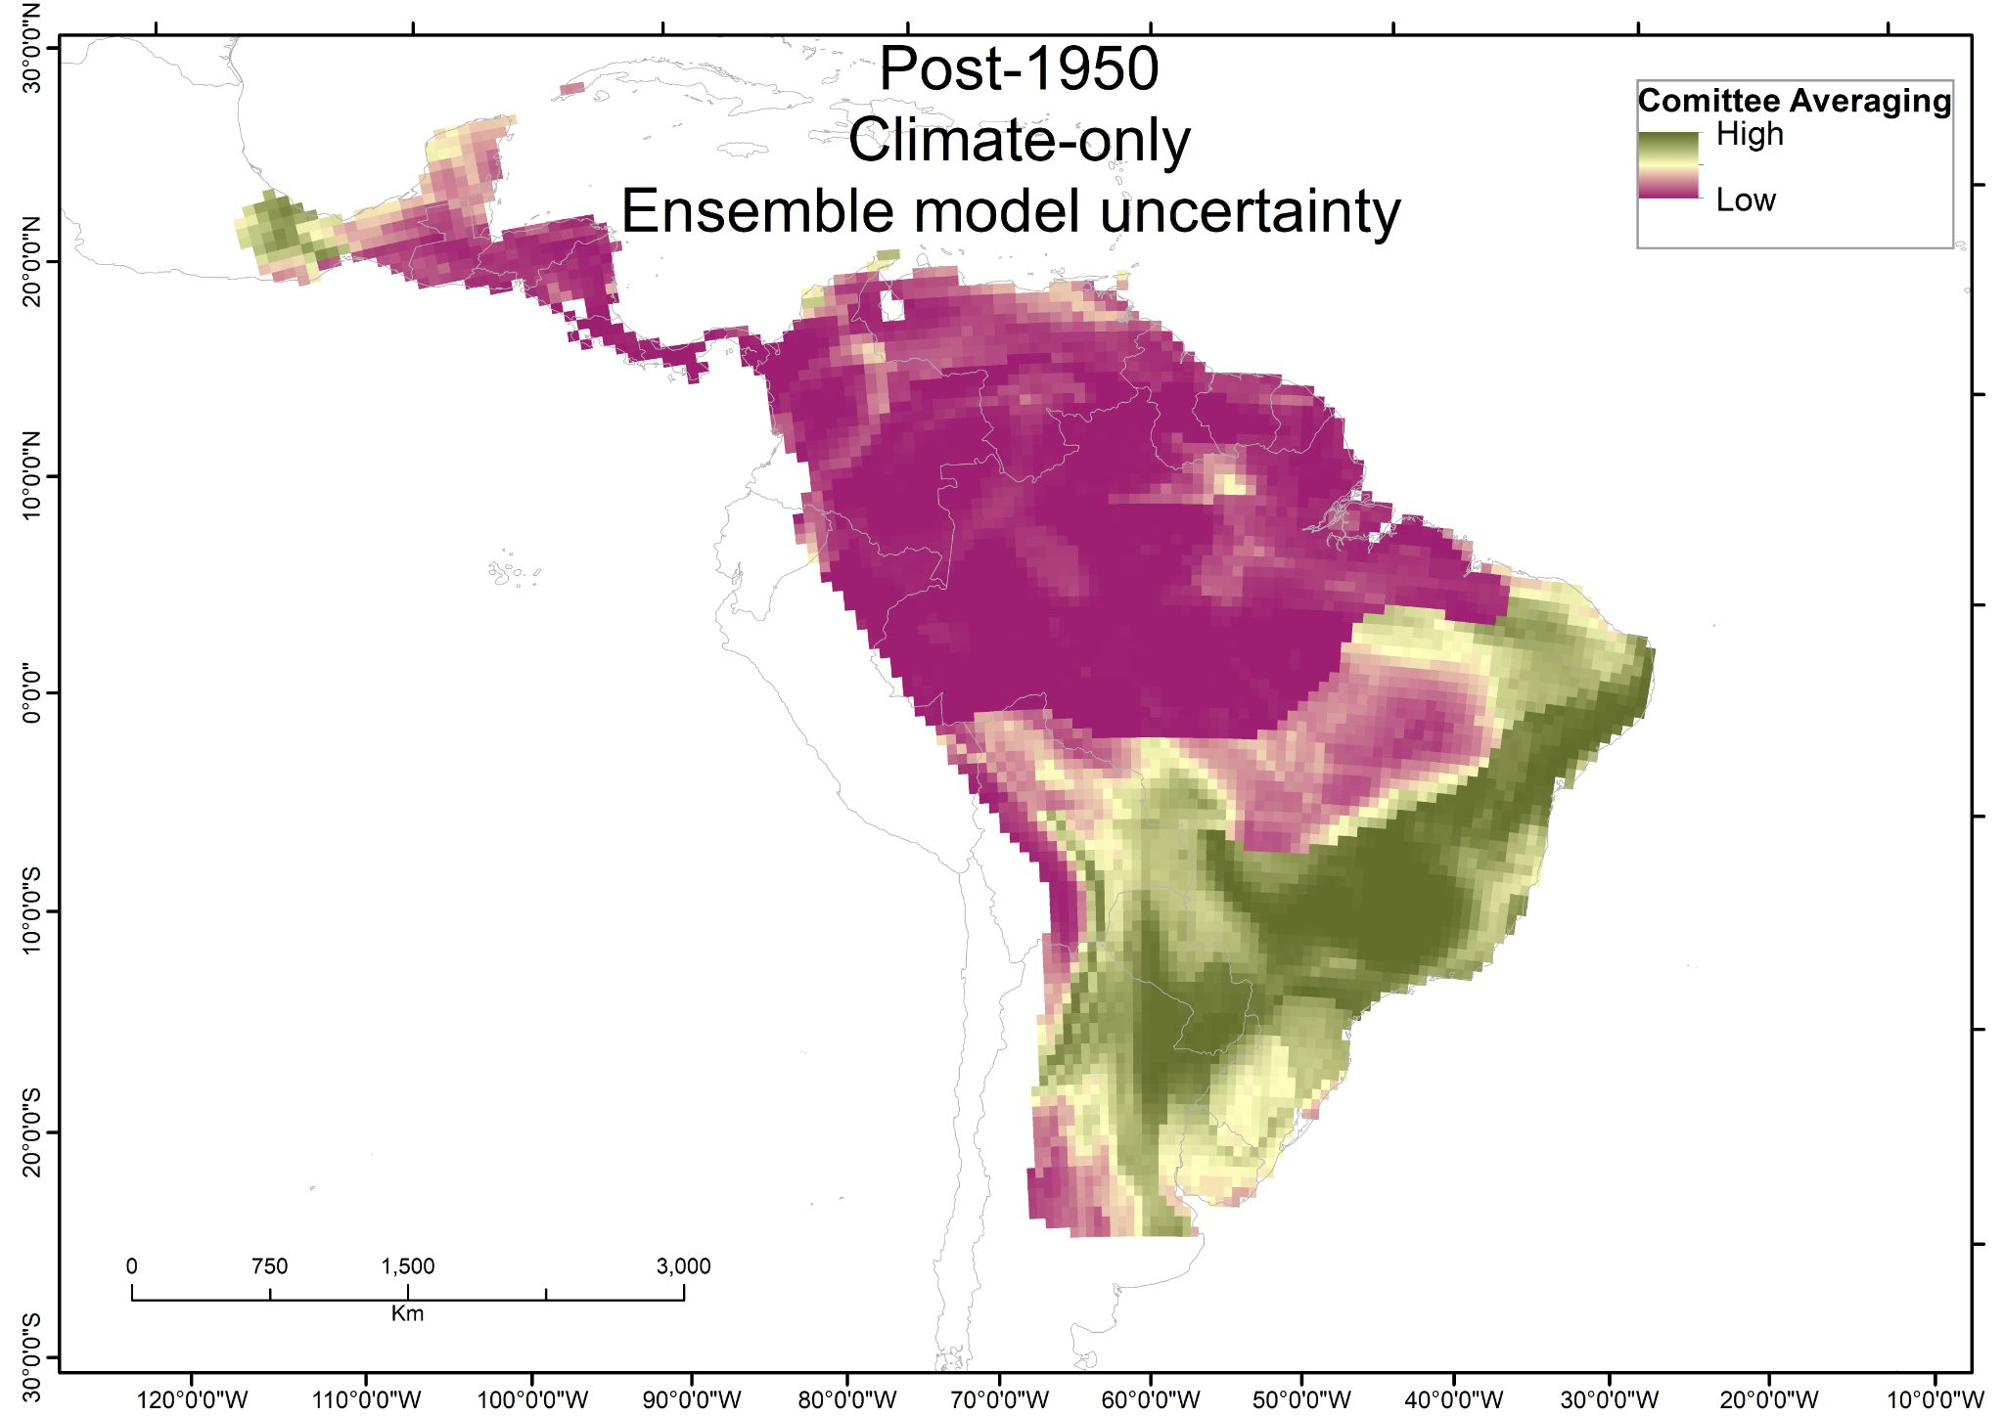
Fig. S6 Uncertainty derived from weighted mean ensemble models using only Climate variables for Crotalus durissus. Green colors indicate models converge to indicate presence. Purple colors indicate models converge to indicate absence. Yellow colors indicate models diverge indicating presence or absence

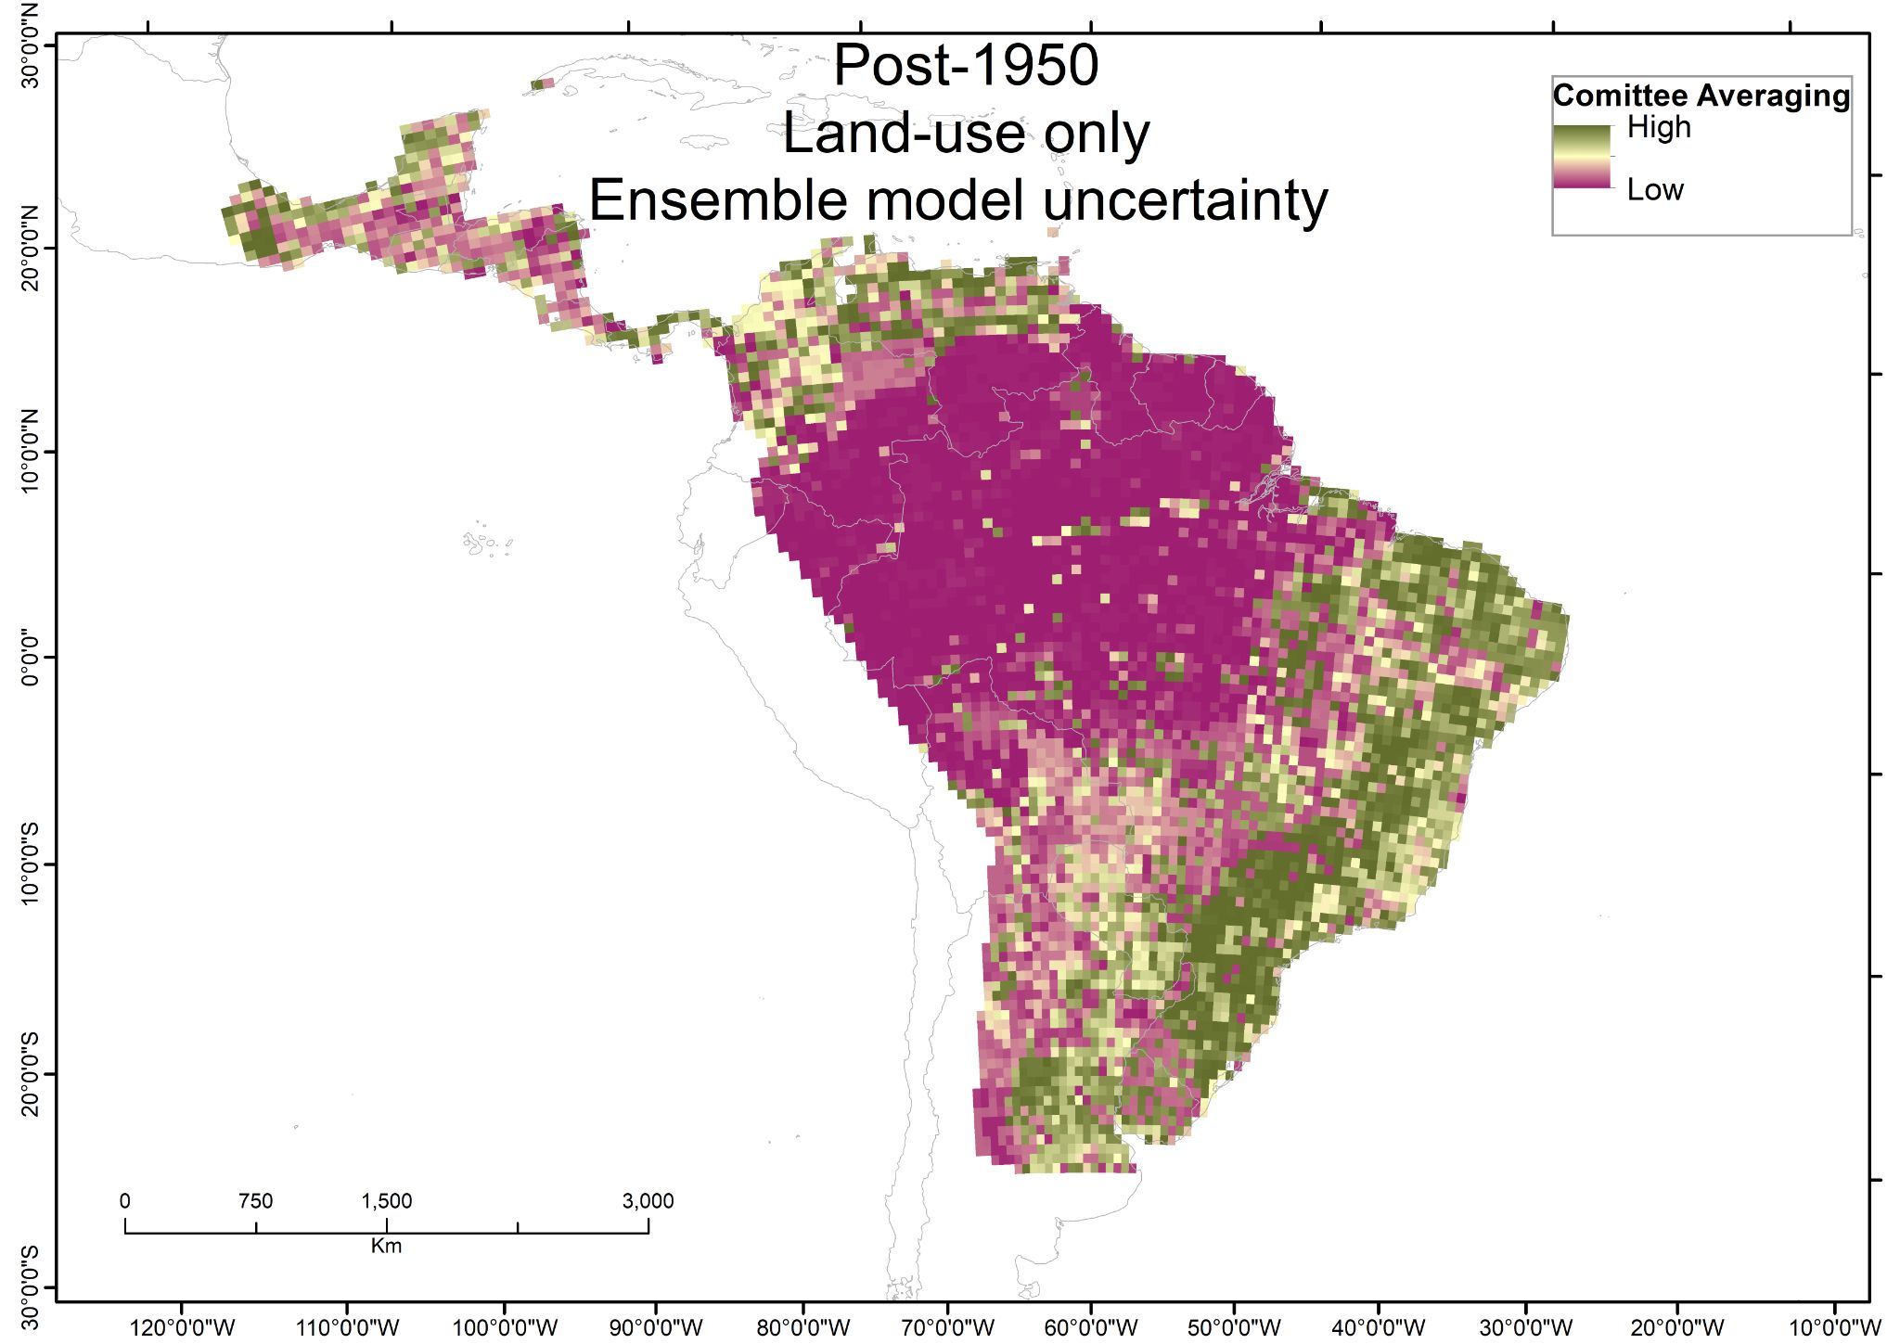
Fig. S7 Uncertainty derived from weighted mean ensemble models using only Land Use/Cover variables for Crotalus durissus. Green colors indicate models converge to indicate presence. Purple colors indicate models converge to indicate absence. Yellow colors indicate models diverge indicating presence or absence

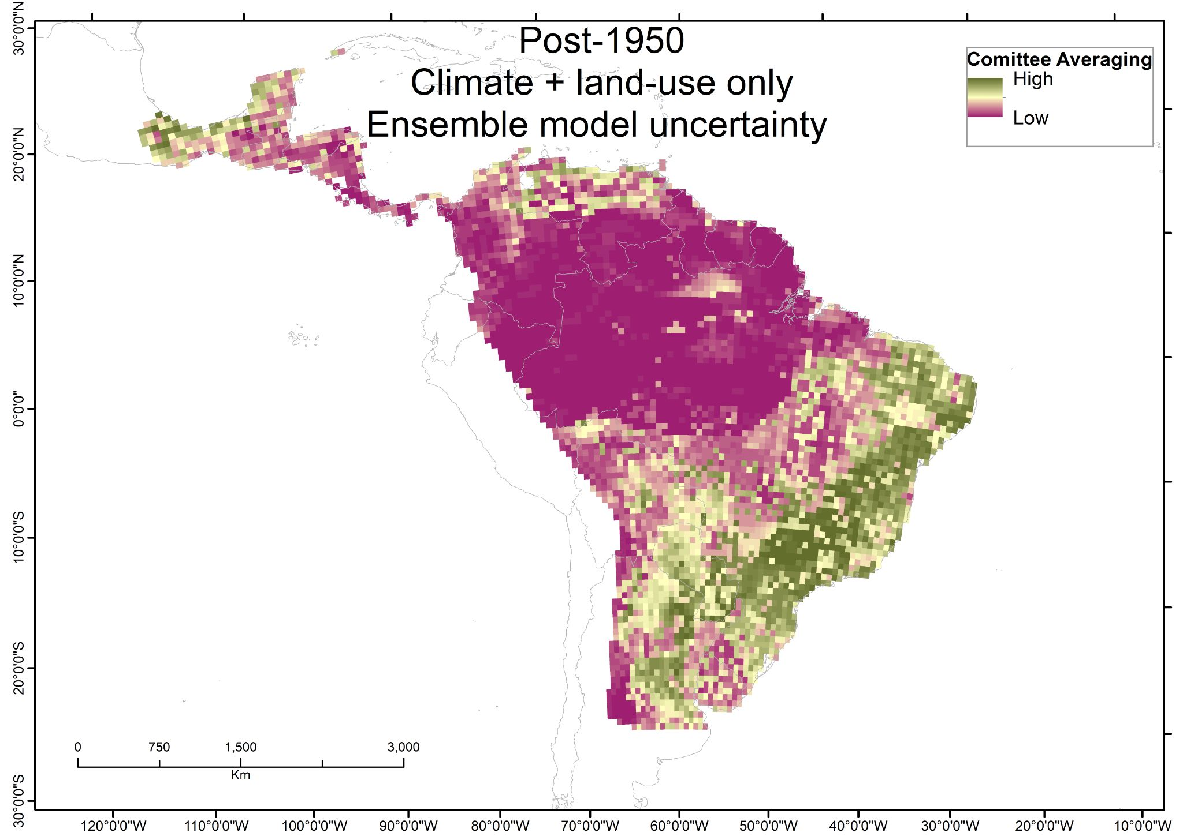
Fig. S8 Uncertainty derived from weighted mean ensemble models using both Climate and Land Use/Cover variables for Crotalus durissus. Green colors indicate models converge to indicate presence. Purple colors indicate models converge to indicate absence. Yellow colors indicate models diverge indicating presence or absence

