Supplementary materials: Development of lipid nanoparticles and liposomes reference materials (II) - Cytotoxic profiles
Krishnapriya Syama ¹, Zygmunt J. Jakubek ¹, Sam Chen ², Josh Zaifman ², Yuen Yi C. Tam ², Shan Zou ^{1,*}
¹ Metrology Research Centre, National Research Council Canada, Ottawa, Ontario, Canada
² Integrated Nanotherapeutics, Burnaby, BC, V5G 4X4, Canada
* Dr. Shan Zou, Metrology Research Centre, National Research Council, Canada, 100 Sussex Drive, Ottawa, Ontario K1A 0R6, Canada. Email: Shan.Zou@nrc-cnrc.gc.ca (ORCID: 0000-0002-2480-6821)

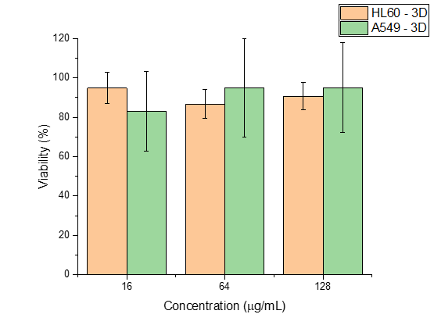
Figure S1. Cell viability (%) of cationic lipid nanoparticle (CLNP- siRNA) treated HL60 and A549 cells in 3D cultures for 48 h. Measurements were carried out in 6 wells for each concentration.
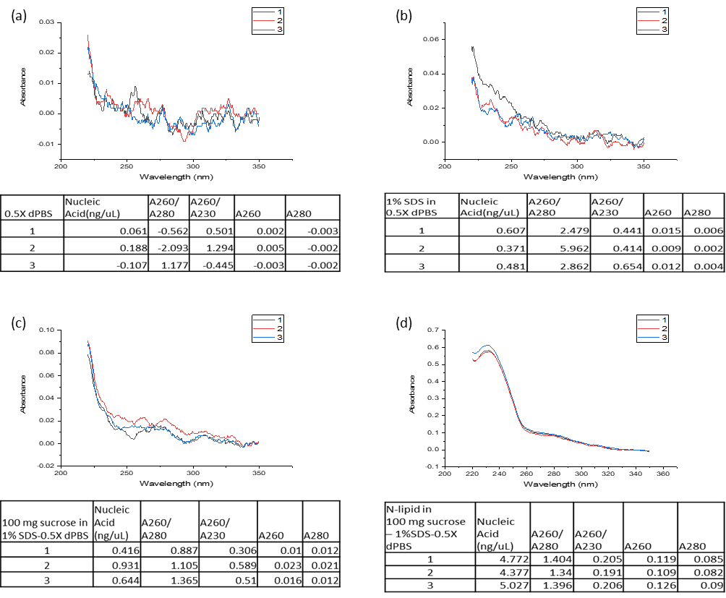
Figure S2. Absorbance measurements with reference solutions of (a) 0.5X dPBS, (b) 1% SDS in 0.5X dPBS, (c) 100 mg (2%) sucrose in 1% SDS-0.5X dPBS and (d) lipid film of neutral LNP for-mulations in 2% sucrose -1% SDS-0.5X dPBS. Three repeats were shown in each set.

