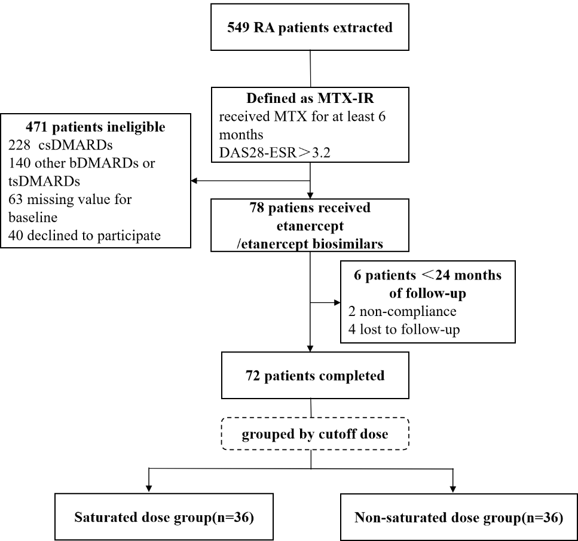
Supplementary Figure S1 Flow chart of our cohort. MTX-IR, methotrexate inadequate response; MTX, methotrexate; RA, rheumatoid arthritis; DAS28-ESR, disease activity score in 28 joints using erythrocyte sedimentation rate; csDMARDs, conventional synthetic disease-modifying antirheumatic drugs; bDMARDs, biological disease-modifying antirheumatic drugs; tsDMARDs, targeted synthetic disease-modifying antirheumatic drugs

Supplementary Table S1 Results of the ROC curve to identify the cumulative dose for remission response at 12 months
Time | Cumulative dose (mg) | Youden index | Sensitivity | Specificity
12-month | 899 | 0 | 1 | 0
 | 950 | 0.021 | 1 | 0.021
 | 1025 | 0.043 | 1 | 0.043
 | 1075 | 0.149 | 1 | 0.149
 | 1112.5 | 0.109 | 0.96 | 0.149
 | 1137.5 | 0.13 | 0.96 | 0.17
 | 1175 | 0.173 | 0.96 | 0.213
 | 1250 | 0.311 | 0.8 | 0.511
 | 1325 | 0.332 | 0.8 | 0.532
 | 1400 | 0.353 | 0.8 | 0.553
 | 1475 | 0.356 | 0.76 | 0.596
 | 1550 | 0.347 | 0.56 | 0.787
 | 1625 | 0.369 | 0.56 | 0.809
 | 1675 | 0.251 | 0.4 | 0.851
 | 1725 | 0.211 | 0.36 | 0.851
 | 1775 | 0.232 | 0.36 | 0.872
 | 1850 | 0.157 | 0.2 | 0.957
 | 1950 | 0.077 | 0.12 | 0. 957
 | 2025 | -0.043 | 0 | 0. 957
 | 2075 | -0.021 | 0 | 0.979
 | 2101 | 0 | 0 | 1

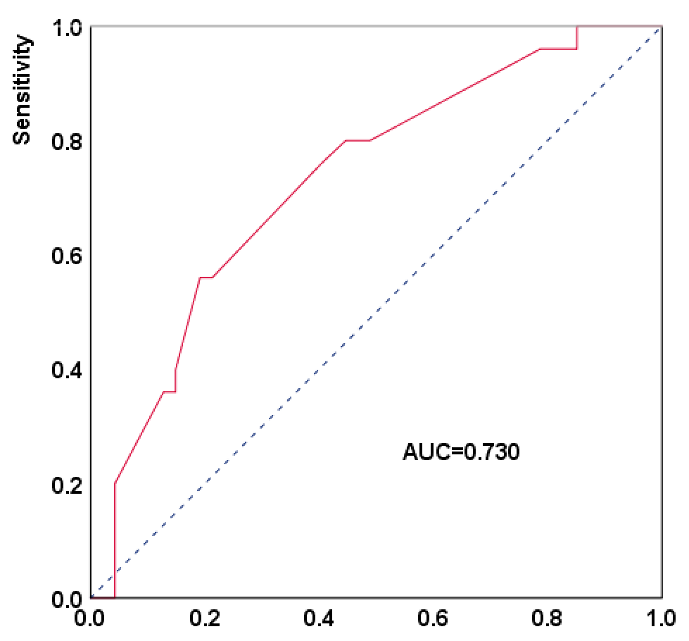
Supplementary Figure S2 ROC curve for remission response at 12 months. ROC, receiver operating characteristics; AUC, area under the curve

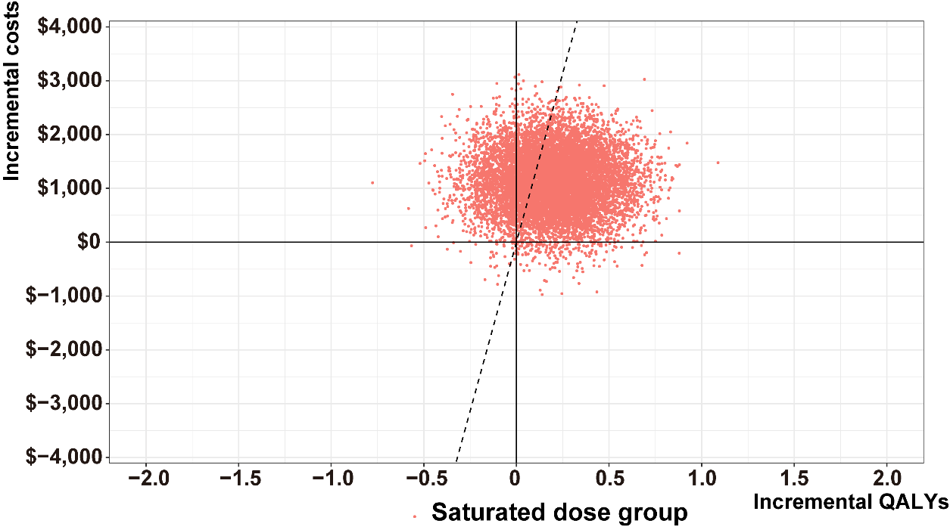
Supplementary Figure S3 Incremental cost-effectiveness plane of two groups. QALY, quality-adjusted life year

