Enhancement of enzymatic hydrolysis of sugarcane bagasse by the combination of delignification pretreatment and Tween 80

Hongdan Zhang,* Tao Dai, Shihang Huang, Jun Xie
Institute of Biomass Engineering, Key Laboratory of Energy Plants Resource and Utilization, Ministry of Agriculture and Rural Affairs, South China Agricultural University, Guangzhou 510642, P.R. China
Corresponding author: Hongdan Zhang; E-mail address: hdzhang@scau.edu.cn.

25ºC pretreated
Raw material
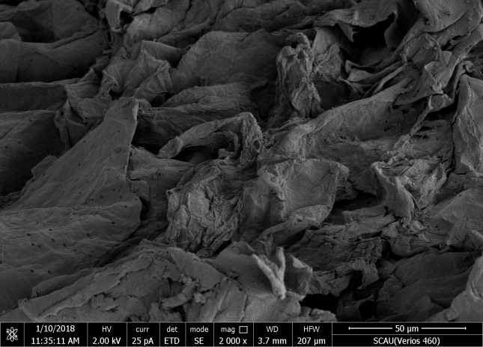
120ºC pretreated
NaOH

60ºC pretreated

NaClO2+HAc pretreated

160ºC pretreated

Fig. S1. SEM images of raw material and pretreated substrates at ×2000 magnification.

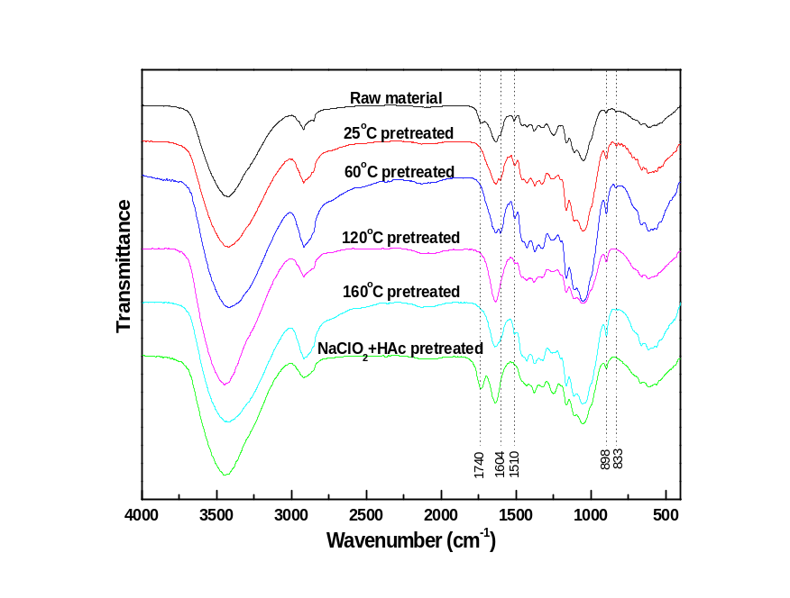
Fig. S2. FTIR spectra of untreated and pretreated samples with different pretreatment conditions.

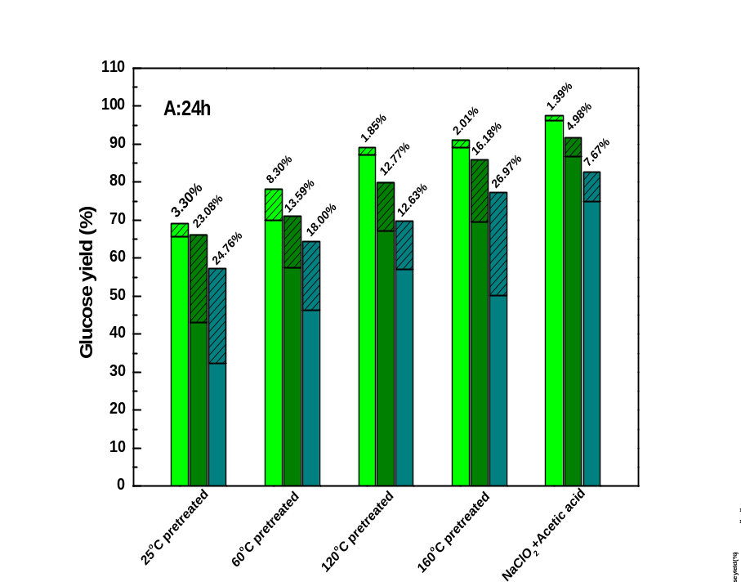
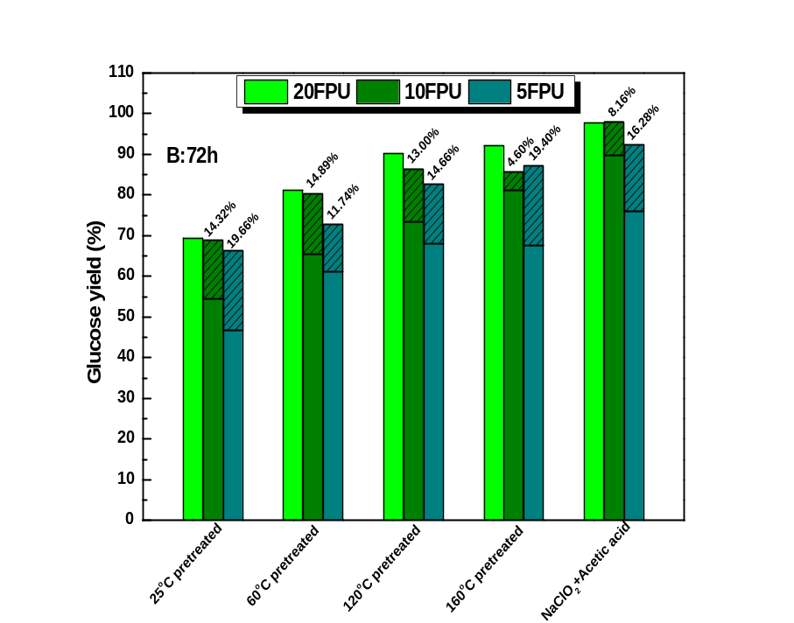
Fig. S3. The improvement of glucose yield with Tween 80 during enzymatic hydrolysis.

