Supplementary Material
Contents

1: HATUA patient recruitment: sites and healthcare facilities 2
2: Developing an asset index 3
3: Statistical Appendix: Bayesian Hierarchical Modelling 5
4: Supplementary material for Results 13

1: HATUA patient recruitment: sites and healthcare facilities

HATUA patient recruitment took place in 9 sites (three each in Kenya, Tanzania, and Uganda). Healthcare facilities were chosen across a number of primary and secondary care levels.

Table S1. Patient recruitment sites in Kenya, Tanzania, and Uganda
Country/site | Number of facilities (TOTAL) | Source of funding | Levels recruited from¹
Kenya
Makueni | 1 | Public | 5
Nairobi | 4 | Public and private | 3-5, National
Nanyuki | 1 | Public | 4
Tanzania
Kilimanjaro/Moshi | 3 | Public and private | 2,3, and 5
Mbeya | 2 | Public and private | 3 and 4
Mwanza | 5 | Public and private | 2,3, and 5
Uganda
Mbarara | 3 | Public | 3 and 5
Nakapiripirit | 3 | Public | 2 and 3
Nakasongola | 3 | Public and private | 3 and 4
¹ Levels of facilities are identified in each country following the Kenya Health Policy 2014-2013 (http://publications.universalhealth2030.org/uploads/kenya_health_policy_2014_to_2030.pdf); Tanzanian Health Sector Strategic Plan (http://www.tzdpg.or.tz/fileadmin/documents/dpg_internal/dpg_working_groups_clusters/cluster_2/health/Key_Sector_Documents/Induction_Pack/Final_HSSP_IV_Vs1.0_260815.pdf), and the Ugandan Hospital and Health Centre IV census survey (https://www.who.int/healthinfo/systems/SARA_H_UGA_Results_2014.pdf).

2: Developing an asset index

We developed an asset index as a proxy measure for the socioeconomic status of each patient, commonly used in LMIC survey analysis, including the Demographic and Health Surveys (DHS). An asset index provides an alternative measure to income which tends to be more stable over time and operates as a relative measure of poverty. It has been recommended to develop an asset index rather than measure each asset variable separately.¹ Previous studies have adopted Principal Components Analysis to generate an asset index, but this method has faced some criticism, particularly where it involves the inclusion of infrastructure-based variables that may impact rich-poor differences.² Instead, we used an exploratory factor analysis^{3,4} because we include some variables specifically related to infrastructure.
Data on assets were collected in the HATUA standardised questionnaire. We included 23 binary variables which covered ownership of durable household goods, and access to water and sanitation (listed in Table S2). To reflect the relative nature of wealth and the spatial differences covered in our study, we derived an asset index for each country separately. The Kaiser-Meyer-Olkin (KMO) was undertaken to ensure the appropriateness of the data for each index. The KMO for each index was over 0·5 (Tanzania: 0·67; Uganda: 0·75; Kenya: 0·62) and deemed suitable for factor analysis.⁵ To create an index, only one factor is extracted from the data for each country. An oblique factor rotation was chosen as it is produces factors that are correlated.⁵ The factor loadings varies by country. Along with the index variables, Table S2 presents the factor loadings for each country’s asset index along with the respective Cronbach alpha, which is used to test scale reliability.⁶ The resulting factor is a continuous variable scoring each patient’s level of wealth from lowest to highest, which we divided it into quintiles.

Table S2. Factor loadings for each country’s asset index
 | Tanzania |  | Uganda |  | Kenya
Asset variable | Factor scores | Alpha | Factor scores | Alpha | Factor scores | Alpha
Electricity | 0·29 | 0·78 | 0·57 | 0·80 | ·· | 0·76
Motor | 0·27 |  | 0·28 |  | ··
Fishboat | ·· |  | ·· |  | ··
TV | 0·43 |  | 0·48 |  | ··
Radio | 0·29 |  | 0·37 |  | ··
Computer | 0·27 |  | ·· |  | 0·25
Refrigerator | 0·43 |  | 0·29 |  | 0·42
Smart phone | ·· |  | 0·29 |  | ··
Older mobile phone | · |  | 0·38 |  | ··
Beds | 0·28 |  | 0·45 |  | ··
Tools | ·· |  | ·· |  | ··
Herds of animals | ·· |  | -0·27 |  | ··
Protected private washing water source | 0·90 |  | 0·79 |  | 0·91
Protected public washing water source | -0·79 |  | -0·75 |  | -0·87
Unprotected private washing water | ·· |  | ·· |  | ··
Unprotected public washing water source | 0·90 |  | ·· |  | ··
Protected private drinking water | -0·79 |  | 0·81 |  | 0·92
Protected public drinking water | ·· |  | -0·77 |  | -0·87
Unprotected private drinking water | ·· |  | ·· |  | ··
Unprotected public drinking water | ·· |  | ·· |  | ··
Private flush | 0·56 |  | ·· |  | 0·64
Public flush | -0·41 |  | ·· |  | -0·55
Pit latrine | ·· |  | 0·50 |  | ··
Factor loadings greater than 0·25 shown

3: Statistical Appendix: Bayesian Hierarchical Modelling

We estimated the posterior distributions of the model parameters using Markov chain Monte Carlo (MCMC) algorithms implemented in the BUGS language through the NIMBLE package7 in R Studio. Given the lack of quantitative studies describing patient treatment-seeking pathways in East African populations from which to draw priors, so we had little information from which to draw informative priors. To avoid possible bias from missing data, we estimated the models on the full sample (N=6,608) with some incomplete values on the covariates and outcomes (n=549). Five chains were initiated at different start values, where each chain ran for 100,000 iterations, with a burn-in (warm-up) of 20,000 iterations. Convergence was assessed through visual inspection of trace plots (Figures S1, S2, and S3). Trace plots were also used to guide our choice of iterations and burn-in time.
All models followed a similar multi-level structure, expressed as:
$${\text{Misuse}}_{i}\sim \text{Bernoulli}\left(π_{i}\right)$$
$$log\left(\frac{π_{i}}{1-π_{i}}\right)={βX}_{i} +{βclinic}_{h_{i}}$$ where
$${βclinic}_{h}\sim N\left({βsite}_{s_{h}},σ_{h}^{2}\right)$$
for each clinic, h.
$${βsite}_{s}\sim N\left({βcountry}_{c_{s}},σ_{s}^{2}\right)$$
for each site, s, and
$${βcountry}_{c}\sim N\left(0,σ_{c}^{2}\right)$$for each country, c.
The variances each having a prior $σ_{X}^{2}\sim exp\left(1\right)$. Coefficients, $β$, associated with covariates in the fixed effects are given a normal prior distribution with standard deviation 2·3 to give a relatively flat distribution after an inverse logit transformation. Missing data are given priors based on the empirical distributions seen in complete cases. The results of these analyses are presented as highest posterior density intervals throughout.

Figure S1: Trace plots for outcome 1: self-treatment at step 1
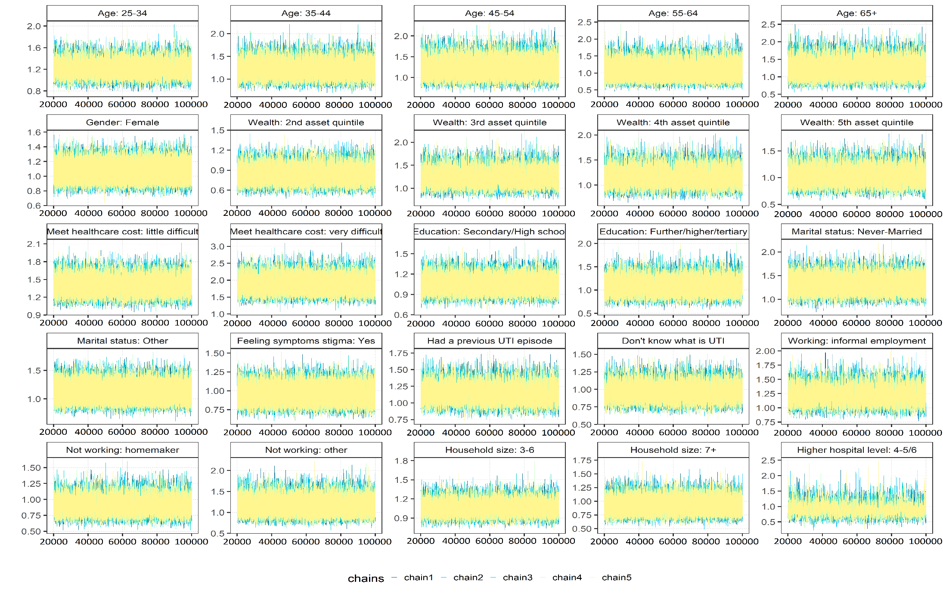
Figure S2: Trace plots for the outcome 2: having 2 or more steps in the pathway
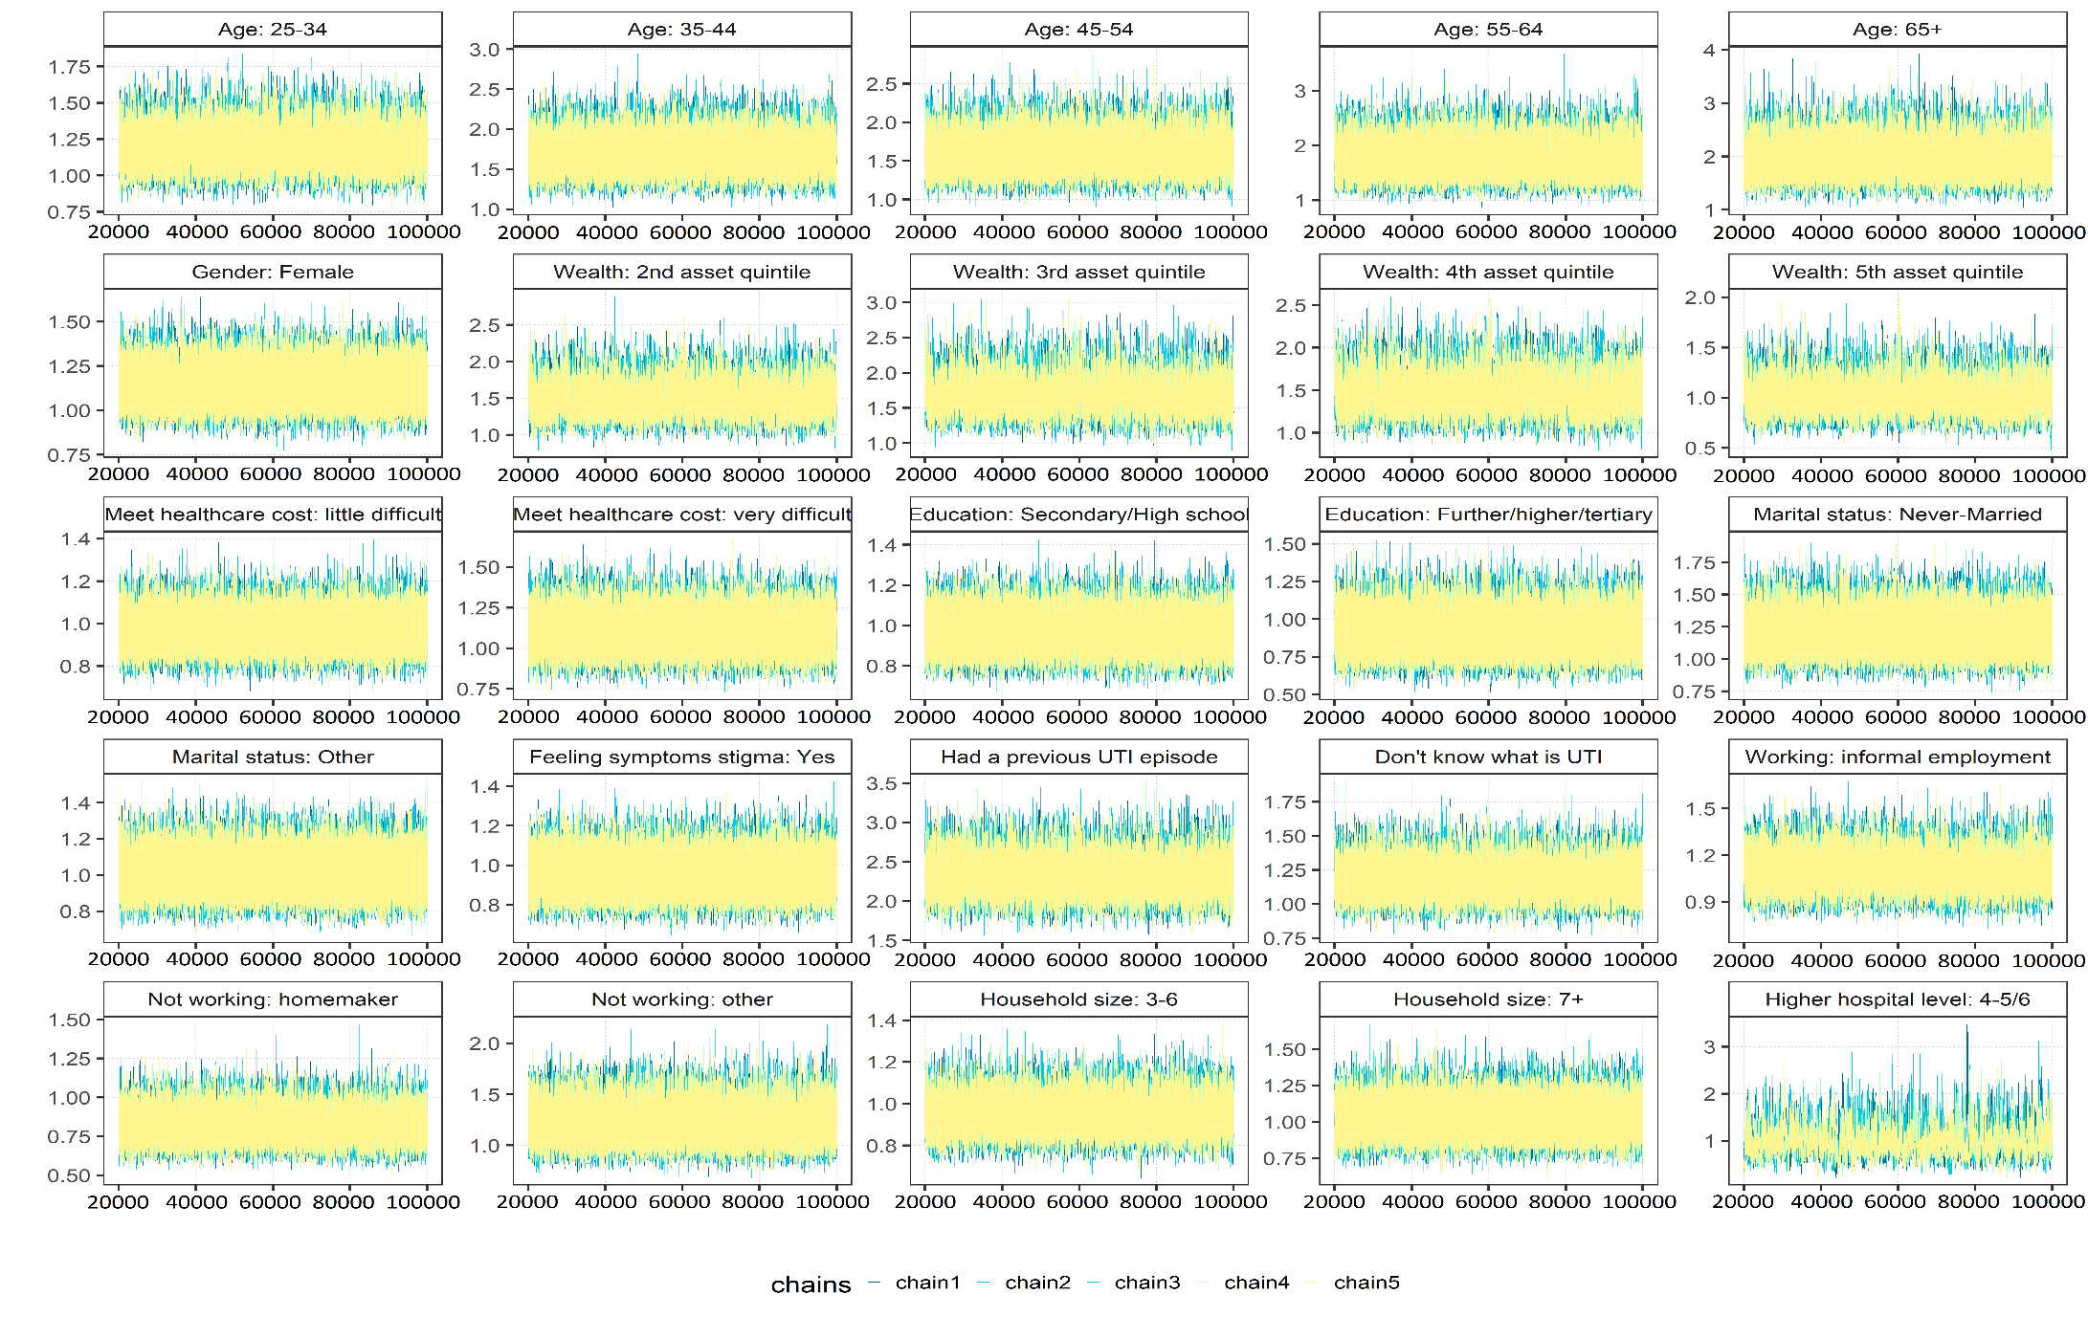

Figure S3: Trace plot for outcome 3: antibiotic consumption at step 1 or 2
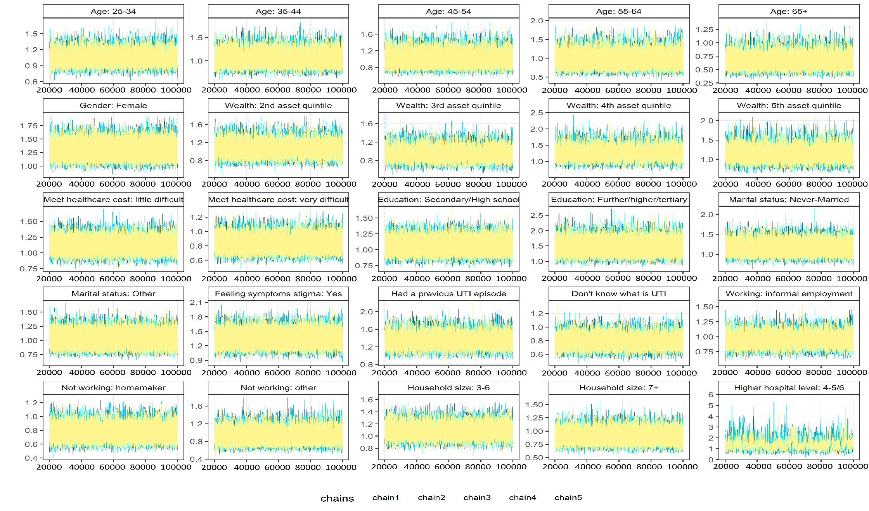
Figure S4: Posterior distribution plots for outcome 1: self-treatment at step 1

Figure S5: Posterior distribution plots for outcome 2: having 2 or more steps in the pathway

Figure S6: Posterior distribution plots for outcome 3: AB consumption at step 1 or 2
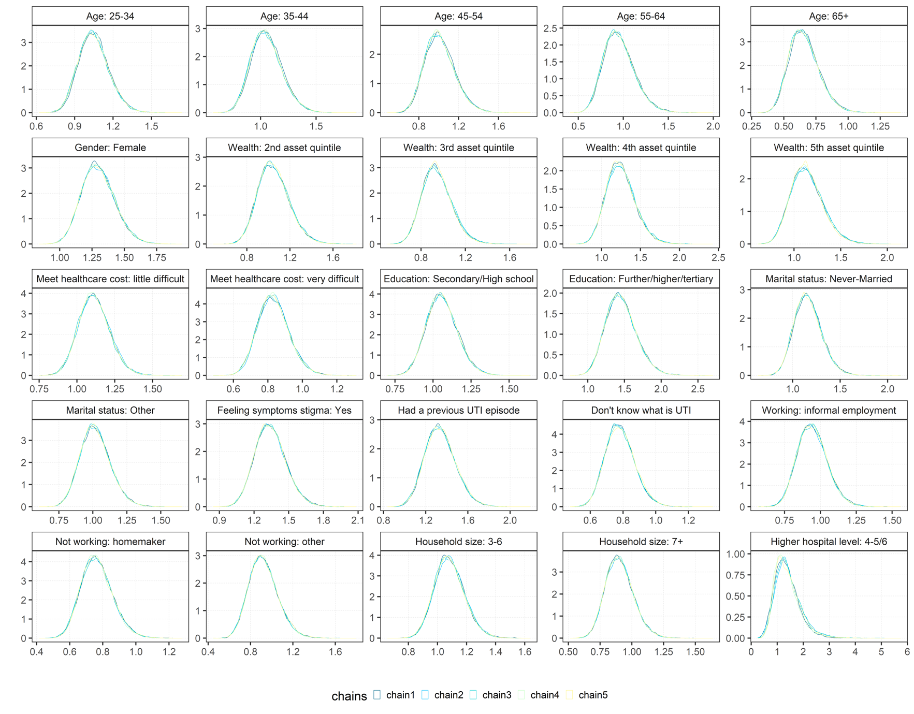

4: Supplementary results material

Supplementary Tables S3 and S4 show the characteristics of the quantitative and qualitative samples respectively. Table S5 shows the HATUA female sample compared with the DHS female samples from the most recently available Demographic and Health country surveys (Tanzania 2015-2016,⁸ Uganda 2016,⁹ and Kenya 2014¹⁰) on age, marital status and education. Patients within the HATUA data sample were older than the DHS participants (the DHS is restricted to women aged up to 49 years). Despite this difference, most women in both samples were under the age of 35. The HATUA samples had proportionally fewer women who were never married and cohabiting, and proportionally more married women than the DHS samples. There were also higher proportions of widows in the HATUA samples compared with DHS estimates (likely related to differing age distributions). The HATUA Tanzania sample was slightly more educated than that seen in the DHS sample, with higher proportions with higher education and lower proportions with no or primary education. The reverse was true for Uganda: the HATUA sample had a high proportion of women with no education (36%) compared with the DHS Uganda (10%). In Kenya, the picture was different again, with HATUA Kenya composed of high proportions of women higher secondary and higher education (57% and 30% ) compared to DHS Kenya (32% and 11%).

Table S3. Characteristics of the quantitative sample (n=6608)
 |  | Tanzania %  N=3190 | Uganda %  N=1757 | Kenya %  N=1661 | Total %  N=6608
Gender | Male | 26·9 | 15·9 | 16·4 | 21·3
Gender | Female | 73·1 | 84·1 | 83·6 | 78·7
Age | <25 | 22 | 33·4 | 27·3 | 26·4
Age | 25-34 | 26·2 | 32 | 47·3 | 33·1
Age | 35-44 | 15·3 | 17 | 15·8 | 15·9
Age | 45-54 | 12 | 9·8 | 5·2 | 9·7
Age | 55-64 | 8·9 | 4 | 1·5 | 5·7
Age | 65+ | 14·6 | 3·5 | 2·5 | 8·6
Age | Missing | 1 | 0·3 | 0·4 | 0·7
Marital status | Married | 70·9 | 65·9 | 72·7 | 70
Marital status | Never married | 16 | 10·5 | 22·9 | 16·3
Marital status | Other: co-habiting, divorced, widowed | 13 | 23·6 | 4·3 | 13·6
Marital status | Missing | 0·1 | 0 | 0·1 | 0·1
Education | No education or primary school | 66·8 | 71·4 | 14·4 | 54·9
Education | Secondary/  high school | 24·5 | 19·2 | 55·1 | 30·8
Education | Any further/ higher education, university | 8·5 | 9·4 | 30·5 | 14·3
Education | Missing | 0·1 | 0 | 0·1 | 0·1
Wealth asset quintile  (1: poorest to 5: wealthiest) | 1 | 20·8 | 20·4 | 19·6 | 20·4
Wealth asset quintile  (1: poorest to 5: wealthiest) | 2 | 18 | 20 | 20·3 | 19·1
Wealth asset quintile  (1: poorest to 5: wealthiest) | 3 | 20·4 | 20·3 | 19·6 | 20·2
Wealth asset quintile  (1: poorest to 5: wealthiest) | 4 | 20·9 | 19·8 | 20·5 | 20·5
Wealth asset quintile  (1: poorest to 5: wealthiest) | 5 | 19·7 | 19·1 | 19·5 | 19·5
Wealth asset quintile  (1: poorest to 5: wealthiest) | Missing | 0·3 | 0·5 | 0·5 | 0·4
Working status | Formal employment | 23·6 | 13·7 | 24·6 | 21·2
Working status | Informal employment | 36·1 | 56 | 33·9 | 40·8
Working status | Homemaker | 25·5 | 22·7 | 26·7 | 25
Working status | Not working | 13·5 | 7·7 | 14·3 | 12·2
Working status | Missing | 1·4 | 0·1 | 0·5 | 0·8
Household size | 1-2 | 20·3 | 19·5 | 28·8 | 22·2
Household size | 3-6 | 58·1 | 56·1 | 68·8 | 60·3
Household size | 7+ | 21 | 24·4 | 1·6 | 17
Household size | Missing | 0·6 | 0·1 | 0·8 | 0·5
Ability to meet healthcare costs | Easy | 47·6 | 15·2 | 37·5 | 36·4
Ability to meet healthcare costs | A little difficult | 33 | 50·6 | 50·5 | 42·1
Ability to meet healthcare costs | Very difficult | 17·1 | 34 | 11·7 | 20·2
Ability to meet healthcare costs | Missing | 2·4 | 0·2 | 0·3 | 1·3
Previous diagnosed with UTI | No | 15·4 | 24·9 | 18·3 | 18·7
Previous diagnosed with UTI | Yes | 50·3 | 24·7 | 51·7 | 43·8
Previous diagnosed with UTI | Don’t know | 32·9 | 50·2 | 27·9 | 36·2
Previous diagnosed with UTI | Missing | 1·4 | 0·2 | 2·2 | 1·3
Symptoms stigma | No | 83·8 | 59·1 | 73·6 | 74·7
Symptoms stigma | Yes | 15·6 | 39·3 | 23·3 | 23·8
Symptoms stigma | Missing | 0·6 | 1·6 | 3·1 | 1·5
Recruitment clinic level | Lower level (2-3) | 66·2 | 78·5 | 21·4 | 58·2
Recruitment clinic level | Higher level (4-6) | 33·8 | 21·5 | 78·6 | 41·8

Table S4: Description of the qualitative sample (n=116)
 |  | Tanzania  n=31(%) |  | Uganda  n=62(%) |  | Kenya  n=23 (%) |  | Total  n=116 (%)
Gender | Female | 19 | (61) | 55 | (89) | 15 | (65) | 89 | (77)
Gender | Male | 12 | (39) | 7 | (11) | 8 | (35) | 27 | (23)
Age | <35 | 9 | (29) | 39 | (63) | 12 | (52) | 60 | (52)
Age | 35+ | 22 | (71) | 23 | (37) | 11 | (48) | 56 | (48)
Wealth asset quintiles (1: poorest to 5: wealthiest) | 1 | 5 | (16) | 20 | (32) | 3 | (13) | 28 | (24)
Wealth asset quintiles (1: poorest to 5: wealthiest) | 2 | 1 | (3) | 10 | (16) | 6 | (26) | 17 | (15)
Wealth asset quintiles (1: poorest to 5: wealthiest) | 3 | 4 | (13) | 21 | (34) | 10 | (43) | 35 | (30)
Wealth asset quintiles (1: poorest to 5: wealthiest) | 4 | 12 | (39) | 7 | (11) | 3 | (13) | 22 | (19)
Wealth asset quintiles (1: poorest to 5: wealthiest) | 5 | 9 | (29) | 4 | (6) | 1 | (4) | 14 | (12)
Working status | Formal employment | 5 | (16) | 4 | (6) | 3 | (13) | 12 | (10)
Working status | Informal employment | 13 | (42) | 43 | (69) | 9 | (39) | 65 | (56)
Working status | Homemaker | 9 | (29) | 13 | (21) | 5 | (22) | 27 | (23)
Working status | Not working-other | 4 | (13) | 2 | (3) | 6 | (26) | 12 | (10)
Recruitment clinic level | Lower level (2-3) | 18 | (58) | 49 | (79) | 3 | (13) | 70 | (60)
Recruitment clinic level | Higher level (4-6) | 13 | (42) | 13 | (21) | 20 | (87) | 46 | (40)

Table S5: Description of sample socio-demographics for Tanzania, Uganda and Kenya, comparing HATUA with DHS survey data (females only)
Women only |  | Tanzania |  | Uganda |  | Kenya
 |  | HATUA  N=2,301  % | DHS 2015-16⁸  N= 13,266  % | HATUA  N=1,475  % | DHS 2016⁹  N=18,506  % | HATUA  N=1,385  % | DHS 2014¹⁰  N=31,079  %
Age | <25 | 27·2 | 40·6 | 36·7 | 43·7 | 30·4 | 37·2
Age | 25-34 | 30·5 | 29·2 | 32·5 | 30·2 | 48 | 34·1
Age | 35-44 | 16·6 | 22·7 | 16·3 | 19·6 | 14·7 | 21·4
Age | 45-54 | 11·4 | 7·5 | 9·2 | 6·5 | 4·3 | 7·3
Age | 55-64 | 7·2 | 0 | 2·9 | 0 | 1 | 0
Age | 65+ | 7·2 | 0 | 2·4 | 0 | 1·6 | 0
Marital status | Never married | 15·9 | 25·3 | 9·3 | 25·8 | 15·8 | 29
Marital status | Cohabiting /living with a partner | 0·5 | 17 | 9·4 | 30·3 | 3·2 | 5·1
Marital status | Married | 69·9 | 44·9 | 65·3 | 30·3 | 69·4 | 54·6
Marital status | Divorced/separated | 6·1 | 10 | 10·8 | 10·7 | 6·3 | 7·7
Marital status | Widowed | 7·6 | 2·9 | 5·2 | 2·8 | 5·3 | 3·7
Education | None | 11·4 | 14·7 | 35·9 | 9·6 | 1·4 | 7
Education | Primary | 56·8 | 61·9 | 37·6 | 57·4 | 12·7 | 50·3
Education | Secondary | 24·4 | 22·1 | 18·1 | 25·1 | 56·7 | 31·5
Education | Higher | 7·4 | 1·4 | 8·4 | 7·9 | 29·2 | 11·2
Notes: DHS proportions are weighted using individual sampling weights.

Figure S7: Sankey plots describing the patient pathway for UTI-like symptoms in a)Tanzania (n=3,101), b) Uganda (n=1,756), and c) Kenya (n=1,521)
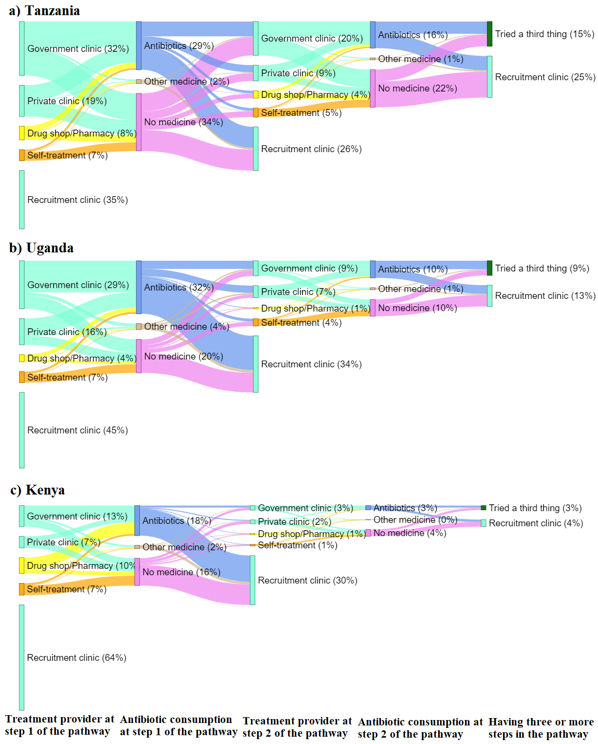

Figure S8. Description of the reasons for choosing the type of treatment in step 1 of the pathway by country
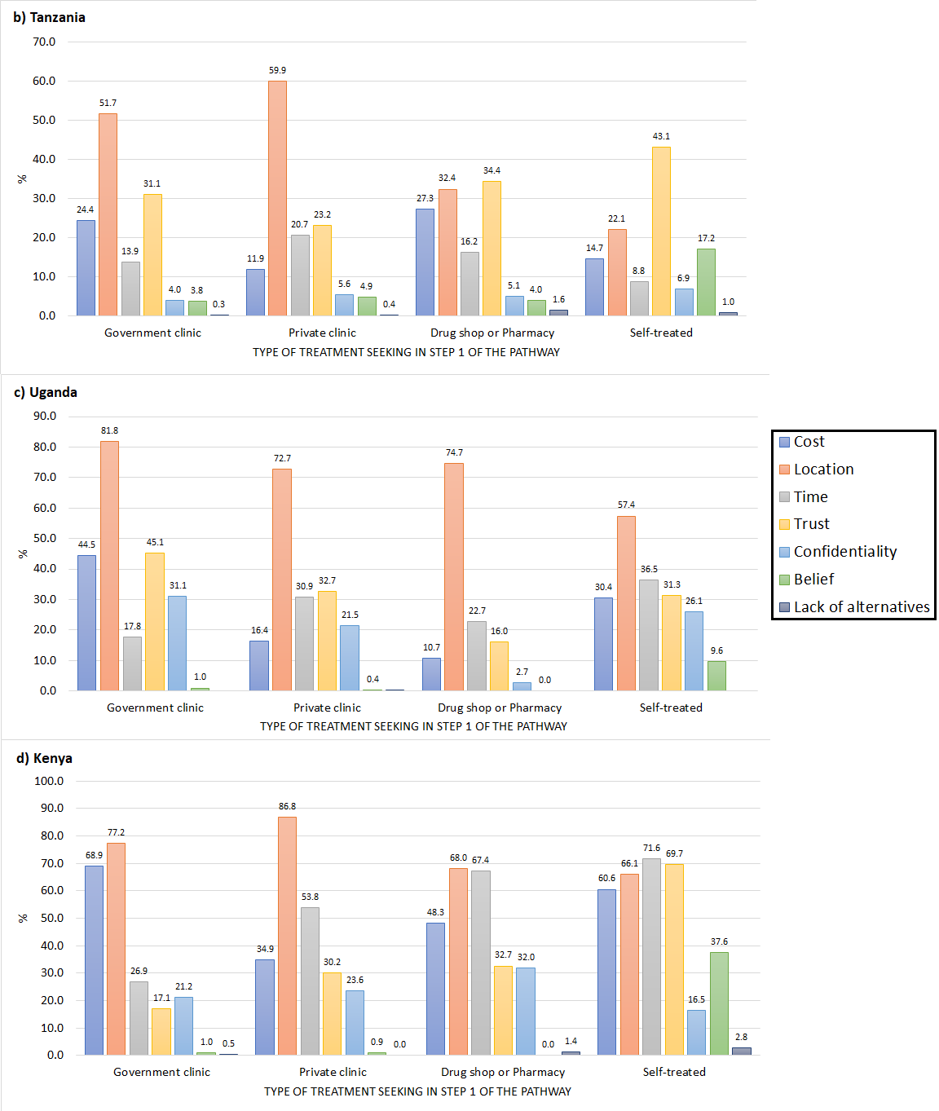

Figure S9: Coefficients (ORs) from multivariable regression models predicting self-treatment in the first step of the pathway (N=6,608)
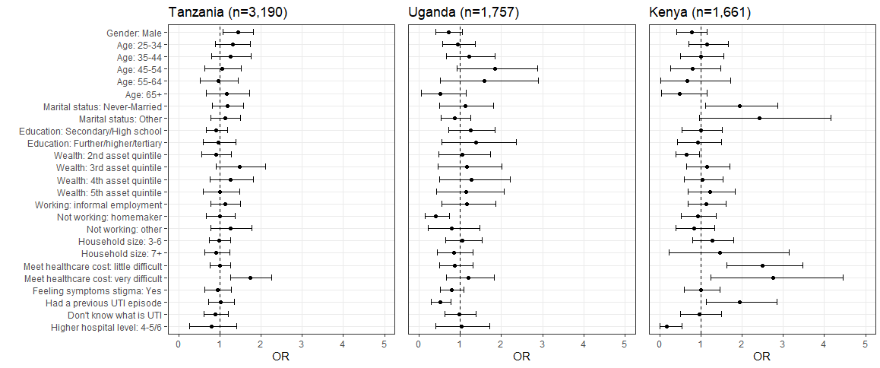Dashed line indicates 95% Highest Posterior Density interval (HPDI) crossing 1.

Figure S10.Coefficients (ORs) from multivariable regression models predicting having two or more steps in the pathway (N=6,608)
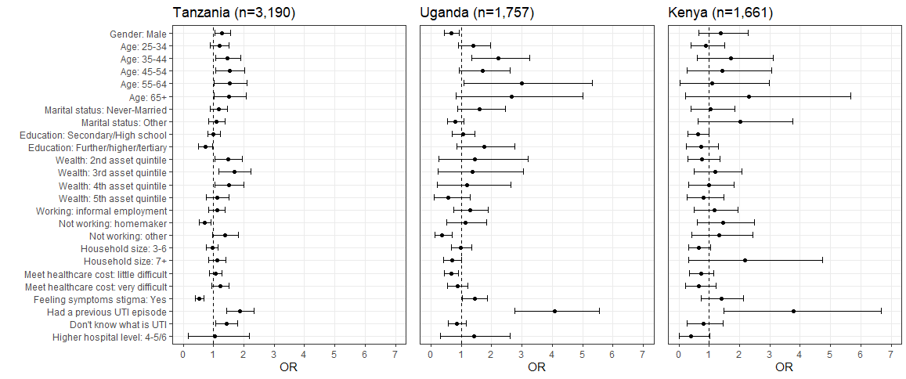Dashed line indicates 95% Highest Posterior Density interval (HPDI) crossing 1.

Figure S11.Coefficients (ORs) from multivariable regression models predicting antibiotic consumption in step 1 or 2 of the pathway (N=3,546)
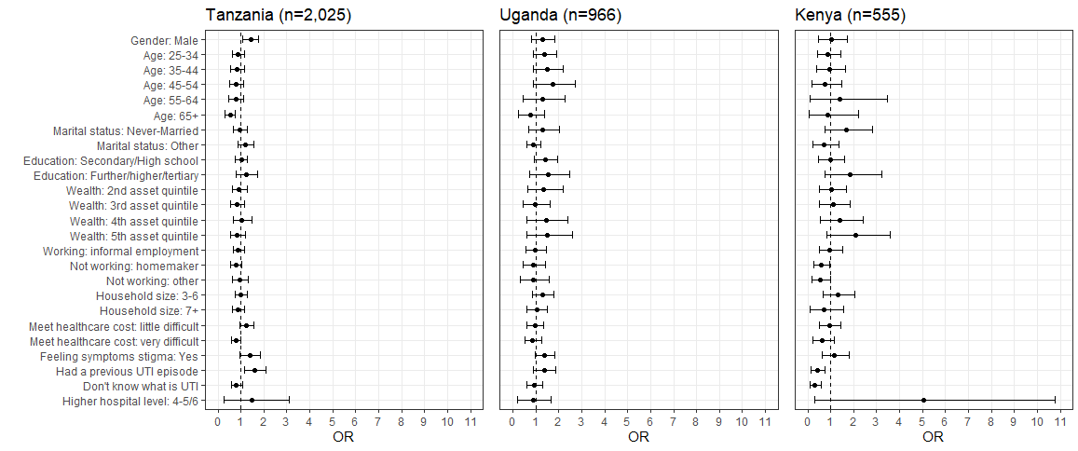
Dashed line indicates 95% Highest Posterior Density interval (HPDI) crossing 1

Figure S12: Sankey plot describing patient treatment seeking pathways for UTI-like symptoms for those who attended clinics at step 1 (N=1,127)
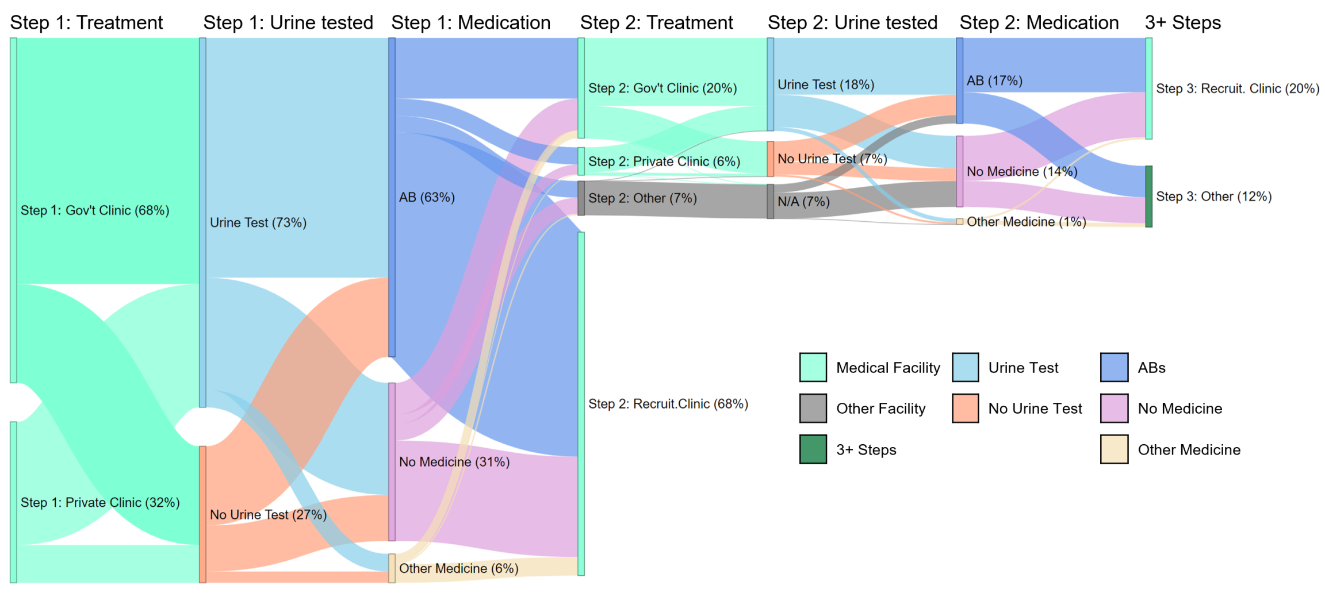
Figure notes: Sub-sample of patients who attended either government or private clinic as a first step and took part in phase 2 of the study (conducted Jan- Sept 2020). The date restriction is due to a new question on testing being introduced only in phase 2.
Table S6: Medications reportedly taken by patients before coming to the recruitment clinic at step 1.
Drug name  (brand names) | Freq¹ | Type of drug
Antibiotics/
antimicrobials
Amoxicillin | 758 | AB
Amoxicillin/ Clavulanic Acid (Amoxiclav) | 88 | AB
Ampicillin | 48 | AB
Ampicillin-Cloxacillin (Ampiclox) | 58 | AB
Azithromycin (Azuma) | 78 | AB
Ceftriaxone | 85 | AB
Cefuroxime | 2 | AB
Cephalexine | 19 | AB
Ciprofloxacin | 687 | AB
Cotrimoxozole (Septrine) | 40 | AB
Doxycycline | 143 | AB
Erythromycin | 98 | AB
Gentamicin | 27 | AB
Levofloxacin | 4 | AB
Metronidazole (Flagyl) | 248 | AB
Nitrofurantoin | 40 | AB
Tetracycline | 21 | AB
Tinidazole | 7 | Antimicrobial
Other medicines
Amlodipine | 2 | High blood pressure
Benzodiazepine | 13 | Central nervous system depressive drugs
Captopril | 1 | hypertension
Clotrimozole (Clotrinozole, Cotrim) | 18 | Anti-fungal
Diclofenac | 50 | Pain relief
Fluconazole | 18 | Antifungal
Lorsatan (Lorsa) | 1 | High blood pressure
Malaria | 3 | Anti-malarial
Nifedepine | 3 | High blood pressure
Omeprazole | 26 | Stomach acid regulator
Paracetamol | 374 | Pain relief
Pregabalin | 2 | Epilepsy/  Anxiety
¹ Frequency of reports of having taken this drug at step 1, drug either named or identified through drug card/ drug bag.

References
1. Howe, L. D. et al. Measuring socio-economic position for epidemiological studies in low- and middle-income countries: a methods of measurement in epidemiology paper. Int. J. Epidemiol. 41, 871–886 (2012).
2. Vyas, S. & Kumaranayake, L. Constructing socio-economic status indices: how to use principal components analysis. Health Policy Plan. 21, 459–468 (2006).
3. Naveed, T. A., Gordon, D., Ullah, S. & Zhang, M. The Construction of an Asset Index at Household Level and Measurement of Economic Disparities in Punjab (Pakistan) by using MICS-Micro Data. Soc. Indic. Res. 155, 73–95 (2021).
4. Lund, C. & Cois, A. Simultaneous social causation and social drift: Longitudinal analysis of depression and poverty in South Africa. J. Affect. Disord. 229, 396–402 (2018).
5. Williams, B., Onsman, A. & Brown, T. Exploratory factor analysis: A five-step guide for novices. Australas. J. Paramed. 8, 1–13 (2010).
6. Chan, L. L. & Idris, N. Validity and Reliability of The Instrument Using Exploratory Factor Analysis and Cronbach’s alpha. Int. J. Acad. Res. Bus. Soc. Sci. 7, 400–410 (2017).
7. NIMBLE Development Team. NIMBLE: MCMC, Particle Filtering, and Programmable Hierarchical Modeling (0.12.1). (2021).
8. Ministry of Health, Community Development, Gender, E. and C. (MoHCDGEC) [Tanzania M. et al. Tanzania Demographic and Health Survey and Malaria Indicator Survey (TDHS-MIS) 2015-16. (2016).
9. Uganda Bureau of Statistics (UBOS)’ & ICF’. Uganda Demographic and Health Survey 2016. (2018).
10. Kenya National Bureau of Statistics’ et al. Kenya Demographic and Health Survey 2014. (2015).

