

The ARRIVE Guidelines Checklist
Animal Research: Reporting In Vivo Experiments
Carol Kilkenny¹, William J Browne², Innes C Cuthill³, Michael Emerson⁴ and Douglas G Altman⁵
¹The National Centre for the Replacement, Refinement and Reduction of Animals in Research, London, UK, ²School of Veterinary Science, University of Bristol, Bristol, UK, ³School of Biological Sciences, University of Bristol, Bristol, UK, ⁴National Heart and Lung Institute, Imperial College London, UK, ⁵Centre for Statistics in Medicine, University of Oxford, Oxford, UK.

 |  | ITEM | RECOMMENDATION | Section/  Paragraph
 |  |  |  | Title (Line 1)
 |  |  |  | Abstract (Line 13)
 | INTRODUCTION
 | 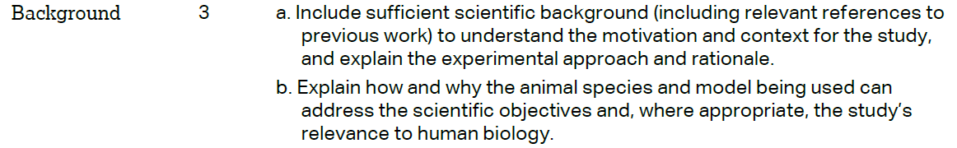 |  |  | Background (Line 40； 54)
 |  |  |  | Background (Line 106)
 | METHODS
 |  |  |  | Declarations- Ethics approval and consent to participate (line 571)
 | 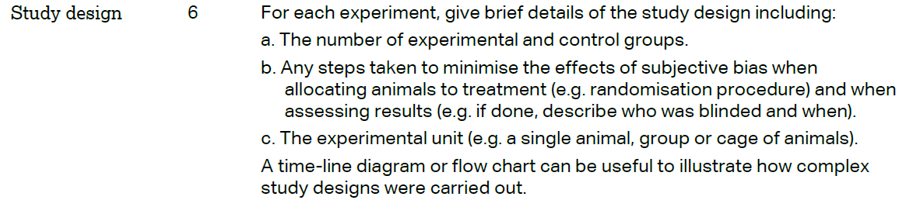 |  |  | Methods-Mapping population and phenotypic data (line 410; 496; 523)
 | 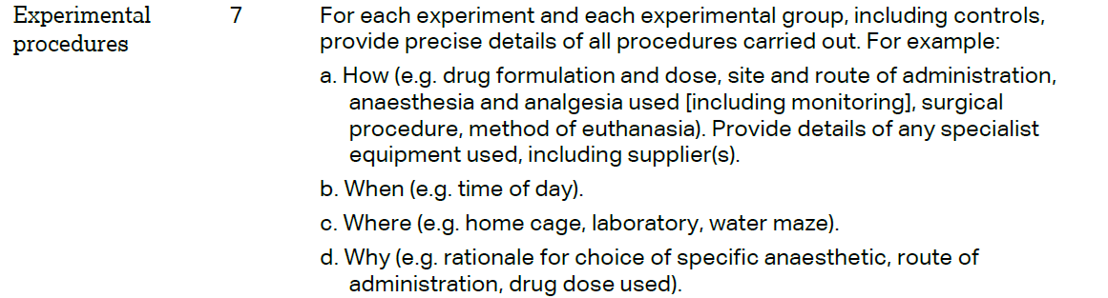 |  |  | Methods  (line 411-417)
 | 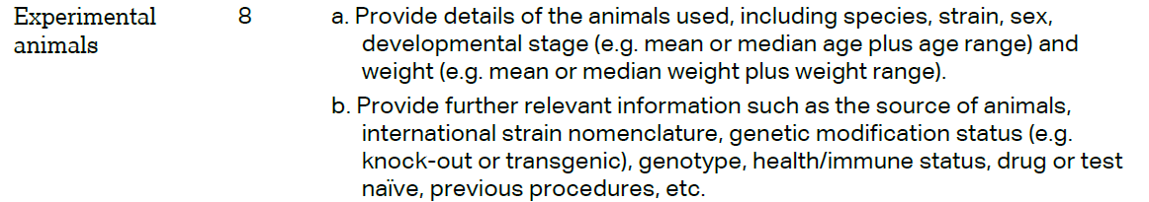 |  |  | Methods  (line 411-417) and Table S1.
The ARRIVE guidelines. Originally published in PLoS Biology, June 2010¹
 | 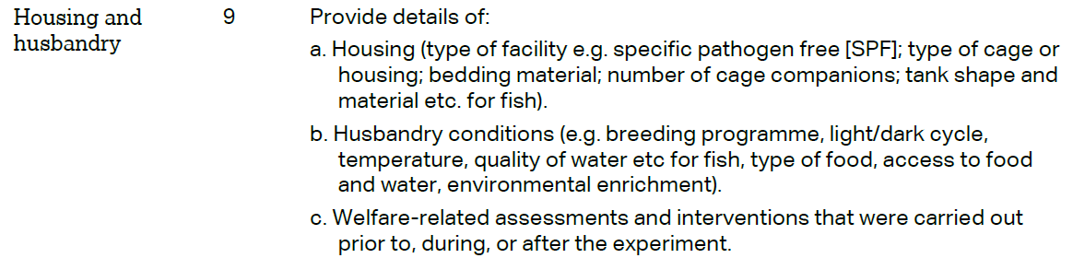 | Methods  (line 402-417)
 | 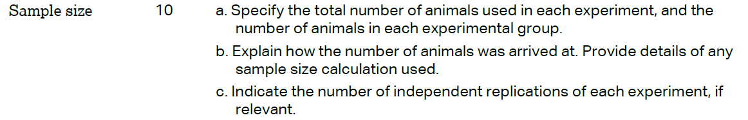 | Methods  Mapping population and phenotypic data  (line 410; 496; 523)
 | 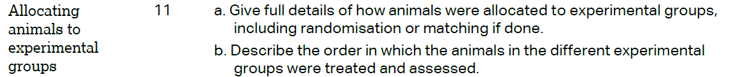 | Methods-Mapping population and phenotypic data  (line 411)
Methods-Mapping population and phenotypic data
(line 413-416)
 | 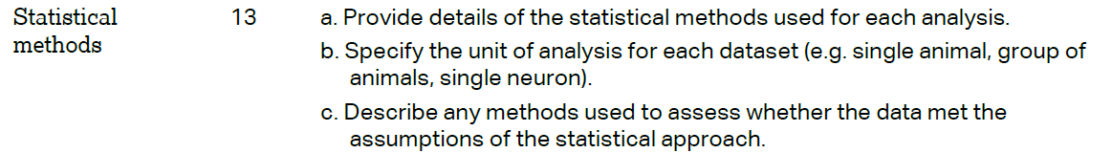 | Methods  (line 511; 547)
 | RESULTS
 |  | Table S1.
 |  | Methods- Mapping population and phenotypic data and Table S1.
 |  | Not Applicable
 |  | Not Applicable
 | DISCUSSION
 | 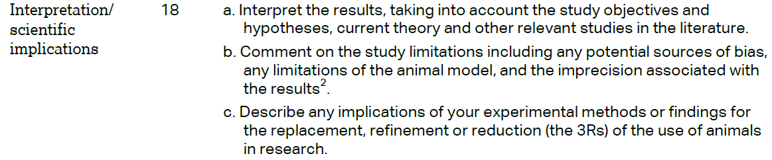 | Discussion (248; 261; 274) and Analysis of candidate genes
 |  | line 115
 |  | line 584

