Nasal Reconstruction for Chinese Patients: A Retrospective Study
Muqian Wei#, Xi Bu#, Guanhuier Wang#, Yonghuan Zhen, Xin Yang, Dong Li, Yang An*
- Department of Plastic Surgery, Peking University Third Hospital, 49 North Garden Road, Haidian District, Beijing, 100191, China
#These authors contributed equally to this work
*Corresponding author:
Yang An MD.
Email: anyangdoctor@163.com;

Supplementary Table S1. Patients Characteristics

Patient | Age, yr | Sex | Nationality | Smoking | Drinking | Comorbidities | BMI | Case of Nasal Injury | Site of Nasal Injury | Follow-up time (years)
1 | 31 | M | Manchu | No | Yes | - | 20.07 | Cicatricial contracture | St + C + A + T + D | 11
2 | 31 | M | Tibetan | No | No | - | 18.40 | Trauma | All nasal tissue below keystone (including cartilage and soft tissue) | 8
3 | 45 | M | Han | No | No | - | 29.53 | SCC | Right A | 8
4 | 31 | F | Han | No | No | - | 22.03 | Mucormycosis | All nasal soft tissue, cartilage and bone | 7
5 | 55 | F | Chaoxian | No | No | - | 21.23 | Secondary contracture | - | 9
6 | 66 | F | Han | No | No | - | 25.28 | SCC | Right A + T | 8
7 | 52 | M | Han | Yes (SI=60) | No | - | 25.46 | SCC | Right A | 9
8 | 28 | M | Han | No | No | - | 20.07 | Trauma | Right A + T | 7
9 | 35 | F | Han | No | No | - | 17.58 | Severe saddle nose | - | 6
10 | 26 | F | Han | No | No | - | 18.73 | Rat bite | A + T | 4
11 | 56 | M | Han | No | No | Hypertension, Diabetes, CHD | 32.05 | Trauma | Left St +Left A | -
12 | 53 | M | Han | No | No | - | 23.73 | Trauma | Right St + Right T | -
13 | 70 | M | Han | Yes | Yes | Hypertension, CHD | 21.97 | BCC | Left A + Left Lw | -
Abbreviations: A, ala; BCC, basal cell carcinoma; BMI, body mass index; C, columella; CHD, coronary heart disease; D, dorsum; F, female; Lw, lateral wall; M, male; SCC, squamous cell carcinoma; SI, Smoking Index; St, soft triangle; T, tip.

Supplementary Figure S1. Patient 4 with a total nasal defect.
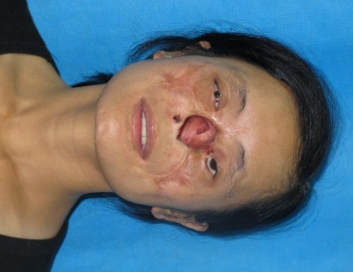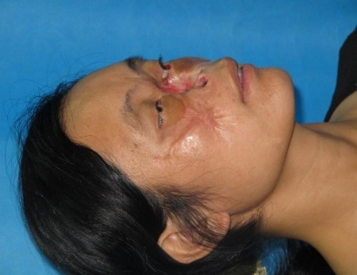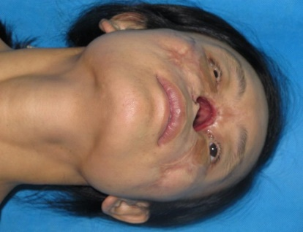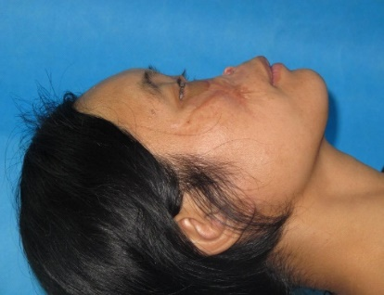

Supplementary Figure S2. Design of the treatment plan. (A) Defect of the nose. (B) Implantation of tissue expander. (C) Transfer of the radial forearm free flap and great saphenous vein. (D) Nasal reconstruction with expanded forehead flap, auricular and costal cartilage, and rib. (E) Dissection of the pedicle. (F) Final result of nasal reconstruction.
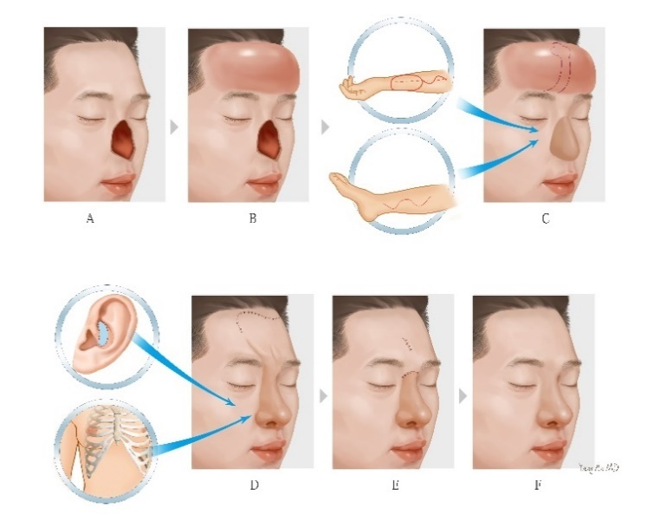

Supplementary Figure S3. Implantation of the tissue expander.
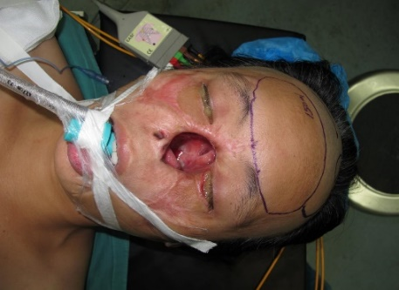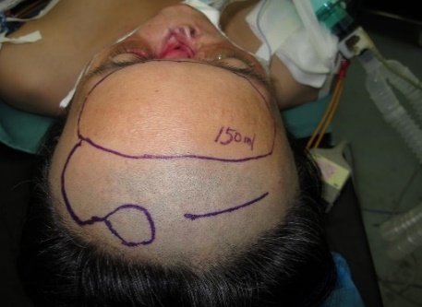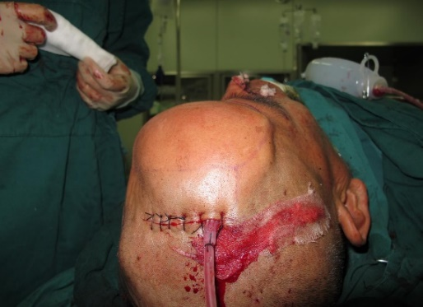

Supplementary Figure S4. A 400 ml expansion volume.
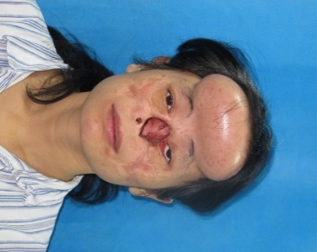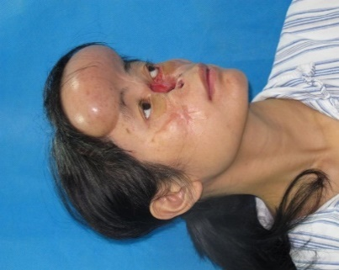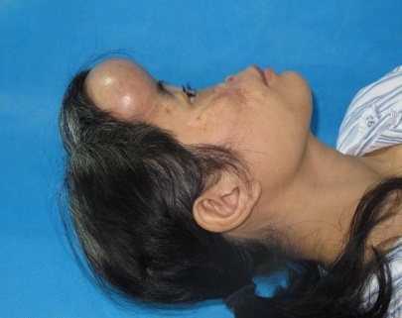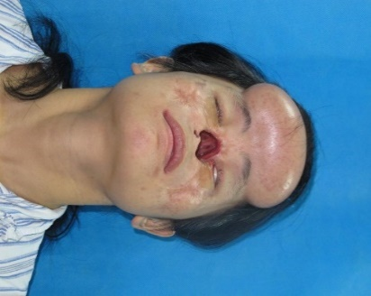

Supplementary Figure S5. (Above, left) A left radial forearm free flap (11cmx7.5cm). (Above, right) A 12cm long right great saphenous vein. (Below) The flap was transferred to fill the nasal cavity.
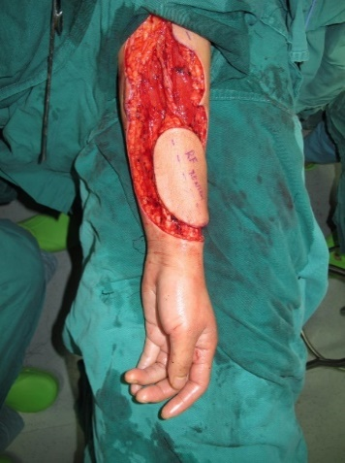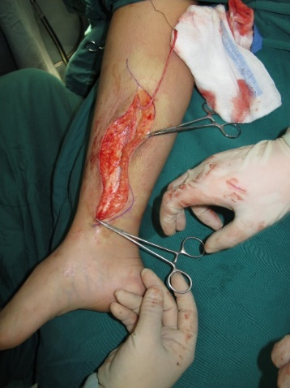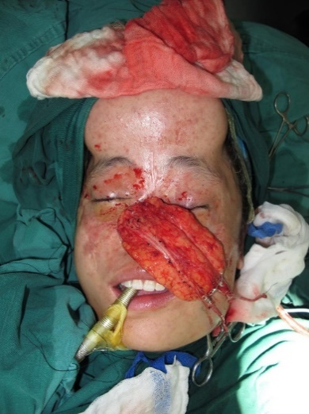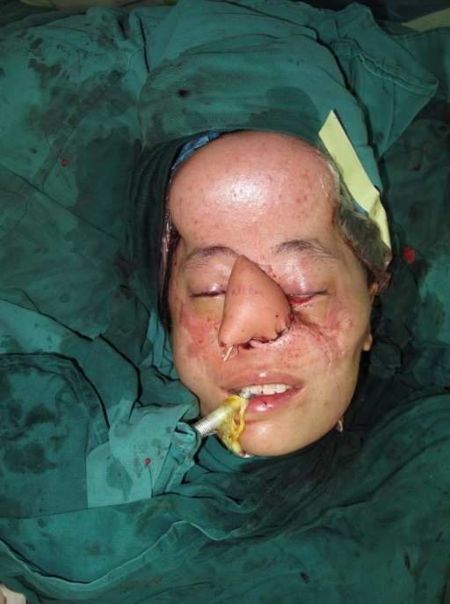

Supplementary Figure S6. The right 7th rib and costal cartilage.
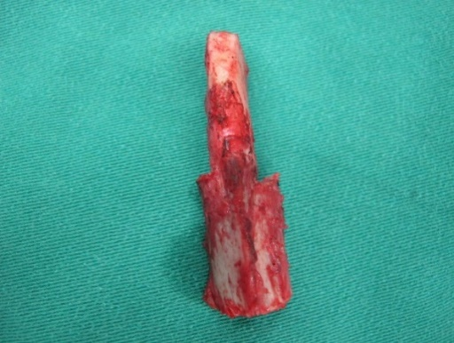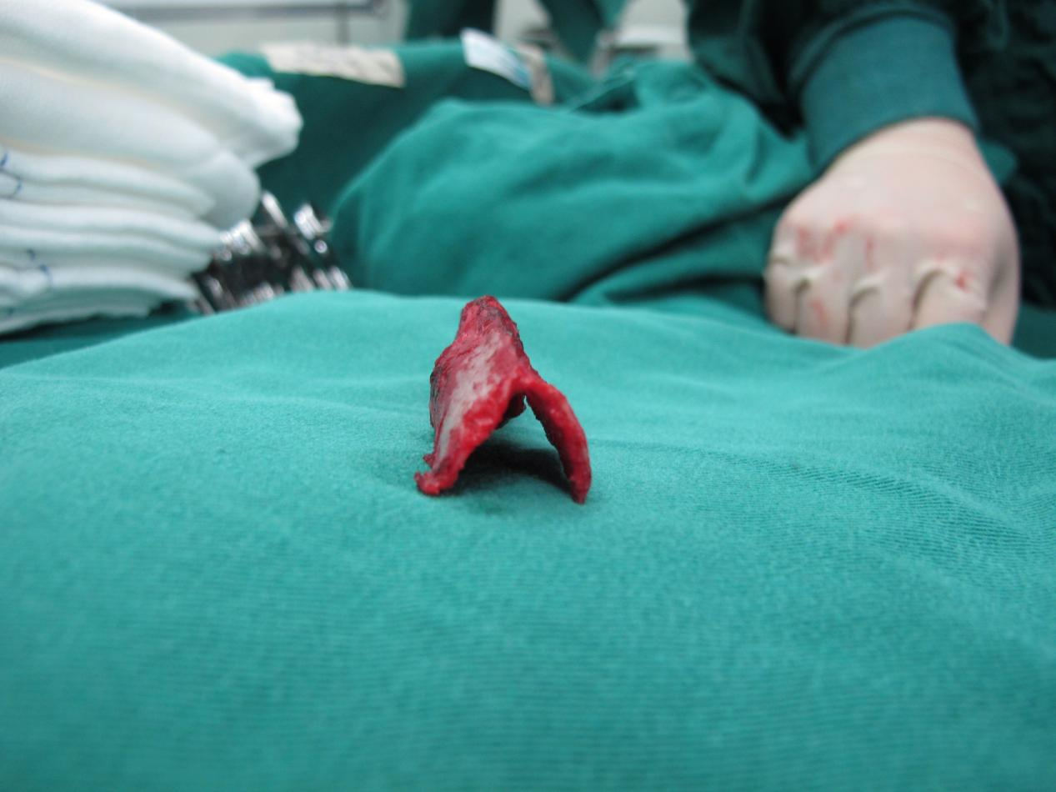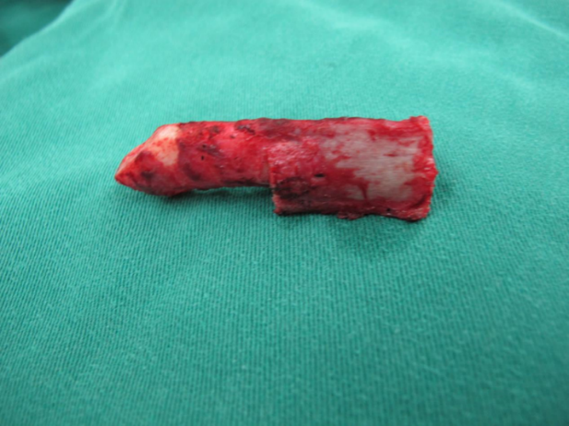

Supplementary Figure S7. Total nasal reconstruction with expanded paramedian forehead flap.
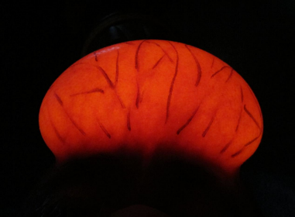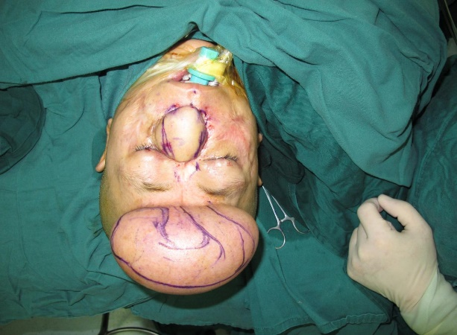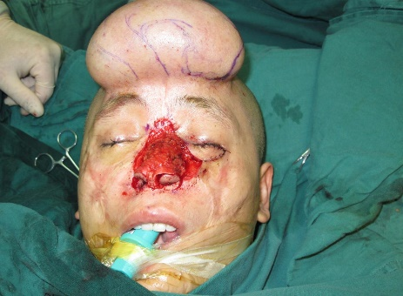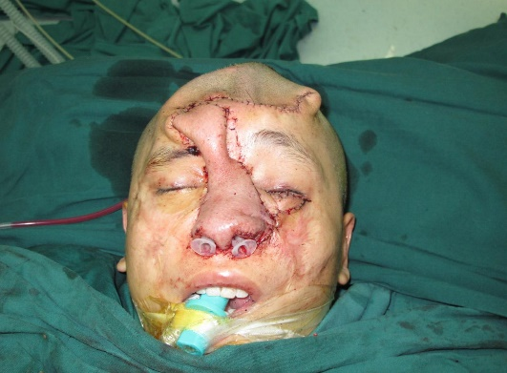

Supplementary Figure S8. Pedicle dissection of the flap.
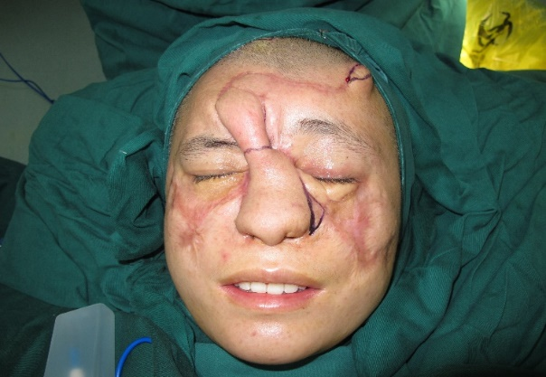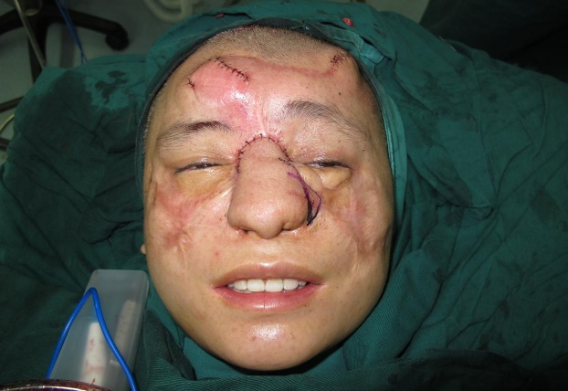

Supplementary Figure S9. 1-year follow-up postoperative result of patient 4.
