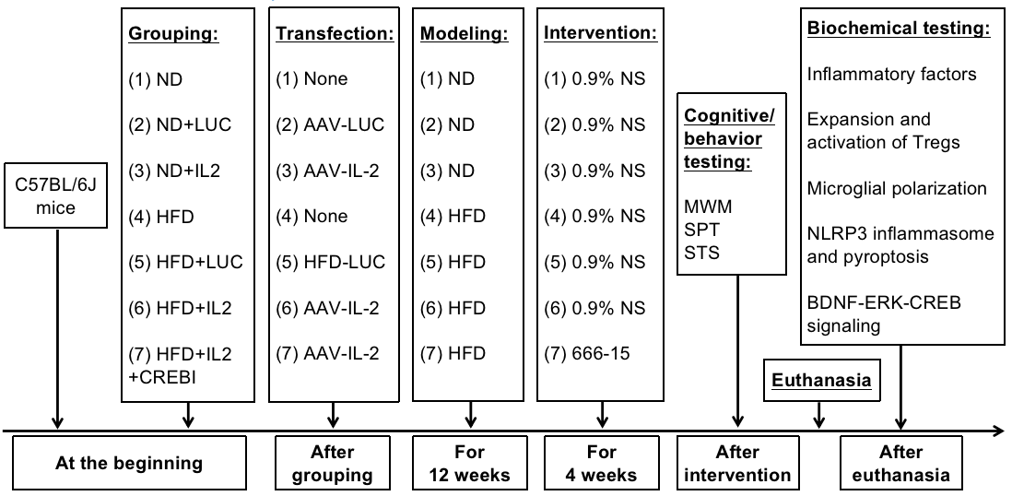

Supplemental Figure 1 Graphical timeline of the study
“ND” = Normal diet, “HFD” = High-fat diet; “NS” = Normal saline.

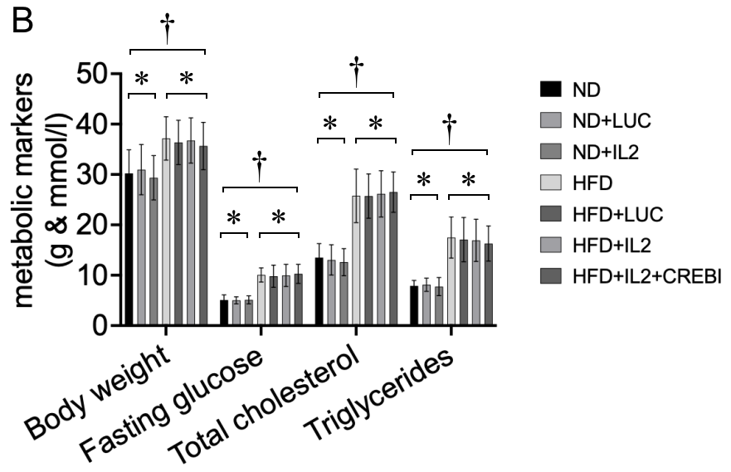
Supplemental Figure 2 Metabolic indicators in the study
“†” indicates P＜0.05；“*” indicates P＞0.05.

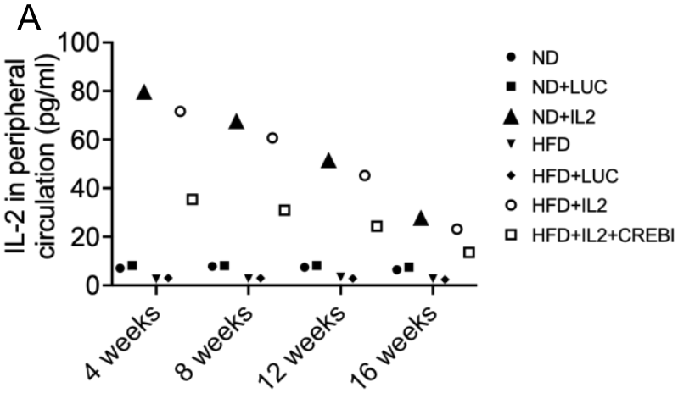
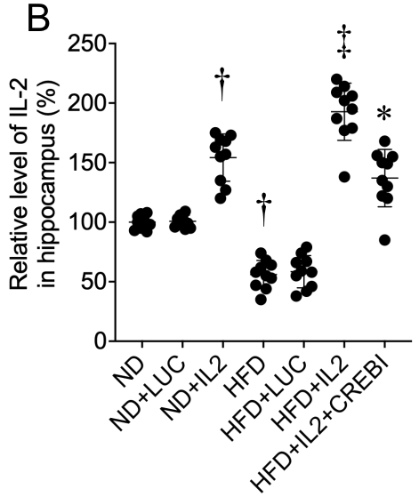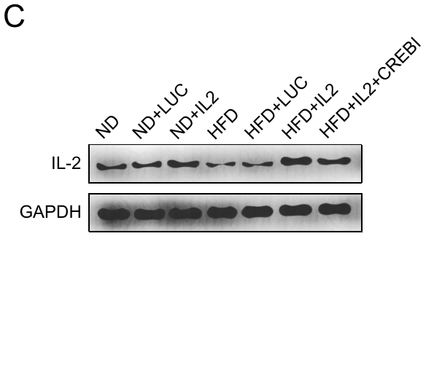
Supplemental Figure 3 IL-2 expression in peripheral circulation and hippocampus
“†” indicates “P＜0.05, compared with the ND group”.
“‡” indicates “P＜0.05, compared with the HFD group”.
“*” indicates “P＜0.05, compared with the HFD+IL2 group”.

